两种可视化方法

**方法1**：Tensorboard

安装：

sudo pip install tensorflow

sudo pip install tensorboard

sudo pip install tensorboardX

运行代码：

import torch  
import torch.nn as nn

from torchvision import models  
from tensorboardX import SummaryWriter  
  
num_classes = 751 # Market1501  
  
class ResNet50(nn.Module):  
 def __init__(self):  
 super(MGN, self).__init__()  
 resnet = models.resnet50(pretrained=True)  
 self.model = resnet

def forward(self, x):  
 y = self.model(x)  
 return y  
  
if __name__ == '__main__':  
 net=ResNet50()  
   
 input = torch.randn(1, 3, 384, 128)  
 output = net(input)  
 with SummaryWriter(comment='ResNet50') as w:  
 w.add_graph(net, (input,))

会在当前文件夹中产生一个./runs文件夹。保证路径没有中文，运行：

tensorboard --logdir runs

得到如下结果：

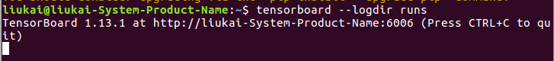

在浏览器打开网址，得到网络结构图：

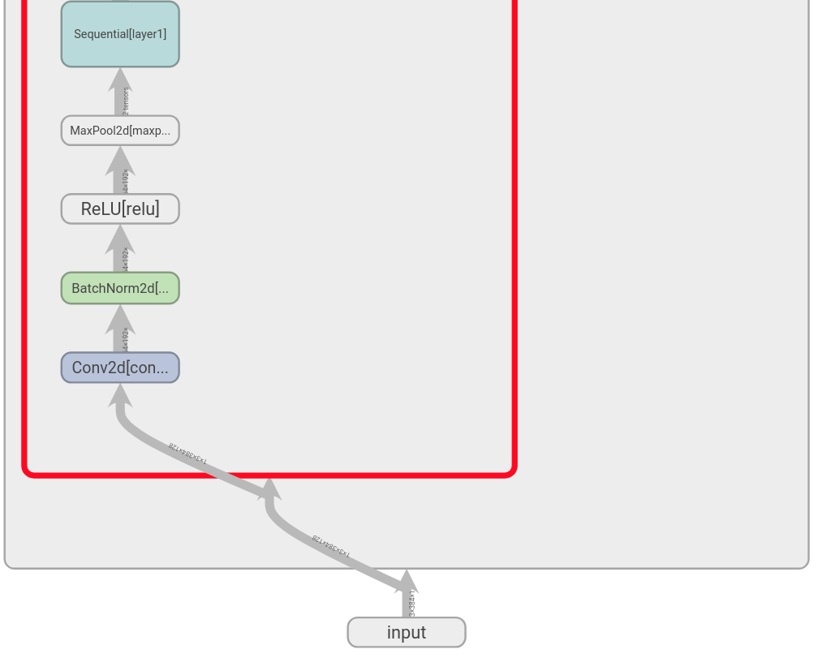

**方法2：**

sudo apt-get install graphviz

git clone https://github.com/szagoruyko/pytorchviz.git

以Alexnet为例，在该git代码目录下，执行代码：

import torch  
from torch import nn  
from torchviz import make_dot  
from torchvision.models import alexnet  
  
model = alexnet(pretrained=True)  
x = torch.randn(1,3,227,227).requires_grad_(True)  
y = model(x)  
vis_graph = make_dot(y)  
vis_graph.view()  
params = list(model.parameters())