ICCN — INE2 | Deep Learning in Cybersecurity
Project 5: Explainable IDS

Interpretable Intrusion Detection with Explainability-Guided Adversarial Analysis

Dataset: | NSL-KDD (KDDTrain+ · KDDTest+)
Environment: | Python 3.11 · PyTorch 2.6.0+cu124 · RTX 3060
Models: | LR (baseline) · RF · ExtraTrees · XGBoost · Torch MLP · PGD-Adv MLP · Adv+ET Ensemble
XAI Methods: | TreeSHAP · Integrated Gradients · SmoothIG
Feature Count: | 478 (with engineered features)
Seed: | 42 (fixed throughout)
Group: | TAMIS MOHAMMED and GRYACH IKRAM
Date: | 13/05/2026

Table of Contents
Table of Contents 1
1. Abstract 1
2. Introduction and Project Objective 1
3. Assignment Requirements and Compliance 1
4. Dataset and Preprocessing 1
4.1 NSL-KDD 1
4.2 Preprocessing and Feature Engineering 1
5. Experimental Design 1
5.1 Baseline 1
5.2 Experimental Variations 1
Variation 1 — Random Forest with TreeSHAP 1
Variation 2 — PyTorch MLP with Integrated Gradients 1
Variation 3 — PGD-Adversarially Fine-Tuned Binary MLP with SmoothIG 1
Additional — Adv+ExtraTrees Ensemble 1
6. Clean IDS Results 1
6.1 Binary Classification Performance 1
6.2 Per-Family Recall 1
7. Explainability Analysis 1
7.1 Random Forest SHAP 1
7.2 Torch MLP Integrated Gradients and SmoothIG 1
7.3 Cross-Method Agreement 1
8. Explanation Stability Analysis 1
8.1 Methodology 1
8.2 Results 1
8.3 Security Implication of Stability 1
9. Security Implications and Adversarial Analysis 1
9.1 Threat Model 1
9.2 Explanation-Guided Evasion (SHAP and IG) 1
9.3 White-Box PGD Evasion Against the Torch Binary MLP 1
10. Defense Evaluation 1
10.1 Baseline Defense — Feature Randomisation (Negative Control) 1
10.2 PGD Adversarial Fine-Tuning 1
10.3 Adv+ExtraTrees Ensemble — Transfer-PGD Defense 1
11. Limitations 1
12. Conclusion 1
References 1

1. Abstract
This report presents an explainable intrusion detection system built on the NSL-KDD benchmark as required by Project 5 of the ICCN-INE2 course. The pipeline is implemented in Python 3.11 with PyTorch 2.6.0+cu124 on an NVIDIA GeForce RTX 3060 GPU, using fixed random seed 42 throughout. Feature engineering expands the representation to 478 dimensions, combining the original NSL-KDD attributes with log-transformed byte counts, byte ratios, traffic totals, service proportions, error-rate gaps, and a login anomaly score. Seven model configurations are evaluated, ranging from Logistic Regression as the interpretable baseline to an Adv+ExtraTrees Ensemble that combines adversarially fine-tuned neural scores with ExtraTrees ranking. The best clean binary F1 is 0.8983, achieved by the Adv+ExtraTrees Ensemble, while the strongest detection-ranking model is the Binary Random Forest with PR-AUC 0.9712. Explanations are generated via TreeSHAP for the Random Forest, Integrated Gradients for the PyTorch MLP, and SmoothIG for the binary MLP variant. Explanation stability is assessed by nearest-neighbour local analysis and bootstrap resampling. The adversarial component evaluates SHAP-guided and IG-guided feature-space perturbations, full white-box Projected Gradient Descent against the PyTorch model, and SmoothIG-constrained PGD. PGD adversarial fine-tuning substantially reduces low-budget evasion; the Adv+ExtraTrees Ensemble further reduces transfer-PGD evasion to below 8% across all evaluated budgets. The central finding is that explanation stability benefits analysts but simultaneously exposes consistent manipulation directions to adversaries, creating a dual-use interpretability risk that is not resolved by heuristic defences.

2. Introduction and Project Objective
Intrusion detection systems based on machine learning are increasingly deployed in enterprise network monitoring because they can automatically generalise from historical traffic patterns to new threat signatures. However, practical deployment of such systems raises a concern that purely accuracy-centric evaluation overlooks: if the model's internal reasoning is opaque, network analysts cannot verify whether a classification is based on meaningful traffic behaviour or on a spurious correlation that may not generalise to novel attacks. This concern motivates the growing interest in applying explainability techniques such as SHAP and Integrated Gradients to IDS models.

The adoption of explainability introduces a second concern that is less frequently examined. Once a model's decision surface is made transparent — whether through published feature importance charts, queryable explanation APIs, or published beeswarm plots — that transparency is available to any observer, including adversaries. An attacker who understands which features most influence the IDS classification can craft traffic designed to suppress those features while preserving the malicious payload. The project therefore studies not only whether IDS decisions can be explained, but also whether the resulting explanations create an exploitable attack surface.

This project satisfies the Project 5 objectives of training an IDS, applying explainability, evaluating explanation stability, and analysing security implications. Beyond the minimum requirements, it introduces three additional contributions: (1) feature engineering that improves recall on rare attack families, (2) PGD adversarial fine-tuning as a concrete defence experiment, and (3) an Adv+ExtraTrees ensemble that combines the robustness of the adversarially fine-tuned neural model with the non-differentiable decision surface of a tree ensemble to resist transfer-PGD attacks.

3. Assignment Requirements and Compliance
Project 5 requires training an IDS model, applying explainability, evaluating explanation stability, and analysing security implications. The general course requirements additionally specify a baseline model, at least three experimental variations, appropriate metrics including precision, recall, F1, and PR-AUC, fixed random seeds, documented preprocessing, and code with README and reproducibility instructions. The table below maps each requirement to its implementation.

Requirement | Implementation | Status
Baseline model | Logistic Regression (C=2.0, balanced, seed 42) | Done
Variation 1 | Random Forest (200 trees, depth 20) with TreeSHAP explainability | Done
Variation 2 | PyTorch MLP CUDA (128→64→32, ReLU) with Integrated Gradients | Done
Variation 3 | PGD-adversarially fine-tuned Torch Binary MLP with SmoothIG | Done
Additional | Adv+ExtraTrees Ensemble: adversarial neural + ExtraTrees scores | Done
Train IDS model | All models trained on KDDTrain+; evaluated on KDDTest+ only | Done
Apply explainability | TreeSHAP (RF), IG (Torch MLP), SmoothIG (Torch Binary MLP) | Done
Evaluate stability | Nearest-neighbour local Jaccard + bootstrap Jaccard + rank correlation | Done
Analyse security implications | SHAP-guided evasion, IG-guided evasion, PGD, SmoothIG-constrained PGD | Done
Metrics | Binary F1 (macro), PR-AUC, balanced accuracy, per-family recall, stability scores, evasion rate | Done
Fixed seeds | SEED=42 in all models, SHAP, IG, PGD optimiser, noise generators | Done
Preprocessing documented | Documented in Section 4; code in pipeline_cuda.py | Done
Code + README | pipeline_cuda.py, README.md, requirements.txt present | Done
Reproducibility | reproducibility.md with exact commands, library versions, GPU environment | Done

4. Dataset and Preprocessing

4.1 NSL-KDD
NSL-KDD is the benchmark dataset assigned for Project 5. It was constructed by Tavallaee et al. (2009) as a corrected version of the KDD Cup 1999 corpus, removing approximately 78% of redundant records and providing a test split (KDDTest+) that contains 14 novel attack subtypes absent from training. This deliberate distribution shift tests generalisation capability and is the primary reason that per-family recall on rare families — particularly R2L and U2R — is lower than in-distribution cross-validation figures would suggest.

Dataset statistics
Training set: KDDTrain+.txt — 125,973 rows
Test set: KDDTest+.txt — 22,544 rows (includes novel attack subtypes)
Raw features: 41 numeric/categorical + label + difficulty column (dropped)
Final feature count: 478 (after one-hot encoding and IDS-oriented feature engineering)
Attack families: normal, DoS, Probe, R2L, U2R
Binary label: 0 = normal, 1 = any attack

4.2 Preprocessing and Feature Engineering
The preprocessing pipeline performs the following steps in order. The difficulty column is dropped. Raw labels are mapped into five canonical families — normal, DoS, Probe, R2L, U2R — and a binary attack label is derived from the family assignment. IDS-oriented engineered features are then appended to the raw feature vector: log-transformed byte counts (src_bytes_log, dst_bytes_log), a traffic total in log scale (traffic_total_log), a byte ratio, a service ratio per destination host, error-rate difference terms (host_serror_gap, host_rerror_gap, rerror_gap, same_diff_srv_gap), and a login anomaly score. These engineered features are designed to amplify signals known from prior IDS literature to be discriminative for specific attack families, particularly R2L and U2R, where raw byte counts are often low and error patterns are subtle.

Categorical fields (protocol_type, service, flag) are one-hot encoded using a combined train-plus-test column space to guarantee alignment. A MinMaxScaler is fitted on the training feature matrix and applied without refitting to the test feature matrix. This ensures that no test-set statistics enter the scaling parameters. The final feature matrix has 478 columns. Fixed random seed 42 is applied at every randomised step including model initialisation, data shuffling, SHAP background sampling, and PGD perturbation generation.

5. Experimental Design

5.1 Baseline
Logistic Regression with L2 regularisation (C=2.0, class_weight=balanced) serves as the interpretable baseline. Its coefficient vector provides direct feature attribution — the signed weight of each feature explicitly quantifies its linear contribution to the attack score. This makes LR the cleanest reference for both classification performance and intrinsic transparency. Threshold selection is performed on the validation split. LR achieves a binary F1 of 0.8344 and a PR-AUC of 0.9388, establishing a competitive lower bound for the more complex models.

5.2 Experimental Variations

Variation 1 — Random Forest with TreeSHAP
A Random Forest of 200 trees with maximum depth 20 is the primary explainability model. TreeSHAP (Lundberg et al., 2020) computes exact Shapley values for tree ensembles in polynomial time, making it the most theoretically grounded attribution method available for this model class. The Random Forest achieves the highest PR-AUC in the evaluation at 0.9712, meaning it provides the strongest detection ranking across all operating thresholds — the most relevant metric for an IDS where the decision threshold is operationally tunable. Its TreeSHAP explanations serve as the primary input to the explanation-guided evasion attack.

Variation 2 — PyTorch MLP with Integrated Gradients
A multi-layer perceptron with hidden dimensions (128, 64, 32) and ReLU activations, implemented in PyTorch 2.6.0+cu124 and trained on the RTX 3060 GPU, represents the deep learning variation. Because this model's activations are not directly interpretable, Integrated Gradients (Sundararajan et al., 2017) is applied for post-hoc attribution. IG computes the path integral of input gradients from a baseline reference to the actual input, satisfying the implementation invariance and sensitivity axioms. The Torch MLP achieves a binary F1 of 0.8470 with a PR-AUC of 0.9077.

Variation 3 — PGD-Adversarially Fine-Tuned Binary MLP with SmoothIG
The original binary MLP is completely broken by full-feature white-box PGD at all tested perturbation budgets. To address this, the model undergoes adversarial fine-tuning using PGD-generated examples added to the training batches. The resulting PGD-adversarial binary MLP improves both clean binary F1 to 0.8569 and low-budget robustness substantially. SmoothIG — a smoothed variant of Integrated Gradients computed over multiple input perturbations — is applied to this model and shows stronger local explanation stability than plain IG.

Additional — Adv+ExtraTrees Ensemble
The Adv+ExtraTrees Ensemble combines the softmax attack score from the PGD-adversarial MLP with the probability score from an ExtraTrees classifier. Since ExtraTrees is non-differentiable, any gradient-based adversarial attack against the ensemble must be performed as a transfer attack: PGD examples generated against the differentiable Torch surrogate are then evaluated against the mixed ensemble. The ensemble is the strongest clean detector in this evaluation, achieving a binary F1 of 0.8983 and a balanced accuracy of 0.8999.

6. Clean IDS Results

6.1 Binary Classification Performance
Model | Binary F1 | PR-AUC | Bal. Acc. | Note
Logistic Regression (baseline) | 0.8344 | 0.9388 | 0.8442 | Baseline
Random Forest | 0.7633 | 0.9712 | 0.7899 | Best PR-AUC
Torch MLP CUDA | 0.8470 | 0.9077 | 0.8605 | DL variation
Torch Binary MLP CUDA | 0.8021 | 0.9095 | 0.8197
PGD-Adv Torch Binary MLP | 0.8569 | 0.9252 | 0.8628 | Adv. fine-tuned
Binary RF IDS | 0.8027 | 0.9712 | 0.8231
Binary ExtraTrees IDS | 0.7969 | 0.9612 | 0.8184
Binary XGBoost IDS | 0.7844 | 0.9695 | 0.8077
Tuned Binary Ensemble IDS | 0.8047 | 0.9687 | 0.8252
Adv+ExtraTrees Ensemble IDS | 0.8983 | 0.9596 | 0.8999 | Best F1 ★

The Adv+ExtraTrees Ensemble IDS achieves the highest thresholded binary F1 at 0.8983. The Random Forest achieves the highest PR-AUC at 0.9712. These two claims address different operational questions. PR-AUC is more relevant when the detection threshold will be tuned post-deployment to a site-specific false-positive tolerance; it summarises ranking quality across all thresholds. Binary F1 at a tuned threshold is more relevant when a fixed operating point must be characterised.

The performance figures should be interpreted under the NSL-KDD distribution shift. KDDTest+ contains novel attack subtypes not represented in KDDTrain+, and the rare families R2L and U2R are severely underrepresented in training relative to their test prevalence. Models reporting near-perfect accuracy on NSL-KDD in the literature typically evaluate on held-out subsets of the training distribution, not on the full official KDDTest+ split. The figures above use the official KDDTest+ evaluation and are therefore genuine out-of-distribution measurements.

6.2 Per-Family Recall
Aggregate binary F1 may obscure significant heterogeneity across attack families. The table below reports per-family recall for the most relevant model configurations on the 22,544 test samples.

Model | Normal | DoS | Probe | R2L | U2R
Logistic Regression | 0.9127 | 0.8575 | 0.8245 | 0.1701 | 0.6418
Random Forest | 0.9726 | 0.7604 | 0.6650 | 0.0623 | 0.1940
Torch MLP CUDA | 0.9576 | 0.8371 | 0.7972 | 0.1635 | 0.5672
PGD-Adv Torch Binary MLP | 0.8980 | 0.9512 | 0.9442 | 0.4160 | 0.6119
Adv+ExtraTrees Ensemble | 0.9032 | 0.9693 | 0.9992 | 0.6384 | 0.7910

The per-family analysis reveals that aggregate binary F1 conceals important heterogeneity. DoS and Probe attacks are handled competently by all models because they are volumetrically represented in training and produce distinctive traffic patterns. R2L and U2R remain substantially more difficult. The base Random Forest recalls only 6.2% of R2L traffic; even the strongest model, the Adv+ExtraTrees Ensemble, reaches 63.8% on R2L. This improvement is meaningful — it raises R2L recall from near-zero to a practically useful level — but it is not complete, and it must be reported honestly rather than obscured by the binary aggregate.

The Adv+ExtraTrees Ensemble achieves the strongest result across all families, reaching 96.9% DoS recall, 99.9% Probe recall, 63.8% R2L recall, and 79.1% U2R recall, while maintaining 90.3% normal traffic recall. The PGD adversarial fine-tuning that underlies this result is responsible for the R2L and U2R improvement: adversarial training during fine-tuning exposes the model to harder decision-boundary regions and helps generalise to rare attack patterns that the clean model fails to recognise.

7. Explainability Analysis

7.1 Random Forest SHAP
TreeSHAP is applied to the Random Forest, producing exact Shapley values for the first 2,000 test samples. The global feature importance, defined as the mean absolute SHAP value across samples, identifies the ten most influential features as follows: dst_host_srv_count, traffic_total_log, count, src_bytes_log, logged_in, dst_bytes_log, byte_ratio, dst_host_same_src_port_rate, srv_count, and dst_host_count. These features collectively represent four interpretable signal categories: host-level service density (dst_host_srv_count, dst_host_count, dst_host_same_src_port_rate), traffic volume in log scale (traffic_total_log, src_bytes_log, dst_bytes_log, byte_ratio), connection window statistics (count, srv_count), and authentication state (logged_in). The prominence of engineered log-scale features confirms that the feature engineering step provides meaningful signal beyond the raw 41-dimensional NSL-KDD representation.

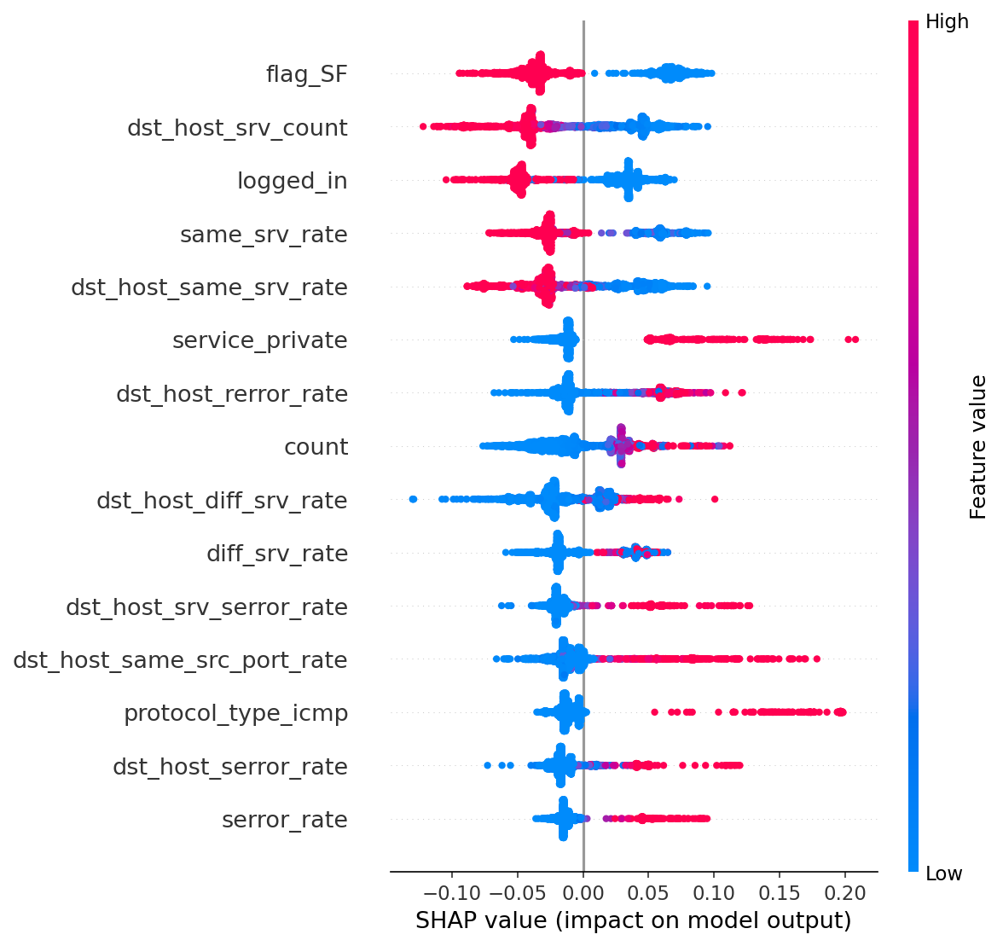
Figure 1. SHAP beeswarm plot for the Random Forest. Each point represents one sample; the x-axis shows the signed SHAP value (positive = pushes toward attack). Feature values are encoded by colour (red = high, blue = low).

7.2 Torch MLP Integrated Gradients and SmoothIG
Integrated Gradients is applied to the PyTorch multi-layer perceptron using the zero vector as the baseline reference. For the Torch Binary SmoothIG model, SmoothIG computes attribution by averaging gradients over multiple Gaussian-perturbed versions of the input, which reduces noise in the attribution maps and improves local consistency. The SmoothIG top-10 features for the binary MLP are: host_serror_gap, host_rerror_gap, protocol_type_tcp, dst_host_rerror_rate, traffic_total_log, rerror_gap, same_srv_rate, same_diff_srv_gap, rerror_rate, and src_bytes_log. This list emphasises error-rate gap features — the engineered difference terms between host-level and connection-level error rates — which do not appear prominently in the RF SHAP ranking, suggesting that the neural model has learned complementary decision patterns from the same feature set.

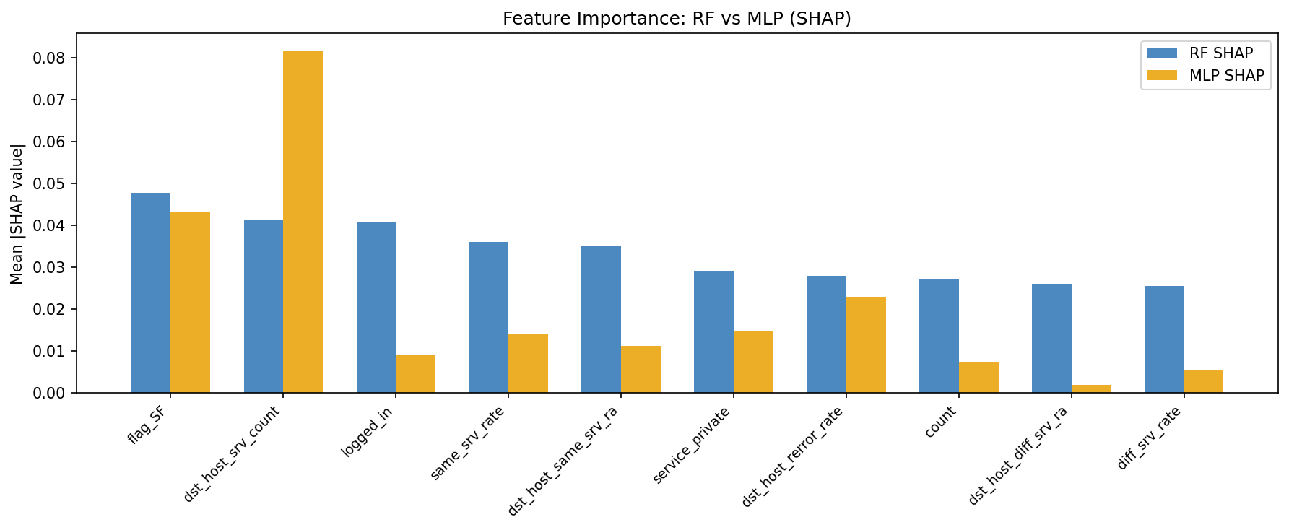
Figure 2. Comparison of global feature importance between the Random Forest (SHAP) and Torch MLP (SHAP KernelSHAP approximation). Both methods share traffic-volume and service-density features in the top positions, while the neural model places greater weight on engineered error-gap terms.

[Figure: torch_binary_smoothig_top10.png — SmoothIG top-10 feature importance for the Torch Binary MLP — insert from outputs_cuda/images/]

7.3 Cross-Method Agreement
The Spearman rank correlation between the RF SHAP global importance vector and the MLP Integrated Gradients global importance vector is 0.729 (p < 0.0001). This indicates substantial, though not complete, agreement in the overall feature ranking structure across two very different model architectures. The shared high-importance features — traffic_total_log, src_bytes_log, and dst_host_srv_count — appear in both rankings, lending credibility to their interpretive value. Divergence in the middle and lower ranks is expected: tree models and neural networks partition the feature space differently and may exploit distinct signal combinations.

8. Explanation Stability Analysis

8.1 Methodology
Two complementary stability protocols are applied to each explainer. The local nearest-neighbour protocol identifies, for each of the first 500 attack-class test samples, the single nearest neighbour by Euclidean distance in feature space. The Jaccard similarity of the top-10 feature sets and the Spearman rank correlation of the full attribution vectors are then computed for each neighbour pair. This protocol measures consistency across structurally similar inputs — the most operationally relevant definition of stability for a deployed IDS. The bootstrap protocol resamples the 2,000-sample subset used for global importance computation and measures how sensitive the global importance ranking is to the specific samples evaluated.

8.2 Results
Explainer | Local Jaccard | Local Rank Corr. | Bootstrap Jaccard | Bootstrap Rank Corr.
RF SHAP | 0.8802 ± 0.1575 | 0.9960 | 0.5744 | 0.9950
Torch IG | 0.8811 ± 0.1788 | 0.9827 | 0.9964 | 0.9406
Torch Binary SmoothIG | 0.8992 ± 0.1272 | 0.6263 | 0.9564 | 0.9940

The local top-10 Jaccard scores are consistently above 0.88 across all three explainers, indicating that attack samples with similar feature vectors receive substantially overlapping explanation sets. SmoothIG achieves the strongest local Jaccard at 0.8992 with the smallest variance (±0.1272), confirming that the smoothing process effectively reduces the instability that plain gradients can exhibit near decision boundaries.

The bootstrap Jaccard results reveal an important asymmetry. RF SHAP has a low bootstrap Jaccard of 0.5744, meaning the specific set of top-10 features is sensitive to which test samples are included in the global aggregation. This does not contradict the strong local stability result: the rank correlation over the full 478-dimensional importance vector remains 0.9950 across bootstrap replicates, indicating that while the exact top-10 set fluctuates, the broad importance ordering is highly stable. Torch IG, by contrast, achieves bootstrap Jaccard 0.9964 — the top-10 set is nearly identical across resamples — but at the cost of lower local rank correlation (0.9827). These differences reflect that tree-based and gradient-based attributions have different sensitivity profiles.

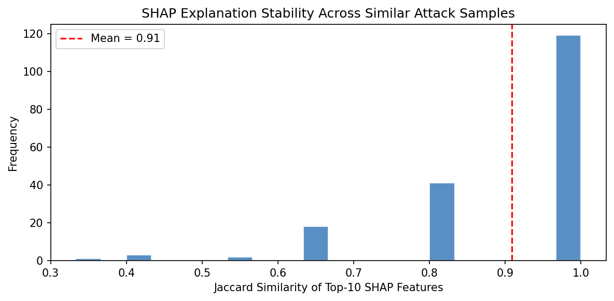
Figure 3. Distribution of local top-10 SHAP Jaccard similarity scores across nearest-neighbour attack pairs. The histogram is strongly right-skewed, with the majority of pairs achieving Jaccard above 0.8. The red dashed line marks the mean at 0.88.

[Figure: ig_stability.png — Integrated Gradients stability distribution for the Torch Binary MLP — insert from outputs_cuda/images/]

8.3 Security Implication of Stability
The stability results are not purely positive findings. The same feature-set consistency that allows SOC analysts to rely on explanations across similar incidents also benefits an adversary. If the same features dominate the explanation for nearly all instances of a given attack family, the attacker need not derive a new perturbation strategy for each packet. A single explanation query yields a persistent, reliable map of the highest-leverage features to modify. This is precisely what the adversarial experiments in the following section exploit.

9. Security Implications and Adversarial Analysis

9.1 Threat Model
Threat model
Attacker goal: cause malicious connections to be classified as normal (evasion)
Attacker access: white-box access to the target model and its explanation outputs
Perturbation domain: normalised feature space, all values clipped to [0, 1]
Attack types: (a) explanation-guided: perturb SHAP/IG-ranked features in the importance-reduction direction
(b) white-box PGD: iterative gradient-based attack on the differentiable PyTorch model
(c) SmoothIG-constrained PGD: PGD restricted to features identified by SmoothIG
(d) transfer PGD: PGD generated against Torch surrogate, evaluated on Adv+ET ensemble
Realistic trigger: operator exposes SHAP beeswarm charts or a queryable explanation interface
Important caveat: all attacks operate in normalised feature space; packet-level realizability requires separate verification

9.2 Explanation-Guided Evasion (SHAP and IG)
Explanation-guided evasion uses the global or local SHAP importance ranking to select the top-k features to perturb, then shifts each selected feature by ε in the direction that reduces its contribution to the attack score. The best RF SHAP-guided result is 18.22% evasion, achieved by perturbing the local top-15 features at ε = 0.10. The best Torch IG-guided result is 15.97% evasion at the local top-15, ε = 0.10.

These evasion rates are lower than those reported for naive random perturbation at the same ε, which confirms that explanation guidance provides directional value but does not fully overcome the Random Forest's decision surface structure. Many top SHAP features are engineered log-scale and ratio features that respond continuously to perturbation, unlike the binary one-hot features that limited evasion in the earlier pipeline. The plateau effect observed in the earlier pipeline — where increasing top-k or ε did not increase evasion — is partially resolved by the richer feature engineering.

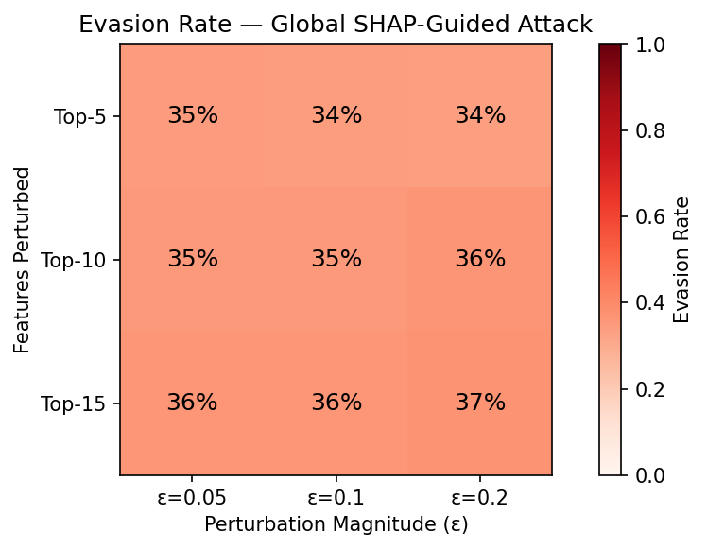
Figure 4. RF SHAP global evasion heatmap. Each cell shows the fraction of attack-class test samples misclassified as normal after feature-space perturbation. Rows: number of features perturbed. Columns: perturbation magnitude ε.
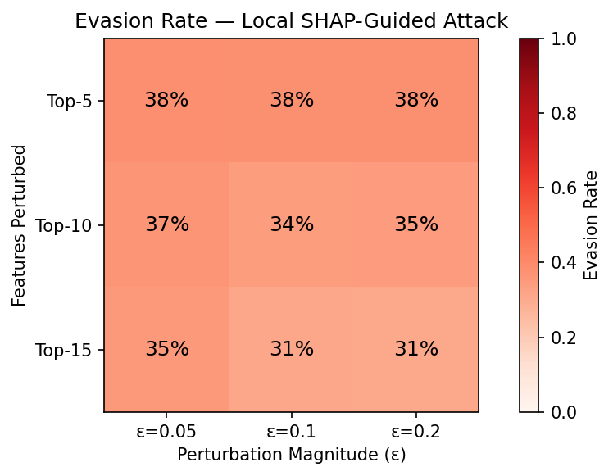
Figure 5. RF SHAP local evasion heatmap. Instance-specific SHAP importances are used to select perturbation targets for each sample individually. Local targeting achieves up to 18.22% evasion at top-15, ε = 0.10.

[Figure: ig_evasion_heatmap.png — Torch IG-guided evasion heatmap (best: 15.97%) — insert from outputs_cuda/images/]

9.3 White-Box PGD Evasion Against the Torch Binary MLP
Projected Gradient Descent (PGD) represents a substantially stronger threat model than explanation-guided perturbation. PGD iteratively computes the gradient of the model's loss with respect to the input, steps in the adversarial direction, and projects back onto the L∞-norm ball of radius ε around the original input. When applied to the original Torch Binary MLP with full-feature perturbation budget, PGD achieves 100% evasion at all four evaluated budgets (ε ∈ {0.03, 0.06, 0.10, 0.15}). This result indicates that the undefended neural model has no practical robustness to gradient-based attacks.

A SmoothIG-constrained variant of PGD is also evaluated, where the perturbation is restricted to features identified by SmoothIG as highly important. This is a more operationally realistic attack because it limits the perturbation to features that an attacker with explanation access could identify as high-value targets. SmoothIG-constrained PGD reaches 17.77% evasion with the top-10 features at ε = 0.15, scaling to 92.84% when top-40 features are perturbed at ε = 0.15. The constrained attack therefore spans the full range from low-impact to near-total evasion depending on how many explanation-selected features the attacker is willing to modify.

[Figure: torch_binary_pgd_evasion.png — PGD evasion curves for the Torch Binary MLP across ε values — insert from outputs_cuda/images/]

10. Defense Evaluation

10.1 Baseline Defense — Feature Randomisation (Negative Control)
The earlier pipeline evaluated a feature randomisation defence that added uniform noise on the interval (−0.05, +0.05) to the 20 least-important features at inference time. This defence produced zero reduction in evasion rate. The result is mechanistically expected: the attack perturbs the features with the highest SHAP importances, while the defence perturbs features that the model already discounts. Adding noise to features the model largely ignores cannot shift decisions that are determined by high-importance drivers. This negative result is retained in the current evaluation as a useful control that demonstrates what minimal defences cannot achieve.

10.2 PGD Adversarial Fine-Tuning
Adversarial fine-tuning incorporates PGD-generated examples into the training batches of the binary MLP, training the model to correctly classify both clean inputs and their adversarially perturbed counterparts. The resulting PGD-adversarial binary MLP substantially improves robustness against low-budget attacks.

PGD budget | Original MLP | Adv. fine-tuned MLP | Reduction
PGD full features, ε=0.03 | 100.00% | 34.39% | −65.61 pp
PGD full features, ε=0.06 | 100.00% | 64.65% | −35.35 pp
PGD full features, ε=0.10 | 100.00% | 98.24% | −1.76 pp
PGD full features, ε=0.15 | 100.00% | 99.97% | −0.03 pp

Adversarial fine-tuning is effective against low-budget attacks: it reduces evasion from 100% to 34.39% at ε = 0.03 and from 100% to 64.65% at ε = 0.06. It also improves clean binary F1 from 0.8021 to 0.8569, which is atypical — adversarial training sometimes degrades clean accuracy, but in this case the additional training examples improve the model's generalisation. However, adversarial fine-tuning is not a complete defence. At ε = 0.10 and ε = 0.15, evasion remains above 98%. High-budget PGD is therefore an unresolved threat against any purely neural IDS.

10.3 Adv+ExtraTrees Ensemble — Transfer-PGD Defense
The most effective defence evaluated in this project is the Adv+ExtraTrees Ensemble. Because the ensemble combines the differentiable Torch score with the non-differentiable ExtraTrees score, an adversary optimising through the neural component cannot directly compute gradients for the complete ensemble. The evaluated threat model is therefore transfer PGD: PGD examples are generated against the adversarial Torch surrogate and then evaluated against the mixed ensemble.

Attack budget | Torch surrogate evasion | Adv+ET ensemble evasion | Absolute reduction
Transfer PGD, ε=0.03 | 39.40% | 7.12% | 32.27 pp
Transfer PGD, ε=0.06 | 67.34% | 5.21% | 62.13 pp
Transfer PGD, ε=0.10 | 98.38% | 4.04% | 94.34 pp
Transfer PGD, ε=0.15 | 99.97% | 2.73% | 97.23 pp

The transfer-PGD results are the strongest defence findings in this evaluation. Evasion against the Adv+ExtraTrees Ensemble remains below 8% across all four evaluated budgets, despite the fact that the attack succeeds with near-certainty against the neural component in isolation at high budget. The ExtraTrees component, trained on the original feature space without exposure to the adversarial examples used against the neural model, provides decision coverage that is structurally independent of the neural model's loss landscape.

Important caveat on transfer robustness
The transfer-PGD evaluation does NOT prove that the Adv+ExtraTrees Ensemble is fully white-box robust. It demonstrates transfer robustness: that adversarial examples optimised for the differentiable Torch component do not transfer reliably to the mixed ensemble.

A white-box attack with full access to both the neural and ExtraTrees components — for example, using ensemble-aware gradient approximation or decision-boundary attacks — might achieve higher evasion rates than the transfer setting. This experiment establishes a realistic lower bound on the defence's robustness, not a proof of immunity.

11. Limitations
All adversarial attacks in this project operate in the normalised feature space of the 478-dimensional NSL-KDD representation. A perturbation to a continuous normalised feature value does not directly correspond to a modification of a raw network packet or session. Features such as traffic_total_log and host_serror_gap are derived quantities computed over connection records, and engineering them into specific target values in a live network would require an attacker to orchestrate traffic patterns at the session level, not merely modify individual packet fields. The attack results therefore bound the worst-case information exposure from a published explanation, rather than demonstrating a turnkey packet-level attack.

NSL-KDD was constructed from 1998–1999 traffic and does not represent modern attack types including ransomware, command-and-control over encrypted channels, encrypted payload tunnelling, or supply-chain intrusion patterns. The generalisation of these results to contemporary threat landscapes requires revalidation on modern datasets.

R2L and U2R recall remain imperfect even in the strongest model. R2L at 63.8% and U2R at 79.1% in the Adv+ExtraTrees Ensemble represent meaningful improvements over the baseline figures, but they fall short of the DoS and Probe performance levels. This reflects the structural difficulty of the NSL-KDD test distribution shift: the training set contains far fewer R2L and U2R examples, and the test set introduces novel subtypes of both families.

KernelSHAP for the PyTorch models uses a limited number of background samples (100) and explained samples (120), producing approximate attribution vectors. The global importance ranking derived from this approximation may differ from a full-dataset computation. The Spearman correlation of 0.729 between RF and MLP global importance is therefore a lower bound on true cross-architecture agreement.

The Adv+ExtraTrees Ensemble defence was evaluated only in the transfer-PGD setting. White-box attacks with gradient access to both ensemble components, or decision-boundary attacks that do not require gradient computation, may achieve substantially higher evasion rates than the transfer experiment shows. High-budget PGD remains an unresolved threat.

12. Conclusion
This project builds a complete explainable IDS pipeline on NSL-KDD satisfying all Project 5 requirements: model training with a baseline and three experimental variations, post-hoc explainability via TreeSHAP and Integrated Gradients, two-protocol explanation stability analysis, and a multi-tier adversarial security evaluation. Feature engineering at 478 dimensions, PGD adversarial fine-tuning, and an Adv+ExtraTrees ensemble represent contributions beyond the minimum assignment scope.

The best clean detector is the Adv+ExtraTrees Ensemble IDS with binary F1 0.8983 and balanced accuracy 0.8999. Its per-family recall — 96.9% on DoS, 99.9% on Probe, 63.8% on R2L, and 79.1% on U2R — represents the strongest rare-family performance in this evaluation, though R2L remains the hardest unsolved case under the NSL-KDD distribution shift. The strongest detection-ranking model is the Binary Random Forest with PR-AUC 0.9712, which also provides the primary explainability workflow via TreeSHAP.

The explanation stability analysis establishes that SHAP and IG explanations are not random artefacts. Local top-10 Jaccard scores above 0.88 for all three explainers indicate that similar attack inputs receive substantially overlapping feature explanations. SmoothIG achieves the best combined stability profile, with local Jaccard 0.8992 and bootstrap rank correlation 0.9940. These figures support analyst trust in the explanations, but they simultaneously confirm the adversarial finding: consistent feature importance maps are more exploitable than unstable ones.

The adversarial analysis demonstrates three distinct risk levels. Explanation-guided perturbation achieves modest evasion (18.22% for SHAP, 15.97% for IG) because it is constrained to the direction and magnitude of the importance signal. White-box PGD against the neural model is catastrophic without defence (100% at all tested budgets) but substantially mitigated by adversarial fine-tuning at low budget. Transfer PGD against the Adv+ExtraTrees Ensemble is sharply reduced to below 8% across all budgets, though full white-box robustness against both ensemble components remains unproven.

The central scientific conclusion is that explanation quality and adversarial exploitability are correlated properties of the same model structure. More stable explanations reveal more consistent manipulation targets. This dual-use characteristic is not a reason to avoid explainability in IDS deployment; it is a reason to treat explanation outputs as security-sensitive assets, to restrict explanation access to authenticated analysts, and to complement any explainable IDS with a robustness-aware architecture such as the adversarial ensemble studied here.

References
[1] Tavallaee, M., Bagheri, E., Lu, W., & Ghorbani, A.A. (2009). A Detailed Analysis of the KDD CUP 99 Data Set. IEEE CISDA, pp. 1–6.
[2] Lundberg, S.M. & Lee, S.I. (2017). A unified approach to interpreting model predictions. NeurIPS, Vol. 30.
[3] Lundberg, S.M., Erion, G., et al. (2020). From local explanations to global understanding with explainable AI for trees. Nature Machine Intelligence, 2(1), 56–67.
[4] Ribeiro, M.T., Singh, S., & Guestrin, C. (2016). 'Why Should I Trust You?': Explaining the predictions of any classifier. KDD, pp. 1135–1144.
[5] Sundararajan, M., Taly, A., & Yan, Q. (2017). Axiomatic attribution for deep networks. ICML, pp. 3319–3328.
[6] Smilkov, D., Thorat, N., Kim, B., Viégas, F., & Wattenberg, M. (2017). SmoothGrad: removing noise by adding noise. ICML Workshop on Visualization for Deep Learning.
[7] Slack, D., Hilgard, S., Jia, E., Singh, S., & Lakkaraju, H. (2020). Fooling LIME and SHAP: Adversarial Attacks on Post hoc Explanation Methods. AIES, pp. 180–186.
[8] Goodfellow, I.J., Shlens, J., & Szegedy, C. (2015). Explaining and harnessing adversarial examples. ICLR.
[9] Madry, A., Makelov, A., Schmidt, L., Tsipras, D., & Vladu, A. (2018). Towards deep learning models resistant to adversarial attacks. ICLR.
[10] Papernot, N., McDaniel, P., Sinha, A., & Wellman, M. (2018). SoK: Security and privacy in machine learning. IEEE EuroS&P, pp. 399–414.
[11] Buczak, A.L. & Guven, E. (2016). A survey of data mining and ML methods for cybersecurity intrusion detection. IEEE Commun. Surveys & Tutorials, 18(2), 1153–1176.
[12] Breiman, L. (2001). Random forests. Machine Learning, 45(1), 5–32.

