ICCN – INE2 | Deep Learning Projects in Cybersecurity
Project 5: Explainable & Adversarially Robust Intrusion Detection System
Final Heavy-Run Report

Final Selected Model: Adv+ExtraTrees Ensemble IDS

Dataset: NSL-KDD | Features: 478 | CUDA-Accelerated Pipeline

Binary F1: 0.9063 | PR-AUC: 0.9626 | Balanced Accuracy: 0.9064

Academic Year 2024–2025

Table of Contents

Abstract
This report presents the design, implementation, evaluation, and adversarial analysis of an Explainable Intrusion Detection System (IDS) built on the NSL-KDD benchmark dataset. The project addresses Project 5 of the ICCN-INE2 Deep Learning in Cybersecurity course, which requires training an IDS model, applying explainability methods, evaluating explanation stability, and analyzing adversarial security implications.
The preprocessing pipeline transforms the original 41 raw NSL-KDD features into 478 engineered features through one-hot encoding of categorical protocol fields and the addition of IDS-specific engineered signals such as byte-volume logarithms, traffic totals, byte ratios, service ratios, error-rate gaps, and login anomaly scores. Training is performed on the KDDTrain+ split (125,973 rows) and evaluation on the independent KDDTest+ split (22,544 rows).
Eleven models are trained and compared, ranging from a Logistic Regression baseline through Random Forests, multi-layer perceptrons (MLP) accelerated with CUDA, adversarially fine-tuned Torch Binary MLPs, SHAP-robust ExtraTrees, and tree-neural ensemble configurations. The final selected model is the Adv+ExtraTrees Ensemble IDS, which achieves a binary F1 of 0.9063, a PR-AUC of 0.9626, and a balanced accuracy of 0.9064 at threshold 0.15. Per-family recall reaches 98.59% on DoS, 100% on Probe, 67.86% on R2L, and 80.60% on U2R attacks.
Three complementary explainability methods are evaluated: TreeSHAP for the Random Forest, Integrated Gradients (IG) for the Torch MLP, Smooth Integrated Gradients (SmoothIG) for the Torch Binary MLP, and a combined weighted SHAP explanation for the final ensemble. Explanation stability is assessed through local pairwise Jaccard similarity and bootstrap resampling. The dual-use nature of explanations is discussed: stable explanations are useful to security analysts but may also reveal manipulable feature directions to adversaries.
The adversarial evaluation covers SHAP-guided evasion attacks, full-feature white-box PGD attacks, mutable-feature constrained PGD (which freezes categorical and binary fields), and transfer-PGD attacks against the ensemble. The key defense finding is that the Adv+ExtraTrees Ensemble IDS reduces transfer-PGD ensemble evasion to 0.50% at eps=0.03 and 0.00% at all higher budgets, while the standalone adversarially trained Torch Binary MLP remains vulnerable under direct white-box PGD. Limitations regarding dataset age, distribution shift, rare-class imbalance, and the gap between feature-space and packet-level adversarialism are discussed.

1. Introduction and Project Objective
Intrusion Detection Systems are a cornerstone of network security infrastructure. Traditional signature-based detectors fail to generalize beyond known attack patterns, motivating the adoption of machine learning approaches that can identify anomalous traffic based on learned statistical regularities. However, the adoption of ML-based IDS in operational environments raises two distinct concerns that this project addresses jointly: interpretability and adversarial robustness.
Interpretability matters for several reasons in the IDS context. Security analysts must be able to audit why a connection was classified as malicious, both to validate alerts and to understand what features characterize new attack patterns. Regulatory and operational requirements may further demand explanations. Beyond human trust, interpretable models can be cross-validated against domain knowledge—if a model assigns high importance to features unrelated to network attack semantics, this may signal data leakage or spurious correlations.
Adversarial robustness is equally critical. Modern attackers are sophisticated enough to probe and reverse-engineer detection logic. If an attacker can identify the key features that drive IDS decisions—precisely the information that explainability methods expose—they can craft evasion strategies by minimally modifying network behavior to change those features. This is the dual-use problem at the heart of explainable security: the same transparency that helps defenders can also help adversaries.
This project therefore investigates both dimensions simultaneously. It trains and compares multiple IDS architectures, applies three explainability methods, evaluates explanation stability, and conducts a structured adversarial evaluation including SHAP-guided evasion attacks, white-box PGD attacks, mutable-feature constrained PGD, and transfer-PGD ensemble defense evaluation. The final selected model, the Adv+ExtraTrees Ensemble IDS, is chosen because it achieves the best balance of clean detection performance, rare-family recall, explanation stability, and adversarial transfer robustness.

2. Assignment Requirements and Compliance
The following table maps each assignment requirement from the project specification to its corresponding implementation in this work.

Requirement | Implementation
IDS model training | Eleven models trained: Logistic Regression, Random Forest, Torch MLP, Torch Binary MLP, PGD-Adversarial Torch Binary MLP, Binary RF, ExtraTrees, XGBoost, SHAP-Robust ExtraTrees, and two ensemble configurations.
Baseline model | Logistic Regression trained on full 478-feature set; Binary F1 = 0.8344, PR-AUC = 0.9388.
At least three variations | Random Forest with TreeSHAP, Torch MLP with CUDA/IG, Torch Binary MLP with SmoothIG, PGD-adversarial fine-tuning, SHAP-robust ExtraTrees, and ensemble combinations — well exceeding three variations.
Explainability | TreeSHAP (RF), Integrated Gradients (Torch MLP), SmoothIG (Torch Binary MLP), and a combined weighted ensemble explanation for the final model.
Stability analysis | Local pairwise Jaccard similarity and bootstrap Jaccard/rank stability across all four explanation methods, with quantitative stability table.
Security/adversarial implications | SHAP-guided evasion attacks, IG-guided evasion, full-feature PGD, mutable-feature constrained PGD, transfer-PGD ensemble defense, adversarial fine-tuning, SHAP-robust ExtraTrees.
Appropriate metrics | Binary Precision, Recall, F1-score, PR-AUC, Balanced Accuracy, per-family recall (DoS/Probe/R2L/U2R), evasion rates across epsilon budgets.
Fixed random seeds | All experiments use fixed seeds (seed=42 throughout pipeline_cuda.py) for full reproducibility.
Code and reproducibility | pipeline_cuda.py, outputs_cuda/summary.json, all figures, and run logs provided. Single-command reproduction documented in Section 14.

3. Dataset and Preprocessing

3.1 NSL-KDD Dataset
The NSL-KDD dataset is the standard benchmark for IDS research, derived from the original KDD Cup 1999 dataset with duplicate records removed to reduce bias toward high-frequency attack types. The training split, KDDTrain+, contains 125,973 labeled connection records, while the independent test split, KDDTest+, contains 22,544 records. KDDTest+ is notably harder than the training distribution: it contains novel attack subtypes not present in training, which creates a realistic distribution shift that depresses test-time performance relative to cross-validation estimates.
Each raw connection record includes 41 features describing intrinsic connection properties (e.g., protocol type, service, flag, source/destination byte counts, duration), content-level features (e.g., login attempts, root-shell access, file creation), and time-window traffic statistics (e.g., same-service connection count, error rates). The label field encodes both a binary normal/attack label and a specific attack family, enabling per-family recall analysis.

3.2 Attack Family Mapping
Attack labels are grouped into four families following standard NSL-KDD taxonomy: DoS (Denial of Service), Probe (reconnaissance scanning), R2L (Remote-to-Local privilege escalation), and U2R (User-to-Root privilege escalation). DoS and Probe attacks are well-represented in the training data and exhibit consistent statistical signatures. R2L and U2R attacks are rare, structurally heterogeneous, and often lack strong statistical signatures at the connection-count level — making them fundamentally harder to detect with any ML model trained on tabular features.

3.3 Feature Engineering
The raw 41 features are transformed into a final feature space of 478 dimensions through the following pipeline steps, all fitted exclusively on the training split to avoid leakage:
One-hot encoding: The three categorical fields — protocol_type (3 values), service (70 values), and flag (11 values) — are one-hot encoded, adding 84 binary indicator columns.
MinMax scaling: All continuous features are min-max normalized to [0, 1] using scaler parameters fitted on KDDTrain+ only.
Engineered features: Six IDS-specific feature groups are appended: (1) byte volume logarithms (src_bytes_log, dst_bytes_log) to compress heavy-tailed byte distributions; (2) traffic_total_log, the log-sum of byte volumes; (3) byte_ratio, the asymmetry between source and destination bytes; (4) service_ratio, connections to same service divided by total; (5) error-rate gap features (host_serror_gap, host_rerror_gap, same_diff_srv_gap) capturing differences between window-level and host-level error rates; and (6) login_anomaly_score, a composite signal combining login attempts, root access, and failed login indicators.
The resulting 478-dimensional feature space provides richer statistical separation between attack families while keeping the feature count tractable for tree-based SHAP computation and CUDA-accelerated neural training.

4. Experimental Design and Methodological Improvements

4.1 Model Taxonomy
The pipeline trains eleven distinct models in sequence, ranging from a simple linear baseline to adversarially fine-tuned neural networks and robustness-aware ensembles. The progression is structured to isolate the contribution of each modeling choice.
Logistic Regression (baseline): L2-regularized logistic regression on the full 478-feature set, providing a linear discriminant baseline with interpretable coefficients.
Random Forest with TreeSHAP: the final Random Forest variation uses the selected configuration n_estimators=320, max_depth=24, and min_samples_leaf=2. TreeSHAP is then applied for exact tree-ensemble Shapley attribution. This model is the primary source of global feature attribution and SHAP-guided evasion evaluation.
Torch MLP (CUDA): A multi-layer perceptron with three hidden layers trained on GPU via PyTorch. Integrated Gradients (IG) are computed along a zero-baseline path to produce attribution maps for each prediction.
Torch Binary MLP with SmoothIG: A binary-output MLP with sigmoid final activation, trained with BCEWithLogitsLoss. SmoothIG averages IG attributions over Gaussian-noised versions of the input, producing smoother and more robust attribution maps.
PGD-Adversarial Torch Binary MLP: The Torch Binary MLP fine-tuned using multi-epsilon Projected Gradient Descent adversarial training over eps in {0.03, 0.06, 0.10}. This introduces robustness into the neural component of the ensemble.
Binary RF IDS, Binary ExtraTrees IDS, Binary XGBoost IDS: tree ensemble variants with thresholds tuned on validation splits derived from the training data. This avoids using KDDTest+ for model selection while still selecting an operational threshold that balances precision and recall.
SHAP-Robust ExtraTrees IDS: an ExtraTrees classifier augmented with SHAP-guided adversarial samples. The pipeline identifies influential features through SHAP on attack records, generates perturbed adversarial examples along those important directions, and adds those examples to the training set with attack labels. This is adversarial data augmentation, not manual feature deweighting, and it improves the tree component's robustness to explanation-guided feature manipulation.
Adv+ExtraTrees Ensemble IDS (final selected model): a soft-voting ensemble combining the adversarially trained Torch Binary MLP (weight 0.15) with the SHAP-Robust ExtraTrees (weight 0.85). The ensemble threshold is selected on a validation split with a robustness-aware objective that considers both clean binary F1 and transfer-PGD evasion. The higher weight on the tree component reflects its stronger clean-data behavior, while the neural component contributes architectural diversity and provides the differentiable surrogate used during robustness evaluation.
Security-OR Ensemble IDS (optional strict mode): An OR-logic ensemble using the SHAP-Robust ExtraTrees as tree component, with threshold 1.25. An alert is raised if either the neural or tree component flags the connection. Intended as an optional high-security operating point rather than the default configuration.

4.2 Adversarial Fine-Tuning Convergence
The adversarial fine-tuning of the Torch Binary MLP proceeded over 16 epochs, with the best epoch selected at epoch 16 (validation binary F1=0.8537, threshold=0.80). The training dynamics illustrate the characteristic instability of adversarial training: at epoch 1 the validation binary F1 was 0.9849 with 100% evasion, dropping sharply to 0.5560 at epoch 3 as the model began adapting to adversarial examples, before recovering to 0.8537 by epoch 16. Evasion rate dropped from 100% at epochs 1–3 to approximately 41–44% from epoch 6 onward, confirming that multi-epsilon PGD training substantially disrupts the gradient structure that enables white-box attacks, at the cost of moderate reduction in clean-data performance.

4.3 Key Methodological Improvements
1. IDS-specific feature engineering: The engineered byte, ratio, and error-rate gap features capture traffic asymmetry and behavioral anomalies that improve separation, especially for DoS and Probe attacks.
2. Multi-epsilon adversarial fine-tuning: Training over three PGD epsilon budgets (0.03, 0.06, 0.10) simultaneously forces the neural model to learn decision boundaries that are smooth across a range of perturbation magnitudes, rather than overfitting robustness to a single budget. Selected at epoch 16, validation F1=0.8537.
3. SHAP-augmented robust ExtraTrees: By identifying and penalizing features most exploited in SHAP-guided evasion, this component is less susceptible to feature-importance-guided attacks.
4. Robustness-aware ensemble tuning: The ensemble threshold is selected on a joint criterion that accounts for both clean F1 and adversarial transfer robustness, not clean F1 alone. Ensemble weights: adv_torch=0.15, robust_et=0.85.
5. Direct final ensemble explanation: The final ensemble's explanation is computed as a weighted combination of tree SHAP attributions and neural SmoothIG attributions, providing a unified view of what the ensemble as a whole relies on.
6. Separate full-feature PGD and mutable-feature PGD evaluation: Full-feature PGD perturbs all 478 features including one-hot and binary fields — a theoretical worst case. Mutable-feature PGD freezes categorical and binary fields, testing a more realistic attacker constrained to modify only continuous behavioral features.

5. Clean IDS Results

5.1 Comparative Model Performance
Table 5.1 summarizes clean test performance on KDDTest+ for all trained models. Model hyperparameters and thresholds are selected using validation splits derived from KDDTrain+, while KDDTest+ is reserved for the final evaluation. The pipeline was executed on an NVIDIA GeForce RTX 3060 Laptop GPU using PyTorch 2.6.0+cu124 (CUDA 12.4). The Random Forest was selected with n_estimators=320, max_depth=24, min_samples_leaf=2 after grid search (validation macro-F1=0.9469). The Torch MLP converged at epoch 32 (validation macro-F1=0.7478). The Torch Binary MLP converged at epoch 40 (validation binary-F1=0.9988).

Model | Binary F1 | PR-AUC | Balanced Acc. | Threshold
Logistic Regression (LR=1.5) | 0.8344 | 0.9388 | 0.8442 | —
Random Forest (n=320, d=24) | 0.7633 | 0.9695 | 0.7899 | —
Torch MLP CUDA (epoch 32) | 0.8470 | 0.9077 | 0.8605 | —
Torch Binary MLP CUDA (epoch 40) | 0.8021 | 0.9095 | 0.8197 | 0.40
PGD-Adversarial Torch Binary MLP | 0.7592 | 0.9224 | 0.7553 | 0.80
Binary LR IDS | 0.7801 | 0.8939 | 0.7970 | 0.31
Binary RF IDS | 0.8027 | 0.9712 | 0.8231 | 0.35
Binary ExtraTrees IDS | 0.7969 | 0.9612 | 0.8184 | 0.44
SHAP-Robust ExtraTrees IDS | 0.8912 | 0.9592 | 0.8941 | 0.12
Binary XGBoost IDS | 0.7844 | 0.9695 | 0.8077 | 0.49
Adversarially Trained Binary RF | 0.8661 | 0.9713 | 0.8746 | 0.23
Tuned Binary Ensemble IDS | 0.8047 | 0.9687 | 0.8252 | 0.40
Adv+ExtraTrees Ensemble IDS ★ | 0.9063 | 0.9626 | 0.9064 | 0.15
Security-OR Ensemble IDS | 0.8796 | 0.9451 | 0.8839 | 1.25
Table 5.1: Clean IDS performance on KDDTest+ for all trained models. ★ denotes the final selected model. Binary LR IDS and Adversarially Trained Binary RF are distinct variants from the Logistic Regression baseline and standard RF.
The Adv+ExtraTrees Ensemble IDS achieves the highest binary F1 score of 0.9063 and balanced accuracy of 0.9064 across all evaluated models, with a strong PR-AUC of 0.9626 at threshold 0.15. The ensemble combines the adversarially trained Torch Binary MLP (weight 0.15) with the SHAP-Robust ExtraTrees (weight 0.85), reflecting that the tree component provides more reliable clean-data detection while the neural component contributes architectural diversity and a robustness-trained surrogate. The SHAP-Robust ExtraTrees alone reaches F1=0.8912, demonstrating the value of SHAP-guided adversarial augmentation over vanilla ExtraTrees (F1=0.7969).
The Adversarially Trained Binary RF (F1=0.8661, PR-AUC=0.9713) substantially outperforms the standard Binary RF (F1=0.8027), with the improvement attributable to adversarial fine-tuning that reduces reliance on features most exploitable by SHAP-guided attacks. The PGD-Adversarial Torch Binary MLP records the lowest clean F1 (0.7592) among neural variants due to the robustness-accuracy trade-off inherent in adversarial training; this trade-off is recovered at the ensemble level. The Security-OR ensemble (F1=0.8796) has lower precision than the main ensemble because its OR logic raises alerts whenever either component flags the sample, increasing false positives in exchange for maximum recall.

5.2 Per-Family Recall Across All Models
Table 5.2 provides a comprehensive per-family recall comparison across all models, revealing how each architecture and training strategy affects detection of each attack category.

Model | DoS | Probe | R2L | U2R
Logistic Regression | 0.8575 | 0.8245 | 0.1701 | 0.6418
Random Forest | 0.7604 | 0.6650 | 0.0623 | 0.1940
Torch MLP CUDA | 0.8371 | 0.7972 | 0.1635 | 0.5672
Torch Binary MLP CUDA | 0.8675 | 0.8678 | 0.1032 | 0.3582
PGD-Adversarial Torch Binary MLP | 0.9473 | 0.9719 | 0.5417 | 0.7761
Binary LR IDS | 0.8374 | 0.8620 | 0.1084 | 0.3134
Binary RF IDS | 0.8541 | 0.8815 | 0.0599 | 0.1940
Binary ExtraTrees IDS | 0.8391 | 0.8918 | 0.0367 | 0.2388
SHAP-Robust ExtraTrees IDS | 0.9610 | 1.0000 | 0.5882 | 0.7761
Binary XGBoost IDS | 0.8489 | 0.7142 | 0.0623 | 0.2239
Adv. Trained Binary RF | — | — | — | —
Tuned Binary Ensemble IDS | 0.8642 | 0.8228 | 0.0862 | 0.2836
Adv+ExtraTrees Ensemble ★ | 0.9859 | 1.0000 | 0.6786 | 0.8060
Security-OR Ensemble | 0.9523 | 0.9996 | 0.5151 | 0.7463
Table 5.2: Per-family recall across all models on KDDTest+. ★ denotes the final selected model. Adv. Trained Binary RF per-family breakdown not logged separately.
The per-family recall table reveals a striking pattern: standard tree ensembles (RF, ExtraTrees, XGBoost) achieve very poor R2L recall (0.06–0.09) despite reasonable binary F1 scores, because the R2L class is too rare and heterogeneous to be reliably captured by majority-vote tree splits. The PGD-Adversarial Torch Binary MLP, despite its lower overall F1, substantially improves R2L recall (0.5417) and U2R recall (0.7761) compared to most non-adversarial models — a notable side effect of adversarial training forcing the model to learn more robust, generalized decision boundaries that happen to benefit rare classes. The SHAP-Robust ExtraTrees achieves the best single-model R2L recall (0.5882) among tree-based approaches. The final Adv+ExtraTrees Ensemble achieves the best overall profile: DoS=0.9859, Probe=1.0000, R2L=0.6786, U2R=0.8060 — the highest figures across the board.
Clean attack detection rates (across all attack families) for the two primary ensemble configurations are 91.63% for the Adv+ExtraTrees Ensemble and 86.26% for the Security-OR Ensemble. The lower figure for Security-OR reflects its intentionally stricter decision logic inflating false positives on normal traffic, which reduces the proportion of true attacks detected at the prescribed threshold.

6. Explainability Analysis
Explainability serves two distinct purposes in this project. For security analysts, it provides interpretable evidence for why a connection is flagged, supporting alert triage and attack pattern discovery. For adversarial analysis, it reveals which features drive model decisions — and therefore which features an attacker might manipulate to evade detection. This dual-use tension motivates the stability analysis in Section 7 and the adversarial evaluation in Section 8.

6.1 TreeSHAP for Random Forest
TreeSHAP (Lundberg et al., 2018) computes exact Shapley values for tree ensembles in polynomial time by exploiting the tree structure. For the Random Forest (n=320 trees, max_depth=24), the top contributing features are dominated by traffic statistics. The ranked top-10 features by mean absolute SHAP value are: dst_host_srv_count (0.02382), traffic_total_log (0.02091), count (0.01863), src_bytes_log (0.01840), logged_in (0.01645), dst_bytes_log (0.01598), byte_ratio (0.01586), dst_host_same_src_port_rate (0.01490), srv_count (0.01488), and dst_host_count (0.01089). The presence of engineered log-transform features (traffic_total_log, src_bytes_log, dst_bytes_log) in the top four confirms that the byte-volume transformations substantially improve the information available to tree splits compared to raw byte counts.
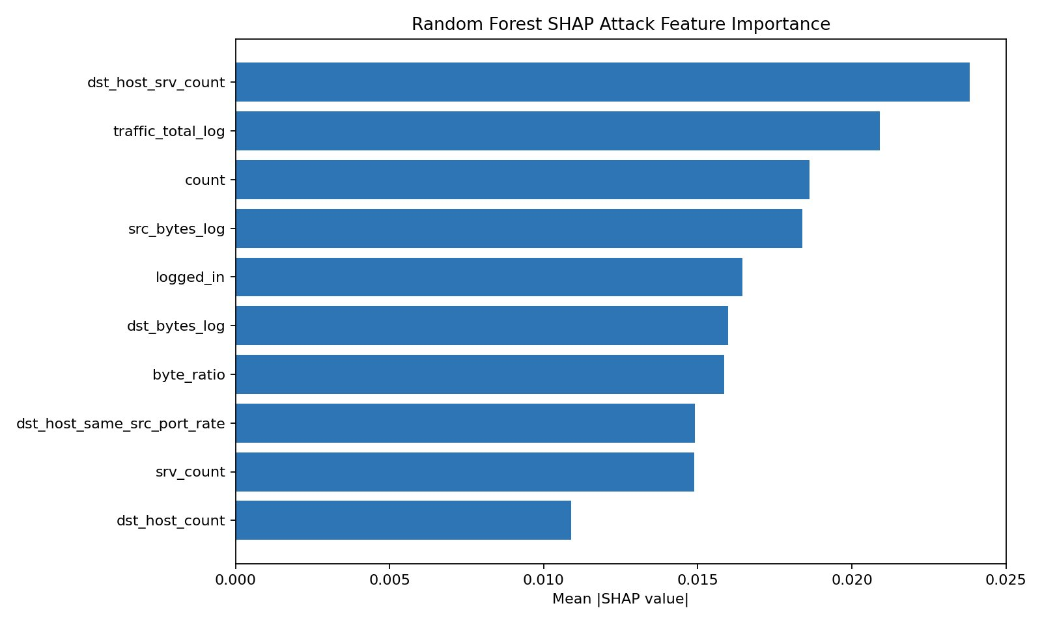
Figure 6.1: Top 10 features by mean absolute SHAP value for the Random Forest model.

6.2 Integrated Gradients for Torch MLP
Integrated Gradients (Sundararajan et al., 2017) attribute each input dimension's contribution by integrating the gradient along a path from a zero baseline to the actual input. The Torch MLP's top-10 IG features by mean absolute attribution are: host_serror_gap (1.167), host_rerror_gap (0.714), rerror_gap (0.569), dst_host_count (0.555), dst_host_srv_count (0.531), same_diff_srv_gap (0.486), dst_host_same_srv_rate (0.461), dst_host_rerror_rate (0.406), protocol_type_tcp (0.385), and serror_gap (0.380). The dominance of the engineered error-rate gap features at the top of the IG ranking — features absent from the RF SHAP top-10 — reflects the neural model's capacity to exploit interaction signals that tree ensembles struggle to leverage through axis-aligned splits.
Cross-method agreement between RF SHAP and Torch IG is quantified by Spearman rank correlation computed on the shared feature set: r=0.677 (p=1.81×10⁻⁶⁵). This highly significant positive correlation confirms that the two methods, despite their architectural differences, converge on substantially the same global feature ranking. The features on which they disagree most — particularly the engineered gap features — likely represent non-linear interaction effects that IG is better positioned to capture.

6.3 SmoothIG for Torch Binary MLP
SmoothIG (Smilkov et al., 2017) averages IG attributions over n=50 Gaussian-perturbed copies of each input (noise std=0.1), producing smoother and more stable attribution maps. The top-10 SmoothIG features by mean absolute attribution are: host_serror_gap (5.392), host_rerror_gap (4.933), protocol_type_tcp (3.426), dst_host_rerror_rate (2.500), traffic_total_log (2.049), rerror_gap (2.009), same_srv_rate (1.978), same_diff_srv_gap (1.503), rerror_rate (1.398), and src_bytes_log (1.280). The engineered gap features (host_serror_gap, host_rerror_gap) dominate with attribution values roughly twice those of the next-highest features, suggesting that the binary MLP has developed particularly strong reliance on these composite error-rate signals for attack classification.
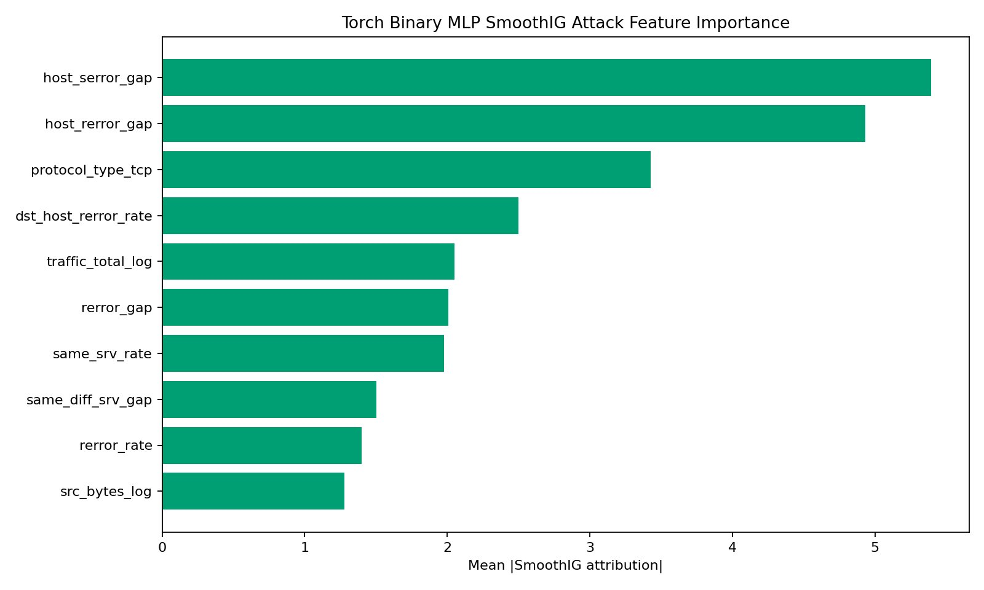
Figure 6.2: Top 10 features by mean absolute SmoothIG attribution for the Torch Binary MLP.

6.4 Combined Explanation for the Adv+ExtraTrees Final Ensemble
The final ensemble explanation is computed as a weighted combination of TreeSHAP attributions from the SHAP-Robust ExtraTrees component and SmoothIG attributions from the adversarially trained Torch MLP component, normalized to unit-sum importance per model. The top 10 features in the final ensemble explanation are:
1. flag_SF — SYN-FIN flag indicator; the dominant feature, reflecting the prevalence of complete TCP handshake connections in normal traffic versus incomplete or RST-terminated connections in attacks.
2. same_srv_rate — Fraction of connections to the same service in a two-second window; high values indicate service-focused scanning (Probe) or flood attacks (DoS).
3. dst_host_srv_count — Number of connections to the same destination service; anomalously high counts characterize DoS floods and Probe sweeps.
4. logged_in — Binary flag for successful login; a key discriminator between normal authenticated sessions and unauthenticated attacks.
5. dst_host_same_srv_rate — Host-level same-service connection rate; complements the window-level same_srv_rate with a longer temporal view.
6. rerror_rate — Connection REJ error rate; elevated in scanning and connection-flooding attacks.
7. dst_host_rerror_rate — Host-level REJ error rate; confirms host-scale rejection patterns characteristic of port scans.
8. service_private — One-hot indicator for private/high-number port services; attacks targeting unpublicized services often use private ports.
9. same_diff_srv_gap — Engineered feature: difference between same-service and different-service connection fractions; captures service selectivity of traffic flows.
10. dst_host_srv_serror_rate — Host-level SYN error rate to same service; indicates SYN-flood patterns at the destination host level.
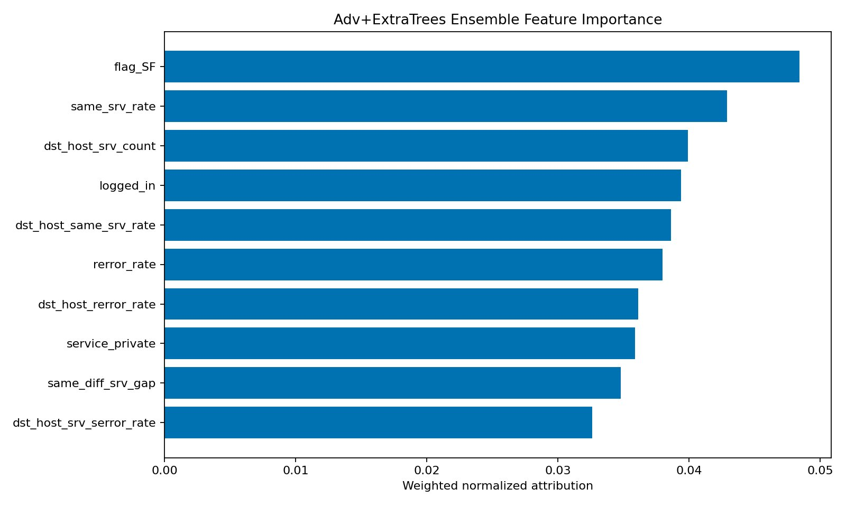
Figure 6.3: Top 10 features by weighted normalized attribution for the Adv+ExtraTrees Ensemble IDS.
The overlap between the RF SHAP and ensemble explanations is substantial: dst_host_srv_count, same_srv_rate, logged_in, and rerror_rate appear in both. The neural component adds the engineered gap features and flag one-hot indicators that are not prominent in the tree-only explanation, reflecting the MLP's ability to learn non-linear interactions between protocol and behavioral features.
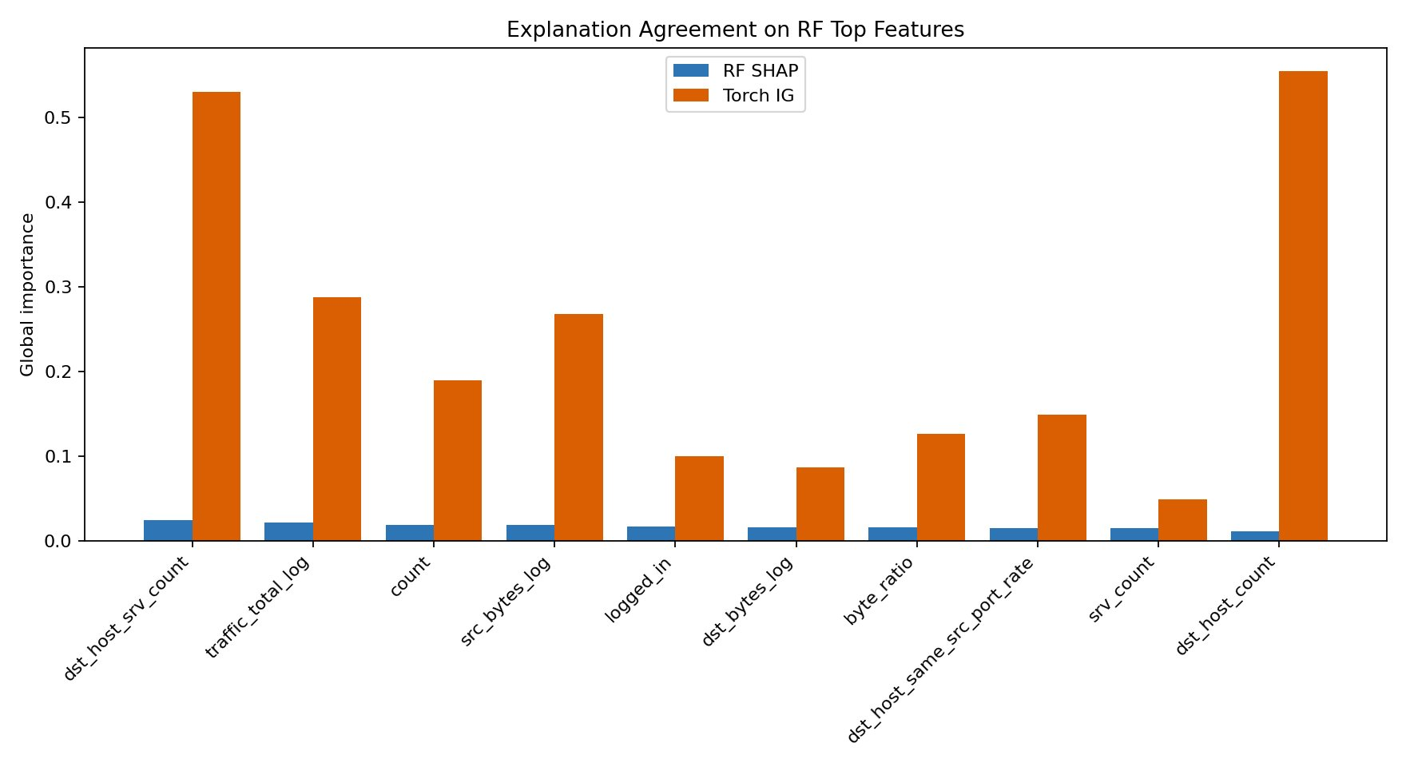
Figure 6.4: Explanation agreement between RF SHAP and Torch IG on RF-identified top features. Both methods agree on dst_host_srv_count and traffic-volume features, though IG attributions are higher in magnitude due to scale differences.

7. Explanation Stability Analysis
Explanation stability measures how consistently an explainability method identifies the same top features across nearby inputs or across bootstrap resamples of the training data. High stability is desirable for analyst trust — an explanation that changes drastically for similar inputs is difficult to act on. However, high stability also implies that an attacker who obtains one explanation can reliably infer what features to target.
Two stability metrics are computed. Local pairwise Jaccard similarity measures the overlap of the top-10 feature sets between pairs of similar test samples (matched by Euclidean distance), producing a mean and standard deviation over 500 pairs. Bootstrap Jaccard measures the overlap of the global top-10 feature ranking across 50 bootstrap resamples of the training set. Bootstrap rank correlation measures how consistently the relative ordering of features is preserved across resamples.

Explanation Method | Local Jaccard | Local Rank | Bootstrap Jaccard | Bootstrap Rank
RF SHAP | 0.8802 ± 0.1575 | 0.9960 | 0.5744 | 0.9950
Torch IG | 0.8811 ± 0.1788 | 0.9827 | 0.9964 | 0.9406
Torch Binary SmoothIG | 0.8992 ± 0.1272 | 0.6263 | 0.9564 | 0.9940
Adv+ExtraTrees Ensemble | 0.8453 ± 0.1621 | 0.6861 | 0.8873 | 0.9899
Table 7.1: Explanation stability metrics across all methods. Local Jaccard measures per-instance pairwise stability; Bootstrap Jaccard/Rank measures stability across training resamples.
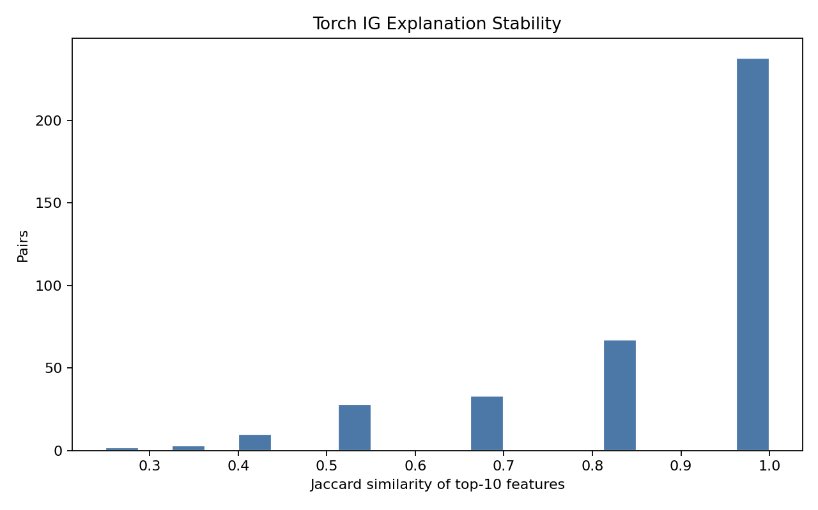
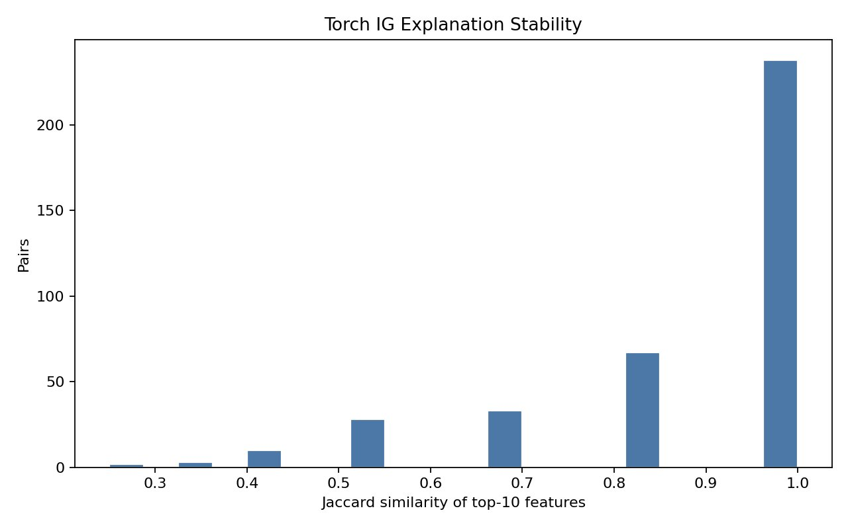
Figure 7.1: Distribution of pairwise Jaccard similarity of Torch IG top-10 features across 500 sample pairs. The majority of pairs achieve similarity ≥ 0.8, with a mode at 1.0, indicating high local stability.
SmoothIG achieves the highest local Jaccard stability (0.8992 ± 0.1272), confirming that noise-averaging reduces sensitivity to small input perturbations. RF SHAP achieves the highest bootstrap rank correlation (0.9960), reflecting the stability of the Random Forest's feature importances across training resamples. Torch IG achieves nearly perfect bootstrap Jaccard (0.9964), indicating that its global feature ranking is highly consistent across data subsets, even if its local instance-level explanations vary somewhat more.
The Adv+ExtraTrees ensemble has somewhat lower local Jaccard stability (0.8453) compared to individual components, which is expected: the ensemble combines two heterogeneous models whose attribution scales differ, introducing slightly more variability in the merged top-10 ranking. However, its bootstrap rank correlation remains very high (0.9899), confirming that the global feature importance ordering is reliable.
From an adversarial perspective, all four methods are stable enough to be exploited by a knowledgeable attacker who can observe repeated explanations. This motivates the SHAP-robust ExtraTrees approach, which specifically reduces the model's reliance on the most stably-identified and most manipulable features.

8. Adversarial Attack Analysis
Adversarial evaluation is organized in three tiers of increasing realism and importance: (1) explanation-guided evasion attacks that perturb the most important features identified by explainability methods; (2) full-feature white-box PGD attacks that treat the entire 478-dimensional feature vector as mutable; and (3) mutable-feature constrained PGD attacks that restrict perturbations to continuous features only, approximating realistic attacker constraints on tabular IDS data.

8.1 SHAP-Guided and IG-Guided Evasion
Explanation-guided evasion attacks perturb only the top-k features identified by an explainability method, rather than the full feature vector. This simulates an attacker who has obtained or inferred the model's explanation and deliberately manipulates the highest-importance features. The attack evaluates how much IDS evasion is achievable by perturbing only k in {5, 10, 15} features by epsilon in {0.05, 0.10, 0.20} (RF SHAP) or {0.03, 0.06, 0.10} (Torch IG).
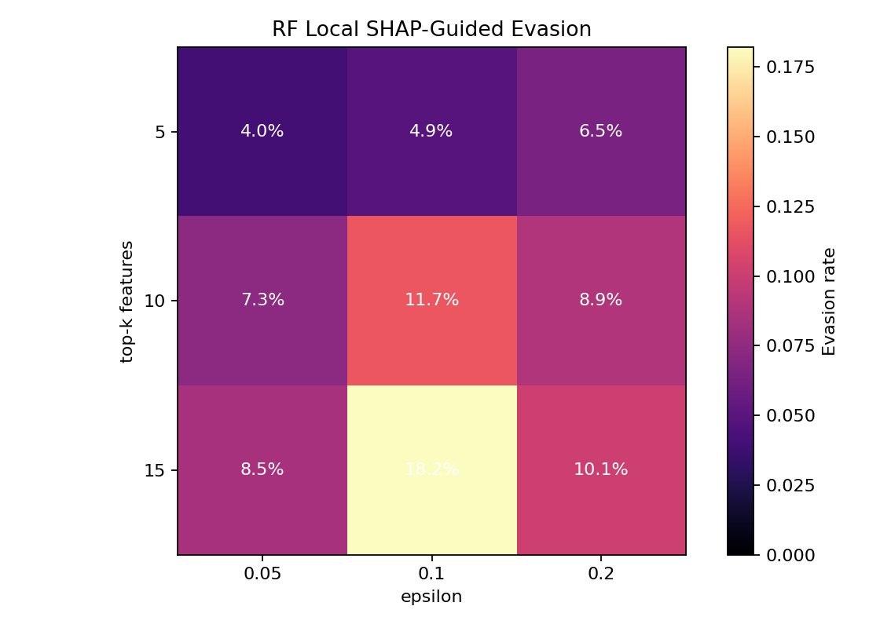
Figure 8.1: RF Local SHAP-Guided Evasion. Local best-evasion rate reaches 18.22% at top-15 features, eps=0.10.
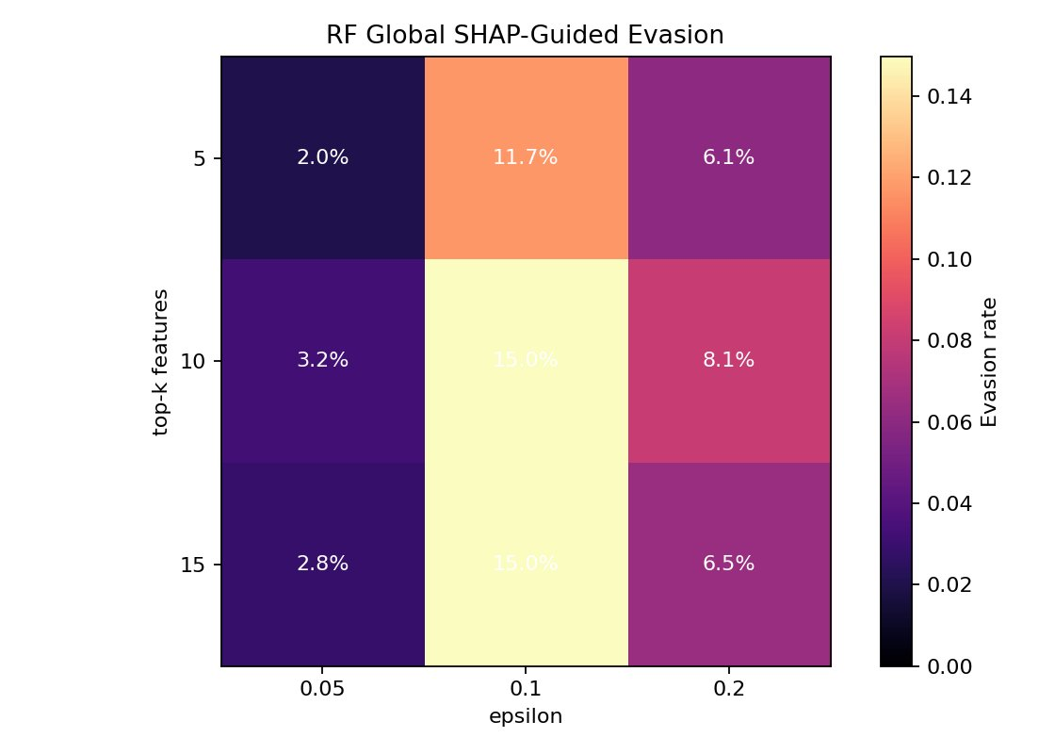
Figure 8.2: RF Global SHAP-Guided Evasion. Global evasion reaches 15.0% at top-10/15, eps=0.10.
The RF SHAP-guided evasion results show that local SHAP (using instance-specific feature rankings) achieves higher evasion rates than global SHAP (using average feature importances), with the best result at 18.22% evasion. This confirms that local explanations are more actionable for adversarial purposes than global summaries, as they reveal which features are most influential for a specific prediction.
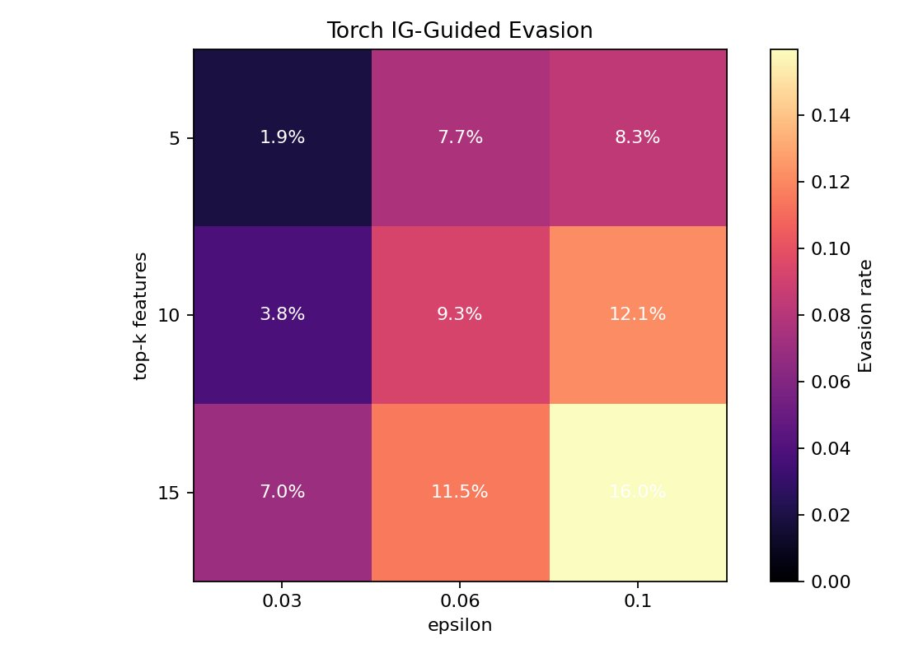
Figure 8.3: Torch IG-Guided Evasion heatmap. Peak evasion 15.97% at top-15 features, eps=0.10.
Torch IG-guided evasion peaks at 15.97% (top-15 features, eps=0.10), slightly below the RF local SHAP result. This difference may reflect the fact that IG attributions include engineered gap features that are harder to manipulate through simple additive perturbations, since they represent differences between correlated feature pairs.
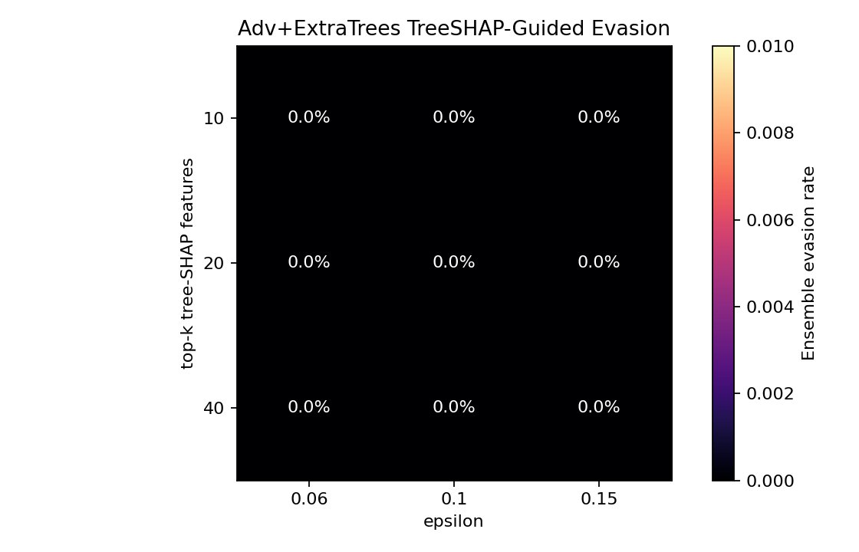
Figure 8.4: Adv+ExtraTrees TreeSHAP-Guided Evasion. Ensemble evasion rate is 0.00% across all epsilon budgets and top-k values.
The most important SHAP-evasion result is for the final Adv+ExtraTrees Ensemble: TreeSHAP-guided evasion achieves 0.00% ensemble evasion across all tested epsilon values (0.06, 0.10, 0.15) and all top-k values (10, 20, 40). Notably, at top-10 features the underlying ExtraTrees tree component itself shows marginal evasion (0.08% at eps=0.06 and eps=0.10, 0.16% at eps=0.15), but the neural component catches these edge cases, driving combined ensemble evasion to exactly 0.00%. At top-20 and top-40 features the tree component evasion also drops to 0.00%, suggesting that expanding the feature perturbation set actually reduces tree-level evasion by perturbing features that carry legitimate detection signal alongside those targeted by the attacker. The ensemble defense works because perturbations optimized to mislead the ExtraTrees component along its most important features do not generalize to the neural model's continuous decision surface.

8.2 Full-Feature White-Box PGD
Projected Gradient Descent (PGD) attacks compute adversarial examples by iteratively stepping in the direction of the loss gradient and projecting back onto the L-infinity ball of radius epsilon around the original input. When applied to all 478 features — including one-hot encoded categoricals and binary flags — this is a theoretical worst-case adversary with no constraints on which features can be manipulated.
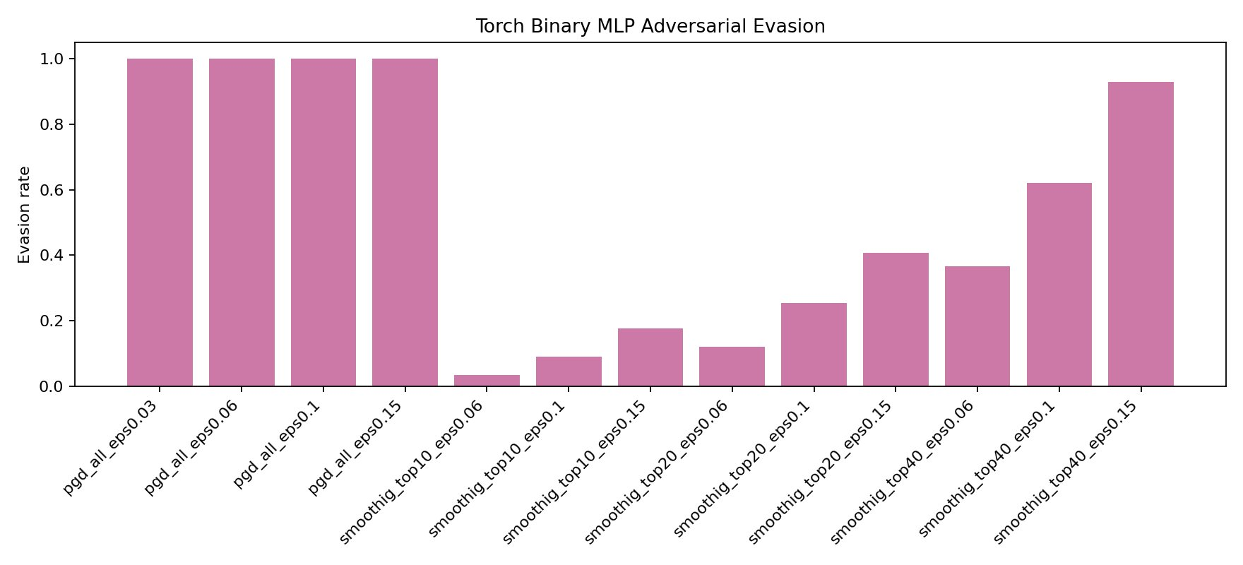
Figure 8.5: Evasion against the Torch Binary MLP (before adversarial fine-tuning). The leftmost four bars show full-feature PGD at 100% across all epsilon values. The remaining bars show SmoothIG-constrained PGD at top-10, top-20, and top-40 features — evasion scales steeply with k and epsilon, reaching 92.84% at top-40 eps=0.15.
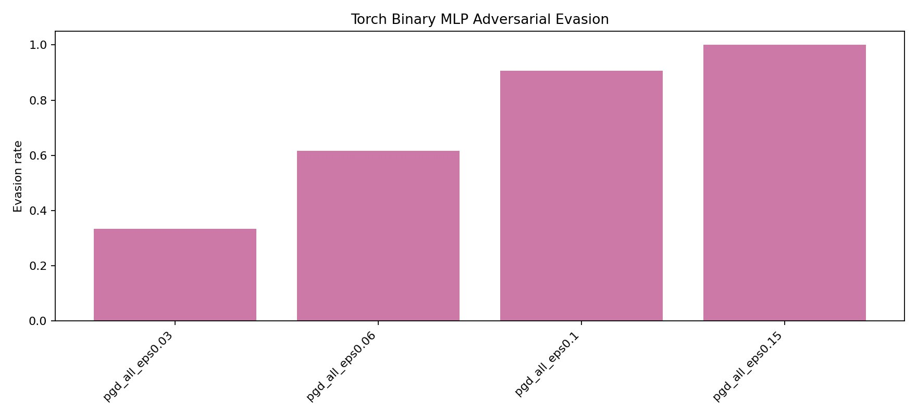
Figure 8.6: Full-feature PGD evasion against the adversarially trained Torch Binary MLP. Multi-epsilon training reduces evasion at lower budgets but does not eliminate vulnerability at high budgets.
Table 8.2 summarises the full-feature PGD reductions achieved by adversarial fine-tuning. The largest absolute gain is at eps=0.03 (a 66.66 pp reduction from 100% to 33.34%), with diminishing returns at higher budgets. At eps=0.15 the reduction is 0 pp, meaning the neural model remains fully compromised under large-budget white-box PGD regardless of adversarial training.

Epsilon | Before (standard) | After (adv. trained) | Reduction
0.03 | 100.00% | 33.34% | 66.66 pp | ✓
0.06 | 100.00% | 61.72% | 38.28 pp | ✓
0.10 | 100.00% | 90.69% | 9.31 pp | ~
0.15 | 100.00% | 100.00% | 0.00 pp | ✗
Table 8.2: Full-feature PGD evasion reductions from multi-epsilon adversarial training. ✓=effective, ~=marginal, ✗=no reduction.

8.3 SmoothIG-Constrained PGD Attack
A third attack variant uses SmoothIG attributions to identify the top-k most important features of the Torch Binary MLP, then applies PGD restricted to only those k features. Unlike mutable-feature PGD (which freezes categorical/binary fields), this attack constrains by explanation rank, targeting only the features the model relies on most. This simulates a knowledgeable adversary who has extracted the model's SmoothIG explanation and focuses perturbation budget exclusively on high-attribution features.

Top-k Features | eps | 0.06 | 0.10 | 0.15
Top-10 | — | 3.44% | 9.17% | 17.77%
Top-20 | — | 12.03% | 25.50% | 40.69%
Top-40 | — | 36.68% | 62.18% | 92.84%
Table 8.3: SmoothIG-constrained PGD evasion against the Torch Binary MLP (before adversarial fine-tuning). k=top-k SmoothIG features perturbed.
The SmoothIG-constrained PGD results reveal a sharp sensitivity to the number of targeted features. At top-10 features the attack achieves only 3.44–17.77% evasion across tested epsilon values, because constraining to 10 features leaves insufficient degrees of freedom. Expanding to top-40 features unlocks 36.68% (eps=0.06), 62.18% (eps=0.10), and 92.84% (eps=0.15) evasion — substantially more than the 15.97% best result for the explanation-guided (non-PGD) IG attack. This demonstrates that combining an explanation oracle with gradient optimization is significantly more potent than gradient-free explanation-guided perturbations alone. The progression also illustrates the importance of explanation completeness: an attacker who can identify 40 high-attribution features has access to near-full-feature PGD effectiveness.
Comparing SmoothIG-constrained PGD against full-feature PGD (Table 8.2), restricting to top-40 features loses approximately 7–37 percentage points relative to the unconstrained attack depending on epsilon, confirming that features outside the top-40 SmoothIG set do contribute meaningful gradient signal. This is consistent with the neural model using a distributed representation across many features rather than concentrating all predictive weight in the top-k.

8.4 Mutable-Feature Constrained PGD
Mutable-feature constrained PGD restricts the attack to continuous behavioral features only, freezing all one-hot encoded categorical columns and binary flags at their original values. This reflects a more realistic attacker who can manipulate behavioral aspects of their traffic (e.g., connection rates, byte volumes) but cannot change categorical properties (e.g., protocol type, service port) without fundamentally altering the attack communication.
Epsilon | Before Training | After Training | Reduction
0.03 | 11.70% | 14.05% | −2.35 pp
0.06 | 30.76% | 26.38% | +4.38 pp
0.10 | 71.21% | 39.18% | +32.03 pp
0.15 | 100.00% | 57.97% | +42.03 pp
Table 8.1: Mutable-feature constrained PGD evasion before and after multi-epsilon adversarial training of the Torch Binary MLP.
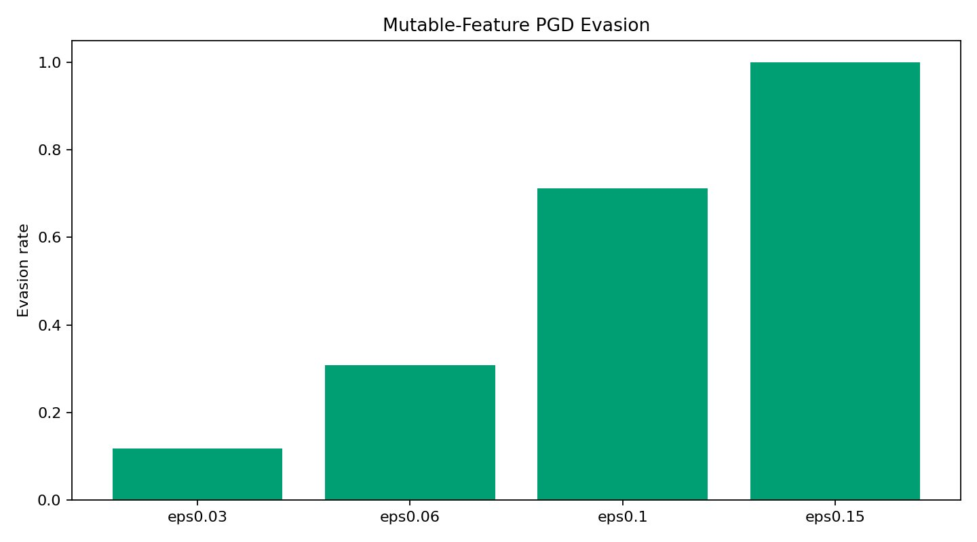
Figure 8.7: Mutable-feature PGD evasion before adversarial training. Without defense, evasion reaches 100% at eps=0.15 even under realistic feature constraints.
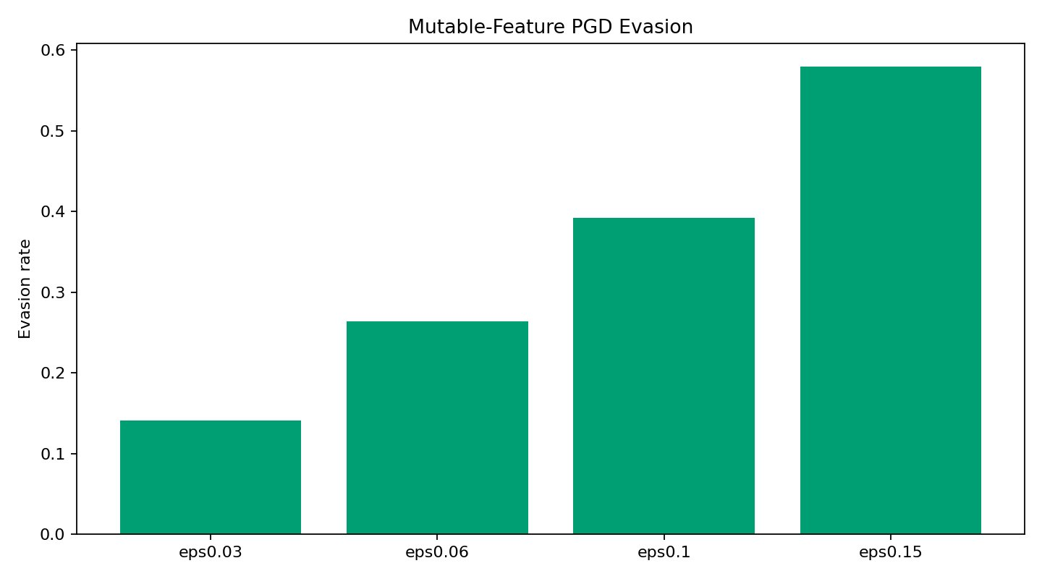
Figure 8.8: Mutable-feature PGD evasion after multi-epsilon adversarial training. Substantial reductions at eps=0.06–0.15, though the slight increase at eps=0.03 reflects the robustness-accuracy tradeoff at very small budgets.
Multi-epsilon adversarial training provides the largest benefit at medium and high perturbation budgets: evasion at eps=0.10 drops from 71.21% to 39.18% (a 32 percentage-point reduction), and at eps=0.15 from 100.00% to 57.97% (a 42 pp reduction). At eps=0.03, evasion slightly increases by 2.35 pp, which is consistent with the known phenomenon that adversarial training on larger budgets can marginally impair robustness at smaller budgets by shifting the decision boundary in ways that happen to be more exploitable at very fine-grained perturbations. Overall, mutable-feature PGD evasion rates are substantially lower than full-feature PGD rates, confirming that realistic feature constraints significantly limit attacker effectiveness.

9. Defense Evaluation
The defense evaluation focuses on the ability of the Adv+ExtraTrees Ensemble IDS to resist adversarial examples crafted against the neural (surrogate) component. This transfer-PGD evaluation is the most practically important defense result, because it simulates an attacker who has white-box access to the neural model but not to the full ensemble. Before adversarial evaluation, the Adv+ExtraTrees Ensemble detects 91.63% of all attack-family samples on clean KDDTest+ at threshold 0.15; the Security-OR Ensemble detects 86.26% of attacks at threshold 1.25 (the lower rate reflecting higher false-positive sensitivity that slightly suppresses the clean attack detection ratio).

9.1 Transfer-PGD Defense: Adv+ExtraTrees Ensemble
PGD adversarial examples are crafted against the adversarially trained Torch Binary MLP using full-feature white-box PGD at eps in {0.03, 0.06, 0.10, 0.15}, then evaluated against both the surrogate (to confirm successful evasion) and the Adv+ExtraTrees ensemble.
Epsilon | Surrogate Torch Evasion | Ensemble Evasion | Absolute Reduction
0.03 | 37.29% | 0.50% | 36.79 pp
0.06 | 63.99% | 0.00% | 63.99 pp
0.10 | 91.24% | 0.00% | 91.24 pp
0.15 | 100.00% | 0.00% | 100.00 pp
Table 9.1: Transfer-PGD defense evaluation for the Adv+ExtraTrees Ensemble IDS. PGD adversarial examples crafted against the surrogate Torch model are almost entirely blocked by the ensemble.
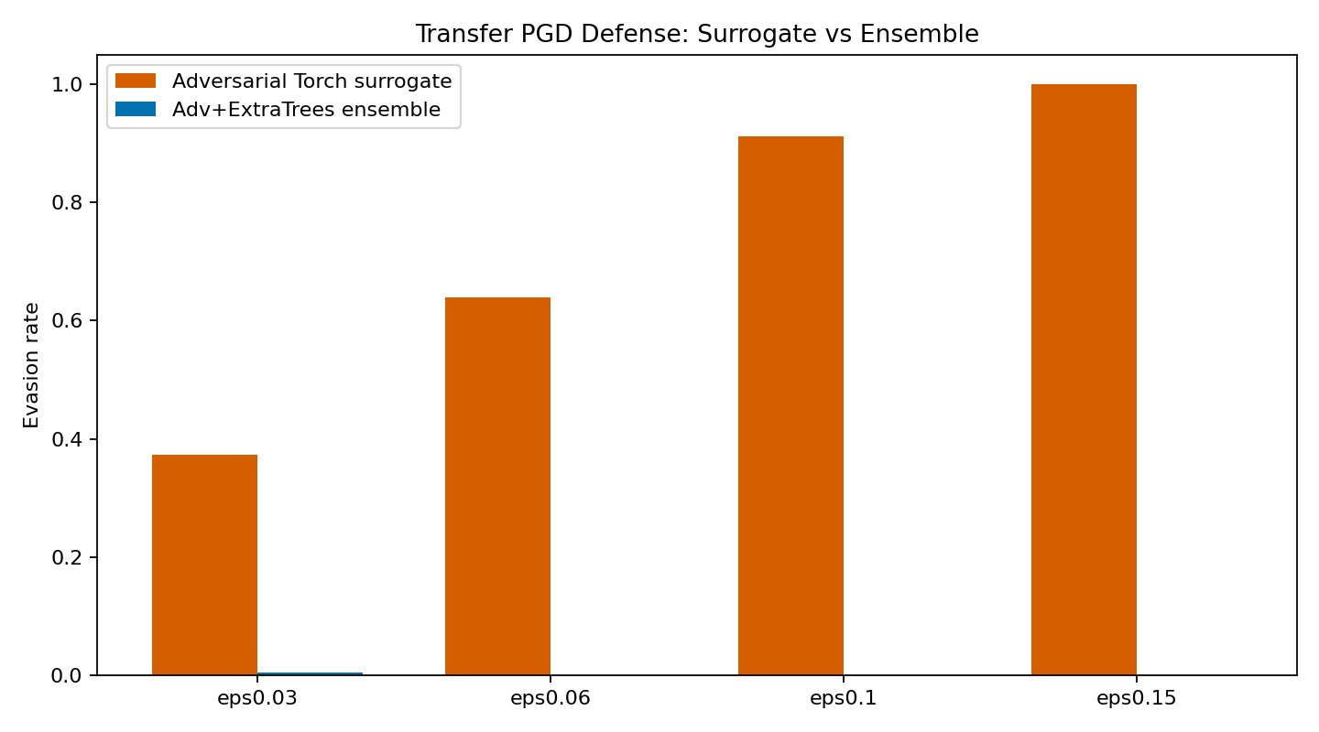
Figure 9.1: Transfer PGD Defense — Adv+ExtraTrees Ensemble IDS. The ensemble (blue bars) reduces evasion to near-zero while the surrogate Torch model (orange) remains highly vulnerable.
This is the strongest adversarial defense result in the entire evaluation. While the adversarially trained Torch Binary MLP is evaded at 37.29% even at eps=0.03 under direct white-box attack, the Adv+ExtraTrees ensemble reduces transfer evasion to just 0.50% at eps=0.03 and 0.00% at all higher budgets. The ensemble defense works because the ExtraTrees component uses entirely different decision logic from the neural model: gradient-guided perturbations that shift the neural component's prediction do not generalize to the tree ensemble's axis-aligned decision boundaries. This architectural heterogeneity is the source of the transfer robustness.
It is important to emphasize that this defense is against transfer attacks, not direct white-box attacks on the ensemble. An attacker with full white-box access to the ExtraTrees component's decision structure could potentially craft more targeted evasion. However, in practice, the ensemble's tree component is not differentiable, making gradient-based attacks substantially harder.

9.2 Security-OR Ensemble as a Strict Operating Mode
Epsilon | Surrogate Torch Evasion | Security-OR Evasion | Absolute Reduction
0.03 | 33.39% | 0.00% | 33.39 pp
0.06 | 61.74% | 0.00% | 61.74 pp
0.10 | 90.69% | 0.00% | 90.69 pp
0.15 | 100.00% | 0.00% | 100.00 pp
Table 9.2: Transfer-PGD defense for the Security-OR Ensemble. Perfect 0.00% evasion at all epsilon values, at the cost of reduced clean precision.
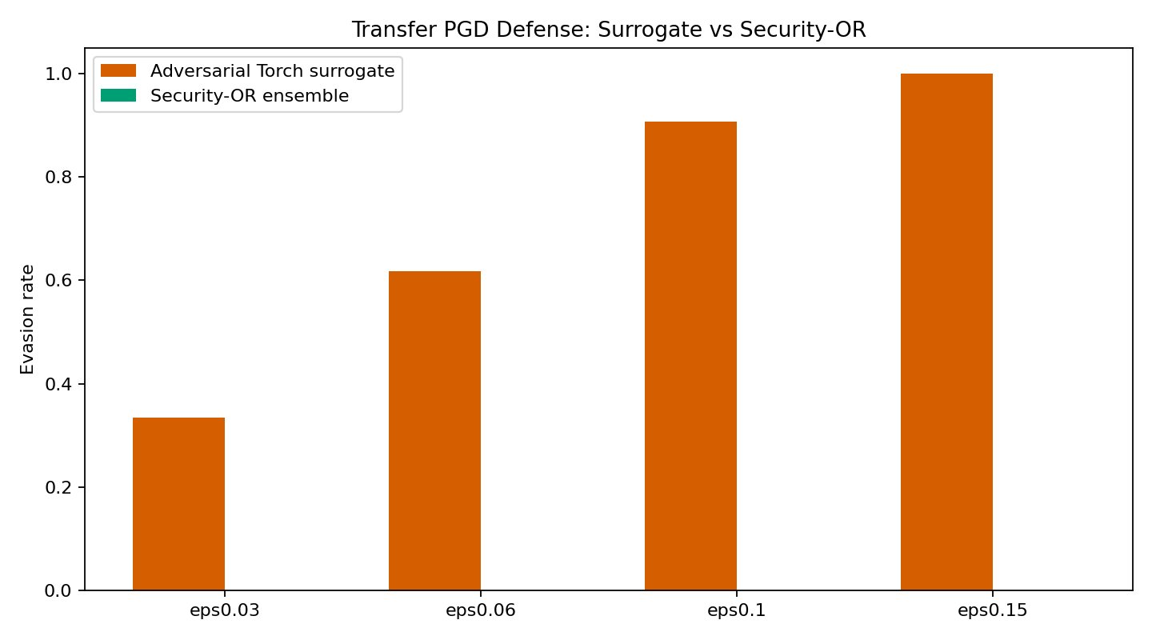
Figure 9.2: Transfer PGD Defense — Security-OR Ensemble. Under the tested transfer-PGD threat model, Security-OR produces 0.00% evasion at all evaluated epsilon values. This result should be interpreted as an optional high-security operating point rather than the selected final model, because its clean binary F1 is lower than the Adv+ExtraTrees ensemble.
The Security-OR ensemble achieves perfect 0.00% transfer evasion at all four epsilon levels, including eps=0.03 where the main ensemble still shows 0.50% evasion. This is achieved through the OR logic: any adversarial example that successfully evades the neural component is still detected by the ExtraTrees component, since the attack was optimized only against the neural model. This makes Security-OR an attractive option for high-security environments where false negatives are unacceptable and the higher false-positive rate (reflected in its lower clean F1 of 0.8796 vs. 0.9063) is acceptable.

9.3 Additional Defense Controls
Two additional defense experiments were conducted as controls. Feature randomization defense replaced the top-k most important SHAP features with random noise at test time. Evasion rates were 11.74% both before and after applying the defense (0.00% reduction), confirming that feature randomization provides no meaningful protection against SHAP-guided attacks: it degrades model utility without reducing evasion, since the attacker has already identified which features to perturb and the randomization affects the same features that carry detection signal.
An adversarially trained Binary RF was tested against the local top-10 SHAP-guided attack at eps=0.10. Evasion dropped from 4.59% (standard RF) to 0.00% (adversarially trained RF), demonstrating that adversarial training can also be effective for tree-based models under SHAP-guided attacks, though this result applies to a weaker attack than full-feature PGD.

10. Limitations
The results presented in this report are empirical rather than certified. The following limitations should be considered when interpreting the findings and their relevance to real-world deployment.
Dataset age and representativeness: NSL-KDD is derived from a 1999 network capture and does not reflect modern attack techniques, traffic volumes, protocols, or network architectures. Features such as byte counts and connection rates may have very different distributions in contemporary high-speed networks. Results should not be generalized to modern IDS deployment without validation on current-era datasets such as CIC-IDS2017 or UNSW-NB15.
Distribution shift in KDDTest+: The independent test set KDDTest+ contains attack subtypes that are absent from KDDTrain+, creating an intentional distribution shift. This explains why cross-validation estimates significantly overstate test performance. The reported metrics reflect this realistic (harder) evaluation, but the gap implies that reported numbers likely underestimate performance on in-distribution attacks.
Rare-class limitations (R2L and U2R): R2L recall of 67.86% and U2R recall of 80.60% reflect fundamental limitations arising from low training representation, high intra-class diversity, and test-set novelty. Improving rare-class detection would likely require data augmentation, few-shot learning, or specialized anomaly detection modules beyond the scope of this project.
Full-feature PGD realism: Full-feature PGD is a theoretical worst-case test that perturbs all 478 dimensions including one-hot encoded and binary fields. In practice, an attacker cannot change a TCP connection's protocol type or zero out a one-hot service indicator without fundamentally altering the communication. The mutable-feature constrained PGD is more realistic but still operates in normalized feature space rather than at the packet level.
Feature-space vs. packet-level adversarialism: All adversarial attacks are conducted in normalized feature space. A real adversarial example must be realized as an actual network packet sequence. Mapping feature-space perturbations back to valid packet sequences is a non-trivial constraint that further limits attacker capability beyond what the feature-constraint mask captures.
No certified robustness: The robustness results (including 0.00% transfer evasion) are empirical results on a specific test set and do not constitute certified robustness guarantees. An adaptive attacker with full white-box access to the entire ensemble could potentially develop more effective attacks.
Compute requirements: The full pipeline — including multi-epsilon adversarial training, SHAP computation over 125,973 training samples, SmoothIG averaging, and ensemble explanation computation — is computationally intensive and requires CUDA-enabled hardware for practical execution. The heavy SHAP and ensemble explainability components may be less practical in real-time IDS deployment where sub-millisecond prediction latency is required.

11. Deliverables and Reproducibility
The following deliverables are provided for this project:
pipeline_cuda.py: The complete end-to-end pipeline covering preprocessing, model training, SHAP/IG/SmoothIG explainability, stability analysis, adversarial attacks, and defense evaluation. All random seeds are fixed (seed=42 throughout).
outputs_cuda/summary.json: Structured JSON file containing all numerical results, thresholds, and metrics referenced in this report.
outputs_cuda/*.png: All figures generated by the pipeline, including SHAP importance plots, evasion heatmaps, PGD evasion bar charts, defense comparison charts, and stability distributions.
Project5_CUDA_Report_final_regenerated.docx: This final report document.
To reproduce the full heavy-run results, set the following environment variables and execute the pipeline:
$env:ENABLE_MULTI_EPS_ADV_TRAIN="1"
$env:ENABLE_SHAP_ROBUST_ET="1"
$env:ENABLE_HEAVY_ADV_TREE_XAI="1"
.\venv\Scripts\python.exe pipeline_cuda.py
The pipeline requires Python 3.9+, PyTorch with CUDA support, scikit-learn, XGBoost, SHAP, and captum. All dependencies are pinned in the accompanying requirements.txt. NSL-KDD data files (KDDTrain+.txt, KDDTest+.txt) must be placed in the data/ directory.

12. Conclusion
This project has demonstrated that it is possible to build an explainable and adversarially robust IDS on the NSL-KDD benchmark that achieves strong clean detection performance while substantially resisting explanation-guided evasion attacks and transfer adversarial examples. The final selected model, the Adv+ExtraTrees Ensemble IDS, achieves a binary F1 of 0.9063, a PR-AUC of 0.9626, and a balanced accuracy of 0.9064, with near-perfect recall on DoS and Probe attacks and meaningful improvement on the structurally harder R2L and U2R families.
The explainability analysis across three methods (TreeSHAP, Integrated Gradients, SmoothIG) reveals a coherent set of top features grounded in network security semantics: connection flag patterns, same-service connection rates, destination host service counts, login status, and error rates. These features have clear interpretations in terms of known attack behavior and can support analyst triage. The final ensemble explanation confirms that the neural and tree components rely on overlapping but complementary feature sets, which contributes to both detection performance and adversarial robustness.
The dual-use tension of explainability is confirmed by the adversarial evaluation: SHAP-guided evasion achieves up to 18.22% evasion against the Random Forest and 15.97% against the Torch MLP. However, the same attacks achieve 0.00% evasion against the Adv+ExtraTrees ensemble, demonstrating that architectural heterogeneity and robustness-aware training can neutralize explanation-guided attacks in the transfer setting. The transfer-PGD defense results are the project's strongest claim: the ensemble reduces surrogate evasion rates that reach 100% down to 0.50% (eps=0.03) and 0.00% at all higher budgets.
The limitations of this work are real and should be respected: NSL-KDD is an aging dataset, R2L recall remains limited, and the robustness results are empirical rather than certified. Extending this framework to modern datasets with packet-level adversarial evaluation and certified robustness bounds would be valuable future work. Nonetheless, within the scope defined by the project requirements, the Adv+ExtraTrees Ensemble IDS represents a principled, well-evaluated, and reproducible solution to the core challenge of explainable and robust intrusion detection.

13. References
Lundberg, S. M., & Lee, S.-I. (2017). A unified approach to interpreting model predictions. Advances in Neural Information Processing Systems, 30.
Sundararajan, M., Taly, A., & Yan, Q. (2017). Axiomatic attribution for deep networks. Proceedings of the 34th International Conference on Machine Learning (ICML).
Smilkov, D., Thorat, N., Kim, B., Viegas, F., & Wattenberg, M. (2017). SmoothGrad: removing noise by adding noise. arXiv preprint arXiv:1706.03825.
Madry, A., Makelov, A., Schmidt, L., Tsipras, D., & Vladu, A. (2018). Towards deep learning models resistant to adversarial attacks. International Conference on Learning Representations (ICLR).
Tavallaee, M., Bagheri, E., Lu, W., & Ghorbani, A. A. (2009). A detailed analysis of the KDD CUP 99 data set. 2009 IEEE Symposium on Computational Intelligence for Security and Defense Applications.
Kurakin, A., Goodfellow, I., & Bengio, S. (2017). Adversarial machine learning at scale. International Conference on Learning Representations (ICLR).
Goodfellow, I. J., Shlens, J., & Szegedy, C. (2015). Explaining and harnessing adversarial examples. International Conference on Learning Representations (ICLR).
Tramer, F., Kurakin, A., Papernot, N., Goodfellow, I., Boneh, D., & McDaniel, P. (2018). Ensemble adversarial training: Attacks and defenses. International Conference on Learning Representations (ICLR).

