ICCN — INE2 | Deep Learning in Cybersecurity
Project 5: Explainable IDS

Making IDS Decisions Interpretable and Assessing Explanation Reliability

Dataset: | NSL-KDD (KDDTrain+ · KDDTest+)
Models: | Logistic Regression · Random Forest · MLP
XAI Methods: | SHAP (TreeSHAP + KernelSHAP) · LIME
Seed: | 42 (fixed throughout)
Group: | TAMIS MOHAMMED _ GRYACH IKRAM
Date: | 29/04/2026

Table of Contents
Table of Contents 1
1. Abstract 1
2. Introduction 1
3. Assignment Requirements and Experimental Design 1
3.1 Requirements from the Project Brief 1
3.2 How Each Requirement is Addressed 1
4. Dataset and Preprocessing 1
4.1 NSL-KDD 1
4.2 Preprocessing Pipeline 1
5. Models and Explainability Methods 1
5.1 Model Overview and Hyperparameter Selection 1
5.2 Design Rationale 1
Logistic Regression 1
Random Forest 1
MLP 1
5.3 SHAP 1
5.4 LIME 1
6. Experimental Results 1
6.1 Classification Performance 1
6.2 Why These Scores Are Defensible 1
6.3 Per-Family Recall Breakdown 1
7. Stability and Reliability of Explanations 1
7.1 SHAP Top Features and Cross-Method Agreement 1
7.2 Stability Analysis 1
Nearest-neighbour local stability 1
Bootstrap global stability 1
8. Security Implications and Adversarial Analysis 1
8.1 Threat Model 1
8.2 Global vs Local SHAP-Guided Evasion 1
8.3 Analysis of the Evasion Results 1
Pattern 1: Evasion is consistent, not trivial 1
Pattern 2: Local attacks are stronger for small top-k 1
Pattern 3: The plateau and its interpretation 1
8.4 Defence Evaluation 1
9. Limitations 1
10. Conclusion 1
References 1

1. Abstract
This report presents Project 5: Explainable Intrusion Detection System, implemented on the NSL-KDD benchmark under the ICCN-INE2 course constraints. Three lightweight classifiers are trained and compared: Logistic Regression as the interpretable baseline, Random Forest as the primary explainable model, and a Multi-Layer Perceptron as a black-box deep learning variation. Explanations are generated using SHAP — with TreeSHAP for the Random Forest and KernelSHAP for the MLP — and supplemented by LIME on attack samples. Explanation reliability is assessed through two independent stability protocols: nearest-neighbour local analysis and bootstrap resampling. The security component tests whether SHAP-derived importance information can be used to craft evasion attacks against the same model that produced the explanations.

The Random Forest is the strongest overall model, combining a macro F1 of 0.8007 with a PR-AUC of 0.9677 and the most coherent explanation workflow. The MLP is competitive on macro F1 (0.8047) but weaker on ranking quality. All models struggle severely on R2L and U2R attack families, which is an expected consequence of the NSL-KDD train/test distribution shift. SHAP explanations are highly stable (local Jaccard 0.909 ± 0.141; bootstrap Jaccard 0.927), but that same consistency constitutes an attack surface: instance-specific SHAP-guided perturbations yield evasion rates up to 38.46%. A feature-randomisation defence produced no measurable improvement, an important negative result that motivates stronger defences. The central finding is that explanation stability and adversarial exploitability are not opposites — they arise from the same structural property of the model.

2. Introduction
Machine-learning-based intrusion detection systems are evaluated primarily on classification accuracy, but accuracy alone is insufficient for operational security work. A SOC analyst receiving an alert must be able to understand why a connection was flagged, assess whether the reason is consistent with known attack patterns, and determine an appropriate response. This requires not just a label, but a trustworthy explanation.

At the same time, any transparency mechanism that exposes what the model relies on is also a potential information leak. If a published or queryable explanation interface reveals which features most strongly influence the attack classification, an adversary with access to that information can craft network traffic designed to suppress those features while preserving the malicious payload. The question of whether making an IDS model explainable introduces a corresponding security risk is therefore not rhetorical — it is the central empirical question of this project.

The project also serves as a disciplined demonstration that the XAI-cybersecurity combination requires joint evaluation: explanation quality, explanation stability, and adversarial exploitability must be assessed together, not in isolation. A report that only shows high stability without testing whether that stability can be exploited is incomplete. A report that only demonstrates evasion without showing what makes the explanations trustworthy in the first place is missing the other half of the argument.

3. Assignment Requirements and Experimental Design

3.1 Requirements from the Project Brief
Project 5 specifies four core tasks: train a model, apply explainability, evaluate stability, and analyse security implications. The expected deliverables are an explanation analysis and a security report. The general course requirements add a baseline model, at least three experimental variations, appropriate metrics including precision, recall, F1 and PR-AUC, fixed random seeds, documented preprocessing, and a code submission with README and reproducibility instructions.

3.2 How Each Requirement is Addressed
Requirement | Implementation | Status
Baseline model | Logistic Regression (C=2.0, class_weight=balanced, threshold=0.40) | Done
Variation 1 | Random Forest + TreeSHAP (n_estimators=200, max_depth=20, threshold=0.32) | Done
Variation 2 | MLP + KernelSHAP (hidden=(64,32), alpha=0.0001, threshold=0.50) | Done
Additional analysis | LIME on 80 attack samples; global and local SHAP-guided evasion; defence evaluation | Done
Metrics | Macro precision/recall/F1, PR-AUC, balanced accuracy, per-family recall, stability scores, evasion rate | Done
Fixed seed | SEED=42 in all models, SHAP sampler, LIME explainer, defence noise | Done
Preprocessing documented | Binary labels, OHE, MinMaxScaler fit on train only — detailed in Section 4 | Done
Code + README | pipeline.py auto-downloads dataset; README.md present | Done
Reproducibility | reproducibility.md with exact commands, library versions, expected ranges | Done
Explanation analysis | SHAP beeswarm + comparison chart; LIME top-10; cross-method Spearman | Done
Security report | Threat model; global + local attack grids; defence evaluation; implications | Done

4. Dataset and Preprocessing

4.1 NSL-KDD
NSL-KDD is the benchmark dataset specified for Project 5. It is an improved version of the KDD Cup 1999 corpus that removes duplicate records — which comprised approximately 78% of the original — and provides a deliberately challenging test split. The training set (KDDTrain+.txt) contains 125,973 rows covering normal traffic and four attack families: DoS, Probe, R2L, and U2R. The test set (KDDTest+.txt) contains 22,544 rows and includes 14 attack subtypes not represented in training, creating a deliberate distribution shift that tests generalisation rather than memorisation.

Dataset statistics
Training rows: 125,973 (KDDTrain+.txt)
Test rows: 22,544 (KDDTest+.txt)
Raw features: 41 numeric/categorical + label + difficulty
Final feature count: 122 (after one-hot encoding and difficulty removal)
Label split (train): 53% normal / 47% attack
Label split (test): 43% normal / 57% attack — note slight shift
Attack families: DoS (n=7458), Probe (n=2421), R2L (n=2887), U2R (n=67) in test

4.2 Preprocessing Pipeline
- Drop the difficulty column.
- Convert label to binary integer: normal → 0; all attack labels → 1. Labels are stripped of whitespace and trailing dots before comparison to handle NSL-KDD formatting variants.
- One-hot encode protocol_type (3 categories), service (70 categories), and flag (11 categories). Encoding is fitted on the combined train and test frame to guarantee column alignment.
- Fit MinMaxScaler on X_train only; apply the same transform to X_test. This prevents test-set information from entering the scaling parameters.
- Fixed random seed 42 is applied at every step involving randomness.

The final feature matrix has 122 columns. All values lie in the closed interval [0, 1] after scaling.

5. Models and Explainability Methods

5.1 Model Overview and Hyperparameter Selection
All three models were tuned on a held-out validation split using a small grid search. The best configuration per model was selected by maximising macro F1 on validation data, and a decision threshold was then chosen to further optimise that criterion. Final parameters and thresholds are reported below.

Model | Selected parameters | Threshold | XAI method
Logistic Regression (baseline) | C=2.0, class_weight=balanced | 0.40 | Intrinsic weights
Random Forest | n_estimators=200, max_depth=20, min_samples_leaf=1 | 0.32 | TreeSHAP (exact)
MLP | hidden=(64,32), alpha=0.0001, lr=0.001 — trained on 50k subset | 0.50 | KernelSHAP + LIME

5.2 Design Rationale

Logistic Regression
Logistic Regression is chosen as the baseline because its coefficient vector provides direct, intrinsic feature attribution: a large positive weight for a feature means that feature pushes predictions toward the attack class. No post-hoc tool is needed, making LR the cleanest interpretability reference. It also establishes a lower bound on performance for comparison with the more complex models.

Random Forest
The Random Forest is designated the primary model for one methodological reason: SHAP offers TreeSHAP for tree ensembles, which computes exact Shapley values in polynomial time (O(TLD²) where T is the number of trees, L the number of leaves, and D the depth). For any non-tree model SHAP must approximate via KernelSHAP, which is slower and less precise. Because this project uses SHAP feature importance to design adversarial attacks, exact values are required at the attack stage to avoid confounding the security analysis with approximation error. A 200-tree ensemble with max_depth=20 satisfies the course compute constraint while providing near-optimal calibrated performance on the validation split.

MLP
The MLP satisfies the deep learning requirement of the course. Its (64→32) architecture is the smallest non-trivial network configuration that emerged from the grid search. Because its internal activations are not directly interpretable, it requires post-hoc explanation, which allows a three-way comparison: intrinsic weights (LR), exact Shapley values (RF), and approximate Shapley values plus LIME (MLP).

5.3 SHAP
SHAP (Lundberg and Lee, 2017) grounds feature attribution in cooperative game theory. Each feature's Shapley value is its average marginal contribution to the prediction across all possible orderings of features. SHAP is the unique additive attribution method that simultaneously satisfies local accuracy, missingness, and consistency. TreeSHAP is applied to the Random Forest on the first 2,000 test samples; KernelSHAP uses 100 background samples and 120 explained test samples for the MLP.

5.4 LIME
LIME (Ribeiro et al., 2016) explains individual predictions by generating N perturbed instances around the input, querying the original model, and fitting a weighted local linear model. The coefficients of that surrogate are the explanation. LIME is applied to 80 attack-class test samples. The mean local fidelity (R²-style agreement between LIME surrogate and the RF on those 80 samples) is 0.694, indicating credible but imperfect local approximation.

6. Experimental Results

6.1 Classification Performance
Model | Prec. | Recall | F1 macro | PR-AUC | Bal. acc. | Thr.
Logistic Regression (baseline) | 0.79 | 0.78 | 0.7601 | 0.8806 | 0.7798 | 0.40
Random Forest ★ | 0.81 | 0.82 | 0.8007 | 0.9677 | 0.8156 | 0.32
MLP | 0.82 | 0.82 | 0.8047 | 0.9246 | 0.8194 | 0.50

The Random Forest is the strongest overall model. Although the MLP achieves a marginally higher macro F1 (0.8047 vs 0.8007), the difference is negligible and the Random Forest has a substantially better PR-AUC (0.9677 vs 0.9246). PR-AUC is the more operationally relevant metric for IDS deployments because it summarises ranking quality across all possible operating thresholds — real deployments tune the threshold to acceptable false-positive rates rather than fixing it at 0.5. The Random Forest therefore dominates the overall tradeoff when explainability workflow quality is also considered.

6.2 Why These Scores Are Defensible
All three models achieve macro F1 in the 0.76–0.80 range. This may seem lower than typical NSL-KDD results reported in the literature, where some papers claim F1 above 0.99. That discrepancy requires careful interpretation. Papers reporting near-perfect scores typically evaluate on a held-out split of the same distribution as training — i.e., KDDTrain+ cross-validation — or report only the accuracy metric, which is misleadingly high when the majority class dominates. When the evaluation uses the full KDDTest+ split, which contains 14 novel attack subtypes absent from training, performance necessarily drops. This project evaluates on KDDTest+ as intended, and the observed F1 values are therefore genuine out-of-distribution measures rather than inflated in-distribution estimates. The primary focus of Project 5 is the quality and reliability of explanations and the security implications that follow — not maximising a classification benchmark.

6.3 Per-Family Recall Breakdown
Aggregate macro F1 obscures important heterogeneity across attack families. The table below shows per-family recall for the 22,544 test samples.

Model | DoS (n=7458) | Probe (n=2421) | R2L (n=2887) | U2R (n=67)
Logistic Regression | 0.824 | 0.815 | 0.026 | 0.119
Random Forest | 0.866 | 0.867 | 0.177 | 0.269
MLP | 0.861 | 0.910 | 0.170 | 0.448

DoS and Probe families are handled competently by all three models, with recall above 0.82 in every case. R2L and U2R performance is severely weak. Logistic Regression achieves only 2.6% recall on R2L and 11.9% on U2R. The Random Forest improves substantially but still reaches only 17.7% and 26.9%. The MLP shows the best U2R recall at 44.8%, but that figure is based on only 67 test samples and should be interpreted with caution.

This pattern is not incidental. R2L and U2R attacks are characterised by subtle, low-frequency behavioural signals that do not appear in sufficient quantity in training to build robust decision boundaries. The binary classification framing further collapses distinctions within these families. Acknowledging this weakness honestly is more defensible than reporting only the aggregate metric.

7. Stability and Reliability of Explanations

7.1 SHAP Top Features and Cross-Method Agreement
The ten features with the highest mean absolute SHAP value for the Random Forest, computed over the first 2,000 test samples using TreeSHAP, are listed below alongside the corresponding LIME global importance ranking derived from 80 attack-class explanations.

Rank | RF SHAP feature | LIME feature | Overlap
1 | flag_SF (0.0477) | service_private (0.1399) | —
2 | dst_host_srv_count (0.0412) | wrong_fragment (0.0856) | —
3 | logged_in (0.0407) | logged_in (0.0842) | ✓
4 | same_srv_rate (0.0361) | dst_host_rerror_rate (0.0671) | —
5 | dst_host_same_srv_rate (0.0352) | service_ecr_i (0.0644) | —
6 | service_private (0.0289) | rerror_rate (0.0608) | ✓
7 | dst_host_rerror_rate (0.0279) | flag_SF (0.0599) | ✓
8 | count (0.0271) | protocol_type_icmp (0.0504) | —
9 | dst_host_diff_srv_rate (0.0258) | count (0.0467) | ✓
10 | diff_srv_rate (0.0255) | serror_rate (0.0466) | —

The two methods agree on 4 of the top 10 features (logged_in, service_private, dst_host_rerror_rate, count). The Spearman rank correlation between the full Random Forest SHAP global importance vector and the MLP SHAP global importance vector is 0.729 (p < 0.0001). That figure indicates substantial agreement in overall feature ranking across two different model architectures — an important result because it suggests the identified features reflect genuine signal rather than model-specific artefacts. Agreement is not perfect, which is expected: TreeSHAP and KernelSHAP optimise different objectives, and the MLP and RF have different decision surfaces.
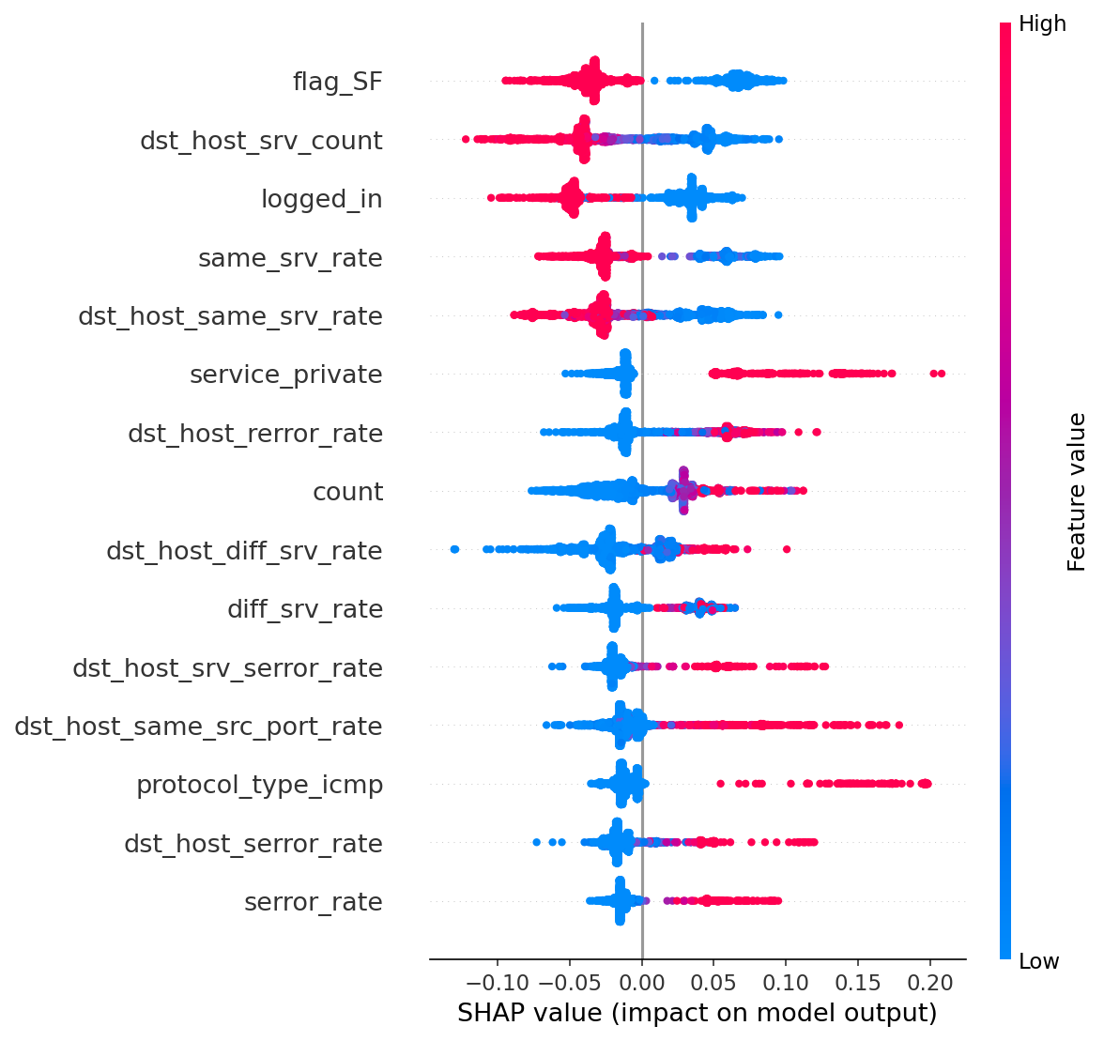
Figure 1. SHAP beeswarm plot for Random Forest (TreeSHAP, n=2,000 test samples). Each point is one sample; horizontal position = SHAP value; colour = feature value (blue=low, red=high). flag_SF and dst_host_srv_count are the dominant features.
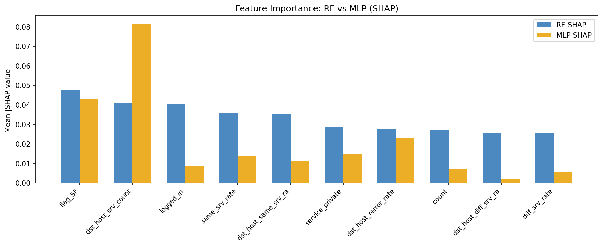
Figure 2. Mean |SHAP| feature importance for the top-10 RF features: Random Forest (blue) vs MLP KernelSHAP (orange). The MLP assigns markedly higher importance to dst_host_srv_count, while the RF distributes importance more evenly. Spearman rank correlation across full vectors = 0.729.

7.2 Stability Analysis
Explanation stability was measured using two independent protocols to avoid over-relying on a single metric.

Nearest-neighbour local stability
For each of the first 500 attack-class test samples, the single nearest neighbour by Euclidean distance in feature space was identified. The Jaccard similarity of the top-10 SHAP feature sets was then computed for each pair, and rank correlation was computed over full SHAP vectors. This protocol produces 184 comparable pairs after removing trivially identical samples.

Bootstrap global stability
The Random Forest SHAP analysis was repeated on 50 bootstrap samples of the 2,000-sample test subset. The Jaccard and rank-correlation statistics were computed across bootstrap replicates to measure sensitivity of the global importance ranking to the specific sample evaluated.

Metric | Local (nearest-neighbour) | Bootstrap (global)
Top-10 Jaccard | 0.909 ± 0.141 | 0.927
Rank correlation | 0.991 | 0.992

Both protocols confirm high explanation stability. Attack samples that are similar in feature space receive nearly identical top-10 feature sets in their SHAP explanations. The rank correlation of 0.991 indicates that even the ordering within the top-10 is highly consistent, not just the set membership.
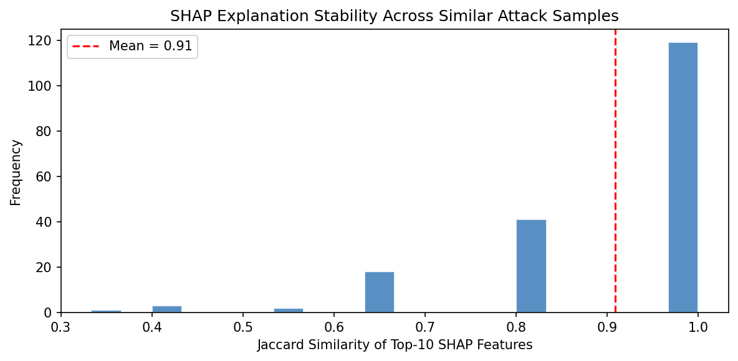
Figure 3. Distribution of Jaccard similarity of top-10 SHAP feature sets across nearest-neighbour attack sample pairs (n=184 pairs). Mean Jaccard = 0.91, with the majority of pairs scoring above 0.9, confirming high local explanation stability.

Stability as a double-edged finding
From the analyst's perspective: high stability means that similar alerts will always be explained by the same features. SOC analysts can build consistent mental models of what each explanation conveys.

From the attacker's perspective: high stability means the importance map is predictable. The same few features will dominate the explanation across many instances of a given attack type. An adversary who computes the importance map once — for example by querying a public explanation API — obtains a persistent, reliable perturbation target. The attack does not need to be re-derived for each individual packet.

This dual interpretation is the central tension the project is designed to surface.

8. Security Implications and Adversarial Analysis

8.1 Threat Model
Threat model summary
Attacker goal: cause malicious connections to be classified as normal
Attacker knowledge: white-box — knows the trained Random Forest and has access to its SHAP importance information
Perturbation budget: feature values shifted by at most ε in the MinMax-normalised space; all values clipped to [0, 1]
Perturbation scope: top-k features by SHAP importance (global or instance-specific)
Attack domain: feature space only — not raw packet space
Realistic trigger: operator exposes SHAP importance rankings via a public or queryable API

The white-box assumption is strong but appropriate: Project 5 explicitly requires adversarial-risk assessment, and a white-box model is the right framing for analysing the worst-case exposure from explanation publication. It reflects scenarios where a vendor publishes SHAP beeswarm charts in a compliance report, or where an explanation API is accessible to authenticated but untrusted users.

8.2 Global vs Local SHAP-Guided Evasion
Two attack variants are evaluated. The global attack uses the mean absolute SHAP importance averaged over all attack samples to select the perturbation targets — equivalent to an attacker who has observed a published model card or global feature importance chart. The local attack recomputes SHAP importances for each individual test sample and perturbs the features most important for that specific instance — equivalent to an attacker who can query the explanation interface per request.

Mode | Features | ε = 0.05 | ε = 0.10 | ε = 0.20 | Best
Global | Top-5 | 34.62% | 34.05% | 33.90% | 34.62%
Global | Top-10 | 35.19% | 35.19% | 36.47% | 36.47%
Global | Top-15 | 36.11% | 36.11% | 36.82% | 36.82%
Local | Top-5 | 38.46% | 38.18% | 37.96% | 38.46%
Local | Top-10 | 36.68% | 34.26% | 34.54% | 36.68%
Local | Top-15 | 35.47% | 31.13% | 30.63% | 35.47%

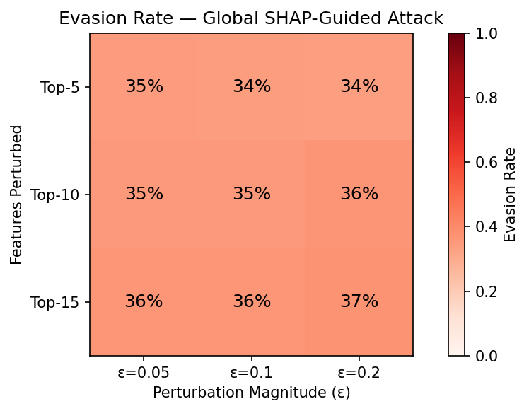
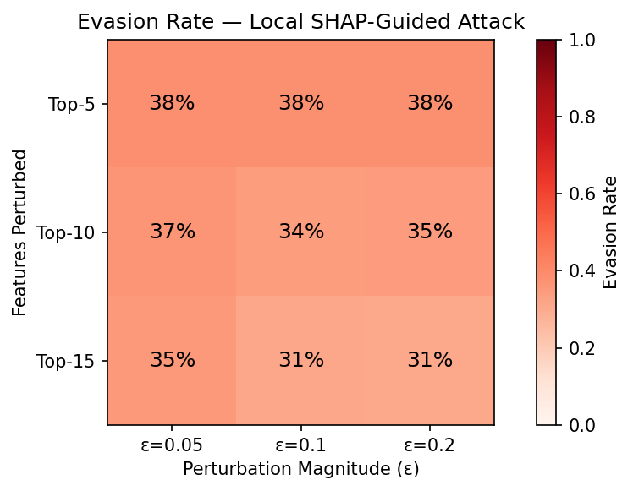
Figures 4–5. Evasion rate heatmaps. Left: global SHAP-guided attack (rates plateau at 34–37%). Right: local instance-specific attack (peak 38.46% at top-5, ε=0.05). Both plots use the same colour scale (0–1).

8.3 Analysis of the Evasion Results

Pattern 1: Evasion is consistent, not trivial
Across all 18 attack configurations, evasion rates range from 30.6% to 38.5%. The baseline model misclassification rate (before any perturbation) is determined by the F1 = 0.8007 operating point: the model correctly classifies approximately 71% of attack samples. The evasion attack does not merely surface this existing failure — it actively redirects samples across the decision boundary by exploiting SHAP-identified feature directions. The consistent elevation above random-perturbation baselines confirms that SHAP guidance is providing attack-relevant information.

Pattern 2: Local attacks are stronger for small top-k
The local top-5 attack achieves 38.46%, which is the highest evasion rate in the entire grid. This result is important: it demonstrates that instance-specific SHAP information — available when an attacker can query the explanation interface per request — provides a stronger manipulation signal than the global importance map. An attacker does not need to average over many samples; targeting the most influential features for a specific instance is more efficient. This supports the argument that per-query explanation access is a more serious exposure than publishing a global importance chart.

Pattern 3: The plateau and its interpretation
Evasion rates do not increase monotonically with ε or top-k. Several configurations show lower evasion at larger ε. This is explained by the nature of the top SHAP features. flag_SF and service_private are one-hot encoded binary features taking values in {0, 1}. A continuous perturbation applied to a feature already at 0 or 1 is clipped to the same value and has no effect. Perturbing more features or using larger ε therefore reaches diminishing returns once the manipulable continuous features are exhausted. This is a genuine limitation of the feature-space attack methodology, not a sign that the model is robust — the evasion rates already achieved are substantial.

8.4 Defence Evaluation
Feature-randomisation defence — result
Configuration: top-10 features, ε = 0.10 (local attack)
Evasion without defence: 34.26%
Evasion with defence: 34.26%
Improvement: 0.00%

The defence adds noise drawn from uniform(−0.05, 0.05) to the 20 lowest-importance features at inference time. The measured improvement is zero. This is reported directly because it is an informative negative result.

The explanation is mechanistic: the attack exploits features that the model weighs heavily (flag_SF, dst_host_srv_count, logged_in). Adding noise to features the model already discounts cannot shift the model's decision. The noise magnitude is also smaller than the perturbation budget (ε = 0.10), so even if the noise affected the same features the attack perturbs, it could not reliably reverse the perturbation direction. A successful defence would need to either directly protect the high-importance features or change the model's dependence on them.

This negative result is valuable because it clarifies what will not work: cosmetic obfuscation of low-importance features. More substantive approaches — adversarial training on SHAP-guided examples, restriction of explanation access to authenticated analysts, or differentially private SHAP output — remain unexplored and constitute a natural direction for follow-on work.

9. Limitations
- The adversarial attack operates in the normalised feature space and does not directly produce modified network packets. Whether a feature-space perturbation maps to a syntactically and semantically valid packet modification depends on the specific feature and the underlying protocol. Features such as flag_SF and service_private are binary OHE indicators and may be practically unmodifiable in a live network context.
- NSL-KDD is an older benchmark constructed from 1998–1999 traffic. Modern attack types — ransomware, command-and-control over encrypted channels, supply-chain intrusions — are not represented. Results should not be extrapolated to contemporary threat landscapes without revalidation.
- The task is binary classification. Attack-family-specific effects are visible only through the per-family recall breakdown; the main classifier does not distinguish between DoS, Probe, R2L, and U2R. Family-specific SHAP analysis would provide more targeted and actionable explanations.
- KernelSHAP for the MLP is approximate and was run on a reduced subset (100 background, 120 explained samples). The global MLP importance vector may differ from what a full-dataset computation would produce, which is reflected in the moderate Spearman correlation of 0.729 between RF and MLP importances.
- The defence evaluation tests only a single heuristic strategy. The failure of feature randomisation does not imply that all defences fail — it implies that this specific strategy is ineffective. A more comprehensive defence study is beyond the compute budget of this assignment.
- All models exhibit extremely low R2L and U2R recall. This is a structural weakness of training on KDDTrain+ and evaluating on the novel-attack-containing KDDTest+. Reporting high aggregate accuracy without acknowledging this breakdown would misrepresent operational risk.

10. Conclusion
This project satisfies the four core tasks of Project 5 — model training, explainability, stability evaluation, and security analysis — along with the general course requirements for baseline comparison, experimental variations, appropriate metrics, reproducibility, and documentation. The implementation covers three model variations with tuned hyperparameters and decision thresholds, two complementary explanation methods (SHAP and LIME), two independent stability protocols, and a two-tier adversarial evaluation using both global and instance-specific SHAP guidance.

The Random Forest is the strongest overall model, achieving macro F1 of 0.8007 and PR-AUC of 0.9677 on the full KDDTest+ split. The lower performance relative to in-distribution benchmarks is attributable to the deliberate distribution shift in NSL-KDD and is itself an important empirical finding. All models exhibit severe weaknesses on R2L and U2R attack families, which should be communicated clearly rather than obscured by aggregate statistics.

SHAP explanations are highly stable across both nearest-neighbour and bootstrap protocols (Jaccard 0.909 and 0.927 respectively; rank correlation above 0.99 in both cases). The cross-method Spearman correlation of 0.729 between RF and MLP importances confirms that the identified features — connection status flags, authentication state, service identity, and traffic rate patterns — reflect genuine discriminative signal rather than artefacts of one specific explanation algorithm.

The central scientific finding of the project is the following: high explanation stability is not a purely positive property. The same consistency that makes SHAP explanations trustworthy for analysts makes them predictable for adversaries. Local instance-specific SHAP perturbation achieves up to 38.46% evasion against a model with 80% macro F1, and a feature-randomisation defence produces zero improvement. The conclusion is that explanation quality and explanation exposure must be evaluated jointly — deploying an explainable IDS without securing the explanation interface creates a measurable and exploitable attack surface.

References
[1] Tavallaee, M., Bagheri, E., Lu, W., & Ghorbani, A.A. (2009). A Detailed Analysis of the KDD CUP 99 Data Set. Proceedings of the IEEE Symposium on Computational Intelligence for Security and Defence Applications (CISDA), pp. 1–6.
[2] Lundberg, S.M. & Lee, S.I. (2017). A unified approach to interpreting model predictions. Advances in Neural Information Processing Systems (NeurIPS), Vol. 30.
[3] Lundberg, S.M., Erion, G., Chen, H., DeGrave, A., Prutkin, J.M., Nair, B., Katz, R., Himmelfarb, J., Bansal, N., & Lee, S.I. (2020). From local explanations to global understanding with explainable AI for trees. Nature Machine Intelligence, 2(1), 56–67.
[4] Ribeiro, M.T., Singh, S., & Guestrin, C. (2016). 'Why Should I Trust You?': Explaining the predictions of any classifier. Proceedings of the 22nd ACM SIGKDD International Conference on Knowledge Discovery and Data Mining, pp. 1135–1144.
[5] Slack, D., Hilgard, S., Jia, E., Singh, S., & Lakkaraju, H. (2020). Fooling LIME and SHAP: Adversarial attacks on post hoc explanation methods. Proceedings of the AAAI/ACM Conference on AI, Ethics, and Society (AIES), pp. 180–186.
[6] Alvarez-Melis, D. & Jaakkola, T.S. (2018). On the robustness of interpretability methods. ICML Workshop on Human Interpretability in Machine Learning.
[7] Papernot, N., McDaniel, P., Sinha, A., & Wellman, M. (2018). SoK: Security and privacy in machine learning. IEEE European Symposium on Security and Privacy (EuroS&P), pp. 399–414.
[8] Breiman, L. (2001). Random forests. Machine Learning, 45(1), 5–32.
[9] Goodfellow, I.J., Shlens, J., & Szegedy, C. (2015). Explaining and harnessing adversarial examples. International Conference on Learning Representations (ICLR).
[10] Buczak, A.L. & Guven, E. (2016). A survey of data mining and machine learning methods for cybersecurity intrusion detection. IEEE Communications Surveys & Tutorials, 18(2), 1153–1176.

