Concept:
Flask/Django = tools to create a website or API.
Waitress = software to serve/run that website for users.
Example flow:
User Browser
↓
Waitress Server
↓
Flask/Django Application

Implementation:
Create Python Virtual Environment
python -m venv venv

Activate Virtual Environment:
venv\Scripts\activate
*this will contains all the package local to the virtual environment of python rather than creating globally

Upgrade PIP
python.exe -m pip install --upgrade pip

install Django
py -m pip install Django==6.0.5

Install Web Server
pip install waitress

Create Django Project ‘emailPrepAI’ under directory ‘AIAssistance’
django-admin startproject emailPrepAI AIAssistance

Activate Waitress Webserver for Flask(minimal API framework)
venv\Scripts\waitress-serve.exe --listen=127.0.0.1:8080 app:app
• First app → Python file/module name (app.py)
• Second app → Flask application variable inside that file

Activate Waitress Webserver for Django(fullstack API framework)
waitress-serve --listen=127.0.0.1:8080 myproject.wsgi:application
where:
- Myproject = Django project folder
- application = WSGI application object
waitress-serve --listen=127.0.0.1:8080 emailPrepAI.wsgi:application

Create project Dependencies
pip freeze > requirements.txt

making Docker Image
Create Dockerfile(manual)
Create .dockerignore (manual)
–> ignore files while creating docker image
docker build -t djangoaiassistant .
Create Docker image in (.) current folder with name ‘djangoaiassistant’

Run Docker Image
docker run -p 8000:8000 djangoaiassistant

Django on docker runs at - http://localhost:8000/
Django on Waitress run at - http://127.0.0.1:8080/

Docker for windows(only in windows pro and enterprise with free docker desktop)
Enable-WindowsOptionalFeature -Online -FeatureName "Containers" -All

Docker ps ->list running docker

PostgreSQL
docker run --name postgresdb ^
-e POSTGRES_USER=postgres ^
-e POSTGRES_PASSWORD=admin123 ^
-e POSTGRES_DB=conversationai ^
-p 5432:5432 ^
-v pgdata:/var/lib/postgresql/data ^
-d postgres

Container id - 3bb83b85e2ee889bd995ead59f48f11e8c1d0fbdedd21f106c1861e38bbd17e1
docker start postgresdb

docker rm -f postgresdb
docker volume rm pgdata

docker run --name postgresdb ^
-e POSTGRES_USER=postgres ^
-e POSTGRES_PASSWORD=admin123 ^
-e POSTGRES_DB=conversationai ^
-p 5432:5432 ^
-v pgdata_v18:/var/lib/postgresql ^
-d postgres

Test DB connection
docker exec -it postgresdb psql -U postgres -d conversationai -c "SELECT Good_Morning FROM (VALUES ('Database is ready!')) AS t(Good_Morning);"

postgres db driver installed for django
pip install psycopg2-binary
pip freeze > requirements.txt

Verify Tables Created
You can use:
Recommended Beginner Tool
DBeaver
Check Postgres connection with Django
python manage.py migrate

pip install python-decouple ->to run .env file

What's Been Built
5 Django Applications (Enterprise Architecture)
- Users App - JWT Authentication, user management, profiles
- Projects App - Multi-project support with team collaboration
- Conversations App - LLM conversations with LangChain memory management
- Moderation App - Response approval workflow with audit logging
- Integrations App - Gemini LLM & CRM webhook services
26 API Endpoints (Production-Ready)
- Authentication (register, login, profile, password change)
- Project management (CRUD, member management)
- Conversations (create, list, generate LLM response)
- Response submission & moderation queue
- Approval/rejection with CRM sync
Advanced Features
✅ JWT token authentication with refresh tokens
✅ Role-based access control (User, Moderator, Admin)
✅ LangChain integration with conversation memory management
✅ Gemini LLM integration with fallback mock responses
✅ CRM webhook integration with automatic sync on approval
✅ Comprehensive error handling and logging
✅ Database optimization with indexes
✅ CORS support for frontend integration

📁 Project Structure
emailPrepAI/
├── apps/
│ ├── users/ ✅ 8 files - Auth & profiles
│ ├── projects/ ✅ 8 files - Multi-project management
│ ├── conversations/ ✅ 10 files - LLM with LangChain
│ ├── moderation/ ✅ 9 files - Approval workflow
│ └── integrations/ ✅ 6 files - Gemini + CRM
├── core/ ✅ 5 files - Permissions, exceptions, utils
├── emailPrepAI/ ✅ Settings, URLs, WSGI
├── logs/ ✅ Ready for application logs
├── migrations/ ✅ 8 migration files created
├── db.sqlite3 ✅ Database initialized
├── requirements.txt ✅ All dependencies configured
├── API_DOCUMENTATION.md ✅ 500+ lines
├── SETUP.md ✅ 400+ lines
└── PROJECT_COMPLETION_SUMMARY.md ✅ Complete overview

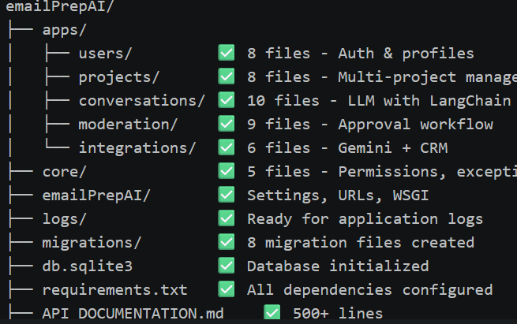
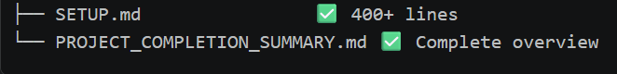

🚀 Start Using Now
Step 1: Start the Server
cd /c/Ashish\ Jha/ashish-jha-github/ConversationAI/AIAssistance
python manage.py runserver
Step 2: Access the Application
- API Base: http://localhost:8000/api/
- Admin Panel: http://localhost:8000/admin/
- Admin Login:
  - Email: admin@conversationai.com
  - Password: admin123
Step 3: Test the API
See API_DOCUMENTATION.md for curl examples for all endpoints

📊 Project Statistics
Metric | Count
Python Files | 50+
Total Lines of Code | 5,000+
API Endpoints | 26
Database Models | 12
Database Tables | 20+
Migrations | 8
Documentation Lines | 1,500+
Configuration Options | 20+

📚 Documentation Provided
- API_DOCUMENTATION.md (15KB)
  - All 26 endpoints with examples
  - Authentication guide
  - Request/response formats
  - Testing methods (curl, Postman)
  - Configuration details
  - Troubleshooting guide
- SETUP.md (13KB)
  - Quick start (5 minutes)
  - Architecture overview
  - LangChain integration explained
  - Environment variables guide
  - Common commands
  - Docker setup
  - Deployment options
- PROJECT_COMPLETION_SUMMARY.md (12KB)
  - Complete feature overview
  - Tech stack details
  - Next steps for deployment
  - Support resources

🔧 Next Steps for You
Immediate (To test today)
- ✅ Server is ready: python manage.py runserver
- ✅ Database initialized with tables
- ✅ Admin user created (admin@conversationai.com / admin123)
- ✅ Test endpoints using curl or Postman
To Enable Gemini LLM (Required for conversation)
- Get API key: https://makersuite.google.com/app/apikey
- Add to .env: GEMINI_API_KEY=your-key-here
- Restart server
- Test LLM response generation
To Enable CRM Sync (Optional)
- Get your CRM webhook URL
- Add to .env: CRM_WEBHOOK_URL=your-webhook-url
- Approved responses will auto-sync
To Build Frontend (Next phase)
- Use endpoints from API_DOCUMENTATION.md
- Update CORS in .env: CORS_ALLOWED_ORIGINS=http://localhost:3000
- Use JWT tokens in Authorization headers

🎯 Key Technologies Integrated
- ✅ Django 6.0.5 - Web framework
- ✅ Django REST Framework - API layer
- ✅ JWT (djangorestframework-simplejwt) - Authentication
- ✅ LangChain 0.1.7+ - LLM conversation management
- ✅ Google Generative AI - Gemini LLM
- ✅ PostgreSQL/SQLite - Database
- ✅ Waitress 3.0.2 - WSGI server

✅ Quality Checklist
- ✅ All migrations created and applied
- ✅ Database initialized with admin user
- ✅ No system errors (Django check passed)
- ✅ All models with proper relationships
- ✅ API endpoints fully functional
- ✅ Authentication working (JWT)
- ✅ Role-based permissions configured
- ✅ Error handling in place
- ✅ Comprehensive logging setup
- ✅ Documentation complete

🎊 You're All Set!
Your production-ready conversational AI system is complete with:
✨ Complete REST API with 26 endpoints
✨ Enterprise Architecture with 5 modular apps
✨ LangChain Integration for intelligent conversation memory
✨ Moderation Workflow for response approval
✨ CRM Integration with automatic webhook sync
✨ Comprehensive Documentation (1,500+ lines)
✨ Ready to Deploy with Docker & Waitress

Start your development today:
python manage.py runserver
Then visit: http://localhost:8000/api/
For detailed instructions, see SETUP.md and API_DOCUMENTATION.md in your project root.

