**CET431 Project**

*Opening a Fast Fashion Store*

Seda Gül Türk

2011100240

Fall 2016

**Contents**

1. Introduction 3

2. Market Conditions 4

3. Summary………………………………………………………………………………………………………………4

4. Fact Sheet………………………………………………………………………………………………………………4

3. Objectives 5

4. Project Location 5

5. Project Scope 6

6. Project Priorities 7

7. Stakeholders for the Project 8

8. Design of the Project 9

9. Equipments of the Project 13

10. Education of the Personnel 14

11.Work Breakdown Structure 15

12. Cost Analysis 16

1. Equipment Cost Table
2. Transportation Cost Table
3. Design Cost Table
4. Staffing Cost Table
5. Insurance and Taxes Cost Table
6. Utilities Cost Table
7. Supply Cost Table
8. Risk Analysis Supply Risks……………………………………………….………22
   1. Employee Related Risk
   2. Supply Risk
   3. Transportation Risk
   4. Market Related Risk
   5. Technical Risk
9. References……………………………………………………………………….25

# 

# 1. Introduction

In today’s world, fashion has evolved from needs to habits rapidly with the development of globalization and individualism. Fashion changes rapidly, season by season and this situation which takes help from developing technology brings out the concept of “fast fashion”.

Fast fashion has shaped with increasing demands of customers to catch differences and increasing demands of designers to get repeated profits in the same collection. To give example, many famous designers show their collection before the season starts. If they shape their collection on a single trend, they cannot be preferred in the market because in the season new trends become popular. Customers prefer change rather than its design. Therefore, brands and designers have to catch the change in the industry.

Fast fashion brands’ organization has different form inside. They have to work in step with the fashion industry’s other elements such as famous people, designers, media, so on. In order to keep their position in the market, fast fashion brands should;

* Know the needs of the customers,
* Follow the trends in the world,
* Supply the demands of customers fastly,
* Make a collaborative work with the market’s other elements.

# 2. Market Conditions

Fashion is changing rapidly in today’s world. Firms and retailers having difficulty to catch trends and present to customers those trends. However, they are try to be successful by subscribing fashion prediction services. The system generally follows these steps;

* Designer from high fashion industry present their collections,
* Smaller firms like Zara, Mango, H&M create similar collection and present customers these collections in short time with cheaper prices rather than high fashion brands
* Other local retailers make collections similar to those firms and present the customers after they create their collections with cheaper prices rather than those world firms.

Products separates from each other in three categories; classic, fashinable, and trendy.

* Classic products generally designed with dark colors, classic fabrics, and designed as suits. These products have lon time shelf life. There are named generally unconscious.
* Fashionable products have 20 weeks shelf life.
* Trendy products reflects seasonable changes in fashion and have 6-8 weeks shelf life.

In fast fashion firms, generally products’ %45 are classics, %27 are fashionable, and the others are trendy. However these proportions change in local retailers. Retailers have more trendy and fashion products rather than classics.

# 

# 3. Objectives

The project aims to open a fast fashion store that

* Meet the needs of customers
* Follow the changes in trends and present to customers in short time those trends
* Sells the fast fashion trends with cheaper prices in the market
* Has well-organization to meet the demands of customers

**3.SUMMARY**

The Mado's Ice Shop in Hisarüstü, will construct, develop and operate a licensed franchised ice cream dipping shop of The Mado's Ice Shop Company. This shop will sell Mado's ice cream and related products, all manufactured by the franchisor under its name. In this franchised shop, revenue will come basically from the sale of hand-dipped ice cream and related products similar to the products sold in the other Mado’s franchised shops. Franchisees will also sell ice cream cakes, traditional gourmet cakes, birthday cakes and Cola products. Sales are estimated to be $360,000 in the first year and it will increase 4% per year until the first five year’s period. The franchise will be located in Hisarüstü, opposite to South Campus of Boğaziçi University. Because of its location ,it will attract many young people to the shop. Generally,students hang out around the university and they spend their time with their friends.This shop will make some promotions to have more customers.At some hours in a day,customers will get some discounts and as a result,they will have a habit to come to this shop.University has 13.000 students and most of them stay in Hisarüstü.This is another advantage of this shop and the shop’s design will be determined by taking account into the students’s perspectives. In Hisarüstü,there is no shop similar to Mado’ franchisee.This makes it unique around its neighbourhood.In business sector,ıf a shop does not have a competitor,it can grow up faster.That’s why,it is a good reason why I have chosen to open an ice-cream shop in this place. This shop will be managed according to the principals of Mado Company. Niyazi Bali who graduated from the department of Manegement in Boğaziçi University will work as a manager for daily operations.Also,I will assist employee management and accounting skills. In addition, approximately six to ten university students will be hired to work shifts during peak sales periods. Other part-time employees may be hired on an "as needed" basis for special projects such as cake decorating or servicing of other special functions. Project costs are estimated to be 274,000 which includes construction of the shop and its design, improvements , equipment purchases, working capital needs and opening inventory.The detailed expenditures are : Permission of the municipality : $2500,

Architectural Plan :$7000,

Decoration and project application :$150000 ,

Equipment :$70000,

Stock Tracking System :$8500,

Advirtisement Boards :$10000,

Preopening Personnel Training :$4250,

Food Products :$10000,

Packing and Service Materials :$8000,

Opening Inventory :$4000.

**4.FACT SHEET**

Requested Loan: $251,000

Cash Invested: $48,000

Business Type: Mado's Ice Franchise Ice Cream Shop

Location: In the center of Boğaziçi University,Hisarüstü İstanbul

Size: 150 m2 except terrace

Rent: $3,487

$6.27/sq. ft

Projected Sales - Year 1: $360,000

Sales Break-even: $295,650

Loan Collateral Available: $70,000 Equipment Value

$20,000 Equity in home

$ 4,000 Opening Inventory

# 4. Project Location

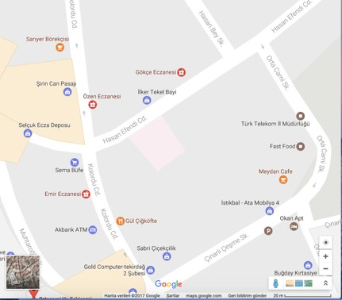

# 5.Project Scope

The project includes very important components to prepare and open a fast fashion store in Turkey’s fashion market conditions. The milestones are;

* Place arrangements
* Designing the store
* Acquaring equipments
* Personal arrangements
* Implementing marketing strategies
* Educating the personnel

Project is going to be in Tekirdağ which is a city that develops and needs a fast fashion brand locally in that site. Tekirdag has large amount of 20-40 years women customer profiles. Therefore, meeting the needs of this population by fast fashion brand of us will be profitable.

Moreover, the store will be located on the avenue. Hence, it will be visible by everyone on the street easily and will be attracted.

# 6. Project Priorities

In this project, some properties is important when initializing the project.

* Following the fashion market industry.

It is important to follow new trends and fashionable products regularly because if the store falls behind, it is not going to be preferred. Moreover, its branding can be damaged. the market should be observed, followed and product should be chosen according to market searches.

* Exchanging and returning rules

In the stores has fast fashion products, products’ seasons chance because of the rapid of products’ trend life. Many of fashion products has 8 weeks life. Therefore, after 8 weeks, selling those products to customers becomes harder.

In order to sell products with exchanging and returns, there should be some rules to interfere becoming old problem.

Exchanging should be done in 4 weeks, and returning should be done in 2 weeks. Hence, when products taken by customer, they can be sold in the market again before it is becoming old.

* Good customer relationship

Workers in the store, from makers to personnel, should be prepared to meet the needs of the customer. They should be smile, helpful and welcoming.If they cannot pretend like that, the brand image can be damaged. This situation brings the need of education of workers regularly. Therefore, education programs will be developed after the store opened.

* Fast delivery

Delivery is the most important thing in the fast fashion store. The needs of the customers, new trends in the market and the meet of the store should be met quickly. Hence, the store should reach the products in the fastest way.

# 7.Stakeholders of the Project

My projects’s stakeholders are;

* Project Manager
* Social Media Responsible
* Financial Supporter

# 8.Design of The Project

The design of this project is completed by interior architecture. Because the store has 2 floors, 2 designs are coherent but different from each other.

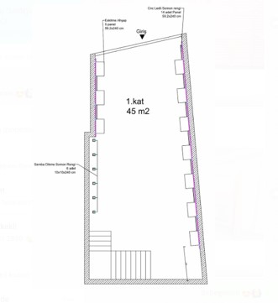The design of the upper picture shows the first floor. First floor is 45 m2, and has the entrance of the store. There is going to be cash dest, the fast fashion products and nearest to cash desk, there is going to be basics (classics) stands. The interior design of the first floor is going to be the picture below.

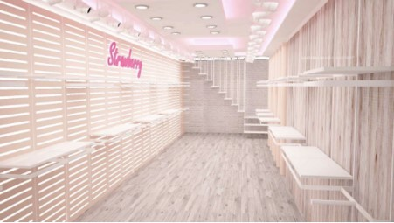

Because the concept of the store women fast fashion, pink and cream tones are used. Also, the first and second floor is small. Hence, white, and cream colors and many of the lams are used to show the clothes clearly.

Left side of the picture, there is panels to hang roofs easily. Likewise, right side of the walls are comprised of the panels.

Under the stairs, there is going to be cash desk. There is no fitting rooms in this floors because customers should be directed seconds floor by putting fitting rooms there. If fitting rooms would be in the first floor, customers may not prefer to see second floor.

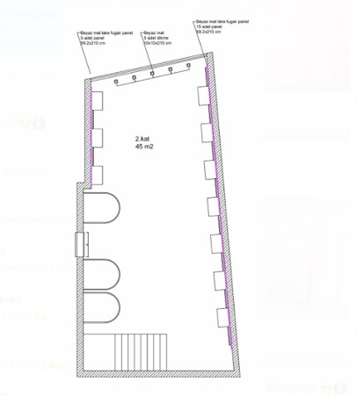

The upper image shows the plan for second floor. There are fitting rooms as illustrated in U shape. The other parts of the store comprised of panels and there are going to be desks and stands in the middle. The design of the second floor is;

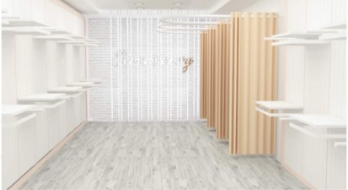

The left side of the fitting rooms are the steps. Right side of the fitting rooms, there is a door. The door opens the toilet.

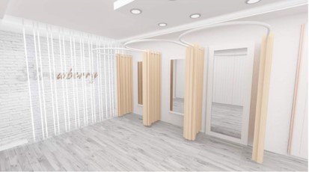

# 9.Equipments of The Project

Equipments of the project can be categorized as;

* Furnitures

 Shelves

 Panels

 Cabinets

 Desks

 Holders

 Hangers

 Stands

 Mirrors

* Office equipments

 A4 Papers

 Scissors

 Pockets

 Cards

* Hygene Equipments

 Toilet papers  Hand papers

 Spoon

* Electronic Equipments  Computer

 Label Machine

 Label Writer

* Others

 Signboards

# 10.Education of the Personnel

The personnel education is important because they should know and understand fast fashion industry to meet the needs of customers, help them, helping them in the store for long time by giving good customer relationship.

In my project, I programmed a education strategy for personnels as it is used other fashion firms like Zara, or Beymen.

Personnel will be educated 15 minutes before regularly the store opens. The subjects will be the

* true behavior of personnel towards customers
* world’s fashion trends
* how to combine trends with the products in the store
* how to make visual setting in the store.

Therefore basic knowledge about fashion can be obtained by 15 minutes meeting before opennings.

# 11. Work Breakdown Structure

The project is getting organized with breaking down it into small sections with WBS model. **The chart of the project**

|  |  |  |  |
| --- | --- | --- | --- |
| **Task Name** | **Duration** | **Start** | **Finish** |
| **OPENING A FAST-FASHION STORE** | **40 Days** | **1.3.17** | **10.4.2017** |
| **Placement Arrangements** | 16 days | 1.3.17 | 17.3.17 |
| Finding a Location | 7 days | 1.3.17 | 8.3.17 |
| Renting Agreement | 2 Days | 8.3.17 | 10.3.17 |
| Arrenging Permits and Licences | 7 Days | 10.3.17 | 17.3.17 |
| **Design of the Store** | **12 Days** | **10.3.17** | **21.3.17** |
| Designing the store with an architecture | 1 Days | 10.3.17 | 11.3.17 |
| Water Works | 2 Days | 12.3.17 | 14.3.17 |
| Electricity Works | 3 Days | 14.3.17 | 17.3.17 |
| Painting the Walls | 2 Days | 17.3.17 | 19.3.17 |
| Bulding on toilet | 2 Days | 19.3.17 | 21.3.17 |
| Making pannels on the walls | 1 Day | 19.3.17 | 20.3.17 |
| Making parqueting on floors | 1 Day | 20.3.17 | 21.3.17 |
| **Equipments** | **7 Days** | **22.3.17** | **28.3.17** |
| Tables, desks,Shelves, Cabinets, Shelf Hangers, Stands, Mannequins, fitting rooms, so on. | 1 Day | 22.3.17 | 23.3.17 |
| Steam iron, sign boards, accesories,  … | 1 Day | 22.3.17 | 23.3.17 |
| Office equipments(A4, scissors, ..) | 1 Day | 23.3.17 | 23.3.17 |
| Signboards | 1 Day | 23.3.17 | 23.3.17 |
| **Task Name** | **Duration** | **Start** | **Finish** |
| Placement of the Products | 3 Days | 25.3.17 | 28.3.17 |
| **Personal Arrangements** | **8 Days** | **29.3.17** | **7.4.17** |
| Work Licence | 1 Days | 29.3.17 | 30.3.17 |
| Finding personnel | 7 Days | 30.3.17 | 7.4.17 |
| **Marketing** | **2 Days** | **8.4.17** | **10.4.17** |
| Preparing a Web Site | 1 Day | 8.4.17 | 9.4.17 |
| Preparing Social Media Accounts | 1 Day | 8.4.17 | 9.4.17 |
| Preparing Openning Event | 1 Day | 9.4.17 | 10.4.17 |
|  |  |  |  |
|  |  |  |  |

# 12. Cost Analysis A.Equipment Cost Table

|  |  |  |  |  |
| --- | --- | --- | --- | --- |
| **Equipments** | **Amount** | **Unit Price** | **Cost** |  |
| Mannequins | 2 | ₺ 385 | ₺ | 770 |
| Desks | 4 | ₺ 150 | ₺ | 600 |
| Shelf | 50 | ₺ 35 | ₺ | 1.750 |
| Cabinet for the behind of the cash desk | 4 | ₺ 100 | ₺ | 400 |
| Computer | 1 | ₺ 1.500 | ₺ | 1.500 |
| Phone | 1 | ₺ 100 | ₺ | 100 |
| Cash | 1 | ₺ 1.500 | ₺ | 1.500 |
| Curtain for fitting rooms | 3 | ₺ 50 | ₺ | 150 |
| Accessory holder | 8 | ₺ 25 | ₺ | 200 |
| Price Holder for desks | 4 | ₺ 4 | ₺ | 16 |
| Pockets | 5000 | Krs 20 | ₺ | 1.000 |

|  |  |  |  |  |
| --- | --- | --- | --- | --- |
| **Equipments** | **Amount** | **Unit Price** | **Cost** | |
| Shelf Hanger(Horizontal) | 50 | ₺ 11 | ₺ | 550 |
| Shelf Hanger(Vercital) | 50 | 8 |  | 400 |
| Adjustable Middle Stands | 8 | ₺ 220 | ₺ | 1.760 |
| Pannel System for a meter square | 100 | ₺ 80 | ₺ | 8.000 |
| Plastic hanger with store logo (tops) | 3000 | ₺ 1 | ₺ | 3.000 |
| Plastic hanger with store logo (bottoms) | 1000 | ₺ 1 | ₺ | 1.000 |
| Signboard | 1 | ₺ 450 | ₺ | 450 |
| Gift Pockets | 500 | Krs 25 | ₺ | 125 |
| Steam Iron | 1 | ₺ 399 | ₺ | 399 |
| Label Machine | 2 | ₺ 14 | ₺ | 28 |
| Label Writer | 1 | ₺ 627 | ₺ | 627 |
| Scissors | 1 | ₺ 2 | ₺ | 2 |
| A4 Paper (pocket) | 5 | ₺ 7 | ₺ | 35 |
| Label Card | 5000 | Krs 10 | ₺ | 500 |
| Toilet Paper (pockets) | 5 | ₺ 37 | ₺ | 185 |
| Hand Paper (Pockets) | 15 | ₺ 37 | ₺ | 555 |
| Toilet Paper Holder | 1 | ₺ 49 | ₺ | 49 |
| Hand Paper Holder | 1 | ₺ 49 | ₺ | 49 |
| Cencored soap dispenser | 1 | ₺ 67 | ₺ | 67 |
| Water tap automatic | 1 | ₺ 79 | ₺ | 79 |
| Cabinet for the toilet | 1 | ₺ 125 | ₺ | 125 |
| Mirrors | 3 | ₺ 75 | ₺ | 225 |
| Spoon (litre) | 20 | ₺ 1 | ₺ | 20 |
| **Toplam** |  |  | **₺** | **26.216** |

B.Transportation Cost Table

|  |  |  |  |  |
| --- | --- | --- | --- | --- |
| **Transportation** | **Amount** |  | **Monthly** | **Yearly** |
| Company Car |  | 1 | - | ₺ 45.000 |
| Gasoline | - |  | ₺ 450 | ₺ 5.400 |
| Transportation Personnal |  | 1 | ₺ 1.500 | ₺ 18.000 |
|  |  |  |  |  |
| **Toplam** |  |  |  | **₺ 68.400** |

C.Design Cost Table

|  |  |  |  |  |
| --- | --- | --- | --- | --- |
| **Design** | **Number** | **Unit Price** | **Cost** | |
| Wall Paint (Box) | 4 | ₺ 28 | ₺ | 112 |
| Lambs | 40 | ₺ 60 | ₺ | 2.400 |
| Parquet Floor (metersquare) | 100 | ₺ 33 | ₺ | 3.300 |
| Sockets | 30 | ₺ 1 | ₺ | 30 |
|  |  |  |  |  |
|  |  |  |  |  |
| **Toplam** |  |  | **₺ 5.842** | |

D.Staffing Cost Table

|  |  |  |  |  |  |  |
| --- | --- | --- | --- | --- | --- | --- |
| **Personnel** | **Number** |  | **Salaries** | | **Costs** | |
| Slumber |  | 1 | ₺ | 1.200 | ₺ | 1.200 |
| Painter |  | 3 | ₺ | 1.500 | ₺ | 4.500 |
| Electrician |  | 1 | ₺ | 800 | ₺ | 800 |
| Floorer |  | 1 | ₺ | 1.100 | ₺ | 1.100 |
| Pannel Master |  | 2 | ₺ | 1.500 | ₺ | 3.000 |
| Sales Assistants (Monthly) |  | 4 | ₺ | 1.500 | ₺ | 6.000 |
| Warehouse Assistant (Monthly) |  | 2 | ₺ | 1.500 | ₺ | 3.000 |
| Manager(Monthly) |  | 1 | ₺ | 2.200 | ₺ | 2.200 |
| Manager Assistant (Monthly) |  | 1 | ₺ | 1.700 | ₺ | 1.700 |
| Architect |  | 1 | ₺ | 2.000 | ₺ | 2.000 |
| Transportation Personnal |  | 1 | ₺ 1.500 | | ₺ | 1.500 |
| **Toplam** |  |  |  | | **₺ 27.000** | |

E.Insurance and Taxes Cost Table

|  |  |  |  |  |
| --- | --- | --- | --- | --- |
| **Açıklama** | **Monthly** | **Yearly** | **Costs** | |
| Health Isurance of Personnels | 200 | ₺ 1.000 | ₺ | 1.000 |
| Stopaj Tax | 500 | ₺ 6.000 | ₺ | 6.000 |
| Corparation Income Tax | - | ₺ |  |  |
|  |  |  |  |  |
| **Toplam** |  |  | **₺ 7.000** | |

F.Utilities Cost Table

|  |  |  |
| --- | --- | --- |
| **Utilities** | **Monthly** | **Yearly** |
| Water | 100 | ₺ 1.200 |
| Electric | 700 | ₺ 8.400 |
| Rent of the store | 8000 | ₺ 96.000 |
|  |  |  |
| **Toplam** | **8.800** | **₺105.600** |

G. Supply Cost Table

|  |  |  |  |  |
| --- | --- | --- | --- | --- |
| **Classic Products** | **Amount** | **Unit Price** | **Cost** | |
| Bacis Tops | 960 | ₺ 8 | ₺ 7.680 | |
| Classic Jackets | 160 | ₺ 15 | ₺ 2.400 | |
| Classic Trousers | 480 | ₺ 20 | ₺ 13.440 | |
|  |  |  |  | |
| **Toplam** |  |  | **₺23.520** | |
| **Fashion Products** | **Amount** | **Unit Price** | **Cost** |  |
| Tops | 400 | ₺ 15 | ₺ | 6.000 |
| Trousers | 200 | ₺ 20 | ₺ | 4.000 |
| Shirts | 100 | ₺ 10 | ₺ | 1.000 |
| T-Shirts | 200 | ₺ 8 | ₺ | 1.600 |
| Outerwears | 100 | ₺ 30 | ₺ | 3.000 |
| Jeans | 200 | ₺ 25 | ₺ | 5.000 |
| Knits | 200 | ₺ 10 | ₺ | 2.000 |
| **Toplam** |  |  | **₺22.000** | |
| **Fast Fashion Products** | **Amount** | **Unit Price** | **Cost** | |
| Tops | 40 | ₺ 15 | ₺ 600 | |
| Bottoms | 30 | ₺ 20 | ₺ 600 | |
| Salopets | 8 | ₺ 35 | ₺ 280 | |
| Dresses | 100 | ₺ 25 | ₺ 2.500 | |
| **Toplam** |  |  | **₺3.980** | |

## 13. Risk Analysis

Risk analysis is important for my project to see risks and interfere them programly. **A.Employee Related Risk**

1. Accidents raised from workplace’s physical conditions Precaution: All physical conditions will be designed as law of safety procedures.
2. Personnel’s health conditions to work

Precaution: There will be company’s doctor who is visiting regularly for personnel and health insurance of personnel will be done. Moreover, there will be enough count of personnel who can do same work instead of the one who is not healthy to work.

1. Personnel’s pyschological situation to able to work Precaution: Health insurance and company’s doctor will help personnel. Moreover, personnel is going to be motivated by bonus salaries monthly.
2. Education needs of personnel

Precaution: Company will organize education programs for its personnel. **B. Supply Risk**

1. Retailers that our company’s choice about supply product inability to predict fashion products

Precaution: To generate a team which follows fashion directions and predict trendy products on its own. Then, choose established programs before buying it according to retailer’s offers.

1. Retailers that sells the same product in different prices according to company’s brands

Precaution: Before buying products, market research on established products can solve the problem. After market research, product can bought from the cheapest retailer.

**C. Transportation Risk**

1. Late delivery of products

Precaution: There is going to be a warehouse which stocks enough products for one more week.

1. Delivery of products to wrong places

Precaution: To outsource a software which is checking the deliberation of products. **D. Market Related Risk**

1. Same products are selling with different prices in the market. To interfere this problem, applying market research before supply products from retailers will be helpful.
2. Price volatility which means the standard deviation of changes in prices of stocks, currencies or commodities.

**E. Technical Risk**

1. In ability to obtain a software which is control stocks and sales daily, weekly, monthly and yearly. It can be outsourced by using Nebim Winner Program for the store.
2. In power cut situations, computer of the store can be damaged. To interfere this problem, generator will be used.

## 14. References

* Yrd. Doç.Dr. Vedat DAL, Muazzez GÜRPINAR, Hazır

Giyim Sanayinde Hızlı Moda Kavramı ve Bir Model Önerisi, *İstanbul Sanayi Odası*.

* İşletme Risk Analizi Eğitim ve Değerlendirme Rapor

Hizmetleri link below; <http://www.riskanalizi.com.tr/risk-analizi-hakkinda-bilgiler>