Penguins: An exploration of the Palmer Penguins Dataset
Leo Kitano
2025-09-26

Introduction
The Palmer Penguins dataset is a simple dataset procured by Dr, Kristen Gorman at the Palmer Station Antartica, and contains body measurement data across three species of penguins (Gentoo, Adelie, and Chinstrap) across three islands (Dream, Torgerson, and Biscoe).Although this is a smaller dataset, it serves as a valuable tool to demonstrate basic analysis techniques such as t-testing, ANOVA, and linear regression. This paper will analyze the differences across the three penguin species and islands and create models to help approximate a given penguin’s dimensions. To view the code used to make the figures and models in this analysis, visit https://github.com/lkitano/Portfolio/tree/main/Penguins.

Our Dataset
This dataset contains 344 observations with 7 factors:
Species: Denotes penguin species
Island: Denotes an island in the Palmer Archipelago where the penguin was observed.
Bill_length_mm: Bill length in millimeters.
Bill_depth_mm: Bill Depth in millimeters.
Flipper_length_mm: Flipper Length in millimeters.
Body_mass_g: Body mass in grams.
Sex: Denotes penguin sex (Male/Female).
Year: Denotes study year(2007,2008, or 2009)
## # A tibble: 6 × 8
## species island bill_length_mm bill_depth_mm flipper_length_mm body_mass_g
## <fct> <fct> <dbl> <dbl> <int> <int>
## 1 Adelie Torgersen 39.1 18.7 181 3750
## 2 Adelie Torgersen 39.5 17.4 186 3800
## 3 Adelie Torgersen 40.3 18 195 3250
## 4 Adelie Torgersen NA NA NA NA
## 5 Adelie Torgersen 36.7 19.3 193 3450
## 6 Adelie Torgersen 39.3 20.6 190 3650

Initial Visualizations
Before diving into regression analysis, it is important to get an overall understanding of what the data looks like and how it is distributed. Below are figures demonstrating the relationships between sex, species, and island habitation. Figure 2 demonstrates that sex is evenly distributed across all species of penguins, which is not very surprising. Figure 1 provides some more valuable insight however, demonstrating that Adelie penguins are the most plentiful, and are also the only species found on every island. This is important information if we want to analyze the differences between penguins across islands, for example, if island habitation has a significant effect on a penguin’s body mass.
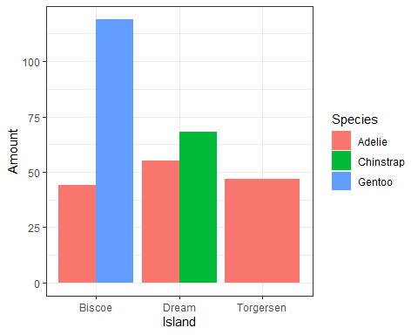
Figure 1: Distribution of Species across Islands
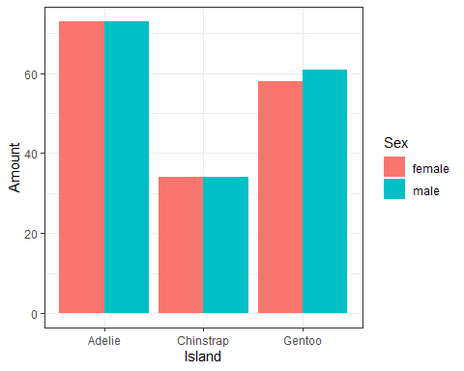
Figure 2: Distribution of Sexes across Species
Suppose we want to analyze the factors behind penguin mass. The following are graphs depicting the relationship between body dimensions and body mass across all species of penguins. Common sense would tell us that there would be a positive relationship between body dimensions and body mass, and below we can see that that intuition is correct: there is a strong positive relationship in each figure. What is more important to note is how each species dimensions compare. For example, Adelie and Chinstrap Penguins seem to have similar dimensions regarding flipper length and bill depth, whereas Gentoo penguins are comparatively separated from the other two species. If we wanted to create a model to predict mass, we would have to isolate the model by species.
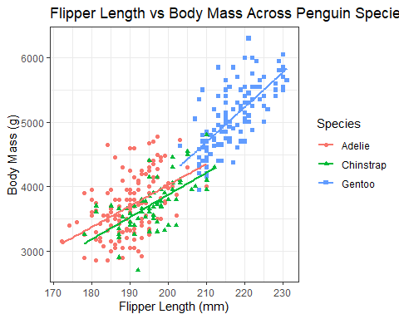
Figure 3: Flipper Length vs Body Mass
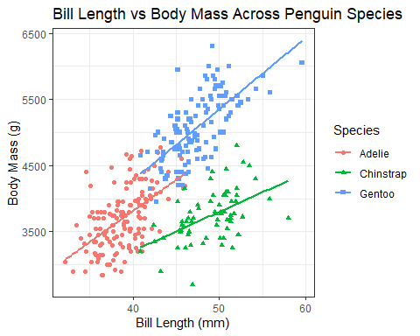
Figure 4: Bill Length vs. Body Mass
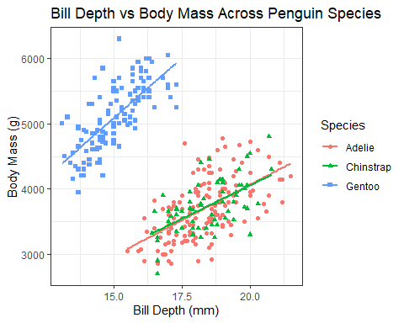
Figure 5: Bill Depth vs Body Mass

Model Creation and Analysis
Now let’s create some models that can help us predict certain dimensions or features of a given penguin. For these models, let us assume a significance level of 0.05. Suppose we wanted to predict a penguin’s body mass using its other body dimensions. As shown in Figures 3-5 above, species have different attributes, so it is important to use only one species in the model. Suppose we were interested in analyzing the Gentoo population. Let’s start with a simple regression analysis using flipper length. In this reduced model, we can see that flipper length is a significant predictor for body mass, with an extremely small p-value well below our significance level of 0.05. We can reject the null and assume the alternative is true: flipper length is a significant predictor for body mass. Our model is as follows:
$$BodyMass=-6674.20+54.12FlipperLength$$
With every 1mm increase with flipper length for a Gentoo penguin, we can expect body mass to increase by 54 grams.
##
## Call:
## lm(formula = body_mass_g ~ flipper_length_mm, data = gentoo.penguins)
##
## Residuals:
## Min 1Q Median 3Q Max
## -704.69 -244.29 -58.87 161.98 1003.65
##
## Coefficients:
## Estimate Std. Error t value Pr(>|t|)
## (Intercept) -6674.204 1075.436 -6.206 8.51e-09 ***
## flipper_length_mm 54.165 4.948 10.946 < 2e-16 ***
## ---
## Signif. codes: 0 '***' 0.001 '**' 0.01 '*' 0.05 '.' 0.1 ' ' 1
##
## Residual standard error: 354 on 117 degrees of freedom
## Multiple R-squared: 0.506, Adjusted R-squared: 0.5017
## F-statistic: 119.8 on 1 and 117 DF, p-value: < 2.2e-16
Suppose we wanted to include more factors into this model and make it a multilinear model, such as Bill Length and Bill Depth. In order to do this, we have to establish that these variables have a linear relationship with body mass, and share low multicolinearity. Our scatterplots above demonstrate the latter, so we should verify the former through a correlation matrix
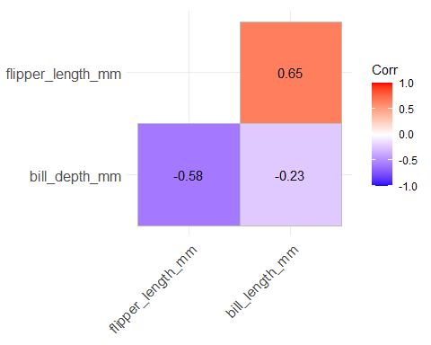
Figure 6: Correlation plot between Body Dimensions
Bill Length and Flipper Length have a relatively high correlation of 0.65. This is not so high that we exclude Bill Length in a full model, but it is possible that it could affect the results in some way and we should keep it in mind. We also have to test for normality and homoscedasticity in our full model. We can do this by using a qq plot and plotting our fitted values against our residual ones.
##
## Call:
## lm(formula = body_mass_g ~ flipper_length_mm + bill_depth_mm +
## bill_length_mm, data = gentoo.penguins)
##
## Residuals:
## Min 1Q Median 3Q Max
## -586.42 -225.83 -23.64 164.71 1022.17
##
## Coefficients:
## Estimate Std. Error t value Pr(>|t|)
## (Intercept) -4444.415 1009.081 -4.404 2.39e-05 ***
## flipper_length_mm 23.259 6.639 3.503 0.000655 ***
## bill_depth_mm 180.005 43.818 4.108 7.51e-05 ***
## bill_length_mm 37.517 13.091 2.866 0.004947 **
## ---
## Signif. codes: 0 '***' 0.001 '**' 0.01 '*' 0.05 '.' 0.1 ' ' 1
##
## Residual standard error: 309.8 on 115 degrees of freedom
## Multiple R-squared: 0.6281, Adjusted R-squared: 0.6184
## F-statistic: 64.73 on 3 and 115 DF, p-value: < 2.2e-16
## Analysis of Variance Table
##
## Model 1: body_mass_g ~ flipper_length_mm
## Model 2: body_mass_g ~ flipper_length_mm + bill_depth_mm + bill_length_mm
## Res.Df RSS Df Sum of Sq F Pr(>F)
## 1 117 14660505
## 2 115 11036708 2 3623798 18.88 8.123e-08 ***
## ---
## Signif. codes: 0 '***' 0.001 '**' 0.01 '*' 0.05 '.' 0.1 ' ' 1
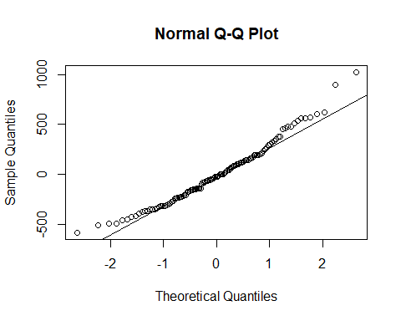
Figure 7: Q-Q plot of our model, demonstrating normality of the residuals
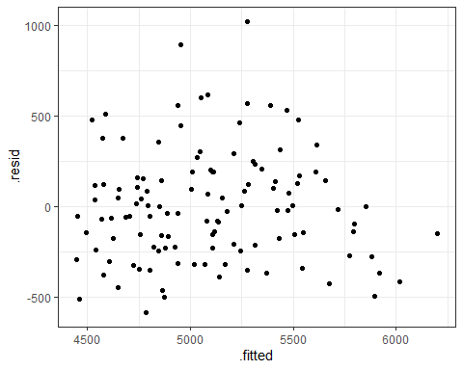
Figure 8: Fitted vs Residuals
These results are promising. According to our anova testing, we result in a p-value well below our significance level of 0.05, meaning we can reject the null and assume that the alternative is true: Our full model is a better fit than our reduced one. Our full model also has significant p-values for all of our variables. With figures 7 and 8, we are also able to establish multivariate normality and homoscedasticity. Our qq plots lie across a straight line, indicating that our residuals are normally distributed, and our fitted vs residual plot has little to no discernible pattern, indicitating that these residuals have constant variance along every point in our model. This is all enough suggestion to abandon our previous model and use our full model as a predictor for body mass. The resulting model is as follows:
$$BodyMass=-4444.42+23.26FlipperLength+180.01BillDepth+37.52BillLength$$
This means that for every 1mm increase in Flipper Length, Bill Depth, and Bill Length, we can expect approximately a 23, 180, and 38 gram increase in body mass, respectively, when holding all other variables constant. If we have a penguin with a flipper length of 220mm, bill depth of 13 mm, and bill length of 51mm, we can expect a body mass of -4444.42 + 23.26(220) + 180.01(13) + 37.52(51) = 4926.3 grams.
Suppose we wanted to compare the mass of the same species penguins across islands and sex. Perhaps the habitat of each island could have an effect on the penguins, causing them to be larger, or male penguins are on average larger than female penguins, for example. For this analysis, let’s focus on only Adelie penguins,since they are the only species found across all three islands. From Figure 9, we can see that there initially seems to be quite a different in mass between male and female penguins, and only a small difference between islands.
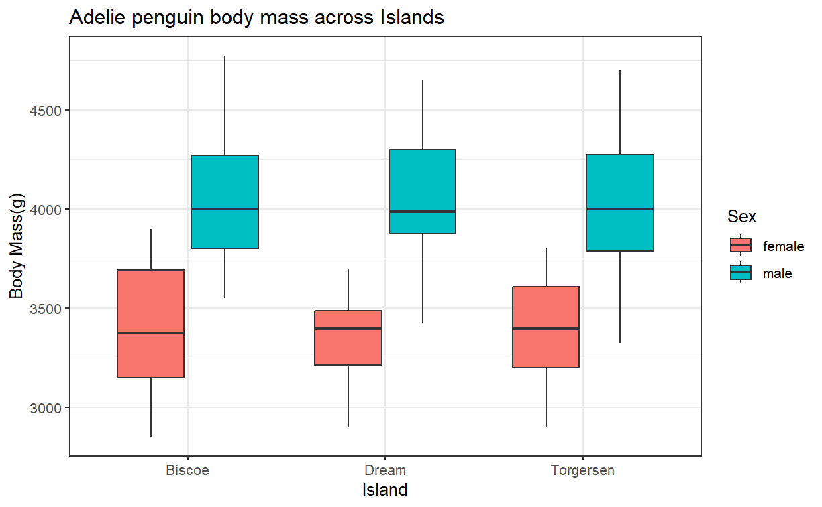Figure 9: Distribution of Body Mass Across Sexes
Using ANOVA in R for body mass between islands confirms these hypotheses: we result in a p-value well above our significance level of 0.05. We fail to reject the null and cannot confirm the alternative to be true. There is not enough evidence to assume that the island has an effect on the Adelie penguin’s mass.
## Df Sum Sq Mean Sq F value Pr(>F)
## island 2 2064 1032 0.005 0.995
## Residuals 143 30496138 213260
However, there is a significant difference in mass for the sex of an Adelie penguin. In our t-test below, we can see that the mean mass in grams for males is significantly larger than females. We additionally have a p-value of nearly 0, meaning that we reject the null and confirm the alternative as true. There is a statistically significant difference between the mass of male and female adelie penuins.
##
## Welch Two Sample t-test
##
## data: body_mass_g by sex
## t = -13.126, df = 135.69, p-value < 2.2e-16
## alternative hypothesis: true difference in means between group female and group male is not equal to 0
## 95 percent confidence interval:
## -776.3012 -573.0139
## sample estimates:
## mean in group female mean in group male
## 3368.836 4043.493

Conclusion
This was an exploratory analysis of the palmer penguins dataset where we built a linear model that could predict a penguin’s body mass given its body dimensions, as well as analyzed the difference between penguin populations between islands and penguin sex. Further research of this dataset could include using logistic regression or creating a ML classifier to identify a penguin species. One thing that should ne noted about this dataset is that it is quite small: the original dataset has only a few hundred observations. The methods used in this project and especially the creation of an ML classifier would result in more accurate models if used on a larger sample size that could more accurately represent the total penguin population.

