For this assignment the objective was to build a series of scatter plots to showcase and analyze the following relationships:

* Temperature (F) vs. Latitude
* Humidity (%) vs. Latitude
* Cloudiness (%) vs. Latitude
* Wind Speed (mph) vs. Latitude

**Temperature (F) vs. Latitude**

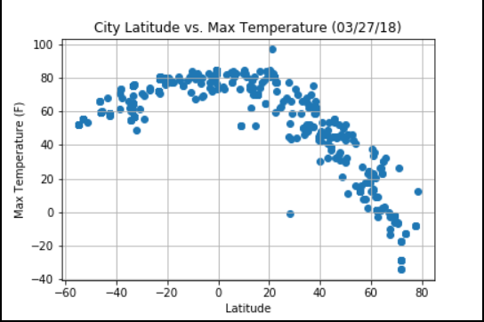

When we look at this scatter plot, we can say that the temperatures cool with increasing latitude.

**Humidity (%) vs. Latitude**

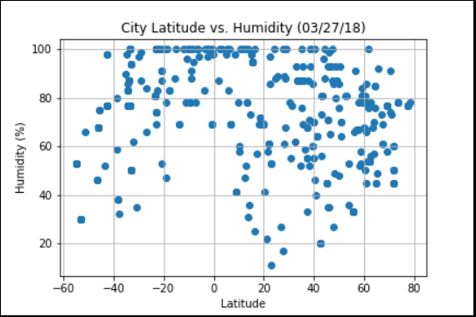

On this scatter plot, we can see that the humidity is not necessarily the same for cities which are located at the same latitude. But the for the cities around the equator (latitude between -40 and 40) the humidity is very high(100%).

**Cloudiness (%) vs. Latitude**

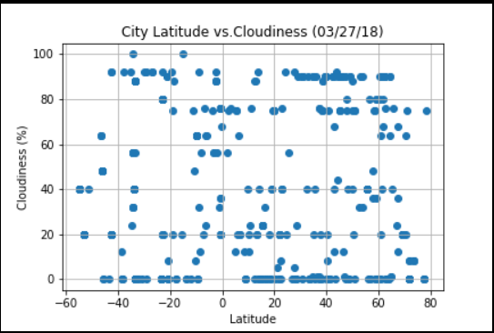

On this scatter plot, the cloudiness varies for cities which are located at the same latitude.

**Wind Speed (mph) vs. Latitude**

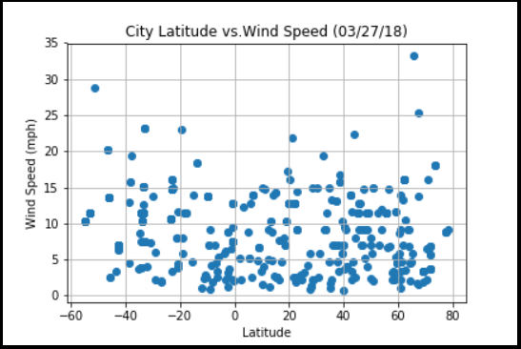

On this scatter plot, we can see that the wind speed varies in average from 1 to 15mph for cities located at the same latitude.

In conclusion, after analyzing the correlation between the latitude and the following variables: temperature, humidity, cloudiness, wind speed, we can say that the latitude has more influence on the temperature . The higher latitudes receive less heat than lower latitude areas nearer the equator therefore, the higher the latitude is, the cooler the temperature will be.