Pymaceuticals Inc. is a burgeoning pharmaceutical company based out of San Diego, CA.

Pymaceuticals is specialized in drug-based, anti-cancer pharmaceuticals.

In their most recent efforts, they've since begun screening for potential treatments to squamous cell carcinoma (SCC), a commonly occurring form of skin cancer.

In their study, 250 mice were treated through a variety of drug regimes over the course of 45 days. Their physiological responses were then monitored over the course of that time.

We had to analyze the data to show how four treatments (Capomulin, Infubinol, Ketapril, and Placebo) act on this type of cancer.

1. We have a scatter plot that shows how the tumor volume changes over time for each treatment.

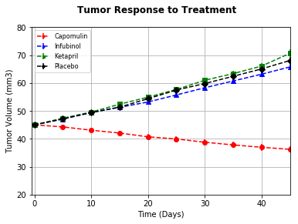

On this plot, we can see the Capomulin drug is the one acting the most the size of the tumor by reducing it . With the others drugs, the sizes of the tumor tend to growth.

Capomulin seems to be effective in the treatment of this cancer

1. The second scatter plot that was created shows how the number of metastatic sites (cancer spreading) sites changes over time for each treatment.

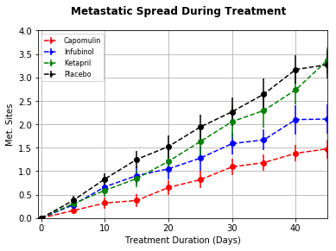

On this scatter plot, we notice that the metastatic spread is less important when the treatment used is the Capomulin. On the other hand the spread is more significant when the Placebo and Ketapril treatment are used.

3) The third scatter plot shows the number of mice still alive through the course of treatment

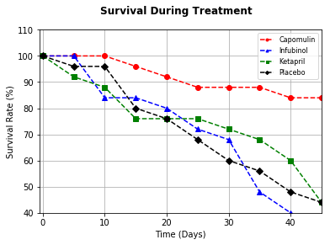

|  |  |  |  |  |  |
| --- | --- | --- | --- | --- | --- |
|  |  |  |  |  |  |

On this third scatter plot, we can see that the survival rate is very high with the Capomulin Drug after 45 days of treatment.

On the other hand, while taking the 3 others drugs(Infubinol, Ketapril, Placebo), the survival rate is almost null after 45 days of treatment.

In conclusion we can say that Capomunil is the best drug to treat the squamous cell carcinoma (SCC)