**Twitter** has become a wildly sprawling jungle of information—140 characters at a time. Somewhere between 350 million and 500 million tweets are estimated to be sent out *per day*. With such an explosion of data, on Twitter and elsewhere, it becomes more important than ever to tame it in some way, to concisely capture the essence of the data.

On this basis, we have been asked to create a Python script to perform a sentiment analysis of the Twitter activity of various news outlets, and to present the findings visually.

Below is the first plot that is a scatter plot of sentiments of the last 100 tweets sent out by each news organization:

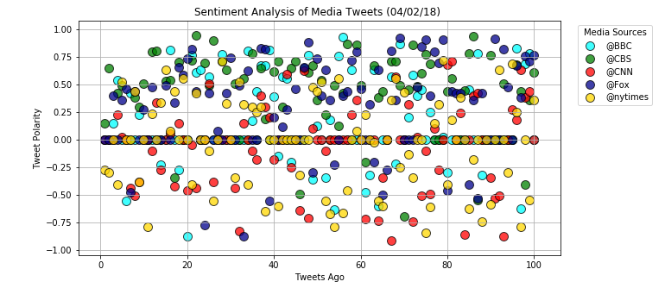

On this scatter plot, we can say that most of the tweets are either neutral or positive.

The three media that receive those tweets are BBC, CBS and Fox.

CNN and the New York Times are the two medias that have the most negative sentiments according to the tweets.

The second graph below is a bar plot which provide a visualized summary of the sentiments expressed in Tweets and sent out by the following news organizations: BBC, CBS, CNN, Fox, and New York times.

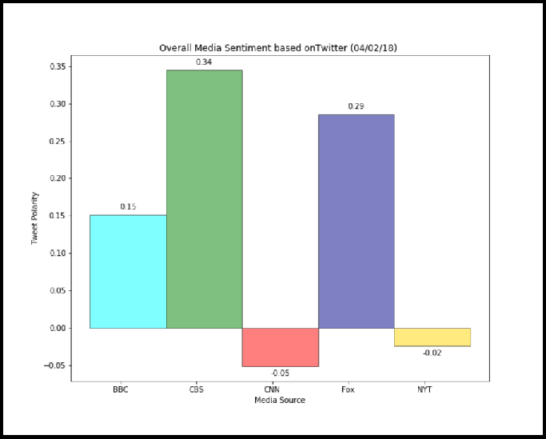

On this bar Chart the trend is the same as the one we had with the scatter plot above.

CNN et New York Times are the media that have, overall, the most negative tweets.

BBC, CBS and Fox have, in general, have positive tweets.