Seminoff EPac green turtle Stable Isotope Data Analysis

Lisa Komoroske

2016-12-14

## Metadata from Jeff

**Site** - an ordinal code for each site  
**Site code** - 3 letter code for each site  
**Location** - location of turtle capture  
**LAB ID** - self explanatory  
**Collection Date** - self explanatory  
**Run Date** - self explanatory  
**%N** - elemental concentration of N. that is, how much each sample is made up of nitrogen. this is used as a diagnostic to know sample quality (anything outside of ~9-17% N raises a red flag)  
**%C** - elemental concentration of C. that is, how much each sample is made up of carbon. this is used as a diagnostic to know sample quality (anything outside of ~40-60% C raises a red flag)  
**d15N** - stable isotope value for N  
**d13C** - stable isotope value for C  
**Color** - rarely filled in. This is largely for the Galapagos and Colombia, where black turtles (eastern Pacific stock) and yellow turtles (west pacific origins) co-exist. Safe to say that anything that is not filled in here would be a ‘black’ morph.  
**SCL** - straight carapace length  
**CCL** - curved carapace length

## Setup

## Load Required Libraries

## Read in data

## Coarse data QC checks to note obvious data structure problems, etc.:

#View(data)  
str(data) #all look like appropriate categories

## 'data.frame': 718 obs. of 17 variables:  
## $ SITE_No : int 1 1 1 1 1 1 1 1 1 1 ...  
## $ SITE_CODE : Factor w/ 22 levels "BLA","BMA","CIN",..: 22 22 22 22 22 22 22 22 22 22 ...  
## $ Ordered_SITE: Factor w/ 22 levels "1-SGR","2-SBN",..: 1 1 1 1 1 1 1 1 1 1 ...  
## $ Habitat_Type: Factor w/ 3 levels "coastal","insular",..: 1 1 1 1 1 1 1 1 1 1 ...  
## $ Location : Factor w/ 22 levels "Bahia de los Angeles, Gulf of California, Mexico",..: 21 21 21 21 21 21 21 21 21 21 ...  
## $ LABID : Factor w/ 718 levels "101","102","103",..: 640 148 149 150 162 163 164 168 175 176 ...  
## $ Collect_Date: POSIXlt, format: "2010-06-18" "2011-07-14" ...  
## $ Run_Date : POSIXlt, format: NA "2014-02-09" ...  
## $ Percent_N : num 15.9 15.7 15.2 15.5 14.7 15.2 15.4 16.4 17 14.9 ...  
## $ Percent_C : num 45.6 45.5 47 45.4 47 46.5 45.3 45.7 46.7 45.4 ...  
## $ d15N : num 15.4 15.8 15.6 16 18.1 15.3 16.8 16.5 17.1 18.8 ...  
## $ d13C : num -16.8 -15.1 -15.6 -14.4 -13.3 -18.9 -13.7 -16 -15.8 -17.9 ...  
## $ COLOR : Factor w/ 3 levels "","BLACK","YELLOW": 1 1 1 1 1 1 1 1 1 1 ...  
## $ SCL : num 44 57.6 54.3 63.2 96.8 71.1 66.1 NA 54.8 53.6 ...  
## $ CCL : num 46.9 62.6 59.3 67.2 101 76.8 69.6 60.6 61.8 56.2 ...  
## $ Alt.ID : Factor w/ 104 levels ""," ","100","105",..: 1 1 1 1 1 1 1 1 1 1 ...  
## $ Notes : Factor w/ 3 levels ""," ","no measurements taken, confirmed in SDB Binder": 1 1 1 1 1 1 1 1 1 1 ...

dim(data)

## [1] 718 17

head(data)

## SITE_No SITE_CODE Ordered_SITE Habitat_Type Location LABID  
## 1 1 SGR 1-SGR coastal San Gabriel River 94379  
## 2 1 SGR 1-SGR coastal San Gabriel River 106875  
## 3 1 SGR 1-SGR coastal San Gabriel River 106876  
## 4 1 SGR 1-SGR coastal San Gabriel River 106877  
## 5 1 SGR 1-SGR coastal San Gabriel River 108450  
## 6 1 SGR 1-SGR coastal San Gabriel River 108451  
## Collect_Date Run_Date Percent_N Percent_C d15N d13C COLOR SCL CCL  
## 1 2010-06-18 <NA> 15.9 45.6 15.4 -16.8 44.0 46.9  
## 2 2011-07-14 2014-02-09 15.7 45.5 15.8 -15.1 57.6 62.6  
## 3 2011-07-14 2014-02-09 15.2 47.0 15.6 -15.6 54.3 59.3  
## 4 2011-08-18 2014-02-09 15.5 45.4 16.0 -14.4 63.2 67.2  
## 5 2012-06-19 2014-02-09 14.7 47.0 18.1 -13.3 96.8 101.0  
## 6 2012-06-19 2014-02-09 15.2 46.5 15.3 -18.9 71.1 76.8  
## Alt.ID Notes  
## 1   
## 2   
## 3   
## 4   
## 5   
## 6

tail(data) #got rid of some NAs at end, now should be good

## SITE_No SITE_CODE Ordered_SITE Habitat_Type  
## 713 24 PPE 24-PPE oceanic  
## 714 24 PPE 24-PPE oceanic  
## 715 24 PPE 24-PPE oceanic  
## 716 24 PPE 24-PPE oceanic  
## 717 24 PPE 24-PPE oceanic  
## 718 24 PPE 24-PPE oceanic  
## Location LABID Collect_Date Run_Date Percent_N  
## 713 Oceanic Waters, Peru (Longline) 87310 2009-02-09 <NA> 14.5  
## 714 Oceanic Waters, Peru (Longline) 87312 2009-02-12 <NA> 11.6  
## 715 Oceanic Waters, Peru (Longline) 87313 2009-02-13 <NA> 12.0  
## 716 Oceanic Waters, Peru (Longline) 87316 2009-02-06 <NA> 10.0  
## 717 Oceanic Waters, Peru (Longline) 87317 2009-02-06 <NA> 14.4  
## 718 Oceanic Waters, Peru (Longline) 87319 2009-02-16 <NA> 14.2  
## Percent_C d15N d13C COLOR SCL CCL Alt.ID Notes  
## 713 42.4 11.4 -15.9 NA NA   
## 714 36.3 12.3 -16.2 NA NA   
## 715 34.9 12.6 -17.0 NA NA   
## 716 27.4 13.0 -15.5 NA NA   
## 717 41.1 12.9 -15.4 NA NA   
## 718 44.3 11.5 -15.6 NA NA

summary(data)

## SITE_No SITE_CODE Ordered_SITE Habitat_Type  
## Min. : 1.00 SDB : 90 3-SDB : 90 coastal:366   
## 1st Qu.: 9.00 GOR : 76 18-GOR : 76 insular:277   
## Median :15.00 PPE : 75 24-PPE : 75 oceanic: 75   
## Mean :13.81 DUL : 74 13-DUL : 74   
## 3rd Qu.:19.00 COC : 67 17-COC : 67   
## Max. :24.00 BLA : 53 9-BLA : 53   
## (Other):283 (Other):283   
## Location LABID   
## San Diego Bay, United States : 90 101 : 1   
## Isla Gorgona, Colombia : 76 102 : 1   
## Oceanic Waters, Peru (Longline) : 75 103 : 1   
## Golfo Dulce, Costa Rica : 74 104 : 1   
## Cocos Island, Costa Rica : 67 105087 : 1   
## Bahia de los Angeles, Gulf of California, Mexico: 53 105088 : 1   
## (Other) :283 (Other):712   
## Collect_Date Run_Date   
## Min. :1990-03-31 00:00:00 Min. :2003-01-17 00:00:00   
## 1st Qu.:2004-08-30 00:00:00 1st Qu.:2005-02-01 00:00:00   
## Median :2006-12-05 00:00:00 Median :2007-06-12 00:00:00   
## Mean :2007-09-13 16:14:06 Mean :2007-09-17 17:31:54   
## 3rd Qu.:2010-10-12 00:00:00 3rd Qu.:2007-08-09 00:00:00   
## Max. :2014-08-06 00:00:00 Max. :2014-02-10 00:00:00   
## NA's :33 NA's :404   
## Percent_N Percent_C d15N d13C   
## Min. : 0.00 Min. : 0.00 Min. : 4.50 Min. :-25.50   
## 1st Qu.:11.45 1st Qu.:37.60 1st Qu.:11.72 1st Qu.:-16.80   
## Median :13.10 Median :42.10 Median :13.50 Median :-15.90   
## Mean :12.66 Mean :40.53 Mean :13.60 Mean :-15.84   
## 3rd Qu.:14.70 3rd Qu.:45.10 3rd Qu.:15.38 3rd Qu.:-14.90   
## Max. :21.00 Max. :65.70 Max. :21.20 Max. : -8.10   
## NA's :87 NA's :87   
## COLOR SCL CCL Alt.ID   
## :642 Min. : 39.70 Min. : 38.30 :589   
## BLACK : 29 1st Qu.: 55.85 1st Qu.: 64.00 Alt ID : 24   
## YELLOW: 47 Median : 64.60 Median : 74.90 : 4   
## Mean : 68.18 Mean : 74.76 100 : 1   
## 3rd Qu.: 75.90 3rd Qu.: 82.00 105 : 1   
## Max. :110.40 Max. :116.50 106 : 1   
## NA's :387 NA's :310 (Other): 98   
## Notes   
## :709   
## : 8   
## no measurements taken, confirmed in SDB Binder: 1   
##   
##   
##   
##

table(data$SITE_CODE,data$Habitat_Type) #frequency table, note some sites have few samples (some 1s and 3s)

##   
## coastal insular oceanic  
## BLA 53 0 0  
## BMA 30 0 0  
## CIN 28 0 0  
## COC 0 67 0  
## DUL 74 0 0  
## ESC 10 0 0  
## GOR 0 76 0  
## IGD 0 37 0  
## IGE 0 37 0  
## IGN 0 3 0  
## IGP 0 42 0  
## IGZ 0 6 0  
## IPD 1 0 0  
## ISL 0 9 0  
## LOR 1 0 0  
## LSI 12 0 0  
## MEJ 21 0 0  
## PAR 21 0 0  
## PPE 0 0 75  
## SBN 6 0 0  
## SDB 90 0 0  
## SGR 19 0 0

#found/fixed issues, but leaving in example code here for if need to find which cases are causing issues:  
#summary(dataframe$variable)  
#which(dataframe$variable=="value")  
#is.na(dataframe$variable), or conversely !is.na(dataframe$variable)  
#which(dataframe$variable=="value")

*N.B. 87 entries are missing percent N or C, but have the delta N and C-follow up with Jeff/Joel if this is an issue given that these are variables to check sample quality (see metadata above)*

## SI data specific QC checks

#Are all the samples unique/any issues of duplicates?  
length(unique(data$LABID))

## [1] 718

length(data$LABID)

## [1] 718

#all good  
  
summary(data$Collect_Date)

## Min. 1st Qu. Median   
## "1990-03-31 00:00:00" "2004-08-30 00:00:00" "2006-12-05 00:00:00"   
## Mean 3rd Qu. Max.   
## "2007-09-13 16:14:06" "2010-10-12 00:00:00" "2014-08-06 00:00:00"   
## NA's   
## "33"

#Any issues with confounding dates of collection or run?  
ggplot(data, aes(x=Collect_Date,y=d15N,fill=Habitat_Type)) + geom_point(size=3, alpha=.8,shape=21,position=position_jitter(width=.5,height=.5))+theme_bw()+theme(axis.text.x = element_text(angle=90, vjust=0.5))+scale_fill_manual(values=palette)

## Warning: Removed 33 rows containing missing values (geom_point).

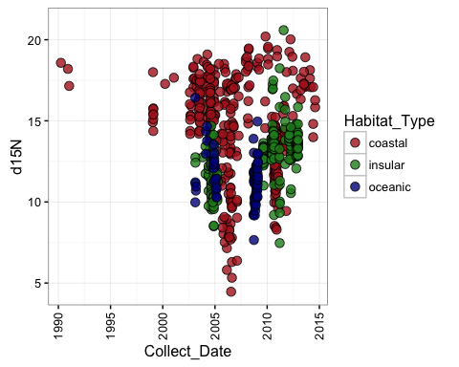

ggplot(data, aes(x=Collect_Date,y=d15N,fill=SITE_CODE)) + geom_point(size=3, alpha=1,shape=21,position=position_jitter(width=5,height=.5))+theme_bw()+theme(axis.text.x = element_text(angle=90, vjust=0.5))

## Warning: Removed 33 rows containing missing values (geom_point).

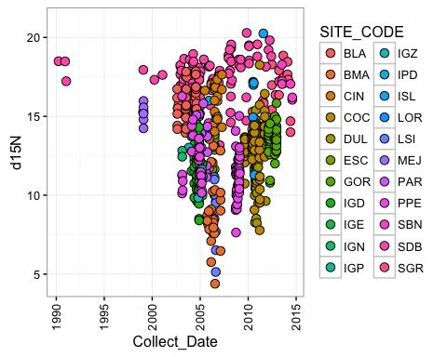

ggplot(data, aes(x=Run_Date,y=d15N,fill=Habitat_Type)) + geom_point(size=3, alpha=.8,shape=21,position=position_jitter(width=5,height=.5))+theme_bw()+theme(axis.text.x = element_text(angle=90, vjust=0.5))+scale_fill_manual(values=palette)

## Warning: Removed 404 rows containing missing values (geom_point).

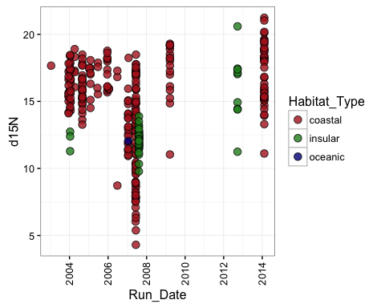

ggplot(data, aes(x=Run_Date,y=d15N,fill=SITE_CODE)) + geom_point(size=3, alpha=1,shape=21,position=position_jitter(width=5,height=.5))+theme_bw()+theme(axis.text.x = element_text(angle=90, vjust=0.5))

## Warning: Removed 404 rows containing missing values (geom_point).

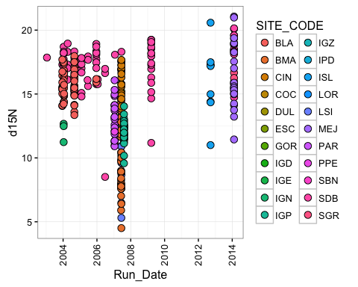 ##Are any samples of suspect quality?  
####Percent N: anything outside of ~9-17% N raises a red flag

## Min. 1st Qu. Median Mean 3rd Qu. Max. NA's   
## 0.00 11.45 13.10 12.66 14.70 21.00 87

## Warning: Removed 87 rows containing non-finite values (stat_bin).

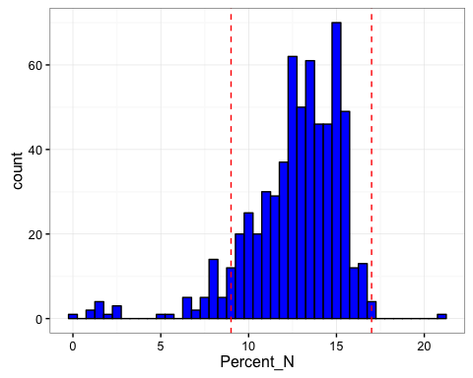

## Warning: Removed 87 rows containing non-finite values (stat_boxplot).

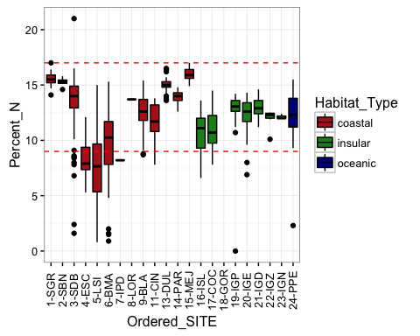

## [1] 48

## [1] 1

#### Percent C: anything outside of ~40-60% C raises a red flag

summary(data$Percent_C)

## Min. 1st Qu. Median Mean 3rd Qu. Max. NA's   
## 0.00 37.60 42.10 40.53 45.10 65.70 87

ggplot(data, aes(x=Percent_C)) + geom_histogram(binwidth=.5, colour="black", fill="red")+theme_bw()+geom_vline(xintercept=40,linetype="dashed",colour="blue")+  
 geom_vline(xintercept=60,linetype="dashed",colour="blue")

## Warning: Removed 87 rows containing non-finite values (stat_bin).

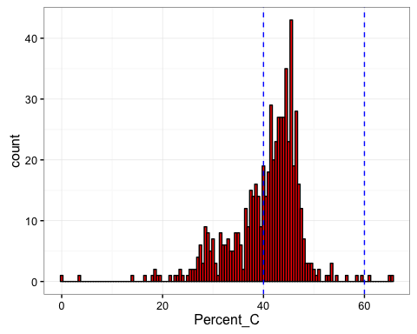

ggplot(data, aes(x=Ordered_SITE,y=Percent_C,fill=Habitat_Type)) + geom_boxplot(colour="black")+theme_bw()+geom_hline(yintercept=40, linetype="dashed",colour="blue")+geom_hline(yintercept=60,linetype="dashed",colour="blue")+  
theme(axis.text.x = element_text(angle=90, vjust=0.5))+scale_fill_manual(values=palette)

## Warning: Removed 87 rows containing non-finite values (stat_boxplot).

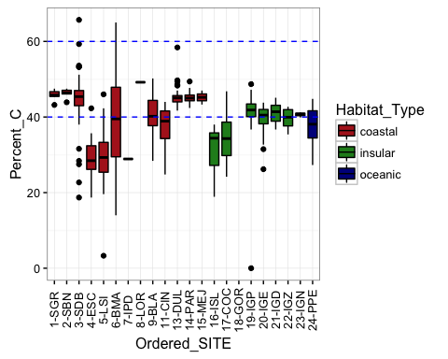

length(which(data_noNAs$Percent_C<39))

## [1] 202

length(which(data_noNAs$Percent_C>61))

## [1] 2

#### Percent C vs. Percent N: are the samples 'bad' values for both?

ggplot(data, aes(y=Percent_C, x=Percent_N,fill=Habitat_Type)) +   
geom_point(size=3, alpha=.8,shape=21,position=position_jitter(width=.5,height=.5)) +theme_bw()+ scale_fill_manual(values=palette)+  
 geom_hline(yintercept=60,linetype="dashed",colour="grey10")+  
 geom_hline(yintercept=40,linetype="dashed",colour="grey10")+  
 geom_vline(xintercept=9,linetype="dashed",colour="grey10")+  
 geom_vline(xintercept=17,linetype="dashed",colour="grey10")

## Warning: Removed 87 rows containing missing values (geom_point).

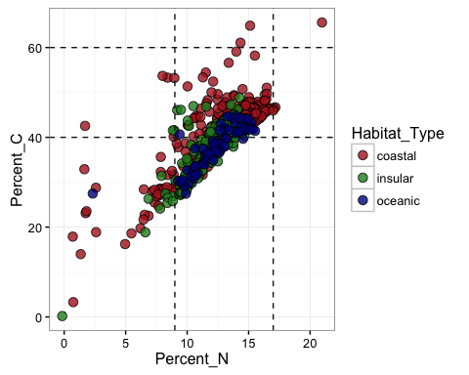

**need to follow up with Jeff to determine what to do about samples that don't pass the QC criteria?**

## Initial Data exploration for delta C and N

*Ggplot univariate & bivariate graphic scans etc* ####1. Nitrogen

#Distributions:  
ggplot(data, aes(x=d15N)) +   
 geom_histogram(aes(y=..density..), # Histogram with density on y-axis  
 binwidth=.5,  
 colour="black", fill="dodgerblue") +  
 geom_density(alpha=.4, fill="yellow")+theme_bw()+  
geom_vline(aes(xintercept=mean(d15N, na.rm=T)), #Ignore NA values for mean  
 color="red", linetype="dashed", size=1)

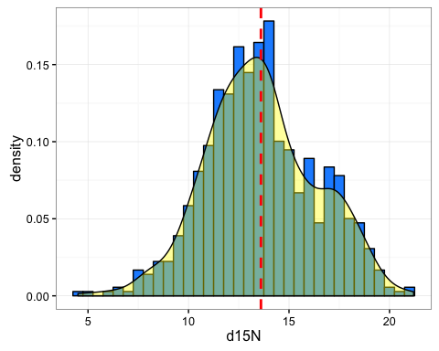

#density only, faceted:  
a<-ggplot(data, aes(x=d15N)) + geom_density(alpha=.4, fill="blue")+theme_bw()+  
geom_vline(aes(xintercept=mean(d15N, na.rm=T)), #Ignore NA values for mean  
 color="red", linetype="dashed", size=1)  
a+facet_wrap( ~ Ordered_SITE, ncol=4)

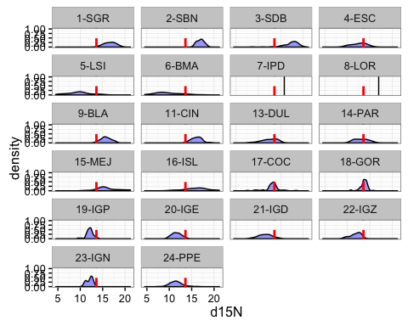

#boxplot:  
ggplot(data, aes(x=Ordered_SITE, y=d15N, fill=Habitat_Type)) + geom_boxplot() +theme_bw()+  
 guides(fill=FALSE)+stat_summary(fun.y=mean, geom="point", shape=5, size=4)+theme(axis.text.x = element_text(angle=55, vjust=0.5))+scale_fill_manual(values=palette)

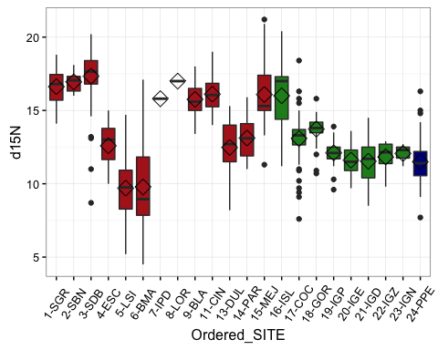

#Q-Q plot:  
qqnorm(data$d15N)  
qqline(data$d15N)#just adding line

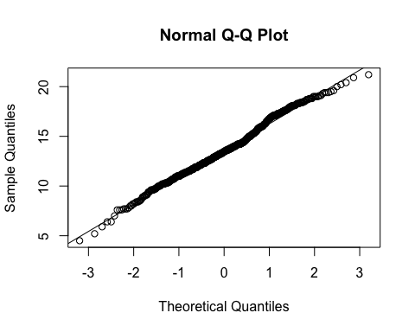

#Additional perhaps useful visualizations  
#ordering by medians  
ggplot(data, aes(x=reorder(Ordered_SITE,d15N), y=d15N, fill=Habitat_Type)) + geom_boxplot() +theme_bw()+xlab("Location (ordered by value)")+  
 guides(fill=FALSE)+stat_summary(fun.y=mean, geom="point", shape=5, size=4)+theme(axis.text.x = element_text(angle=55, vjust=0.5))+scale_fill_manual(values=palette)

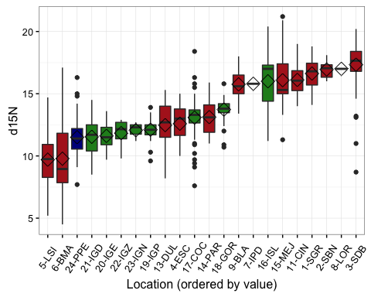

stripplot(d15N~Ordered_SITE, data=data, jitter.data=T, group=Habitat_Type, aspect=1, xlab="Location")

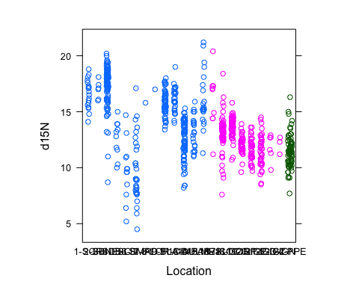

#faceted mean dot  
ggplot(data_Nsum, aes(y=reorder(Ordered_SITE,N_to_S_ordination), x=mean_d15N, fill=Habitat_Type)) +   
 geom_errorbarh(aes(xmin=mean_d15N-se_d15N,xmax=mean_d15N+se_d15N),size=0.25)+  
 geom_point(size=3, aes(colour=Habitat_Type)) +theme_bw()+ guides(fill=FALSE)+  
 theme(panel.grid.major.x=element_blank(),  
 panel.grid.minor.x=element_blank(),  
 panel.grid.major.y=element_line(colour="grey60",linetype="dashed"))+ scale_colour_manual(values=palette,guide=FALSE)+  
 ylab("Location (N to S)") +xlab("Mean d15N") +  
 facet_grid(Habitat_Type~.,scales="free_y",space="free_y")

## Warning: Removed 2 rows containing missing values (geom_errorbarh).

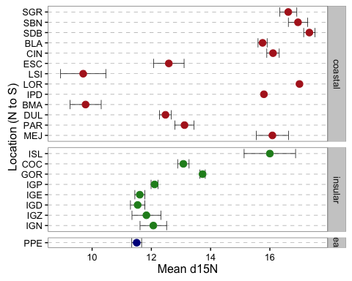

ggplot(data,aes(x=SITE_CODE,y=d15N))+geom_boxplot()

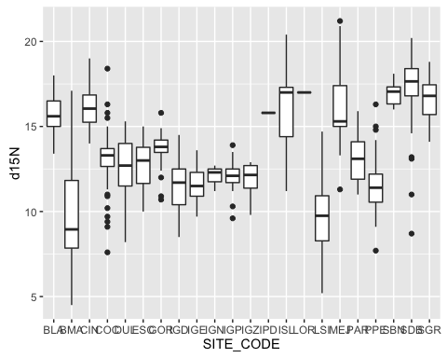

ggplot(data,aes(x=SITE_CODE,y=d15N))+geom_boxplot()+facet_grid(Habitat_Type~.)

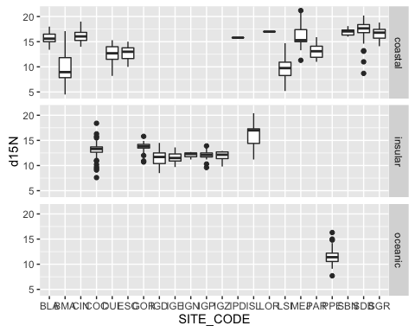

ggplot(data,aes(x=Habitat_Type,y=d15N))+geom_boxplot()

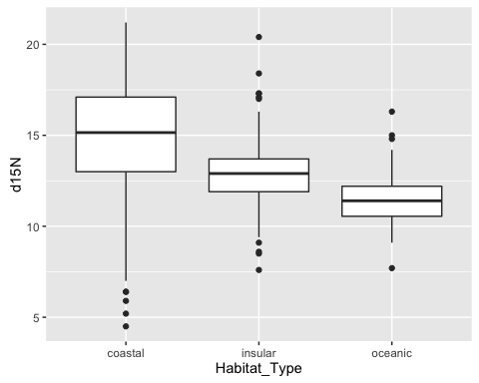

#### Carbon

#Distributions:  
ggplot(data, aes(x=d13C)) +   
 geom_histogram(aes(y=..density..), # Histogram with density on y-axis  
 binwidth=.5,  
 colour="black", fill="blue") +  
 geom_density(alpha=.4, fill="yellow")+theme_bw()+  
geom_vline(aes(xintercept=mean(d13C, na.rm=T)), #Ignore NA values for mean  
 color="red", linetype="dashed", size=1)

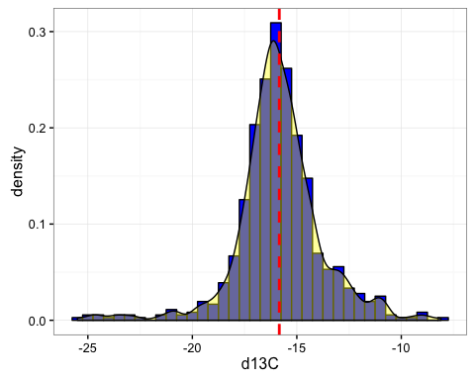

#density only:  
a<-ggplot(data, aes(x=d13C)) + geom_density(alpha=.4, fill="blue")+theme_bw()+  
geom_vline(aes(xintercept=mean(d13C, na.rm=T)), #Ignore NA values for mean  
 color="red", linetype="dashed", size=1)  
a+facet_wrap( ~ Ordered_SITE, ncol=4)

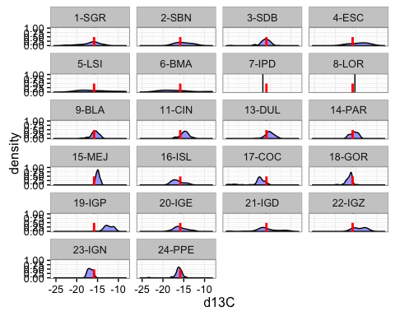

#boxplot:  
ggplot(data, aes(x=Ordered_SITE, y=d13C, fill=Habitat_Type)) + geom_boxplot()+theme_bw()+  
 guides(fill=FALSE)+stat_summary(fun.y=mean, geom="point", shape=5, size=4)+theme(axis.text.x = element_text(angle=55, vjust=0.5))+scale_fill_manual(values=palette)

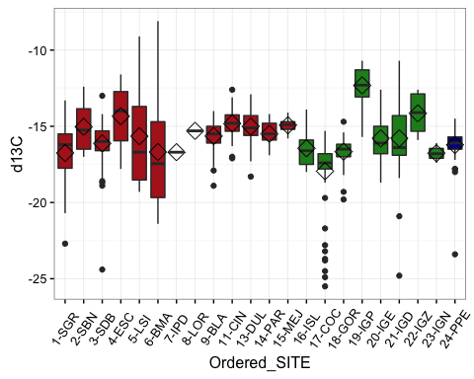

#Q-Q plot:  
qqnorm(data$d13C)  
qqline(data$d13C)#just adding line

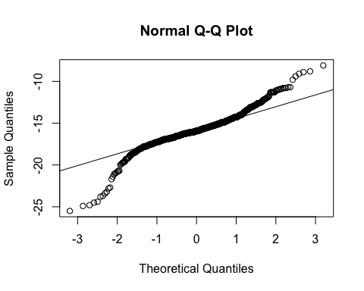

#Additional perhaps useful visualizations  
#ordering by medians  
ggplot(data, aes(x=reorder(Ordered_SITE,d13C), y=d13C, fill=Habitat_Type)) + geom_boxplot() +theme_bw()+xlab("Location (ordered by value)")+  
 guides(fill=FALSE)+stat_summary(fun.y=mean, geom="point", shape=5, size=4)+theme(axis.text.x = element_text(angle=55, vjust=0.5))+scale_fill_manual(values=palette)

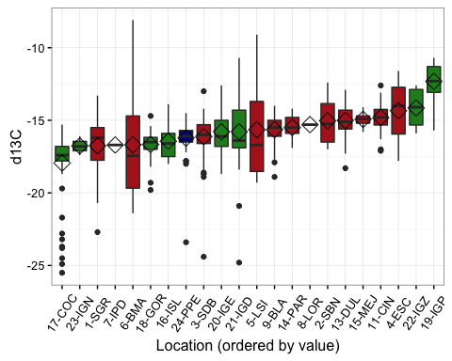

stripplot(d13C~Ordered_SITE, data=data, jitter.data=T, group=Habitat_Type, aspect=1, xlab="Location")

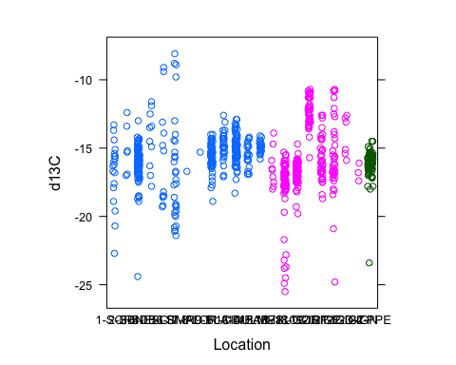

#faceted mean dot  
ggplot(data_Csum, aes(y=reorder(Ordered_SITE,N_to_S_ordination), x=mean_d13C, fill=Habitat_Type)) +   
 geom_errorbarh(aes(xmin=mean_d13C-se_d13C,xmax=mean_d13C+se_d13C),size=0.25)+  
 geom_point(size=3, aes(colour=Habitat_Type)) +theme_bw()+ guides(fill=FALSE)+  
 theme(panel.grid.major.x=element_blank(),  
 panel.grid.minor.x=element_blank(),  
 panel.grid.major.y=element_line(colour="grey60",linetype="dashed"))+ scale_colour_manual(values=palette,guide=FALSE)+  
 ylab("Location (N to S)") +xlab("Mean d13C") +  
 facet_grid(Habitat_Type~.,scales="free_y",space="free_y")

## Warning: Removed 2 rows containing missing values (geom_errorbarh).

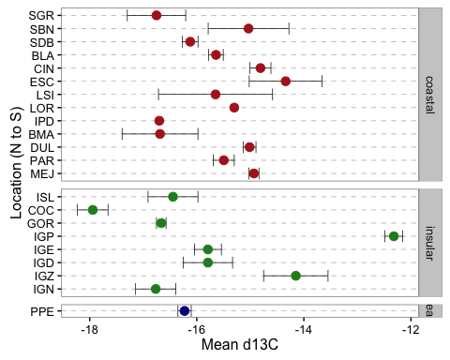

ggplot(data,aes(x=SITE_CODE,y=d13C))+geom_boxplot()

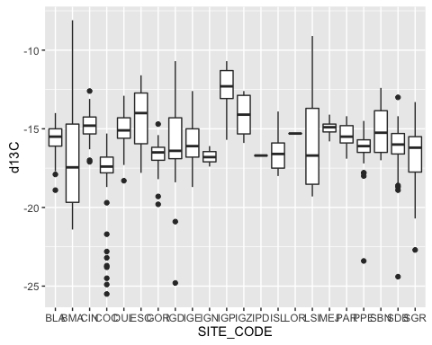

ggplot(data,aes(x=SITE_CODE,y=d13C))+geom_boxplot()+facet_grid(Habitat_Type~.)

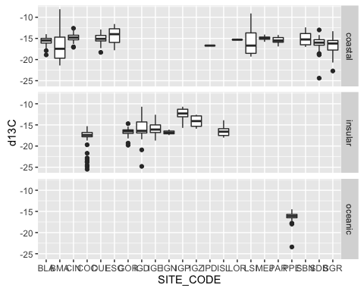

ggplot(data,aes(x=Habitat_Type,y=d13C))+geom_boxplot()

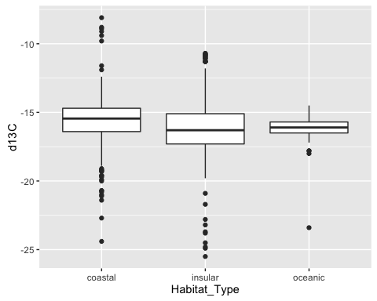

#### Any relationships/confounding issues with Turtle Size?

ggplot(data,aes(x=SCL,y=CCL))+geom_point()+theme_bw()#duh-but maybe double check the few that are way out there off the line?

## Warning: Removed 488 rows containing missing values (geom_point).

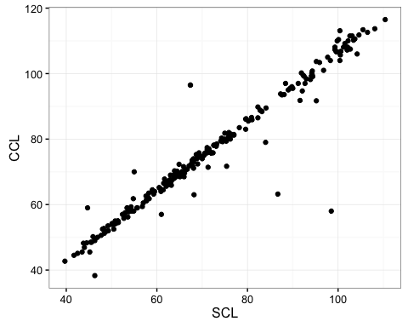

sum(!is.na(data$SCL))

## [1] 331

sum(!is.na(data$CCL))#CCL has fewer missing/NA's, so use this for now

## [1] 408

#bunch of missing carapace data, for insular sites, only have 3 sites with carpace data but there are 5 sites according to frequency table below  
  
#issue of big turtles at certain sites?  
ggplot(data, aes(x=Ordered_SITE,y=CCL,fill=Habitat_Type)) + geom_boxplot()+theme_bw()+theme(axis.text.x = element_text(angle=50, vjust=0.5))+scale_fill_manual(values=palette)

## Warning: Removed 310 rows containing non-finite values (stat_boxplot).

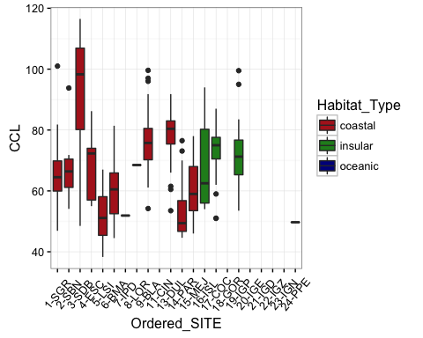

ggplot(data, aes(x=Ordered_SITE,y=CCL,fill=Habitat_Type)) + geom_boxplot()+theme_bw()+theme(axis.text.x = element_text(angle=50, vjust=0.5))+scale_fill_manual(values=palette)+facet_grid(Habitat_Type~.)

## Warning: Removed 310 rows containing non-finite values (stat_boxplot).

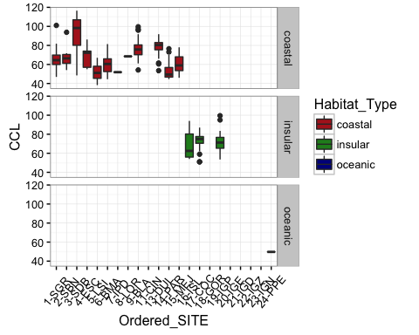

#Size vs. Nitrogen  
p<-ggplot(data, aes(x=CCL,y=d15N,fill=Habitat_Type)) + geom_point(size=3, alpha=.8,shape=21,position=position_jitter(width=.5,height=.5))+theme_bw()+theme(axis.text.x = element_text(angle=90, vjust=0.5))+scale_fill_manual(values=palette)  
p+geom_smooth(method=lm)

## Warning: Removed 310 rows containing non-finite values (stat_smooth).

## Warning: Removed 310 rows containing missing values (geom_point).

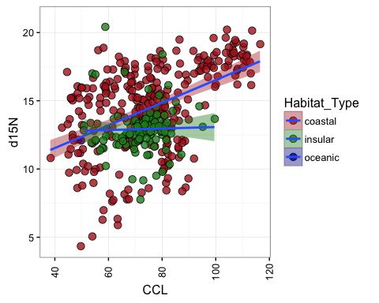

ggplot(data, aes(x=CCL,y=d15N,fill=Ordered_SITE)) + geom_point(size=3, alpha=.8,shape=21,position=position_jitter(width=.5,height=.5))+theme_bw()+theme(axis.text.x = element_text(angle=90, vjust=0.5))+facet_grid(Habitat_Type~.)

## Warning: Removed 310 rows containing missing values (geom_point).

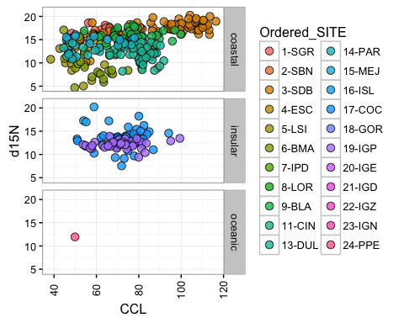

#Size vs. Carbon  
p<-ggplot(data, aes(x=CCL,y=d13C,fill=Habitat_Type)) + geom_point(size=3, alpha=.8,shape=21,position=position_jitter(width=.5,height=.5))+theme_bw()+theme(axis.text.x = element_text(angle=90, vjust=0.5))+scale_fill_manual(values=palette)  
p+geom_smooth(method=lm)

## Warning: Removed 310 rows containing non-finite values (stat_smooth).  
  
## Warning: Removed 310 rows containing missing values (geom_point).

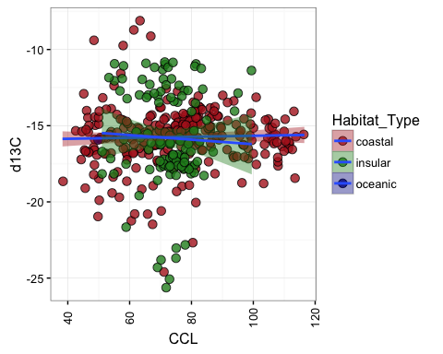

ggplot(data, aes(x=CCL,y=d13C,fill=Ordered_SITE)) + geom_point(size=3, alpha=.8,shape=21,position=position_jitter(width=.5,height=.5))+theme_bw()+theme(axis.text.x = element_text(angle=90, vjust=0.5))

## Warning: Removed 310 rows containing missing values (geom_point).

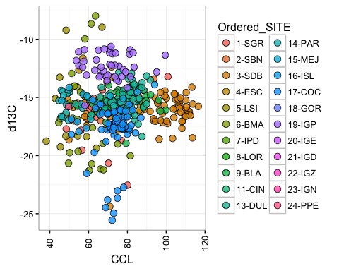

ggplot(data, aes(x=d15N,y=d13C,fill=Ordered_SITE)) + geom_point(size=3, alpha=.8,shape=21,position=position_jitter(width=.5,height=.5))+theme_bw()+theme(axis.text.x = element_text(angle=0, vjust=0.5))

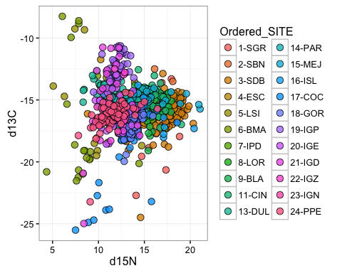

ggplot(data, aes(x=d15N,y=d13C,fill=Habitat_Type)) + geom_point(size=3, alpha=.8,shape=21,position=position_jitter(width=.5,height=.5))+theme_bw()+theme(axis.text.x = element_text(angle=0, vjust=0.5))+scale_fill_manual(values=palette)

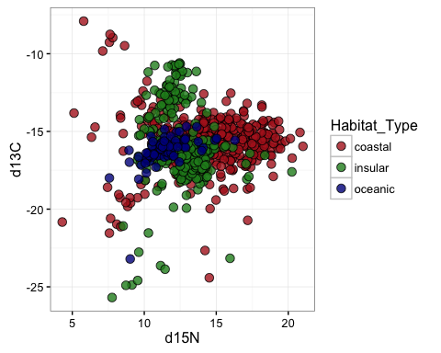

CNsum_merge<-merge(data_Csum,data_Nsum)  
CNsum_merge$SITENS<-paste(CNsum_merge$N_to_S_ordination, "-",CNsum_merge$Ordered_SITE)  
CNsum_merge$SITENS<-factor(CNsum_merge$SITENS,levels= c("1 - MEJ", "2 - PAR" ,"3 - PPE", "4 - IGN", "5 - IGZ", "6 - IGD", "7 - IGE", "8 - IGP", "9 - GOR","10 - COC", "11 - DUL", "12 - ISL", "13 - BMA", "14 - IPD","15 - LOR", "16 - LSI", "17 - ESC","18 - CIN", "19 - BLA", "20 - SDB", "21 - SBN", "22 - SGR"))  
  
ggplot(CNsum_merge, aes(x=mean_d13C,y=mean_d15N,fill=Habitat_Type)) +  
 geom_errorbar(aes(ymin=mean_d15N-se_d15N,ymax=mean_d15N+se_d15N),size=0.25)+  
 geom_errorbarh(aes(xmin=mean_d13C-se_d13C,xmax=mean_d13C+se_d13C),size=0.25)+  
 geom_point(size=3, alpha=.9,shape=21)+theme_bw()+theme(axis.text.x = element_text(angle=0, vjust=0.5))+scale_fill_manual(values=palette)+ylab("Mean d15N per Location")+xlab("Mean d13C per Location")

## Warning: Removed 2 rows containing missing values (geom_errorbar).

## Warning: Removed 2 rows containing missing values (geom_errorbarh).

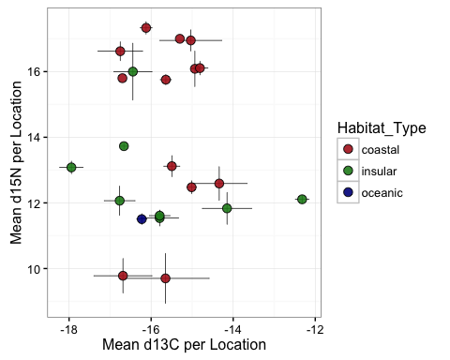

ggplot(CNsum_merge, aes(x=mean_d13C,y=mean_d15N,fill=SITENS)) +  
 geom_errorbar(aes(ymin=mean_d15N-se_d15N,ymax=mean_d15N+se_d15N),size=0.25)+  
 geom_errorbarh(aes(xmin=mean_d13C-se_d13C,xmax=mean_d13C+se_d13C),size=0.25)+  
 geom_point(size=3, alpha=.9,shape=21)+theme_bw()+theme(axis.text.x = element_text(angle=0, vjust=0.5))+ylab("Mean d15N per Location")+xlab("Mean d13C per Location")

## Warning: Removed 2 rows containing missing values (geom_errorbar).  
  
## Warning: Removed 2 rows containing missing values (geom_errorbarh).

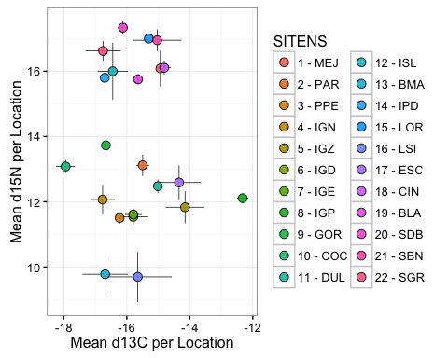

ggplot(CNsum_merge, aes(x=mean_d13C,y=mean_d15N,fill=SITENS)) +  
 geom_errorbar(aes(ymin=mean_d15N-se_d15N,ymax=mean_d15N+se_d15N),size=0.25)+  
 geom_errorbarh(aes(xmin=mean_d13C-se_d13C,xmax=mean_d13C+se_d13C),size=0.25)+  
 geom_point(size=3, alpha=.9,shape=21)+theme_bw()+theme(axis.text.x = element_text(angle=0, vjust=0.5))+ylab("Mean d15N per Location")+xlab("Mean d13C per Location")+geom_text(aes(label=Ordered_SITE),hjust=1.5, vjust=0.5,size=3)

## Warning: Removed 2 rows containing missing values (geom_errorbar).  
  
## Warning: Removed 2 rows containing missing values (geom_errorbarh).

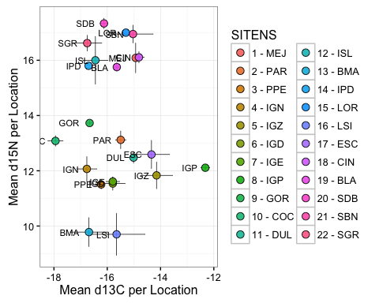

#analysis (don't read into results because some carapace data is missing)  
#random effect of site nested within habitat type  
  
#Nitrogen:  
  
mN1<-lmer(data=data2, d15N~Habitat_Type+(1|Habitat_Type/SITE_CODE)) #single Habitat model  
mN2<-lmer(data=data2, d15N~CCL+(1|Habitat_Type/SITE_CODE)) #single CCL model  
mN3<-lmer(data=data2, d15N~Habitat_Type+CCL+(1|Habitat_Type/SITE_CODE)) #additive model  
mN4<-lmer(data=data2, d15N~Habitat_Type*CCL+(1|Habitat_Type/SITE_CODE)) #interactive model  
summary(mN1)

## Linear mixed model fit by REML t-tests use Satterthwaite approximations  
## to degrees of freedom [lmerMod]  
## Formula: d15N ~ Habitat_Type + (1 | Habitat_Type/SITE_CODE)  
## Data: data2  
##   
## REML criterion at convergence: 2488.7  
##   
## Scaled residuals:   
## Min 1Q Median 3Q Max   
## -5.4398 -0.4849 0.0487 0.5187 4.5741   
##   
## Random effects:  
## Groups Name Variance Std.Dev.  
## SITE_CODE:Habitat_Type (Intercept) 5.277 2.297   
## Habitat_Type (Intercept) 1.445 1.202   
## Residual 2.510 1.584   
## Number of obs: 643, groups: SITE_CODE:Habitat_Type, 21; Habitat_Type, 2  
##   
## Fixed effects:  
## Estimate Std. Error df t value Pr(>|t|)  
## (Intercept) 14.4718764 1.3718541 0.0001221 10.55 0.999  
## Habitat_Typeinsular -1.7226543 2.0033180 0.0001388 -0.86 0.999  
##   
## Correlation of Fixed Effects:  
## (Intr)  
## Hbtt_Typnsl -0.685

summary(mN2)

## Linear mixed model fit by REML t-tests use Satterthwaite approximations  
## to degrees of freedom [lmerMod]  
## Formula: d15N ~ CCL + (1 | Habitat_Type/SITE_CODE)  
## Data: data2  
##   
## REML criterion at convergence: 1612.6  
##   
## Scaled residuals:   
## Min 1Q Median 3Q Max   
## -5.2857 -0.4106 0.0683 0.4803 4.6734   
##   
## Random effects:  
## Groups Name Variance Std.Dev.   
## SITE_CODE:Habitat_Type (Intercept) 6.202e+00 2.490e+00  
## Habitat_Type (Intercept) 4.455e-14 2.111e-07  
## Residual 2.669e+00 1.634e+00  
## Number of obs: 407, groups: SITE_CODE:Habitat_Type, 15; Habitat_Type, 2  
##   
## Fixed effects:  
## Estimate Std. Error df t value Pr(>|t|)   
## (Intercept) 1.257e+01 8.138e-01 3.090e+01 15.449 4.44e-16 ***  
## CCL 2.382e-02 6.907e-03 3.992e+02 3.449 0.000622 ***  
## ---  
## Signif. codes: 0 '***' 0.001 '**' 0.01 '*' 0.05 '.' 0.1 ' ' 1  
##   
## Correlation of Fixed Effects:  
## (Intr)  
## CCL -0.575

summary(mN3)

## Linear mixed model fit by REML t-tests use Satterthwaite approximations  
## to degrees of freedom [lmerMod]  
## Formula: d15N ~ Habitat_Type + CCL + (1 | Habitat_Type/SITE_CODE)  
## Data: data2  
##   
## REML criterion at convergence: 1609.7  
##   
## Scaled residuals:   
## Min 1Q Median 3Q Max   
## -5.2868 -0.4107 0.0699 0.4796 4.6754   
##   
## Random effects:  
## Groups Name Variance Std.Dev.  
## SITE_CODE:Habitat_Type (Intercept) 6.694 2.587   
## Habitat_Type (Intercept) 2.128 1.459   
## Residual 2.669 1.634   
## Number of obs: 407, groups: SITE_CODE:Habitat_Type, 15; Habitat_Type, 2  
##   
## Fixed effects:  
## Estimate Std. Error df t value Pr(>|t|)   
## (Intercept) 12.662282 1.715426 0.000000 7.381 0.99973   
## Habitat_Typeinsular -0.394562 2.673730 0.000000 -0.148 0.99981   
## CCL 0.023783 0.006911 398.500000 3.441 0.00064 ***  
## ---  
## Signif. codes: 0 '***' 0.001 '**' 0.01 '*' 0.05 '.' 0.1 ' ' 1  
##   
## Correlation of Fixed Effects:  
## (Intr) Hbtt_T  
## Hbtt_Typnsl -0.592   
## CCL -0.269 -0.011

summary(mN4)

## Linear mixed model fit by REML t-tests use Satterthwaite approximations  
## to degrees of freedom [lmerMod]  
## Formula: d15N ~ Habitat_Type * CCL + (1 | Habitat_Type/SITE_CODE)  
## Data: data2  
##   
## REML criterion at convergence: 1614.8  
##   
## Scaled residuals:   
## Min 1Q Median 3Q Max   
## -5.2796 -0.4002 0.0693 0.4819 4.7001   
##   
## Random effects:  
## Groups Name Variance Std.Dev.  
## SITE_CODE:Habitat_Type (Intercept) 6.609 2.571   
## Habitat_Type (Intercept) 2.143 1.464   
## Residual 2.670 1.634   
## Number of obs: 407, groups: SITE_CODE:Habitat_Type, 15; Habitat_Type, 2  
##   
## Fixed effects:  
## Estimate Std. Error df t value Pr(>|t|)  
## (Intercept) 12.470104 1.728769 0.000000 7.213 0.999472  
## Habitat_Typeinsular 0.919076 2.996176 0.000000 0.307 0.999379  
## CCL 0.026643 0.007511 398.500000 3.547 0.000435  
## Habitat_Typeinsular:CCL -0.018622 0.019205 392.200000 -0.970 0.332842  
##   
## (Intercept)   
## Habitat_Typeinsular   
## CCL ***  
## Habitat_Typeinsular:CCL   
## ---  
## Signif. codes: 0 '***' 0.001 '**' 0.01 '*' 0.05 '.' 0.1 ' ' 1  
##   
## Correlation of Fixed Effects:  
## (Intr) Hbtt_T CCL   
## Hbtt_Typnsl -0.577   
## CCL -0.290 0.168   
## Hbtt_Ty:CCL 0.114 -0.452 -0.391

#just simple LM-some sites are different? follow up checking df's, etc.  
m5<-lm(data=data2, d15N~SITE_CODE)  
summary(m5)

##   
## Call:  
## lm(formula = d15N ~ SITE_CODE, data = data2)  
##   
## Residuals:  
## Min 1Q Median 3Q Max   
## -8.6333 -0.7785 0.0711 0.8341 7.3200   
##   
## Coefficients:  
## Estimate Std. Error t value Pr(>|t|)   
## (Intercept) 15.75472 0.21767 72.379 < 2e-16 ***  
## SITE_CODEBMA -5.97472 0.36206 -16.502 < 2e-16 ***  
## SITE_CODECIN 0.35243 0.37022 0.952 0.3415   
## SITE_CODECOC -2.67412 0.29131 -9.180 < 2e-16 ***  
## SITE_CODEDUL -3.27769 0.28516 -11.494 < 2e-16 ***  
## SITE_CODEESC -3.16472 0.54635 -5.792 1.10e-08 ***  
## SITE_CODEGOR -2.02577 0.28359 -7.143 2.56e-12 ***  
## SITE_CODEIGD -4.21688 0.33948 -12.421 < 2e-16 ***  
## SITE_CODEIGE -4.14391 0.33948 -12.206 < 2e-16 ***  
## SITE_CODEIGN -3.68805 0.94044 -3.922 9.77e-05 ***  
## SITE_CODEIGP -3.64519 0.32737 -11.135 < 2e-16 ***  
## SITE_CODEIGZ -3.92138 0.68257 -5.745 1.44e-08 ***  
## SITE_CODEIPD 0.04528 1.59954 0.028 0.9774   
## SITE_CODEISL 0.24528 0.57131 0.429 0.6678   
## SITE_CODELOR 1.24528 1.59954 0.779 0.4366   
## SITE_CODELSI -6.05472 0.50660 -11.952 < 2e-16 ***  
## SITE_CODEMEJ 0.33100 0.40861 0.810 0.4182   
## SITE_CODEPAR -2.63567 0.40861 -6.450 2.24e-10 ***  
## SITE_CODESBN 1.19528 0.68257 1.751 0.0804 .   
## SITE_CODESDB 1.57862 0.27438 5.753 1.37e-08 ***  
## SITE_CODESGR 0.86634 0.42373 2.045 0.0413 *   
## ---  
## Signif. codes: 0 '***' 0.001 '**' 0.01 '*' 0.05 '.' 0.1 ' ' 1  
##   
## Residual standard error: 1.585 on 622 degrees of freedom  
## Multiple R-squared: 0.6752, Adjusted R-squared: 0.6647   
## F-statistic: 64.64 on 20 and 622 DF, p-value: < 2.2e-16

#Carbon:  
mC1<-lmer(data=data2, d13C~Habitat_Type+(1|Habitat_Type/SITE_CODE)) #single Habitat model

## Warning in checkConv(attr(opt, "derivs"), opt$par, ctrl = control  
## $checkConv, : unable to evaluate scaled gradient

## Warning in checkConv(attr(opt, "derivs"), opt$par, ctrl = control  
## $checkConv, : Hessian is numerically singular: parameters are not uniquely  
## determined

mC2<-lmer(data=data2, d13C~CCL+(1|Habitat_Type/SITE_CODE)) #single CCL model  
mC3<-lmer(data=data2, d13C~Habitat_Type+CCL+(1|Habitat_Type/SITE_CODE)) #additive model

## Warning in checkConv(attr(opt, "derivs"), opt$par, ctrl = control$checkConv, : Model is nearly unidentifiable: large eigenvalue ratio  
## - Rescale variables?

mC4<-lmer(data=data2, d13C~Habitat_Type*CCL+(1|Habitat_Type/SITE_CODE)) #interactive model

## Warning in checkConv(attr(opt, "derivs"), opt$par, ctrl = control$checkConv, : Model is nearly unidentifiable: large eigenvalue ratio  
## - Rescale variables?

summary(mC1)

## Warning in checkConv(attr(opt, "derivs"), opt$par, ctrl = control  
## $checkConv, : unable to evaluate scaled gradient  
  
## Warning in checkConv(attr(opt, "derivs"), opt$par, ctrl = control  
## $checkConv, : Hessian is numerically singular: parameters are not uniquely  
## determined

## Linear mixed model fit by REML t-tests use Satterthwaite approximations  
## to degrees of freedom [lmerMod]  
## Formula: d13C ~ Habitat_Type + (1 | Habitat_Type/SITE_CODE)  
## Data: data2  
##   
## REML criterion at convergence: 2600.1  
##   
## Scaled residuals:   
## Min 1Q Median 3Q Max   
## -5.1130 -0.3811 0.0618 0.4476 4.8290   
##   
## Random effects:  
## Groups Name Variance Std.Dev.  
## SITE_CODE:Habitat_Type (Intercept) 1.46484 1.2103   
## Habitat_Type (Intercept) 0.02906 0.1705   
## Residual 3.10659 1.7626   
## Number of obs: 643, groups: SITE_CODE:Habitat_Type, 21; Habitat_Type, 2  
##   
## Fixed effects:  
## Estimate Std. Error df t value Pr(>|t|)  
## (Intercept) -1.555e+01 4.098e-01 7.107e-06 -37.933 1  
## Habitat_Typeinsular -1.748e-01 6.393e-01 1.052e-05 -0.273 1  
##   
## Correlation of Fixed Effects:  
## (Intr)  
## Hbtt_Typnsl -0.641  
## convergence code: 0  
## unable to evaluate scaled gradient  
## Hessian is numerically singular: parameters are not uniquely determined

summary(mC2)

## Linear mixed model fit by REML t-tests use Satterthwaite approximations  
## to degrees of freedom [lmerMod]  
## Formula: d13C ~ CCL + (1 | Habitat_Type/SITE_CODE)  
## Data: data2  
##   
## REML criterion at convergence: 1692.2  
##   
## Scaled residuals:   
## Min 1Q Median 3Q Max   
## -4.3541 -0.3011 0.0892 0.5241 4.6383   
##   
## Random effects:  
## Groups Name Variance Std.Dev.  
## SITE_CODE:Habitat_Type (Intercept) 1.764 1.328   
## Habitat_Type (Intercept) 0.000 0.000   
## Residual 3.399 1.844   
## Number of obs: 407, groups: SITE_CODE:Habitat_Type, 15; Habitat_Type, 2  
##   
## Fixed effects:  
## Estimate Std. Error df t value Pr(>|t|)   
## (Intercept) -16.371468 0.647733 101.900000 -25.275 <2e-16 ***  
## CCL 0.011188 0.007657 402.100000 1.461 0.145   
## ---  
## Signif. codes: 0 '***' 0.001 '**' 0.01 '*' 0.05 '.' 0.1 ' ' 1  
##   
## Correlation of Fixed Effects:  
## (Intr)  
## CCL -0.809

summary(mC3)

## Warning in checkConv(attr(opt, "derivs"), opt$par, ctrl = control$checkConv, : Model is nearly unidentifiable: large eigenvalue ratio  
## - Rescale variables?

## Linear mixed model fit by REML t-tests use Satterthwaite approximations  
## to degrees of freedom [lmerMod]  
## Formula: d13C ~ Habitat_Type + CCL + (1 | Habitat_Type/SITE_CODE)  
## Data: data2  
##   
## REML criterion at convergence: 1690.5  
##   
## Scaled residuals:   
## Min 1Q Median 3Q Max   
## -4.3522 -0.3008 0.0901 0.5246 4.6413   
##   
## Random effects:  
## Groups Name Variance Std.Dev.  
## SITE_CODE:Habitat_Type (Intercept) 1.9072 1.3810   
## Habitat_Type (Intercept) 0.1119 0.3345   
## Residual 3.4003 1.8440   
## Number of obs: 407, groups: SITE_CODE:Habitat_Type, 15; Habitat_Type, 2  
##   
## Fixed effects:  
## Estimate Std. Error df t value Pr(>|t|)  
## (Intercept) -16.398440 0.761285 0.000000 -21.540 1.000  
## Habitat_Typeinsular 0.124908 1.062536 0.000000 0.118 1.000  
## CCL 0.011196 0.007674 401.500000 1.459 0.145  
##   
## Correlation of Fixed Effects:  
## (Intr) Hbtt_T  
## Hbtt_Typnsl -0.366   
## CCL -0.681 -0.027  
## convergence code: 0  
## Model is nearly unidentifiable: large eigenvalue ratio  
## - Rescale variables?

summary(mC4)

## Warning in checkConv(attr(opt, "derivs"), opt$par, ctrl = control$checkConv, : Model is nearly unidentifiable: large eigenvalue ratio  
## - Rescale variables?

## Linear mixed model fit by REML t-tests use Satterthwaite approximations  
## to degrees of freedom [lmerMod]  
## Formula: d13C ~ Habitat_Type * CCL + (1 | Habitat_Type/SITE_CODE)  
## Data: data2  
##   
## REML criterion at convergence: 1695.6  
##   
## Scaled residuals:   
## Min 1Q Median 3Q Max   
## -4.3804 -0.2961 0.0867 0.5167 4.6450   
##   
## Random effects:  
## Groups Name Variance Std.Dev.  
## SITE_CODE:Habitat_Type (Intercept) 1.91874 1.3852   
## Habitat_Type (Intercept) 0.09866 0.3141   
## Residual 3.40241 1.8446   
## Number of obs: 407, groups: SITE_CODE:Habitat_Type, 15; Habitat_Type, 2  
##   
## Fixed effects:  
## Estimate Std. Error df t value Pr(>|t|)  
## (Intercept) -16.218514 0.783808 0.000000 -20.692 1.000  
## Habitat_Typeinsular -1.147154 1.855852 0.000000 -0.618 0.999  
## CCL 0.008533 0.008319 397.500000 1.026 0.306  
## Habitat_Typeinsular:CCL 0.017973 0.021603 398.100000 0.832 0.406  
##   
## Correlation of Fixed Effects:  
## (Intr) Hbtt_T CCL   
## Hbtt_Typnsl -0.422   
## CCL -0.717 0.303   
## Hbtt_Ty:CCL 0.276 -0.824 -0.385  
## convergence code: 0  
## Model is nearly unidentifiable: large eigenvalue ratio  
## - Rescale variables?

#just simple LM-some sites are different? follow up checking df's, etc.  
m5<-lm(data=data2, d13C~SITE_CODE)  
summary(m5)

##   
## Call:  
## lm(formula = d13C ~ SITE_CODE, data = data2)  
##   
## Residuals:  
## Min 1Q Median 3Q Max   
## -9.0081 -0.6837 0.1135 0.7936 8.5867   
##   
## Coefficients:  
## Estimate Std. Error t value Pr(>|t|)   
## (Intercept) -15.641509 0.242429 -64.520 < 2e-16 ***  
## SITE_CODEBMA -1.045157 0.403239 -2.592 0.00977 **   
## SITE_CODECIN 0.830795 0.412333 2.015 0.04435 *   
## SITE_CODECOC -2.301774 0.324442 -7.095 3.55e-12 ***  
## SITE_CODEDUL 0.627996 0.317592 1.977 0.04844 *   
## SITE_CODEESC 1.301509 0.608491 2.139 0.03283 *   
## SITE_CODEGOR -1.021648 0.315844 -3.235 0.00128 **   
## SITE_CODEIGD -0.150382 0.378098 -0.398 0.69096   
## SITE_CODEIGE -0.150382 0.378098 -0.398 0.69096   
## SITE_CODEIGN -1.125157 1.047412 -1.074 0.28314   
## SITE_CODEIGP 3.322462 0.364604 9.113 < 2e-16 ***  
## SITE_CODEIGZ 1.491509 0.760212 1.962 0.05021 .   
## SITE_CODEIPD -1.058491 1.781480 -0.594 0.55262   
## SITE_CODEISL -0.802935 0.636295 -1.262 0.20746   
## SITE_CODELOR 0.341509 1.781480 0.192 0.84804   
## SITE_CODELSI -0.008491 0.564222 -0.015 0.98800   
## SITE_CODEMEJ 0.708176 0.455083 1.556 0.12018   
## SITE_CODEPAR 0.146271 0.455083 0.321 0.74800   
## SITE_CODESBN 0.608176 0.760212 0.800 0.42401   
## SITE_CODESDB -0.480713 0.305584 -1.573 0.11621   
## SITE_CODESGR -1.111122 0.471926 -2.354 0.01886 *   
## ---  
## Signif. codes: 0 '***' 0.001 '**' 0.01 '*' 0.05 '.' 0.1 ' ' 1  
##   
## Residual standard error: 1.765 on 622 degrees of freedom  
## Multiple R-squared: 0.3547, Adjusted R-squared: 0.3339   
## F-statistic: 17.09 on 20 and 622 DF, p-value: < 2.2e-16