Seminoff EPac green turtle Stable Isotope Data Analysis

Lisa Komoroske

2016-12-22

## Metadata from Jeff

**Site** - an ordinal code for each site  
**Site code** - 3 letter code for each site  
**Ordered_SITE** - combined site code with ordered # roughly North to South for graphing ordering **Location_Label** - shortened locatin names for graphing labeling purposes **Location** - location of turtle capture  
**LAB ID** - self explanatory  
**Collection Date** - self explanatory  
**Run Date** - self explanatory  
**%N** - elemental concentration of N. that is, how much each sample is made up of nitrogen. this is used as a diagnostic to know sample quality (anything outside of ~9-17% N raises a red flag)  
**%C** - elemental concentration of C. that is, how much each sample is made up of carbon. this is used as a diagnostic to know sample quality (anything outside of ~40-60% C raises a red flag)  
**d15N** - stable isotope value for N  
**d13C** - stable isotope value for C  
**Color** - rarely filled in. This is largely for the Galapagos and Colombia, where black turtles (eastern Pacific stock) and yellow turtles (west Pacific origins) co-exist. Safe to say that anything that is not filled in here would be a ‘black’ morph.  
**SCL** - straight carapace length **CCL_calc_fromSCL** - used formula from Seminoff et al. 2003 to interpolate CCLs from SCLs **CCL_empirical** - curved carapace length-these are only the empirically collected values **CCL_combined** - curved carapace length-I pasted over all the empirical values, and then for ones that were missing empirical CCL but had **CCL_calc_fromSCL**, I added these in; so this is the combined variable that we'll use for size relationships

## Setup

## Load Required Libraries

## Read in data

## Coarse data QC checks to note obvious data structure problems, etc.:

#see version 1 for more in depth QC checks  
summary(data)

## SITE_No SITE_CODE Ordered_SITE  
## Min. : 1.00 SDB : 88 3-SDB : 88   
## 1st Qu.: 9.00 GOR : 76 18-GOR : 76   
## Median :15.00 DUL : 74 13-DUL : 74   
## Mean :13.79 PPE : 74 24-PPE : 74   
## 3rd Qu.:19.00 COC : 67 17-COC : 67   
## Max. :24.00 BLA : 53 9-BLA : 53   
## (Other):255 (Other):255   
## Location_Label Habitat_Type  
## San Diego Bay, USA : 88 coastal:355   
## Isla Gorgona, Colombia : 76 insular:258   
## Golfo Dulce, CR : 74 oceanic: 74   
## Oceanic Waters, Peru (Longline): 74   
## Cocos Island, Costa Rica : 67   
## Bahia de los Angeles, GoC, MX : 53   
## (Other) :255   
## Region   
## Cen-SoAm Pac Coast:116   
## EPac Islands :258   
## Gulf of Cal : 81   
## Oceanic : 74   
## SC-BC Pac Coast :158   
##   
##   
## Location LABID   
## San Diego Bay, United States : 88 101 : 1   
## Isla Gorgona, Colombia : 76 102 : 1   
## Golfo Dulce, Costa Rica : 74 103 : 1   
## Oceanic Waters, Peru (Longline) : 74 104 : 1   
## Cocos Island, Costa Rica : 67 105087 : 1   
## Bahia de los Angeles, Gulf of California, Mexico: 53 105088 : 1   
## (Other) :255 (Other):681   
## Collect_Date Run_Date   
## Min. :0000-03-23 00:00:00 Min. :0003-01-17 00:00:00   
## 1st Qu.:0004-08-30 00:00:00 1st Qu.:0005-02-01 00:00:00   
## Median :0007-12-17 00:00:00 Median :0007-06-07 00:00:00   
## Mean :0009-05-26 17:57:16 Mean :0007-07-30 01:04:34   
## 3rd Qu.:0010-11-03 00:00:00 3rd Qu.:0007-08-09 00:00:00   
## Max. :0099-02-04 00:00:00 Max. :0014-02-10 00:00:00   
## NA's :32 NA's :397   
## Percent_N Percent_C d15N d13C   
## Min. : 4.80 Min. :16.30 Min. : 5.90 Min. :-25.50   
## 1st Qu.:11.68 1st Qu.:38.08 1st Qu.:11.85 1st Qu.:-16.80   
## Median :13.25 Median :42.40 Median :13.50 Median :-15.90   
## Mean :12.92 Mean :41.04 Mean :13.66 Mean :-15.82   
## 3rd Qu.:14.70 3rd Qu.:45.23 3rd Qu.:15.40 3rd Qu.:-14.90   
## Max. :21.00 Max. :65.70 Max. :21.20 Max. : -8.10   
## NA's :87 NA's :87   
## COLOR SCL CCL_calc_fromSCL CCL_empirical   
## :611 Min. : 39.70 Min. : 43.39 Min. : 42.70   
## BLACK : 29 1st Qu.: 56.55 1st Qu.: 60.85 1st Qu.: 65.50   
## YELLOW: 47 Median : 64.90 Median : 69.50 Median : 75.00   
## Mean : 68.47 Mean : 73.21 Mean : 75.29   
## 3rd Qu.: 76.20 3rd Qu.: 81.21 3rd Qu.: 82.40   
## Max. :110.40 Max. :116.65 Max. :116.50   
## NA's :368 NA's :368 NA's :295   
## CCL_combined Alt.ID   
## Min. : 42.70 :561   
## 1st Qu.: 62.01 Alt ID : 24   
## Median : 72.35 : 4   
## Mean : 73.03 100 : 1   
## 3rd Qu.: 81.00 105 : 1   
## Max. :116.50 106 : 1   
## NA's :197 (Other): 95   
## Notes   
## :678   
## : 8   
## no measurements taken, confirmed in SDB Binder: 1   
##   
##   
##   
##

data$Ordered_SITE<-factor(data$Ordered_SITE)#reset variable to get rid of excluded sites in count  
table(data$Ordered_SITE) #frequency table

##   
## 1-SGR_SBN 3-SDB 4-ESC 5-LSI 6-BMA 9-BLA 11-CIN   
## 25 88 10 9 26 53 28   
## 13-DUL 14-PAR 15-MEJ 17-COC 18-GOR 19-IGP 20-IGE   
## 74 21 21 67 76 41 37   
## 21-IGD 24-PPE   
## 37 74

Laguna San Ignacio now only one with lower sample #s-confirm with Jeff keeping/seperate with Estero Coyote

## Data Exploration for delta C and N

*Ggplot univariate & bivariate graphic scans etc* ####1. Nitrogen

#Distributions:  
ggplot(data, aes(x=d15N)) +   
 geom_histogram(aes(y=..density..), # Histogram with density on y-axis  
 binwidth=.5,  
 colour="black", fill="dodgerblue") +  
 geom_density(alpha=.4, fill="yellow")+theme_bw()+  
geom_vline(aes(xintercept=mean(d15N, na.rm=T)), #Ignore NA values for mean  
 color="red", linetype="dashed", size=1)

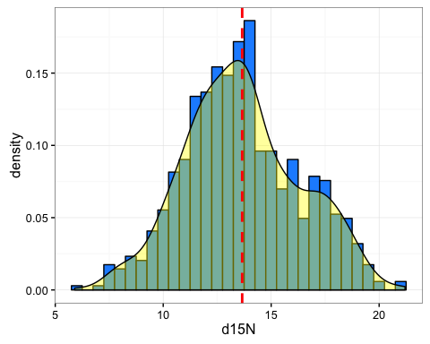

#histograms only, faceted:  
a<-ggplot(data, aes(x=d15N)) + geom_histogram(alpha=.75, fill="blue",colour="black")+theme_bw()+  
geom_vline(aes(xintercept=mean(d15N, na.rm=T)), #Ignore NA values for mean  
 color="red", linetype="dashed", size=1)  
a+facet_wrap( ~ Location_Label, ncol=4)

## `stat_bin()` using `bins = 30`. Pick better value with `binwidth`.

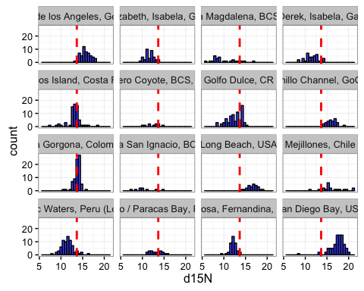

#Boxplot, ordering by medians  
ggplot(data, aes(x=Ordered_SITE, y=d15N,fill=Region)) + geom_boxplot(alpha=0.9) +theme_bw()+xlab("Location (ordered by value)")+scale_fill_manual(values=palette)+  
 guides(fill=FALSE)+stat_summary(fun.y=mean, geom="point", shape=5, size=4)+theme(axis.text.x = element_text(angle=90, vjust=0.5))+coord_flip()

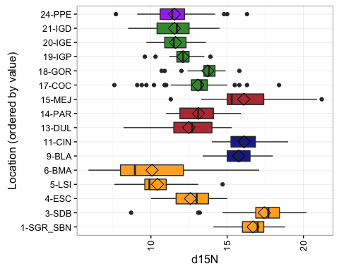

#faceted mean dot  
ggplot(data_Nsum, aes(y=reorder(Ordered_SITE,N_to_S_ordination), x=mean_d15N, fill=Region)) +   
 geom_errorbarh(aes(xmin=mean_d15N-se_d15N,xmax=mean_d15N+se_d15N),size=0.25)+  
 geom_point(size=3, aes(colour=Region)) +theme_bw()+ guides(fill=FALSE)+  
 theme(panel.grid.major.x=element_blank(),  
 panel.grid.minor.x=element_blank(),  
 panel.grid.major.y=element_line(colour="grey60",linetype="dashed"))+ scale_colour_manual(values=palette,guide=FALSE)+  
 ylab("Location (N to S)") +xlab("Mean d15N") +  
 facet_grid(Region~.,scales="free_y",space="free_y")

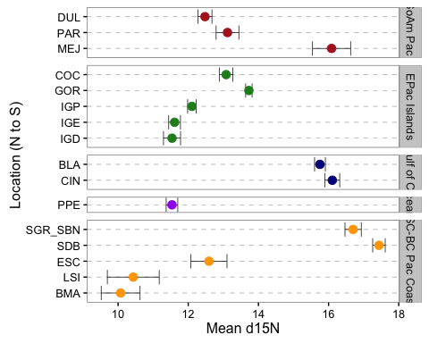

#### Carbon

#Distributions:  
ggplot(data, aes(x=d13C)) +   
 geom_histogram(aes(y=..density..), # Histogram with density on y-axis  
 binwidth=.5,  
 colour="black", fill="dodgerblue") +  
 geom_density(alpha=.4, fill="yellow")+theme_bw()+  
geom_vline(aes(xintercept=mean(d13C, na.rm=T)), #Ignore NA values for mean  
 color="red", linetype="dashed", size=1)

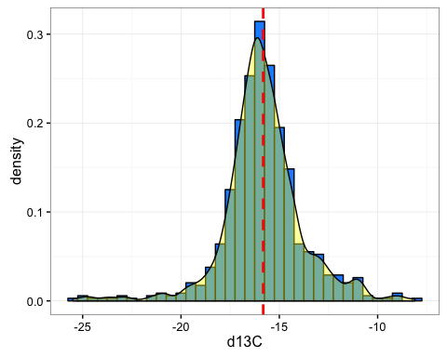

#histograms only, faceted:  
a<-ggplot(data, aes(x=d13C)) + geom_histogram(alpha=.75, fill="blue",colour="black")+theme_bw()+  
geom_vline(aes(xintercept=mean(d13C, na.rm=T)), #Ignore NA values for mean  
 color="red", linetype="dashed", size=1)  
a+facet_wrap( ~ Location_Label, ncol=4)

## `stat_bin()` using `bins = 30`. Pick better value with `binwidth`.

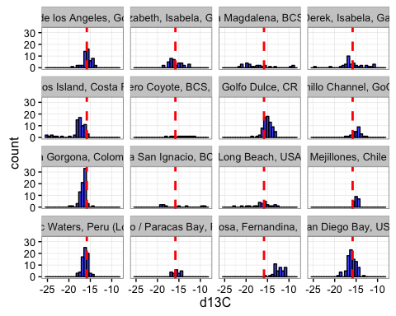

#Boxplot, ordering by medians  
ggplot(data, aes(x=Ordered_SITE, y=d13C, fill=Region)) + geom_boxplot(alpha=0.9) +theme_bw()+xlab("Location (ordered by value)")+scale_fill_manual(values=palette)+  
 guides(fill=FALSE)+stat_summary(fun.y=mean, geom="point", shape=5, size=4)+theme(axis.text.x = element_text(angle=90, vjust=0.5))+coord_flip()

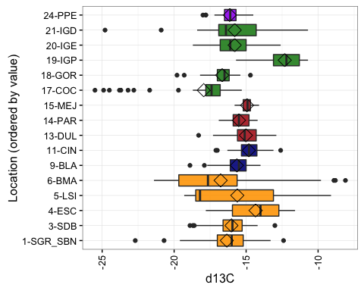

#faceted mean dot  
ggplot(data_Csum, aes(y=reorder(Ordered_SITE,N_to_S_ordination), x=mean_d13C, fill=Region)) +   
 geom_errorbarh(aes(xmin=mean_d13C-se_d13C,xmax=mean_d13C+se_d13C),size=0.25)+  
 geom_point(size=3, aes(colour=Region)) +theme_bw()+ guides(fill=FALSE)+  
 theme(panel.grid.major.x=element_blank(),  
 panel.grid.minor.x=element_blank(),  
 panel.grid.major.y=element_line(colour="grey60",linetype="dashed"))+ scale_colour_manual(values=palette,guide=FALSE)+  
 ylab("Location (N to S)") +xlab("Mean d13C") +  
 facet_grid(Region~.,scales="free_y",space="free_y")

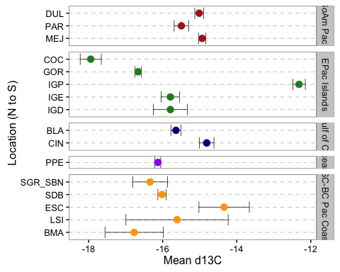

#### Relationships Turtle Size or Color

#use CCL_combined  
  
#issue of big turtles at certain sites?  
ggplot(data, aes(x=Ordered_SITE,y=CCL_combined,fill=Region)) + geom_boxplot()+theme_bw()+theme(axis.text.x = element_text(angle=50, vjust=0.5))+scale_fill_manual(values=palette)

## Warning: Removed 197 rows containing non-finite values (stat_boxplot).

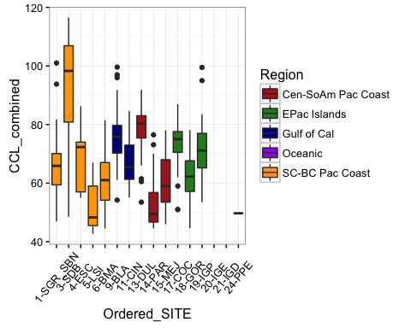

ggplot(data, aes(x=Ordered_SITE,y=CCL_combined,fill=Region)) + geom_boxplot()+theme_bw()+theme(axis.text.x = element_text(angle=50, vjust=0.5))+scale_fill_manual(values=palette)+facet_grid(Region~.)

## Warning: Removed 197 rows containing non-finite values (stat_boxplot).

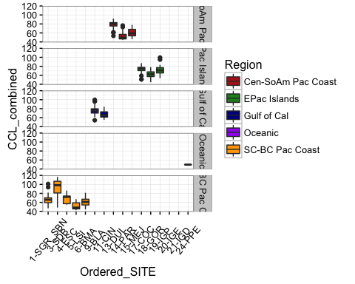

#Size vs. Nitrogen  
p<-ggplot(data, aes(x=CCL_combined,y=d15N,fill=Region)) + geom_point(size=3, alpha=.8,shape=21,position=position_jitter(width=.5,height=.5))+theme_bw()+theme(axis.text.x = element_text(angle=90, vjust=0.5))+scale_fill_manual(values=palette)  
p+geom_smooth(method=lm)

## Warning: Removed 197 rows containing non-finite values (stat_smooth).

## Warning: Removed 197 rows containing missing values (geom_point).

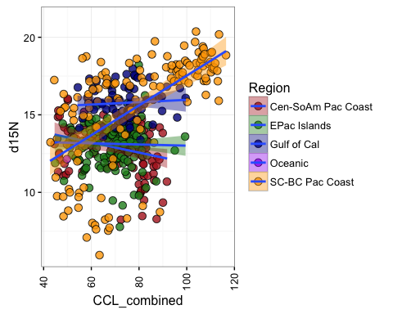

s<-ggplot(data, aes(x=CCL_combined,y=d15N,fill=Ordered_SITE)) + geom_point(size=3, alpha=.8,shape=21,position=position_jitter(width=.5,height=.5))+theme_bw()+theme(axis.text.x = element_text(angle=90, vjust=0.5))+facet_wrap( ~ Ordered_SITE, ncol=4)  
s+geom_smooth(method=lm)

## Warning: Removed 197 rows containing non-finite values (stat_smooth).  
  
## Warning: Removed 197 rows containing missing values (geom_point).

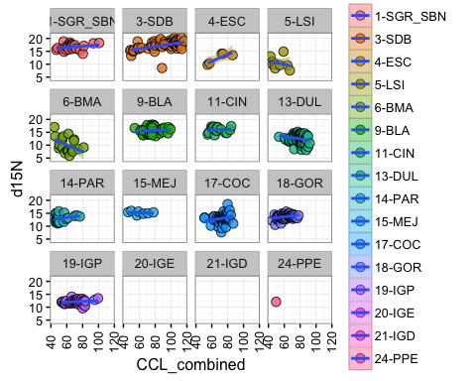

t<-ggplot(data, aes(x=CCL_combined,y=d15N,fill=Ordered_SITE)) + geom_point(size=3, alpha=.8,shape=21,position=position_jitter(width=.5,height=.5))+theme_bw()+theme(axis.text.x = element_text(angle=90, vjust=0.5))+facet_wrap( ~ Region, ncol=3)  
t+geom_smooth(method=lm)

## Warning: Removed 197 rows containing non-finite values (stat_smooth).  
  
## Warning: Removed 197 rows containing missing values (geom_point).

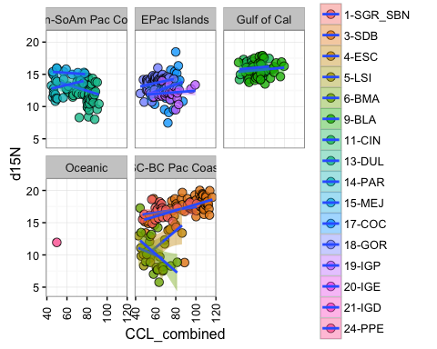

#Size vs. Carbon  
p1<-ggplot(data, aes(x=CCL_combined,y=d13C,fill=Region)) + geom_point(size=3, alpha=.8,shape=21,position=position_jitter(width=.5,height=.5))+theme_bw()+theme(axis.text.x = element_text(angle=90, vjust=0.5))+scale_fill_manual(values=palette)  
p1+geom_smooth(method=lm)

## Warning: Removed 197 rows containing non-finite values (stat_smooth).  
  
## Warning: Removed 197 rows containing missing values (geom_point).

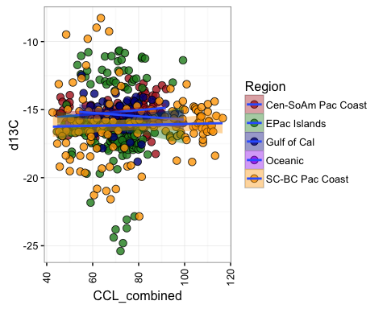

s1<-ggplot(data, aes(x=CCL_combined,y=d13C,fill=Ordered_SITE)) + geom_point(size=3, alpha=.8,shape=21,position=position_jitter(width=.5,height=.5))+theme_bw()+theme(axis.text.x = element_text(angle=90, vjust=0.5))+facet_wrap( ~ Ordered_SITE, ncol=4)  
s1+geom_smooth(method=lm)

## Warning: Removed 197 rows containing non-finite values (stat_smooth).  
  
## Warning: Removed 197 rows containing missing values (geom_point).

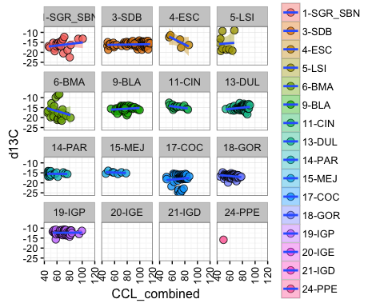

t1<-ggplot(data, aes(x=CCL_combined,y=d13C,fill=Ordered_SITE)) + geom_point(size=3, alpha=.8,shape=21,position=position_jitter(width=.5,height=.5))+theme_bw()+theme(axis.text.x = element_text(angle=90, vjust=0.5))+facet_wrap( ~ Region, ncol=3)  
t1+geom_smooth(method=lm)

## Warning: Removed 197 rows containing non-finite values (stat_smooth).  
  
## Warning: Removed 197 rows containing missing values (geom_point).

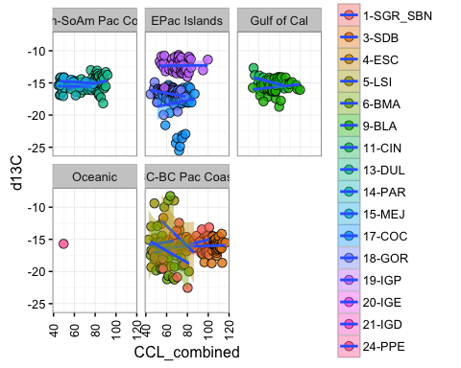

m1<-lm(data=data, d15N~CCL_combined*Ordered_SITE)  
summary(m1)

##   
## Call:  
## lm(formula = d15N ~ CCL_combined * Ordered_SITE, data = data)  
##   
## Residuals:  
## Min 1Q Median 3Q Max   
## -8.6045 -0.6357 0.0457 0.7435 4.9751   
##   
## Coefficients: (1 not defined because of singularities)  
## Estimate Std. Error t value Pr(>|t|)   
## (Intercept) 15.215621 1.544769 9.850 < 2e-16 ***  
## CCL_combined 0.022199 0.022722 0.977 0.32910   
## Ordered_SITE3-SDB -2.007840 1.729158 -1.161 0.24617   
## Ordered_SITE4-ESC -11.983570 4.063756 -2.949 0.00335 **   
## Ordered_SITE5-LSI -1.339973 3.354081 -0.400 0.68971   
## Ordered_SITE6-BMA 3.013827 2.507790 1.202 0.23006   
## Ordered_SITE9-BLA -0.557172 2.254574 -0.247 0.80492   
## Ordered_SITE11-CIN -0.225050 3.087399 -0.073 0.94192   
## Ordered_SITE13-DUL 1.066214 2.382912 0.447 0.65477   
## Ordered_SITE14-PAR -4.046355 2.360187 -1.714 0.08712 .   
## Ordered_SITE15-MEJ 0.660695 3.464625 0.191 0.84885   
## Ordered_SITE17-COC -6.099384 2.461556 -2.478 0.01357 *   
## Ordered_SITE18-GOR -3.629723 2.076665 -1.748 0.08115 .   
## Ordered_SITE19-IGP -3.967754 2.178048 -1.822 0.06915 .   
## Ordered_SITE24-PPE -4.218894 1.474401 -2.861 0.00441 **   
## CCL_combined:Ordered_SITE3-SDB 0.023935 0.024170 0.990 0.32255   
## CCL_combined:Ordered_SITE4-ESC 0.109412 0.058399 1.874 0.06163 .   
## CCL_combined:Ordered_SITE5-LSI -0.087518 0.060249 -1.453 0.14701   
## CCL_combined:Ordered_SITE6-BMA -0.156964 0.039628 -3.961 8.64e-05 ***  
## CCL_combined:Ordered_SITE9-BLA -0.008431 0.031208 -0.270 0.78715   
## CCL_combined:Ordered_SITE11-CIN -0.007696 0.045390 -0.170 0.86543   
## CCL_combined:Ordered_SITE13-DUL -0.070234 0.032281 -2.176 0.03008 *   
## CCL_combined:Ordered_SITE14-PAR 0.014275 0.039977 0.357 0.72119   
## CCL_combined:Ordered_SITE15-MEJ -0.033077 0.055119 -0.600 0.54873   
## CCL_combined:Ordered_SITE17-COC 0.031659 0.034480 0.918 0.35899   
## CCL_combined:Ordered_SITE18-GOR 0.012204 0.031719 0.385 0.70060   
## CCL_combined:Ordered_SITE19-IGP -0.010126 0.031221 -0.324 0.74583   
## CCL_combined:Ordered_SITE24-PPE NA NA NA NA   
## ---  
## Signif. codes: 0 '***' 0.001 '**' 0.01 '*' 0.05 '.' 0.1 ' ' 1  
##   
## Residual standard error: 1.394 on 463 degrees of freedom  
## (197 observations deleted due to missingness)  
## Multiple R-squared: 0.7222, Adjusted R-squared: 0.7066   
## F-statistic: 46.3 on 26 and 463 DF, p-value: < 2.2e-16

library(car)

## Warning: package 'car' was built under R version 3.2.5

Anova(m1)

## Anova Table (Type II tests)  
##   
## Response: d15N  
## Sum Sq Df F value Pr(>F)   
## CCL_combined 38.70 1 19.9084 1.021e-05 ***  
## Ordered_SITE 1647.81 13 65.2055 < 2.2e-16 ***  
## CCL_combined:Ordered_SITE 97.68 12 4.1874 2.868e-06 ***  
## Residuals 900.04 463   
## ---  
## Signif. codes: 0 '***' 0.001 '**' 0.01 '*' 0.05 '.' 0.1 ' ' 1

plot(m1)

## Warning: not plotting observations with leverage one:  
## 349

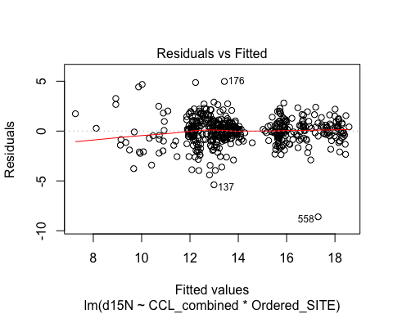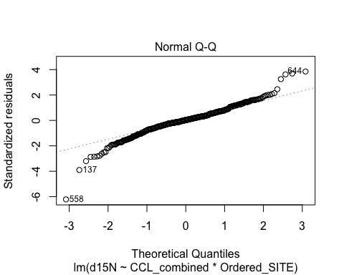

## Warning: not plotting observations with leverage one:  
## 349

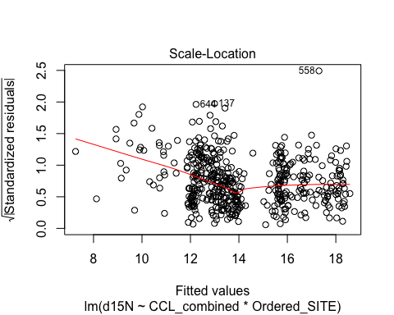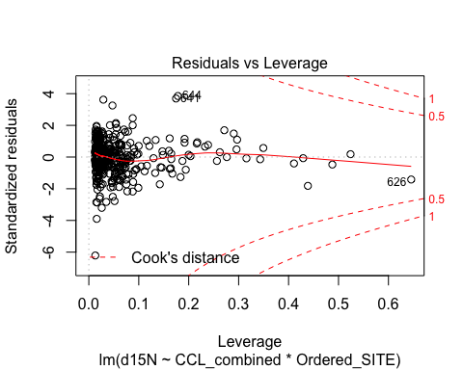

m2<-lm(data=data, d13C~CCL_combined*Ordered_SITE)  
summary(m2)

##   
## Call:  
## lm(formula = d13C ~ CCL_combined * Ordered_SITE, data = data)  
##   
## Residuals:  
## Min 1Q Median 3Q Max   
## -7.5044 -0.5290 0.1388 0.7268 8.9948   
##   
## Coefficients: (1 not defined because of singularities)  
## Estimate Std. Error t value Pr(>|t|)   
## (Intercept) -18.914096 1.817744 -10.405 < 2e-16 ***  
## CCL_combined 0.038495 0.026738 1.440 0.15062   
## Ordered_SITE3-SDB 2.403662 2.034716 1.181 0.23808   
## Ordered_SITE4-ESC 15.522821 4.781859 3.246 0.00125 **   
## Ordered_SITE5-LSI 2.037651 3.946779 0.516 0.60590   
## Ordered_SITE6-BMA 7.759773 2.950940 2.630 0.00883 **   
## Ordered_SITE9-BLA 1.937006 2.652978 0.730 0.46568   
## Ordered_SITE11-CIN 7.145099 3.632970 1.967 0.04981 *   
## Ordered_SITE13-DUL 1.323466 2.803995 0.472 0.63715   
## Ordered_SITE14-PAR 3.528808 2.777254 1.271 0.20451   
## Ordered_SITE15-MEJ 4.671991 4.076856 1.146 0.25240   
## Ordered_SITE17-COC -1.425880 2.896536 -0.492 0.62276   
## Ordered_SITE18-GOR 4.053179 2.443631 1.659 0.09786 .   
## Ordered_SITE19-IGP 6.471274 2.562930 2.525 0.01190 *   
## Ordered_SITE24-PPE 1.200885 1.734941 0.692 0.48917   
## CCL_combined:Ordered_SITE3-SDB -0.033457 0.028441 -1.176 0.24005   
## CCL_combined:Ordered_SITE4-ESC -0.197112 0.068718 -2.868 0.00431 **   
## CCL_combined:Ordered_SITE5-LSI -0.014485 0.070896 -0.204 0.83820   
## CCL_combined:Ordered_SITE6-BMA -0.132046 0.046631 -2.832 0.00483 **   
## CCL_combined:Ordered_SITE9-BLA -0.020943 0.036722 -0.570 0.56874   
## CCL_combined:Ordered_SITE11-CIN -0.081858 0.053411 -1.533 0.12606   
## CCL_combined:Ordered_SITE13-DUL -0.006554 0.037985 -0.173 0.86309   
## CCL_combined:Ordered_SITE14-PAR -0.040552 0.047041 -0.862 0.38911   
## CCL_combined:Ordered_SITE15-MEJ -0.048836 0.064859 -0.753 0.45186   
## CCL_combined:Ordered_SITE17-COC -0.005935 0.040573 -0.146 0.88377   
## CCL_combined:Ordered_SITE18-GOR -0.067427 0.037324 -1.807 0.07149 .   
## CCL_combined:Ordered_SITE19-IGP -0.036724 0.036738 -1.000 0.31802   
## CCL_combined:Ordered_SITE24-PPE NA NA NA NA   
## ---  
## Signif. codes: 0 '***' 0.001 '**' 0.01 '*' 0.05 '.' 0.1 ' ' 1  
##   
## Residual standard error: 1.641 on 463 degrees of freedom  
## (197 observations deleted due to missingness)  
## Multiple R-squared: 0.4511, Adjusted R-squared: 0.4203   
## F-statistic: 14.63 on 26 and 463 DF, p-value: < 2.2e-16

Anova(m2)

## Anova Table (Type II tests)  
##   
## Response: d13C  
## Sum Sq Df F value Pr(>F)   
## CCL_combined 0.33 1 0.1217 0.72733   
## Ordered_SITE 969.51 13 27.7071 < 2e-16 ***  
## CCL_combined:Ordered_SITE 53.32 12 1.6506 0.07496 .   
## Residuals 1246.23 463   
## ---  
## Signif. codes: 0 '***' 0.001 '**' 0.01 '*' 0.05 '.' 0.1 ' ' 1

plot(m2)

## Warning: not plotting observations with leverage one:  
## 349

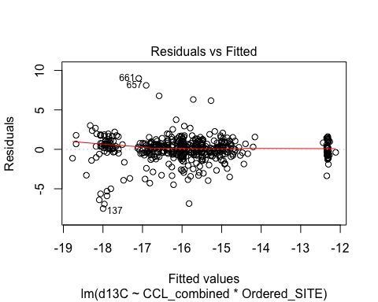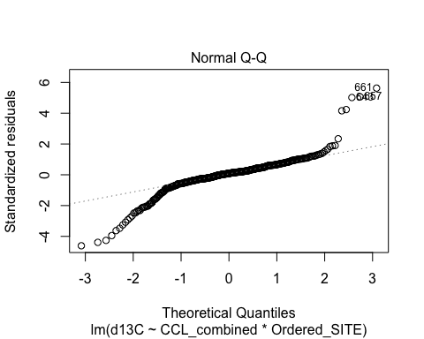

## Warning: not plotting observations with leverage one:  
## 349

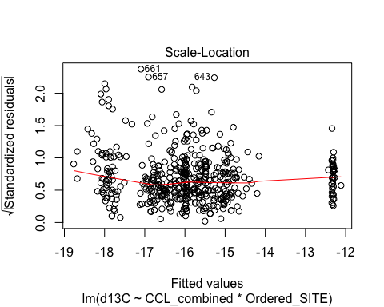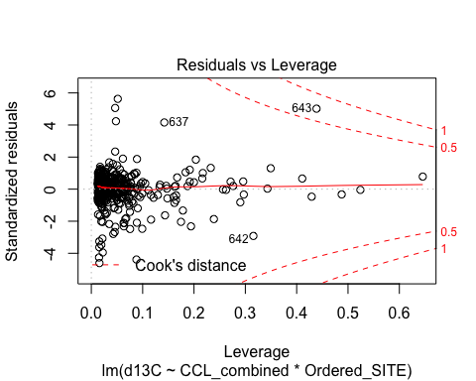

#remember to come back and remove point to see if makes difference in weight of sign. at BMA

ggplot(data_new2, aes(x=d15N,y=d13C,fill=Location_Label)) + geom_point(size=3, alpha=.8,shape=21,position=position_jitter(width=.5,height=.5))+theme_bw()+theme(axis.text.x = element_text(angle=0, vjust=0.5))+facet_wrap( ~ Region, ncol=2)#excluding oceanic/longline turtles

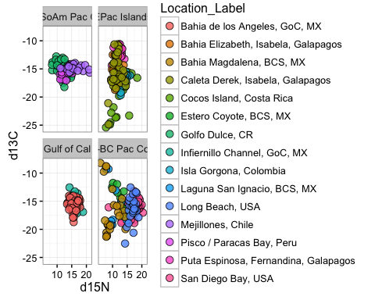

ggplot(data, aes(x=d15N,y=d13C,fill=Region)) + geom_point(size=3, alpha=.8,shape=21,position=position_jitter(width=.5,height=.5))+theme_bw()+theme(axis.text.x = element_text(angle=0, vjust=0.5))+scale_fill_manual(values=palette)

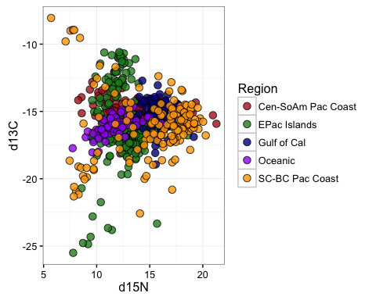

CNsum_merge<-merge(data_Csum,data_Nsum)  
CNsum_merge$SITENS<-paste(CNsum_merge$N_to_S_ordination, "-",CNsum_merge$Ordered_SITE)  
CNsum_merge$SITENS

## [1] "1 - MEJ" "10 - COC" "11 - DUL" "13 - BMA"   
## [5] "16 - LSI" "17 - ESC" "18 - CIN" "19 - BLA"   
## [9] "2 - PAR" "20 - SDB" "21 - SGR_SBN" "3 - PPE"   
## [13] "6 - IGD" "7 - IGE" "8 - IGP" "9 - GOR"

CNsum_merge$SITENS<-factor(CNsum_merge$SITENS,levels= c("1 - MEJ","2 - PAR","3 - PPE" ,"6 - IGD",  
"7 - IGE","8 - IGP","9 - GOR", "10 - COC", "11 - DUL","13 - BMA", "16 - LSI" ,"17 - ESC","18 - CIN","19 - BLA",  
"20 - SDB","21 - SGR_SBN"))   
  
ggplot(CNsum_merge, aes(x=mean_d13C,y=mean_d15N,fill=Region)) +  
 geom_errorbar(aes(ymin=mean_d15N-se_d15N,ymax=mean_d15N+se_d15N),size=0.25)+  
 geom_errorbarh(aes(xmin=mean_d13C-se_d13C,xmax=mean_d13C+se_d13C),size=0.25)+  
 geom_point(size=3, alpha=.9,shape=21)+theme_bw()+theme(axis.text.x = element_text(angle=0, vjust=0.5))+scale_fill_manual(values=palette)+ylab("Mean d15N per Location")+xlab("Mean d13C per Location")

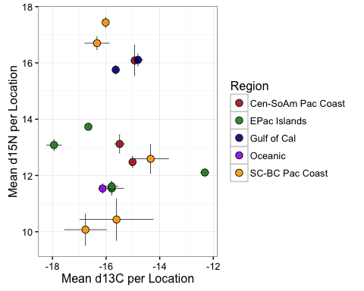

ggplot(CNsum_merge, aes(x=mean_d13C,y=mean_d15N,fill=SITENS)) +  
 geom_errorbar(aes(ymin=mean_d15N-se_d15N,ymax=mean_d15N+se_d15N),size=0.25)+  
 geom_errorbarh(aes(xmin=mean_d13C-se_d13C,xmax=mean_d13C+se_d13C),size=0.25)+  
 geom_point(size=3, alpha=.9,shape=21)+theme_bw()+theme(axis.text.x = element_text(angle=0, vjust=0.5))+ylab("Mean d15N per Location")+xlab("Mean d13C per Location")

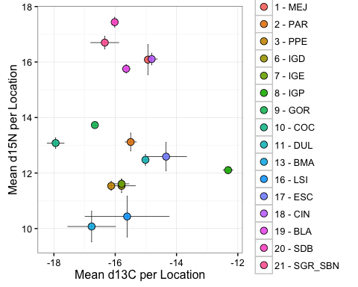

ggplot(CNsum_merge, aes(x=mean_d13C,y=mean_d15N,fill=SITENS)) +  
 geom_errorbar(aes(ymin=mean_d15N-se_d15N,ymax=mean_d15N+se_d15N),size=0.25)+  
 geom_errorbarh(aes(xmin=mean_d13C-se_d13C,xmax=mean_d13C+se_d13C),size=0.25)+  
 geom_point(size=3, alpha=.9,shape=21)+theme_bw()+theme(axis.text.x = element_text(angle=0, vjust=0.5))+ylab("Mean d15N per Location")+xlab("Mean d13C per Location")+geom_text(aes(label=Ordered_SITE),hjust=1.5, vjust=0.5,size=3)

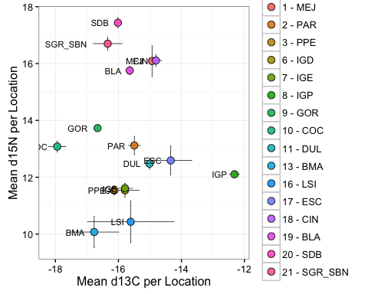

ggplot(data, aes(x=d13C,y=d15N,fill=Ordered_SITE)) +  
 geom_point(aes(size=CCL_combined), alpha=.9,shape=21)+theme_bw()

## Warning: Removed 197 rows containing missing values (geom_point).

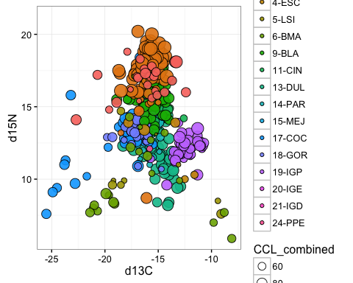

#come back to if decide worth it  
#dataEllipse(data$d13C, data$d15N, data$Ordered_SITE, levels=c(0.95, 0.95), center.pch=19, center.cex=1.5, col=palette2)

data_color<-subset(data, COLOR=="BLACK" | COLOR=="YELLOW")  
ggplot(data_color, aes(x=d15N,y=d13C,fill=COLOR)) + geom_point(aes(size=CCL_combined), alpha=.8,shape=21,position=position_jitter(width=.5,height=.5))+theme_bw()+theme(axis.text.x = element_text(angle=0, vjust=0.5))+scale_fill_manual(values=palette)

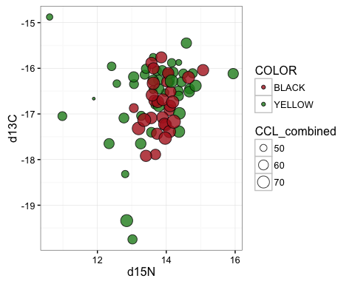

#histogram N  
ggplot(data_color, aes(x=d15N, fill=COLOR)) + geom_histogram(alpha=.75, colour="black")+theme_bw()+  
geom_vline(aes(xintercept=mean(d15N, na.rm=T)), #Ignore NA values for mean  
 color="red", linetype="dashed", size=1)+scale_fill_manual(values=palette)

## `stat_bin()` using `bins = 30`. Pick better value with `binwidth`.

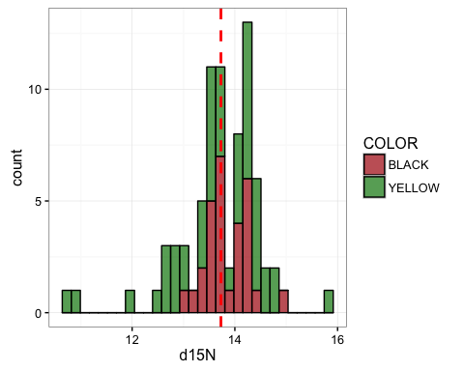

#Boxplot N  
ggplot(data_color, aes(x=COLOR, y=d15N)) + geom_boxplot(alpha=0.9, fill="skyblue") +theme_bw()+xlab("Morph Type")+scale_fill_manual(values=palette)+  
 guides(fill=FALSE)+stat_summary(fun.y=mean, geom="point", shape=5, size=4)+theme(axis.text.x = element_text(angle=90, vjust=0.5))

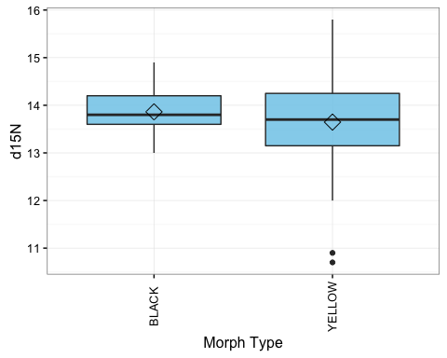

#histogram C  
ggplot(data_color, aes(x=d13C, fill=COLOR)) + geom_histogram(alpha=.75, colour="black")+theme_bw()+  
geom_vline(aes(xintercept=mean(d13C, na.rm=T)), #Ignore NA values for mean  
 color="red", linetype="dashed", size=1)+scale_fill_manual(values=palette)

## `stat_bin()` using `bins = 30`. Pick better value with `binwidth`.

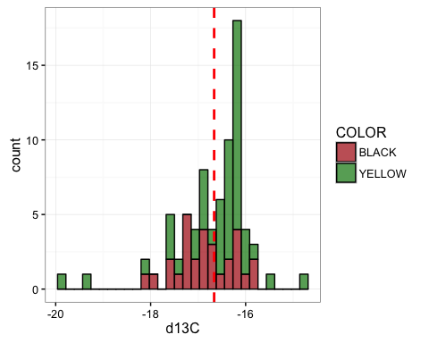

#Boxplot C  
ggplot(data_color, aes(x=COLOR, y=d13C)) + geom_boxplot(alpha=0.9, fill="skyblue") +theme_bw()+xlab("Morph Type")+scale_fill_manual(values=palette)+  
 guides(fill=FALSE)+stat_summary(fun.y=mean, geom="point", shape=5, size=4)+theme(axis.text.x = element_text(angle=90, vjust=0.5))

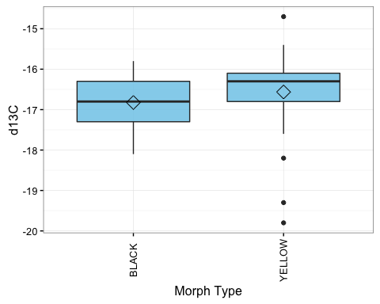

#using raster package for biooracle data  
library(raster)

## Warning: package 'raster' was built under R version 3.2.5

## Loading required package: sp

##   
## Attaching package: 'raster'

## The following objects are masked from 'package:MASS':  
##   
## area, select

#read in raster data  
#asc is a file format  
quartz(4,4)

## Warning: 'mode(title)' differs between new and previous  
## ==> NOT changing 'title'

sst.mean<-raster("sstmean.asc")  
sst.mean #like str for a raster

## class : RasterLayer   
## dimensions : 1680, 4320, 7257600 (nrow, ncol, ncell)  
## resolution : 0.08333333, 0.08333333 (x, y)  
## extent : -180, 180, -70, 69.99999 (xmin, xmax, ymin, ymax)  
## coord. ref. : NA   
## data source : /Users/lisakomoroske/Dropbox/KomoCheng/Seminoff_isotope_MS_transitionfiles/sstmean.asc   
## names : layer

EPGT_latlong<-read.csv("Lat_long_EPGT.csv")  
xy<-cbind(EPGT_latlong$Longitude,EPGT_latlong$Latitude)  
  
  
EPGT_latlong$mean_d15N_scale<-EPGT_latlong$mean_d15N*0.15  
plot(sst.mean,main="East Pacific", col=colorRampPalette(c("blue","purple", "yellow","red"))(255),   
 legend.args=list(text='Degrees C', side=4,font=2, line=2.5, cex=0.8), xlim=c(-152,-58), ylim=c(-50,50))  
points(xy, pch=21, cex=EPGT_latlong$mean_d15N_scale, bg="grey90")

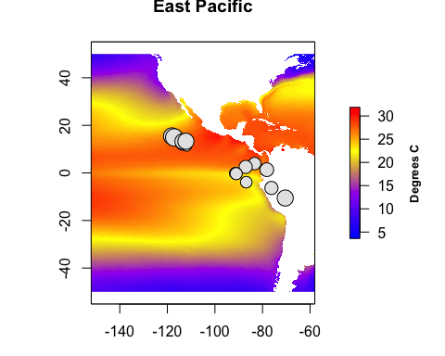

EPGT_latlong$mean_d13C_scale<-EPGT_latlong$mean_d13C*-0.15  
plot(sst.mean,main="East Pacific", col=colorRampPalette(c("blue","purple", "yellow","red"))(255),   
 legend.args=list(text='Degrees C', side=4,font=2, line=2.5, cex=0.8), xlim=c(-152,-58), ylim=c(-50,50))  
points(xy, pch=21, cex=EPGT_latlong$mean_d13C_scale, bg="grey90")

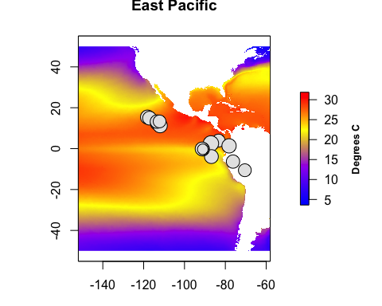

#if want to annotate, edit this:  
#text(x=-88.5,y=0, labels="Shark Bait")