Seminoff EPac green turtle Stable Isotope Data Analysis

Lisa Komoroske

2016-12-22

## Metadata

**Site** - an ordinal code for each site  
**Site code** - 3 letter code for each site  
**Ordered_SITE** - combined site code with ordered # roughly North to South for graphing ordering **Location_Label** - shortened locatin names for graphing labeling purposes **Location** - location of turtle capture  
**LAB ID** - self explanatory  
**Collection Date** - self explanatory  
**Run Date** - self explanatory  
**%N** - elemental concentration of N. that is, how much each sample is made up of nitrogen. this is used as a diagnostic to know sample quality (anything outside of ~9-17% N raises a red flag)  
**%C** - elemental concentration of C. that is, how much each sample is made up of carbon. this is used as a diagnostic to know sample quality (anything outside of ~40-60% C raises a red flag)  
**d15N** - stable isotope value for N  
**d13C** - stable isotope value for C  
**Color** - rarely filled in. This is largely for the Galapagos and Colombia, where black turtles (eastern Pacific stock) and yellow turtles (west Pacific origins) co-exist. Safe to say that anything that is not filled in here would be a ‘black’ morph.  
**SCL** - straight carapace length

**CCL_calc_fromSCL** - used formula from Seminoff et al. 2003 to interpolate CCLs from SCLs **CCL_empirical** - curved carapace length-these are only the empirically collected values

**CCL_combined** - curved carapace length-I pasted over all the empirical values, and then for ones that were missing empirical CCL but had **CCL_calc_fromSCL**, I added these in; so this is the combined variable that we'll use for size relationships

Summary (Sample Sizes)

##   
## 1-SGR_SBN 3-SDB 4-ESC 5-LSI 6-BMA 9-BLA 11-CIN   
## 25 88 10 9 26 53 28   
## 13-DUL 14-PAR 15-MEJ 17-COC 18-GOR 19-IGP 20-IGE   
## 74 21 21 67 76 41 37   
## 21-IGD 24-PPE   
## 37 74

Laguna San Ignacio now only one with lower sample #s-confirm with Jeff keeping/seperate with Estero Coyote

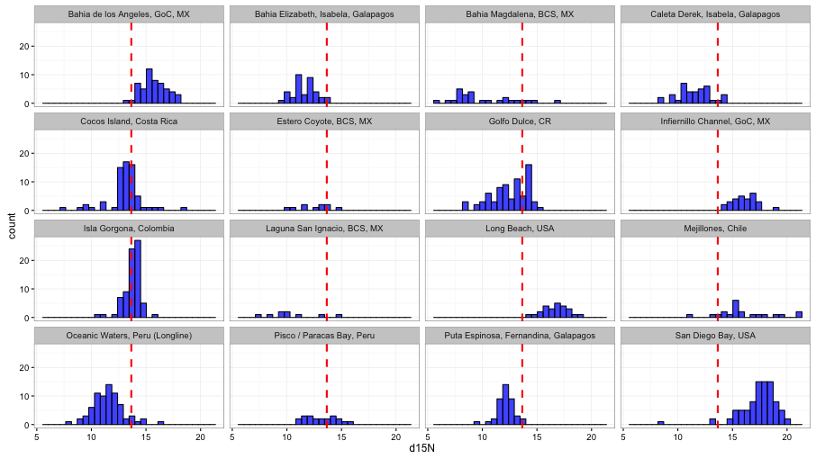

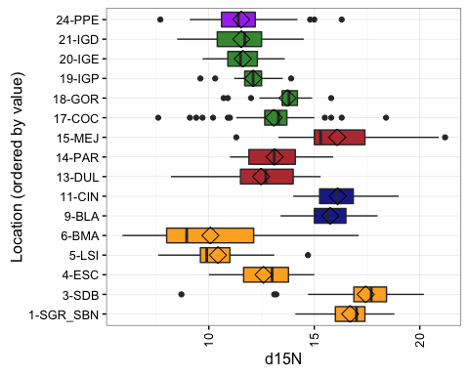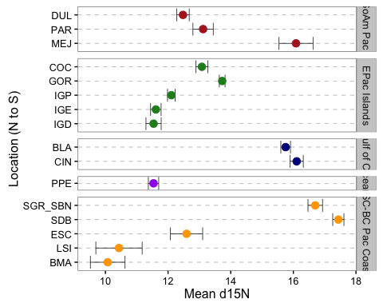

#### Carbon

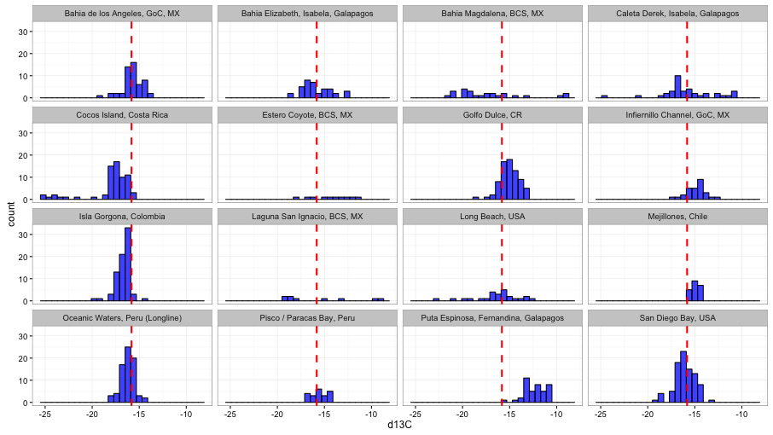

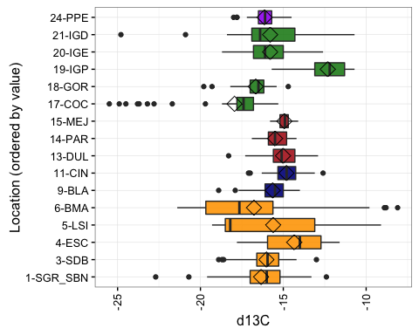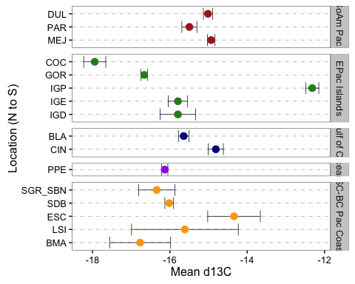

#### Turtle Size or Color

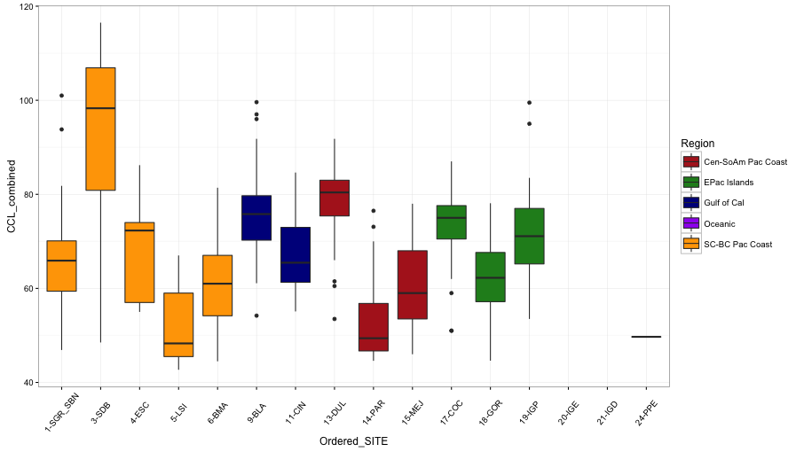

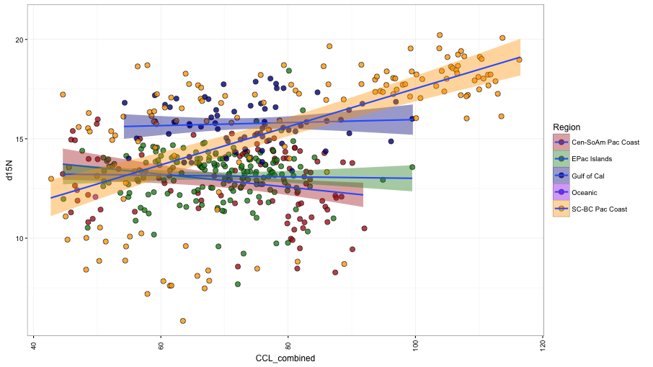

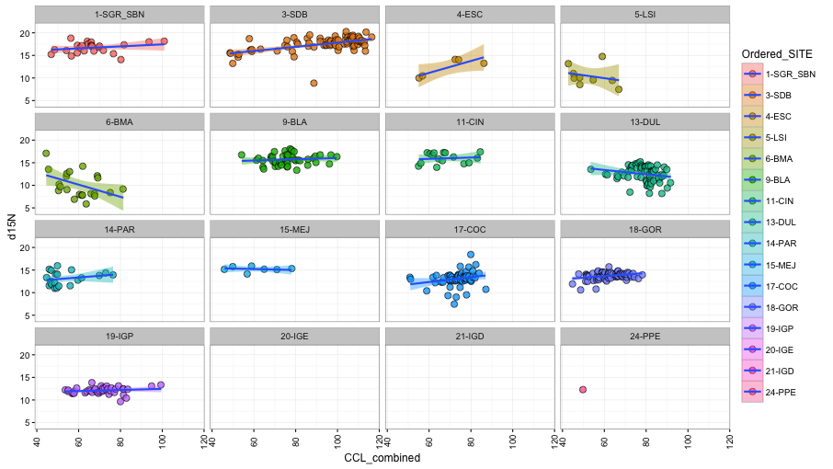

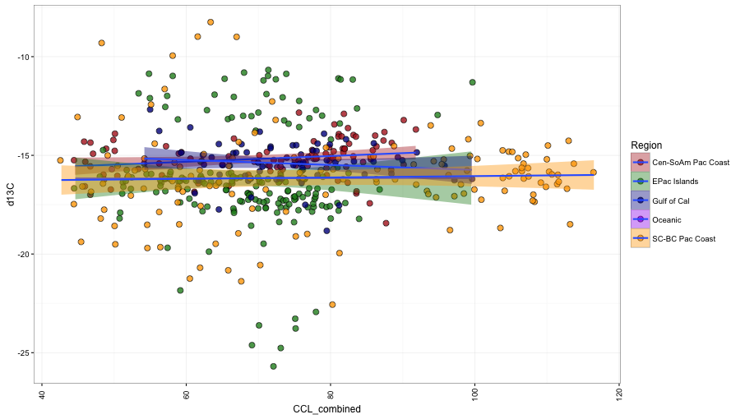 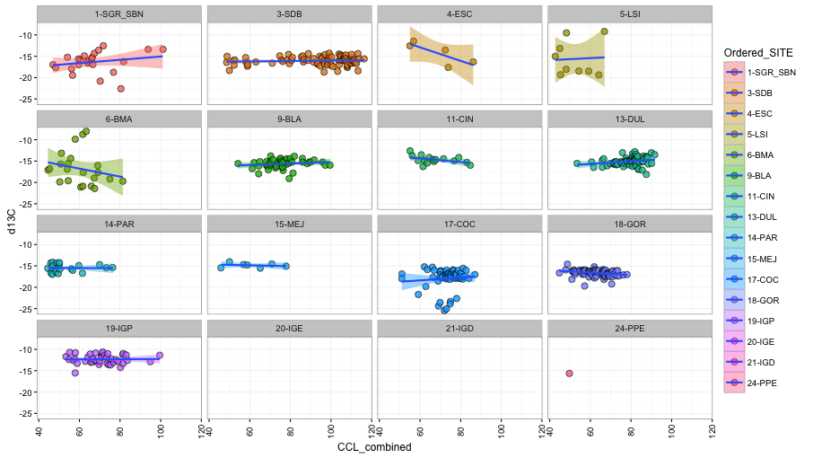

m1<-lm(data=data, d15N~CCL_combined*Ordered_SITE)  
## CCL_combined:Ordered_SITE6-BMA -0.156964 0.039628 -3.961 8.64e-05 ***  
## CCL_combined:Ordered_SITE13-DUL -0.070234 0.032281 -2.176 0.03008 *

## Anova Table (Type II tests)  
## Response: d15N  
## Sum Sq Df F value Pr(>F)   
## CCL_combined 38.70 1 19.9084 1.021e-05 ***  
## Ordered_SITE 1647.81 13 65.2055 < 2.2e-16 ***  
## CCL_combined:Ordered_SITE 97.68 12 4.1874 2.868e-06 ***  
## Residuals 900.04 463

#remember to come back and remove point to see if makes difference in weight of sign. at BMA



