Seminoff EPac green turtle Stable Isotope Data Analysis

Lisa Komoroske

2020-07-15

### Metadata from Jeff

**Site** - an ordinal code for each site  
**Site code** - 3 letter code for each site  
**Ordered_SITE** - combined site code with ordered # roughly North to South for graphing ordering  
**Location_Label** - shortened location names for graphing labeling purposes  
**Location** - location of turtle capture  
**LAB ID** - self explanatory  
**Collection Date** - self explanatory  
**Run Date** - self explanatory  
**%N** - elemental concentration of N. that is, how much each sample is made up of nitrogen. this is used as a diagnostic to know sample quality (anything outside of ~9-17% N raises a red flag)  
**%C** - elemental concentration of C. that is, how much each sample is made up of carbon. this is used as a diagnostic to know sample quality (anything outside of ~40-60% C raises a red flag)  
**d15N** - stable isotope value for N  
**d13C** - stable isotope value for C  
**Color** - rarely filled in. This is largely for the Galapagos and Colombia, where black turtles (eastern Pacific stock) and yellow turtles (west Pacific origins) co-exist. Safe to say that anything that is not filled in here would be a ‘black’ morph.  
**SCL** - straight carapace length  
**CCL_calc_fromSCL** - used formula from Seminoff et al. 2003 to interpolate CCLs from SCLs  
**CCL_empirical** - curved carapace length-these are only the empirically collected values  
**CCL_combined** - curved carapace length-I copied over all the empirical values, and then for ones that were missing empirical CCL but had **CCL_calc_fromSCL**, I added these in; so this is the combined variable that we’ll use for size relationships

### Setup

### Load Required Libraries

### Read in data

### Coarse data QC checks to note obvious data structure problems, etc.:

### Figures

#### Figure 1. Map

#### Figure 2. Whiskers

## [1] "1 - MEJ" "10 - COC" "11 - DUL" "12 - NAV" "13 - BMA"   
## [6] "16 - NGU" "18 - CIN" "19 - BLA" "2 - PAR" "20 - SDB"   
## [11] "21 - SGR_SBN" "3 - PPE" "6 - IGD" "7 - IGE" "8 - IGP"   
## [16] "9 - GOR"

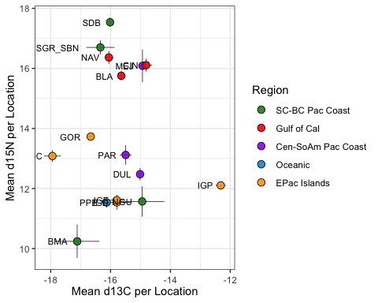

#### Figure 3. See seperate script for Bayesian ellipses and convex hulls

#### Figure 4. CSIA graphic

## Warning: `add_rownames()` is deprecated as of dplyr 1.0.0.  
## Please use `tibble::rownames_to_column()` instead.  
## This warning is displayed once every 8 hours.  
## Call `lifecycle::last_warnings()` to see where this warning was generated.

## 'data.frame': 98 obs. of 4 variables:  
## $ amino.acid: chr "Ala" "Asx" "Glx" "Gly" ...  
## $ location : chr "BLA" "BLA" "BLA" "BLA" ...  
## $ mean_N : num 27 18.4 21.4 19 23.3 ...  
## $ sd_N : num 4.18 1.7 3.4 1.91 5.2 ...

## [1] "Ala" "Asx" "Glx" "Gly" "Iso" "Leu" "Lys" "Met" "Phe" "Pro" "Ser" "Thr"  
## [13] "Tyr" "Val"

## [1] "BLA" "BMA" "DUL" "IGD" "MEJ" "PAR" "SDB"

## Warning: Removed 2 rows containing missing values (geom_point).

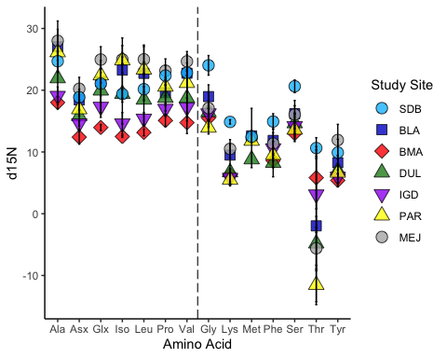

#### Supplemental Figure 1. Faceted Histograms

## [1] "Bahia de los Angeles, GoC, MX"   
## [2] "Bahia Elizabeth, Isabela, Galapagos"   
## [3] "Bahia Magdalena, BCS, MX"   
## [4] "Caleta Derek, Isabela, Galapagos"   
## [5] "Cocos Island, Costa Rica"   
## [6] "El Pardito Island, GoC, MX"   
## [7] "Golfo Dulce, Costa Rica"   
## [8] "Infiernillo Channel, GoC, MX"   
## [9] "Isla Gorgona, Colombia"   
## [10] "Isla San Lazaro, GoC, MX"   
## [11] "Long Beach, USA"   
## [12] "Loreto, GoC, MX"   
## [13] "Mejillones, Chile"   
## [14] "Navachiste, GoC, MX"   
## [15] "North Gulf of Ulloa, BCS, MX"   
## [16] "Oceanic Waters, Peru (Longline)"   
## [17] "Pisco / Paracas Bay, Peru"   
## [18] "Punta Espinosa, Fernandina, Galapagos"  
## [19] "Punta Nunez, Santa Cruz, Galapagos"   
## [20] "San Diego Bay, USA"

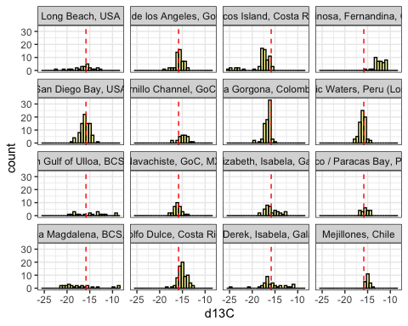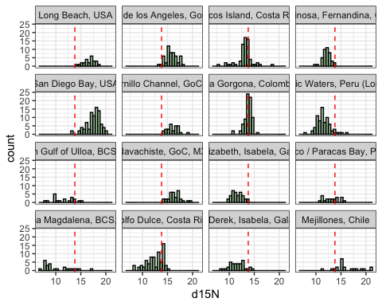

#### Supplemental Figure 2. Variance Multiplication Factors

*[come back and insert code or redirect to script]*  
#### Supplemental Figure 3. Boxplots, 2 panel (C then N)

## [1] "1-SGR_SBN" "3-SDB" "4-NGU" "6-BMA" "9-BLA" "11-CIN"   
## [7] "12-NAV" "13-DUL" "14-PAR" "15-MEJ" "17-COC" "18-GOR"   
## [13] "19-IGP" "20-IGE" "21-IGD" "24-PPE"

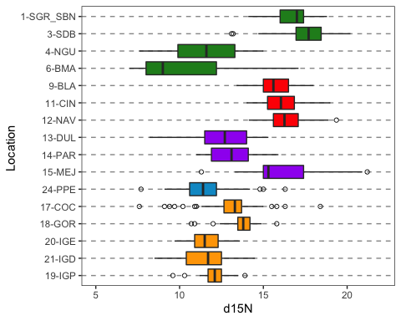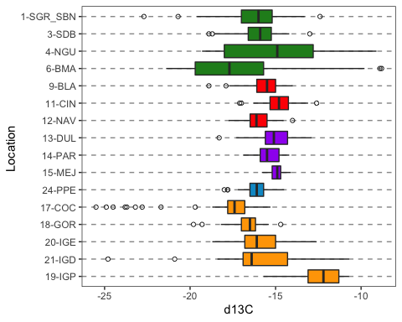

#### Supplemental Figure 4. See seperate script for Bayesian ellipses and convex hull areas