Seminoff EPac green turtle Stable Isotope Data Analysis-models only doc

Lisa Komoroske

2020-07-16

##Setup

##Load Required Libraries

##Read in data

####Hierarchical models: Nitrogen

## Linear mixed-effects model fit by REML  
## Data: data   
## AIC BIC logLik  
## 2658.886 2677.187 -1325.443  
##   
## Random effects:  
## Formula: ~1 | Region  
## (Intercept)  
## StdDev: 0.9730053  
##   
## Formula: ~1 | Ordered_SITE %in% Region  
## (Intercept) Residual  
## StdDev: 2.142459 1.458205  
##   
## Fixed effects: d15N ~ 1   
## Value Std.Error DF t-value p-value  
## (Intercept) 13.7532 0.7094788 702 19.38494 0  
##   
## Standardized Within-Group Residuals:  
## Min Q1 Med Q3 Max   
## -3.75843773 -0.52640297 0.01332273 0.53754287 4.65905624   
##   
## Number of Observations: 718  
## Number of Groups:   
## Region Ordered_SITE %in% Region   
## 5 16

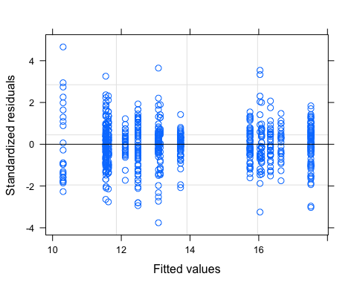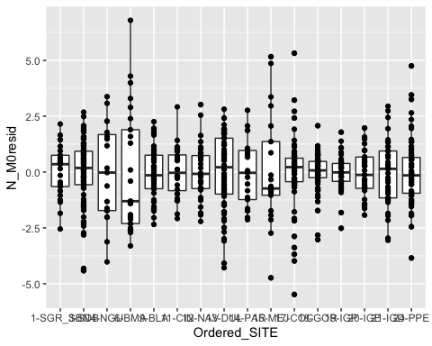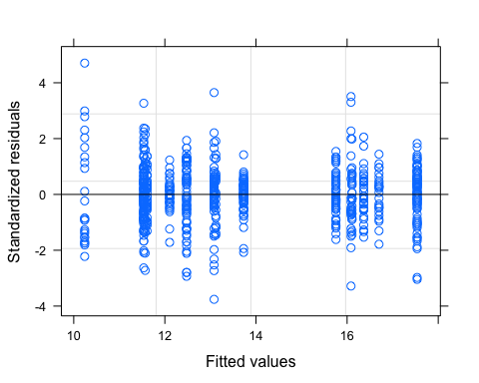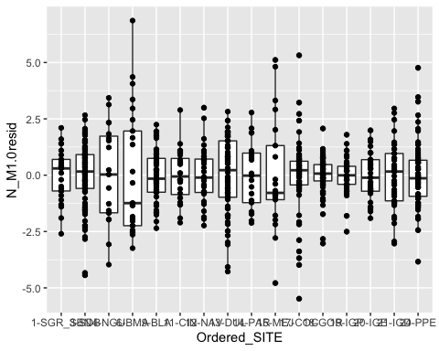

## Linear mixed-effects model fit by REML  
## Data: data   
## AIC BIC logLik  
## 2616.589 2698.56 -1290.295  
##   
## Random effects:  
## Formula: ~1 | Region  
## (Intercept) Residual  
## StdDev: 0.3244935 1.458191  
##   
## Fixed effects: d15N ~ Ordered_SITE   
## Value Std.Error DF t-value p-value  
## (Intercept) 16.700000 0.4362899 699 38.27730 0.0000  
## Ordered_SITE3-SDB 0.836782 0.3308978 699 2.52882 0.0117  
## Ordered_SITE4-NGU -5.131579 0.4438069 699 -11.56264 0.0000  
## Ordered_SITE6-BMA -6.460000 0.4124388 699 -15.66293 0.0000  
## Ordered_SITE9-BLA -0.945283 0.5794516 699 -1.63134 0.1033  
## Ordered_SITE11-CIN -0.592857 0.6095777 699 -0.97257 0.3311  
## Ordered_SITE12-NAV -0.334848 0.6000658 699 -0.55802 0.5770  
## Ordered_SITE13-DUL -4.222973 0.5695428 699 -7.41467 0.0000  
## Ordered_SITE14-PAR -3.580952 0.6299987 699 -5.68406 0.0000  
## Ordered_SITE15-MEJ -0.614286 0.6299987 699 -0.97506 0.3299  
## Ordered_SITE17-COC -3.619403 0.5721722 699 -6.32572 0.0000  
## Ordered_SITE18-GOR -2.971053 0.5688786 699 -5.22265 0.0000  
## Ordered_SITE19-IGP -4.595122 0.5894968 699 -7.79499 0.0000  
## Ordered_SITE20-IGE -5.089189 0.5942332 699 -8.56430 0.0000  
## Ordered_SITE21-IGD -5.162162 0.5942332 699 -8.68710 0.0000  
## Ordered_SITE24-PPE -5.163514 0.5695428 3 -9.06607 0.0028  
## Correlation:   
## (Intr) O_SITE3 O_SITE4 O_SITE6 O_SITE9 O_SITE11 O_SITE12  
## Ordered_SITE3-SDB -0.589   
## Ordered_SITE4-NGU -0.439 0.579   
## Ordered_SITE6-BMA -0.473 0.623 0.465   
## Ordered_SITE9-BLA -0.753 0.444 0.331 0.356   
## Ordered_SITE11-CIN -0.716 0.422 0.314 0.338 0.837   
## Ordered_SITE12-NAV -0.727 0.428 0.319 0.344 0.850 0.808   
## Ordered_SITE13-DUL -0.766 0.451 0.336 0.362 0.577 0.548 0.557   
## Ordered_SITE14-PAR -0.693 0.408 0.304 0.327 0.521 0.496 0.504   
## Ordered_SITE15-MEJ -0.693 0.408 0.304 0.327 0.521 0.496 0.504   
## Ordered_SITE17-COC -0.763 0.449 0.335 0.360 0.574 0.546 0.554   
## Ordered_SITE18-GOR -0.767 0.452 0.337 0.363 0.577 0.549 0.558   
## Ordered_SITE19-IGP -0.740 0.436 0.325 0.350 0.557 0.530 0.538   
## Ordered_SITE20-IGE -0.734 0.433 0.323 0.347 0.553 0.525 0.534   
## Ordered_SITE21-IGD -0.734 0.433 0.323 0.347 0.553 0.525 0.534   
## Ordered_SITE24-PPE -0.766 0.451 0.336 0.362 0.577 0.548 0.557   
## O_SITE13 O_SITE14 O_SITE15 O_SITE17 O_SITE18 O_SITE19  
## Ordered_SITE3-SDB   
## Ordered_SITE4-NGU   
## Ordered_SITE6-BMA   
## Ordered_SITE9-BLA   
## Ordered_SITE11-CIN   
## Ordered_SITE12-NAV   
## Ordered_SITE13-DUL   
## Ordered_SITE14-PAR 0.824   
## Ordered_SITE15-MEJ 0.824 0.745   
## Ordered_SITE17-COC 0.584 0.528 0.528   
## Ordered_SITE18-GOR 0.587 0.531 0.531 0.908   
## Ordered_SITE19-IGP 0.567 0.513 0.513 0.877 0.882   
## Ordered_SITE20-IGE 0.562 0.508 0.508 0.870 0.875 0.844   
## Ordered_SITE21-IGD 0.562 0.508 0.508 0.870 0.875 0.844   
## Ordered_SITE24-PPE 0.587 0.530 0.530 0.584 0.587 0.567   
## O_SITE20 O_SITE21  
## Ordered_SITE3-SDB   
## Ordered_SITE4-NGU   
## Ordered_SITE6-BMA   
## Ordered_SITE9-BLA   
## Ordered_SITE11-CIN   
## Ordered_SITE12-NAV   
## Ordered_SITE13-DUL   
## Ordered_SITE14-PAR   
## Ordered_SITE15-MEJ   
## Ordered_SITE17-COC   
## Ordered_SITE18-GOR   
## Ordered_SITE19-IGP   
## Ordered_SITE20-IGE   
## Ordered_SITE21-IGD 0.837   
## Ordered_SITE24-PPE 0.562 0.562   
##   
## Standardized Within-Group Residuals:  
## Min Q1 Med Q3 Max   
## -3.7584899 -0.5328705 0.0133062 0.5428503 4.7044584   
##   
## Number of Observations: 718  
## Number of Groups: 5

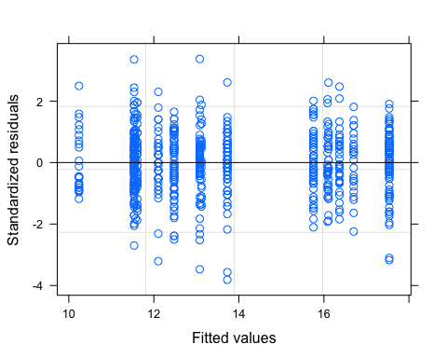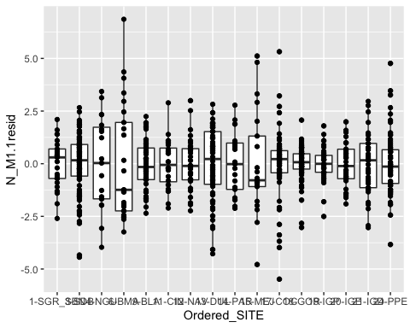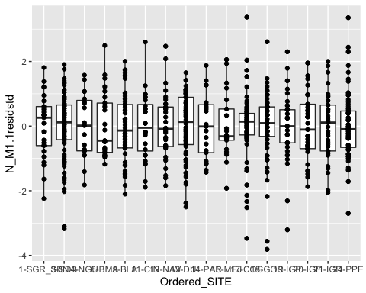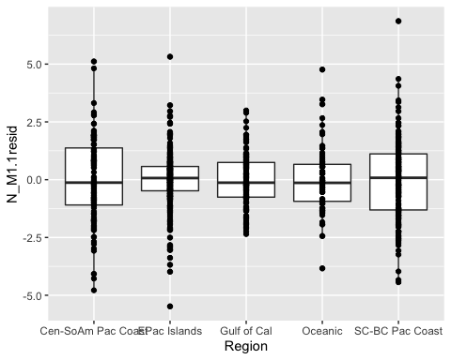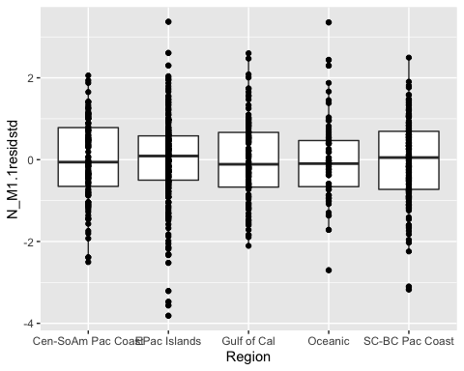

## Linear mixed-effects model fit by REML  
## Data: data   
## AIC BIC logLik  
## 2504.902 2655.182 -1219.451  
##   
## Random effects:  
## Formula: ~1 | Region  
## (Intercept) Residual  
## StdDev: 0.3802233 1.708639  
##   
## Variance function:  
## Structure: Different standard deviations per stratum  
## Formula: ~1 | Ordered_SITE   
## Parameter estimates:  
## 13-DUL 14-PAR 15-MEJ 17-COC 18-GOR 19-IGP 20-IGE 21-IGD   
## 1.0000000 0.8676174 1.4549767 0.9237127 0.4647658 0.4567214 0.5961817 0.8652709   
## 9-BLA 11-CIN 12-NAV 24-PPE 1-SGR_SBN 3-SDB 4-NGU 6-BMA   
## 0.6545007 0.6511250 0.7094520 0.8311136 0.6785455 0.8182476 1.2737699 1.6098360   
## Fixed effects: d15N ~ Ordered_SITE   
## Value Std.Error DF t-value p-value  
## (Intercept) 16.700000 0.4453506 699 37.49855 0.0000  
## Ordered_SITE3-SDB 0.836782 0.2761063 699 3.03065 0.0025  
## Ordered_SITE4-NGU -5.131579 0.5505191 699 -9.32135 0.0000  
## Ordered_SITE6-BMA -6.460000 0.5969973 699 -10.82082 0.0000  
## Ordered_SITE9-BLA -0.945283 0.6053951 699 -1.56143 0.1189  
## Ordered_SITE11-CIN -0.592857 0.6221832 699 -0.95287 0.3410  
## Ordered_SITE12-NAV -0.334848 0.6224426 699 -0.53796 0.5908  
## Ordered_SITE13-DUL -4.222973 0.6183517 699 -6.82940 0.0000  
## Ordered_SITE14-PAR -3.580952 0.6689967 699 -5.35272 0.0000  
## Ordered_SITE15-MEJ -0.614286 0.7982538 699 -0.76954 0.4418  
## Ordered_SITE17-COC -3.619403 0.6165112 699 -5.87078 0.0000  
## Ordered_SITE18-GOR -2.971053 0.5926251 699 -5.01338 0.0000  
## Ordered_SITE19-IGP -4.595122 0.5981305 699 -7.68247 0.0000  
## Ordered_SITE20-IGE -5.089189 0.6090582 699 -8.35583 0.0000  
## Ordered_SITE21-IGD -5.162162 0.6340204 699 -8.14195 0.0000  
## Ordered_SITE24-PPE -5.163514 0.6084064 3 -8.48695 0.0034  
## Correlation:   
## (Intr) O_SITE3 O_SITE4 O_SITE6 O_SITE9 O_SITE11 O_SITE12  
## Ordered_SITE3-SDB -0.437   
## Ordered_SITE4-NGU -0.219 0.354   
## Ordered_SITE6-BMA -0.202 0.326 0.164   
## Ordered_SITE9-BLA -0.736 0.322 0.161 0.149   
## Ordered_SITE11-CIN -0.716 0.313 0.157 0.145 0.910   
## Ordered_SITE12-NAV -0.715 0.313 0.157 0.145 0.910 0.885   
## Ordered_SITE13-DUL -0.720 0.315 0.158 0.146 0.530 0.516 0.515   
## Ordered_SITE14-PAR -0.666 0.291 0.146 0.135 0.490 0.476 0.476   
## Ordered_SITE15-MEJ -0.558 0.244 0.122 0.113 0.410 0.399 0.399   
## Ordered_SITE17-COC -0.722 0.316 0.158 0.146 0.531 0.517 0.517   
## Ordered_SITE18-GOR -0.751 0.329 0.165 0.152 0.553 0.538 0.538   
## Ordered_SITE19-IGP -0.745 0.326 0.163 0.151 0.548 0.533 0.533   
## Ordered_SITE20-IGE -0.731 0.320 0.160 0.148 0.538 0.523 0.523   
## Ordered_SITE21-IGD -0.702 0.307 0.154 0.142 0.517 0.503 0.503   
## Ordered_SITE24-PPE -0.732 0.320 0.161 0.148 0.538 0.524 0.524   
## O_SITE13 O_SITE14 O_SITE15 O_SITE17 O_SITE18 O_SITE19  
## Ordered_SITE3-SDB   
## Ordered_SITE4-NGU   
## Ordered_SITE6-BMA   
## Ordered_SITE9-BLA   
## Ordered_SITE11-CIN   
## Ordered_SITE12-NAV   
## Ordered_SITE13-DUL   
## Ordered_SITE14-PAR 0.829   
## Ordered_SITE15-MEJ 0.695 0.642   
## Ordered_SITE17-COC 0.520 0.481 0.403   
## Ordered_SITE18-GOR 0.541 0.500 0.419 0.939   
## Ordered_SITE19-IGP 0.536 0.496 0.415 0.930 0.967   
## Ordered_SITE20-IGE 0.527 0.487 0.408 0.913 0.950 0.941   
## Ordered_SITE21-IGD 0.506 0.468 0.392 0.877 0.913 0.904   
## Ordered_SITE24-PPE 0.527 0.487 0.408 0.529 0.550 0.545   
## O_SITE20 O_SITE21  
## Ordered_SITE3-SDB   
## Ordered_SITE4-NGU   
## Ordered_SITE6-BMA   
## Ordered_SITE9-BLA   
## Ordered_SITE11-CIN   
## Ordered_SITE12-NAV   
## Ordered_SITE13-DUL   
## Ordered_SITE14-PAR   
## Ordered_SITE15-MEJ   
## Ordered_SITE17-COC   
## Ordered_SITE18-GOR   
## Ordered_SITE19-IGP   
## Ordered_SITE20-IGE   
## Ordered_SITE21-IGD 0.888   
## Ordered_SITE24-PPE 0.535 0.514   
##   
## Standardized Within-Group Residuals:  
## Min Q1 Med Q3 Max   
## -3.81423212 -0.59962216 0.01229366 0.61508932 3.37035421   
##   
## Number of Observations: 718  
## Number of Groups: 5

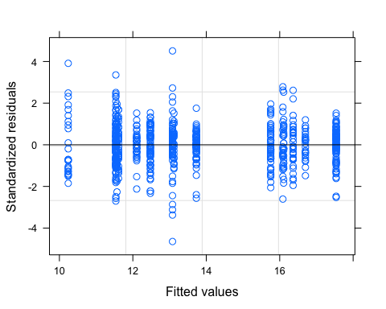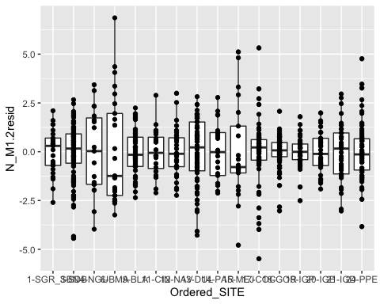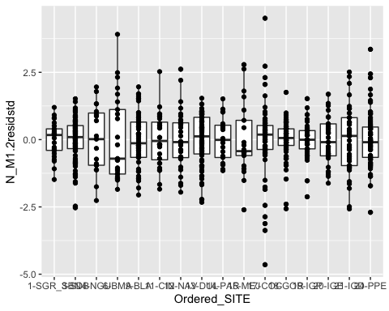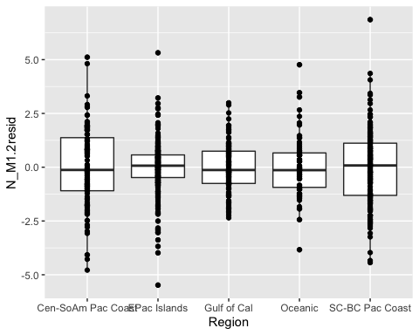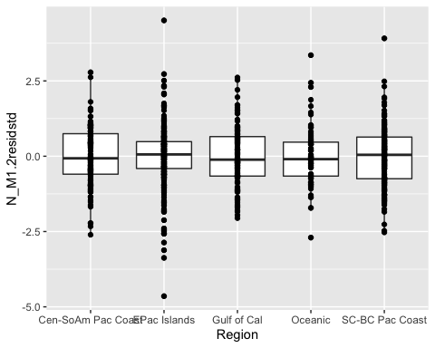

## Linear mixed-effects model fit by REML  
## Data: data   
## AIC BIC logLik  
## 2567.78 2667.967 -1261.89  
##   
## Random effects:  
## Formula: ~1 | Region  
## (Intercept) Residual  
## StdDev: 0.4084349 1.835498  
##   
## Variance function:  
## Structure: Different standard deviations per stratum  
## Formula: ~1 | Region   
## Parameter estimates:  
## Cen-SoAm Pac Coast EPac Islands Gulf of Cal Oceanic   
## 1.0000000 0.6427140 0.6236877 0.7736567   
## SC-BC Pac Coast   
## 0.9551762   
## Fixed effects: d15N ~ Ordered_SITE   
## Value Std.Error DF t-value p-value  
## (Intercept) 16.700000 0.5383037 699 31.023381 0.0000  
## Ordered_SITE3-SDB 0.836782 0.3978477 699 2.103271 0.0358  
## Ordered_SITE4-NGU -5.131579 0.5336015 699 -9.616876 0.0000  
## Ordered_SITE6-BMA -6.460000 0.4958867 699 -13.027169 0.0000  
## Ordered_SITE9-BLA -0.945283 0.6937698 699 -1.362531 0.1735  
## Ordered_SITE11-CIN -0.592857 0.7095027 699 -0.835595 0.4037  
## Ordered_SITE12-NAV -0.334848 0.7044874 699 -0.475308 0.6347  
## Ordered_SITE13-DUL -4.222973 0.7086026 699 -5.959579 0.0000  
## Ordered_SITE14-PAR -3.580952 0.7855068 699 -4.558779 0.0000  
## Ordered_SITE15-MEJ -0.614286 0.7855068 699 -0.782025 0.4345  
## Ordered_SITE17-COC -3.619403 0.6909135 699 -5.238576 0.0000  
## Ordered_SITE18-GOR -2.971053 0.6891311 699 -4.311303 0.0000  
## Ordered_SITE19-IGP -4.595122 0.7003810 699 -6.560889 0.0000  
## Ordered_SITE20-IGE -5.089189 0.7029959 699 -7.239287 0.0000  
## Ordered_SITE21-IGD -5.162162 0.7029959 699 -7.343090 0.0000  
## Ordered_SITE24-PPE -5.163514 0.6955863 3 -7.423254 0.0051  
## Correlation:   
## (Intr) O_SITE3 O_SITE4 O_SITE6 O_SITE9 O_SITE11 O_SITE12  
## Ordered_SITE3-SDB -0.574   
## Ordered_SITE4-NGU -0.428 0.579   
## Ordered_SITE6-BMA -0.461 0.623 0.465   
## Ordered_SITE9-BLA -0.776 0.445 0.332 0.357   
## Ordered_SITE11-CIN -0.759 0.436 0.325 0.349 0.928   
## Ordered_SITE12-NAV -0.764 0.439 0.327 0.352 0.934 0.913   
## Ordered_SITE13-DUL -0.760 0.436 0.325 0.350 0.589 0.576 0.580   
## Ordered_SITE14-PAR -0.685 0.393 0.293 0.316 0.532 0.520 0.524   
## Ordered_SITE15-MEJ -0.685 0.393 0.293 0.316 0.532 0.520 0.524   
## Ordered_SITE17-COC -0.779 0.447 0.333 0.359 0.605 0.591 0.595   
## Ordered_SITE18-GOR -0.781 0.448 0.334 0.360 0.606 0.593 0.597   
## Ordered_SITE19-IGP -0.769 0.441 0.329 0.354 0.596 0.583 0.587   
## Ordered_SITE20-IGE -0.766 0.440 0.328 0.353 0.594 0.581 0.585   
## Ordered_SITE21-IGD -0.766 0.440 0.328 0.353 0.594 0.581 0.585   
## Ordered_SITE24-PPE -0.774 0.444 0.331 0.356 0.600 0.587 0.591   
## O_SITE13 O_SITE14 O_SITE15 O_SITE17 O_SITE18 O_SITE19  
## Ordered_SITE3-SDB   
## Ordered_SITE4-NGU   
## Ordered_SITE6-BMA   
## Ordered_SITE9-BLA   
## Ordered_SITE11-CIN   
## Ordered_SITE12-NAV   
## Ordered_SITE13-DUL   
## Ordered_SITE14-PAR 0.820   
## Ordered_SITE15-MEJ 0.820 0.740   
## Ordered_SITE17-COC 0.592 0.534 0.534   
## Ordered_SITE18-GOR 0.593 0.535 0.535 0.959   
## Ordered_SITE19-IGP 0.584 0.527 0.527 0.944 0.946   
## Ordered_SITE20-IGE 0.582 0.525 0.525 0.940 0.942 0.927   
## Ordered_SITE21-IGD 0.582 0.525 0.525 0.940 0.942 0.927   
## Ordered_SITE24-PPE 0.588 0.530 0.530 0.603 0.605 0.595   
## O_SITE20 O_SITE21  
## Ordered_SITE3-SDB   
## Ordered_SITE4-NGU   
## Ordered_SITE6-BMA   
## Ordered_SITE9-BLA   
## Ordered_SITE11-CIN   
## Ordered_SITE12-NAV   
## Ordered_SITE13-DUL   
## Ordered_SITE14-PAR   
## Ordered_SITE15-MEJ   
## Ordered_SITE17-COC   
## Ordered_SITE18-GOR   
## Ordered_SITE19-IGP   
## Ordered_SITE20-IGE   
## Ordered_SITE21-IGD 0.924   
## Ordered_SITE24-PPE 0.593 0.593   
##   
## Standardized Within-Group Residuals:  
## Min Q1 Med Q3 Max   
## -4.64575327 -0.59147127 0.01644738 0.58420696 4.50911347   
##   
## Number of Observations: 718  
## Number of Groups: 5

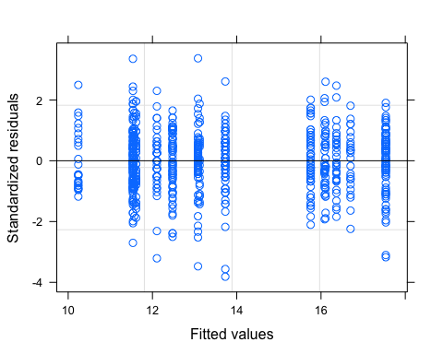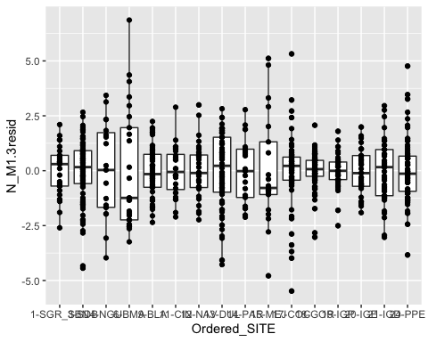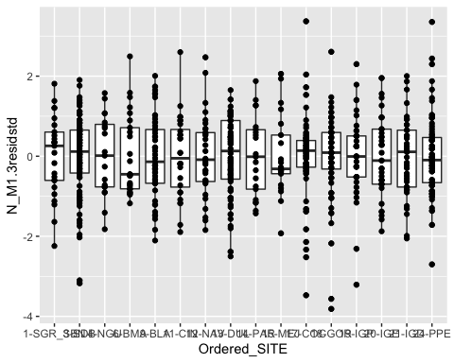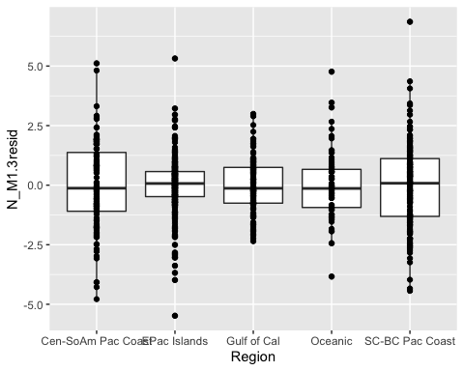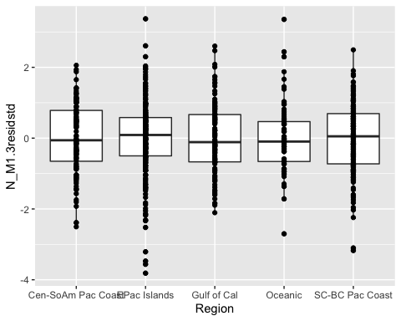

## Linear mixed-effects model fit by REML  
## Data: data   
## AIC BIC logLik  
## 2512.902 2681.398 -1219.451  
##   
## Random effects:  
## Formula: ~1 | Region  
## (Intercept) Residual  
## StdDev: 0.3802342 1.70868  
##   
## Combination of variance functions:   
## Structure: Different standard deviations per stratum  
## Formula: ~1 | Region   
## Parameter estimates:  
## Cen-SoAm Pac Coast EPac Islands Gulf of Cal Oceanic   
## 1.0000000 0.6825690 0.7415201 0.9116382   
## SC-BC Pac Coast   
## 1.0262474   
## Structure: Different standard deviations per stratum  
## Formula: ~1 | Ordered_SITE   
## Parameter estimates:  
## 13-DUL 14-PAR 15-MEJ 17-COC 18-GOR 19-IGP 20-IGE 21-IGD   
## 1.0000000 0.8675921 1.4549464 1.3532518 0.6808869 0.6691018 0.8734114 1.2676368   
## 9-BLA 11-CIN 12-NAV 24-PPE 1-SGR_SBN 3-SDB 4-NGU 6-BMA   
## 0.8826260 0.8780622 0.9567213 0.9116382 0.6611702 0.7973114 1.2411701 1.5686221   
## Fixed effects: d15N ~ Ordered_SITE   
## Value Std.Error DF t-value p-value  
## (Intercept) 16.700000 0.4453590 699 37.49784 0.0000  
## Ordered_SITE3-SDB 0.836782 0.2761058 699 3.03066 0.0025  
## Ordered_SITE4-NGU -5.131579 0.5505212 699 -9.32131 0.0000  
## Ordered_SITE6-BMA -6.460000 0.5969956 699 -10.82085 0.0000  
## Ordered_SITE9-BLA -0.945283 0.6054081 699 -1.56140 0.1189  
## Ordered_SITE11-CIN -0.592857 0.6221949 699 -0.95285 0.3410  
## Ordered_SITE12-NAV -0.334848 0.6224546 699 -0.53795 0.5908  
## Ordered_SITE13-DUL -4.222973 0.6183660 699 -6.82924 0.0000  
## Ordered_SITE14-PAR -3.580952 0.6690076 699 -5.35263 0.0000  
## Ordered_SITE15-MEJ -0.614286 0.7982648 699 -0.76953 0.4418  
## Ordered_SITE17-COC -3.619403 0.6165238 699 -5.87066 0.0000  
## Ordered_SITE18-GOR -2.971053 0.5926384 699 -5.01326 0.0000  
## Ordered_SITE19-IGP -4.595122 0.5981435 699 -7.68231 0.0000  
## Ordered_SITE20-IGE -5.089189 0.6090709 699 -8.35566 0.0000  
## Ordered_SITE21-IGD -5.162162 0.6340327 699 -8.14179 0.0000  
## Ordered_SITE24-PPE -5.163514 0.6084189 3 -8.48677 0.0034  
## Correlation:   
## (Intr) O_SITE3 O_SITE4 O_SITE6 O_SITE9 O_SITE11 O_SITE12  
## Ordered_SITE3-SDB -0.437   
## Ordered_SITE4-NGU -0.219 0.354   
## Ordered_SITE6-BMA -0.202 0.326 0.164   
## Ordered_SITE9-BLA -0.736 0.322 0.161 0.149   
## Ordered_SITE11-CIN -0.716 0.313 0.157 0.145 0.910   
## Ordered_SITE12-NAV -0.715 0.313 0.157 0.145 0.910 0.885   
## Ordered_SITE13-DUL -0.720 0.315 0.158 0.146 0.530 0.516 0.515   
## Ordered_SITE14-PAR -0.666 0.291 0.146 0.135 0.490 0.476 0.476   
## Ordered_SITE15-MEJ -0.558 0.244 0.122 0.113 0.410 0.399 0.399   
## Ordered_SITE17-COC -0.722 0.316 0.158 0.146 0.531 0.517 0.517   
## Ordered_SITE18-GOR -0.751 0.329 0.165 0.152 0.553 0.538 0.538   
## Ordered_SITE19-IGP -0.745 0.326 0.163 0.151 0.548 0.533 0.533   
## Ordered_SITE20-IGE -0.731 0.320 0.160 0.148 0.538 0.523 0.523   
## Ordered_SITE21-IGD -0.702 0.307 0.154 0.142 0.517 0.503 0.503   
## Ordered_SITE24-PPE -0.732 0.320 0.161 0.148 0.538 0.524 0.524   
## O_SITE13 O_SITE14 O_SITE15 O_SITE17 O_SITE18 O_SITE19  
## Ordered_SITE3-SDB   
## Ordered_SITE4-NGU   
## Ordered_SITE6-BMA   
## Ordered_SITE9-BLA   
## Ordered_SITE11-CIN   
## Ordered_SITE12-NAV   
## Ordered_SITE13-DUL   
## Ordered_SITE14-PAR 0.829   
## Ordered_SITE15-MEJ 0.695 0.642   
## Ordered_SITE17-COC 0.520 0.481 0.403   
## Ordered_SITE18-GOR 0.541 0.500 0.419 0.939   
## Ordered_SITE19-IGP 0.536 0.496 0.415 0.930 0.967   
## Ordered_SITE20-IGE 0.527 0.487 0.408 0.913 0.950 0.941   
## Ordered_SITE21-IGD 0.506 0.468 0.392 0.877 0.913 0.904   
## Ordered_SITE24-PPE 0.527 0.487 0.408 0.529 0.550 0.545   
## O_SITE20 O_SITE21  
## Ordered_SITE3-SDB   
## Ordered_SITE4-NGU   
## Ordered_SITE6-BMA   
## Ordered_SITE9-BLA   
## Ordered_SITE11-CIN   
## Ordered_SITE12-NAV   
## Ordered_SITE13-DUL   
## Ordered_SITE14-PAR   
## Ordered_SITE15-MEJ   
## Ordered_SITE17-COC   
## Ordered_SITE18-GOR   
## Ordered_SITE19-IGP   
## Ordered_SITE20-IGE   
## Ordered_SITE21-IGD 0.888   
## Ordered_SITE24-PPE 0.535 0.514   
##   
## Standardized Within-Group Residuals:  
## Min Q1 Med Q3 Max   
## -3.8142526 -0.5996262 0.0122937 0.6150851 3.3703654   
##   
## Number of Observations: 718  
## Number of Groups: 5

## Warning in anova.lme(N_M1.null, N_M1.0, N_M1.1, N_M1.2, N_M1.3): fitted objects  
## with different fixed effects. REML comparisons are not meaningful.

## Model df AIC BIC logLik Test L.Ratio p-value  
## N_M1.null 1 3 3163.237 3176.962 -1578.618   
## N_M1.0 2 18 2616.589 2698.560 -1290.295 1 vs 2 576.6475 <.0001  
## N_M1.1 3 33 2504.902 2655.182 -1219.451 2 vs 3 141.6870 <.0001  
## N_M1.2 4 22 2567.780 2667.967 -1261.890 3 vs 4 84.8780 <.0001  
## N_M1.3 5 37 2512.902 2681.398 -1219.451 4 vs 5 84.8780 <.0001

## Model df AIC BIC logLik Test L.Ratio p-value  
## N_M1.1 1 33 2504.902 2655.182 -1219.451   
## N_M1.3 2 37 2512.902 2681.398 -1219.451 1 vs 2 9.141422e-08 1

## Model selection table   
## (Int) Ord_SIT weights df logLik AICc delta weight  
## N_M1.1 16.7 + vI(Or_SI) 33 -1219.451 2508.2 0.00 0.988  
## N_M1.3 16.7 + vR 37 -1219.451 2517.0 8.85 0.012  
## N_M1.2 16.7 + vI(Rg) 22 -1261.890 2569.2 61.05 0.000  
## N_M1.0 16.7 + 18 -1290.295 2617.6 109.38 0.000  
## N_M1.null 13.8 3 -1578.618 3163.3 655.09 0.000  
## Abbreviations:  
## weights: vI(Or_SI) = 'varIdent(~1|Ordered_SITE)',   
## vI(Rg) = 'varIdent(~1|Region)', vR = 'varRegionSite'  
## Models ranked by AICc(x)   
## Random terms (all models):   
## '1 | Region'

## [1] "BLA" "BMA" "CIN" "COC" "DUL" "GOR" "IGD" "IGE" "IGP" "LB" "MEJ" "NAV"  
## [13] "NGU" "PAR" "PPE" "SDB"

## [1] "Central-S. America Pacific Coast" "East Pacific Islands"   
## [3] "Gulf of California" "Oceanic"   
## [5] "SoCal-Baja Pacific Coast"

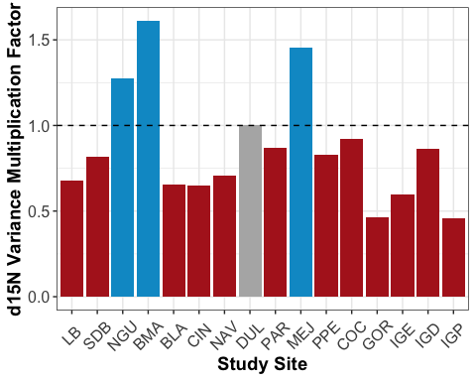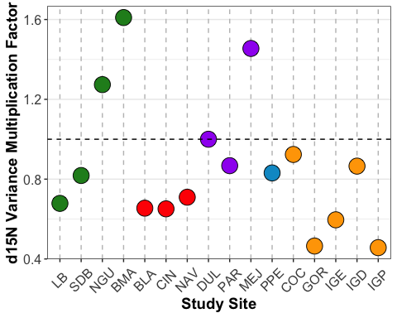

####Hierarchical models: Carbon

## Linear mixed-effects model fit by REML  
## Data: data   
## AIC BIC logLik  
## 2769.506 2787.807 -1380.753  
##   
## Random effects:  
## Formula: ~1 | Region  
## (Intercept)  
## StdDev: 0.0002808464  
##   
## Formula: ~1 | Ordered_SITE %in% Region  
## (Intercept) Residual  
## StdDev: 1.208618 1.598704  
##   
## Fixed effects: d13C ~ 1   
## Value Std.Error DF t-value p-value  
## (Intercept) -15.69305 0.309548 702 -50.69667 0  
##   
## Standardized Within-Group Residuals:  
## Min Q1 Med Q3 Max   
## -5.63742357 -0.36188433 0.05604302 0.42977038 5.14349539   
##   
## Number of Observations: 718  
## Number of Groups:   
## Region Ordered_SITE %in% Region   
## 5 16

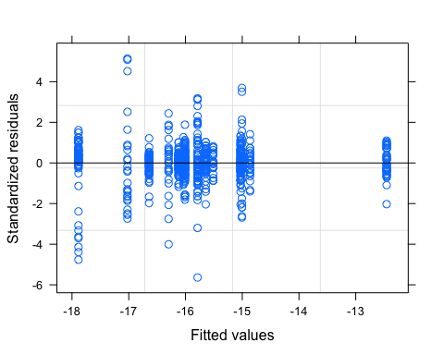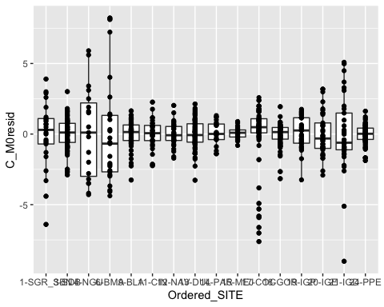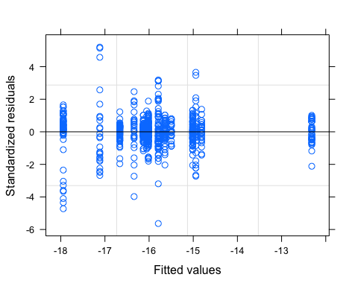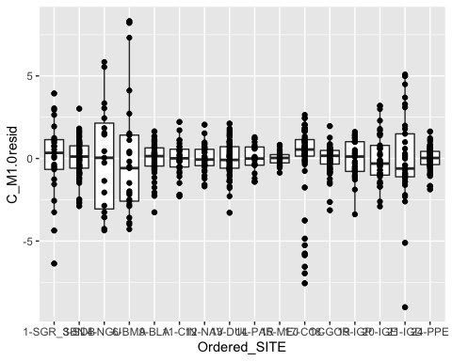

## Linear mixed-effects model fit by REML  
## Data: data   
## AIC BIC logLik  
## 2745.846 2827.817 -1354.923  
##   
## Random effects:  
## Formula: ~1 | Region  
## (Intercept) Residual  
## StdDev: 0.3557858 1.598811  
##   
## Fixed effects: d13C ~ Ordered_SITE   
## Value Std.Error DF t-value p-value  
## (Intercept) -16.340000 0.4783633 699 -34.15814 0.0000  
## Ordered_SITE3-SDB 0.323908 0.3628077 699 0.89278 0.3723  
## Ordered_SITE4-NGU 1.397895 0.4866051 699 2.87275 0.0042  
## Ordered_SITE6-BMA -0.776000 0.4522121 699 -1.71601 0.0866  
## Ordered_SITE9-BLA 0.698491 0.6353307 699 1.09941 0.2720  
## Ordered_SITE11-CIN 1.529286 0.6683620 699 2.28811 0.0224  
## Ordered_SITE12-NAV 0.284242 0.6579328 699 0.43202 0.6659  
## Ordered_SITE13-DUL 1.326486 0.6244663 699 2.12419 0.0340  
## Ordered_SITE14-PAR 0.844762 0.6907522 699 1.22296 0.2218  
## Ordered_SITE15-MEJ 1.406667 0.6907522 699 2.03643 0.0421  
## Ordered_SITE17-COC -1.603284 0.6273493 699 -2.55565 0.0108  
## Ordered_SITE18-GOR -0.323158 0.6237381 699 -0.51810 0.6046  
## Ordered_SITE19-IGP 4.022927 0.6463445 699 6.22412 0.0000  
## Ordered_SITE20-IGE 0.548108 0.6515377 699 0.84125 0.4005  
## Ordered_SITE21-IGD 0.548108 0.6515377 699 0.84125 0.4005  
## Ordered_SITE24-PPE 0.208919 0.6244663 3 0.33456 0.7600  
## Correlation:   
## (Intr) O_SITE3 O_SITE4 O_SITE6 O_SITE9 O_SITE11 O_SITE12  
## Ordered_SITE3-SDB -0.589   
## Ordered_SITE4-NGU -0.439 0.579   
## Ordered_SITE6-BMA -0.473 0.623 0.465   
## Ordered_SITE9-BLA -0.753 0.444 0.331 0.356   
## Ordered_SITE11-CIN -0.716 0.422 0.314 0.338 0.837   
## Ordered_SITE12-NAV -0.727 0.428 0.319 0.344 0.850 0.808   
## Ordered_SITE13-DUL -0.766 0.451 0.336 0.362 0.577 0.548 0.557   
## Ordered_SITE14-PAR -0.693 0.408 0.304 0.327 0.521 0.496 0.504   
## Ordered_SITE15-MEJ -0.693 0.408 0.304 0.327 0.521 0.496 0.504   
## Ordered_SITE17-COC -0.763 0.449 0.335 0.360 0.574 0.546 0.554   
## Ordered_SITE18-GOR -0.767 0.452 0.337 0.363 0.577 0.549 0.558   
## Ordered_SITE19-IGP -0.740 0.436 0.325 0.350 0.557 0.530 0.538   
## Ordered_SITE20-IGE -0.734 0.433 0.323 0.347 0.553 0.525 0.534   
## Ordered_SITE21-IGD -0.734 0.433 0.323 0.347 0.553 0.525 0.534   
## Ordered_SITE24-PPE -0.766 0.451 0.336 0.362 0.577 0.548 0.557   
## O_SITE13 O_SITE14 O_SITE15 O_SITE17 O_SITE18 O_SITE19  
## Ordered_SITE3-SDB   
## Ordered_SITE4-NGU   
## Ordered_SITE6-BMA   
## Ordered_SITE9-BLA   
## Ordered_SITE11-CIN   
## Ordered_SITE12-NAV   
## Ordered_SITE13-DUL   
## Ordered_SITE14-PAR 0.824   
## Ordered_SITE15-MEJ 0.824 0.745   
## Ordered_SITE17-COC 0.584 0.528 0.528   
## Ordered_SITE18-GOR 0.587 0.531 0.531 0.908   
## Ordered_SITE19-IGP 0.567 0.513 0.513 0.877 0.882   
## Ordered_SITE20-IGE 0.562 0.508 0.508 0.870 0.875 0.844   
## Ordered_SITE21-IGD 0.562 0.508 0.508 0.870 0.875 0.844   
## Ordered_SITE24-PPE 0.587 0.530 0.530 0.584 0.587 0.567   
## O_SITE20 O_SITE21  
## Ordered_SITE3-SDB   
## Ordered_SITE4-NGU   
## Ordered_SITE6-BMA   
## Ordered_SITE9-BLA   
## Ordered_SITE11-CIN   
## Ordered_SITE12-NAV   
## Ordered_SITE13-DUL   
## Ordered_SITE14-PAR   
## Ordered_SITE15-MEJ   
## Ordered_SITE17-COC   
## Ordered_SITE18-GOR   
## Ordered_SITE19-IGP   
## Ordered_SITE20-IGE   
## Ordered_SITE21-IGD 0.837   
## Ordered_SITE24-PPE 0.562 0.562   
##   
## Standardized Within-Group Residuals:  
## Min Q1 Med Q3 Max   
## -5.63425432 -0.36682664 0.05956807 0.44452675 5.20136508   
##   
## Number of Observations: 718  
## Number of Groups: 5

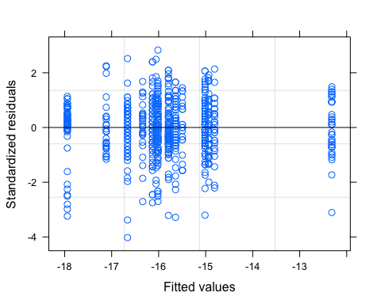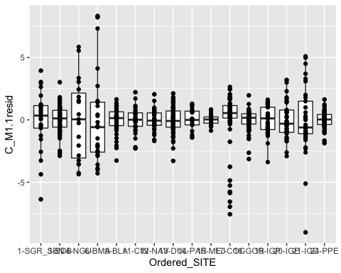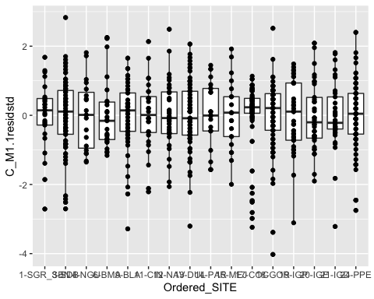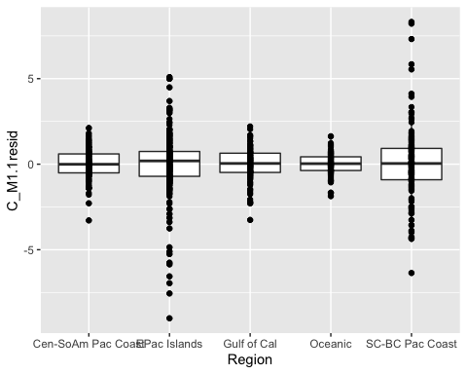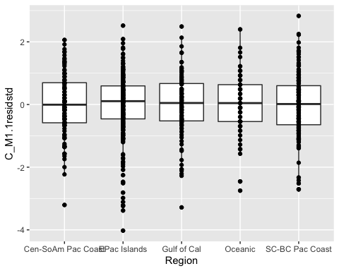

## Linear mixed-effects model fit by REML  
## Data: data   
## AIC BIC logLik  
## 2357.587 2507.867 -1145.794  
##   
## Random effects:  
## Formula: ~1 | Region  
## (Intercept) Residual  
## StdDev: 0.2281737 1.025348  
##   
## Variance function:  
## Structure: Different standard deviations per stratum  
## Formula: ~1 | Ordered_SITE   
## Parameter estimates:  
## 13-DUL 14-PAR 15-MEJ 17-COC 18-GOR 19-IGP 20-IGE 21-IGD   
## 1.0000000 0.8720286 0.4232444 2.2749285 0.7601065 1.0609710 1.4905384 2.7319772   
## 9-BLA 11-CIN 12-NAV 24-PPE 1-SGR_SBN 3-SDB 4-NGU 6-BMA   
## 0.9678292 1.0098258 0.8013033 0.6630219 2.2891212 1.0398159 3.1405197 3.6013454   
## Fixed effects: d13C ~ Ordered_SITE   
## Value Std.Error DF t-value p-value  
## (Intercept) -16.340000 0.5219453 699 -31.305964 0.0000  
## Ordered_SITE3-SDB 0.323908 0.4831453 699 0.670415 0.5028  
## Ordered_SITE4-NGU 1.397895 0.8752777 699 1.597087 0.1107  
## Ordered_SITE6-BMA -0.776000 0.8750912 699 -0.886765 0.3755  
## Ordered_SITE9-BLA 0.698491 0.5857226 699 1.192528 0.2335  
## Ordered_SITE11-CIN 1.529286 0.6023117 699 2.539027 0.0113  
## Ordered_SITE12-NAV 0.284242 0.5873212 699 0.483964 0.6286  
## Ordered_SITE13-DUL 1.326486 0.5819771 699 2.279276 0.0230  
## Ordered_SITE14-PAR 0.844762 0.6021298 699 1.402957 0.1611  
## Ordered_SITE15-MEJ 1.406667 0.5774585 699 2.435961 0.0151  
## Ordered_SITE17-COC -1.603284 0.6369450 699 -2.517146 0.0121  
## Ordered_SITE18-GOR -0.323158 0.5766130 699 -0.560442 0.5754  
## Ordered_SITE19-IGP 4.022927 0.5944365 699 6.767631 0.0000  
## Ordered_SITE20-IGE 0.548108 0.6225904 699 0.880367 0.3790  
## Ordered_SITE21-IGD 0.548108 0.7325078 699 0.748262 0.4546  
## Ordered_SITE24-PPE 0.208919 0.5750962 3 0.363276 0.7405  
## Correlation:   
## (Intr) O_SITE3 O_SITE4 O_SITE6 O_SITE9 O_SITE11 O_SITE12  
## Ordered_SITE3-SDB -0.874   
## Ordered_SITE4-NGU -0.482 0.521   
## Ordered_SITE6-BMA -0.482 0.521 0.288   
## Ordered_SITE9-BLA -0.891 0.779 0.430 0.430   
## Ordered_SITE11-CIN -0.867 0.757 0.418 0.418 0.920   
## Ordered_SITE12-NAV -0.889 0.777 0.429 0.429 0.943 0.917   
## Ordered_SITE13-DUL -0.897 0.784 0.433 0.433 0.799 0.777 0.797   
## Ordered_SITE14-PAR -0.867 0.757 0.418 0.418 0.772 0.751 0.770   
## Ordered_SITE15-MEJ -0.904 0.790 0.436 0.436 0.805 0.783 0.803   
## Ordered_SITE17-COC -0.819 0.716 0.395 0.395 0.730 0.710 0.728   
## Ordered_SITE18-GOR -0.905 0.791 0.437 0.437 0.807 0.784 0.804   
## Ordered_SITE19-IGP -0.878 0.767 0.424 0.424 0.782 0.761 0.780   
## Ordered_SITE20-IGE -0.838 0.733 0.404 0.404 0.747 0.726 0.745   
## Ordered_SITE21-IGD -0.713 0.623 0.344 0.344 0.635 0.617 0.633   
## Ordered_SITE24-PPE -0.908 0.793 0.438 0.438 0.809 0.786 0.807   
## O_SITE13 O_SITE14 O_SITE15 O_SITE17 O_SITE18 O_SITE19  
## Ordered_SITE3-SDB   
## Ordered_SITE4-NGU   
## Ordered_SITE6-BMA   
## Ordered_SITE9-BLA   
## Ordered_SITE11-CIN   
## Ordered_SITE12-NAV   
## Ordered_SITE13-DUL   
## Ordered_SITE14-PAR 0.926   
## Ordered_SITE15-MEJ 0.966 0.933   
## Ordered_SITE17-COC 0.735 0.710 0.741   
## Ordered_SITE18-GOR 0.812 0.785 0.818 0.884   
## Ordered_SITE19-IGP 0.787 0.761 0.794 0.857 0.947   
## Ordered_SITE20-IGE 0.752 0.727 0.758 0.818 0.904 0.877   
## Ordered_SITE21-IGD 0.639 0.618 0.644 0.695 0.768 0.745   
## Ordered_SITE24-PPE 0.814 0.787 0.820 0.744 0.822 0.797   
## O_SITE20 O_SITE21  
## Ordered_SITE3-SDB   
## Ordered_SITE4-NGU   
## Ordered_SITE6-BMA   
## Ordered_SITE9-BLA   
## Ordered_SITE11-CIN   
## Ordered_SITE12-NAV   
## Ordered_SITE13-DUL   
## Ordered_SITE14-PAR   
## Ordered_SITE15-MEJ   
## Ordered_SITE17-COC   
## Ordered_SITE18-GOR   
## Ordered_SITE19-IGP   
## Ordered_SITE20-IGE   
## Ordered_SITE21-IGD 0.712   
## Ordered_SITE24-PPE 0.761 0.647   
##   
## Standardized Within-Group Residuals:  
## Min Q1 Med Q3 Max   
## -4.02482539 -0.54766733 0.07265628 0.66571573 2.82889582   
##   
## Number of Observations: 718  
## Number of Groups: 5

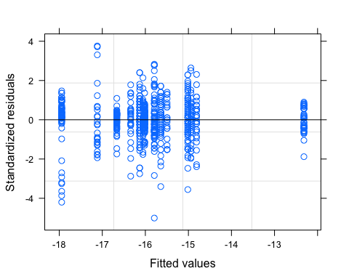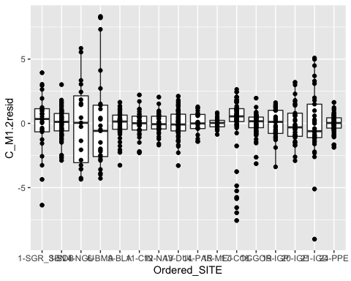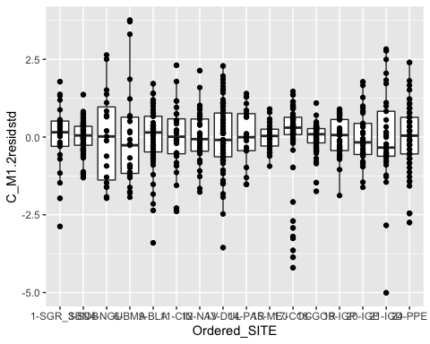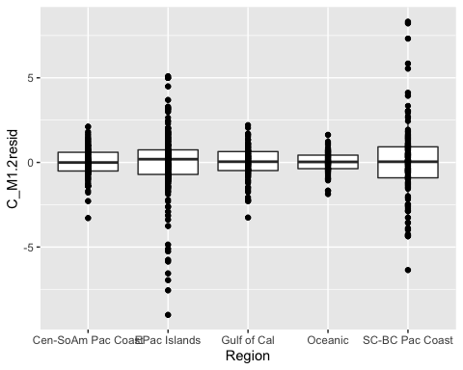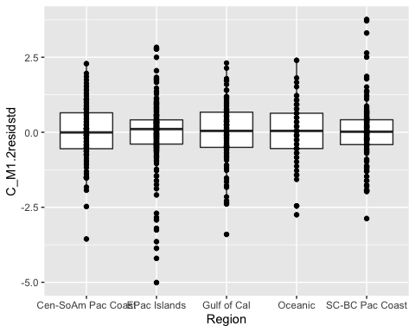

## Linear mixed-effects model fit by REML  
## Data: data   
## AIC BIC logLik  
## 2549.62 2649.806 -1252.81  
##   
## Random effects:  
## Formula: ~1 | Region  
## (Intercept) Residual  
## StdDev: 0.205647 0.9241237  
##   
## Variance function:  
## Structure: Different standard deviations per stratum  
## Formula: ~1 | Region   
## Parameter estimates:  
## Cen-SoAm Pac Coast EPac Islands Gulf of Cal Oceanic   
## 1.0000000 1.9464310 1.0360745 0.7356491   
## SC-BC Pac Coast   
## 2.3938602   
## Fixed effects: d13C ~ Ordered_SITE   
## Value Std.Error DF t-value p-value  
## (Intercept) -16.340000 0.4879015 699 -33.49036 0.0000  
## Ordered_SITE3-SDB 0.323908 0.5020053 699 0.64523 0.5190  
## Ordered_SITE4-NGU 1.397895 0.6732997 699 2.07619 0.0382  
## Ordered_SITE6-BMA -0.776000 0.6257111 699 -1.24019 0.2153  
## Ordered_SITE9-BLA 0.698491 0.5455597 699 1.28032 0.2009  
## Ordered_SITE11-CIN 1.529286 0.5595346 699 2.73314 0.0064  
## Ordered_SITE12-NAV 0.284242 0.5550841 699 0.51207 0.6088  
## Ordered_SITE13-DUL 1.326486 0.5402585 699 2.45528 0.0143  
## Ordered_SITE14-PAR 0.844762 0.5665735 699 1.49100 0.1364  
## Ordered_SITE15-MEJ 1.406667 0.5665735 699 2.48276 0.0133  
## Ordered_SITE17-COC -1.603284 0.5732620 699 -2.79677 0.0053  
## Ordered_SITE18-GOR -0.323158 0.5682523 699 -0.56869 0.5698  
## Ordered_SITE19-IGP 4.022927 0.5993769 699 6.71185 0.0000  
## Ordered_SITE20-IGE 0.548108 0.6064519 699 0.90379 0.3664  
## Ordered_SITE21-IGD 0.548108 0.6064519 699 0.90379 0.3664  
## Ordered_SITE24-PPE 0.208919 0.5353355 3 0.39026 0.7224  
## Correlation:   
## (Intr) O_SITE3 O_SITE4 O_SITE6 O_SITE9 O_SITE11 O_SITE12  
## Ordered_SITE3-SDB -0.799   
## Ordered_SITE4-NGU -0.596 0.579   
## Ordered_SITE6-BMA -0.641 0.623 0.465   
## Ordered_SITE9-BLA -0.894 0.715 0.533 0.573   
## Ordered_SITE11-CIN -0.872 0.697 0.520 0.559 0.918   
## Ordered_SITE12-NAV -0.879 0.703 0.524 0.564 0.926 0.903   
## Ordered_SITE13-DUL -0.903 0.722 0.538 0.579 0.808 0.787 0.794   
## Ordered_SITE14-PAR -0.861 0.688 0.513 0.552 0.770 0.751 0.757   
## Ordered_SITE15-MEJ -0.861 0.688 0.513 0.552 0.770 0.751 0.757   
## Ordered_SITE17-COC -0.851 0.680 0.507 0.546 0.761 0.742 0.748   
## Ordered_SITE18-GOR -0.859 0.686 0.512 0.551 0.768 0.749 0.755   
## Ordered_SITE19-IGP -0.814 0.651 0.485 0.522 0.728 0.710 0.715   
## Ordered_SITE20-IGE -0.805 0.643 0.479 0.516 0.719 0.702 0.707   
## Ordered_SITE21-IGD -0.805 0.643 0.479 0.516 0.719 0.702 0.707   
## Ordered_SITE24-PPE -0.911 0.728 0.543 0.584 0.815 0.795 0.801   
## O_SITE13 O_SITE14 O_SITE15 O_SITE17 O_SITE18 O_SITE19  
## Ordered_SITE3-SDB   
## Ordered_SITE4-NGU   
## Ordered_SITE6-BMA   
## Ordered_SITE9-BLA   
## Ordered_SITE11-CIN   
## Ordered_SITE12-NAV   
## Ordered_SITE13-DUL   
## Ordered_SITE14-PAR 0.916   
## Ordered_SITE15-MEJ 0.916 0.873   
## Ordered_SITE17-COC 0.769 0.733 0.733   
## Ordered_SITE18-GOR 0.775 0.739 0.739 0.861   
## Ordered_SITE19-IGP 0.735 0.701 0.701 0.816 0.823   
## Ordered_SITE20-IGE 0.727 0.693 0.693 0.806 0.813 0.771   
## Ordered_SITE21-IGD 0.727 0.693 0.693 0.806 0.813 0.771   
## Ordered_SITE24-PPE 0.823 0.785 0.785 0.776 0.783 0.742   
## O_SITE20 O_SITE21  
## Ordered_SITE3-SDB   
## Ordered_SITE4-NGU   
## Ordered_SITE6-BMA   
## Ordered_SITE9-BLA   
## Ordered_SITE11-CIN   
## Ordered_SITE12-NAV   
## Ordered_SITE13-DUL   
## Ordered_SITE14-PAR   
## Ordered_SITE15-MEJ   
## Ordered_SITE17-COC   
## Ordered_SITE18-GOR   
## Ordered_SITE19-IGP   
## Ordered_SITE20-IGE   
## Ordered_SITE21-IGD 0.762   
## Ordered_SITE24-PPE 0.733 0.733   
##   
## Standardized Within-Group Residuals:  
## Min Q1 Med Q3 Max   
## -5.00800197 -0.46523719 0.05247751 0.51261696 3.75911485   
##   
## Number of Observations: 718  
## Number of Groups: 5

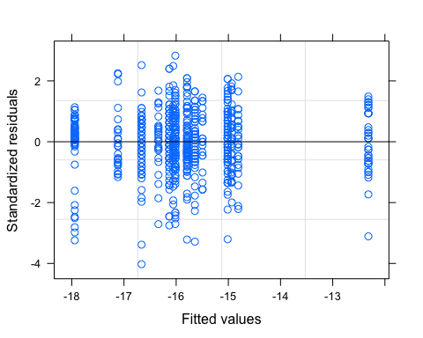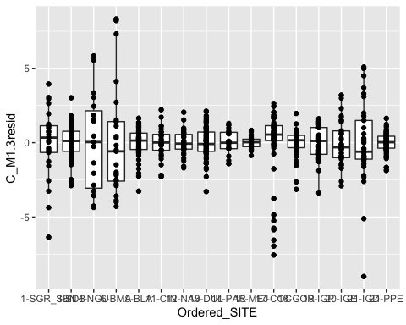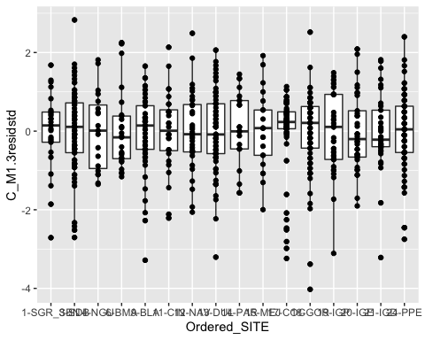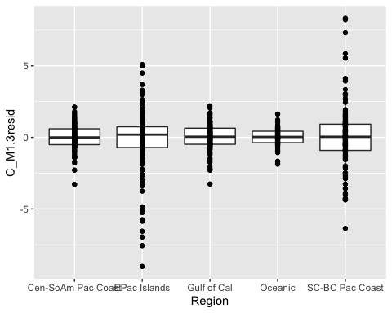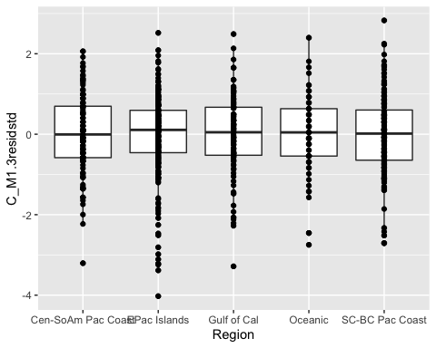

## Linear mixed-effects model fit by REML  
## Data: data   
## AIC BIC logLik  
## 2365.587 2534.083 -1145.794  
##   
## Random effects:  
## Formula: ~1 | Region  
## (Intercept) Residual  
## StdDev: 0.22817 1.02534  
##   
## Combination of variance functions:   
## Structure: Different standard deviations per stratum  
## Formula: ~1 | Region   
## Parameter estimates:  
## Cen-SoAm Pac Coast EPac Islands Gulf of Cal Oceanic   
## 1.0000000 1.3981712 0.9407325 0.8142666   
## SC-BC Pac Coast   
## 1.9320785   
## Structure: Different standard deviations per stratum  
## Formula: ~1 | Ordered_SITE   
## Parameter estimates:  
## 13-DUL 14-PAR 15-MEJ 17-COC 18-GOR 19-IGP 20-IGE 21-IGD   
## 1.0000000 0.8720400 0.4232498 1.6270889 0.5436483 0.7588321 1.0660734 1.9539714   
## 9-BLA 11-CIN 12-NAV 24-PPE 1-SGR_SBN 3-SDB 4-NGU 6-BMA   
## 1.0288164 1.0734499 0.8517886 0.8142666 1.1848154 0.5381858 1.6254867 1.8639845   
## Fixed effects: d13C ~ Ordered_SITE   
## Value Std.Error DF t-value p-value  
## (Intercept) -16.340000 0.5219471 699 -31.305856 0.0000  
## Ordered_SITE3-SDB 0.323908 0.4831489 699 0.670410 0.5028  
## Ordered_SITE4-NGU 1.397895 0.8752849 699 1.597074 0.1107  
## Ordered_SITE6-BMA -0.776000 0.8750920 699 -0.886764 0.3755  
## Ordered_SITE9-BLA 0.698491 0.5857228 699 1.192527 0.2335  
## Ordered_SITE11-CIN 1.529286 0.6023116 699 2.539028 0.0113  
## Ordered_SITE12-NAV 0.284242 0.5873212 699 0.483964 0.6286  
## Ordered_SITE13-DUL 1.326486 0.5819771 699 2.279276 0.0230  
## Ordered_SITE14-PAR 0.844762 0.6021303 699 1.402955 0.1611  
## Ordered_SITE15-MEJ 1.406667 0.5774587 699 2.435961 0.0151  
## Ordered_SITE17-COC -1.603284 0.6369453 699 -2.517145 0.0121  
## Ordered_SITE18-GOR -0.323158 0.5766131 699 -0.560441 0.5754  
## Ordered_SITE19-IGP 4.022927 0.5944365 699 6.767631 0.0000  
## Ordered_SITE20-IGE 0.548108 0.6225908 699 0.880367 0.3790  
## Ordered_SITE21-IGD 0.548108 0.7325068 699 0.748263 0.4546  
## Ordered_SITE24-PPE 0.208919 0.5750964 3 0.363276 0.7405  
## Correlation:   
## (Intr) O_SITE3 O_SITE4 O_SITE6 O_SITE9 O_SITE11 O_SITE12  
## Ordered_SITE3-SDB -0.874   
## Ordered_SITE4-NGU -0.482 0.521   
## Ordered_SITE6-BMA -0.482 0.521 0.288   
## Ordered_SITE9-BLA -0.891 0.779 0.430 0.430   
## Ordered_SITE11-CIN -0.867 0.757 0.418 0.418 0.920   
## Ordered_SITE12-NAV -0.889 0.777 0.429 0.429 0.943 0.917   
## Ordered_SITE13-DUL -0.897 0.784 0.433 0.433 0.799 0.777 0.797   
## Ordered_SITE14-PAR -0.867 0.757 0.418 0.418 0.772 0.751 0.770   
## Ordered_SITE15-MEJ -0.904 0.790 0.436 0.436 0.805 0.783 0.803   
## Ordered_SITE17-COC -0.819 0.716 0.395 0.395 0.730 0.710 0.728   
## Ordered_SITE18-GOR -0.905 0.791 0.437 0.437 0.807 0.784 0.804   
## Ordered_SITE19-IGP -0.878 0.767 0.424 0.424 0.782 0.761 0.780   
## Ordered_SITE20-IGE -0.838 0.733 0.404 0.404 0.747 0.726 0.745   
## Ordered_SITE21-IGD -0.713 0.623 0.344 0.344 0.635 0.617 0.633   
## Ordered_SITE24-PPE -0.908 0.793 0.438 0.438 0.809 0.786 0.807   
## O_SITE13 O_SITE14 O_SITE15 O_SITE17 O_SITE18 O_SITE19  
## Ordered_SITE3-SDB   
## Ordered_SITE4-NGU   
## Ordered_SITE6-BMA   
## Ordered_SITE9-BLA   
## Ordered_SITE11-CIN   
## Ordered_SITE12-NAV   
## Ordered_SITE13-DUL   
## Ordered_SITE14-PAR 0.926   
## Ordered_SITE15-MEJ 0.966 0.933   
## Ordered_SITE17-COC 0.735 0.710 0.741   
## Ordered_SITE18-GOR 0.812 0.785 0.818 0.884   
## Ordered_SITE19-IGP 0.787 0.761 0.794 0.857 0.947   
## Ordered_SITE20-IGE 0.752 0.727 0.758 0.818 0.904 0.877   
## Ordered_SITE21-IGD 0.639 0.618 0.644 0.695 0.768 0.745   
## Ordered_SITE24-PPE 0.814 0.787 0.820 0.744 0.822 0.797   
## O_SITE20 O_SITE21  
## Ordered_SITE3-SDB   
## Ordered_SITE4-NGU   
## Ordered_SITE6-BMA   
## Ordered_SITE9-BLA   
## Ordered_SITE11-CIN   
## Ordered_SITE12-NAV   
## Ordered_SITE13-DUL   
## Ordered_SITE14-PAR   
## Ordered_SITE15-MEJ   
## Ordered_SITE17-COC   
## Ordered_SITE18-GOR   
## Ordered_SITE19-IGP   
## Ordered_SITE20-IGE   
## Ordered_SITE21-IGD 0.712   
## Ordered_SITE24-PPE 0.761 0.647   
##   
## Standardized Within-Group Residuals:  
## Min Q1 Med Q3 Max   
## -4.0248181 -0.5476706 0.0726562 0.6657119 2.8289127   
##   
## Number of Observations: 718  
## Number of Groups: 5

## Warning in anova.lme(C_M1.null, C_M1.0, C_M1.1, C_M1.2, C_M1.3): fitted objects  
## with different fixed effects. REML comparisons are not meaningful.

## Model df AIC BIC logLik Test L.Ratio p-value  
## C_M1.null 1 3 3015.483 3029.208 -1504.741   
## C_M1.0 2 18 2745.846 2827.817 -1354.923 1 vs 2 299.6363 <.0001  
## C_M1.1 3 33 2357.587 2507.867 -1145.794 2 vs 3 418.2589 <.0001  
## C_M1.2 4 22 2549.620 2649.806 -1252.810 3 vs 4 214.0324 <.0001  
## C_M1.3 5 37 2365.587 2534.083 -1145.794 4 vs 5 214.0324 <.0001

## Model df AIC BIC logLik Test L.Ratio p-value  
## C_M1.1 1 33 2357.587 2507.867 -1145.794   
## C_M1.3 2 37 2365.587 2534.083 -1145.794 1 vs 2 8.694769e-09 1

## Model selection table   
## (Int) Ord_SIT weights df logLik AICc delta weight  
## C_M1.1 -16.34 + vI(Or_SI) 33 -1145.794 2360.9 0.00 0.988  
## C_M1.3 -16.34 + vR 37 -1145.794 2369.7 8.85 0.012  
## C_M1.2 -16.34 + vI(Rg) 22 -1252.810 2551.1 190.21 0.000  
## C_M1.0 -16.34 + 18 -1354.923 2746.8 385.96 0.000  
## C_M1.null -15.79 3 -1504.741 3015.5 654.65 0.000  
## Abbreviations:  
## weights: vI(Or_SI) = 'varIdent(~1|Ordered_SITE)',   
## vI(Rg) = 'varIdent(~1|Region)', vR = 'varRegionSite'  
## Models ranked by AICc(x)   
## Random terms (all models):   
## '1 | Region'

## [1] "BLA" "BMA" "CIN" "COC" "DUL" "GOR" "IGD" "IGE" "IGP" "LB" "MEJ" "NAV"  
## [13] "NGU" "PAR" "PPE" "SDB"

## [1] "Central-S. America Pacific Coast" "East Pacific Islands"   
## [3] "Gulf of California" "Oceanic"   
## [5] "SoCal-Baja Pacific Coast"

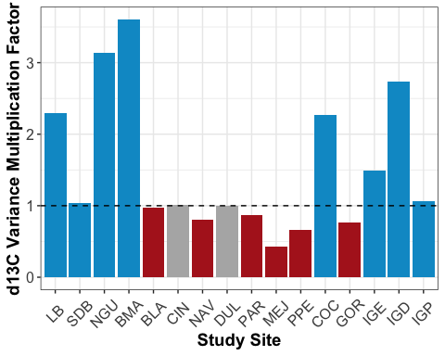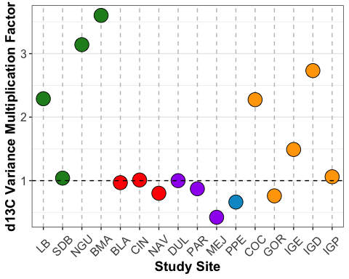

#### Linear Models

Note: these are now just anovas bc took out turtle body size due to missing data from some sites. Just left these in from EDA in case turns out useful to look at fanning, etc.

## SITE_No SITE_CODE Ordered_SITE  
## Min. : 1.00 SDB : 87 3-SDB : 87   
## 1st Qu.: 9.00 GOR : 76 18-GOR : 76   
## Median :14.00 DUL : 74 13-DUL : 74   
## Mean :13.73 PPE : 74 24-PPE : 74   
## 3rd Qu.:19.00 COC : 67 17-COC : 67   
## Max. :24.00 BLA : 53 9-BLA : 53   
## (Other):287 (Other):287   
## Location_Label Habitat_Type Region   
## San Diego Bay, USA : 87 coastal:386 Cen-SoAm Pac Coast:116   
## Isla Gorgona, Colombia : 76 insular:258 EPac Islands :258   
## Golfo Dulce, Costa Rica : 74 oceanic: 74 Gulf of Cal :114   
## Oceanic Waters, Peru (Longline): 74 Oceanic : 74   
## Cocos Island, Costa Rica : 67 SC-BC Pac Coast :156   
## Bahia de los Angeles, GoC, MX : 53   
## (Other) :287   
## Location LABID   
## San Diego Bay, United States : 87 : 33   
## Isla Gorgona, Colombia : 76 101 : 1   
## Golfo Dulce, Costa Rica : 74 102 : 1   
## Oceanic Waters, Peru (Longline) : 74 103 : 1   
## Cocos Island, Costa Rica : 67 104 : 1   
## Bahia de los Angeles, Gulf of California, Mexico: 53 105087 : 1   
## (Other) :287 (Other):680   
## Collect_Date Run_Date Percent_N   
## Min. :0000-03-23 00:00:00 Min. :0003-01-17 00:00:00 Min. : 5.30   
## 1st Qu.:0004-11-15 06:00:00 1st Qu.:0005-01-26 18:00:00 1st Qu.:11.70   
## Median :0008-09-23 12:00:00 Median :0007-06-07 00:00:00 Median :13.40   
## Mean :0009-09-08 08:34:18 Mean :0007-07-31 14:45:00 Mean :12.98   
## 3rd Qu.:0011-03-08 18:00:00 3rd Qu.:0007-08-09 00:00:00 3rd Qu.:14.70   
## Max. :0099-02-04 00:00:00 Max. :0014-02-10 00:00:00 Max. :17.00   
## NA's :32 NA's :430 NA's :87   
## Percent_C d15N d13C COLOR SCL   
## Min. :18.7 Min. : 7.0 Min. :-25.50 :642 Min. : 39.70   
## 1st Qu.:38.2 1st Qu.:11.9 1st Qu.:-16.80 BLACK : 29 1st Qu.: 56.80   
## Median :42.5 Median :13.6 Median :-15.98 YELLOW: 47 Median : 65.10   
## Mean :41.1 Mean :13.8 Mean :-15.84 Mean : 67.97   
## 3rd Qu.:45.2 3rd Qu.:15.7 3rd Qu.:-14.90 3rd Qu.: 74.88   
## Max. :65.0 Max. :21.2 Max. : -8.80 Max. :110.40   
## NA's :87 NA's :368   
## CCL_calc_fromSCL CCL_empirical CCL_combined Alt.ID   
## Min. : 43.39 Min. : 42.70 Min. : 42.70 :594   
## 1st Qu.: 61.11 1st Qu.: 65.67 1st Qu.: 62.00 Alt ID : 24   
## Median : 69.71 Median : 75.00 Median : 71.68 : 4   
## Mean : 72.69 Mean : 75.28 Mean : 72.68 100 : 1   
## 3rd Qu.: 79.84 3rd Qu.: 82.30 3rd Qu.: 80.00 105 : 1   
## Max. :116.65 Max. :116.50 Max. :116.50 106 : 1   
## NA's :368 NA's :328 NA's :197 (Other): 93   
## Notes N_M0resid   
## :709 Min. :-5.48057   
## : 8 1st Qu.:-0.76760   
## no measurements taken, confirmed in SDB Binder: 1 Median : 0.01943   
## Mean : 0.00000   
## 3rd Qu.: 0.78385   
## Max. : 6.79386   
##   
## N_M1.0resid N_M1.1resid N_M1.1residstd N_M1.2resid   
## Min. :-5.4806 Min. :-5.4806 Min. :-3.81423 Min. :-5.4806   
## 1st Qu.:-0.7770 1st Qu.:-0.7770 1st Qu.:-0.59962 1st Qu.:-0.7770   
## Median : 0.0194 Median : 0.0194 Median : 0.01229 Median : 0.0194   
## Mean : 0.0000 Mean : 0.0000 Mean : 0.00000 Mean : 0.0000   
## 3rd Qu.: 0.7916 3rd Qu.: 0.7916 3rd Qu.: 0.61509 3rd Qu.: 0.7916   
## Max. : 6.8600 Max. : 6.8600 Max. : 3.37035 Max. : 6.8600   
##   
## N_M1.2residstd N_M1.3resid N_M1.3residstd C_M0resid   
## Min. :-4.64575 Min. :-5.4806 Min. :-3.81425 Min. :-9.0126   
## 1st Qu.:-0.59147 1st Qu.:-0.7770 1st Qu.:-0.59963 1st Qu.:-0.5785   
## Median : 0.01645 Median : 0.0194 Median : 0.01229 Median : 0.0896   
## Mean : 0.00000 Mean : 0.0000 Mean : 0.00000 Mean : 0.0000   
## 3rd Qu.: 0.58421 3rd Qu.: 0.7916 3rd Qu.: 0.61508 3rd Qu.: 0.6871   
## Max. : 4.50911 Max. : 6.8600 Max. : 3.37037 Max. : 8.2229   
##   
## C_M1.0resid C_M1.1resid C_M1.1residstd C_M1.2resid   
## Min. :-9.00811 Min. :-9.00811 Min. :-4.02482 Min. :-9.00811   
## 1st Qu.:-0.58649 1st Qu.:-0.58649 1st Qu.:-0.54767 1st Qu.:-0.58649   
## Median : 0.09524 Median : 0.09524 Median : 0.07266 Median : 0.09524   
## Mean : 0.00000 Mean : 0.00000 Mean : 0.00000 Mean : 0.00000   
## 3rd Qu.: 0.71071 3rd Qu.: 0.71071 3rd Qu.: 0.66572 3rd Qu.: 0.71071   
## Max. : 8.31600 Max. : 8.31600 Max. : 2.82890 Max. : 8.31600   
##   
## C_M1.2residstd C_M1.3resid C_M1.3residstd   
## Min. :-5.00800 Min. :-9.00811 Min. :-4.02482   
## 1st Qu.:-0.46524 1st Qu.:-0.58649 1st Qu.:-0.54767   
## Median : 0.05248 Median : 0.09524 Median : 0.07266   
## Mean : 0.00000 Mean : 0.00000 Mean : 0.00000   
## 3rd Qu.: 0.51262 3rd Qu.: 0.71071 3rd Qu.: 0.66571   
## Max. : 3.75911 Max. : 8.31600 Max. : 2.82891   
##

##   
## 1-SGR_SBN 3-SDB 4-NGU 6-BMA 9-BLA 11-CIN 12-NAV 13-DUL   
## 25 87 19 25 53 28 33 74   
## 14-PAR 15-MEJ 17-COC 18-GOR 19-IGP 20-IGE 21-IGD 24-PPE   
## 21 21 67 76 41 37 37 74

## Cen-SoAm Pac Coast EPac Islands Gulf of Cal Oceanic   
## 116 258 114 0   
## SC-BC Pac Coast   
## 156

## Df Sum Sq Mean Sq F value Pr(>F)   
## Ordered_SITE 3 1382.3 460.8 149.9 <2e-16 ***  
## Residuals 152 467.2 3.1   
## ---  
## Signif. codes: 0 '***' 0.001 '**' 0.01 '*' 0.05 '.' 0.1 ' ' 1

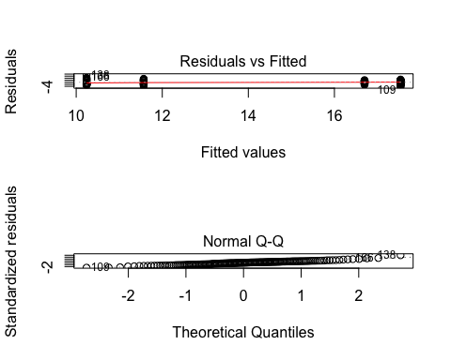

## null device   
## 1

## Df Sum Sq Mean Sq F value Pr(>F)   
## Ordered_SITE 2 7.87 3.937 3.004 0.0536 .  
## Residuals 111 145.47 1.311   
## ---  
## Signif. codes: 0 '***' 0.001 '**' 0.01 '*' 0.05 '.' 0.1 ' ' 1

## null device   
## 1

## Df Sum Sq Mean Sq F value Pr(>F)   
## Ordered_SITE 2 213.4 106.72 31.68 1.2e-11 ***  
## Residuals 113 380.7 3.37   
## ---  
## Signif. codes: 0 '***' 0.001 '**' 0.01 '*' 0.05 '.' 0.1 ' ' 1

## null device   
## 1

## Df Sum Sq Mean Sq F value Pr(>F)   
## Ordered_SITE 4 198.5 49.62 35.66 <2e-16 ***  
## Residuals 253 352.1 1.39   
## ---  
## Signif. codes: 0 '***' 0.001 '**' 0.01 '*' 0.05 '.' 0.1 ' ' 1

## null device   
## 1

## Df Sum Sq Mean Sq F value Pr(>F)   
## Ordered_SITE 3 53.3 17.768 3.631 0.0144 *  
## Residuals 152 743.9 4.894   
## ---  
## Signif. codes: 0 '***' 0.001 '**' 0.01 '*' 0.05 '.' 0.1 ' ' 1

## null device   
## 1

## Df Sum Sq Mean Sq F value Pr(>F)   
## Ordered_SITE 2 24.18 12.091 13.19 7.26e-06 ***  
## Residuals 111 101.76 0.917   
## ---  
## Signif. codes: 0 '***' 0.001 '**' 0.01 '*' 0.05 '.' 0.1 ' ' 1

## null device   
## 1

## Df Sum Sq Mean Sq F value Pr(>F)   
## Ordered_SITE 2 4.4 2.198 2.573 0.0807 .  
## Residuals 113 96.5 0.854   
## ---  
## Signif. codes: 0 '***' 0.001 '**' 0.01 '*' 0.05 '.' 0.1 ' ' 1

## null device   
## 1

## Df Sum Sq Mean Sq F value Pr(>F)   
## Ordered_SITE 4 845.0 211.25 65.29 <2e-16 ***  
## Residuals 253 818.6 3.24   
## ---  
## Signif. codes: 0 '***' 0.001 '**' 0.01 '*' 0.05 '.' 0.1 ' ' 1

## null device   
## 1