All your codes save it into file with your ID Name_Surname_ID.txt
- Create DB MidTerm_Your_ID (Пр. MidTerm_9051).
- Create empty DB, like on the image (diagram):
Tables

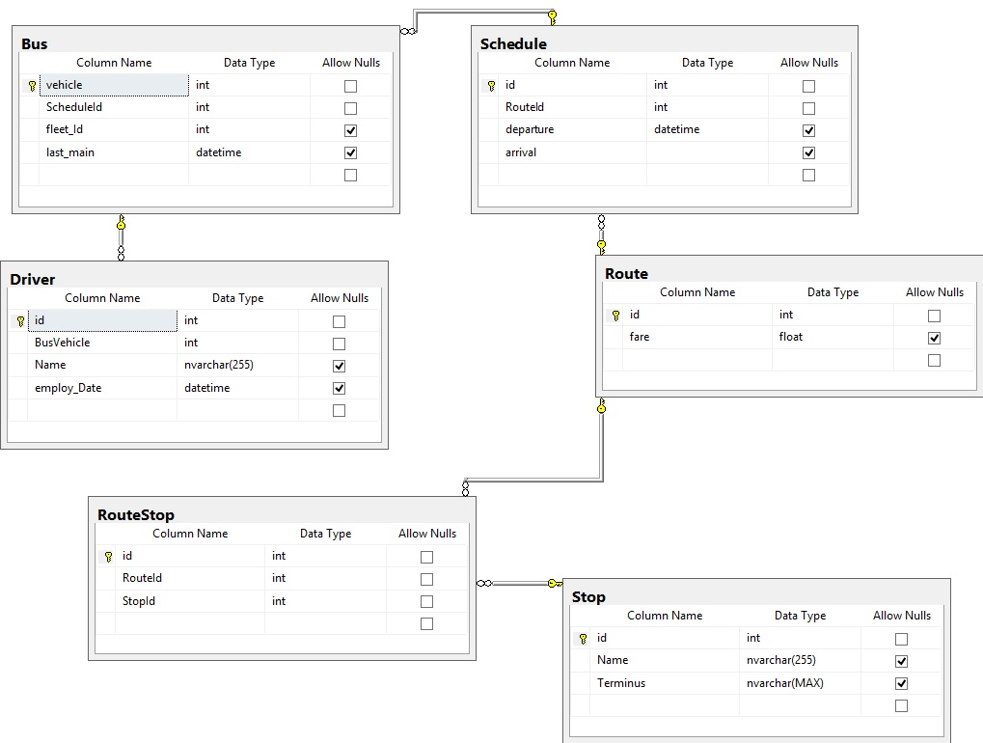
Tip: Create tables without relations and afterword from excel import the data, you can try with copy-paste
- Write a Migration plan
- Create table driverStat with columns
- ID_STAT, NUMERIC, PK IDENTITY(1,1)
- DESC_STAT TEXT(500)
- DATE_STAT DATETIME

- Create Trigger which will activate on a new Vehicle. Trigger will add data into column DESC_STAT in the following format:
DESC_STAТ A new vehicle is inserted with an ID = ID, which will go on the route = ScheduleId
- Bonus: DESC_STAТ A new vehicle is inserted with an ID = ID, which will go on the route = RouteId

DATE_STAT: timestamp (date and hour)

Ex. A new vehicle is inserted with an id=23, which will go on a route = 3
(A new vehicle is inserted with an id=23, which will go on a route = 6)

- Create Procedure that will return ALL bus stops that a vehicle stops at (vehicle ID passed as a parameter) and the time of passing
- Create a function that for a given date will output how many days that month has.
  - Ex. FunctionName(‘20161015’) = 31

- Create view that has all the data for each bus stop that belongs to some route.

- Generate a script that will consist structure and Data of your database.

- Create folder that will have
  - Files from your database
  - Backup
  - Files with codes.SSSSS

