Snapshots :

1. client and server running on same system
shows : adding new user and sending emails ad reading emails
also shows the error raised by server on incomplete or invalid commands
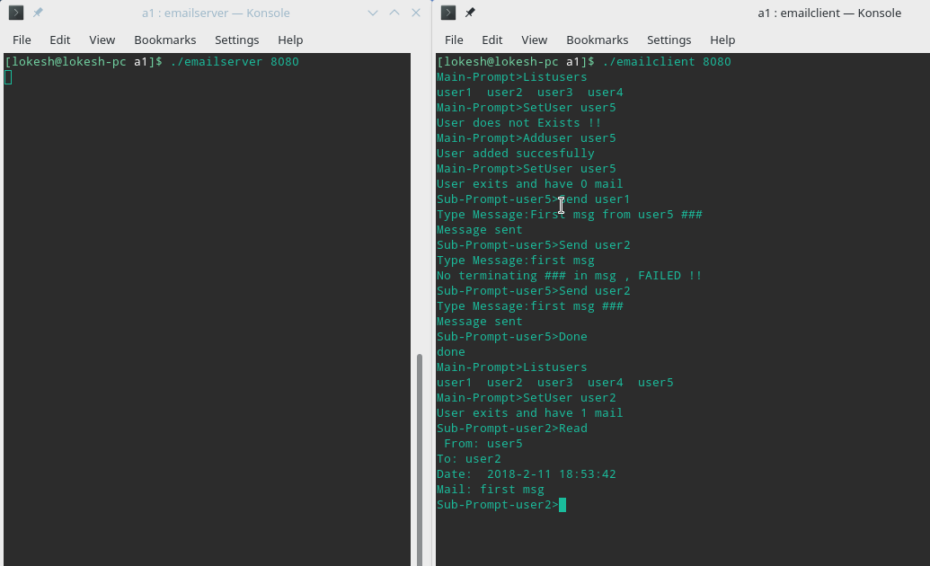

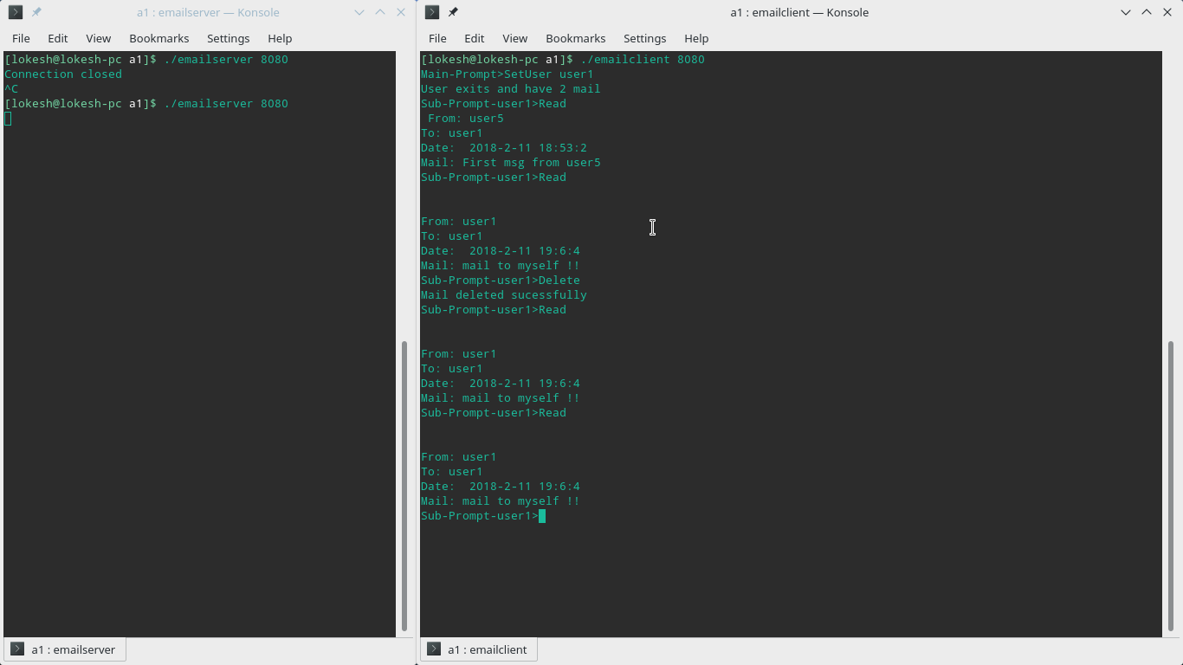
2. Delete mail command

3. below snapshot shows that port 0 is system port and the client and serve both should have same port number when running on same system
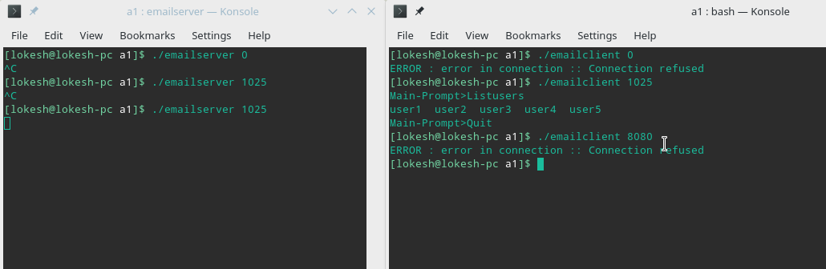

4. Sending self Mails( from user1 to user1 below )

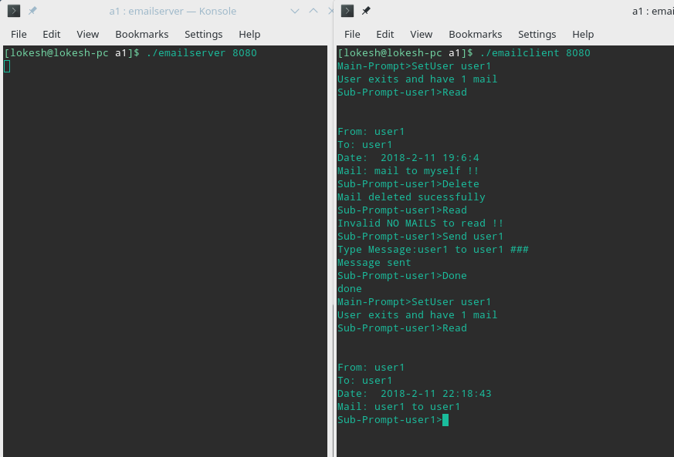

Summary :
lessons learnt:
1. how to create TCP sockets , listen to sockets and send , receive messages through them.
2. what are ports ?how and why they are used in networking systems.
3. Ports can be any integer from 1025 to 65535 (0-1024 are system reserved) but mostly port number from 8000 are for html connection.
4. port binding with specific sockets and exceptions raised by system.
5. various step involved while communicating through network systems.
6. revision of system programming in C.

i feel the assignment was pretty helpful for me to totally understand the theory behind sockets and client user interface.

