PCB Stitching Vias & Shielding Vias
Complete Reference Notes — Grounding, Return Paths & EMI Control

Quick Glossary
A few terms used throughout these notes, explained in plain language:
- Via — a small plated hole that lets electricity pass from one copper layer of the board to another, like a mini elevator between floors.
- Ground (GND) plane — a sheet of copper used as the board's common electrical “floor level” that current returns to.
- Return current — every signal that goes out needs a path back; this is that path, usually through the nearest ground copper.
- Impedance — the overall “resistance” a signal feels while travelling, including effects that only show up at high speed.
- Loop inductance — a property that grows when the outgoing signal and its return path are far apart; larger loops resist fast changes more and radiate more noise.
- EMI (Electromagnetic Interference) — unwanted electrical noise that leaks out of a circuit and can disturb nearby circuits.
- Crosstalk — unwanted signal “leaking” from one trace into a neighbouring trace.

1. Introduction
In PCB design, vias are plated holes that electrically connect copper traces or planes on different PCB layers. Two important categories of ground vias covered in these notes are:
- Stitching Via
- Shielding Via (Ground Via Fence)
Although the two are physically identical (a plated through-hole connected to ground), they differ in placement pattern and design intent.
💡 Beginner tip: Think of a via like a tiny elevator inside the board. It lets electricity move straight up or down between copper “floors” (layers) instead of only sideways.

2. What is a Stitching Via?
A stitching via connects copper areas belonging to the same electrical net across different PCB layers — most commonly Ground → Ground, and occasionally Power (VCC) → Power (VCC) on boards with split or multiple power planes.
It is called “stitching” because it stitches together copper planes on different layers so they behave electrically as one continuous plane.
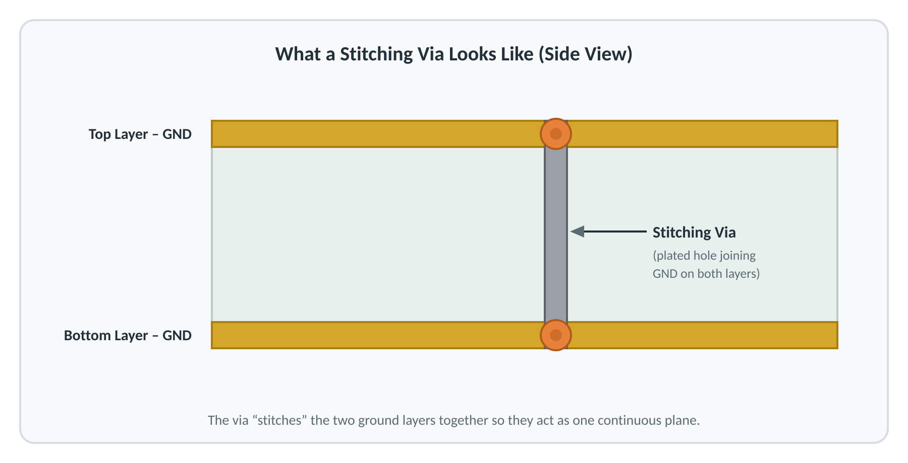

3. Why Do We Use Stitching Vias?

3.1 Maintain a Continuous Ground Plane
Ground planes on different layers should behave like one solid conductor. Without stitching vias, only a few distant connections exist between layers; with stitching vias distributed across the plane, the layers are tied together at many points.
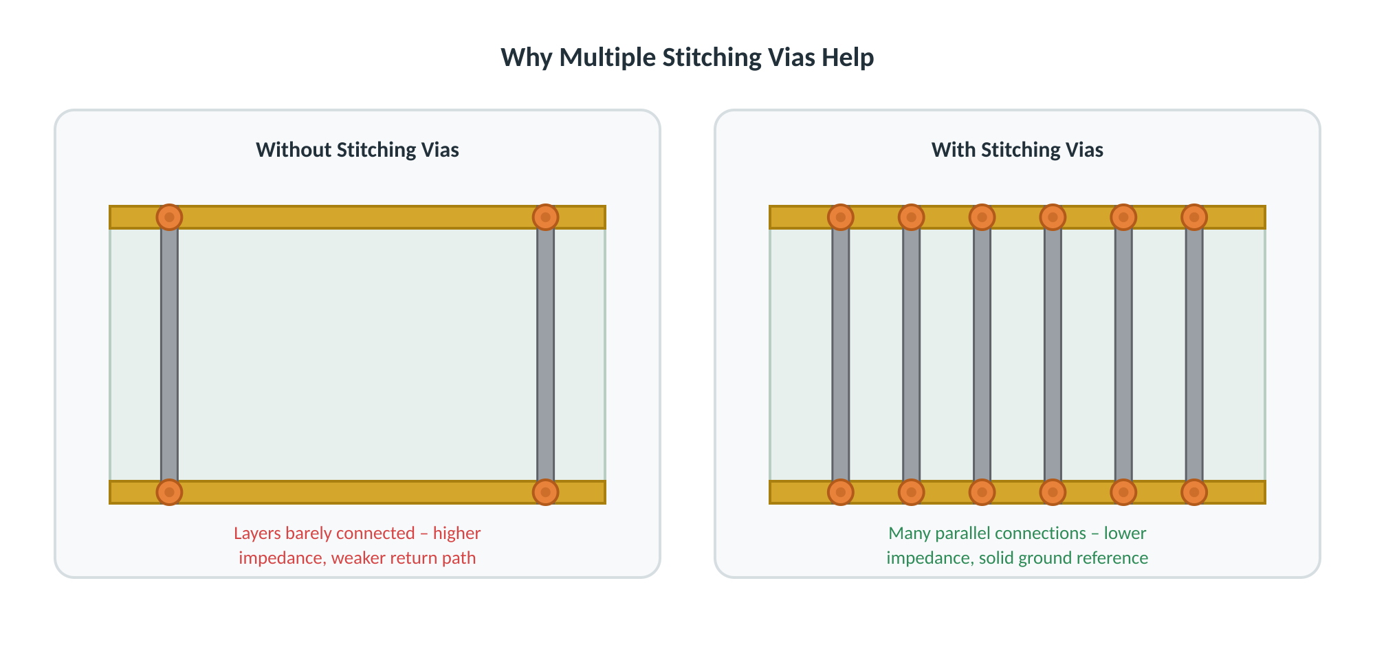
Benefits
- Continuous ground reference
- Lower ground impedance
- Better current distribution
- Improved overall PCB performance

3.2 Provide a Better Return-Current Path
Every signal current has a corresponding return current, that flows through the ground plane. When a signal changes layers (via a signal via), its return current must also change layers. Placing a ground stitching via close to the signal via gives the return current a short path to follow.
💡 Beginner tip: Current always travels in a loop — out along the signal and back along the ground. The bigger that loop, the more it acts like an accidental antenna, radiating noise. Keeping the ground via close keeps the loop small.
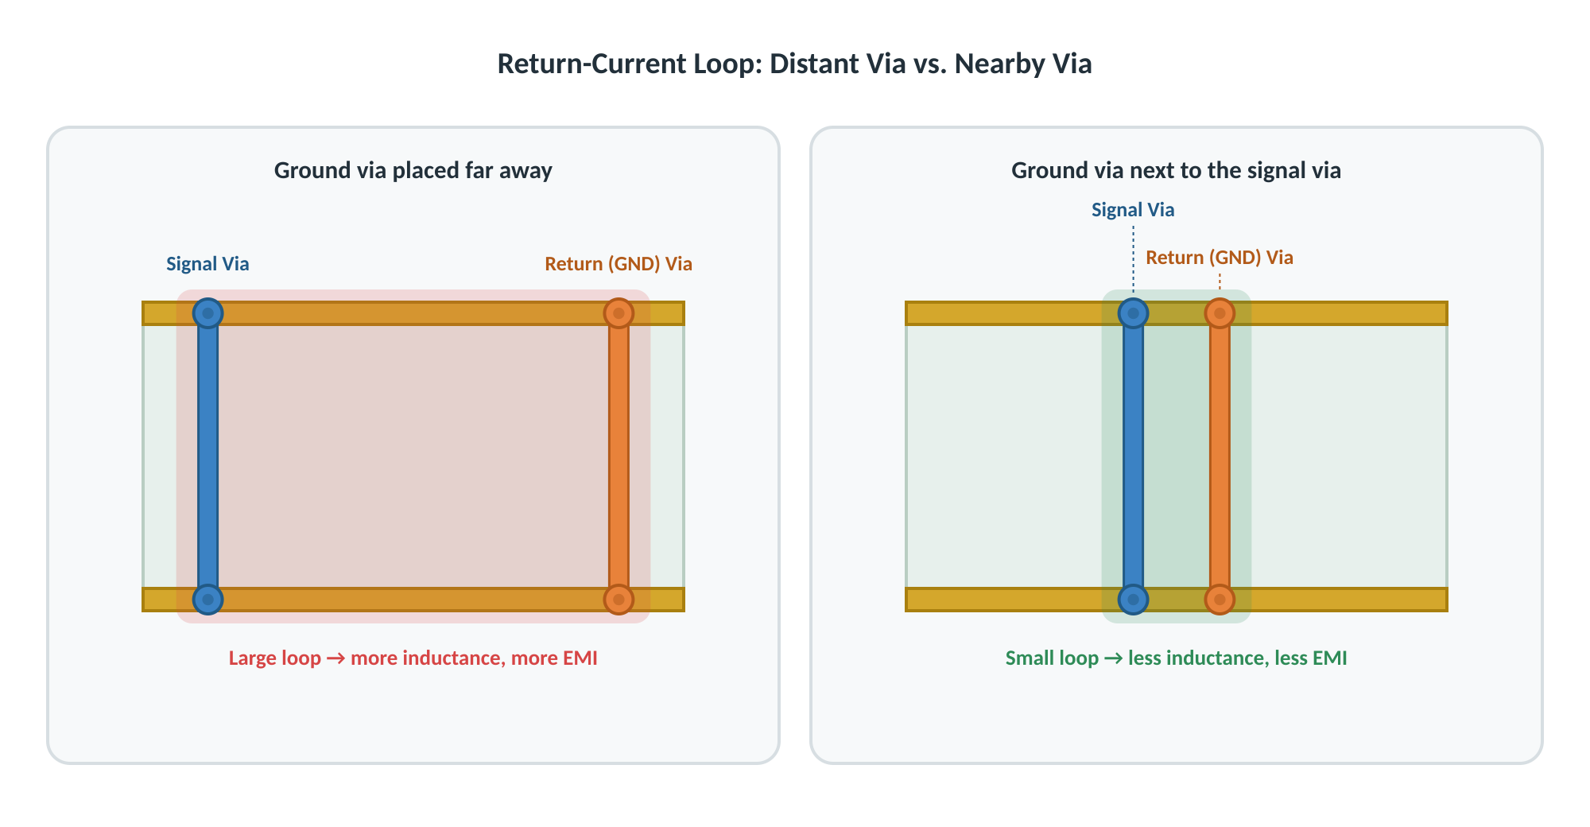
Benefits
- Short return path
- Smaller current loop area
- Lower loop inductance
- Better signal integrity
- Less EMI

3.3 Reduce Ground Impedance
Ground planes have finite resistance and inductance. Multiple stitching vias create several parallel current paths, which lowers overall impedance.
💡 Beginner tip: This is just like adding extra lanes to a busy highway. One lane (one via) forces all the traffic (current) through a single route; several lanes (many vias) spread the load and reduce congestion (impedance).
Benefits
- Lower impedance
- Lower voltage drop across the plane
- Better overall grounding

3.4 Reduce EMI
High-frequency current creates electromagnetic fields. Without stitching vias, the return current can spread over a larger area. Stitching vias keep the return current close to the signal path, reducing the electromagnetic field and noise.
Result
- Less radiation
- Less EMI
- Better EMC performance

3.5 Connect Ground Copper Pours
PCB layouts often contain ground copper pours on multiple layers. Stitching vias tie these pours together into a single low-impedance ground network.
Benefits
- Stronger ground connection
- Lower impedance
- More uniform ground potential across the board

4. Where Are Stitching Vias Used?

Around Layer-Changing High-Speed Signals
Examples: USB, HDMI, PCIe, Ethernet, DDR, LVDS.
Purpose: provide a nearby return path whenever the signal changes PCB layers.

Around Large Ground Pours
Purpose: connect all ground copper together into one electrical node.

Around Switching Power Supplies
Examples: buck converters, boost converters, flyback converters.
- Reduce ground impedance
- Provide a return-current path
- Reduce switching noise

Around Crystal Oscillators
- Stable local ground
- Lower clock jitter/noise
- Better oscillator performance

Along PCB Edges
- Connect ground layers near the board perimeter
- Improve shielding at edges
- Reduce edge radiation

Under Thermal Pads (Thermal Stitching Vias)
Power ICs usually have an exposed thermal pad. Multiple stitching vias placed under the pad transfer heat to inner/bottom copper while also improving the local ground connection.

5. What is a Shielding Via?
A shielding via is a ground stitching via placed in a specific, repeating arrangement — usually a row or closed “fence” — around a noisy or sensitive part of the PCB to reduce electromagnetic interference (EMI).
Also called: Ground Via Fence, Via Fence, or EMI Shielding Via.
💡 Beginner tip: Think of shielding vias as a protective wall around a noisy area. They don't stop the signal itself, but they help keep the electrical noise inside the protected area so it doesn't affect other parts of the PCB
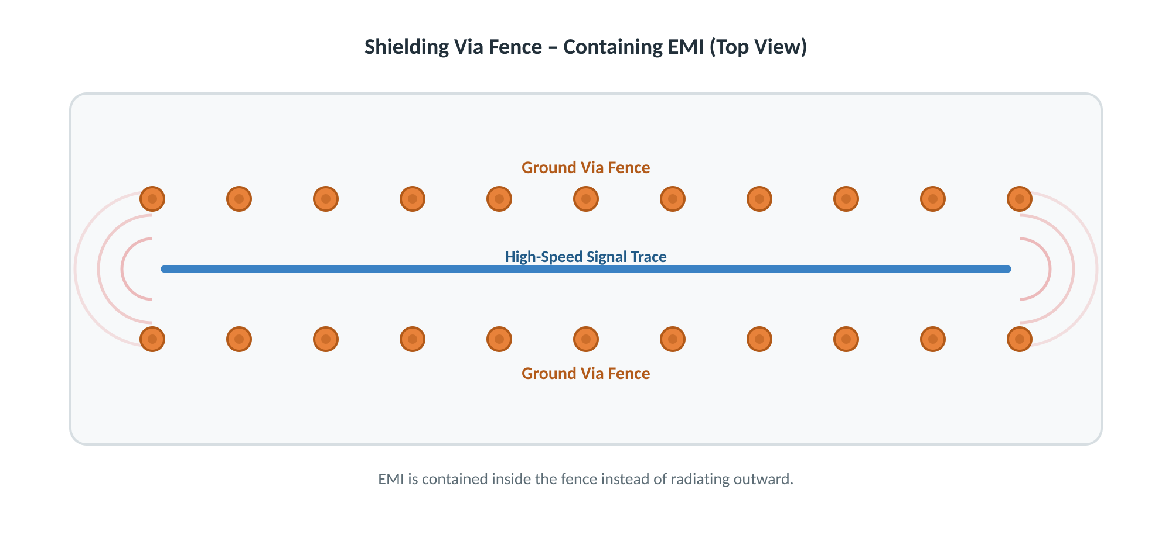
The row of ground vias forms a grounded barrier along the signal, reducing radiated field coupling to and from neighbouring circuits.

6. Why Do We Use Shielding Vias?

6.1 Reduce EMI
High-speed signals generate electromagnetic fields that can radiate outward. A via fence on both sides of the trace helps contain the field close to the signal, reducing radiated emissions.
Benefits
- Lower EMI
- Easier EMC compliance
- Reduced radiated emissions

6.2 Prevent Crosstalk
Nearby high-speed traces can couple energy into each other through their electromagnetic fields. A grounded via fence placed between two traces acts as a barrier that reduces this coupling.
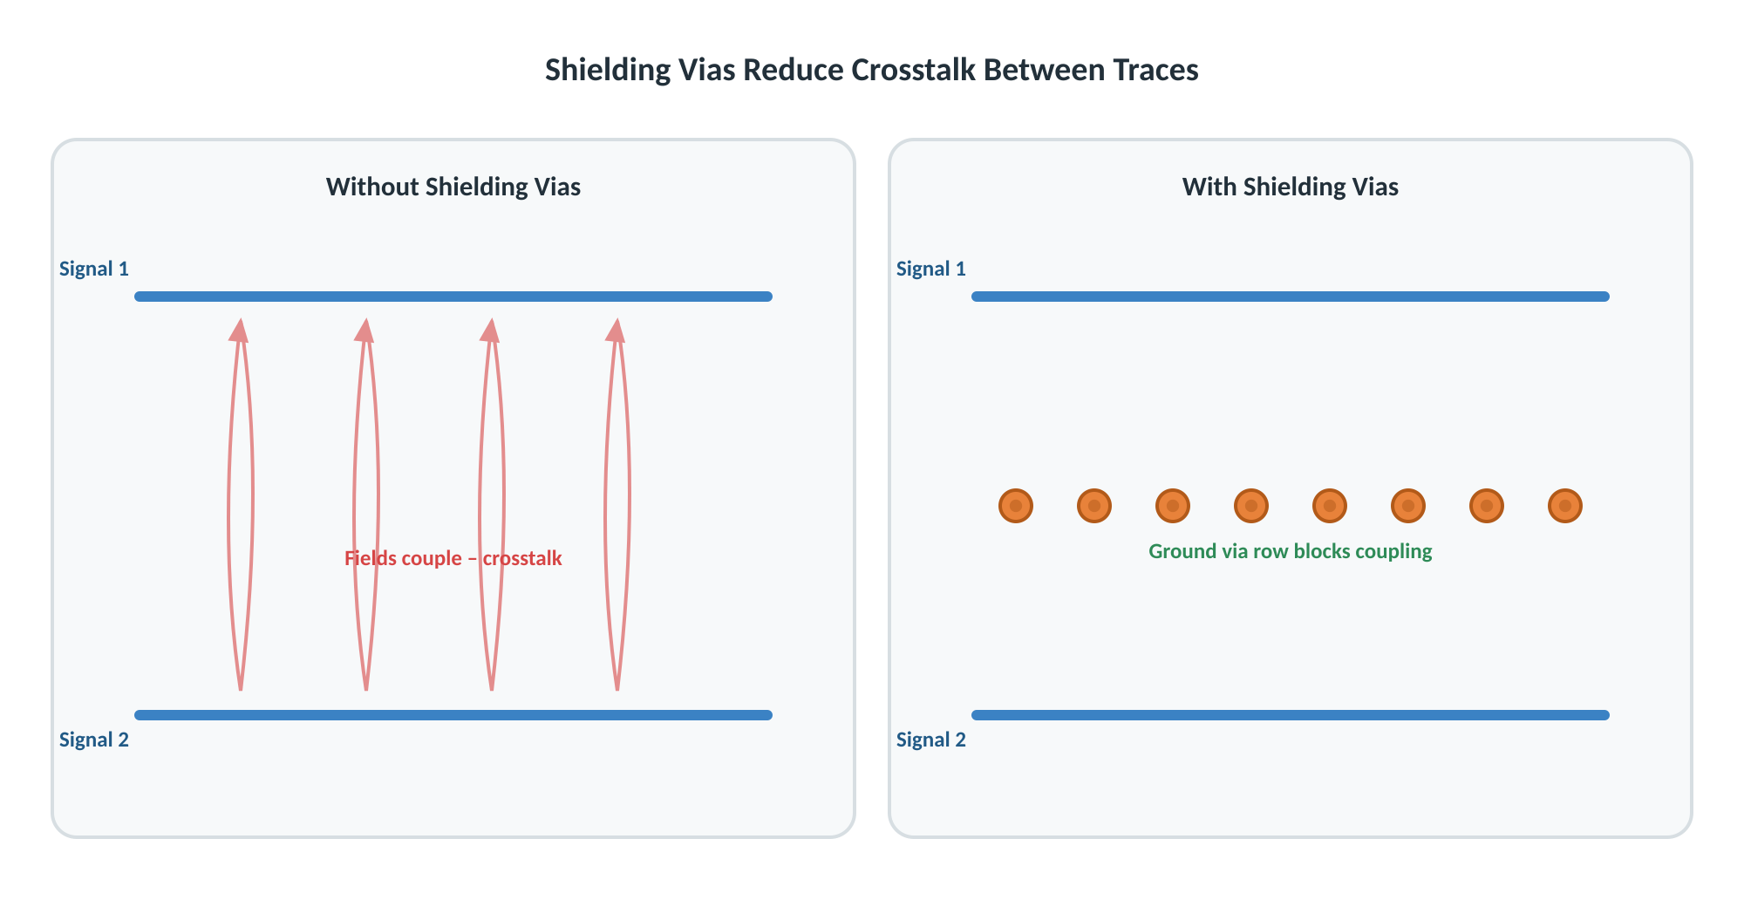
Benefits
- Lower crosstalk
- Cleaner signals
- Better communication reliability

6.3 Provide a Better Return Path
Because a shielding via fence also connects ground planes together, it functions as a stitching via as well — every shielding via provides the same low-impedance return-path benefit described in Section 3.2.
Result
- Lower loop inductance
- Less ground noise
- Better signal integrity

6.4 Improve RF Performance
RF circuits are especially sensitive to noise coupling. A via fence around an RF section helps:
- Keep RF energy confined to its intended area
- Reduce RF leakage into neighbouring circuits
- Maintain controlled impedance along the RF trace
- Improve antenna and front-end performance

7. Where Are Shielding Vias Used?

Around RF Circuits
Examples: Bluetooth, Wi-Fi, GPS, cellular modules, RF amplifiers.
Purpose: prevent RF energy from leaking into other areas of the PCB.

Along High-Speed Differential Pairs
Examples: USB 3.x, HDMI, PCIe, Ethernet, LVDS.
Purpose: reduce EMI while preserving controlled differential impedance.

Around Switching Power Supplies
Switching regulators turn their MOSFETs on and off rapidly, generating broadband high-frequency noise. A shielding via fence around the switching node contains this noise.
- Contain switching noise
- Prevent EMI from spreading to nearby circuits
- Protect nearby analog and RF sections

Around Crystal Oscillators
Purpose: reduce clock radiation and improve clock stability.

Along PCB Edges
- Reduce edge radiation
- Improve overall EMI shielding
- Strengthen inter-layer ground connections near the board boundary

8. Example: Stitching Vias in a Buck Converter
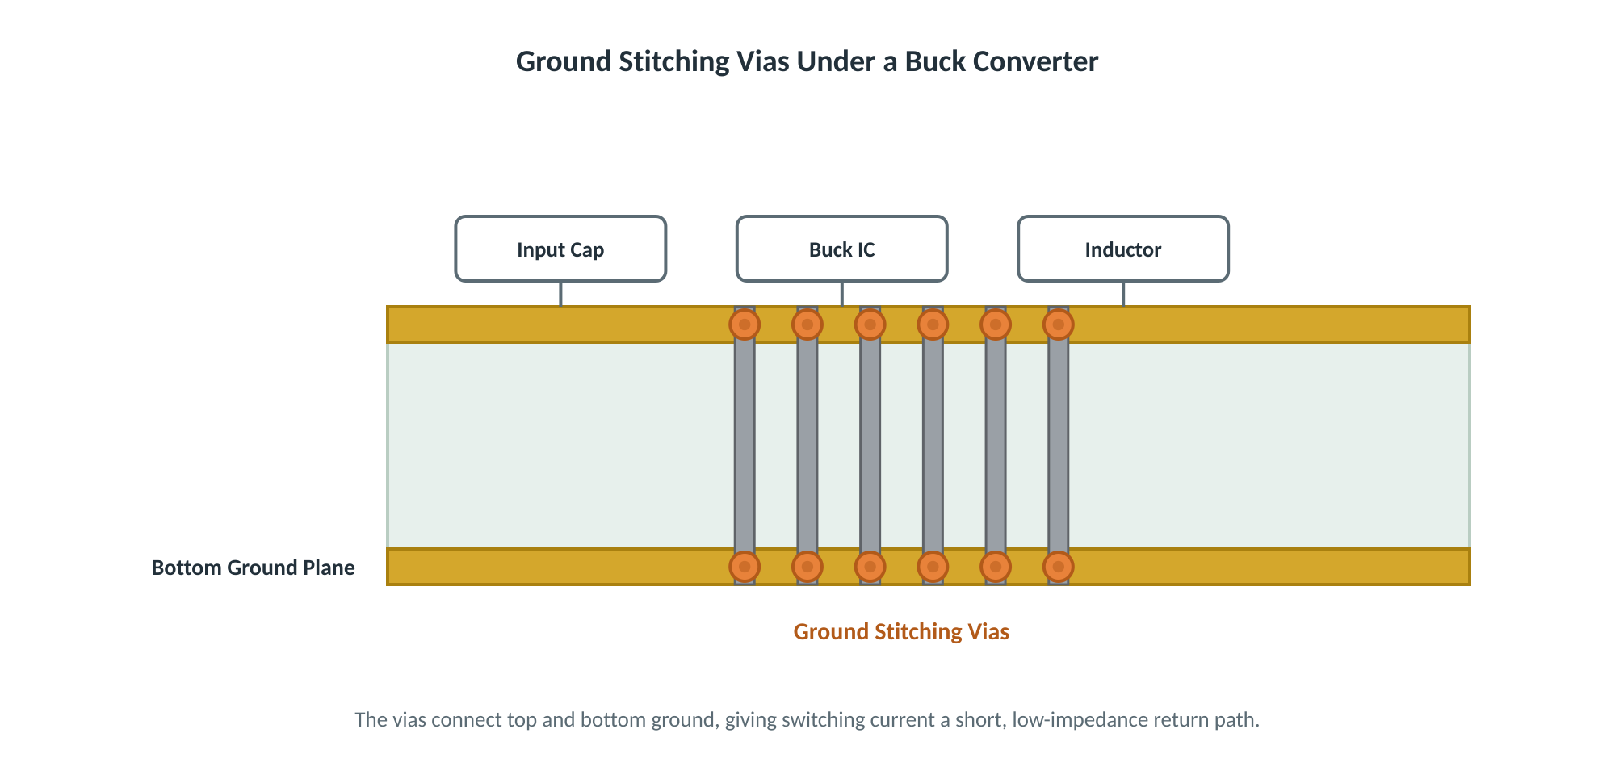
Functions:
- Connect top and bottom ground planes
- Provide a low-impedance return path for switching current
- Reduce ground noise
- Improve heat dissipation when placed under a thermal pad

9. Stitching Via vs. Shielding Via — Comparison
Feature | Stitching Via | Shielding Via
Connects GND planes | Yes | Yes
Improves return-current path | Yes | Yes
Reduces ground impedance | Yes | Yes
Reduces loop inductance | Yes | Yes
Primary purpose is EMI shielding | Not necessarily | Yes
Forms a continuous ground barrier / fence | No | Yes
Typical placement | Anywhere GND continuity is needed | Around high-speed traces, RF blocks, switching regulators, crystals, board edges

10. Key Difference
A stitching via connects copper areas of the same net, improving grounding, reducing impedance, and providing a better return path.
A shielding via is a special arrangement of stitching vias placed as a ground fence around noisy or sensitive areas, to contain electromagnetic fields, reduce EMI, and prevent crosstalk.
Every shielding via is a stitching via, but not every stitching via is a shielding via. The physical via is identical — the difference lies entirely in its placement pattern and intended purpose.

