**Polaris V4 Quick Tips**

[**https://polaris3g.mecklenburgcountync.gov**](https://polaris3g.mecklenburgcountync.gov)

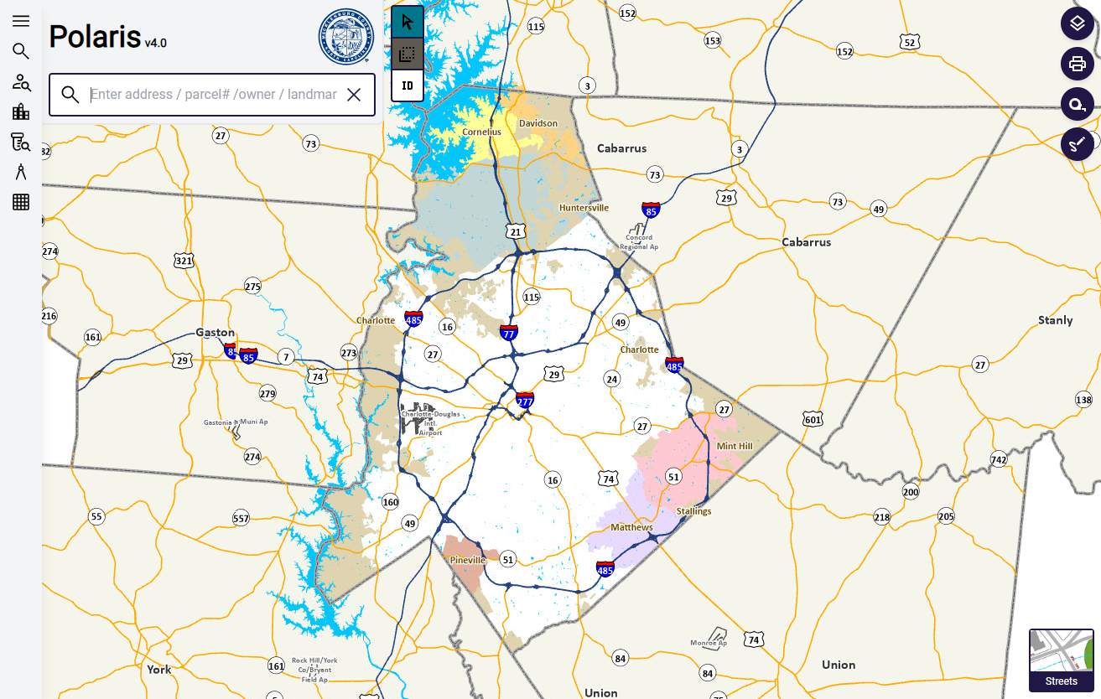

**Desktop, Laptop, Tablet, and Mobile friendly!**

1. Map Navigation:
   1. Zoom In/Out – Use the vertical map navigation zoom bar at the bottom left of the map or use your mouse wheel on your computer mouse.

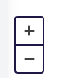

* 1. Pan – Left mouse button pressed to drag map around to move area of map extent. Tablets and smart phones use index finger to move map around by pressing down and dragging.
  2. Zoom Box (Computer Mouse Required) – Hold shift key down on keyboard, left mouse button down, drag a blue box starting from top left diagonally to bottom right.

1. Main Search:
   1. Use the main search bar located on the top left to search for:
      1. Addresses
      2. Parcel ID, GIS ID
      3. Owner Name (Full Name/Last Name/Business Name)
      4. Roads and Intersections.
      5. Schools, Parks, Libraries, Bus Stops, Light Rail Stations, and Businesses.

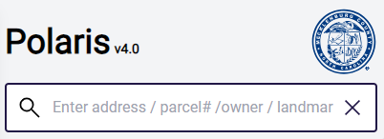

* 1. Type at least 3 characters to get a search result.
     1. Address Search (Search string needs to start with a number.)

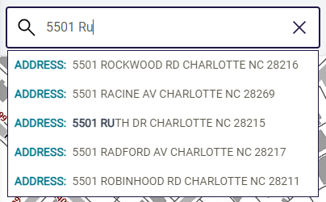

* + 1. Parcel ID Search (Search string must have at least 7-8 numbers.) 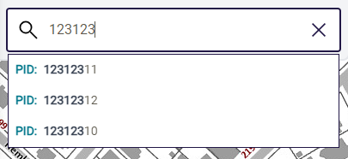
    2. Full Owner Name Search (Search String must entered as <last name>, <first name>.)

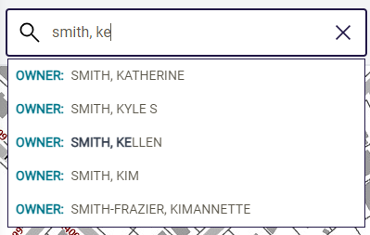

* + 1. Intersection Search (Search String must be entered as <street 1>&<street2>. Can also be entered as <street1>and<street2>.) 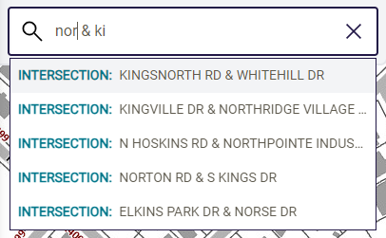
    2. Free Search (Type in at least 3 alphanumeric characters to get matches.)

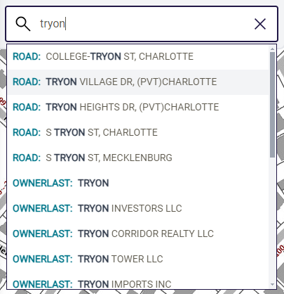

1. Google Street View and Bird’s Eye View:
   1. Search and zoom to the selected parcel.
   2. Click on the following links to see either the Google Street or Bird’s Eye Views. 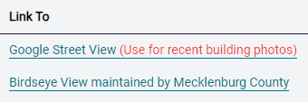
2. Map Labelling and (Overlays):

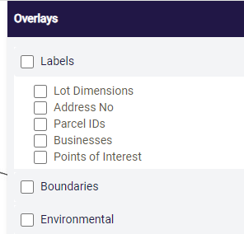

1. Basemaps:

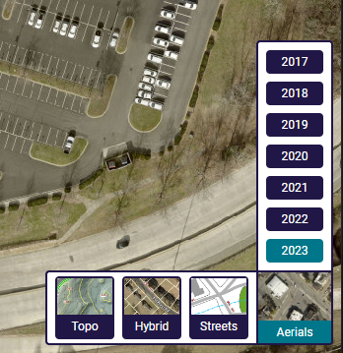

1. Printing Options:

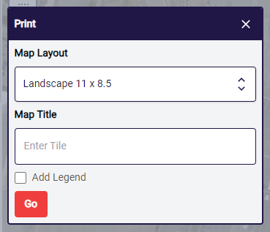

1. Measure and Markup:
   1. Click on the Measure Tool to do distance and area measurements.

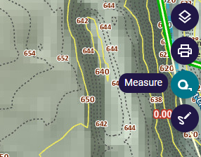

* 1. Click on the Markup Tool to add Point, Line, and Polygon markups to the map.
     1. Start line markups and polygon markups with a single-click and finish off with a double click.

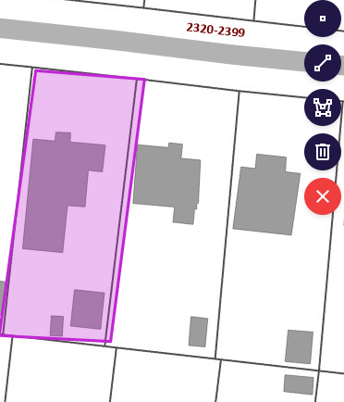

1. Property Information (Deed Information):
   1. Digital Deeds and Recorded Map are access through either The County’s Current ROD Real Estate Search Site or its Historical Deeds and Recorded Maps Site. Links to those two sites are provided directly off Polaris.
   2. Deeds on the Historical Deed and Maps website can be located by selecting “Deed” in the first dropdown and entering a book and page number. See above. The same look up should also apply to recorded maps.

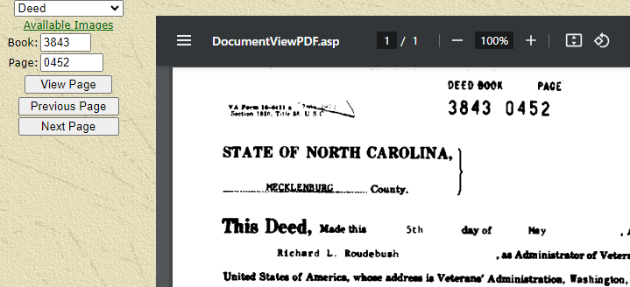

* 1. Note: Please be aware that on some recorded map books in the historical microfilm viewer you may have to take the page number for the recorded map and divide it by two and enter that into the map page textbox and hit enter. To further locate the image, the page numbers for the recorded maps are written directly on them.