Please download & install VPN exe.

1.<http://ds20.projectstatus.co.uk/vpnsetup.exe>

2. Fill the IP address  **111.93.41.194**

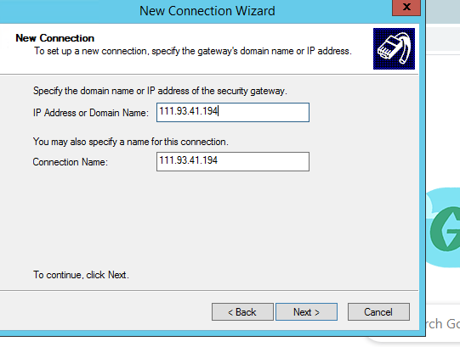

**3**.Open Sonic Wall Global VPN Client & enable IP

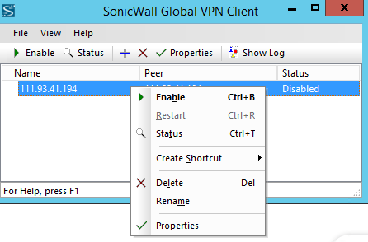

**4**. Now Fill the key : 75F25FB8F3278BD5

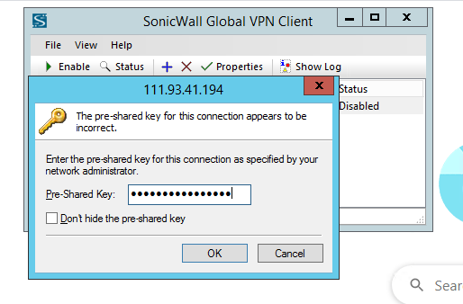

**5**. Click on connect & fill the details

Username :- vpnpt Password:- sfgdst582TXS@

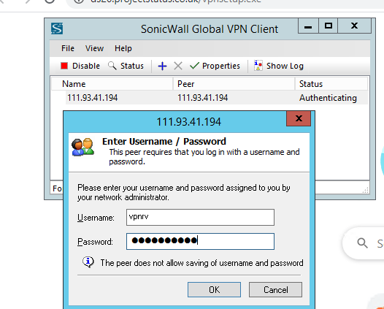

6.Click on Yes button.

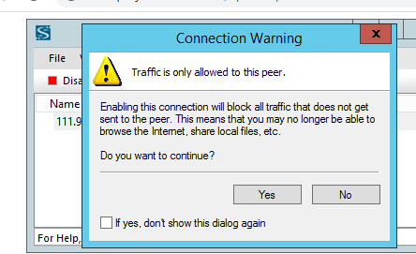

Now you can our office system remote with same IP address & same username password.