Brewery API Overview

1. Brewery API Overview
The Brewery API is a RESTful ASP.NET Core Web API developed using .NET 8. It consumes brewery information from the Open Brewery DB backend data source and exposes a simplified API for searching and sorting brewery information.

Key Features
- API endpoint: https://api.openbrewerydb.org/v1/breweries.
- Uses Open Brewery DB as the external data source.
- Search works by brewery Name or City only.
- Breweries can be sorted by Name, City, or Distance.
- Only the required brewery details are exposed: Name, City, Phone.
- Brewery data is stored in in-memory cache for 10 minutes to reduce repeated calls to the external API.

2. Implementation of Technical Specifications

SOLID Principles
The application follows the SOLID principles through separation of responsibilities and interface-based design.
- Single Responsibility Principle: Controller, Service, Client and Exception Filter have separate responsibilities.
- Open/Closed Principle: Interfaces allow implementations to be extended or replaced without changing the consuming components.
- Liskov Substitution Principle: Interface implementations can be substituted without changing the behavior expected by their consumers.
- Interface Segregation Principle: Small and focused interfaces are used for the Service and API Client.
- Dependency Inversion Principle: Higher-level components depend on interfaces rather than concrete implementations.

Dependency Injection
ASP.NET Core's built-in Dependency Injection is used to provide dependencies such as Brewery Service, Brewery API Client, In-memory Cache, and Logger. The Controller depends on the Service interface, and the Service depends on the API Client interface. This reduces tight coupling and makes the application easier to maintain and test.

In-Memory Caching and 10-Minute Refresh
The application uses in-memory caching to avoid unnecessary calls to the external brewery API. The flow is:
- First request checks the cache.
- If data is not available, the application calls the external API.
- The returned brewery data is stored in memory for 10 minutes.
- Subsequent requests use the cached data.
- After 10 minutes, the cache expires.
- The next request retrieves fresh data from the external API and refreshes the cache.
- Search and sorting are performed on the retrieved/cached brewery data.

Exception Handling
Exception handling is implemented using an exception filter. Exceptions from the Client, Service or Controller can propagate to the exception-handling layer. The actual exception details are logged for troubleshooting. The client receives a controlled response such as "Service is unavailable" instead of internal exception details. This prevents implementation or infrastructure details from being exposed to API consumers.

Logging
The application uses the built-in ASP.NET Core ILogger framework. Logging is performed at important points (Controller: Request received and response; Service: Cache activity, search and sorting; Client: External API call and response; Exception Filter: Exception details and errors). The application avoids excessive logging and focuses on meaningful operational information.

API Versioning
API versioning is represented in the URL: /api/v1/brewery. Using a versioned route provides a clear API contract and allows future API versions to be introduced without breaking existing consumers.

3. Layer Responsibilities
Layer | Responsibility | Main Activities
App Layer – Controller | Handles HTTP requests and responses | Receives query parameters, calls the Service layer and returns the API response
Service Layer | Contains application/business logic | Handles caching, search, sorting and response mapping
Client Layer | Communicates with the external API | Calls Open Brewery DB and converts the external response into the application model

App Layer – Controller
The Controller is the entry point for the API request. It receives the HTTP GET request, accepts search, sorting and location parameters, calls the Service layer, and returns the final HTTP response.

Service Layer
The Service layer contains the main application logic. It retrieves data from cache or external API, searches breweries by Name or City, sorts by Name, City or Distance, maps external brewery data to the API response model, and ensures that only Name, City and Phone are exposed.

Client Layer
The Client layer is responsible for communication with the external Open Brewery DB API. It sends requests, receives brewery data, converts the external response into the application's model, and keeps external API communication separate from the business logic.

4. Architecture Diagram
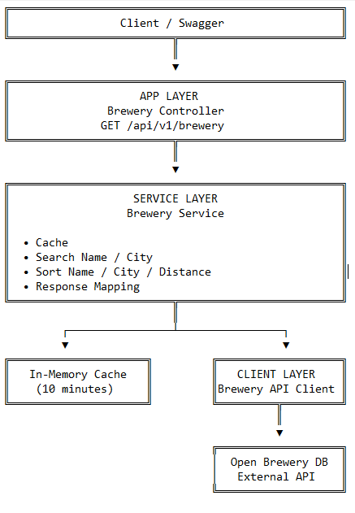

Supporting Components
- Dependency Injection
- ILogger / Logging
- Exception Filter
- API Versioning
- Configuration

5. API Behavior Summary

Search
The Search parameter searches breweries by Name or City. It does not search by other brewery fields.

Sorting
The API supports sorting by Name, City, or Distance. Distance sorting uses the brewery location and the location supplied by the client.

Response
The API intentionally exposes only the required brewery information: Name, City, Phone. Other data received from the external API, such as latitude and longitude, is not exposed in the public response.

Caching
Brewery data is cached for 10 minutes. Once the cache expires, the next request retrieves fresh data from Open Brewery DB and refreshes the cache.

How to Test the API
The API can be tested using Swagger UI by providing values for the Search, SortBy, Latitude, and Longitude parameters.

1. Search by Brewery Name
Use the following brewery names in the Search field:
Search Type | Example Values
Name | T Kroontje
Name | 10 Barrel Brewing Co
Name | (512) Brewing Co
Name | (405) Brewing Co
The API searches the brewery Name field using a case-insensitive search.

2. Search by City
Use the following city names in the Search field:
Search Type | Example Values
City | Norman
City | Bend
City | Portland
City | Austin
The API searches the brewery City field using a case-insensitive search.

3. Sort Breweries
The SortBy field supports the following values:
SortBy Value | Description
name | Sort breweries by brewery name
city | Sort breweries by city
distance | Sort breweries by distance from the supplied location

4. Sort by Distance
When: SortBy = distance
provide both Latitude and Longitude.
Example:
Parameter | Value
Search | New York
SortBy | distance
Latitude | 40.7128
Longitude | -74.0060
Latitude and longitude are used to calculate a distance value for each brewery and sort the breweries from nearest to farthest.

