|  |
| --- |
|  |
| The Documentation |
| [Type the document subtitle] |
|  |
| **[Your Name]** |
| **[Pick the date]** |

[Type the abstract of the document here. The abstract is typically a short summary of the contents of the document. Type the abstract of the document here. The abstract is typically a short summary of the contents of the document.]

Table of Contents

[To update the table of contents, right click the message below and select Update Field (F9 on PC, ⌥⌘U on Mac).]

**No table of contents entries found.**

1. Pages
   1. Page Tree

物料批量查询  
 评估信息弹框  
 库存地点弹框  
 销售信息弹框  
物料财务信息查询  
物料-分类信息批量维护  
评估信息批量维护  
销售信息批量维护  
销项税批量维护  
单位换算批量维护  
下载基础信息弹出框

* 1. 物料批量查询
     1. User Interface

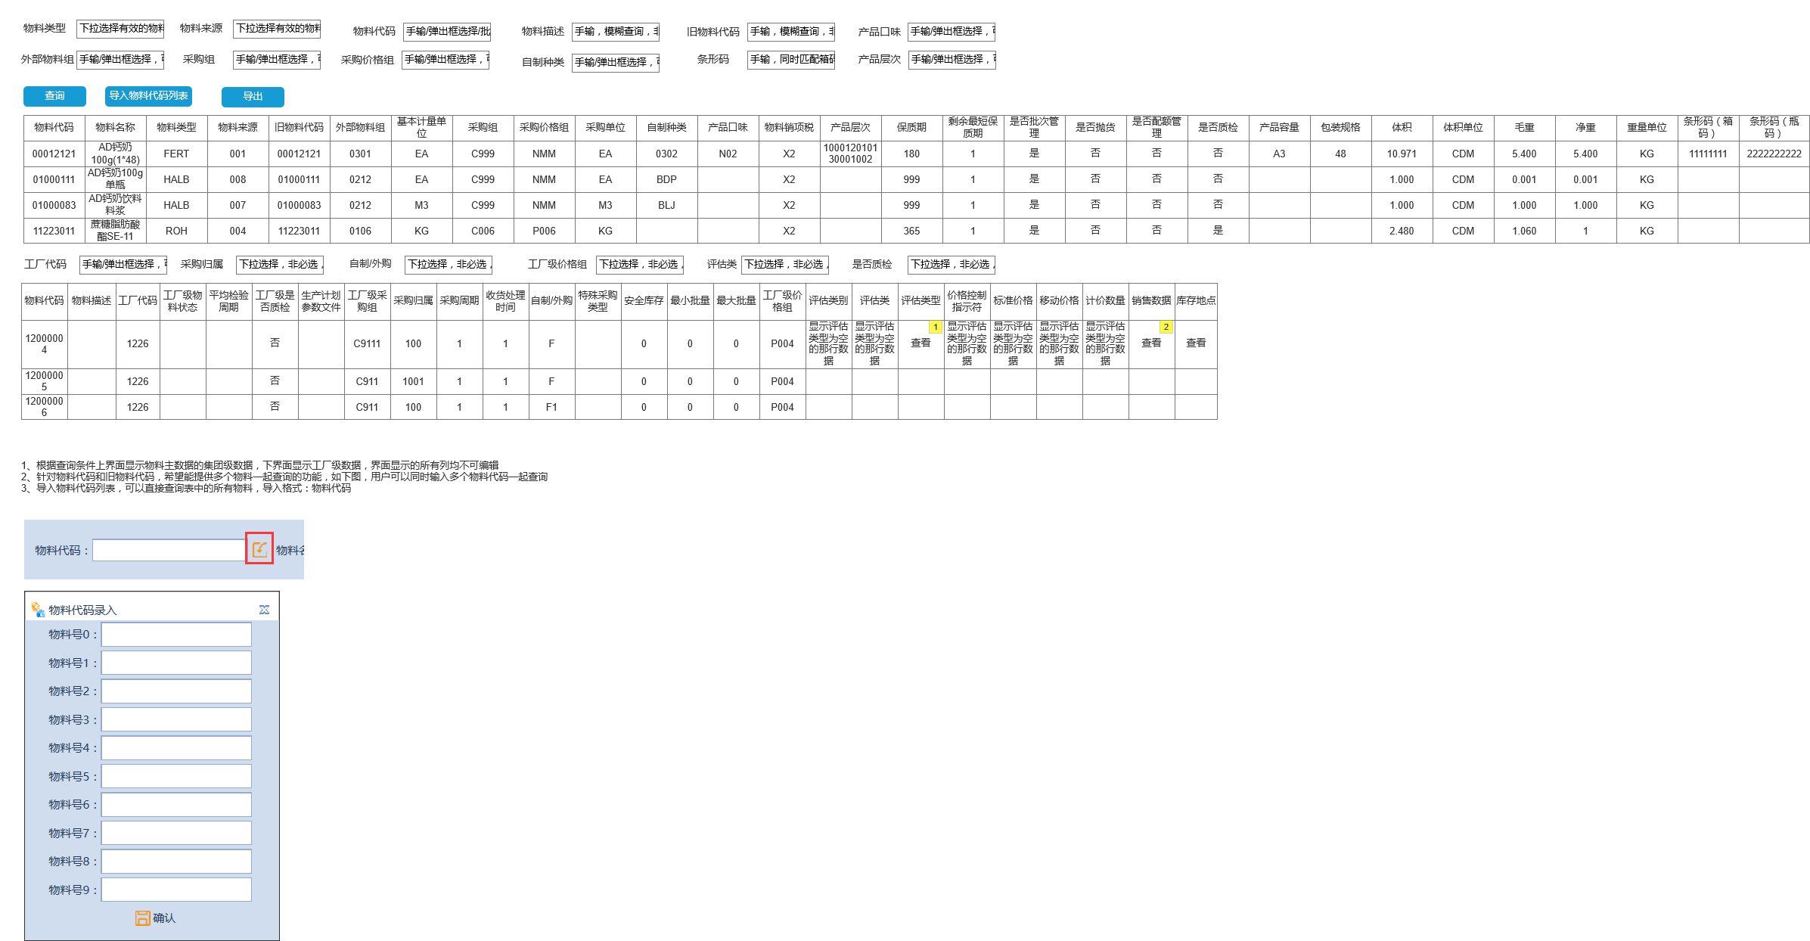

* + 1. Widget Table

| Note number | Interactions | Note |
| --- | --- | --- |
| 1 |  | 是 |
| 2 |  |  |

* 1. 评估信息弹框
     1. User Interface

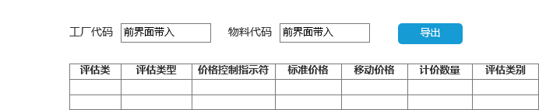

* 1. 库存地点弹框
     1. User Interface

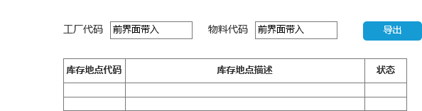

* 1. 销售信息弹框
     1. User Interface

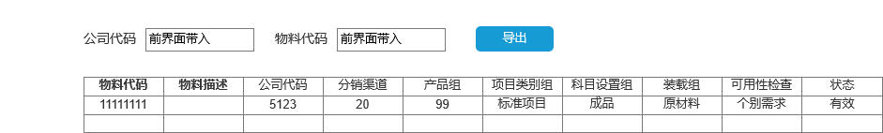

* 1. 物料财务信息查询
     1. User Interface

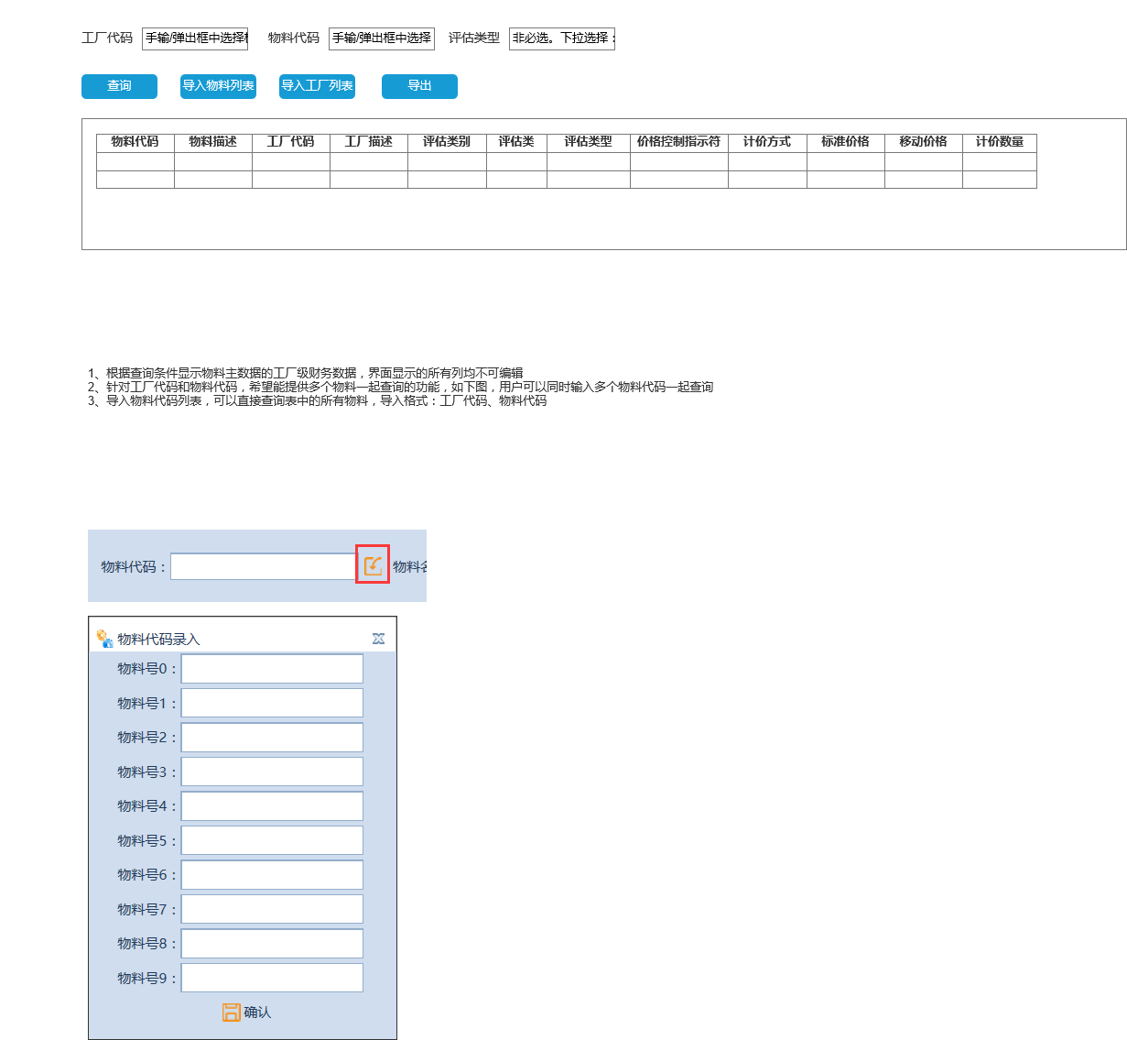

* 1. 物料-分类信息批量维护
     1. User Interface

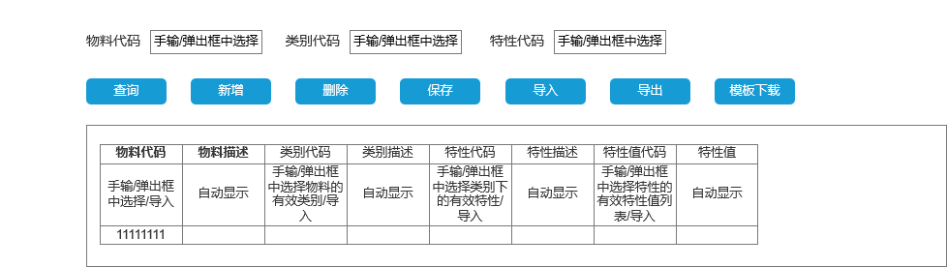

* 1. 评估信息批量维护
     1. User Interface

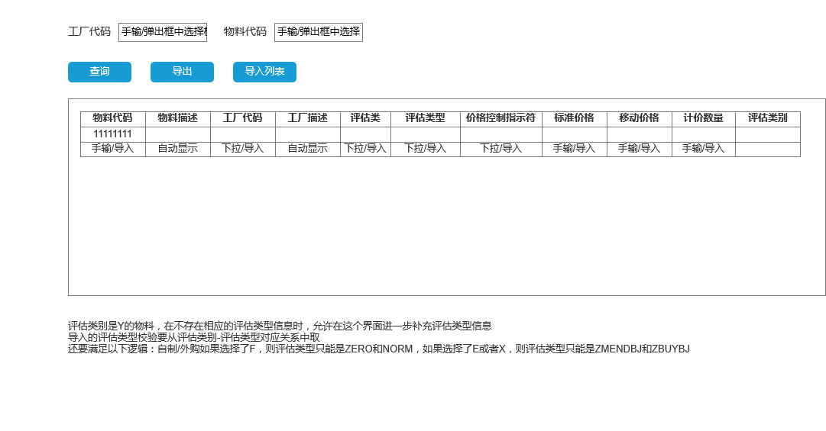

* 1. 销售信息批量维护
     1. User Interface

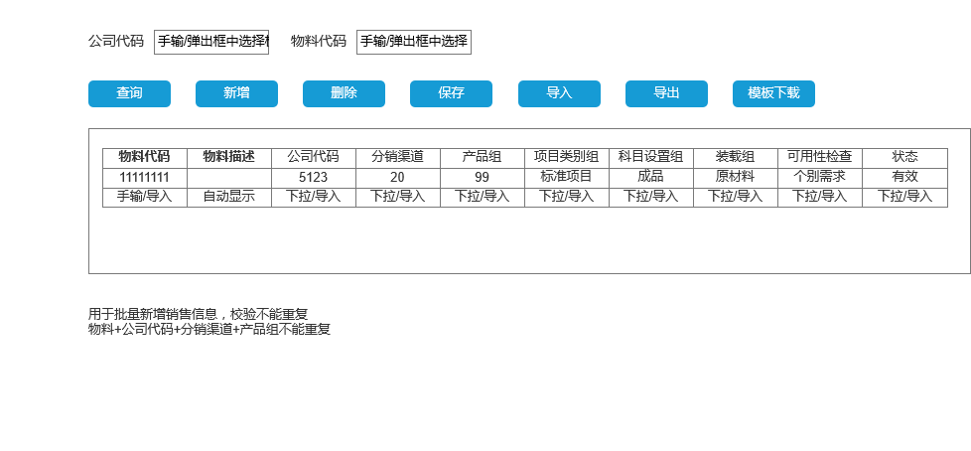

* 1. 销项税批量维护
     1. User Interface

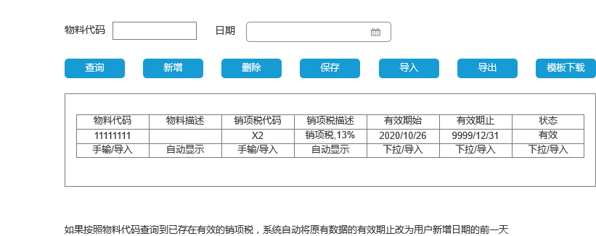

* + 1. Calendar Pane
       1. August
       2. User Interface

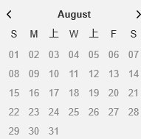

* + - 1. July
      2. User Interface

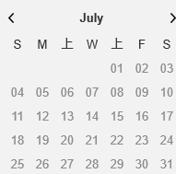

* + - 1. June
      2. User Interface

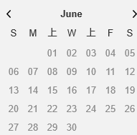

* 1. 单位换算批量维护
     1. User Interface

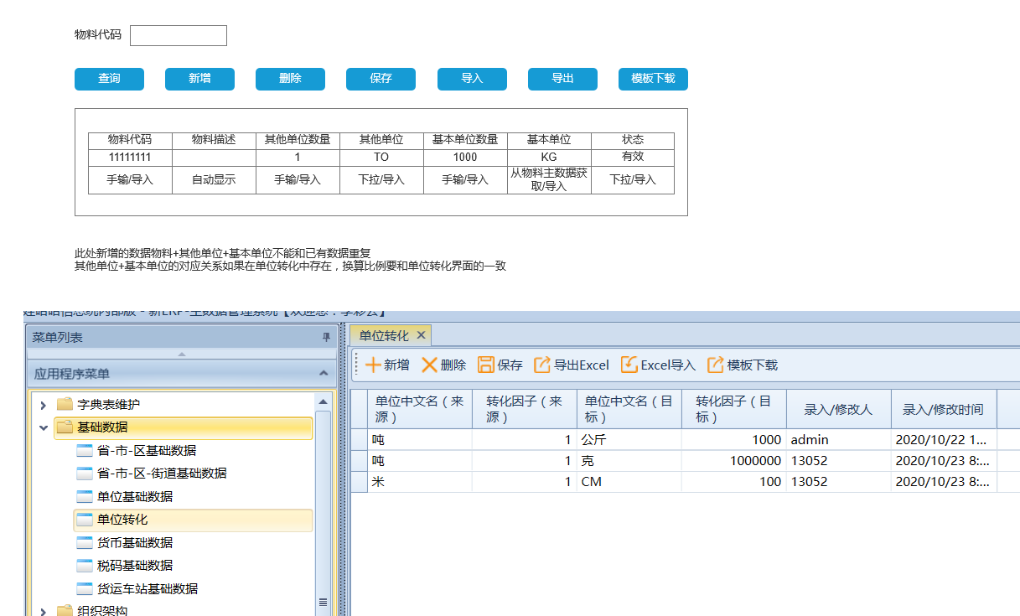

* 1. 下载基础信息弹出框
     1. User Interface

