**Genome-Wide Association Studies of Antimicrobial Activity in Global Sorghum [*Sorghum bicolor* (L.) Moench]**

Lindsay Shieldsa,b *, Yang Gangc,+, Kathleen Jordanb, Sirjan Sapkotaa,b, Lucas Boatwrighta,b, Xiuping Jiangc, Stephen Kresovicha,b, Richard Boylesa,d

SUPPLEMENTARY FIGURES AND TABLES

|  |  |  |
| --- | --- | --- |
| **Table S1**. Summary of *S. enterica* samples regarding testa and antimicrobial activity | | |
|  | No activity | Antimicrobial activity |
| Unpigmented testa | 350 | 19 |
| Pigmented testa | 109 | 165 |

**Table S1** summarizes the distribution of samples having weak or no antimicrobial activity across unpigmented and pigmented testa. The majority of samples (350) show no antimicrobial activity and do not have a pigmented testa. Complemented by 165 samples that both do demonstrate antimicrobial activity and have a pigmented testa. The distribution of samples of these two traits follow expected relationships with germplasm that does not meet our criteria for breeding material. The 19 samples identified as having antimicrobial activity and unpigmented testa do meet the criteria of interest, however, only weak effect was observed and therefore was not considered any further.

|  |  |  |  |  |  |  |  |
| --- | --- | --- | --- | --- | --- | --- | --- |
| **Table S2.** T-test between 2014 and 2013 tannin data for the SAP | | | | | | | |
|  | T | DF | P-val | CI (95%) | Cohen-d | BF10 | Power |
| T-test | 0.954 | 510 | 0.34 | [-1.1 – 3.18] | 0.084 | 0.153 | 0.159 |

T= t-value

DF = degrees of freedom

P-val = p-value

CI = 95% confidence intervals of the difference in means

Cohen-d = Cohen d effect size

BF10 = Bayes Factor of the alternative hypothesis

Power= achieved power of he test (= 1 – type II error)

**Figure S1**. Relationship between antimicrobial activity against *S. enterica* (0 = no activity, 1= weak activity) and total phenol concentration. Pearson’s r = 0.77

**Figure S2**. Relationship between antimicrobial activity against *S. enterica* (0 = no activity, 1 = weak activity) and tannin content. *r* = 0. 63

Total phenol (**Figure S1**) and tannin content (**Figure S2)** were found to correlate with antimicrobial activity. Findings suggest that the majority of accessions do not meet the criteria required to identify sorghum germplasm that can be used for its potential as an antimicrobial in feed grain.

**Figure S3**. Distribution of accession with unpigmented testa (0) and pigmented testa (1) as it relates to inhibtion zone size (mm) measured from *C. perfringens* disc-diffusion assay.

|  |  |  |  |
| --- | --- | --- | --- |
| **Table S3**. Summary statistics for compositional,yield, and metabolite data of sorghum grain | | | |
|  | Minimum | Maximum | Average |
| ADF | 3.03 | 9.39 | 5.32 |
| Amylopectin to Starch | 75 | 102.33 | 86.33 |
| Amylopectin to Total Dry Matter | 40.78 | 67.33 | 55.72 |
| Amylose to Starch | 0.83 | 23.46 | 13.46 |
| Ash | 1.38 | 1.93 | 1.64 |
| BTU | 7146.63 | 8006.36 | 7434.27 |
| Cal | 3922.98 | 4371.81 | 4079.62 |
| Calcium | 0.01 | 0.02 | 0.01 |
| Copper | 2.97 | 5.08 | 4.02 |
| Dry matter | 86.63 | 89.27 | 87.85 |
| Fat | 0.64 | 6.04 | 2.23 |
| Iron | 15.75 | 68.06 | 39.99 |
| IVSD | 38.6 | 56.06 | 46.23 |
| KCal | 1797.73 | 2004.51 | 1870.32 |
| Lead | 0.03 | 0.77 | 0.22 |
| Magnesium | 1094.48 | 2258.23 | 1537.04 |
| Manganese | 9.28 | 18.49 | 14.02 |
| Moisture | 10.73 | 13.37 | 12.15 |
| Moisture for Ash | 10.29 | 12.35 | 11.68 |
| Moisture for Fat | 9.81 | 12.59 | 11.64 |
| NDF | 4.5 | 23.68 | 9.23 |
| Nitrogen | 0.91 | 2.6 | 1.8 |
| Nitrogen mg | 4.53 | 13.46 | 9.22 |
| Phosphorus | 0.28 | 0.46 | 0.36 |
| Prolamin | 3.64 | 7.07 | 5.31 |
| Protein | 6.27 | 16.43 | 11.38 |
| Sodium | 0 | 0 | 0 |
| Starch | 54.97 | 76.54 | 68.49 |
| Zinc | 8.8 | 27.87 | 19.01 |
| GNP | 79 | 3445 | 1085 |
| TGW (g) | 5.73 | 56.2 | 23.3 |
| YPP | 0.47 | 97.9 | 25.2 |
| Tannins (mg CE/g) | 0 | 88.1 | 8.24 |
| Total phenols [GAE/g] | 6.9 | 420 | 292 |

a ADF, acid detergent fiber; BTU, British thermal unit; Cal, calorie; IVSD, in vittrol starch. Disappearance/digestion; Kcal, kilocalorie; NDF, neutral detergent fiber; GNP, grain number panicle; TWG, thousand grain weight; YPP, yield primary panicle

**Table S3** provides summary statistics of all 29 composition traits measured using NIRS. Correlation values and significant testing was determined to evaluate the relationships between antimicrobial activity against *C. perfringens* and each composition trait. All traits, with the exception of dry matter, moisture, and moisture for ash, were found to have insignificant correlations (**Table S4**). Due to the inevitable increase in the error during multivariate testing, a false discovery rate (FDR) correction was applied (q). Upon the FDR correction, all correlations between composition traits and antimicrobial activity were found insignificant (**Table S4**).

|  |  |  |  |
| --- | --- | --- | --- |
| **Table S4**. Correlation and significance of compositional, yield, and metabolite traits to antimicrobial activitiy | | | |
|  | r value | p value | q value |
| ADF | 0 | 0.989 | 0.989 |
| Amylopectin to Starch | -0.048 | 0.181 | 0.59 |
| Amylopectin to Total Dry Matter | 0.01 | 0.784 | 0.895 |
| Amylose to Starch | 0.041 | 0.259 | 0.716 |
| Ash | -0.008 | 0.829 | 0.904 |
| BTU | 0.047 | 0.193 | 0.59 |
| Cal | 0.037 | 0.301 | 0.773 |
| Calcium | -0.059 | 0.103 | 0.59 |
| Copper | 0.029 | 0.417 | 0.877 |
| Dry matter | 0.078 | 0.03 | 0.361 |
| Fat | 0.023 | 0.514 | 0.877 |
| Iron | 0.019 | 0.598 | 0.895 |
| IVSD | 0.022 | 0.538 | 0.877 |
| KCal | 0.064 | 0.077 | 0.59 |
| Lead | 0.021 | 0.56 | 0.877 |
| Magnesium | -0.023 | 0.526 | 0.877 |
| Manganese | 0.011 | 0.763 | 0.895 |
| Moisture | -0.078 | 0.03 | 0.361 |
| Moisture for Ash | -0.093 | 0.01 | 0.354 |
| Moisture for Fat | 0.011 | 0.752 | 0.895 |
| NDF | -0.012 | 0.729 | 0.895 |
| Nitrogen | 0.009 | 0.795 | 0.895 |
| Nitrogen mg | 0.015 | 0.686 | 0.895 |
| Phosphorus | -0.061 | 0.088 | 0.59 |
| Prolamin | -0.025 | 0.491 | 0.877 |
| Protein | -0.006 | 0.858 | 0.908 |
| Sodium | 0 | 0 | 0 |
| Starch | 0.014 | 0.697 | 0.895 |
| Zinc | 0.004 | 0.906 | 0.932 |
| GNP | 0.00308 | 0.9353 | - |
| TGW (g) | 0.00796 | 0.8334 | - |
| YPP | 0.00201 | 0.9577 | - |
| Tannins (mg CE/g) | 0.12 | 0.032 | - |
| Total phenols [GAE/g] | -0.12 | 0.036 | - |

**Figure S4.** QQ plot for LMM of anitmicrobial activtiy

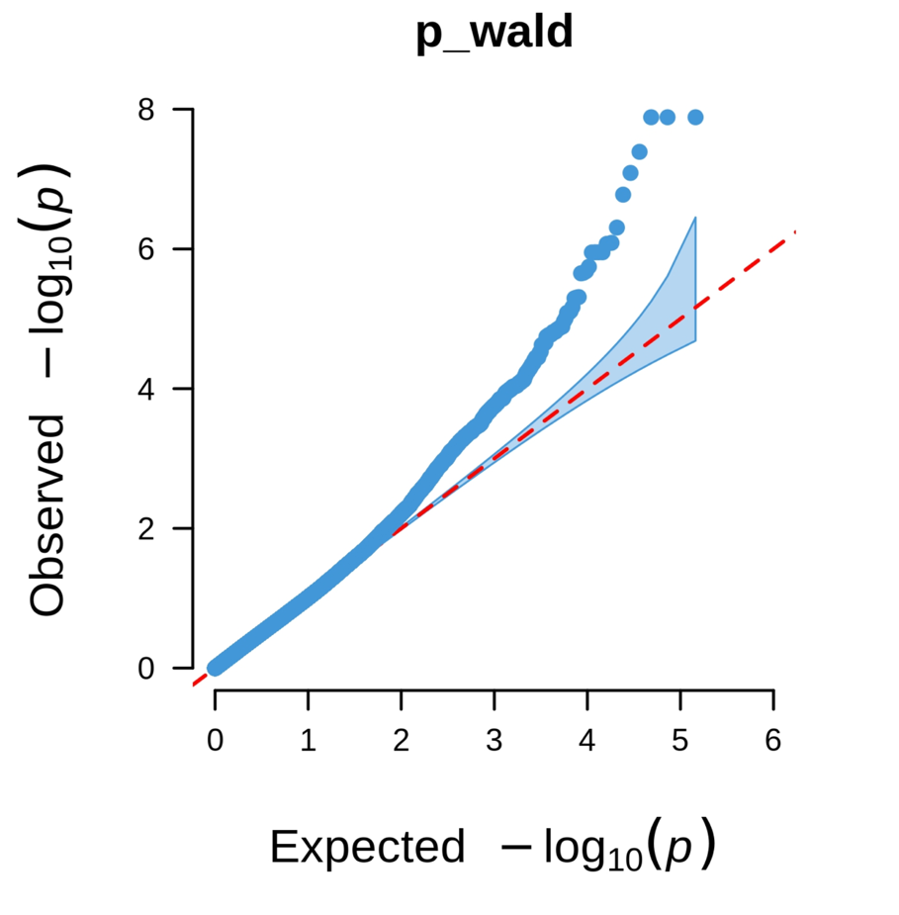

**Figure S5**. QQ plot for LMM with tannin covariate of antimicrobial activity.

|  |  |  |  |  |  |  |
| --- | --- | --- | --- | --- | --- | --- |
| **Table S5.** Top four significant associations for antimicrobial activity GWAS. P-Wald value was calculated and adjusted by the Bonferroni correction. | | | | | | |
| **Chromosome** | **SNP** | **Position** | **allele1** | **allele0** | **MAF** | **p_wald** |
| 2 | S2_8924006 | 8924006 | C | T | 0.06 | 2.31E-08 |
| 4 | S4_64038743 | 64038743 | T | G | 0.051 | 8.13E-08 |
| 4 | S4_64439967 | 64439967 | C | A | 0.15 | 8.92E-08 |
| 10 | S10_56476103 | 56476103 | T | G | 0.055 | 1.48E-08 |

|  |  |  |  |  |  |  |  |  |  |
| --- | --- | --- | --- | --- | --- | --- | --- | --- | --- |
| **Table S6.** **T-**test comparing pwald values for SNPs in antimicrobial activity and tannin covariate GWAS | | | | | | | | | |
|  | T | DF | Tail | P-Val | CI 95% | Cohen-D | BF10 | Power |
| T-Test | -1.21 | 198239 | Two-sided | 0.227 | [-0, 0] | 0.00543 | 0.011 | 0.227 |

**Figure S6**. QQ plot for LMM of tannin trait.

**Figure S7**. Distribution and density of accessions that have both favorable alleles at SNPs S2_8924006 and S10_56476103 (C/C + T/T), only S2_8934006 (C/C + G/G), only S10_56476103 (T/T + T/T), and neither favorable allele (T/T + G/G), across inhibition zone (mm). Triangles represent the mean inhibition zones for each genotype.