INTERNSHIP REPORT

Utilizing blockchain to manage and monitor the supply chain

Loukas Litsos

The Scenario

This project is about showing how we can leverage blockchain technology to build an efficient and reliable supply chain network. Specifically, we utilized Hyperledger Fabric and we studied the supply chain of fuel and gas. A typical chain in the fuel-gas industry looks like this:

Oil-Pumper -> Crude oil Transporter -> Refiner -> Fuel & Gas Trasporter -> Retailer (fuel stations).
So, as we can see, there are at least 5 organizations involved, each of them having a completely seperate role in the supply chain. The Oil Pumper pumps huge amounts of crude oil from the ground and gets paid by the Refiner, whose role is to refine the crude oil and store it.
The trasportation of the crude is made by the Crude oil Transporter via tankers. When crude is refined, it's time to be send to the Retailers (fuel stations). This is done with the help of the Fuel & Gas Transporter via trucks. For every route,each truck has a Delivery Plan that specifies which Retailers should be visited in order to receive their orders.

Design

In order to implement the above scenario, we used Hyperledger Fabric v1.4. All transactions take place in a single channel consisting of 6 Organizations and each organization has 2 peers. The role of each organization is the same as described above but here we have added an extra organization (at the above example there were 5 in total) which acts as a second Retailer, so we have two fuel stations. Because all data in the blockchain are public,ideally one could create multiple channels (or use Fabric's Private Data feature) to retain privacy and confidentiality, but this project lacks this feature.
Below, we provide the network graph so a reader can have a better understanding on the network architecture:

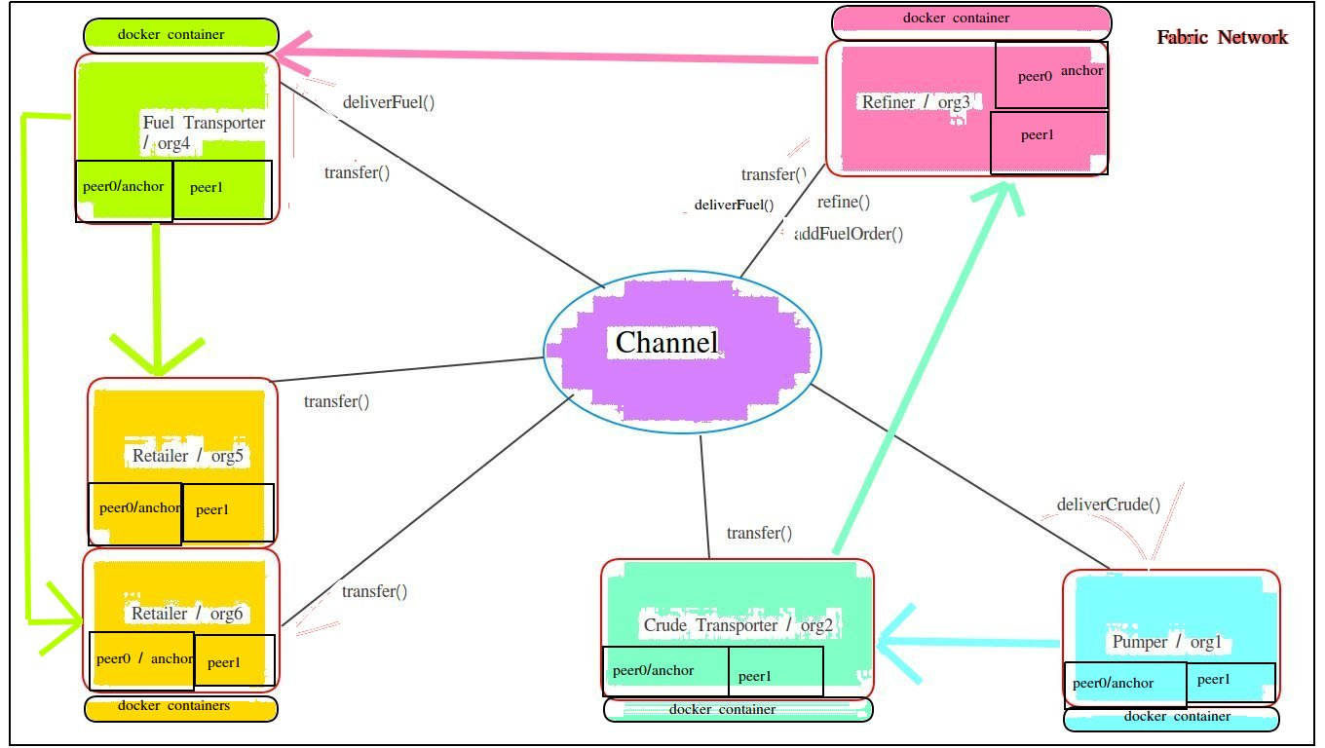

  - In the middle on the graph, we see a channel (eclipse) whose participants are the six orgs (rectangles). Each organization has a colour based on its functionality. Organization 5 and 6 have the same colour because they have the same functionality.
  - Every organization can invoke smart contracts. Next to the black lines,
there are the the available contracts which an organization can call.
  - The coloured arrows show how differents products are forwarded to different organizations – the supply chain - starting from org1 (blue).

A client can connect to the Fabric Network through the Fabric Node SDK.
Many clients can be silmutaneously connected to a network.We provide an image which shows the API between the Clients (node.js app) and the Fabric network. The API calls will be explained in detail later at the ‘Transact with the Network’ section.

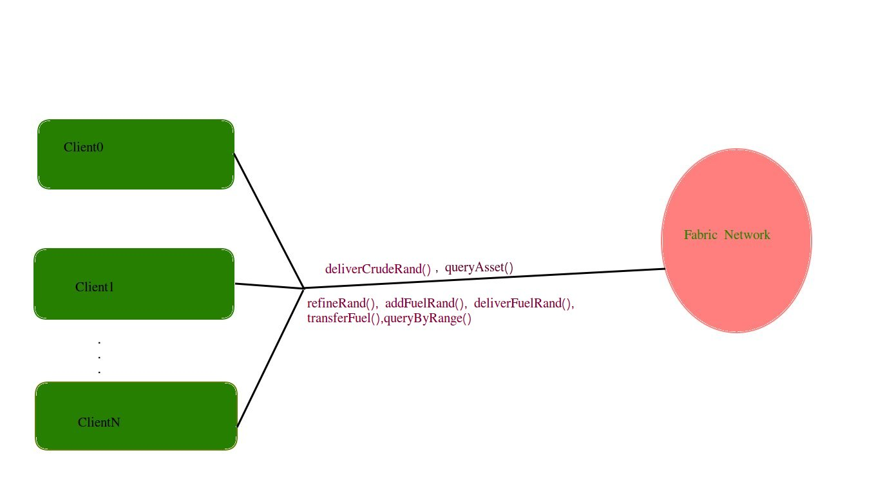

HyperLedger Fabric

Hyperledger Fabric is an open source enterprise-grade permissioned distributed ledger technology (DLT) platform, designed for use in enterprise contexts.It has a modular and configurable architecture and supports smart contracts authored in general-purpose programming languages such as Java, Go and Node.js, rather than constrained domain-specific languages (DSL).The Fabric platform is also permissioned, meaning that, unlike with a public permissionless network, the participants are known to each other, rather than anonymous and therefore fully untrusted. This means that while the participants may not fully trust one another (they may, for example, be competitors in the same industry), a network can be operated under a governance model that is built off of what trust does exist between participants, such as a legal agreement or framework for handling disputes.

The blockchain network

A blockchain network is a technical infrastructure that provides ledger and smart contract (chaincode) services to applications. Primarily, smart contracts are used to generate transactions which are subsequently distributed to every peer node in the network where they are immutably recorded on their copy of the ledger. The users of applications might be end users using client applications or blockchain network administrators.One example of a blockchain network is the following:
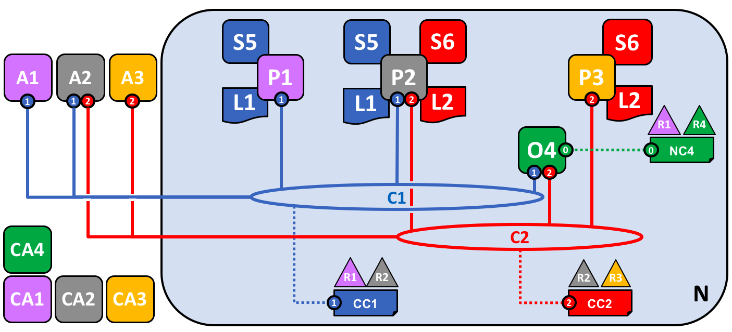

Four organizations, R1, R2, R3 and R4 have jointly decided, and written into an agreement, that they will set up and exploit a Hyperledger Fabric network. R4 has been assigned to be the network initiator – it has been given the power to set up the initial version of the network. R4 has no intention to perform business transactions on the network. R1 and R2 have a need for a private communications within the overall network, as do R2 and R3. Organization R1 has a client application that can perform business transactions within channel C1. Organization R2 has a client application that can do similar work both in channel C1 and C2. Organization R3 has a client application that can do this on channel C2. Peer node P1 maintains a copy of the ledger L1 associated with C1. Peer node P2 maintains a copy of the ledger L1 associated with C1 and a copy of ledger L2 associated with C2. Peer node P3 maintains a copy of the ledger L2 associated with C2. The network is governed according to policy rules specified in network configuration NC4, the network is under the control of organizations R1 and R4. Channel C1 is governed according to the policy rules specified in channel configuration CC1; the channel is under the control of organizations R1 and R2. Channel C2 is governed according to the policy rules specified in channel configuration CC2; the channel is under the control of organizations R2 and R3. There is an ordering service O4 that services as a network administration point for N, and uses the system channel. The ordering service also supports application channels C1 and C2, for the purposes of transaction ordering into blocks for distribution. Each of the four organizations has a preferred Certificate Authority.

Channels

Channels are a mechanism by which a set of components within a blockchain network can communicate and transact privately.These components are typically peer nodes, orderer nodes and applications and, by joining a channel, they agree to collaborate to collectively share and manage identical copies of the ledger associated with that channel.

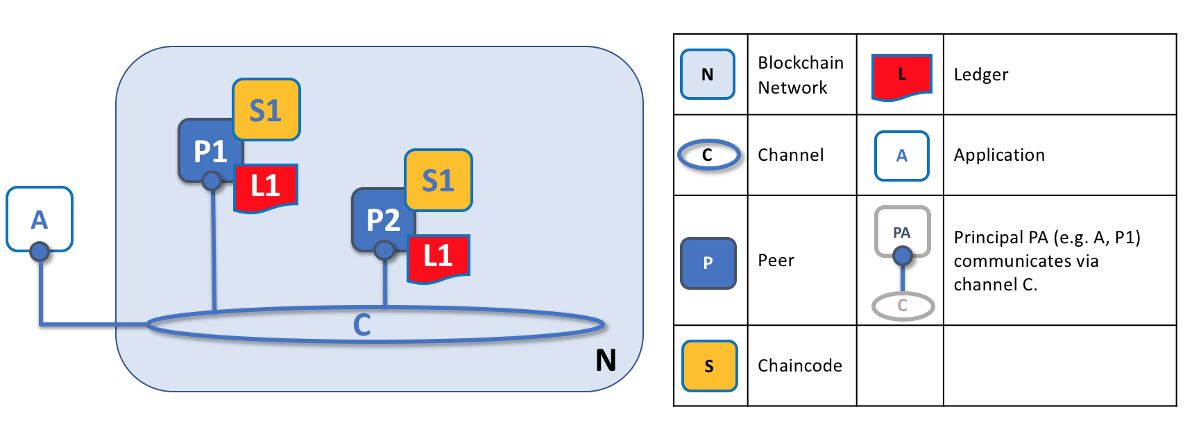

Channels allow a specific set of peers and applications to communicate with each other within a blockchain network. In this example, application A can communicate directly with peers P1 and P2 using channel C. You can think of the channel as a pathway for communications between particular applications and peers. (For simplicity, orderers are not shown in this diagram, but must be present in a functioning network.)
We see that channels don’t exist in the same way that peers do — it’s more appropriate to think of a channel as a logical structure that is formed by a collection of physical peers. It is vital to understand this point — peers provide the control point for access to, and management of, channels.

Consensus

We’ve seen that peers form the basis for a blockchain network, hosting ledgers and smart contracts which can be queried and updated by peer-connected applications. However, the mechanism by which applications and peers interact with each other to ensure that every peer’s ledger is kept consistent is mediated by special nodes called orderers, and it’s to these nodes we now turn our attention.
An update transaction is quite different from a query transaction because a single peer cannot, on its own, update the ledger — updating requires the consent of other peers in the network. A peer requires other peers in the network to approve a ledger update before it can be applied to a peer’s local ledger. This process is called consensus, which takes much longer to complete than a simple query. But when all the peers required to approve the transaction do so, and the transaction is committed to the ledger, peers will notify their connected applications that the ledger has been updated. You’re about to be shown a lot more detail about how peers and orderers manage the consensus process in this section.
Specifically, applications that want to update the ledger are involved in a 3-phase process, which ensures that all the peers in a blockchain network keep their ledgers consistent with each other. In the first phase, applications work with a subset of endorsing peers, each of which provide an endorsement of the proposed ledger update to the application, but do not apply the proposed update to their copy of the ledger. In the second phase, these separate endorsements are collected together as transactions and packaged into blocks. In the final phase, these blocks are distributed back to every peer where each transaction is validated before being applied to that peer’s copy of the ledger.
As you will see, orderer nodes are central to this process, so let’s investigate in a little more detail how applications and peers use orderers to generate ledger updates that can be consistently applied to a distributed, replicated ledger.
Phase 1

Phase 1 of the transaction workflow involves an interaction between an application and a set of peers — it does not involve orderers. Phase 1 is only concerned with an application asking different organizations’ endorsing peers to agree to the results of the proposed chaincode invocation.
To start phase 1, applications generate a transaction proposal which they send to each of the required set of peers for endorsement. Each of these endorsing peers then independently executes a chaincode using the transaction proposal to generate a transaction proposal response. It does not apply this update to the ledger, but rather simply signs it and returns it to the application. Once the application has received a sufficient number of signed proposal responses, the first phase of the transaction flow is complete. Let’s examine this phase in a little more detail.

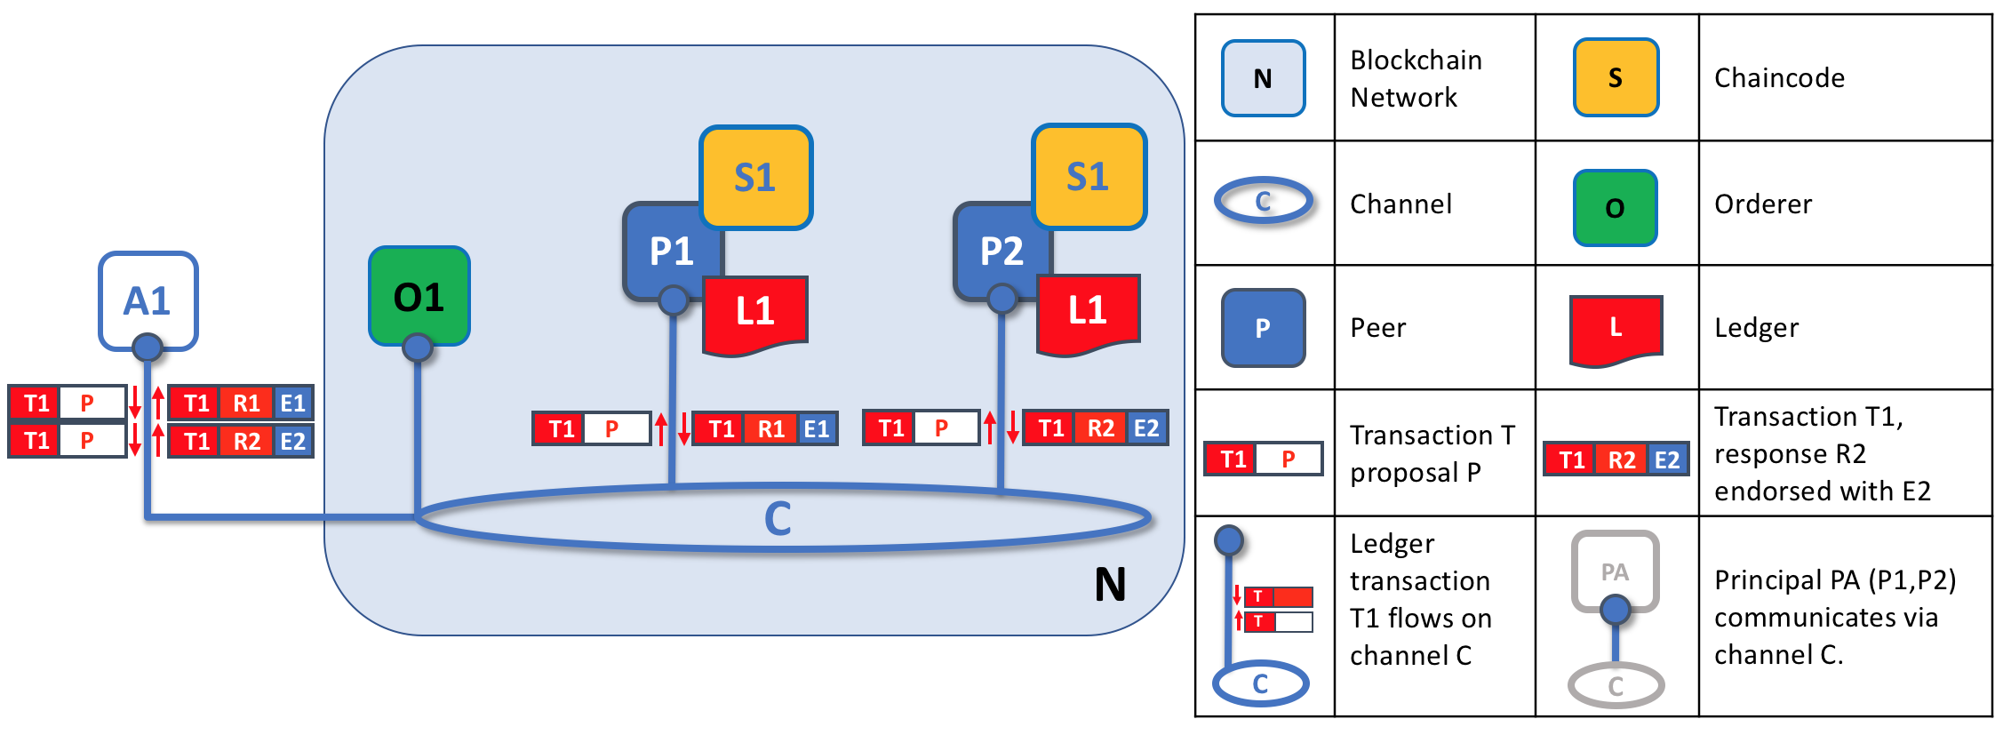

Transaction proposals are independently executed by peers who return endorsed proposal responses. In this example, application A1 generates transaction T1 proposal P which it sends to both peer P1 and peer P2 on channel C. P1 executes S1 using transaction T1 proposal P generating transaction T1 response R1 which it endorses with E1. Independently, P2 executes S1 using transaction T1 proposal P generating transaction T1 response R2 which it endorses with E2. Application A1 receives two endorsed responses for transaction T1, namely E1 and E2.
Initially, a set of peers are chosen by the application to generate a set of proposed ledger updates. Which peers are chosen by the application? Well, that depends on the endorsement policy (defined for a chaincode), which defines the set of organizations that need to endorse a proposed ledger change before it can be accepted by the network. This is literally what it means to achieve consensus — every organization who matters must have endorsed the proposed ledger change before it will be accepted onto any peer’s ledger.
A peer endorses a proposal response by adding its digital signature, and signing the entire payload using its private key. This endorsement can be subsequently used to prove that this organization’s peer generated a particular response. In our ht simply be that the result was generated at different times on different peers with ledgers at different states, in which case an application can simply request a more up-to-date proposal response. Less likely, but much more seriously, results might be different because the chaincode is non-deterministic. Non-determinism is the enemy of chaincodes and ledgers and if it occurs it indicates a serious problem with the proposed transaction, as inconsistent results cannot, obviously, be applied to ledgers. An individual peer cannot know that their transaction result is non-deterministic — transaction rexample, if peer P1 is owned by organization Org1, endorsement E1 corresponds to a digital proof that “Transaction T1 response R1 on ledger L1 has been provided by Org1’s peer P1!”.
Phase 1 ends when the application receives signed proposal responses from sufficient peers. We note that different peers can return different and therefore inconsistent transaction responses to the application for the same transaction proposal. It migesponses must be gathered together for comparison before non-determinism can be detected. (Strictly speaking, even this is not enough, but we defer this discussion to the transaction section, where non-determinism is discussed in detail.)
At the end of phase 1, the application is free to discard inconsistent transaction responses if it wishes to do so, effectively terminating the transaction workflow early. We’ll see later that if an application tries to use an inconsistent set of transaction responses to update the ledger, it will be rejected.

Phase 2

The second phase of the transaction workflow is the packaging phase. The orderer is pivotal to this process — it receives transactions containing endorsed transaction proposal responses from many applications, and orderes the transactions into blocks.

Phase 3

At the end of phase 2, we see that orderers have been responsible for the simple but vital processes of collecting proposed transaction updates, ordering them, and packaging them into blocks, ready for distribution to the peers.
The final phase of the transaction workflow involves the distribution and subsequent validation of blocks from the orderer to the peers, where they can be applied to the ledger. Specifically, at each peer, every transaction within a block is validated to ensure that it has been consistently endorsed by all relevant organizations before it is applied to the ledger. Failed transactions are retained for audit, but are not applied to the ledger.
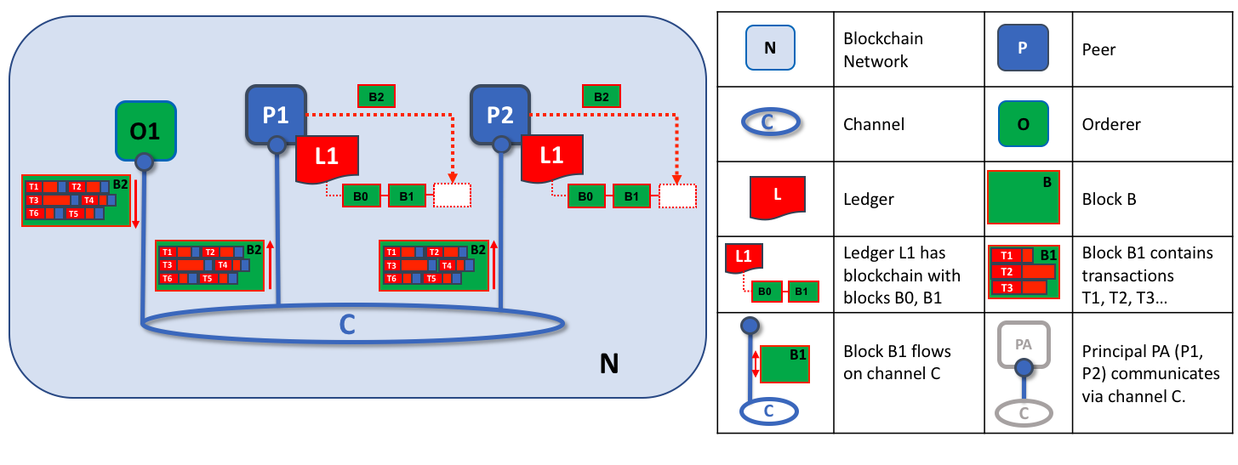
The second role of an orderer node is to distribute blocks to peers. In this example, orderer O1 distributes block B2 to peer P1 and peer P2. Peer P1 processes block B2, resulting in a new block being added to ledger L1 on P1. In parallel, peer P2 processes block B2, resulting in a new block being added to ledger L1 on P2. Once this process is complete, the ledger L1 has been consistently updated on peers P1 and P2, and each may inform connected applications that the transaction has been processed.
Phase 3 begins with the orderer distributing blocks to all peers connected to it. Peers are connected to orderers on channels such that when a new block is generated, all of the peers connected to the orderer will be sent a copy of the new block. Each peer will process this block independently, but in exactly the same way as every other peer on the channel. In this way, we’ll see that the ledger can be kept consistent. It’s also worth noting that not every peer needs to be connected to an orderer — peers can cascade blocks to other peers using the gossipprotocol, who also can process them independently. But let’s leave that discussion to another time!
Upon receipt of a block, a peer will process each transaction in the sequence in which it appears in the block. For every transaction, each peer will verify that the transaction has been endorsed by the required organizations according to the endorsement policy of the chaincode which generated the transaction. For example, some transactions may only need to be endorsed by a single organization, whereas others may require multiple endorsements before they are considered valid. This process of validation verifies that all relevant organizations have generated the same outcome or result. Also note that this validation is different than the endorsement check in phase 1, where it is the application that receives the response from endorsing peers and makes the decision to send the proposal transactions. In case the application violates the endorsement policy by sending wrong transactions, the peer is still able to reject the transaction in the validation process of phase 3.
If a transaction has been endorsed correctly, the peer will attempt to apply it to the ledger. To do this, a peer must perform a ledger consistency check to verify that the current state of the ledger is compatible with the state of the ledger when the proposed update was generated. This may not always be possible, even when the transaction has been fully endorsed. For example, another transaction may have updated the same asset in the ledger such that the transaction update is no longer valid and therefore can no longer be applied. In this way each peer’s copy of the ledger is kept consistent across the network because they each follow the same rules for validation.
After a peer has successfully validated each individual transaction, it updates the ledger. Failed transactions are not applied to the ledger, but they are retained for audit purposes, as are successful transactions. This means that peer

blocks are almost exactly the same as the blocks received from the orderer, except for a valid or invalid indicator on each transaction in the block.
In summary, phase 3 sees the blocks which are generated by the orderer consistently applied to the ledger. The strict ordering of transactions into blocks allows each peer to validate that transaction updates are consistently applied across the blockchain network.
We saw the basic concepts of Hyperledger Fabric and we are now ready to see how we implemented this project utilizing the Fabric platform.

Implementation

In order to launch a fabric network with six organizations, we made some changes at the byfn tutorial files. Specifically, the tutorial builds a network with 2 organizations so we added 4 orgs on top of the two existing ones. The configuration files that we've changed are:

  - crypto-config.yaml

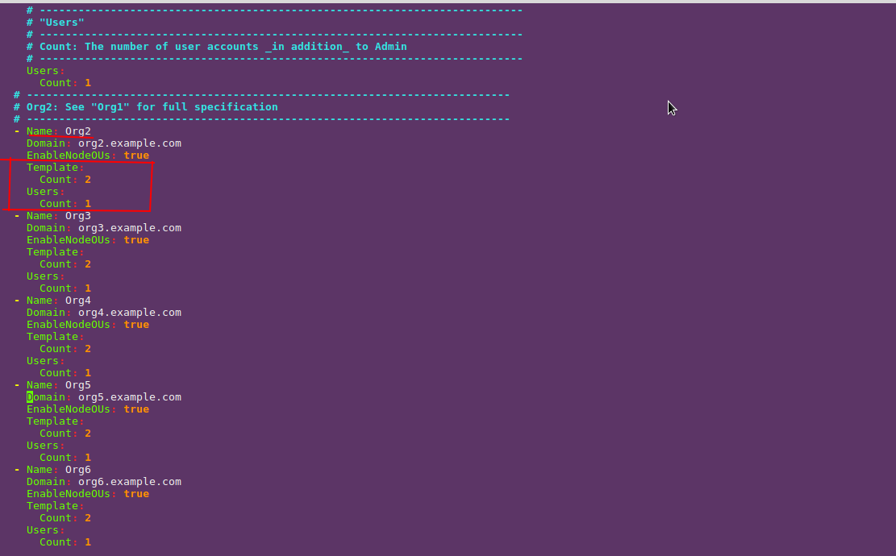

The Template field specifies how many peers each organization will have.

- configtx.yaml:
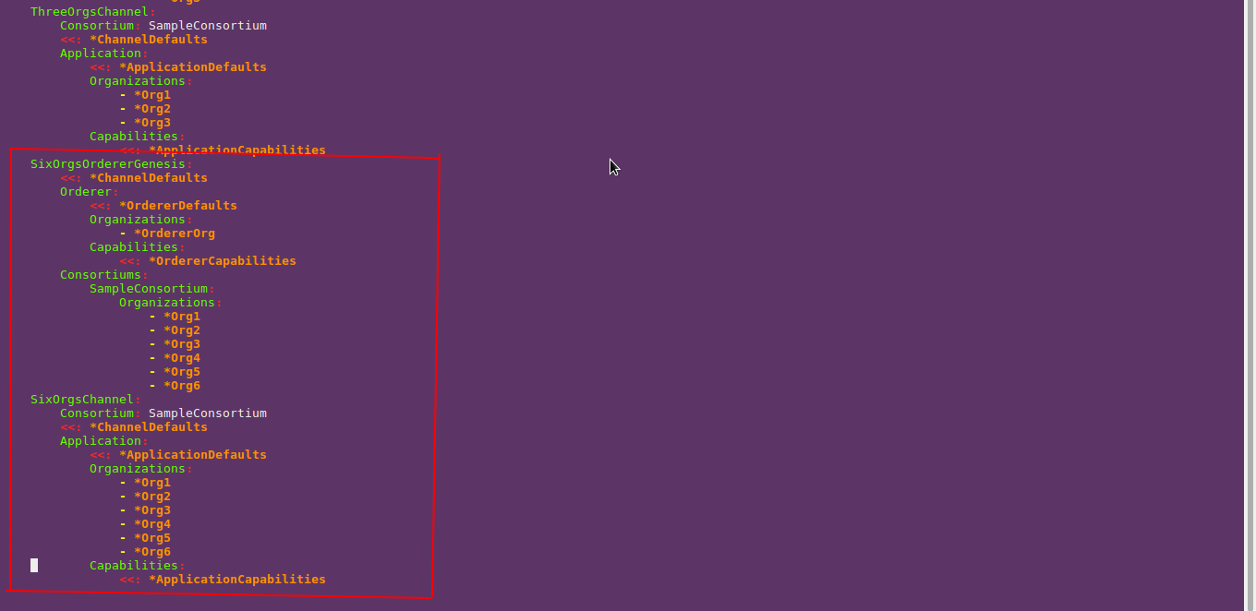

We added SixOrgsOrdererGenesis and SixOrgsChannel fields
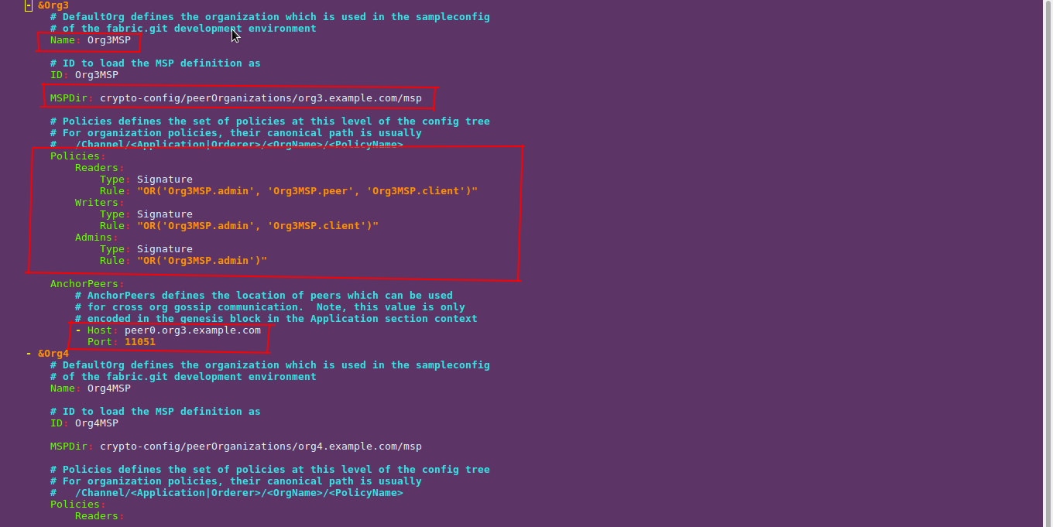

We defined the organizations 3-6.

Each org in fabric runs in a docker container so we modified some docker-compose files.

- cli.yaml

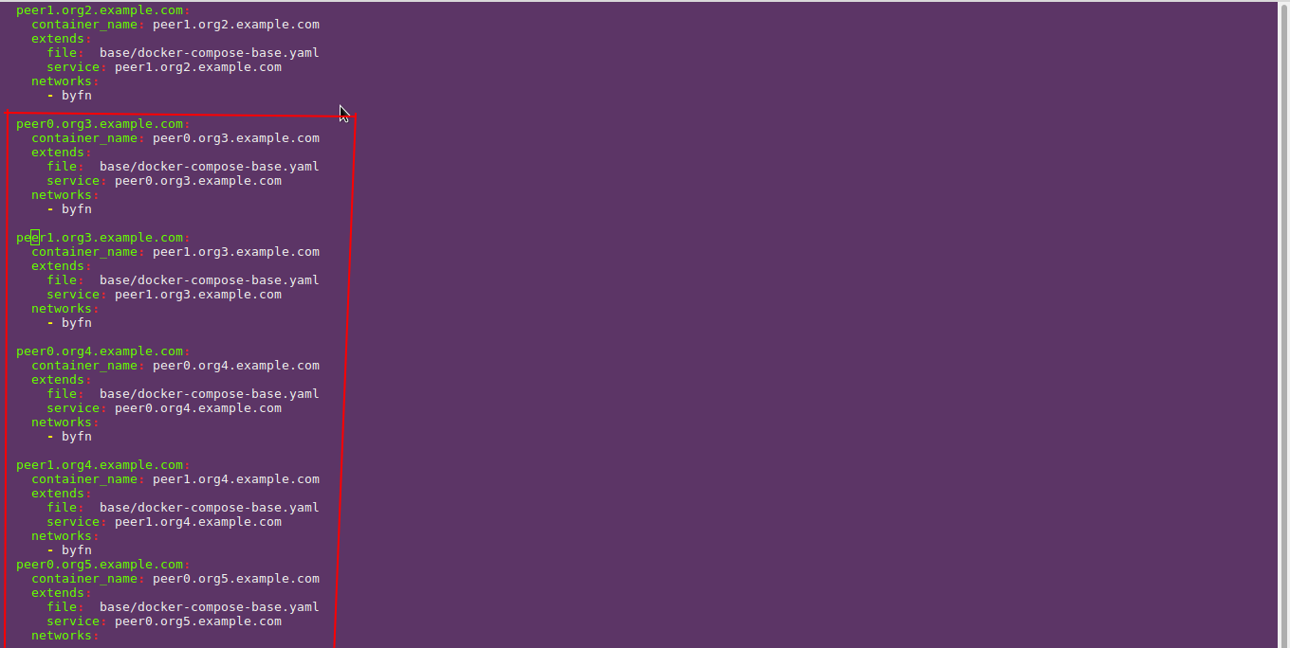

- base.yaml
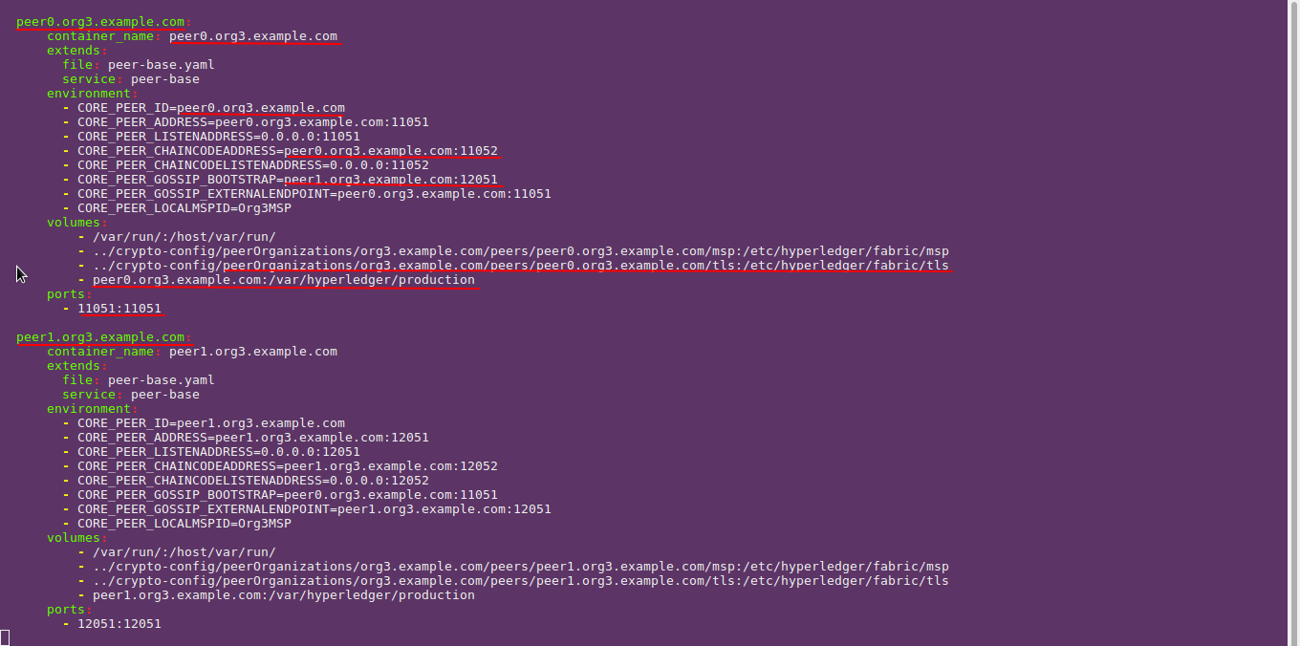

In essence, we added 4 orgs with the same configuration as the two previsously existing ones, so we just extended the network participants but not its funcionality.
Finally, we needed to extend some scripts to be able to launch the network. Specifically, byfn.sh , utils.sh and script.sh need to be changed in order to serve our needs.

Chaincode

We used Go (Golang) to develop the chaincode (smart contracts). The whole chaincode leaves in a single file so let's have a closer look at this file. First and foremost, the structs that we created give a good insight into the functionality of the chaincode.
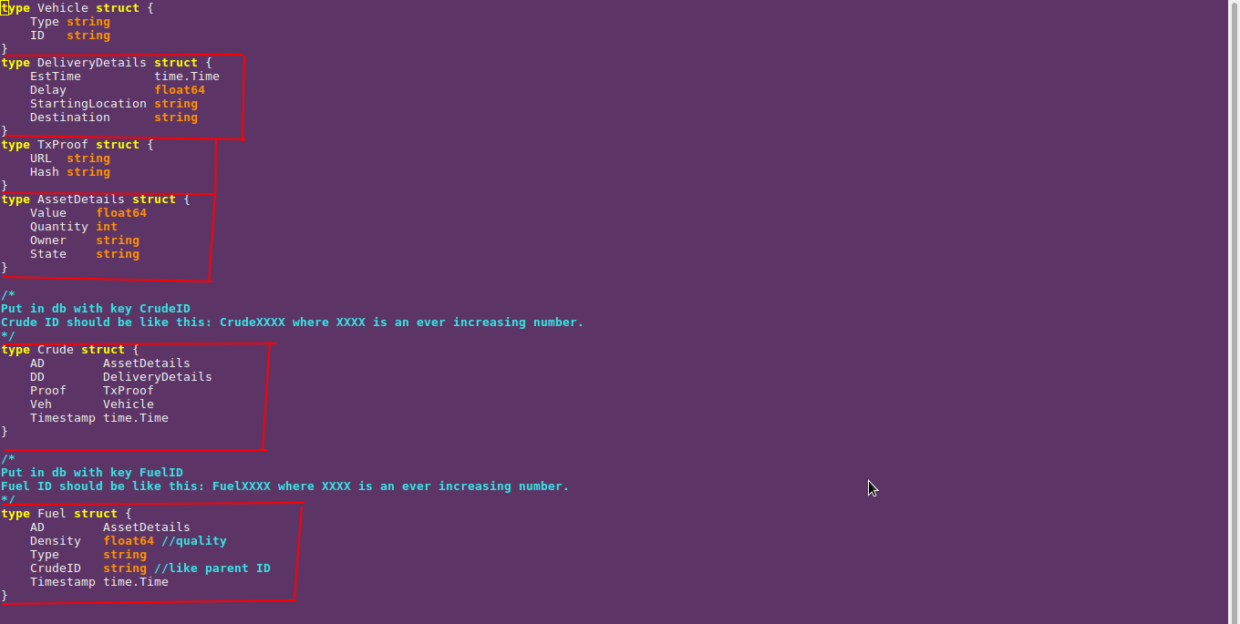
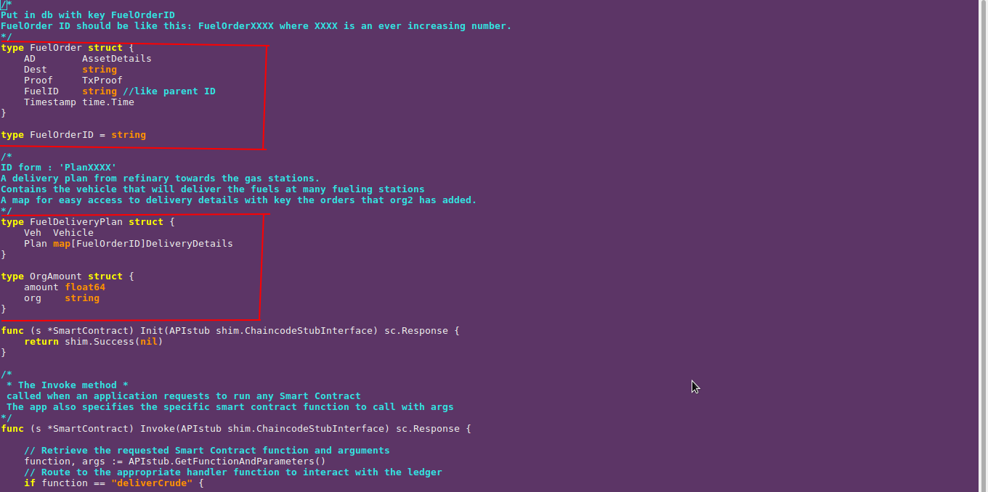

- Vehicle: Each transportation vehicle has a type (e.g Vessel, Truck) and an ID
- Asset Details : Every Asset (e.g. Crude , Fuel , FuelOrder) has a State (e.g. READY_FOR_DISTRIBUTION, DELIVERED,REFINED) and some other essential fields like Value etc.
- Delivery Details: Contains the starting point of the asset's route and its destination. Also, it contains the Estimated Delivery Time (EstTime) . This is the approximate time that the Transporter believes he can deliver the asset. The Delay field is how much the delivery of the asset was actually delayed relatively to the EstTime field. If Delay is negative, this means that the Transporter delivered the asset before the EstTime.
- TxProof: A realistic application would need to couple the transaction data with some 'real' data. What I mean by real is for example, the original documents which were signed by two or more orgs in order to make an order for an asset. So, this struct cointains the URL of an original document and its Hash in order to ensure its integrity. This is a proof-of-concept project so no 'real' documents were created nor signed by anyone. For every asset, this struct contains the same dummy URL and Hash fields which is "www.ait.gr" and "7cb0d761a60f4968299cda86c333dafe318fbf87b0979f60befd0499e39e21d6" (the SHA-256 Hash of 'www.ait.gr') respectively.
- Fuel Delivery Plan: A delivery plan from the refinary towards the gas stations.Contains the vehicle that will deliver the fuelOrders at many fueling stations. Each fuelOrder has some delivery details and when the order is eventually delivered, the state of the order will become 'DELIVERED'.

Chaincode API

- InitLedger: Every organization is associated with an escrow account.For example, the account for organization 1 is named 'org1'. By calling initLedger we initialize all accounts with some starting balance (100000) . If an asset in the blockchain changes ownership, all organizations involved will send/receive money from these escrow accounts.

- deliverCrude: When this function is called , it creates a new Crude Asset based on the supplied arguments and starts the delivery of the Crude.
- refine: When the Crude gets eventually delivered , the refine process takes place. The crude is transformed into some other useful products (e.g. fuel , gas).
- addFuelOrder: When a Retailer makes an order for fuel from the Refiner, this method should be called. By the end of this invokation, a new fuelOrder will be created and stored in the blockchain.
- deliverFuel: When this function is called, a new Delivery Plan is made. The caller specifies which fuelOrders will be delivered and the Plan is made based on these orders. There is no limit to how many orders a Delivery Plan can hold.
- transfer : This method should be called when an asset is going to change ownership. For example, if the Oil-Pumper sells crude oil to Refiner then after the delivery, a transfer transaction should be submited on the blockchain. When calling this method, all payments associated with the transfer of the asset will take place.Transporters will have their payment decreased based on the value of Delay field (see Delivery Details above).Sellers will get paid based on quantity and value of the asset they sold and buyers will pay both the transporter and the seller as usual.
- queryAsset: API for quering a single asset or an account balance (e.g.Crude423 , Fuel212).
- queryAssetByRange: API for quering a range of assets of the same type (e.g. Crude1-999, Plan1-999).
- queryHistoryForKey: API for quering a single asset for its complete update history in the database (maybe there are some bugs at this method).

Transact with the network

Note: All instructions should be run under first-network/app/application/ directory

A client can transact with the blockchain with the help of a node.js app that has been developed for this purpose.

Config & Wallet

The app uses the Node SDK of Hyperledger Fabric to connect to the network and submit transactions.In order to
connect to a Fabric network with the Node SDK, a client should first create a config file called Connection Profile.
Here's what ours looks like:

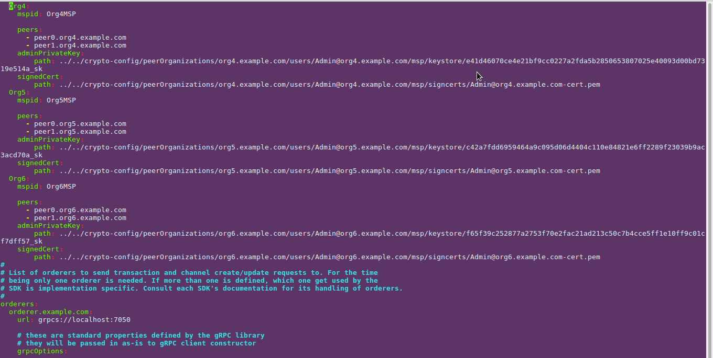

The Connection Profile has the information needed for the SDK to establish a connection between the peers of the network.
Because Fabric uses CAs (Certificate Authorities) to authenticate every action on the network,a client should also be equipped with some crypto material. For this purpose, a wallet should be made. A script has been developed to create a wallet and it is available under first-network/app/application/addToWallet.js.
(anyone can run the script with this command : node addToWallet.js)

Update the ledger

After creating the Connection Profile and the Wallet, we are ready to interact with the network (assuming there is one running). The very first think we need to do is call the initLedger method to initialize the escrow accounts. So, we run the following command:
$ node init.js

This script establishes a connection with the network by using the Connection Profile file and submits a transaction with a single argument that is 'initLedger' i.e the name of the method we want to call.
Here's what the file looks like:

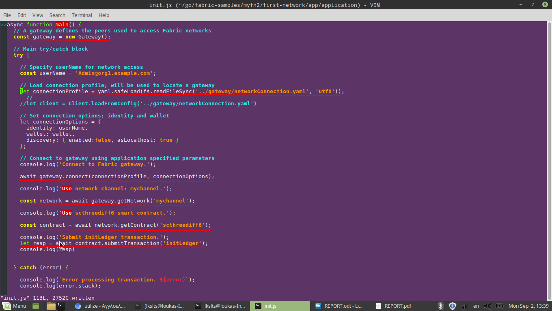

The above picture shows the steps that a client should make to connect to a Fabric network and submit a transaction.
If we want to call other methods than initLedger, then we should run another script called issue.js. This script offers a wide variety of methods to call, so we should pass as command line args the specific method we would like to invoke. We can run this script like this:

$ node issue.js <method_name> <arg0> <arg1> <arg2> ... <argN>

method_name can be any of the Chaincode API methods (see above) except the last three, so we can only update the ledger with issue.js. These are the available method_names and the args one should give after:
- deliverCrude: needs one more arg that is the ID of the Crude that will be created. Example :
$ node issue.js deliverCrude 9842
- transferCrude: needs one more arg that is the ID of the Crude that will be transfered. Example:
$ node issue.js transferCrude 4324
- refineRand: needs two more args that is the ID of the Crude that will be transformed to fuel and the ID of the newly created fuel (the Crude ID should pre-exist in the database).Example:
$ node issue.js refineRand 342 98
- addFuelOrderRand: needs two more args that is the ID of the refined fuel that the order originated and the ID of the newly created fuel order(the fuel ID should pre-exist in the database ).Example:
$ node issue.js addFuelOrderRand 321 908
- deliverFuelRand: can have infinite arguments. The first one should be the ID of the newly created Plan and the rest should be the FuelOrder IDs that the Delivery Plan will contain (FuelOrderIDs should pre-exist in db). Example:
$ node issue.js deliverFuelRand 4 1 2 3 4 5 6 ...
- transferFuel: should have two args . The first one should be the FuelOrderID and the second the PlanID (both args should pre-exist in db). Example:
$ node issue.js transferFuel 5423 6546.

Alternatively, we can run issue.js without any args ($ node issue.js) if we want to invoke all previous methods N times (N is random). If someone looks at the chaincode file, he/she will notice that in order to create/deliver/transfer aasset, more arguments should be supplied on top of IDs. Hence, a reasonable question will be: Where the issue.js script finds all the extra arguments that are needed? The answer is that it generates them randomly. That's why some method_names have a Rand suffix.

HTTP Server

In order to query/update the ledger, we should run the serve.js file:
$ node serve.js
This command will start up a server on your machine (localhost) listening at port 8080.We can make GET requests to the server from our browser and query/update the blockchain:

Query for a specific asset : localhost:8080/<Asset><ID> , where Asset = {Crude,Fuel,FuelOrder,Plan}
and ID is a positive integer.

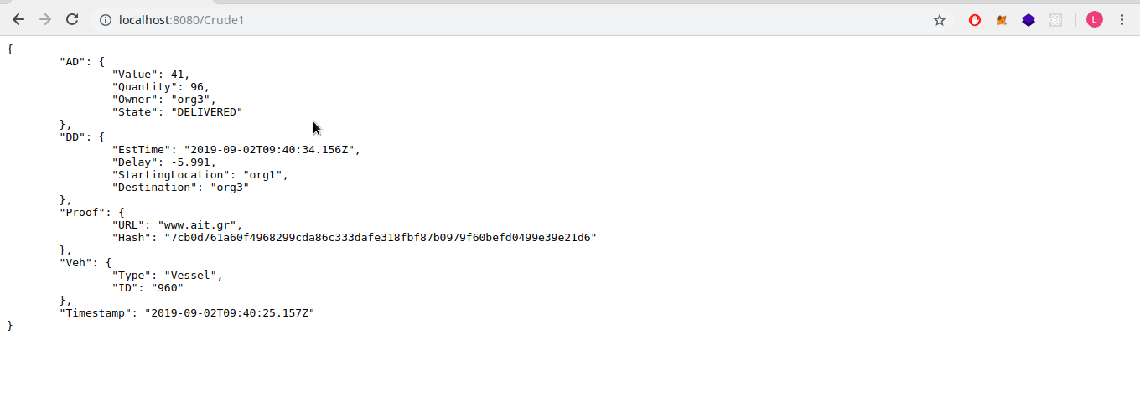

- Query a range of assets /<Asset> . Asset here is defined as above.

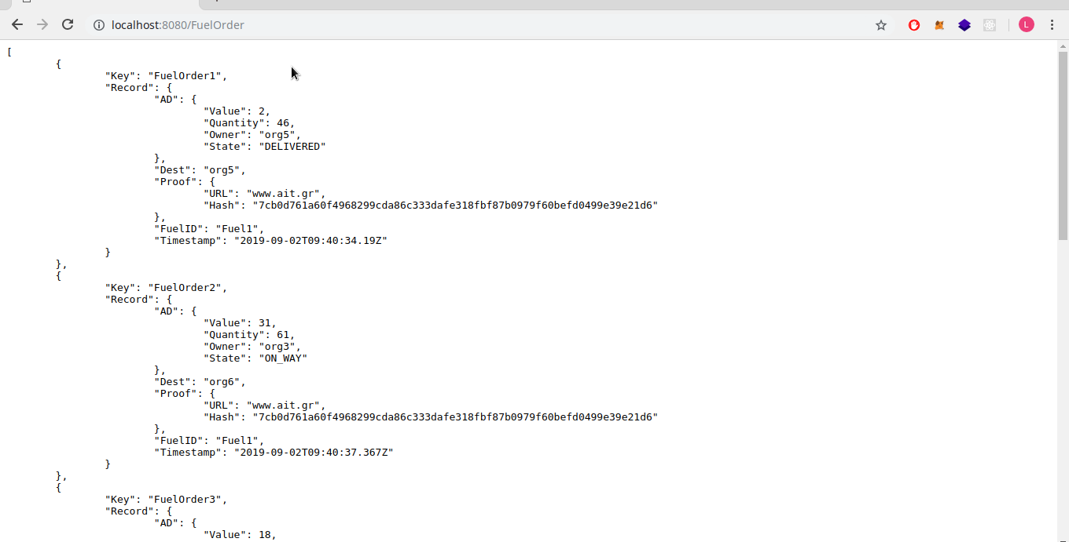

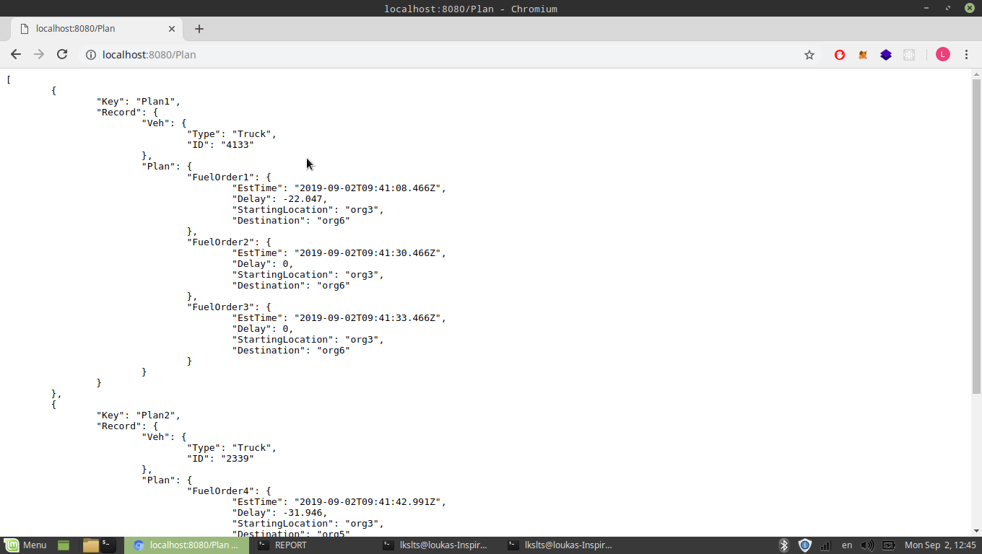

- Query for the last commited block at /blocks

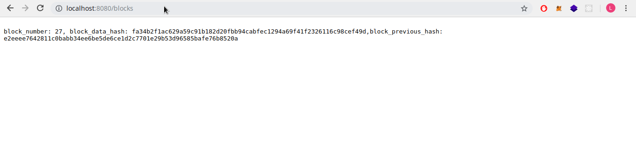

- Query for the balance of a specific account at /org<ID> , where ID = {1,2,3,4,5,6}.

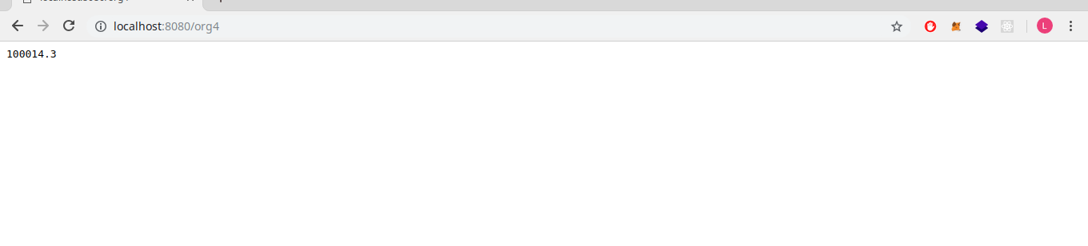

- Update ledger: A client can update the ledger by supplying a URL whose form is :
http://localhost:8080/update?m=<method>&id=<id>&id2=<id2>&idN=<idN>

where method is the method name of the Chaincode API and id the ID of the asset that will be inserted or updated. This is the list of the available options for <method> query parameter and its corresponding IDs:

- deliverCrude: needs one more arg that is the ID of the Crude that will be created. Example :
- http://localhost:8080/update?m=deliverCrude&id=4
- transferCrude: needs one more arg that is the ID of the Crude that will be transfered. Example:
http://localhost:8080/update?m=transferCrude&id=7
- refineRand: needs two more args that is the ID of the Crude that will be transformed to fuel and the ID of the newly created fuel (the Crude ID should pre-exist in the database).Example:
http://localhost:8080/update?m=refineRand&id=43&id2=654
- addFuelOrderRand: needs two more args that is the ID of the refined fuel that the order originated and the ID of the newly created fuel order(the fuel ID should pre-exist in the database ).Example:
http://localhost:8080/update?m=addFuelOrderRand&id=534&id2=87
- deliverFuelRand: can have infinite arguments. The first one should be the ID of the newly created Plan and the rest should be the FuelOrder IDs that the Delivery Plan will contain (FuelOrderIDs should pre-exist in db).
transferFuel: should have two args . The first one should be the FuelOrderID and the second the PlanID (both args should pre-exist in db). Example:
http://localhost:8080/update?m=transferFuel&id=132&id2=423

- Create and deliver crude
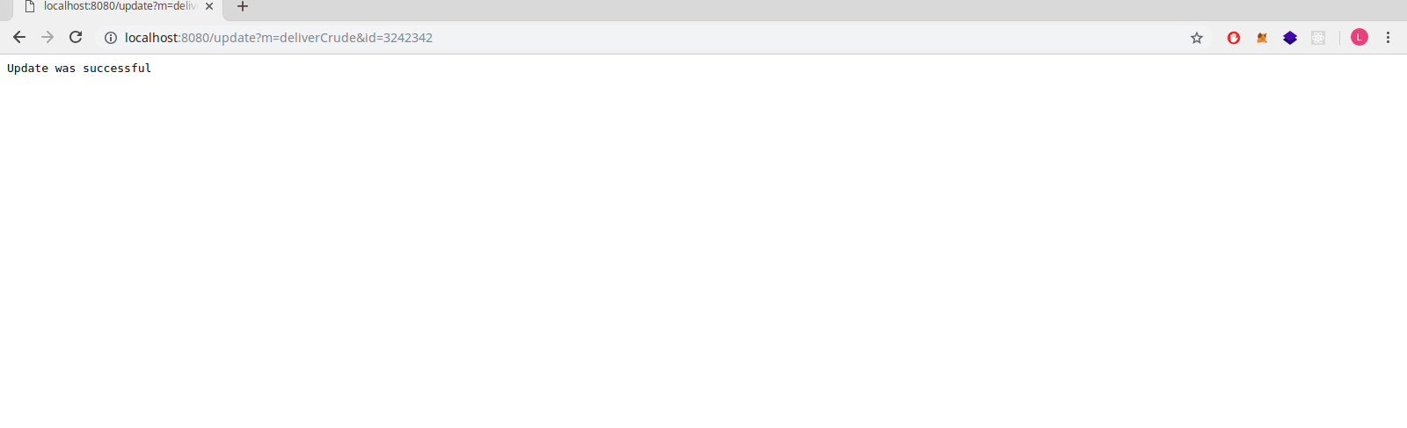

- Transfer the crude to the Refiner

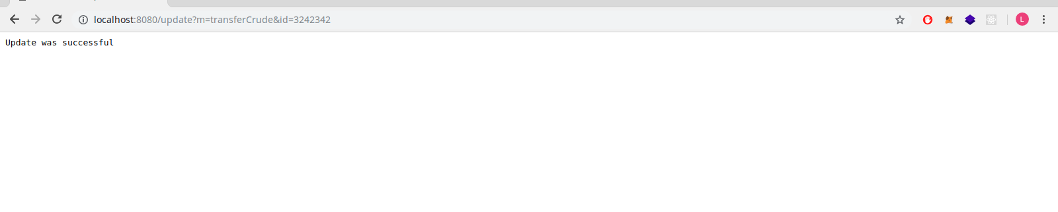

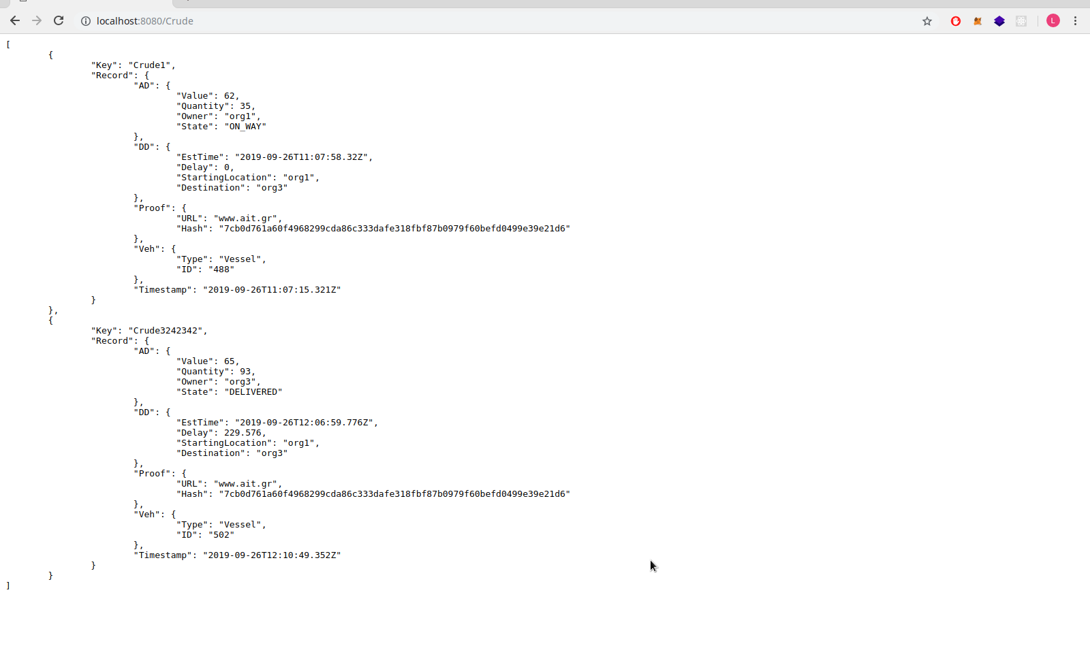
- Ensure Crude3242342 exists in the database

Installation

IMPORTANT: This project is intented for personal use and will not be maintaned in the future.
The installation process is intented for Debian based platforms only and you may have to make some workarounds to
build the network correctly for other ones.May the Force be with you!

Prerequisites:
- Hyperledger fabric 1.4

After installing Fabric, a new directory called fabric-samples/ should exist (propably under go/ directory).

In order to build the network (Debian based platforms) :

1) clone this repo under fabric-samples/ directory
2) $ cd supply_chain_fabric/first-network/supply_chainCode/
3) $ go build all-orgsCC.go
4) copy chaincode directory (supply_chainCode/) under fabric-samples/chaincode/
5) navigate under supply_chain_fabric/first-network/ directory
6) $ sudo ./byfn up
7) $ sudo docker exec -it cli bash
8) $ cd scripts && ./upgrade.sh 8.0

In order to make transactions and query the network with the SDK:

1) navigate under app/application directory.
2) $ npm install
3) $ node addToWallet.js
4) $ node init.js
Now you are ready to transact with the blockchain.
5) Run issue.js to update the blockchain and after serve.js to query/update the blockchain.

