

Physical Activity and Academic Achievement
Kun Liu
April 25, 2014

Applied Regression Analysis
STAT 6450
Spring 2014

Abstract
Poor academic performance is a serious problem in the United States. This study focused on the relationship between physical activity amount and academic performance in 3rd grade students. After imputation of the missing observations, the multiple linear regression model was built to investigate correlation between physical activity and three academic test scores: letter-word identification, calculation and applied problems. The results showed little or no linear relationship between these variables. Transformed linear regression may be necessary such as polynomial regression. The students' gender, race, family income-to-need ratio and BMI also have some relationship with students' physical activity.
Introduction
Students in every grade level at schools across the country are struggling in class. According to U. S. Department of Education, most students reading and math performances were below proficiency level after four-year public schooling. There has been frequent speculation about the effects of physical activity on the school learning process in children and adolescents, and in the past there was a tendency to think that time devoted to nonacademic goals has a negative effect on academic performance^{[1]}. More and more time and resources have been spent on mathematics and science subjects to increase students performances on standardized tests. Very often, budget restrictions and students poor academic ability have been used as the primary reasons for cutting other areas such as physical education.
There is myriad research trying to prove that students need adequate amounts of physical activity throughout the school day—not only do they prevent obesity and obesity-related issues, but they also perform better academically. Researchers have put forth great efforts to examine the relation between PA amount and academic achievement and cognition. However, several well-designed studies about this issue have reached different conclusions^{[2]}. Some researchers found that physical activity has no relationship to academic performance^{[3][4]}, while others suggesting physical activity in students is associated with improvement in academic performance. Shephard and Trudeau (2005)^{[5]} suggested that increasing the time spent in physical activity at school increased academic performance in comparison with students who had no additional activity. Symons, et al. (1997) ^{[6]} believed that physical exercise helps interneuronal connection and enhances concentration. Dwyer, Sallis et al. (2001) ^{[7]} and Lindner (1999) ^{[8]} both surveyed larger groups of students (7961 and 4690 respectively) concluded a significant, but small, correlation between academic outcomes and participation in more physical activities.
These results seem to suggest that the hours spent of physical activity and academic performance do not show a clear linear relationship. Lack of certain amount of physical exercise can definitely decrease oxygen flow to the brain and brain neurotransmission, as well as obesity and other health issues. However, since academic achievements and physical activity both require effort and time commitment, this could explain why some studies have found that the academic performance achieved by students who are also elite athletes is similar to or lower than that of the general student population^{[9]}. All this suggests that there may be an optimum amount of physical activity that is related to higher academic performance^{[2]}.
The objective of this study is to investigate the relationship between physical activity and academic performance by using regression methods, and to justify the importance roles that PA and PE play in school academic.
Methods
A group of 1364 3rd graders were recruited as study subjects to investigate the relations between PA and academic performance via the National Institute of Child Health and Human Development Early Child Care Research Network. The variables in the dataset are:
- SITE: Data collection regions
- CSEX: Gender
- CRACE: Race (White, Black, Hispanic, Asian, and other)
- INCNTMG3: Family income-to-needs ratio (family pre-tax income divided by
- the poverty threshold for a household)
- BMIPG3: Body Mass Index (BMI)
- MMVPACG3: Minutes of daily moderate-to-vigorous physical activity (MVPA)
- WJPCSCG3: Test score for letter-word identification
- WJCLSCG3: Test score for calculation
- WJAPSCG3: Test score for applied problems
Some abbreviations of variable names were used in later analysis, they are: CSEX(SEX), CRACE(RACE), INCNTMG3(INT), BMIPG3(BMI), MMVPACG3(MVPA), WJPCSCG3(PC), WJCLSCG3(CL), WJAPSCG3(AP).
1. Multiple imputation of missing data

The 1364 surveyed individuals include some missing observations. After abandoning those observations regarded as "completely missing" and not as informative for this study, I then use multiple imputation to fill the missing values with a distribution of imputation that reflect the uncertainty. The bootstrap-based EMB algorithm included in Amelia II was capable to impute multiple variables with many missing observations. It assumes that the complete data are multivariate normal. Transformations of many types of variables can often make this normality assumption more plausible^{[10]}. We also need to make the usual assumption that the data are missing at random (MAR). This assumption means that the pattern of missingness only depends on the observed data Dobs, not the unobserved data D^{mis}. Let M be a matrix that indicates whether or not a cell is missing in the data, we can define the MAR assumption as

$p\left(M | D\right)=p(M|D^{obs})$ (1)
The likelihood of observed data is p(D^{obs}, M|$θ$). Now we have:
$p(D^{obs}, M|θ)=p(M|D^{obs})p(D^{obs}|θ)$ (2)
As we only care about inference on the complete data parameters, we can write the likelihood as

$L(θ|D^{obs})∝p(D^{obs}|θ)$ (3)
With this likelihood and a at prior on _, we can see that the posterior is

$p\left(θ | D^{obs}\right)∝p\left(D^{obs} | θ\right)=\int{p(D|θ)dD^{mis}}$ (4)
The main computational difficulty in the analysis of incomplete data is taking draws from this posterior^{[10]}. EMB algorithm combines the classic EM algorithm with a bootstrap approach to take draws from this posterior. A schematic of EMB algorithm is shown in Figure 1.

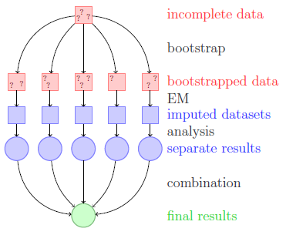
Figure 1 A schematic of our approach to multiple imputation with the EMB algorithm^{[10]}

2. Multiple linear regression
In this study, we are particularly interested in the correlation between academic performance measures and MVPA. we can construct a multi-variable regression model as follows:
$Y_{i}=β_{0}+β_{1}X_{i1}+β_{2}X_{i2}+…+β_{p-1}X_{i,p-1}+ϵ_{i}$ (5)
Where:
${β_{0}, β}_{1}$and $β_{p-1}$ are parameters
$X_{i1},…, X_{i,p-1}$are known constants
$ϵ_{i}$ is independent
The regression model started from using the three academic performance scores as predictors and MVPA as response. The regression diagnostics and model selection will be performed to evaluate and optimize the model. After this, I will try to find if there is an optimum amount of physical activity that is related to higher academic performance.
3. Other regression analysis
Based on studies from other researchers, a linear regression may not be a optimum fit for data. We may also consider other transformed linear models or nonlinear models.
Quadratic regression model was used in the analysis, the model can be written as:
$Y_{i}=β_{0}+β_{1}X_{i}+β_{2}X_{i}^{2}+ϵ_{i}$ (6)
A nonlinear regression model has the form
$Y_{i}=f\left(X_{i, }θ\right)+ϵ_{i} , i=1,…, n$ (7)
where the Yi are responses, f is a known function of the vector X_{i}= (x_{i1},..., x_{ik})^{T} and parameter vector $θ={(θ_{1},…, θ_{p})}^{T}$, and $ϵ_{i}$ are random errors.
The roles of those controlling variables were also investigated by regression of subset data.

Results and Discussion
1. Missing data imputation
Before doing imputation, We first looked the feature of missing data. There are 283 students only had their SEX and RACE recorded, and 20 students only had SITE, SEX and RACE record. These data were considered completely missing since they didn't carry too much useful information. After excluding these 303 datasets, We can pair the other variables with remaining data to look for any relationship. Figure 2 shows the pair plot of the six variables. We can see positive linear correlation between those three academic performance variables, the MVPA score doesn't seem to have clear trend with any of these three variables.
The distribution of variables were also analyzed. Figure 3 shows distribution of family income-to-need ratio and BMI. They both skew in both direction. For family income-to-need ratio, there are 71 below 1.00, which indicates that the income for the respective family or unrelated individual is below the official definition of poverty. The majority falls into the [0,5] interval. There are more interesting findings in BMI value. As shown in Table 1, among the 1061 students, there are 293 students categorized as overweight and within which, 157 of them categorized as obese (>95 percentile). In other words, 27% of students had overweight issue in their third grade.
The histogram of MVPA and three academic performance variables are plotted in Figure 4. All of these variables are more or less normally distributed.
Figure 2. Relationship between variables of for data with valid observations
Other than the 303 "completely missing" datasets, there are also a certain group of data (only 25) contains either or both of INT and BMI, without any observations of MVPA, PC, CL and AP. Since we are more interested in the latter four variables, these dataset was also abandoned in the following study. Thus we had 1036 students had at least one of the four variables recorded: MVPA, PC, CL and AP. The complete data without any observation missing is only 733, abandoning the rest would lead to too much loss (46.3%) of valuable observations. So in this study, we use multiple imputation method to fill the missing observations in the 1036 datasets and perform regression analysis based on imputation results.
The imputation results is shown in Figure 5. We set SITE, SEX and RACE as categorical variables and did log transformation to ITN, and set the BMI bound as 0 to 100. Figure 6 through 9 shows some diagnostics of imputation results. Figure 6 shows a well-distributed imputation with most 90% interval line cover the y=x line, which indicates the line of perfect agreement. Figure 8 shows a well behaved likelihood, as the starting values all converge to the same point. The black horizontal line is the point where model converges when it uses the default method for choosing the starting values. The diagnostic takes the end point of this chain as the possible maximum and disperses the starting values away from it to see if the chain will ever finish at another mode.
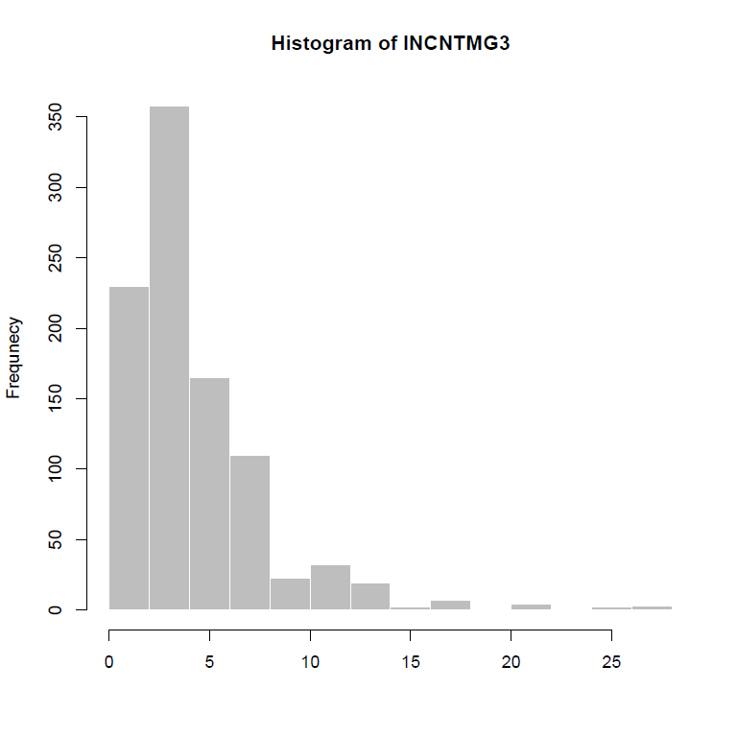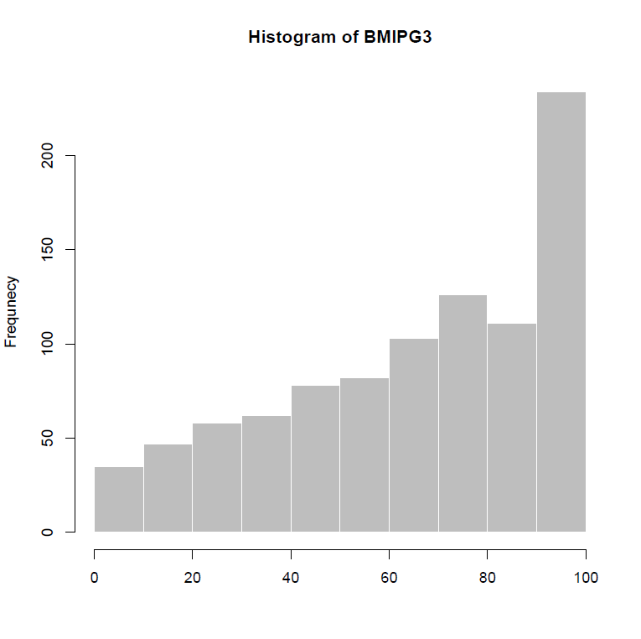
Figure 3 distribution of income-to-need ratio and BMI of students
Table 1 BMI percentile and their belonged weight status for children
Weight Status Category | BMI Percentile Range
Underweight | Less than the 5th percentile
Healthy weight | 5th percentile to less than the 85th percentile
Overweight | 85th to less than the 95th percentile
Obese | Equal to or greater than the 95th percentile
2. Linear regression analysis
After imputation, the regression model was built on MVPA using PC, CL and AP as predictor. Figure 10 and 11 show the results graphs. The leverage plot in Figure 11 suggests that adding CL into regression is of little additional help in the model with PC and AP already in the model. The regression adjusted R² is very low (adjusted R²=0.00268) due to the large amount of noise existing in this large amount of data. The regression p-value is 01235.
Figure 12 shows the Component + Residual plots, an extension of partial residual plots. They are a good way to see if the predictors have a linear relationship to the dependent variable. A partial residual plot essentially attempts to model the residuals of one predictor against the dependent variable. A significant difference between the residual line and the component line indicates that the predictor does not have a linear relationship with the dependent variable. The plot shows some nonlinearity on lower and upper end of predictor variables.
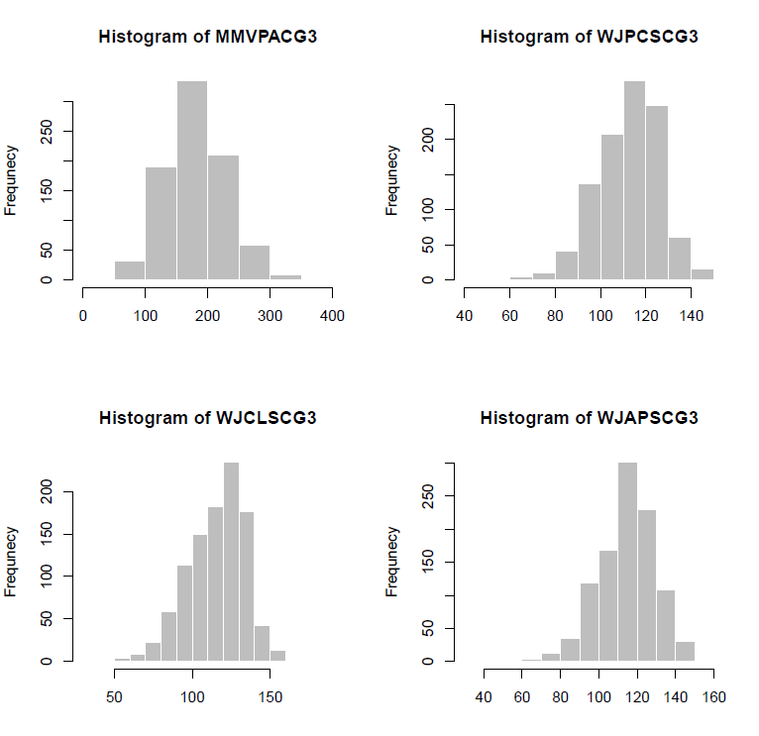
Figure 4 Distribution of MVPA and PC, CL, AP

The estimated slope for CL is -0.08 with p-value 0.4771, which reveals that the time spent on physical activities has little or no relationship with performance of students in calculation. The estimated slope is -0.28777 for PC (p=0.0507) and 0.29091 for AP (p= 0.0525), indicating that with increasing amount of time spent on physical activities, the performance for letter-word identification will decrease while the performance on applied problems will be enhanced.
The three predictor variables showed some collinearity in Figure 2. Thus we used model selection method to simplify the full model. By using AIC criterion, we have the final model with only PC and AP as predictor variable, the less significant CL was excluded. At this point, we can find that the relationship between physical activity minutes and academic performance is not the same as to different academic subjects. The relationship should be further investigated from different aspects.
Figure 5 Distribution of observed (black) and imputed (red) values of variables

3. Subset regression analysis
Based on the assumption that there may be a optimum number of MVPA for best academic performance, also with the believe that both low and high MVPA compared to average can lead to degrade of academic performance, we intended to split the data into low MVPA and high MVPA groups, and do the regression analysis separately. The cutoff value of MVPA was set at 150. Among the 1036 samples, 270 of them have MVPA below 150, and 766 above 150.
The results of both subset suggests PC is the only significant variable in the regression to MVPA, and the model selection process leads to simple linear regression, which has only PC as predictor. In the lower MVPA group (MVPA<150), estimated coefficients are slope=0.16, intercept= 103.93, indicating positive correlation between letter-word identification and physical activity minutes. In the higher MVPA group (MVPA>=150), estimated coefficients are slope= -0.21,
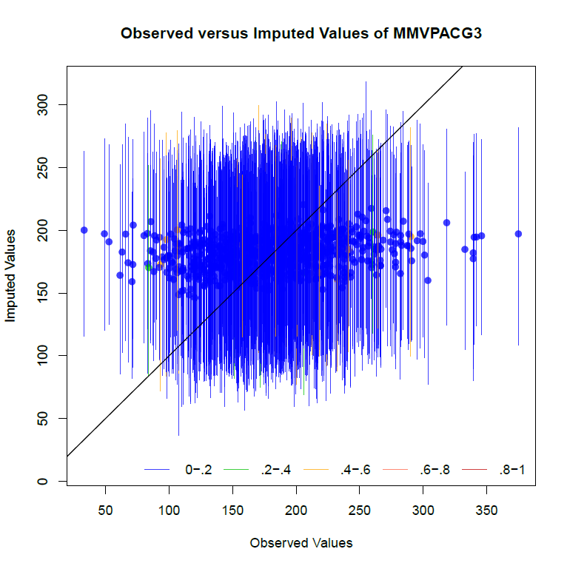
Figure 6 Overimputation diagnostic graph for variable MVPA. Ninety percent confidence intervals are constructed that detail where an observed value would have been imputed had it been missing from the dataset, given the imputation model. The dots represent the mean imputation. Around ninety percent of these confidence intervals contain the y = x line, which means that the true observed value falls within this range. The color of the line (as coded in the legend) represents the fraction of missing observations in the pattern of missingness for that observation. ^{[10]}
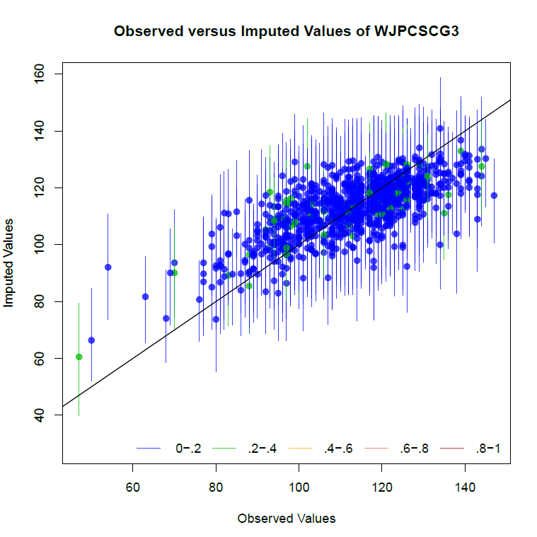
Figure 7 Overimputation diagnostic graph for variable letter-word identification (PC)
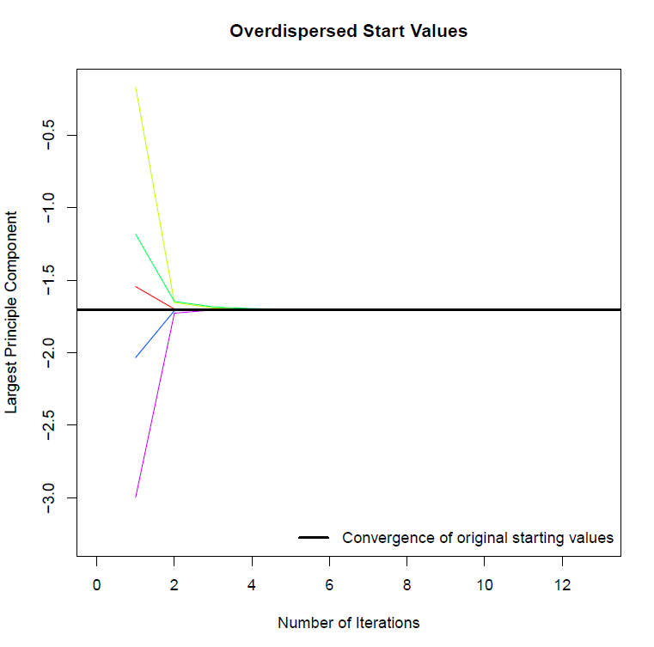
Figure 8 Overdispersion diagnostic for variable MVPA
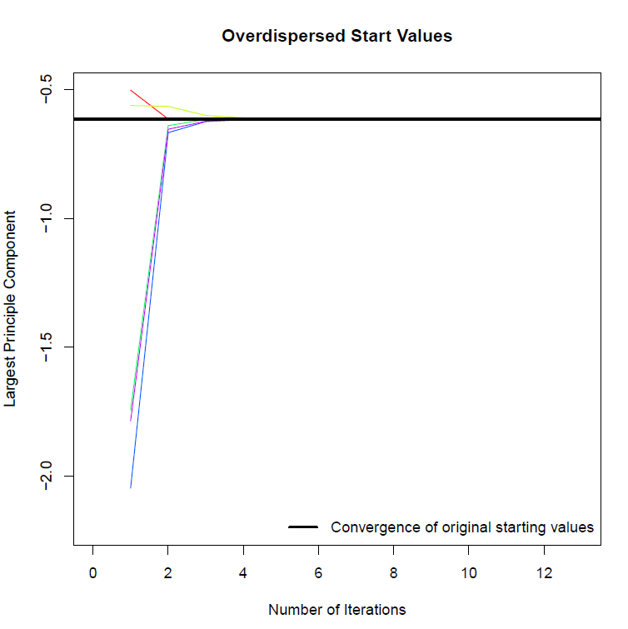
Figure 9 Overdispersion diagnostic for variable PC
Figure 10 Summary of regression between MVPA and PC, CL, AP
intercept= 226.05, suggesting a decreasing trend of physical activity minutes when letter-word identification performance increases. The results support prior research showing that physical activity practice at moderate intensity is related to better cognitive performance, and this also suggested that the linear relationship between academic performance and physical activity may need to be adjusted: they may not be simple linear correlated.
3. Adjusted regression
Based on previous results, we can do some adjustments to the model to answer the question we are more interested in: how does the time spent on physical activity effect the academic performance? In this case we use MVPA as predictor and PC as response. The simple linear regression analysis showed poor linear relationship (R²=0.0018, p-value=0.1624). Polynomial fit analysis (Figure 13,14) showed that there was a relatively significant linear relationship between physical activity minutes (MVPA) and letter-word identification (PC). From the model, we can find the "optimum" physical activity minutes which brings better PC score is 162.
Figure 11 Leverage plots for variable PC, CL and AP.
It is reasonable to fit a quadratic model between MVPA and PC because high and low MVPA can adversely affect the academic performance. However, the result should be considered preliminary. Such a trend to a second-order relationship between academic performance and physical activity could mean that a certain amount of weekly physical activity might prove optimal for academic performance.
4. Impact of controlling factors
The controlling variables in the dataset, SITE, SEX, RACE, INT and BMI, were also analyzed regarding to their influence to the physical activity-- academic performance relationship.
(1) male vs. female
among the 1036 object, there are same number of male and female students (518 for each). They are analyzed separately to see how RACE works as an controlling variable in this study. The regression results showed that the for male students, the MVPA have positive correlation with applied problems score (AP) (slope=0.44, p=0.0406) and negative correlation with letter-word identification score (PC) (slope=-0.34, p=0.1024). This indicates that increasing physical activity will help boys to perform better in applied problems but decrease the letter-word identification

Figure 12 Component + Residual plots for variables PC, CL and AP
Figure 13 polynomial regression between MVPA and PC

Figure 14 Residual plots for polynomial regression between MVPA and PC
problem. For female students, however, the performance of calculation seemed to be more related to physical activity minutes (slope= -0.13785, p=0.384) compared to the other to academic score. This result is opposite to the male data. This finding doesn't seem to support other studies ^{[11]} ^{[12]}which concluded that boys` and girls` academic performance scores were similar at baseline and changed similarly during the intervention period. The results also showed that boys (mean MVPA=190) were more physically active than girls (mean MVPA=173) with more MVPA per day.
(2) comparison of different races
The students' race demographics is shown in Table 2.
Table 2 race demographics of students
Race | American Indian | Asian | Black | White | Other
n | 4 | 14 | 123 | 847 | 48

The majority are black and white students. When we are only looking at black students, there's positive correlation between MVPA and calculation scores (slope=0.46, p=0.163). For white students, however, the significant positive correlation transferred to applied problems (slope=0.45, p=0.006). The Asian students have relatively high academic scores while the MVPA per day is lower than black and white students. There's no obvious correlation between MVPA and any of the three academic performance for Asian students.
(3) influence of ITN ratio
To evaluate the influence of ITN to MVPA, we split the data into two groups: group with ITN<1 and with ITN>=1. There are 70 students have family income-to-needs less than 1, within this group, the correlation between MVPA and ITN is weak. For the group with ITN greater than 1, however, strong correlation between log(ITN) and MVPA was observed (slope=-10.2, p=1.86e-5), suggesting that the increasing income-to-needs ratio in family will decrease the minutes on physical activity, but all the academic performance will increase. These results may conclude that high income-to-needs family tend to let their kids spend less time on physical activity and more on academic performance, thus having higher scores.
(2) influence of BMI
The overall influence of BMI is not surprising: there's a negative correlation between BMI and MVPA(slope=-0.06, p=0.00018), the less MVPA will increase children's BMI. There are 312 students have BMI>85 percentile, categorized as overweight. Among this 312 children, the average MVPA is 172.5 minutes, lower than the average of all children. The high rate of overweight underscore the need for effective and innovative school-based physical activity as well as healthy diets that address child health and health behaviors.
From analysis of these controlling variables, it is evident that they are all playing important roles in this study, affecting both physical activity and academic performance.

Conclusion:
In this study, we analyzed the correlation between physical activity and academic performance among a group of grade 3 students (n=1036 after exclusion and imputation). The results shows that the academic performance does not have strong linear correlation with MVPA. The three difference academic variables showed some variety in relating MVPA, the overall trend is not obvious. One can conclude that the increase of MVPA will not negatively affect academic performance.
The results also suggest that it may be reasonable that the relationship between physical activity and academic performance can be second-order, which means there could be an optimal amount of physical activity for best academic performance.
The controlling variables have direct influence in this study. Different gender leads to different subject performance correlated with MVPA, as well as difference race. Higher income-to-needs ratios families tend to have kids spend less time on physical activity yet have higher academic performance, other factors may be involved in this result, which usually comes along while one have higher income. It is clear that students has higher MVPA usually have lower BMI. The 27% overweight rate underscore the need for more effective physical activity and healthy diet.
To better understand the relationship between physical activity and academic performance, further study is required to strengthen studies that address the relation between enhanced physical activity and academic performance.

References:
- Lindner, K. J. (2002) The physical activity participation-academic performance relationship revisited: perceived and actual performance and the effect of banding (academic tracking). Pediatric Exercise Science, 14, 155-169.
- Morales, J., M.Pellicer-Chenoll, X. Carcia, A. Gomez. 2011. Relation between physical activity and academic performance in 3rd-year secondary education students. Perceptual and Motor Skills. 113.2, 539-546.
- Daley, A. J., & Ryan, J. (2000) Academic performance and participation in physical activity by secondary school adolescents. Perceptual and Motor Skills, 91, 531- 534.
- Sallis, J. F., McKenzie, T. L., Kolody, B., Lewis, M., Marshall, S., & Rosengard, P. (1999) Effects of health-related physical education on academic achievement: project SPARK. Research Quarterly for Exercise and Sport, 70, 127-134.
- Shephard, R. J., & Trudeau, F. (2005) Lessons learned from the Trois-Rivières Physical Education Study: a retrospective. Pediatric Exercise Science, 17, 112-123.
- Symons, C. W., Cinelli, B., James, T. C., & Groff, P. (1997) Bridging student health risks and academic achievement through comprehensive school health programs. Journal of School Health, 67, 220-227.
- Dwyer, T., Sallis, J., Blizzard, L., Lazarus, R., & Dean, K. (2001) Relation of academic performance to physical activity and fitness in children. Pediatric Exercise Science, 13, 225-237.
- Lindner, K. (1999) Sport participation and perceived academic performance of school children and youth. Pediatric Exercise Science, 11, 129-143.
- Calabria, E., Garcia-Mas, A., Gimenez, R., Aguado, F. J., Cuartero, J., & Pérez, P. (2003) Sueño, descanso y rendimiento en jóvenes deportistas de competición. Revista de Psicologia del Deporte, 12, 181-196.
- Honaker J., G. King, M. Blackwell.2013. Amelia II: A program for missing data. Version 1.7.2. June 8, 2013.
- CARR, M., and H. DAVIS. Gender differences in arithmetic strategy use: a function of skill and preference. Contemp. Educ. Psychol. 26:330–347, 2001.
- Ahamed Y., H. Macdonald, K. Reed, P. Naylor, T. Liu-Ambrose, H. Mckay. 2007. School-based physical activity does not compromise children's academic performance. Psychobiology and Behavioral Strategies. 0195-9131/07/3902-0371/0.
- Kutner, M., C. Nachtsheim, J. Neter. (2004). Applied Linear Regression Models: 4th edition. McGraw-Hill/Irwin.

Appendix (Original R code):

load("Lab3data.Rdata")
summary(reg.data)

#names(reg.data)=c("SITE","SEX","RACE","ITN","BMI","MVPA","PC","CL","AP")
attach(reg.data)
nrow(reg.data)

#call amelia
library(Amelia)
library(foreign)

pairs(reg.data[,4:9])

list.na=is.na(reg.data)

## data only has SEX and RACE ###
list.missing6 <- rowSums(list.na) >= 6
reg.data.missing6 <- reg.data[list.missing6,]
nrow(reg.data.missing6)

## exclude data that are completely missing

list.missing5<-rowSums(list.na)<=5
reg.data.full<-reg.data[list.missing5,]
nrow(reg.data.full)

# save data file
write.dta(reg.data.full, "f:/R/6450/full.dta")

###### senario 1 ############
## Exclude any data that has variable missing
reg.data.valid <- na.omit(reg.data)
reg.data.valid
pairs(reg.data.valid[,6:9])
nrow(reg.data.valid)

# save data file
write.dta(reg.data.valid, "f:/R/6450/valid.dta")

###### senario 2 ############
## Exclude data that missing all of MVPA, PC, CL and AP
list.na=is.na(reg.data[,6:9])
list.nomissing= rowSums(list.na)<=3
reg.data.select=reg.data[list.nomissing,]
reg.data.select
nrow(reg.data.select)
pairs(reg.data.select[,6:9])

# save data file
write.dta(reg.data.select, "f:/R/6450/select.dta")

############ Regression analysis ############
library(leaps)
library(car)

####### regress using imputated data ###########
## load imputated data ##
data.imp=read.csv("select-imp1.csv",header=T)
names(data.imp)

names(data.imp)=c("SITE","SEX","RACE","ITN","BMI","MVPA","PC","CL","AP")

## fit multiple linear regression
fit.imp=lm(data.imp$MVPA~data.imp$PC+data.imp$CL+data.imp$AP,data=data.imp)
summary(fit.imp)
par(mfrow=c(2,2))
plot(fit.imp)

####### diagnostics #######
# Assessing Outliers
outlierTest(fit.imp) # Bonferonni p-value for most extreme obs
qqPlot(fit.imp, main="QQ Plot") #qq plot for studentized resid
# leverage plots

# Normality of Residuals
# qq plot for studentized resid
qqPlot(fit.imp, main="QQ Plot")
# distribution of studentized residuals
library(MASS)
sresid <- studres(fit.imp)
hist(sresid, freq=FALSE,
main="Distribution of Studentized Residuals")
xfit<-seq(min(sresid),max(sresid),length=40)
yfit<-dnorm(xfit)
lines(xfit, yfit)

# Evaluate homoscedasticity
# non-constant error variance test
ncvTest(fit.imp)
# plot studentized residuals vs. fitted values
spreadLevelPlot(fit.imp)

# Evaluate Collinearity
vif(fit.imp) # variance inflation factors
sqrt(vif(fit.imp)) > 2 # problem?

# Evaluate Nonlinearity
# component + residual plot
crPlots(fit.imp)

####### excludeing a few possible outliers 497, 502 ########
data.imp.adj = data.imp[c(1:496,498:501,503:1036),]
fit.imp.adj=lm(data.imp.adj$MVPA~data.imp.adj$PC+data.imp.adj$CL+data.imp.adj$AP,data=data.imp.adj)
summary(fit.imp.adj)
plot(fit.imp.adj)

## Model selection
leaps( x=data.imp[,7:9], y=data.imp[,6],
names=names(data.imp)[7:9], method="Cp")

Base <- lm( data.imp$MVPA ~ data.imp$PC, data=data.imp )
step(Base, scope = list( upper=fit.imp, lower=~1 ), direction = "both", trace=FALSE)

####### regress using valid data ###########
## load valid data
load("Lab3data.Rdata")
data.valid <- na.omit(reg.data)

names(data.valid)=c("SITE","SEX","RACE","ITN","BMI","MVPA","PC","CL","AP")

## fit multiple linear regression
fit.valid=lm(data.valid$MVPA~data.valid$PC+data.valid$CL+data.valid$AP,data=data.valid)
summary(fit.valid)

fit.other=lm(data.imp$PC~data.imp$MVPA,data=data.imp)
summary(fit.other)

####### regress using subset data ###########
library(leaps)
library(car)

## Read glaobal data ##
data.imp=read.csv("select-imp1.csv",header=T)
names(data.imp)=c("SITE","SEX","RACE","ITN","BMI","MVPA","PC","CL","AP")

## only use data with MVPA<150 ##
data.imp.low <- subset(data.imp, MVPA < 150)
nrow(data.imp.low)

fit.imp.low=lm(data.imp.low$MVPA~data.imp.low$PC+data.imp.low$CL+data.imp.low$AP,data=data.imp.low)
summary(fit.imp.low)

plot(fit.imp.low)

## Model selection

Base.low <- lm( data.imp.low$MVPA ~ data.imp.low$PC, data=data.imp.low )
step(Base.low, scope = list( upper=fit.imp.low, lower=~1 ), direction = "both", trace=FALSE)

## only use data with MVPA>=150 ##
data.imp.high <- subset(data.imp, MVPA >= 150)
nrow(data.imp.high)

fit.imp.high=lm(data.imp.high$MVPA~data.imp.high$PC+data.imp.high$CL+data.imp.high$AP,data=data.imp.high)
summary(fit.imp.high)
plot(fit.imp.high)

## Model selection

Base.high <- lm( data.imp.high$MVPA ~ data.imp.high$PC, data=data.imp.high )
step(Base.high, scope = list( upper=fit.imp.high, lower=~1 ), direction = "both", trace=FALSE)

### only use male data ###

data.imp.boy = subset(data.imp, SEX == 1)
nrow(data.imp.boy)
summary(data.imp.boy$MVPA)

fit.imp.boy=lm(data.imp.boy$MVPA~data.imp.boy$PC+data.imp.boy$CL+data.imp.boy$AP,
data=data.imp.boy)
summary(fit.imp.boy)

par(mfrow=c(2,2))
plot(fit.imp.boy)

## Model selection
library (MASS)
step.boy <- stepAIC(fit.imp.boy, direction="both")
step.boy$anova # display results

### only use female data ###

data.imp.girl = subset(data.imp, SEX == 2)
nrow(data.imp.girl)

fit.imp.girl=lm(data.imp.girl$MVPA~data.imp.girl$PC+data.imp.girl$CL+data.imp.girl$AP,
data=data.imp.girl)
summary(fit.imp.girl)

plot(fit.imp.girl)

## Model selection

step.girl <- stepAIC(fit.imp.girl, direction="both")
step.girl$anova # display results

### only use asian ###
data.imp.asian = subset(data.imp, RACE== 2)
nrow(data.imp.asian)

fit.imp.asian=lm(data.imp.asian$MVPA~data.imp.asian$PC+data.imp.asian$CL+data.imp.asian$AP,
data=data.imp.asian)
summary(fit.imp.asian)

plot(fit.imp.asian)

## Model selection

step.asian <- stepAIC(fit.imp.asian, direction="both")
step.asian$anova # display results

### only use black ###
data.imp.black = subset(data.imp, RACE== 3)
nrow(data.imp.black)

fit.imp.black=lm(data.imp.black$MVPA~data.imp.black$PC+data.imp.black$CL+data.imp.black$AP,
data=data.imp.black)
summary(fit.imp.black)
summary(data.imp.black$MVPA)
summary(data.imp.black$CL)

plot(fit.imp.black)

## Model selection

step.black <- stepAIC(fit.imp.black, direction="both")
step.black$anova # display results

### only use white ###
data.imp.white = subset(data.imp, RACE== 4)
nrow(data.imp.white)

fit.imp.white=lm(data.imp.white$MVPA~data.imp.white$PC+data.imp.white$CL+data.imp.white$AP,
data=data.imp.white)
summary(fit.imp.white)
summary(data.imp.white$MVPA)
summary(data.imp.white$CL)
plot(fit.imp.white)

## Model selection

step.white <- stepAIC(fit.imp.white, direction="both")
step.white$anova # display results

### only use other ###
data.imp.other = subset(data.imp, RACE== 5)
nrow(data.imp.other)

fit.imp.other=lm(data.imp.other$MVPA~data.imp.other$PC+data.imp.other$CL+data.imp.other$AP,
data=data.imp.other)
summary(fit.imp.other)

plot(fit.imp.other)

## Model selection
step.other <- stepAIC(fit.imp.other, direction="both")
step.other$anova # display results

### regression using ITN ###

fit.itn = lm(data.imp$MVPA ~ log(data.imp$ITN), data=data.imp)
data.itn.low=subset(data.imp, ITN<1)
fit.itn.low=lm(data.itn.low$MVPA~log(data.itn.low$ITN), data=data.itn.low)
summary(fit.itn.low)

data.itn.high=subset(data.imp, ITN>=1)
fit.itn.high=lm(data.itn.high$MVPA~log(data.itn.high$ITN), data=data.itn.low)
summary(fit.itn.high)
fit.itn.high=lm(data.itn.high$PC~log(data.itn.high$ITN), data=data.itn.low)
summary(fit.itn.high)
fit.itn.high=lm(data.itn.high$CL~log(data.itn.high$ITN), data=data.itn.low)
summary(fit.itn.high)
fit.itn.high=lm(data.itn.high$AP~log(data.itn.high$ITN), data=data.itn.low)
summary(fit.itn.high)
### regression using BMI ###

fit.bmi = lm( data.imp$BMI~ data.imp$MVPA, data=data.imp)
summary(fit.bmi)

data.bmi.high=subset(data.imp, BMI>=85)

nrow(data.bmi.high)

fit.bmi.high=lm( data.bmi.high$BMI~ data.bmi.high$MVPA, data=data.bmi.high)
summary(fit.bmi.high)

