Instruction Guide for Dashboard Tool

Introduction

- Start the application by selecting EDS -> Window Dashboard option from the Program menu.
- Once the application is started an icon will appear on your system tray as well as a window strip will be displayed as shown below.
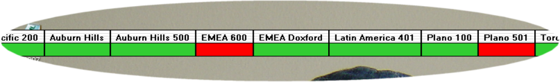
Note : Header displays either Instance or Application name. Rectangular box below displays the status.

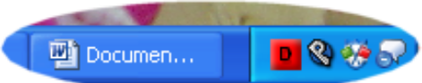
Note : Dashboard icon is red square box with Letter D. It changes color based on the status of instances and application we are monitoring.

Customizing the tool

Following Menu will be displayed when you right click either the any header on the Status window or the icon in the system tray.

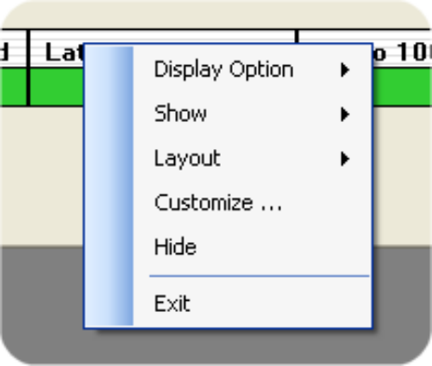
- Exit => Select this option to close the application
- Hide => Select this option to close the Status window but the application will be running in the background.
You can make the Status Window visible again by right clicking on the Icon on the System Tray and selecting show or by double clicking on the icon.
- Layout => Following option will be displayed when you select Layout option
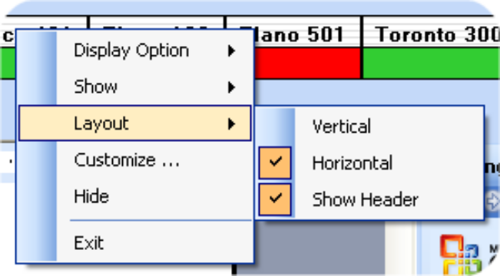
  - If you select Vertical, all the status bar will be stacked in the Vertical fashion
  - If you select horizontal, status bar will be arranged in horizontal fashion.
  - Show Header will be used to indicate whether the instance/application identifier is displayed in header or in the status display bar itself.

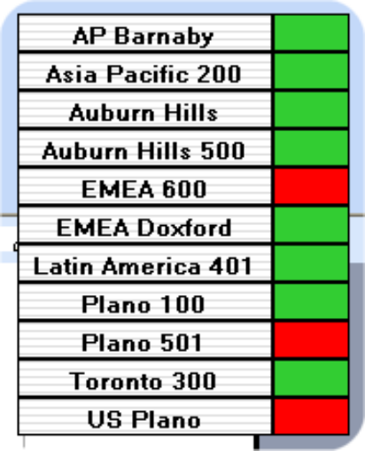 | 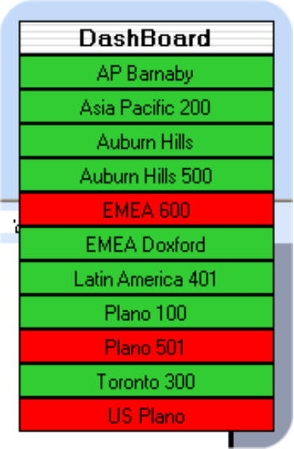
Vertical layout with Show Header enabled | Vertical layout with no Show Header setting

- Show => Selecting show menu will display following options
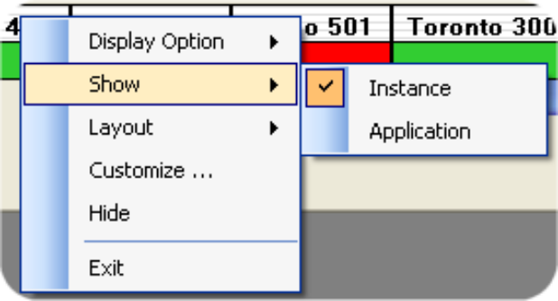
  - Selecting Instance will display data by Instance
  - Selecting Application will display data by Application

- Display Option => Select this menu will display following options

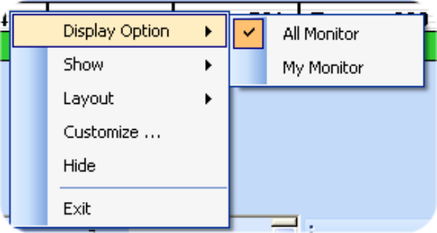

  - Selecting All Monitor will display status for all instance/Application
  - Selecting My Monitor will display status for your selected instance and application. To defined My monitor option, see customize option. If no my monitor option is defined then it will display status for all monitor.

- Customize => Selecting the customize option will bring up the following window
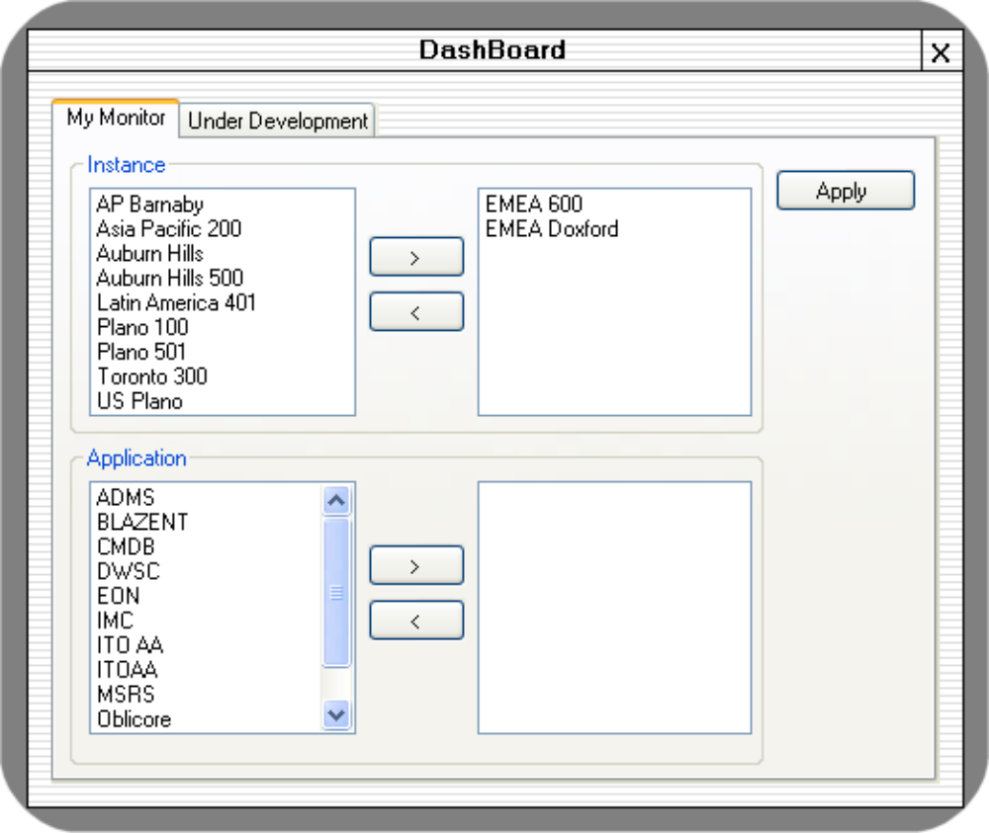
On this window use the > and < button to select all the application and Instances you want to display on the status window. After that click on the Apply button.

Notification Messages

This tool used two mode of notification. When a Severity 1 or 2 condition is found
- Application announce the details
- A message pop up on the screen. Some example messages are shown below.
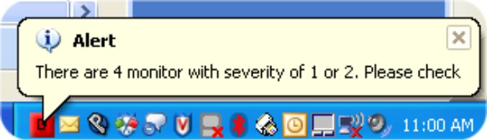
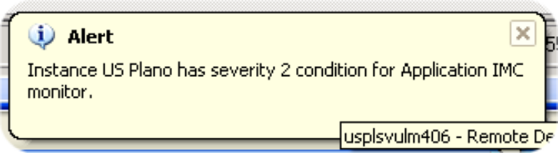
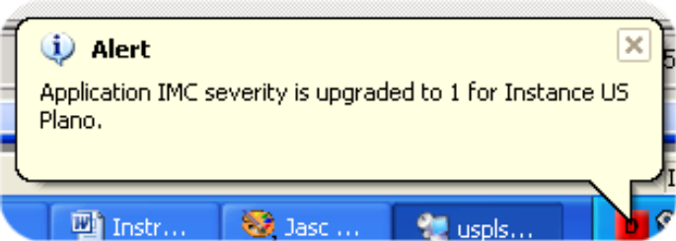

Checking Which Monitor has problem

You can identify which monitor has severity 1 or 2 condition and what is the error message by right clicking on the Colored status box as shown below. For Severity 1, background of the menu will be red and for severity 2 it will be yellow. There will be no pop up menu for severity 3 or 4 condition.

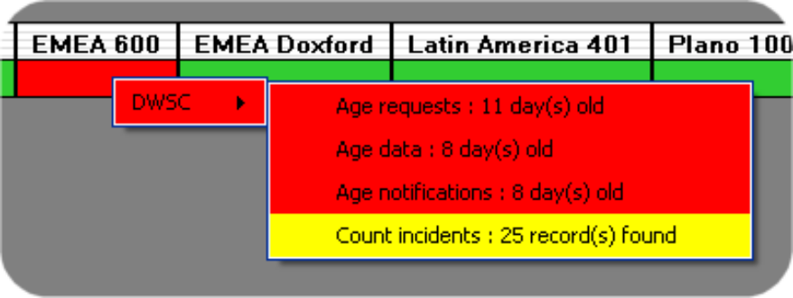

You can also pull all the monitor details by double clicking any of the status box on the tool bar.
