**Introduction**

Data visualization refers to the graphical representation of information and data. By using visual elements like charts, graphs, and maps, data visualization is an accessible way to see and understand trends, outliers, and patterns in data.[1] Effective visualization helps users analyze and reason about data and evidence. It makes complex data more accessible, understandable and usable.

The python installation needed various libraries including Pandas,Matplotlib and Numpy. However, it was discovered later that a Tableau software running on a Windows machine helps in various rapid prototyping and generation of basic plots.

**Visualizations**

**Histograms:**

A histogram is an accurate representation of the distribution of numerical data[2]

1. Histogram showing age distribution over the dataset

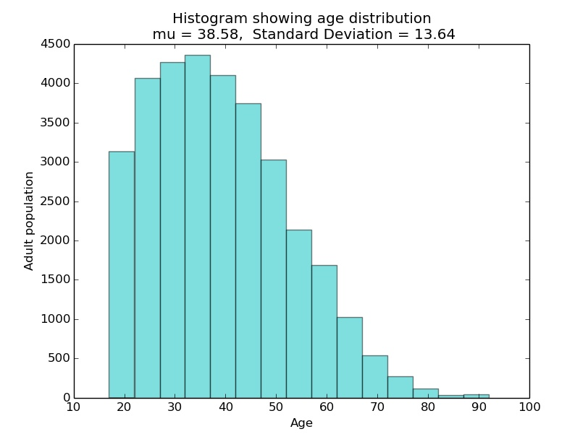

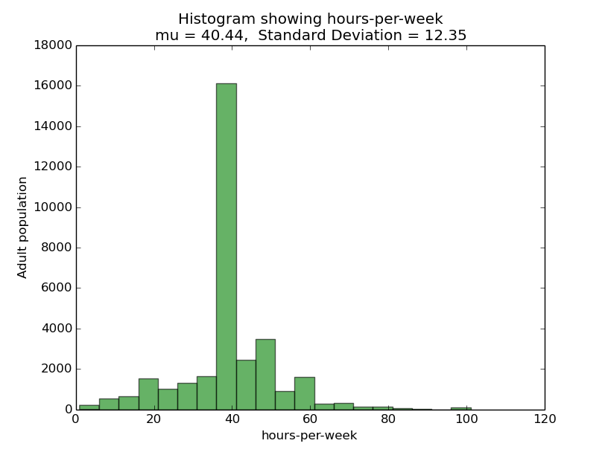2. Histogram showing hours-per-week distribution over the dataset

**Bar charts:**

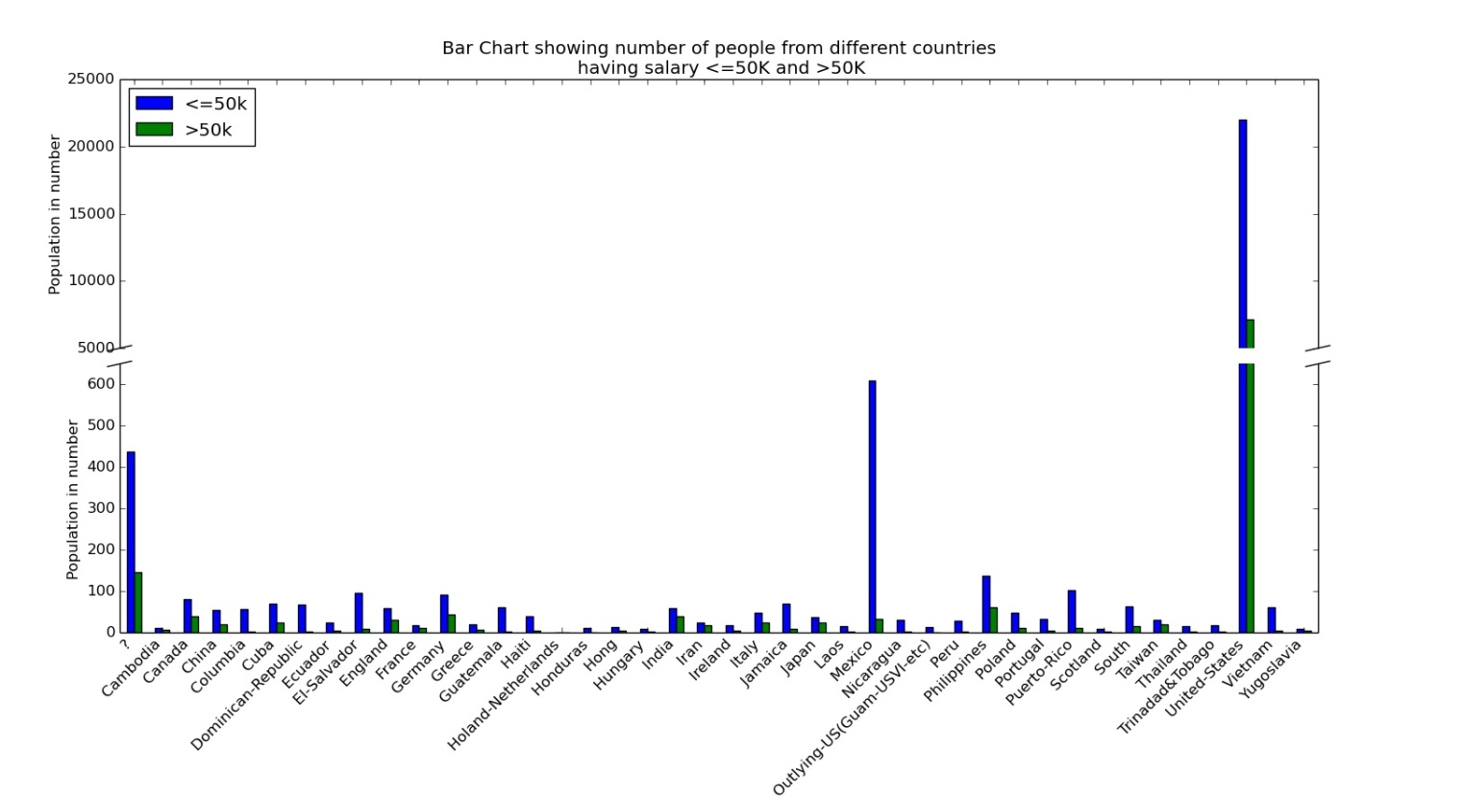

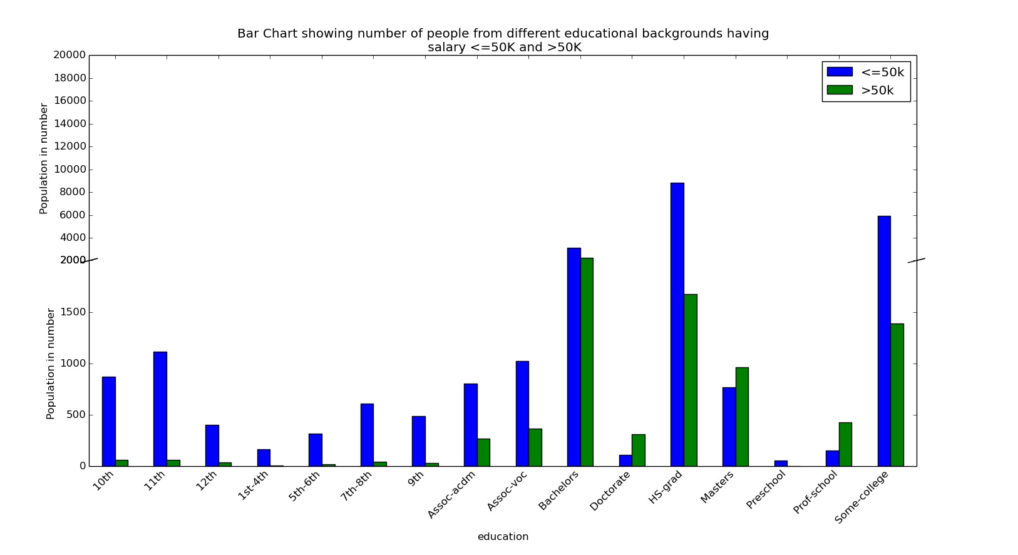

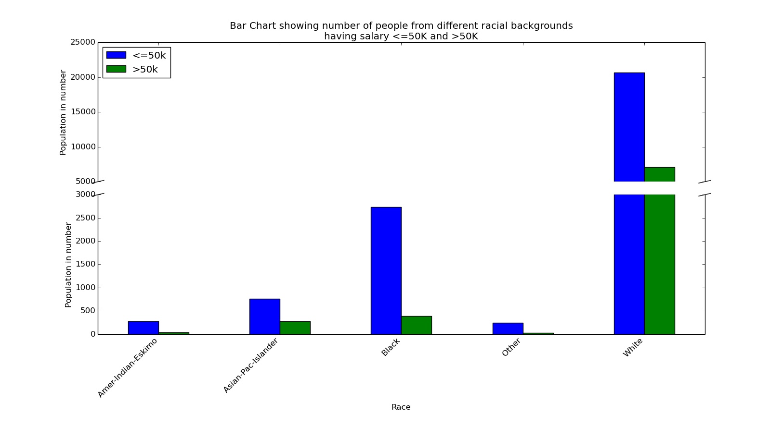

**Scatter plots:**

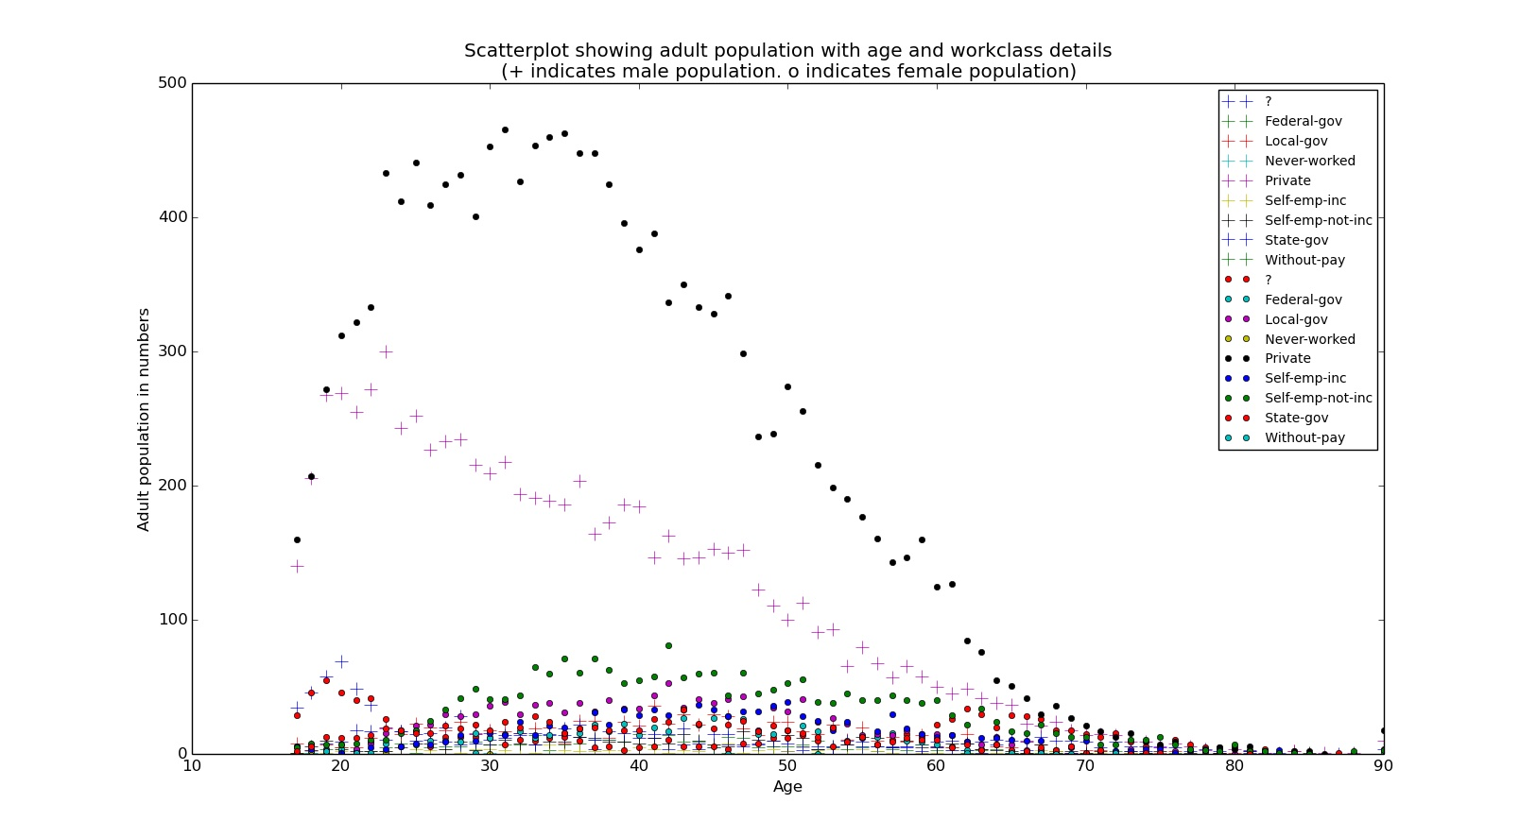

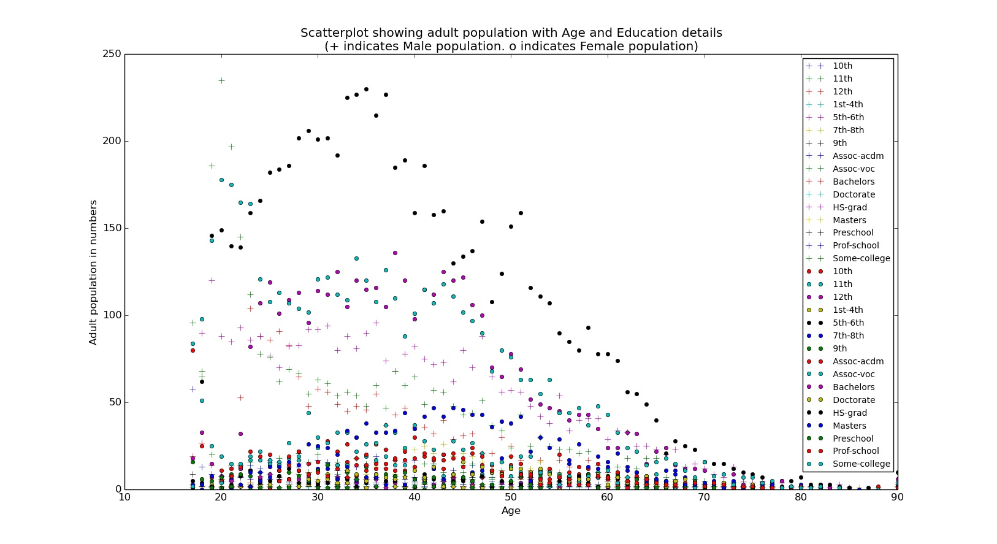

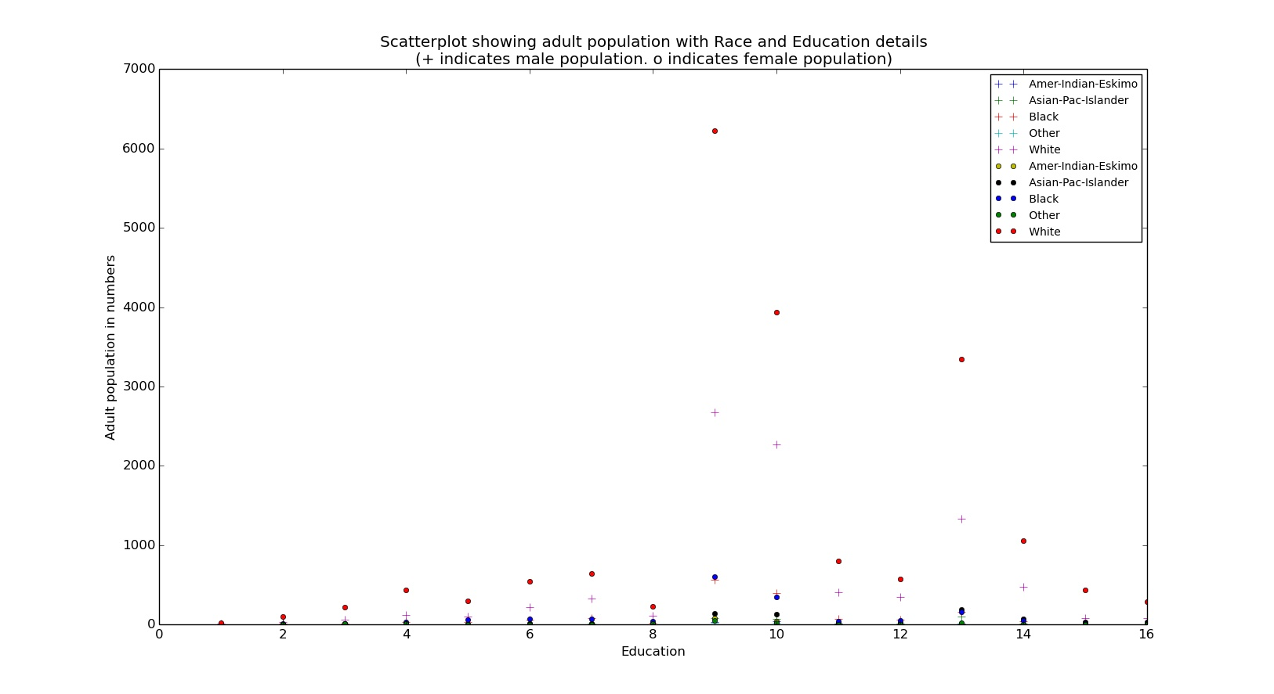

**Bubble plot:**

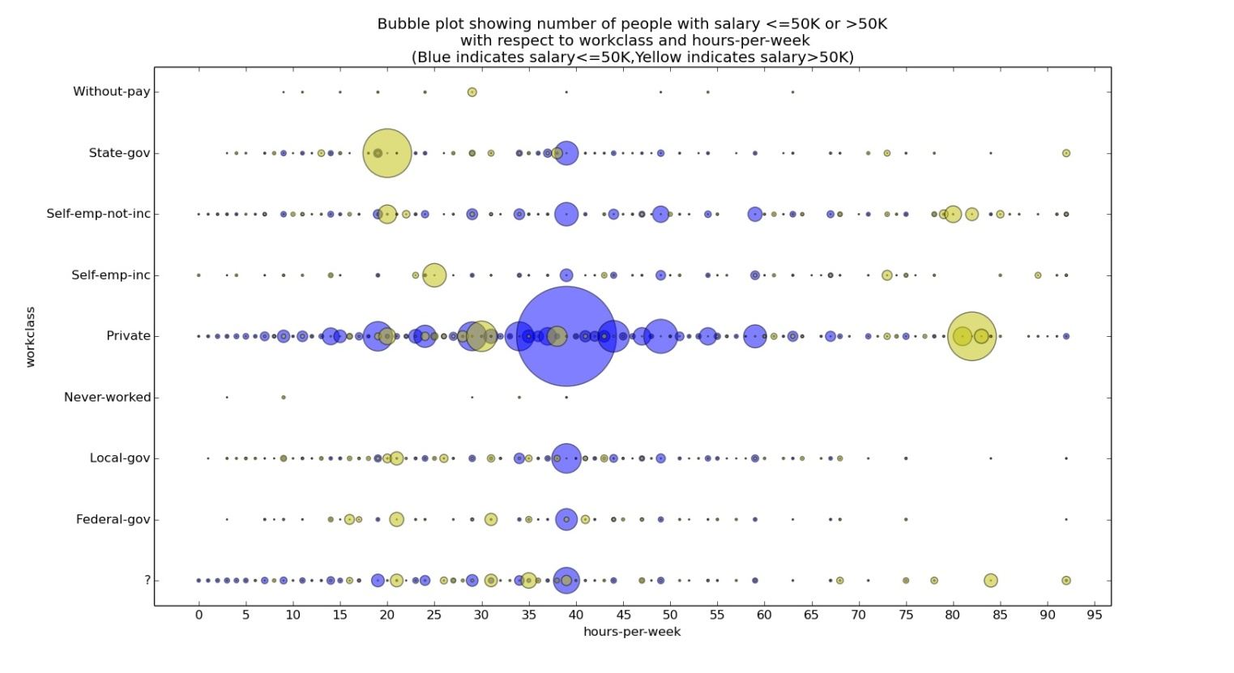

**Pie chart:**

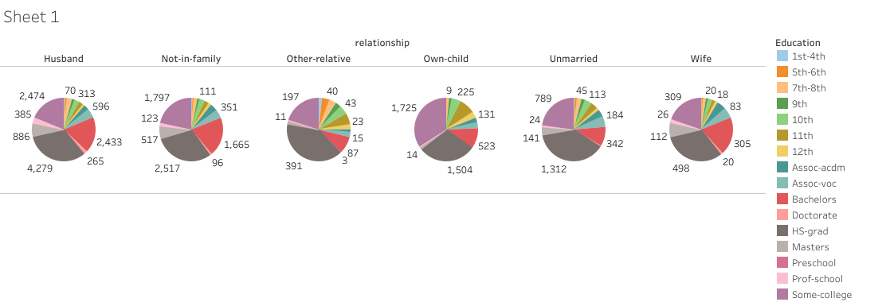

**Box plot:**

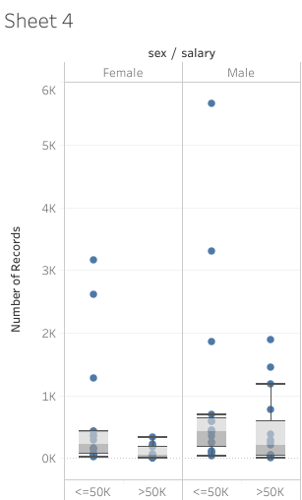

**Stacked Bar Graph:**

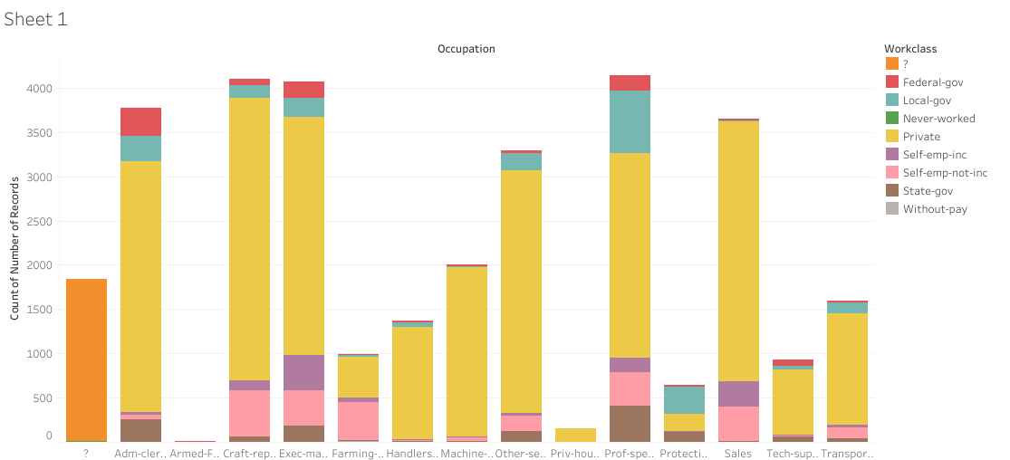

**Mosaic plot/Treemap:**

