Testing Maze Generator Method

Test 1
I tested my calculatePositions() which calculates the centers of each cell position. I connected the centers with lines and I expected to get a honeycomb pattern (as shown below)

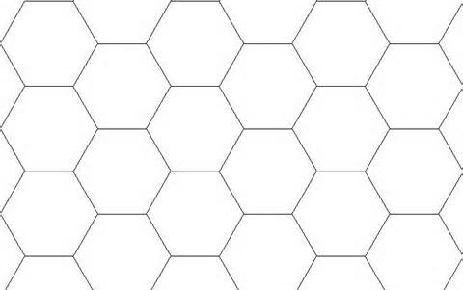
in case I didn't get this pattern I would have to revise my equation that I used for calculating the positions.

Results
My program has failed. It drew this:

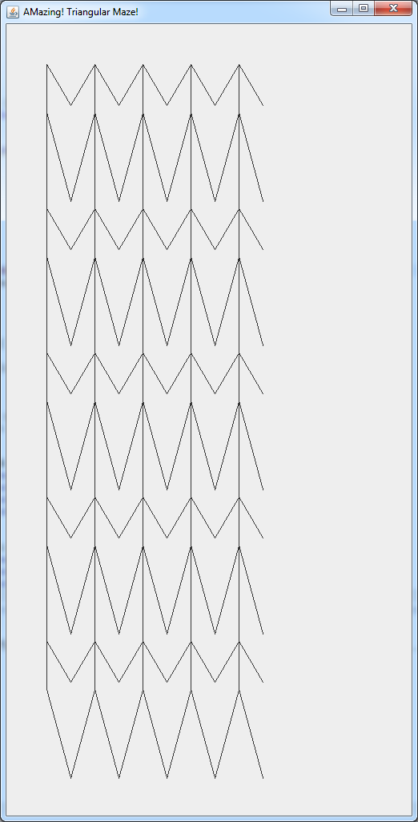

at least it made a pattern which is more assuring than a total mess. So I had to go back to my equation and modify it.

So after a while of going through the equation, I realized that in the heat of excitement I forgot to multiply the x and y coordinates by specific ratios of the triangle. Because the triangles in my maze are equilaterals there are special trigonometric ratios I can use to find their centers. So I added those ratios and expected everything to work just fine, and then this happened:

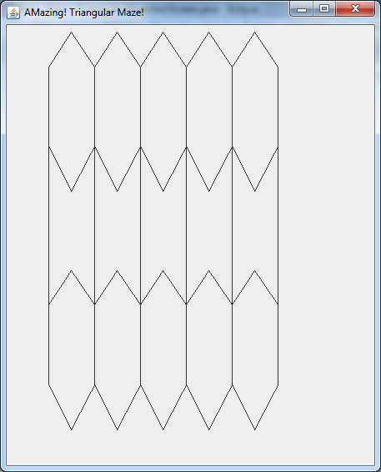

This time the program was making somewhat a hexagonal pattern but made a systematic error in the even rows (I tested for bigger grids). This time it wasn't my equation's fault. I soon realized that the problem was in my logic when I connected the centers. I thought that whenever the column of the cell was odd then I can draw down. However, after drawing out and numbering the pattern that I wanted to be drawn. I realized there is a different rule for when to draw down from a point. And the rule is that if the cell is in an even row and odd column or odd row and even column then I'm allowed to draw down. So after I fixed that problem, my program worked properly.

Test 2
My second test involved the generateMaze(). To test this part of my program I first took out the randomness out of this method so I could predict the maze that will be created.

I made my program so that it would only go to the right.
So what I expected was a horizontal line across
and after testing it the program did work.

so next I made my generator go right
again I expected a straight line across
and as I predicted the program worked

Next I added randomness to the program to see what happens. Due to the randomness I couldn't really predict what the maze looks like. However one thing that the generator should have done is that it has to cover every single cell on the board.

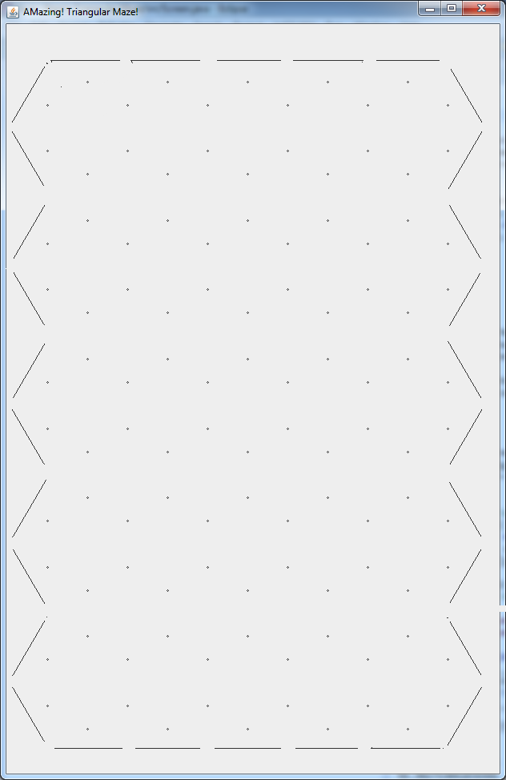

Unfortunately, the maze generator removed all the walls inside the maze. So something was wrong. To debug the program I slowed down the maze so that it paused before removing a wall, so that I could see what it was doing. What I noticed was that the generator was working fine until it started backtracking. That's when it started to remove the remaining walls.

After that I realized what the problem was. When the generator reached a cell it would check whether it could go to the neighboring cells and it would choose one and then do the other one when it back tracked. However after the generator has went through the first path, the second path now would be unavailable. So to fix this problem, when the generator went back to the cell I added extra code to check again whether it was possible to go to a neighboring cell.

Test 3
Finally I tested whether my maze solver is able to solve the maze. This was a fairly straightforward test. First I generated a maze then I run the solver and see what would happen.
I expected the solver to paint the path from the top left corner to bottom right corner.

these are some of the results:
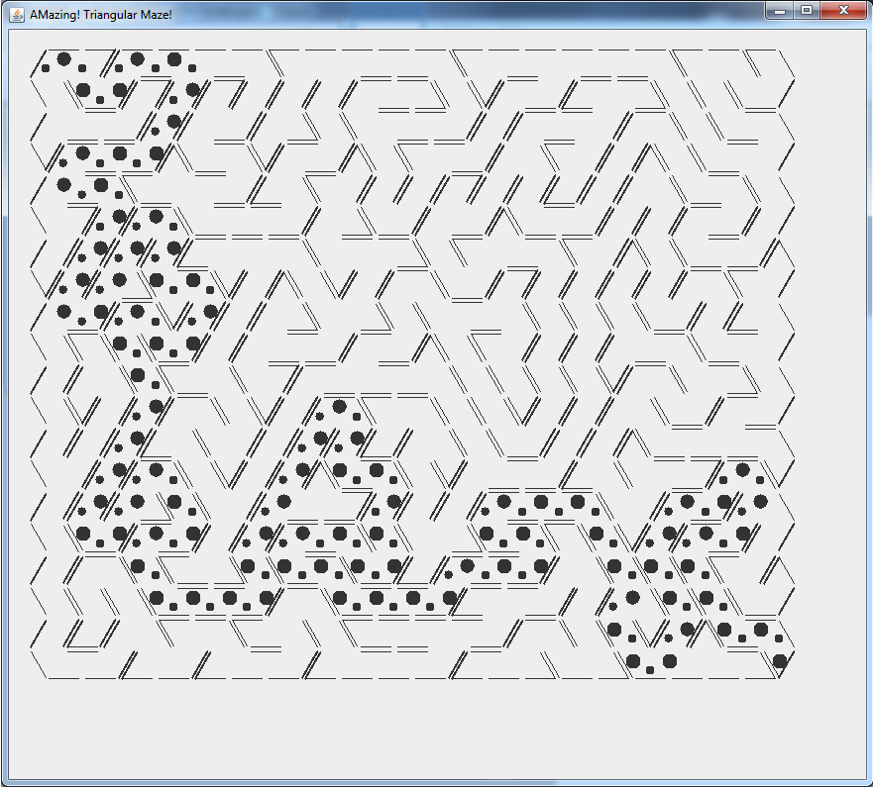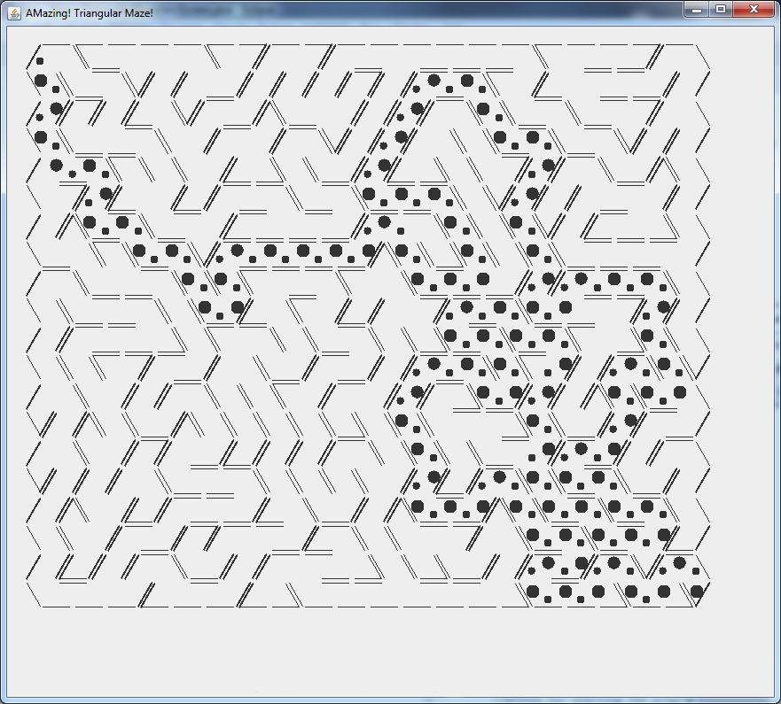

I didn't have any problems with the solving method. Except for small glitches in painting the path, which I fixed by adding 2 booleans: generating and solving, which determined when the path should be drawn on the screen.

