

**CarBreezy**

|  |  |  |
| --- | --- | --- |
| **Supervisor:** | *LE MONG THUY* | |
| **Semester:** | *01* | |
| **Batch No:** | *E1.2210.T1* | |
| **Group No:** | *03* | |
| **Order:** | **Full name** | **Roll No.** |
| *1.* | *Trần Vĩnh Phát* | *Student1429097* |
| *2.* | *Vũ Hữu Tài* | *Student1429106* |
| *3.* | *Lý Hoài Nam* | *Student1429419* |

***Month****: 01* ***Year****: 2023*



This is to certify that

|  |  |
| --- | --- |
| **Mr.** | **Tran Vinh Phat** |
| **Mr.** | **Vu Huu Tai** |
| **Mr.** | **Ly Hoai Nam** |

Have successfully Designed & Developed

|  |  |  |
| --- | --- | --- |
|  |  |  |
| **CarBreezy** | | |

Submitted by:

|  |
| --- |
| **Ms. LE MONG THUY** |

Date Of Issue:

|  |  |
| --- | --- |
|  |  |

Authorized Signature:

|  |  |
| --- | --- |
|  |  |

|  |
| --- |
| **Content** |

Content

Acknowledge

Synopsis

Review1 5

Review2 7

Review3 8

Testing Document 10

Final Checklist 11

Task sheet 12

|  |
| --- |
| **Acknowledge** |

As we understand that the e-Project is a step-by-step learning environment that closely simulates the class-room and Lab based learning environment into actual implementation. It is a project implementation at your fingertips!! An electronic, live juncture on the machine that allows you to.

* Practice step by step i.e., laddered approach.
* Build a larger more robust application.
* Usage of certain utilities in applications designed by user.
* Single program to unified code leading to a complete application.
* Learn implementation of concepts in a phased manner.
* Enhance skills and add value.
* Work on real life projects.
* Give a real-life scenario and help to create applications more complicated and useful.
* Mentoring through email support.

We would like to send a great thank to our professor and others student for the adorable supports during the time in project.

Beside several mistakes we had made in the project, we hope to have more opportunities to widen our knowledge in web developing world.

We also thank you so much for your information and the “demo” project from India APTECH to help us get more reality experience in this project. Since we have gained more experience from this project, we will not stop learning anything as much as we can to be more successful in the future.

Your Sincerely,

Team Group 03.

|  |
| --- |
| **Synopsis** |

The Objective of this program we aim is to give a sample project to work on real life projects. These applications help us build a larger more robust application.

The objective is not to teach us HTML/JavaScript but to provide us with a real-life scenario and help us create basic applications using the tools.

Hence, we can revise the chapters before we start with the project.

This project is meant for students like us who have completed the module of HTML5. These programs should be done in the Lab sessions with assistance of the faculty if required.

|  |
| --- |
| The website (in this project) is a tool that consumers can use to explore vehicles from an expansive, cross-brand selection of inventory from our vast network… |

It is very essential for us that will have a clear understanding of the subject. We think we should go through the project and solve the assignments as per requirements given.

And get back ***eprojects@aptech.ac.in*** as the assigned schedule.

|  |
| --- |
| **Problem Definition** |

**CarBreezy** is a leading automotive digital marketplace that seeks to make car buying and selling easy, transparent and efficient.

Your car buying destiny is in your hands, but we will help you every step of the way. We built this site to make car buying as fast and easy as possible.

From discovery to delivery, consumers can use CarBreezy to explore vehicles from an expansive, cross-brand selection of inventory from our vast network.

CarBreezy has built a trusted brand and a strong reputation for providing consumers with useful tools, research, market context and pricing transparency as they embark on their car-buying journey. The Company is bringing more of the purchasing process online by allowing consumers to find a vehicle that is right for them and complete their purchase with all from the comfort of their home.

You are supposed to create a Single-Page-Application and responsive Website for them with the below mentioned requirement specifications.

The website is to be developed for the Windows Platform using HTML5, JSON, Angular JS, JavaScript and Geolocation. The site should work well in all leading browsers including Chrome, IE, Firefox etc.

The portal will be designed as a Single-Page-Application and responsive Website with a set of pages and menus that represent choice of activities to be performed. The pages, menus, and other visual elements must be designed in a visually appealing manner with attractive fonts, colors, and animations.

All of these should also be laid out in a responsive manner

The Web site is to be created based on the following requirements.

1) The Top of the Page should be presented with a suitable logo and a banner with depiction of cars onto it.

2) The site must contain menu with links to New, Used, Brands, Offers etc.

3) Sections should be created with proper listing of cars under NEW, USED, Brands etc.

4) Clicking on any car should open pop-up window with images of car and price along with tabs as Internal Specification, External, Engine, Dimensions with details mentioned in these tabs

5) Filter with options as “Hatchbacks”, “Sedan”, “SUV”, “Convertibles” etc. should be provided.

6) Section for various Offers should be provided with listing of available offers.

7) Gallery should be provided for viewing different images.

8) Site map, Gallery, about us, Queries link, contact us link must be added.

9) About Us and Contact Us: This menu option should display Email id, address, and contact number.

10) Colour combination must be uniform throughout the project.

11) Navigation must be smooth.

Over and above this, the portal should implement the following functionalities:

• Display a continuous scrolling ticker at the bottom of the page with current date, time, and location (hint: Use geolocation features of HTML5).

• Display a visitor count at the top right corner of the page beside a logo image.

• The menu options should change color on hover and also after clicking.

• Fade in and fade out options can be used for the menus.

|  |  |
| --- | --- |
| |  | | --- | | **Customer Requirements Specifications** | |

|  |  |
| --- | --- |
| **User:** | |
|  | **input:** |
|  | * Name of Brands, Model or Price * Input data to register a new user and login data. * Click button add to cart. |
|  | **Process:** |
|  | * Filter out unrelated item. * Validate the register’s data if it is valid. * Count the item has been added. |
|  | **Output:** |
|  | * Display only related items. * Display an alert if the information is valid. * Display items has been added. |

|  |  |
| --- | --- |
| **Hardware / software requirement:** | |
|  | **Software:** |
|  | * Frontend: HTML5, CSS, Bootstrap, JavaScript, jQuery, AngularJS, XML * Data Store: JSON files or TXT files * Operating Portal: Windows * Browsers: Edge, Chrome, Mozilla Firefox, Safari |
|  | **Hardware:** |
|  | * Intel Core i3/i5 Processor or higher * 8 GB RAM or above * Colour SVGA * 500 GB Hard Disk space * Mouse * Keyboard |

|  |
| --- |
| **Architecture and design of the project** |

Webpage request



Requested Page

**RENDERING**

**ENGINE**

**CSS CODE**

**HTML CODE**

**WEB SERVER**

**WEB BROWSER**

**CLIENT**

**SERVER**

|  |
| --- |
| **SiteMap** |

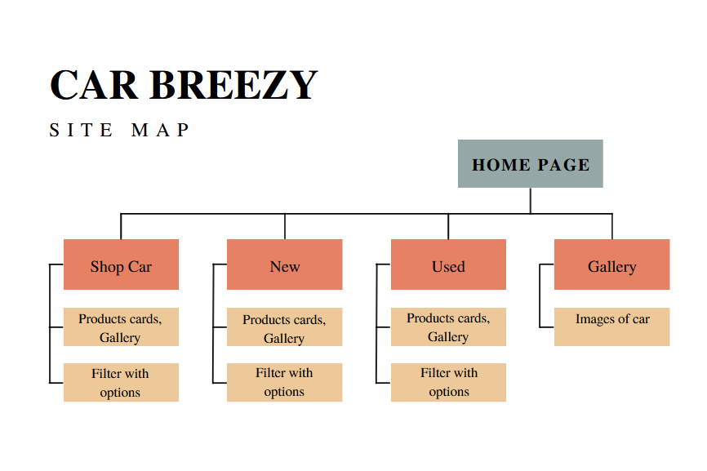

|  |
| --- |
| **Layout** |

1. **Homepage:**

|  |  |  |  |  |  |  |  |
| --- | --- | --- | --- | --- | --- | --- | --- |
| Contact info, email, phone number | | | | | | | |
| Logo |  | | Shop Car | New | | Used | Brands |
| Banner | | | | | | | |
| New car section  < Carousel >  View more >>> | | Used car section  < Carousel >  View more >>> | | | Brands car section  < Carousel >  View more >>> | | |
| Banner | | | | | | | |
| Banner | | | | | | | |
| Footer | | | | | | | |

**Description** : This is Homepage, which is used to delivery an overlook through website’s product. This site also has sticky navigation bar for navigating to others site like New, Used, Brands and Offers.

**From** : This site can be opened from index.html file in root folder.

**To** : From Homepage, you can navigate to New, Used, Brands and Offers site.

1. **Shopcar.html:**

|  |  |  |  |  |  |  |
| --- | --- | --- | --- | --- | --- | --- |
| Contact info, email, phone number | | | | | | |
| Logo |  | | Shop Car | New | Used | Brands |
| Search bar |  | | | | | |
| Filters | Items | Items | | Item | |  |
| Items | Items | | Item | |
| Items | Items | | Item | |
| Footer | | | | | | |

**Description** : In this site, customer can view car and others information about that car such as: model, price...

**From** : This site can be reach from index.html through Shop Car link in the navbar.

**To** : From Homepage, you can navigate to New, Used, Brands and Offers site.

1. **Login.html**

|  |  |  |  |  |  |
| --- | --- | --- | --- | --- | --- |
| Contact info, email, phone number | | | | | |
| Logo |  | Shop Car | New | Used | Brands |
| Login Form | | | | | |
| Footer | | | | | |

**Description** : In this site, customer can login using username and password which has registered in Register site.

**From** : This site can be reach from Sign In link in the navbar.

**To** : When login successful, user will be guided back to Homepage

1. **Register.html**

|  |  |  |  |  |  |
| --- | --- | --- | --- | --- | --- |
| Contact info, email, phone number | | | | | |
| Logo |  | Shop Car | New | Used | Brands |
| Register form | | | | | |
| Footer | | | | | |

**Description** : In this site, customer can sign up using username, phone, password, email ...

**From** : This site can be reach from Sign Up link in the navbar.

**To** : When sign up successful, user will be guided back to Homepage

|  |
| --- |
| **Testing document** |

|  |  |  |
| --- | --- | --- |
| **Sr.No** | **Features Tested** | **Remarks** |
| 1 | The menu options should change color on hover and also after clicking. |  |
| 2 | Display a continuous scrolling ticker at the bottom of the page with current date, time, and location |  |
| 3 | Display a visitor count at the top right corner of the page beside a logo image. |  |
| 4 | Fade in and fade out options can be used for the menus. |  |
| 5 | Clicking on any car should open pop-up window with images of car and price along with tabs as Internal Specification, External, Engine, Dimensions with details mentioned in these tabs. |  |

|  |
| --- |
| **Final checklist** |

|  |  |  |
| --- | --- | --- |
| **Sr.No** | **Aspected Tested** | **Suggestion/**  **Remarks** |
| 1 | Are all the users able to view the images and links? |  |
| 2 | Have all the views, modules and controllers been properly integrated and is the site function as a single page application? |  |
| 3 | Are the GUI content devoid of spelling mistakes? |  |
| 4 | Is the application user-friendly? |  |
| 5 | Is the Website launching correctly in all popular browsers? |  |
| 6 | Are all the forms validated with proper criteria? |  |
| 7 | Do all text links lead to the appropriate website? |  |
| 8 | Do all image links lead to the appropriate website? |  |
| 9 | Are all the images and links clearly visible on the page? |  |
| 10 | Does the Web page work properly in all the tested browsers? |  |
| 11 | Does the Web page take too long to be loaded fully? |  |
| 12 | Is the navigation sequences correct through all the Web pages on the site? |  |
| 13 | Is the JavaScript code working as expected in all click events? |  |
|  |  |  |
|  |  |  |

|  |  |  |  |  |  |  |  |
| --- | --- | --- | --- | --- | --- | --- | --- |
| **No** | **Member** | **Contents** | **Page Name** | **Activity Plan** | **Date of Preparation of Activity Plan** | | |
| **Planed Start Date** | **Actual Start Date** | **Actual Days** | **Status** |
| 1 | Trần Vĩnh Phát | Homepage | Hompage.html | 17/01/2023 | 24/1/2023 | 5 | OK |
| Shop (HTML, CSS, Shop cart) | ShopCar.html | 17/01/2023 | 24/1/2023 | 5 | OK |
| New, Used | New.html, Used.html | 17/01/2023 | 24/1/2023 | 5 | OK |
|  | | | | | | | |
| 2 | Vũ Hữu Tài | Register, login | Register.html | 17/01/2023 | 24/1/2023 | 5 | OK |
| Search, Shop (Get data from JSON) | Shopcar.html  Login.html | 17/01/2023 | 24/1/2023 | 5 | OK |
|  | | | | | | | |
| 3 | Lý Hoài Nam | About us | AboutUs.html | 17/01/2023 | 24/1/2023 | 5 | OK |
| Geolocation |  |  |  |  |  |