Power Analysis Exercises

B). (3 pts) Compute the sample size for a paired, two-tailed t-test with a large effect size (dz = 0.8), an alpha level of 0.05, and 80% power. 15

1. (4 pts) Compute the sample size for a one-way repeated measures ANOVA for an effect size of ηp2= 0.2 for a within-subject independent variable with 5 levels. Use an alpha level of 0.05 and 80% power. You can assume a sphericity correction of 1 (indicating no correction). 15

1. (4 pts) Compute the sample size for a two-way independent ANOVA for an effect size of ηp2= 0.18 for two between subject independent variables, one with 2 levels and one with 3 levels. Use an alpha level of 0.05 and 80% power. 48

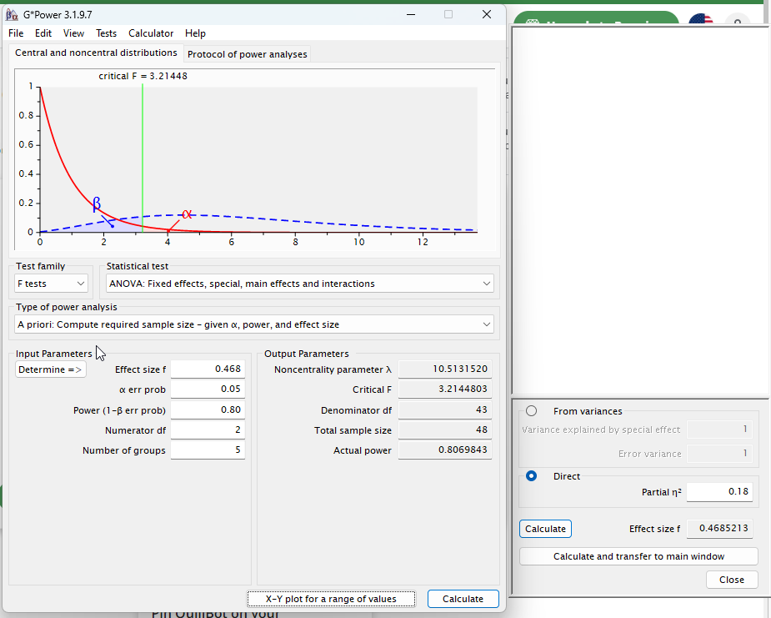

1. (4 pts) Compute the sample size for a two-way repeated measures ANOVA for an effect size of ηp2= 0.1 for two within subject independent variables, two each with 2 levels. Use an alpha level of 0.05 and 80% power. Do not correct for sphericity. 35

1. (3 pts) Recompute the sample size for the previous problem (F) but with four replications per participant with an expected correlation between replications of r = 0.14. 13

