Cisco MDS/Nexus

Last update 12/11/2013

**Device Discovery configuration:**

Every Cisco MDS/Nexus switch must be discovered and the “devtype” attribute must be set to “FabricSwitch”. Most switches should have this information discovered automatically. However, if your switch is not discovered with “devtype” equal to “FabricSwitch”, this will result having your switch not represented under the SolutionPack reports.

If your switch is not properly discovered, open the Device Discovery GUI (<http://yourserver_ip:58080/device-discovery/>), and edit your device settings.

For example:

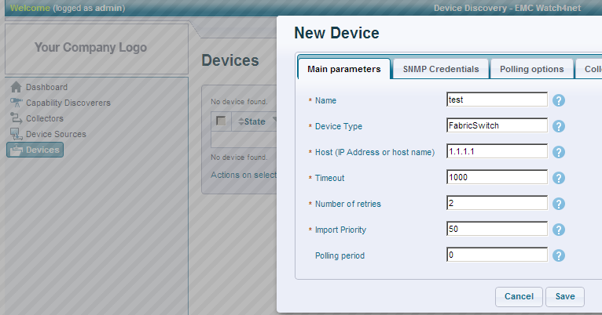

**Capabilities:**

You can safely exclude the “GENERIC-INTERFACES” capability on your Cisco MDS/Nexus switches. This capability is not used for the SolutionPack, and thus will result in more polling.

To exclude the capability, edit your SNMP agent settings (under Devices), and exclude it. For example:

