EMC VNX

Last update 06/14/2013

**Requirements:**

Naviseccli must be installed on the Watch4net collector host system, as Naviseccli commands are used to communicate with the VNX. EMC recommends matching Naviseccli versions with Block Operating Environment versions of VNX systems configured in Watch4net collector. For information on compatible Block OE and Naviseccli versions, please see the VNX OE for Block Release Notes and the Unisphere Host Agent/CLI and Utilities Release Notes located on EMC Online Support.

For block and unified data collection, you must enable statistics logging on the array. To enable statistic logging, refer to Unisphere documentation.

Naviseccli binaries can be found on EMC’s support site, at: <https://support.emc.com/downloads/7948_Navisphere>

**Generating VNX security file on Windows:**

Refer to Navisphere documentation on how to create a security file.

The Watch4net collector runs, by default, with the “Local System account”. This is a special Windows user, which has no environment. You have different option to use security file under Windows.

1. Change the collector, and make it use a specific service account. Login on Windows with this account, and generate the security file. The service configuration would look like this:

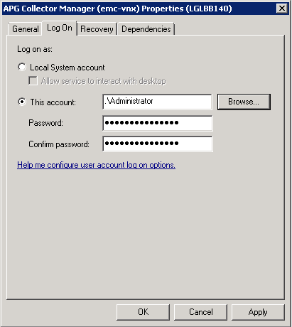

1. Login as the “Local System account”, and generate the security file. You will need to run the 3rd party tool called “psexec.exe” on your collector server. psexec is available through “Windows Sysinternals” at <http://technet.microsoft.com/en-us/sysinternals/bb897553>. Run this command from a Windows command line, like this: psexec.exe -i -s cmd.exe.  
   From the new command line, generate your security file, as stated in the Navisphere CLI documentation.

Nb: Security file is tight to Operating System user. If you generated a security file in a custom path, make sure you are running Watch4net collector with the same OS user (cf. above). You can then configure your VNX collect, point to this path.

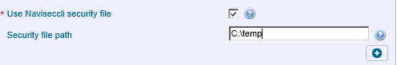

**VNX File requirements:**

You must use the “nasadmin” account, since it is the only user that is able to connect using SSH & XML API.

**Known issues:**

* You may observe in collector logs a message similar to:

|  |
| --- |
| SEVERE -- [2013-02-20 15:30:05 EST] -- FileDownloadingTask::run(): Could not download file(s) from SFTP server on directory '/tmp/w4n_data/5min/APM00112100464'.  com.watch4net.apg.file.retriever.ClientException: Could not download file(s) from SFTP server on directory '/tmp/w4n_data/5min/APM00112100464'.  at com.watch4net.apg.file.retriever.protocol.SFTPClient.retrieveFiles(SFTPClient.java:437)  at com.watch4net.apg.file.retriever.FileDownloadingTask.run(FileDownloadingTask.java:161)  at java.util.concurrent.Executors$RunnableAdapter.call(Executors.java:439)  at java.util.concurrent.FutureTask$Sync.innerRunAndReset(FutureTask.java:317)  at java.util.concurrent.FutureTask.runAndReset(FutureTask.java:150)  at java.util.concurrent.ScheduledThreadPoolExecutor$ScheduledFutureTask.access$101(ScheduledThreadPoolExecutor.java:98)  at java.util.concurrent.ScheduledThreadPoolExecutor$ScheduledFutureTask.runPeriodic(ScheduledThreadPoolExecutor.java:180)  at java.util.concurrent.ScheduledThreadPoolExecutor$ScheduledFutureTask.run(ScheduledThreadPoolExecutor.java:204)  at java.util.concurrent.ThreadPoolExecutor$Worker.runTask(ThreadPoolExecutor.java:886)  at java.util.concurrent.ThreadPoolExecutor$Worker.run(ThreadPoolExecutor.java:908)  at java.lang.Thread.run(Thread.java:662)  Caused by: com.trilead.ssh2.SFTPException: No such file (SSH_FX_NO_SUCH_FILE: A reference was made to a file which does not exist.)  at com.trilead.ssh2.SFTPv3Client.openDirectory(SFTPv3Client.java:823)  at com.trilead.ssh2.SFTPv3Client.ls(SFTPv3Client.java:930)  at com.watch4net.apg.file.retriever.protocol.SFTPClient.retrieveFiles(SFTPClient.java:320)  ... 10 more  com.watch4net.apg.v2.collector.plugins.propertytaggingfilter.webservice.jaxws.AddResponse |

The issue can be observed on initial polling, after collector startup. The behavior is normal, and can be ignored. If message repeats often, it can indicate a problem with the data collection.