CREATE TABLE `example` (
`id` int(11) NOT NULL AUTO_INCREMENT,
`name` varchar(20) DEFAULT NULL,
`age` int(11) DEFAULT NULL,
PRIMARY KEY (`id`)
) ENGINE=InnoDB AUTO_INCREMENT=11 DEFAULT CHARSET=latin1;

-- ----------------------------
-- Records of example
-- ----------------------------
INSERT INTO `example` VALUES ('2', 'aaa', '18');
INSERT INTO `example` VALUES ('3', 'aaa', '18');
INSERT INTO `example` VALUES ('4', 'aaa', '18');
INSERT INTO `example` VALUES ('5', 'aaa', '18');
INSERT INTO `example` VALUES ('6', 'bbb', '18');
INSERT INTO `example` VALUES ('7', 'bbb', '18');
INSERT INTO `example` VALUES ('8', 'ccc', '19');
INSERT INTO `example` VALUES ('9', 'ccc', '19');
INSERT INTO `example` VALUES ('10', 'ccc', '19');

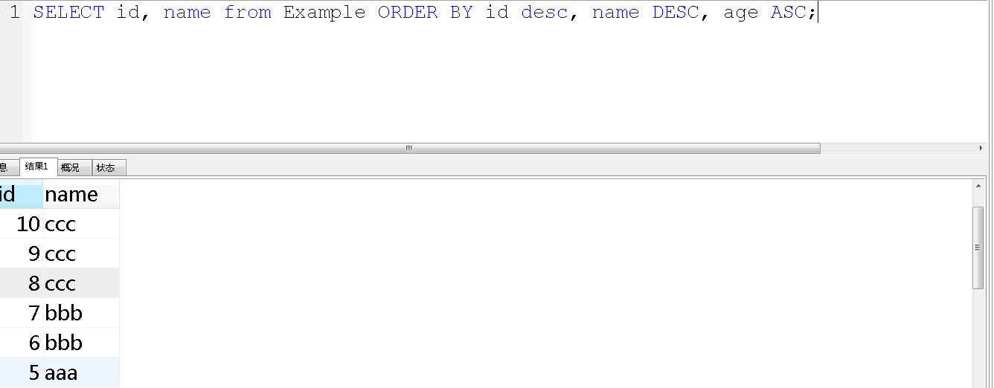

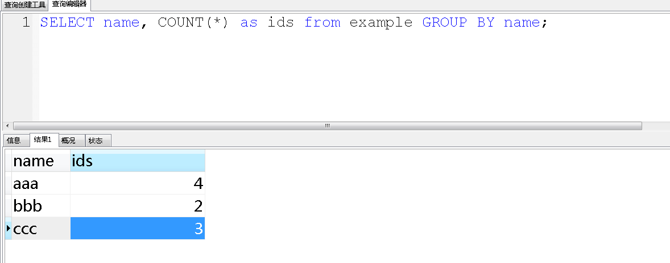

group_concat(id)

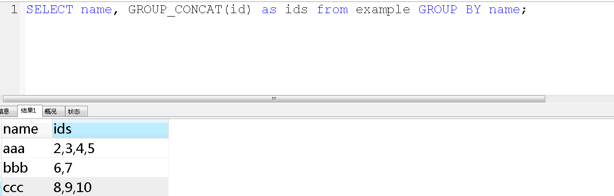

with rollup是用来在分组统计数据的基础上再进行统计汇总，即用来得到group by的汇总信息
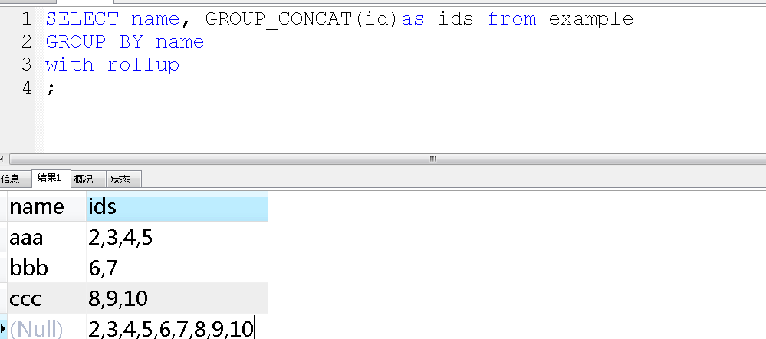

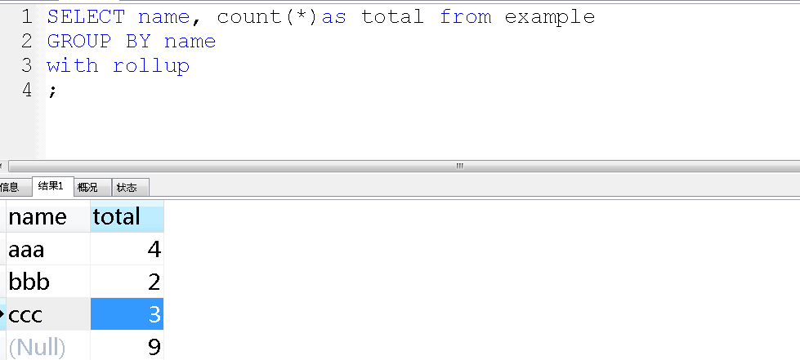

Where是在分组之前用来选择记录，Having在数据分组之后进行过滤选择分组。

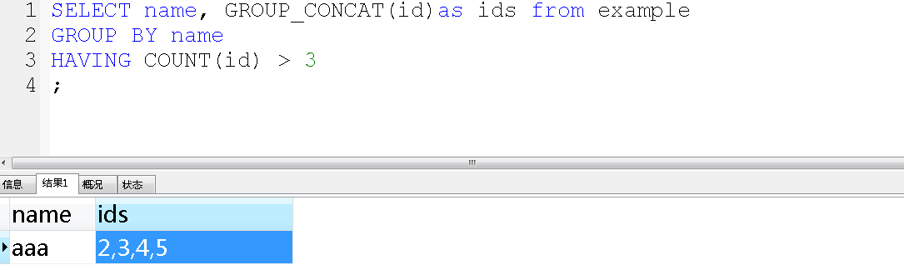
查询订单价格大于100的订单号和总订单价格
SELECT orderID, SUM(quantity * price) as orderTotal
FROM order
GROUP BY orderID
HAVING SUM(quantity * price) >100
ORDER BY orderTotal ASC；

返回表中前6行记录
Select *from tableName LIMIT 6;

返回第6个记录开始，行数长度为3的记录
Select id from tableName LIMIT 5, 3;
Select id from tableName LIMIT 5 offset 3;

