Screen 1
Personal: Fresh graduate, job risk
Group: HR or manager, TVET, or Uni career center

Login function : user name/ email, password, continue with gmail

Screen 2.0
- Fill up interest (computer science, financial, business)
  - Select stream first
  - Them from the selected stream, multiselect the interested career
- User upload cv/ fill up personal information.
- AI scan the cv, then auto fill up the blank box

- 2.1 basic information, 2.2 experience, 2.3 education, 2.4 skill, 2.5 summary (back/next)

  - Ask for highest education, if ug and above, allow to ask
  - For 2.3 Education, if autofill, fill up all ug,pg, phd
  - If fill by user, then give

- 2.4 skill, give user understanding level for their skills.
  - List out a range of skills for users (related to the interest)
  - Can give a others option for them to fill in
  - Evaluate themselves (for the level of the skills)

- If the cv not complete, empty box/space, wait for user to fill up. 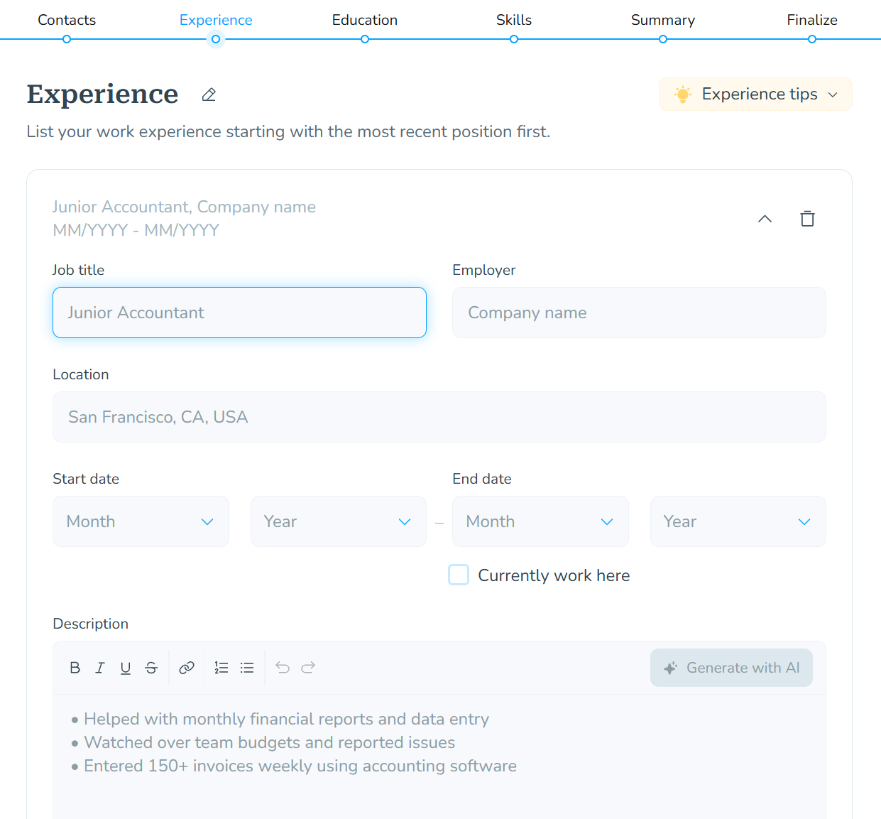
Screen 3 (analysis)
General
- Skills
  - Horizontal bar chart: to analyse the skill trend nowadays (rising, declining)
  - When clicked, can flip to the right side and show the future scenarios of the trends (eg: fast or moderate scenarios)
  - 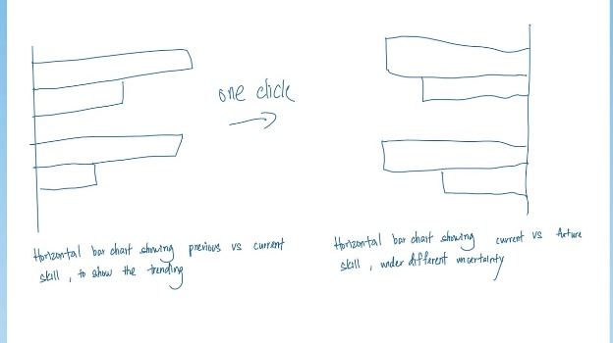
- Job trend (jobstreet/ others job app) (below just example)
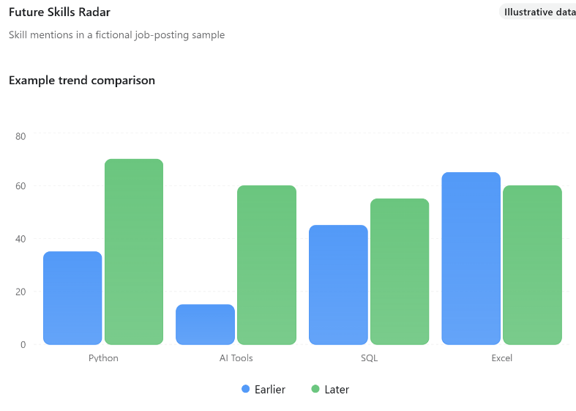
- can do a 3d type chart, like having a light reflection below the chart (first: showing previous and now trending)
- Click and flip 180° (up and down)
- Shows the future scenarios
- Have a button to select fast or moderate ai adoption
Specific (based on suggested jobs)
- Suggest jobs based on interest (if not satisfied, a button “Explore more”(related to their interest))
- When suggest jobs. Show the match score
  - Match Score = 100 × (0.65 × Skill Fit + 0.15 × Interest Fit + 0.10 × Experience Fit + 0.10 × Market Fit)

Screen 3.1
- When select jobs, show the analysis of the skills existing, and skills required for that job, like an overlapping hexagon on the highlighted hexagon existing skills
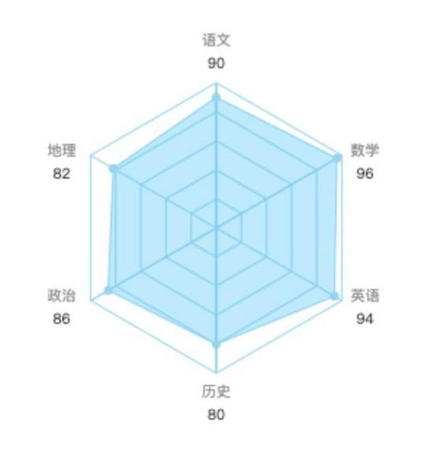
- label the different colors with different functions
- Show related SDG, example :
- At radar map, each point of skill have a small SDG title
- Also how job and each skills are connected to SDG, when hover 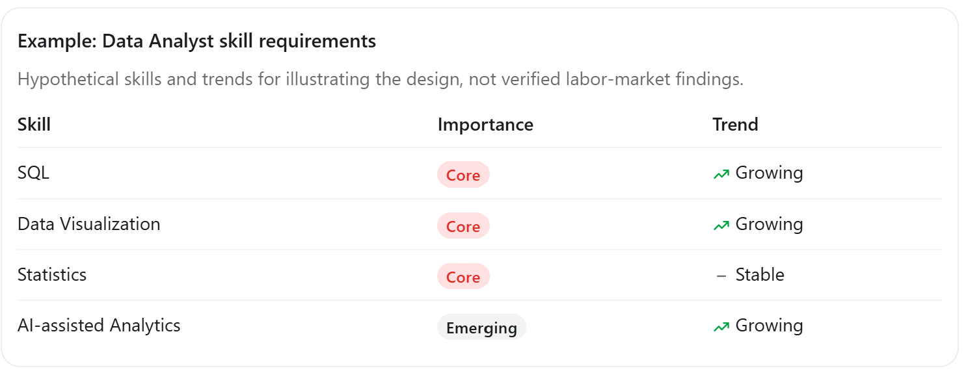
- Job description, prospection, expected salary, other analysis
- Also shows the fast and moderate ai adoption
Condition:
- If they miss any skills during skills assessments, and that skill is required for the selected job, allow users to reassess.
- Allow to refresh the hexagon and match score
Screen 4
Ask user preferences
- Indoor/outdoor
- Study period / duration per day
- Cost (free/low cost, HRD Corp claimable programmes)
- Online courses
- Others
- 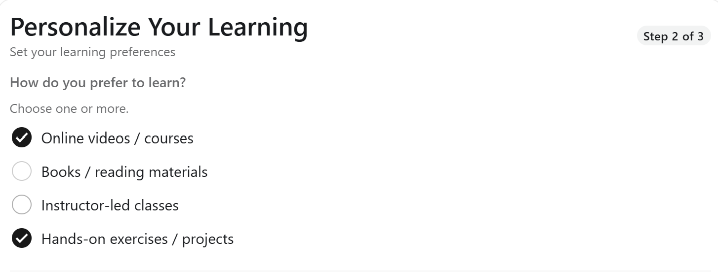
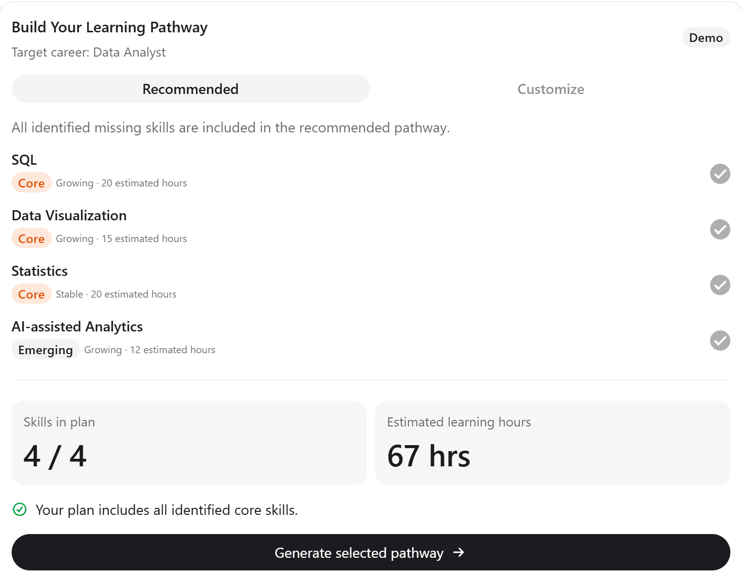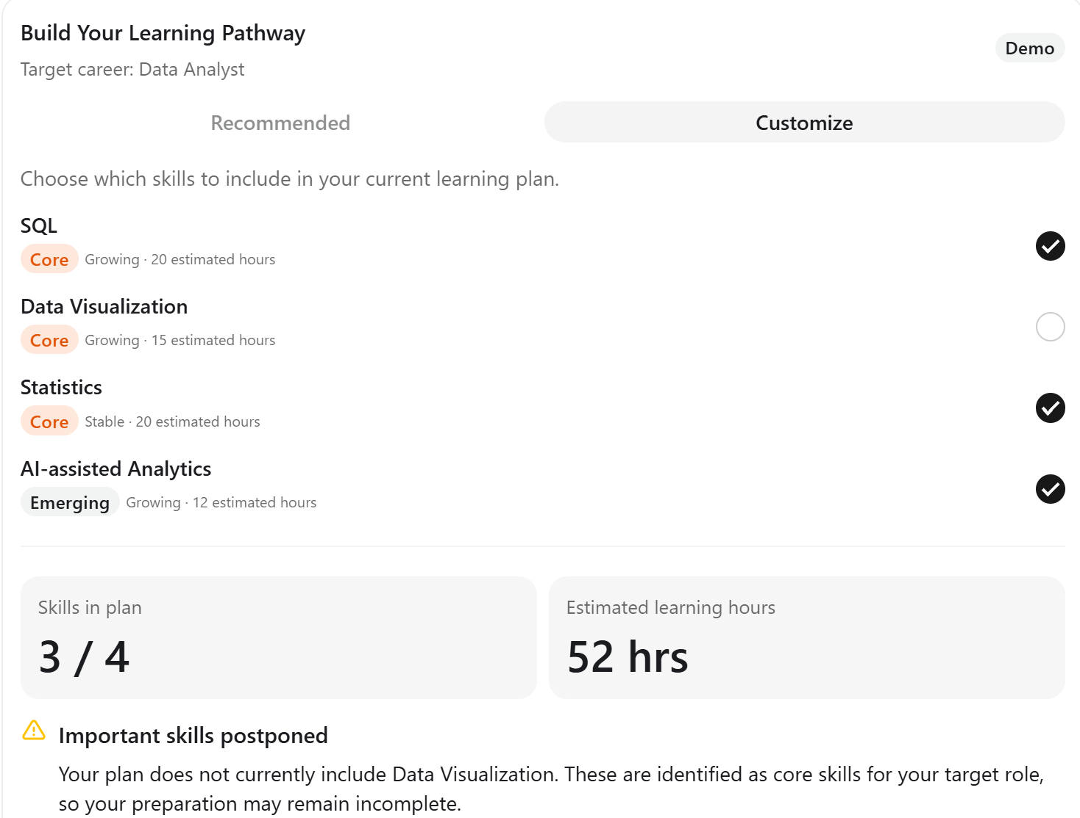
- Select recommended or custom plan
  - Study plan change according to the future scenarios
- Let user select skills to learned
  - If users unselect core skills, disclaimer
  - 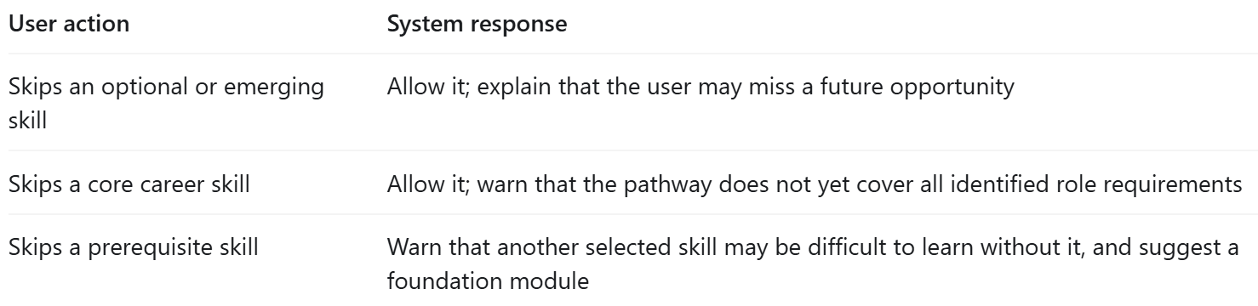
- If any cost needed- show cost

Screen 5
Showing the learning progress
- For each skill, show the details of the skill, and also recommend resources
- Example: C++, shows the estimated time (for each structure of C++), and an animated progress (a small people running), then for give checklist for them to check
- For each checkpoint, like every skill finished, pop out a skill badge
- Connect database (ESCO), then let AI scan through it, generate related study plan
- Have updated job match score, can refresh

Organization view - TVET, HR
Select Company/University
Company
Screen 1
Basic information
- Name for company
- Department
  - Have a button can let user add departments
  - Then can jump to spreadsheets to enter member details
    - Enter names, position, skills (let evaluate), can add skills
Screen 2

