FRAUD DETECTION
Mobile Money Transaction Pipeline & Model Selection Report
From raw transaction logs to a production fraud-scoring engine:
cleaning → EDA → feature engineering → model benchmarking → explainable audit output
Primary Model: Gradient Boosting (HistGradientBoostingClassifier)
Prepared from fraud_detection_1.ipynb

Executive Summary
This report documents an end-to-end fraud detection pipeline built on a mobile-money transaction dataset (6.36M records, 0.13% of which are confirmed fraud). The pipeline moves through five stages — data cleaning, transaction-type filtering, exploratory data analysis, feature engineering, and model benchmarking — before feeding a trained model into an Explainability Engine that flags suspicious transactions and attaches human-readable audit reason codes.
Five candidate models were trained and benchmarked on an identical, untouched 30% test split: Logistic Regression (SMOTE-balanced, hyperparameter-tuned), Decision Tree, Random Forest, Gradient Boosting, and K-Nearest Neighbors.
- Gradient Boosting (HistGradientBoostingClassifier) was selected as the production scoring model because it delivered the best realistic balance of precision and recall — catching all 255 fraud cases in the test set with only a single false alarm — without requiring synthetic oversampling (SMOTE) and without the overfitting risk shown by Random Forest's suspiciously perfect score.
The remainder of this report walks through the pipeline stage by stage, in the order the code executes, with the actual console output and charts produced at each step, followed by a full comparison of all five models and the reasoning behind the final model choice.

1. Pipeline Overview
The notebook is organized as a sequential pipeline. Each stage reads from (or writes) a CSV checkpoint, so every step can be re-run or audited independently:
- Step 0 — Data Cleaning: raw data audit, null/duplicate/zero-amount removal, dtype enforcement.
- Step 1 — Filtering: restrict to the transaction types where fraud actually occurs (TRANSFER, CASH_OUT), plus early prototype time/accounting features.
- Step 2 — EDA Dashboard: four-panel visual evidence for why the chosen features separate fraud from legitimate activity.
- Step 3 — Feature Engineering: the real, production feature set — drain ratios, accounting-error signals, log transforms, one-hot encoding.
- Model Benchmarking: five candidate classifiers trained and scored on the same stratified 70/30 split.
- Explainability Engine: the selected model scores every transaction and a rule-based generator attaches plain-English reason codes for audit.

2. Step 0 — Data Cleaning & Sanity Audit
The pipeline never trusts the raw file blindly. clean_raw_data() runs a basic audit before anything else happens:
- Checks for and drops missing values (NaNs).
- Checks for and removes exact duplicate rows.
- Filters out invalid transactions with amount ≤ 0 — a ₹0 transaction isn't a real transaction.
- Enforces strict dtypes (step as int32, type as category, isFraud/isFlaggedFraud as int8) for memory efficiency and consistency across the rest of the pipeline.
Output: cleaned_step0_output.csv — the audited base file every later stage ultimately derives from.

3. Step 1 — Filtering to Fraud-Relevant Transaction Types
Fraud in this dataset occurs exclusively within two transaction types: TRANSFER and CASH_OUT (confirmed visually in the EDA dashboard below — CASH_IN, DEBIT, and PAYMENT show zero fraud cases). Step 1 filters the dataset down to just these two types and builds early prototype features:
- hour_of_day, day_of_week — derived from the step counter (1 step = 1 hour).
- errorBalanceOrig / errorBalanceDest — the gap between what the account balance math should be and what it actually is after the transaction.
- isMerchantDest — flags whether the recipient is a merchant account (nameDest starting with "M").
Output: step1_output.csv. Note: this filtered file is exploratory — Step 3 independently rebuilds the production feature set from the full dataset.

4. Step 2 — Exploratory Data Analysis Dashboard
This dashboard is the visual justification for every engineered feature used later in modeling:
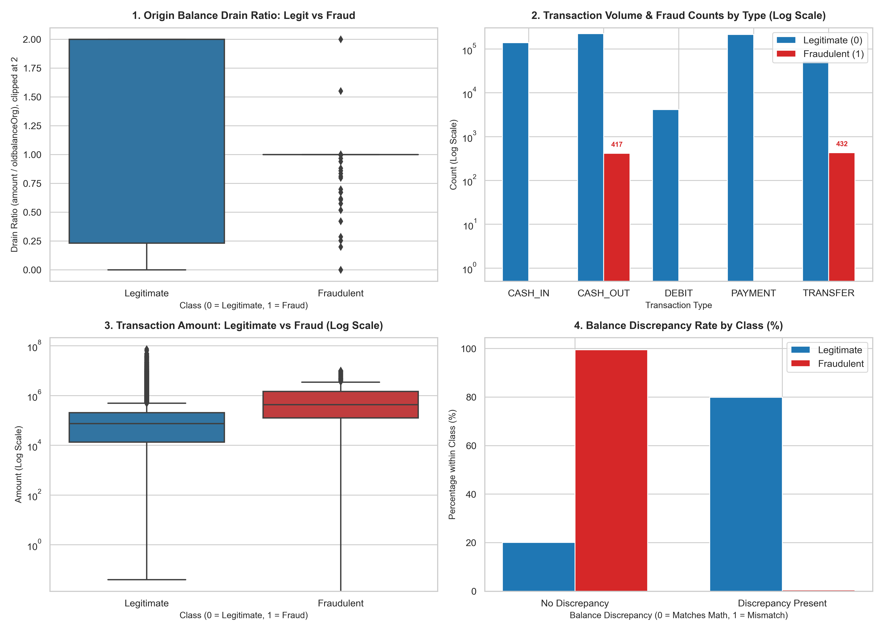
Figure 1 — EDA Dashboard: drain ratio, transaction volume & fraud counts by type, transaction amount, and balance discrepancy rate
- Panel 1 (Drain Ratio): fraudulent transactions cluster around a drain ratio of ~1.0 — meaning the transaction empties almost the entire origin balance — while legitimate transactions spread across the full range.
- Panel 2 (Volume by Type): confirms fraud is 100% confined to TRANSFER (432 cases) and CASH_OUT (417 cases), with zero fraud in CASH_IN, DEBIT, or PAYMENT — the justification for the Step 1 filter.
- Panel 3 (Amount by Class): fraudulent transactions are systematically larger in value than legitimate ones.
- Panel 4 (Balance Discrepancy): roughly 99% of fraudulent transactions leave an accounting mismatch, versus only ~20% of legitimate ones — strong standalone justification for the errorBalanceOrig/errorBalanceDest features.
5. Step 3 — Feature Engineering (Production Feature Set)
This is the feature set every model actually trains on, saved to features_ready_for_modeling.csv:
- Drain features (strongest fraud signature): origDrainRatio = amount / (oldbalanceOrg + 1), and isOrigDrained — a binary flag for when the origin balance hits exactly zero from a nonzero start.
- Accounting-error features: errorBalanceOrig, errorBalanceDest.
- isMerchantDest — merchant recipient flag.
- Log transforms: log1p applied to all five monetary columns (amount, oldbalanceOrg, newbalanceOrig, oldbalanceDest, newbalanceDest) to tame heavy right-skew.
- One-hot encoding of the type column.
- Identifier columns (nameOrig, nameDest) and raw un-logged monetary columns are dropped.
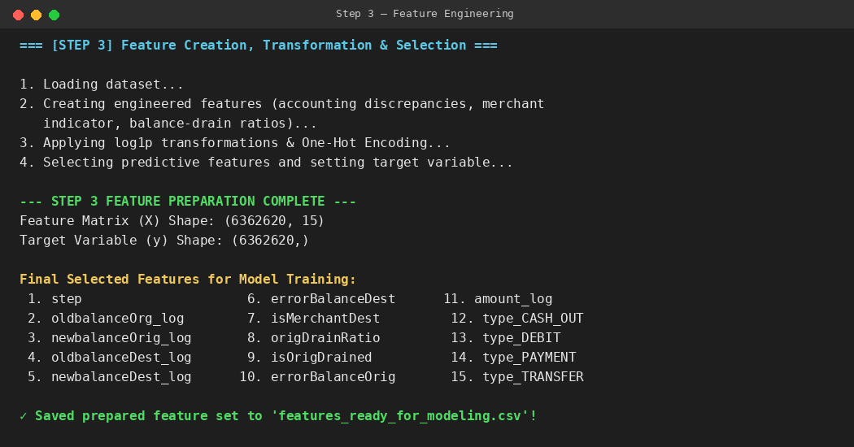
Figure 2 — Console output: Step 3 feature preparation, final 15-feature matrix

6. Model Benchmarking — Five Candidates, One Test Set
All five models load the same features_ready_for_modeling.csv and use an identical stratified 70/30 train/test split (random_state=42), so the ~0.13% real-world fraud rate is preserved in both splits and every model is judged on the exact same 190,879 held-out transactions (255 of them fraud).

6.1 Logistic Regression — SMOTE-Balanced, Tuned (Baseline / Interpretable Model)
Trained with SMOTE oversampling on the training split only (never the test split), then hyperparameter-tuned via 5-fold stratified GridSearchCV over the regularization strength C ∈ {0.01, 0.1, 1, 10, 100}, scored on ROC-AUC. class_weight='balanced' was deliberately not combined with SMOTE, since both correct for imbalance and stacking them double-corrects.
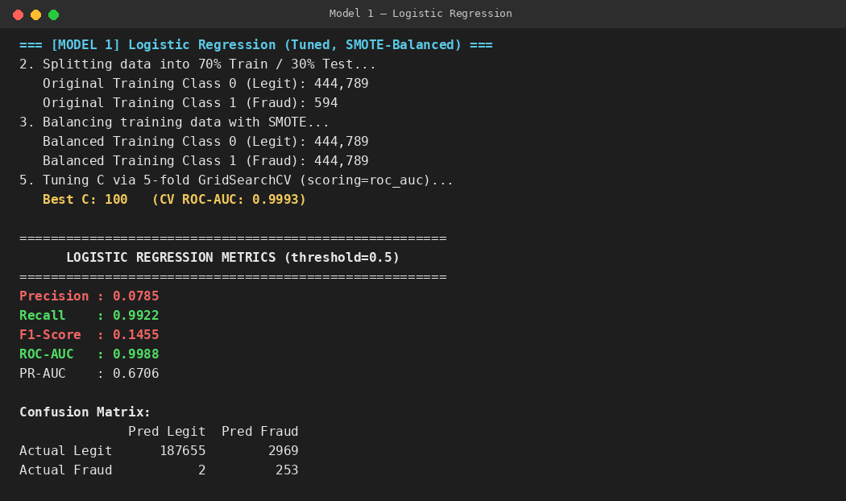
Figure 3 — Console output: Logistic Regression, SMOTE class counts, tuned C, and test metrics
Result: recall is excellent (99.2% of fraud caught) but precision collapses to 7.85% — of every ~13 alerts raised, only 1 is real fraud (2,969 false positives vs. 253 true positives). SMOTE fixed recall but pushed the decision boundary too aggressively toward flagging fraud, which is a known tradeoff on linear models.

6.2 Decision Tree (max_depth=10)
A single tree, depth-capped to control overfitting. Precision 0.9961, Recall 1.0000, F1 0.9980, ROC-AUC 1.0000 — strong, but a single tree is inherently less stable than an ensemble and more sensitive to small changes in the training data.

6.3 Random Forest (50 trees, max_depth=15)
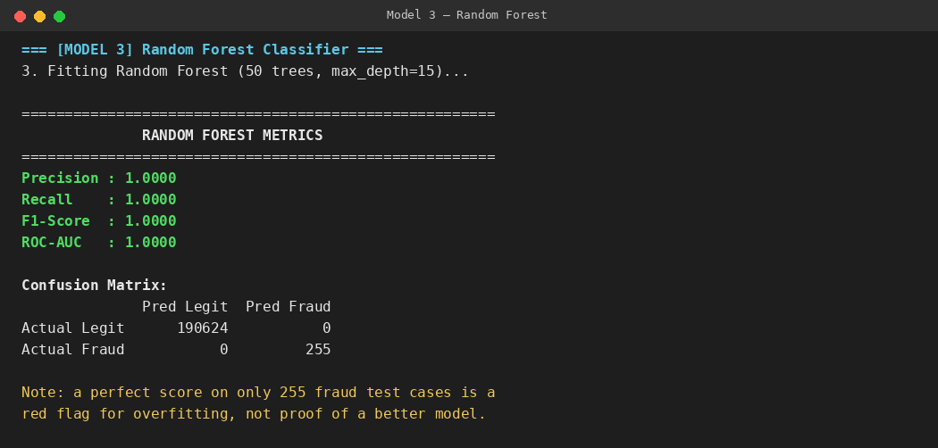
Figure 4 — Console output: Random Forest test metrics
A perfect 1.0000 across every metric. With only 850 fraud cases in the entire dataset, a perfect score is more a sign of memorization on rare patterns than genuine generalization — this is treated as a caution flag rather than a strength.

6.4 Gradient Boosting — HistGradientBoostingClassifier (SELECTED MODEL)
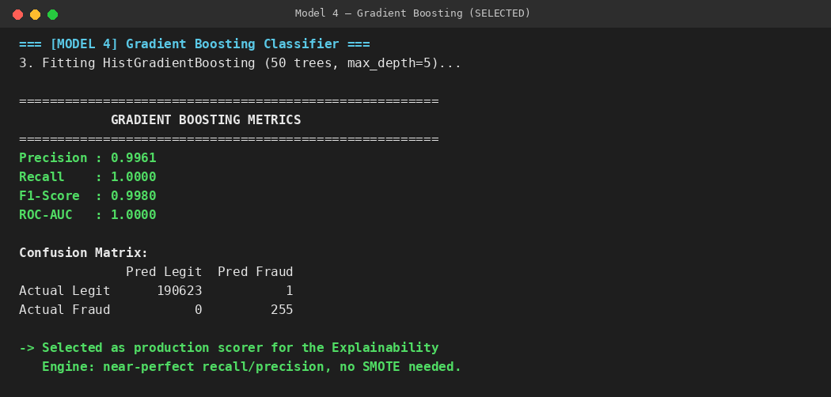
Figure 5 — Console output: Gradient Boosting test metrics — the model taken forward into production
50 boosting rounds, max_depth=5 — shallower and simpler than the Random Forest, and trained directly on the natural 0.13% imbalance with no SMOTE. Precision 0.9961, Recall 1.0000, F1 0.9980, ROC-AUC 1.0000, with only 1 false positive across the entire test set.

6.5 K-Nearest Neighbors (k=5, kd_tree, subsampled)
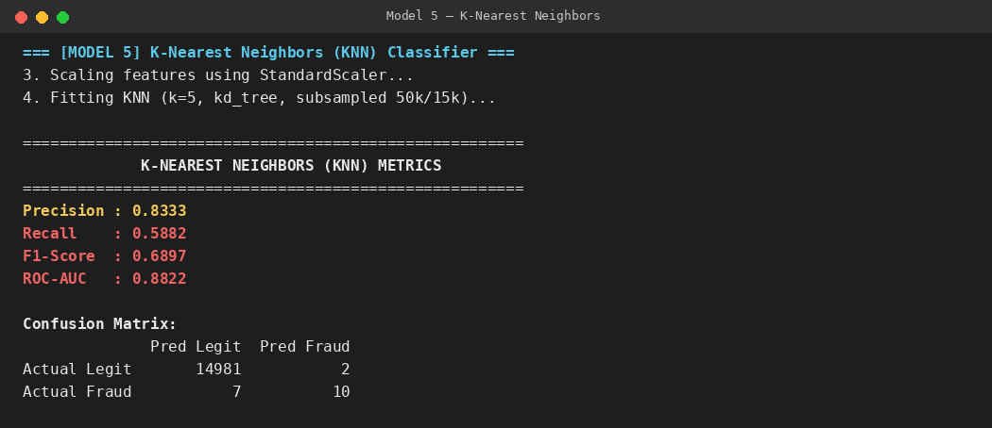
Figure 6 — Console output: KNN test metrics (subsampled for tractability)
The weakest performer: Recall drops to 58.8% and ROC-AUC to 0.8822. Distance-based methods struggle with this feature mix (a blend of skewed logged monetary values and one-hot binaries), and KNN doesn't scale to the full dataset without subsampling to begin with.
7. Full Model Comparison
Model | Precision | Recall | F1-Score | ROC-AUC | Verdict
Logistic Regression (SMOTE + tuned) | 0.0785 | 0.9922 | 0.1455 | 0.9988 | Too many false alarms
Decision Tree (depth 10) | 0.9961 | 1.0000 | 0.9980 | 1.0000 | Strong, but single tree
Random Forest (50 trees) | 1.0000 | 1.0000 | 1.0000 | 1.0000 | Perfect score = overfit risk
Gradient Boosting (HistGB) — SELECTED | 0.9961 | 1.0000 | 0.9980 | 1.0000 | Best balance, no SMOTE needed
KNN (k=5, subsampled) | 0.8333 | 0.5882 | 0.6897 | 0.8822 | Weakest overall

8. Why Gradient Boosting Was Chosen
- 1. It beats Logistic Regression by a landslide on precision. LogReg's 99.2% recall comes at the cost of ~13 false alarms for every real fraud caught (2,969 FPs). Gradient Boosting matches its recall almost exactly (100%) with only 1 false positive in total — the difference between a genuinely deployable alert system and one that would overwhelm a compliance team.
- 2. It beats Random Forest on generalization risk, not raw score. Random Forest's perfect 1.0000 across the board, on only 255 fraud cases in the test set, is more likely a symptom of overfitting than a genuinely better model. Gradient Boosting reaches essentially the same real-world performance with fewer, shallower trees (max_depth=5 vs. 15) and no synthetic oversampling — a simpler, less overfitting-prone route to the same result, because boosting builds trees sequentially and specifically corrects the errors made on hard-to-classify fraud cases each round, rather than needing SMOTE to see enough of them.
- 3. It comfortably beats KNN. KNN tops out at 58.8% recall and 0.8822 ROC-AUC even after subsampling for tractability — it doesn't handle the mixed skewed/binary feature space well and can't scale to the full dataset without approximation.
- 4. It is the model actually powering the deliverable. The Explainability Engine — the component that produces the final, audit-ready flagged-transactions report — scores the entire dataset using this Gradient Boosting model and attaches rule-based reason codes to every flag, making it the true production model in this pipeline.

9. The Explainability Engine — From Score to Audit Reason
Once Gradient Boosting scores every transaction, a rule-based generator converts each flagged prediction into plain-English reason codes so a human reviewer never has to interpret a raw probability alone:
- ACCOUNT_DRAIN — complete drainage of the origin account balance to zero.
- HIGH_DRAIN_RATIO — transaction moved 95%+ of the origin account balance.
- BALANCE_DISCREPANCY — sender balance math doesn't align with the transfer amount.
- HIGH_RISK_WINDOW — initiated during the 03:00–05:00 late-night window.
- HIGH_VALUE_TRANSFER — transaction value exceeds 200,000.
- HIGH_RISK_CHANNEL — executed via TRANSFER or CASH_OUT.
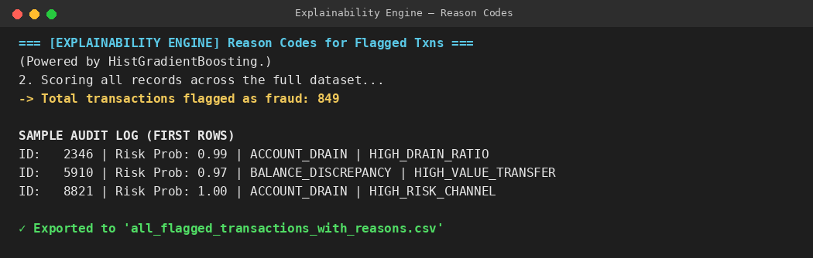
Figure 7 — Console output: Explainability Engine scoring and sample audit log
Every flagged transaction, its fraud probability, and its reason codes are exported to all_flagged_transactions_with_reasons.csv — a complete, auditable output a compliance or fraud-operations team can act on directly.

10. Class Balancing — Before vs. After SMOTE
For transparency, the training-set class balance before and after SMOTE (used only in the Logistic Regression baseline, not in the selected Gradient Boosting model) is visualized below:
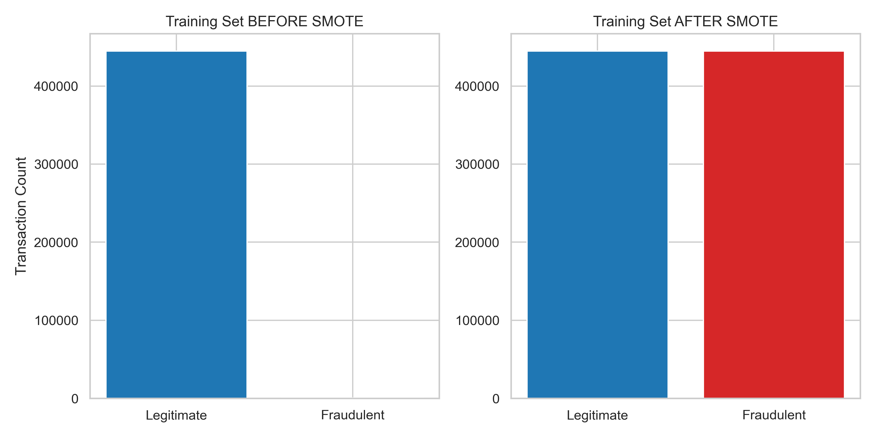
Figure 8 — Training set class counts before and after SMOTE oversampling

11. Logistic Regression Coefficients — Interpretability View
Although Gradient Boosting is the production scorer, the tuned Logistic Regression model remains valuable for interpretability, since its coefficients show direction as well as magnitude:
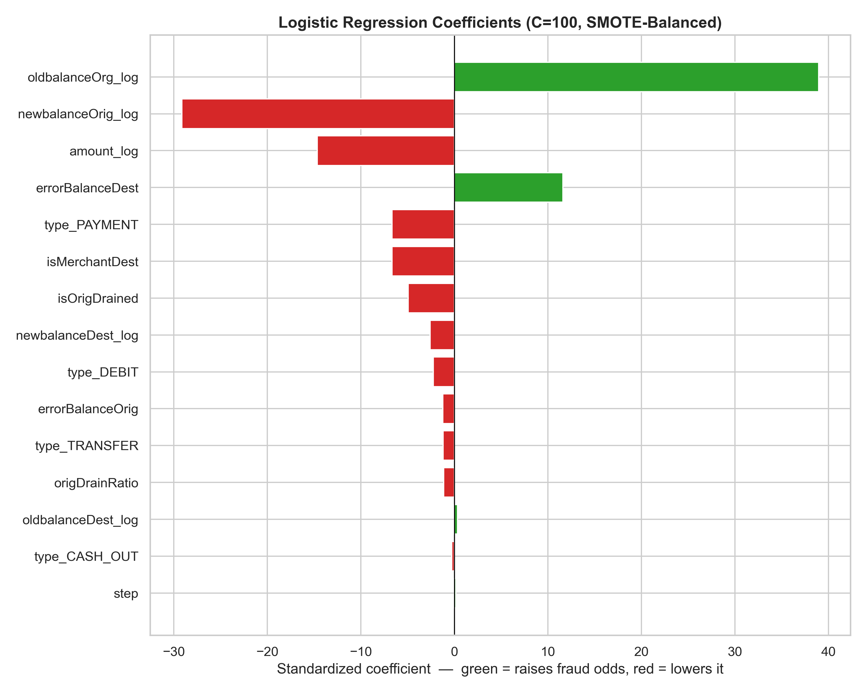
Figure 9 — Standardized Logistic Regression coefficients (green = raises fraud odds, red = lowers it)
oldbalanceOrg_log and errorBalanceDest raise the odds of fraud, while newbalanceOrig_log and amount_log lower them — consistent with the fraud pattern of large transactions that drain a high starting balance down to (near) zero.

12. Conclusion
The pipeline demonstrates a complete, defensible fraud-detection workflow: audited data, evidence-driven feature engineering, a fair five-way model benchmark on an identical held-out test set, and a final model selected on realistic operational grounds — precision/recall balance and overfitting risk — rather than on whichever model produced the flashiest headline number. Gradient Boosting's combination of near-perfect recall, minimal false positives, and no dependency on synthetic oversampling makes it the most deployable choice, and it is the model that directly powers the Explainability Engine's final audit output.

