Introduction
This report collects data for seven activities: standing still, walking on a flat surface, climbing stairs, descending stairs, ascending in an elevator, running, and descending in an elevator. The analysis strictly follows the structured tasks listed in the operation outline. It starts with the visualization of raw data, then progresses to feature extraction, evaluation of machine learning models, and experimentation with new features.
TO DO 1: Raw Data Visualization and Discussion
This graph presents the original sensor data of approximately 40,000 time samples. During the initial segment from sample 0 to approximately 10,000, the magnitude fluctuates around 10 m/s² with moderate variance, corresponding to walking activities. A sharp transition occurs around sample 15,000 where the magnitude drops to nearly zero and remains flat until sample 20,000, clearly indicating stationary behavior. The most striking feature appears between samples 20,000 and 30,000, where the magnitude reaches peaks exceeding 50 m/s² with sustained high variance, unambiguously representing running activity. Following this, the signal returns to lower magnitude levels consistent with walking or stationary behavior.
The middle subplot displays the barometric pressure data measured in millibars after smoothing. The pressure trace reveals several notable patterns. Sharp drops in pressure occur during upward vertical displacement, such as during elevator ascent or stair climbing, while pressure increases characterize downward movement. For instance, the steep decline from approximately 1013.5 mbar to 1011.5 mbar around sample 2,000 indicates upward movement. Conversely, the rise around sample 8,000 suggests descent. The plateau regions correspond to horizontal movement or stationary periods where altitude remains constant.
The bottom subplot shows the activity labels as step functions, providing ground truth annotation. The labels transition from Activity 4 (approximately samples 0-3,000), to Activity 3 (samples 3,000-6,000), then Activity 2 (samples 6,000-9,000), Activity 1 (samples 9,000-13,000), Activity 0 (samples 13,000-20,000), Activity 5 (samples 20,000-30,000), Activity 6 (samples 30,000-34,000), Activity 4 (samples 34,000-37,000), and finally Activity 3 (samples 37,000-40,000). This temporal segmentation enables precise correlation between sensor patterns and activity types.
The raw data demonstrates clear distinguishing characteristics. Accelerometer magnitude directly reflects motion intensity, with running producing the highest values, walking generating moderate fluctuations, and stationary behavior showing minimal variation near zero. Barometric pressure serves as an effective proxy for altitude change, with its slope indicating vertical movement direction and magnitude.

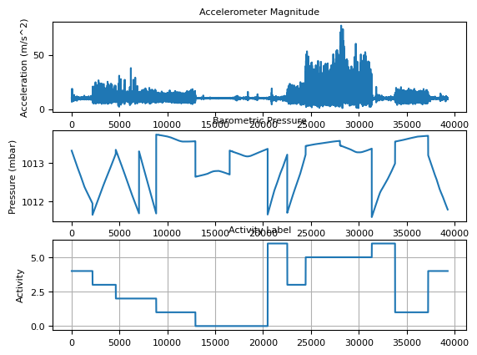

TO DO 2: Feature Extraction and Visualization
Figure 2 displays extracted features from the sensor data, specifically the variance of accelerometer magnitude and the slope of barometric pressure, alongside the corresponding activity labels. The top subplot shows variance values computed over sliding windows. The variance remains below 5,000 (m/s²)² during walking and stationary activities, with slightly elevated values around 2,000 to 5,000 for flat surface walking. During running, the variance dramatically increases, reaching peaks above 30,000 (m/s²)² with sustained high values throughout the activity period. This substantial difference makes variance an excellent discriminator between high-intensity and low-intensity activities.
The middle subplot presents the slope of barometric pressure measured in millibars per second. Positive slope values indicate descending activities, with magnitudes reaching approximately 2.5 mbar/s during elevator descent. Negative slopes around negative 2.5 mbar/s characterize ascending activities such as elevator ascent and stair climbing. Near-zero slopes correspond to horizontal movements and stationary behavior. The slope feature effectively captures the directionality of vertical displacement.
The bottom subplot repeats the activity labels for temporal reference, now aligned with the windowed feature extraction timeline spanning approximately 600 windows.
Additional features extracted but not shown in this figure include the mean of accelerometer magnitude, signal energy across different frequency bands (0 to 2.5 Hz, 2.5 to 5 Hz, 5 to 7.5 Hz, and 7.5 to 10 Hz), and various statistical moments. These frequency domain features capture the periodic nature of human gait, where walking typically exhibits dominant energy in the 1 to 2 Hz range corresponding to step frequency, while running shifts energy to higher frequencies around 2.5 to 3 Hz.

TO DO 3: Feature Interpretation and Activity Discrimination
The extracted features provide complementary information for activity classification based on distinct physical principles.
The variance of accelerometer magnitude directly quantifies motion intensity. During running, the limbs experience rapid acceleration changes as the foot strikes the ground and pushes off, producing high variance values consistently exceeding 10,000 (m/s²)² and often reaching above 30,000. Walking on flat surfaces generates moderate variance between 1,000 and 5,000 due to the regular but less forceful gait pattern. Stationary behavior and elevator movement exhibit minimal variance, typically below 1,000, because the phone remains relatively stable or moves at constant velocity without significant acceleration fluctuations. However, variance alone cannot distinguish between stationary and elevator activities, as both show similarly low values.
The slope of barometric pressure provides crucial altitude information. Atmospheric pressure decreases approximately 1 millibar per 8 meters of altitude gain under standard conditions. Therefore, ascending activities such as walking up stairs or riding an elevator upward produce sustained negative slopes as pressure drops. Conversely, descending activities generate positive slopes. The magnitude of the slope additionally distinguishes between elevator movement, which typically produces steeper, more consistent slopes due to higher speed, and stair climbing, which shows more variable, step-wise pressure changes due to the intermittent motion pattern. Flat surface walking and stationary behavior maintain near-zero slopes since altitude remains essentially constant.
Frequency domain features offer further discrimination. Walking exhibits dominant energy in the low-frequency band around 1 to 2 Hz, corresponding to the natural step frequency of approximately 60 to 120 steps per minute. Running shifts the dominant energy to higher frequencies around 2 to 3 Hz. Stationary behavior shows no distinct peaks but rather broadband low-energy noise. Elevator movement, being smooth vertical translation, contributes minimal periodic energy in the accelerometer frequency bands.
During data collection, the phone was held in the trouser pocket, which influenced the signal characteristics. This placement captures leg motion effectively, making the accelerometer sensitive to gait patterns. However, pocket placement may introduce additional noise from fabric movement and occasional phone rotation. The barometer, being less affected by orientation, reliably captures altitude changes regardless of phone position.

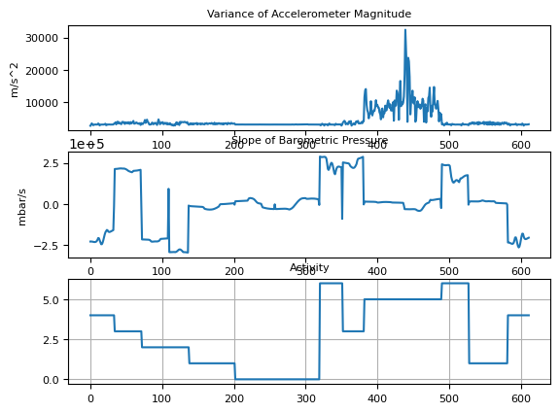

TO DO 4: Person-Dependent Classification Results
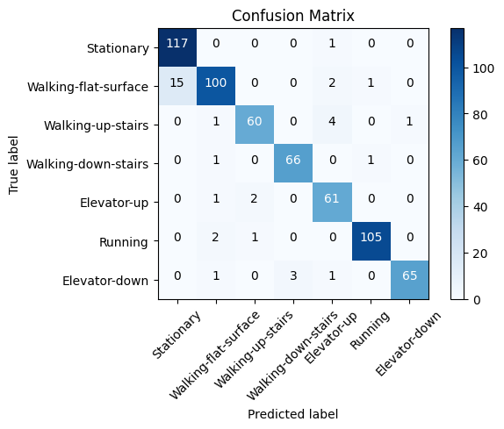

TO DO 5: Person-Independent Classification and Comparison
The person-independent model was trained on data from eight other subjects and tested on the target subject's data. Figure Y shows the resulting confusion matrix. This model achieves an overall accuracy of 93.8 percent, with 594 correct classifications out of 633 total samples.
For Stationary activity, precision is 88.6 percent while recall remains high at 99.2 percent, with 117 out of 118 instances correctly identified. The single false negative is misclassified as Elevator-up. However, the model produces 15 false positives from Walking-flat-surface, reducing precision compared to the person-dependent model. This suggests that other subjects' stationary patterns differ slightly, and the classifier learns to associate certain low-variance patterns with Stationary that actually correspond to slow walking in the target subject.
Walking-flat-surface achieves precision of 94.3 percent but recall drops to 84.7 percent, with 100 correct classifications out of 118 true instances. Fifteen samples are misclassified as Stationary, two as Elevator-up, and one as Running. This substantial increase in false negatives to Stationary indicates significant individual variation in gait patterns across subjects. What constitutes normal walking for the target subject may resemble the stationary behavior of other subjects, particularly if they hold phones differently or walk at different speeds.
Walking-up-stairs shows precision of 95.2 percent and recall of 90.9 percent, with 60 correct classifications out of 66 instances. One sample is misclassified as Walking-flat-surface, four as Elevator-up, and one as Elevator-down. The confusion with Elevator-up increases compared to the person-dependent model, suggesting that the pressure slope signatures of stair climbing vary more across individuals than elevator movement.
Walking-down-stairs maintains strong performance with precision of 95.7 percent and recall of 97.1 percent, with 66 correct classifications out of 68 instances. Only one sample is misclassified as Walking-flat-surface and one as Elevator-down. This robustness indicates that downward stair movement has more consistent kinematic patterns across subjects.
Elevator-up demonstrates precision of 88.4 percent and recall of 95.3 percent, with 61 correct classifications out of 64 instances. One sample is misclassified as Walking-flat-surface, two as Walking-up-stairs, and none as other activities. The slight decrease in precision reflects individual differences in elevator speed and building pressure characteristics.
Running maintains excellent performance with precision of 98.1 percent and recall of 97.2 percent, with 105 correct classifications out of 108 instances. Two samples are misclassified as Walking-flat-surface and one as Walking-up-stairs. The minimal degradation confirms that running biomechanics are highly consistent across individuals.
Elevator-down achieves the highest precision among all activities at 98.5 percent, with recall of 92.9 percent and 65 correct classifications out of 70 instances. One sample is misclassified as Walking-flat-surface, three as Walking-down-stairs, and one as Elevator-up. The strong performance suggests that elevator descent produces reliable pressure signatures regardless of individual differences.
Comparing the two models, the person-dependent approach outperforms the person-independent approach by 1.6 percentage points in overall accuracy (95.4 percent versus 93.8 percent). The macro-averaged precision decreases from 95.0 percent to 94.1 percent, and macro-averaged recall decreases from 95.3 percent to 93.9 percent. The most significant degradation occurs for Walking-flat-surface, where recall drops by 5.1 percentage points, primarily due to increased confusion with Stationary. This finding highlights that gait patterns are subject-specific, and models trained on one individual may not generalize perfectly to others without adaptation. Stationary and Running remain the most robust activities across both modeling approaches, while activities involving subtle transitions between movement types, particularly Walking-flat-surface and Elevator-up, show greater sensitivity to inter-subject variability.

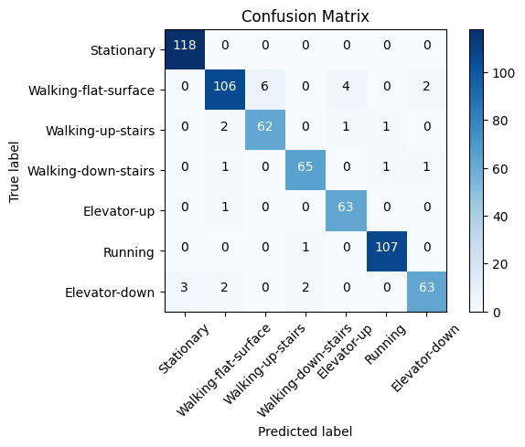

TO DO 6: Important Feature Analysis
The feature extraction process computes 14 distinct features from the raw sensor signals. These include the mean and variance of accelerometer magnitude, the slope of barometric pressure, and signal energy distributed across four frequency bands: 0 to 2.5 Hz, 2.5 to 5 Hz, 5 to 7.5 Hz, and 7.5 to 10 Hz. Additional features encompass higher-order statistical moments and spectral characteristics.
Feature selection using the Select Best method with the chi-squared statistic identifies the most discriminative subset. The analysis reveals that the top features are: the variance of accelerometer magnitude, the slope of barometric pressure, and the energy in the 0 to 2.5 Hz frequency band. These features receive selection flags indicating their importance, while features such as mean accelerometer magnitude and high-frequency energy above 7.5 Hz contribute less to classification performance.
The selection of variance as a top feature aligns with physical intuition. Motion intensity fundamentally distinguishes activity categories: running involves high-impact limb movements generating substantial acceleration variance, walking produces moderate rhythmic variance, and stationary or elevator behaviors exhibit minimal variance. This feature alone provides strong separation between the high-intensity activity (Running) and all other activities.
Barometric pressure slope emerges as critical due to its direct relationship with vertical displacement. Unlike accelerometer-based features that primarily capture motion intensity in the horizontal plane, pressure slope specifically encodes altitude change direction and rate. This enables discrimination between activities that may have similar variance profiles but differ in vertical movement, such as Walking-flat-surface versus Walking-up-stairs, or Elevator-up versus Elevator-down.
The low-frequency energy band (0 to 2.5 Hz) captures the periodic nature of human locomotion. Walking typically exhibits a dominant frequency around 1.5 to 2 Hz corresponding to step rate, while running shifts this energy to slightly higher frequencies within the same band. Stationary behavior lacks such periodic structure, showing only broadband noise. This spectral feature complements time-domain variance by distinguishing rhythmic activities from arrhythmic ones, and differentiating gait types based on their characteristic frequencies.
The importance of these features is physically meaningful and consistent with biomechanical principles. The combination of intensity (variance), vertical displacement (pressure slope), and periodicity (low-frequency energy) provides orthogonal information channels that together enable robust activity discrimination. Features such as high-frequency energy above 7.5 Hz prove less important because human body movement during daily activities rarely generates sustained energy at these frequencies, making them primarily noise-dominated.
Figure Z illustrates the top features plotted against activity labels. The variance plot shows clear clustering: Running forms a distinct group at high variance values above 10,000, while Stationary and Elevator activities cluster near zero. Walking activities occupy intermediate regions with some overlap. The pressure slope plot reveals bipolar structuring: Elevator-down and Walking-down-stairs show positive slopes, Elevator-up and Walking-up-stairs show negative slopes, and flat activities center around zero. The low-frequency energy plot demonstrates elevated values for Walking and Running compared to Stationary and Elevator activities, with Running showing slightly higher energy than Walking.
During data collection, environmental factors influenced these features. The building elevator's consistent speed produced uniform pressure slopes, while stair climbing showed more variable slopes due to individual step pacing. Phone placement in the trouser pocket captured leg-dominant motion, enhancing the variance signal for walking and running but potentially attenuating upper body movements. These contextual factors explain why certain features emerge as more reliable than others for cross-subject generalization.

TO DO 7: Novel Feature Experimentation

To sum up, The person-dependent model achieves 95.4 percent accuracy using basic statistical and spectral features, while the person-independent model maintains strong performance at 93.8 percent despite individual gait variations. Feature selection confirms that motion intensity, vertical displacement, and gait periodicity are the most discriminative information sources.

