
China Restaurant
Kimberley

Owners: Wen-Ching Ho and Hsieh Huei-Mei

Website User Documention
Written by: Liang-Shih Lin

Table of Contents
Introduction 3
Navigation 3
Homepage 3
Left Side 4
Main Contents 4
Right Side 4
Gallery 5
Reviews 5
Contact Us 6
Photographer 6

Introduction
In Kimberley there is a Chinese Restaurant which opened in 1994, this was after Wen-Ching (The Restaurant owner) closed down a gadget store and opened a China Restaurant. China Restaurant was the only Asian restaurant in Kimberley until 2014 when more Asians moved to Kimberley and opened up more restaurants. The restaurant only sells traditional Asian food, with recipes that are taken from Taiwan. The restaurant is run by a couple named, Wen-Ching Ho, and Huei-Mei Hsieh. Wen-Ching is in charge of the customers, he waiters, in charge of the cashier, answers the phone and stocks up the restaurant whenever it needs something. Huei-Mei is in charge of the kitchen and the kitchen staff, whenever there is a new kitchen staff she needs to train them and she is also a replacement for Wen-Ching if he is out on an errand. There have been many customers from all over the world who have tried the food at this restaurant, and many of them really enjoy it. If you ever come by Kimberley, please come have a look.
This user documentation will help you navigate around the website with ease, if you need further assistance you may contact us in the contact us page.

Setting Up
The first thing you will need to do is setup the database. The database is included with the entire package, it is stored in the folder “_resources/db_setup”. Run the php file inside that folder from a web server such as Apache2 and have your MySQL server started. Make sure that your MySQL credentials matches the first few lines in the file. There is an alternative way to setup the database, I have included a SQL file in the “_resources” directory, run the SQL file and it should setup your database, before doing this, you should also make sure that your MySQL server is running.
To setup the website, just copy the contents of the “public” folder into the correct directory, or you can create an alias from your web server to point to the public folder.

Navigation

Homepage
Our homepage is split up into 3 seconds: Left side, main content, and right side.
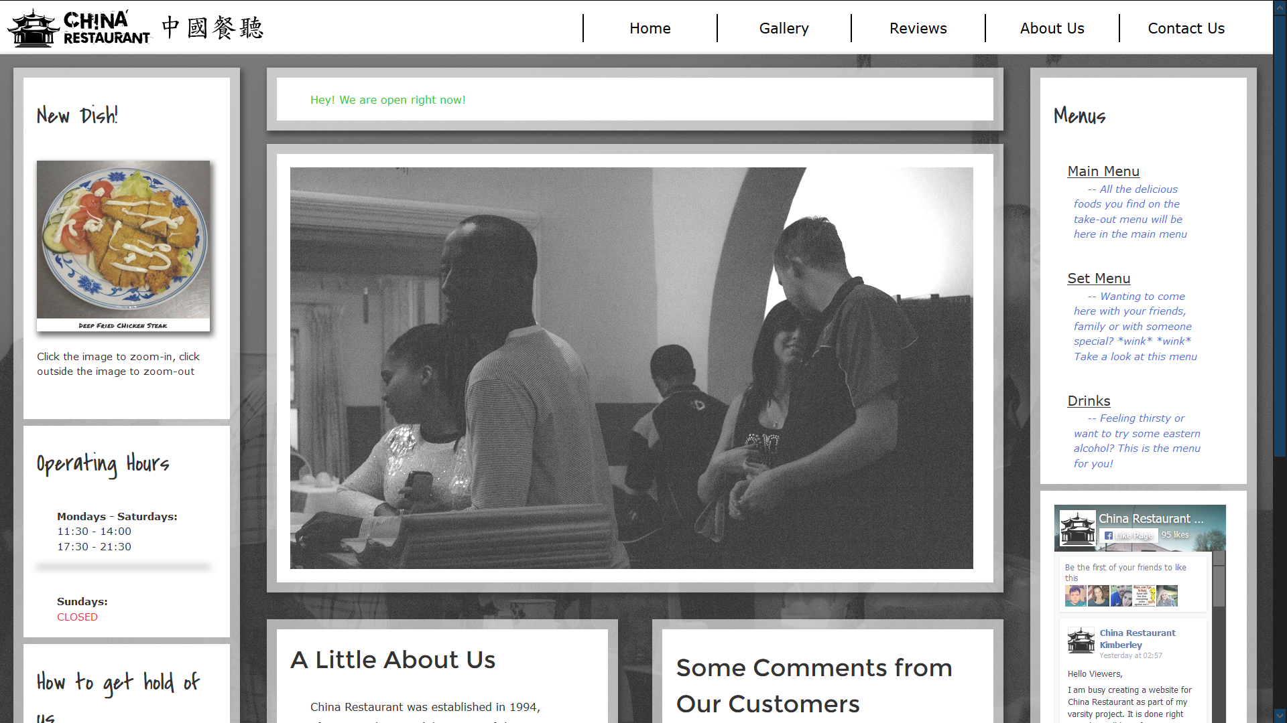

Left Side
The left side shows what is the new dish that is in our menu. Below that you will have 3 types of menus, we will constantly update these menus with new prices whenever they are available:
- The first menu is the main menu, all of the items in this menu can also be found in our take-away menu.
- The second menu is our set menus, if you want meals that comes in a set price, then this is the place to look.
- The third menu is drink menu, it has both alcoholic and non-alcoholic drinks. If you want to try out Chinese Liquor, we got it!

Main Contents
On top there will be a status message showing whether the restaurant is open or not.
The next part is a carousel displaying pictures of the restaurant, these pictures are taken by a photographer located in Kimberley called Kharla Rose Photography.
The last part is split up into two sections, the left side is an extract from our “About Us” page. The right side is the comments that customers have given us which aren’t on the website. It can be from our Facebook page or our email.

Right Side
The first section shows our operating hours.
The second section shows our contact details for bookings or ordering, but you will need to fetch the food yourself. If you want the meal delivered to you, you can call Mr Delivery. The location of the restaurant is also placed on Google maps, as displayed on the website.
The last section is a section of our timeline, you can like our page through here and view through the posts.

Gallery
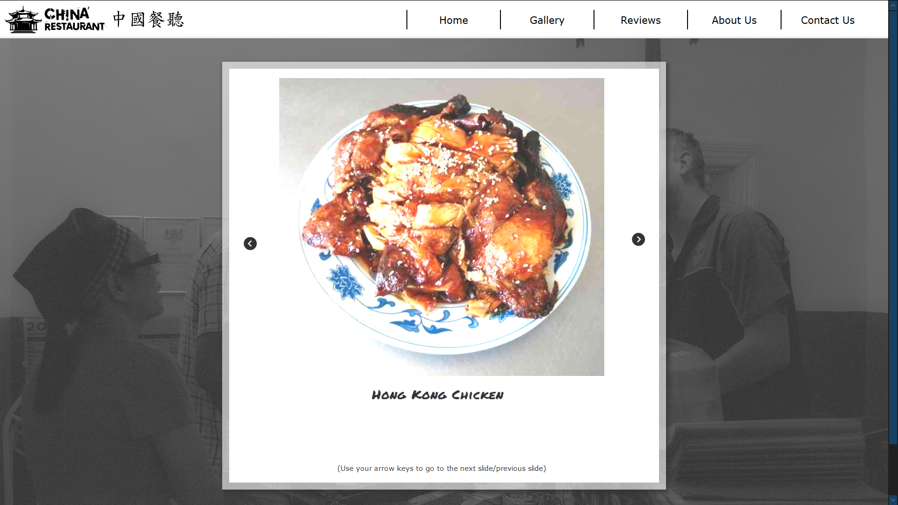
The carousel will automatically rotate through the pictures here. Not all of the food are displayed here, but the most popular dishes are here. If you want to navigate the pictures

Reviews
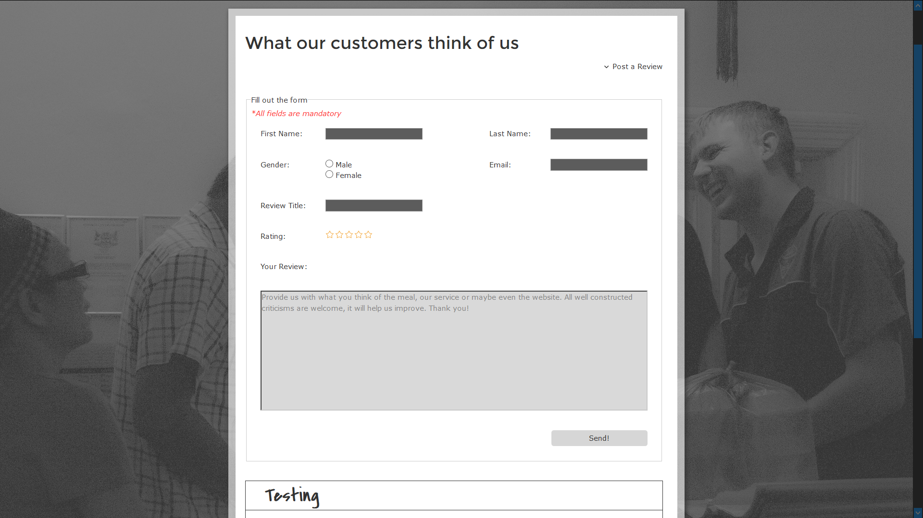
If you want to place a review, you can press the “Post a Review” button and the form for you to enter the review will show up. All fields are mandatory.

Contact Us
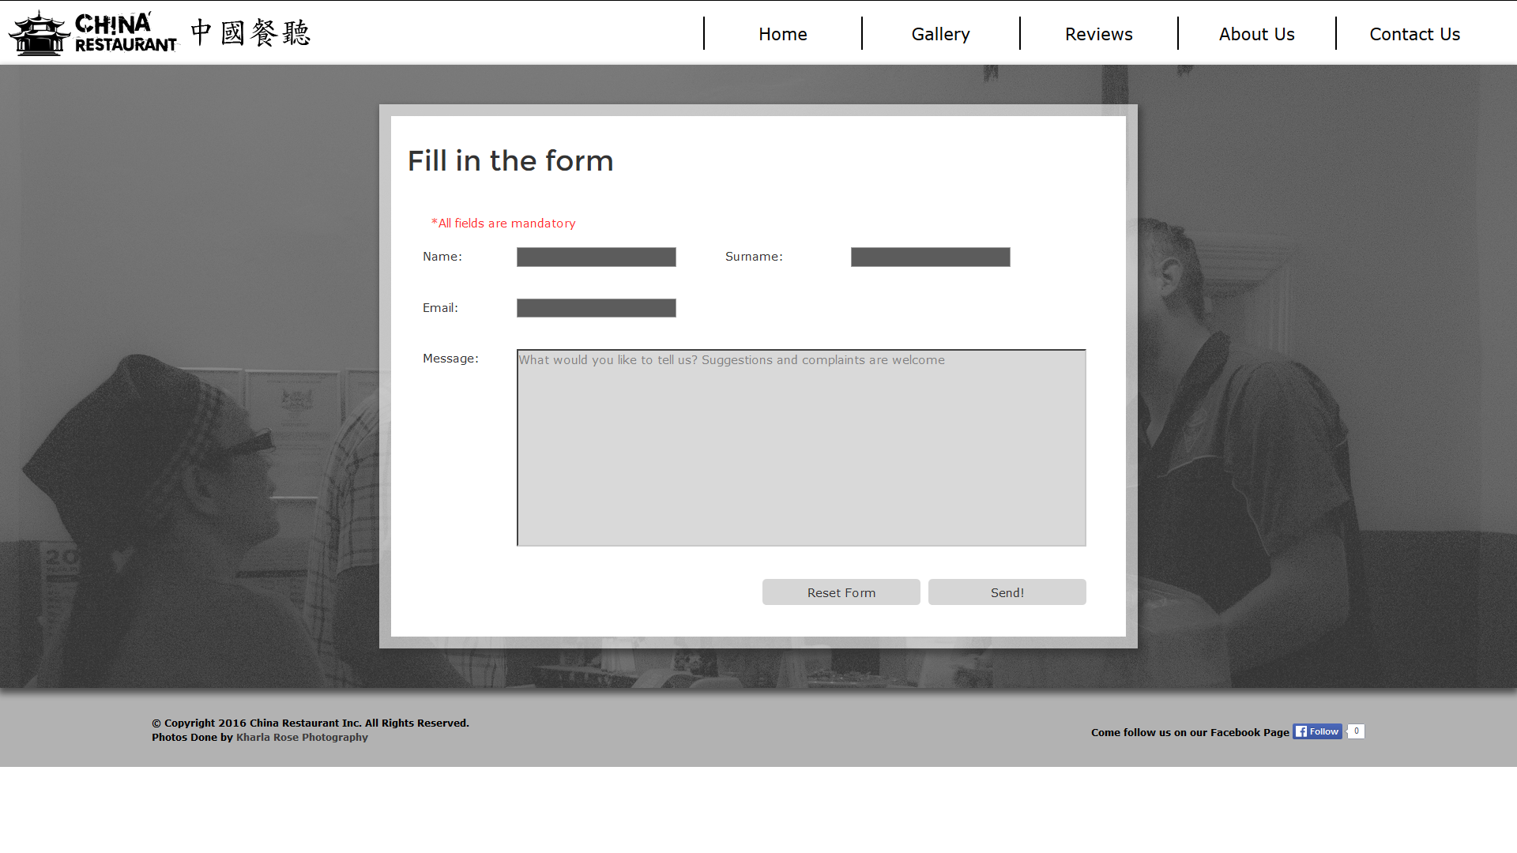
This page is for customers or viewers to inform the restaurant owner directly, if you got any questions, this is the place to send them.

Photographer
If you want to contact the photographer, the link to her Facebook Page is in the footer of every including the LinkedIn profile of the designer and developer of the website.

For Other Developers
I have created a github repo (https://github.com/ll931217/china_restaurant) that includes all of the required code. If you want to play around with the code, you may clone a copy to your machine. If you want to improve on the coding, you make create a fork and if it is good enough, I will pull the request.

