

**e-Yantra Robotics Competition - 2016**

**Theme and Implementation Analysis – Cross a Crater**

**<3035>**

|  |  |
| --- | --- |
| **Team leader name** | SPARSH DUTTA |
| **College** | THE LNM INSTITUTE OF INFORMATION TECHNOLOGY |
| **Email** | [15uec063@lnmiit.ac.in](mailto:15uec063@lnmiit.ac.in) |
| **Date** | 4th Feb, 2017 |

**Scope and Preparing the Arena**

**Q1 a. State the scope of the theme assigned to you. (3)**

**ANS:**

As we know that we are progressing in space exploration very rapidly, recently we became the first country to complete a Mars orbiter mission at first attempt.

So it is possible that we may send some rovers on other planets and on our moon for that we need these kinds of advanced robots and projects on basic level so that we can develop this understanding in early stages.

These kind of robots can also prove vital for manned missions on space and moon with more Artificial Intelligence and more level of Image processing. We can contribute to our nation for these Advanced level Space exploration missions.

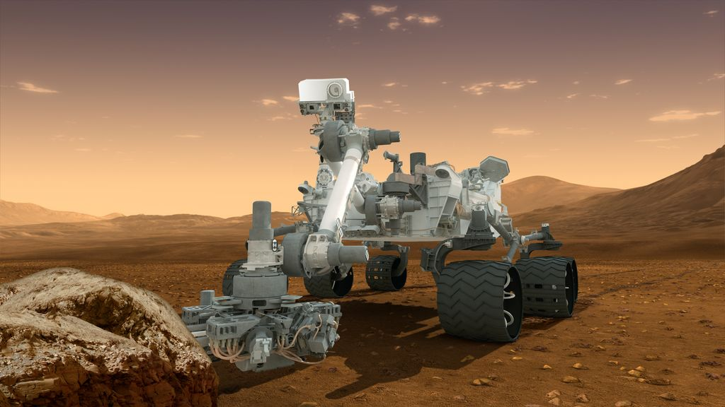

b.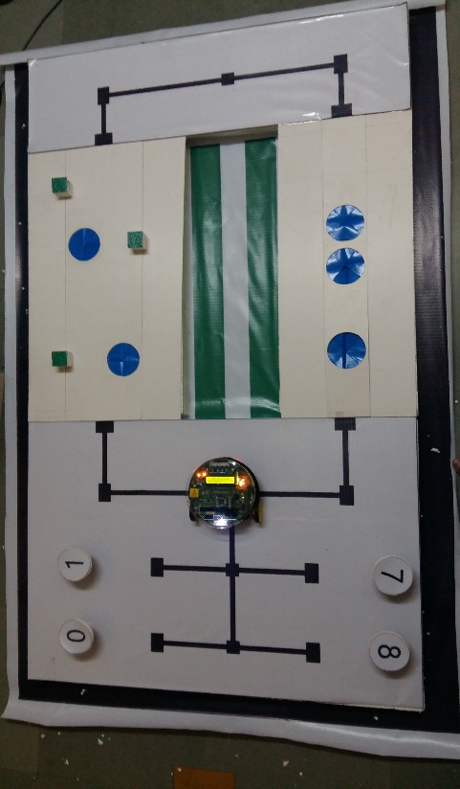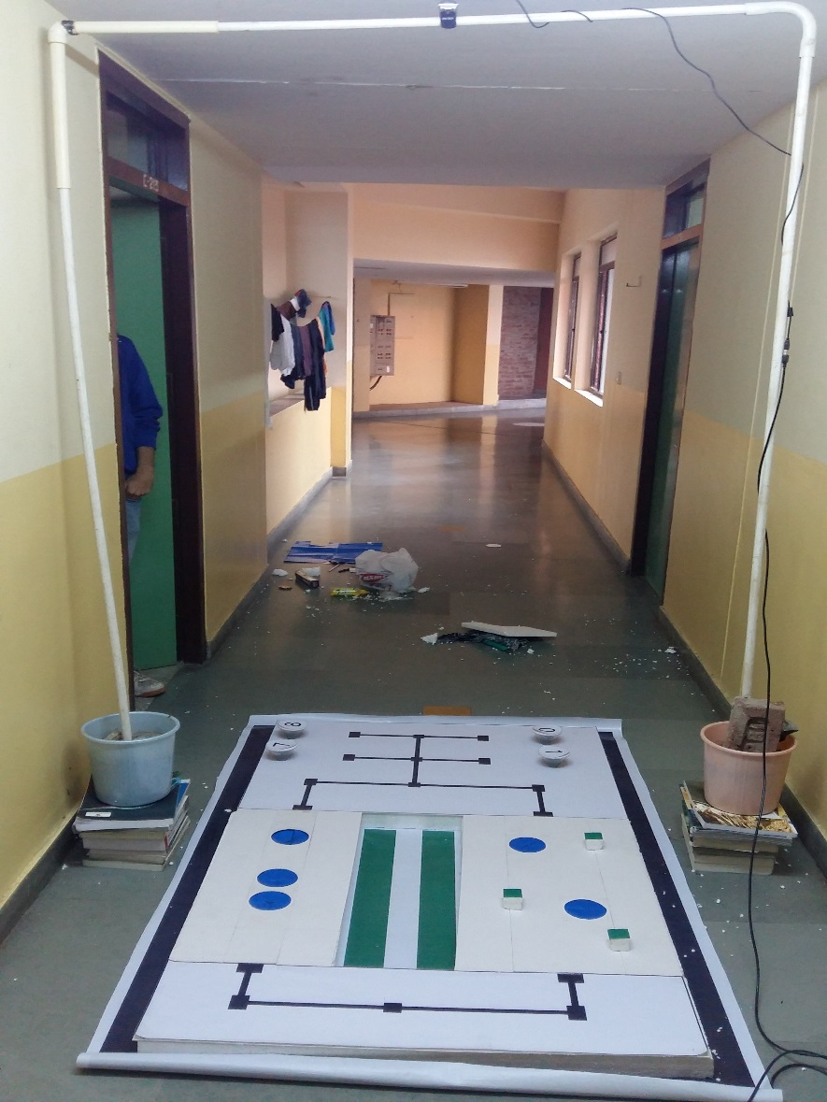 **Attach the Final Arena Images. (20)**

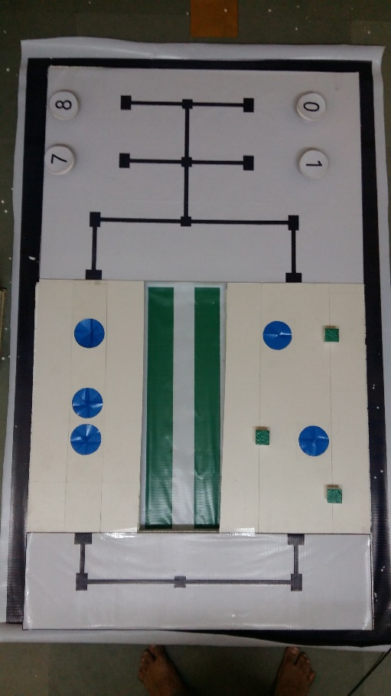

IMAGE CAPTURED FROM MOUNTED CAMERA (SATELLITE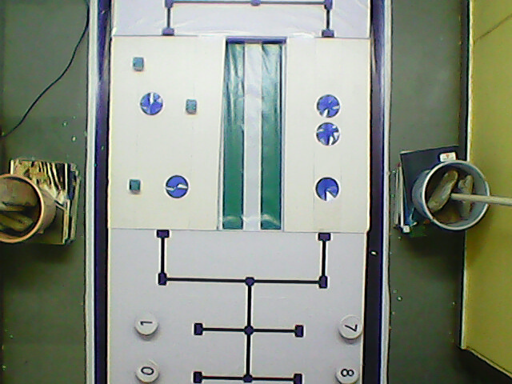)

**Building Modules**

**Q2. Identify the major components required for designing the robotic system for the solution of the theme assigned to you. (5)**

**ANS:**

* **ELECTRONIC SYSTEM:**
  1. Sensors : Sharp IR Range Sensor, White Line Sensor
  2. Overhead Camera
  3. Signal Processing Unit: (ADC etc)
  4. Central Processing Unit in the Robot
  5. Power Supply
  6. XBEE S2C-Communication Module
  7. LCD Display
* **ELECTRO-MECHANICAL SYSTEM**
  1. Actuators : DC motor, Servo Motor
* **MECHANICAL SYSTEM**
  1. Boulder Grapping mechanism

**Explanation about ELECTRONIC SYSTEM used:**

1. Sharp IR Range Sensor will be used to detect the nearby boulder and the obstacles, and White line Sensor are used to follow the black line trace on the flex for bot navigation.

2. Camera is used to track the position of cavities, boulder and obstacles in the arena.

3. XBEE S2C module is used to communicate between the robot and the computer in which image processing is being done.

4. LCD Display is used to display the number on the boulder.

**Explanation about ELECTO-MECHANICAL SYSTEM used:**

1. Actuators like DC motor and Servo Motor are used to control the motion of the bot and boulder grapping mechanism of the bot.

**Actuators**

**Q3. List all the actuators present on Firebird V robot. Besides the existing actuators, please mention any additional actuators that may be required for designing the theme. (5)**

**ANS:** For the Implementation of the given theme robot requires a various actuators:

* **ACTUATOR AVAILABLE ON THE BOT:**
  1. DC motors: required for primary motion of the robot along the arena.
* **EXTERNAL ACTUATORS:**
  1. Servo motors (0-180’rotation): required for controlling the boulder grapping mechanism on the bot.

**Power Management (2)**

**Q4. Explain the power management system required for a robot in general and for Firebird V robot in particular.**

**ANS:**

* Servo motors: the servo motor require 5-10 volts supply  and 500-1amp of current depending on its application
* Dc motors: They are powered by internal power supply, l293D IC is a motor driver IC which is used to provide a maximum of 600 mA of continuous and 1A of starting current to the two motors.
* Sensors: On board sensors are supplied by the internal power supply which require a supply of 5volts and current rating of 100-500 mA and white line sensor uses 3.3 Volts and rating 100 mA.
* We will use battery powered mode in most of the application of the robot as it is much easy and handy to use in battery powered mode and at the time of the competition we will be using battery powered supply mode.

**Design Analysis**

**Q5.** **Teams have to design a mechanism for picking and dropping the Boulders into the Cavities.**

1. **Choose an** **option to position the mechanism on the robot and why? (4)**
2. **Front 2. Back 3. Right/Left**

**Answer: Front**

* Our team has made the decision of placing the boulder picking and dropping mechanism in front of the robot, as there is a sharp ir sensor in front of the robot which will give us a precise control over the distance of the bot and boulder so that robot does not hit the boulder and make the boulder fall.
* Placing the mechanism at front of the robot will make the grapping mechanism easy to handle as robot will not have to change its orientation as in the case of back or right/left placement of mechanism.
* So placing the mechanism in front of the robot is a wise choice.

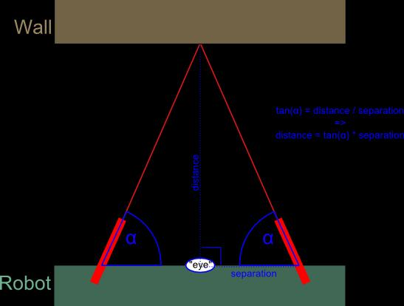

**SHARP IR SENSOR**

1. **Explain the design of the mechanism and how it is mounted on the robot. (4)**

**ANS:**

* We may be using wood/steel frame for design of the arm of the boulder grapping mechanism.
* Here we are using 3 Servo Motor for the control of the bot arm giving it movement in the x and y direction both and giving control over grapping arm for grapping the boulders.
* The arm design is the best we could think of for better stability and less power consumption.
* The design of the arm is not bulky, easy and manageable and could proficiently pick and drop all the necessary boulders in the cavities.
* Our arm design has differential gear mechanism which will give us better grip by providing more torque while picking up the boulder from the arena and placing in it perfect cavity.

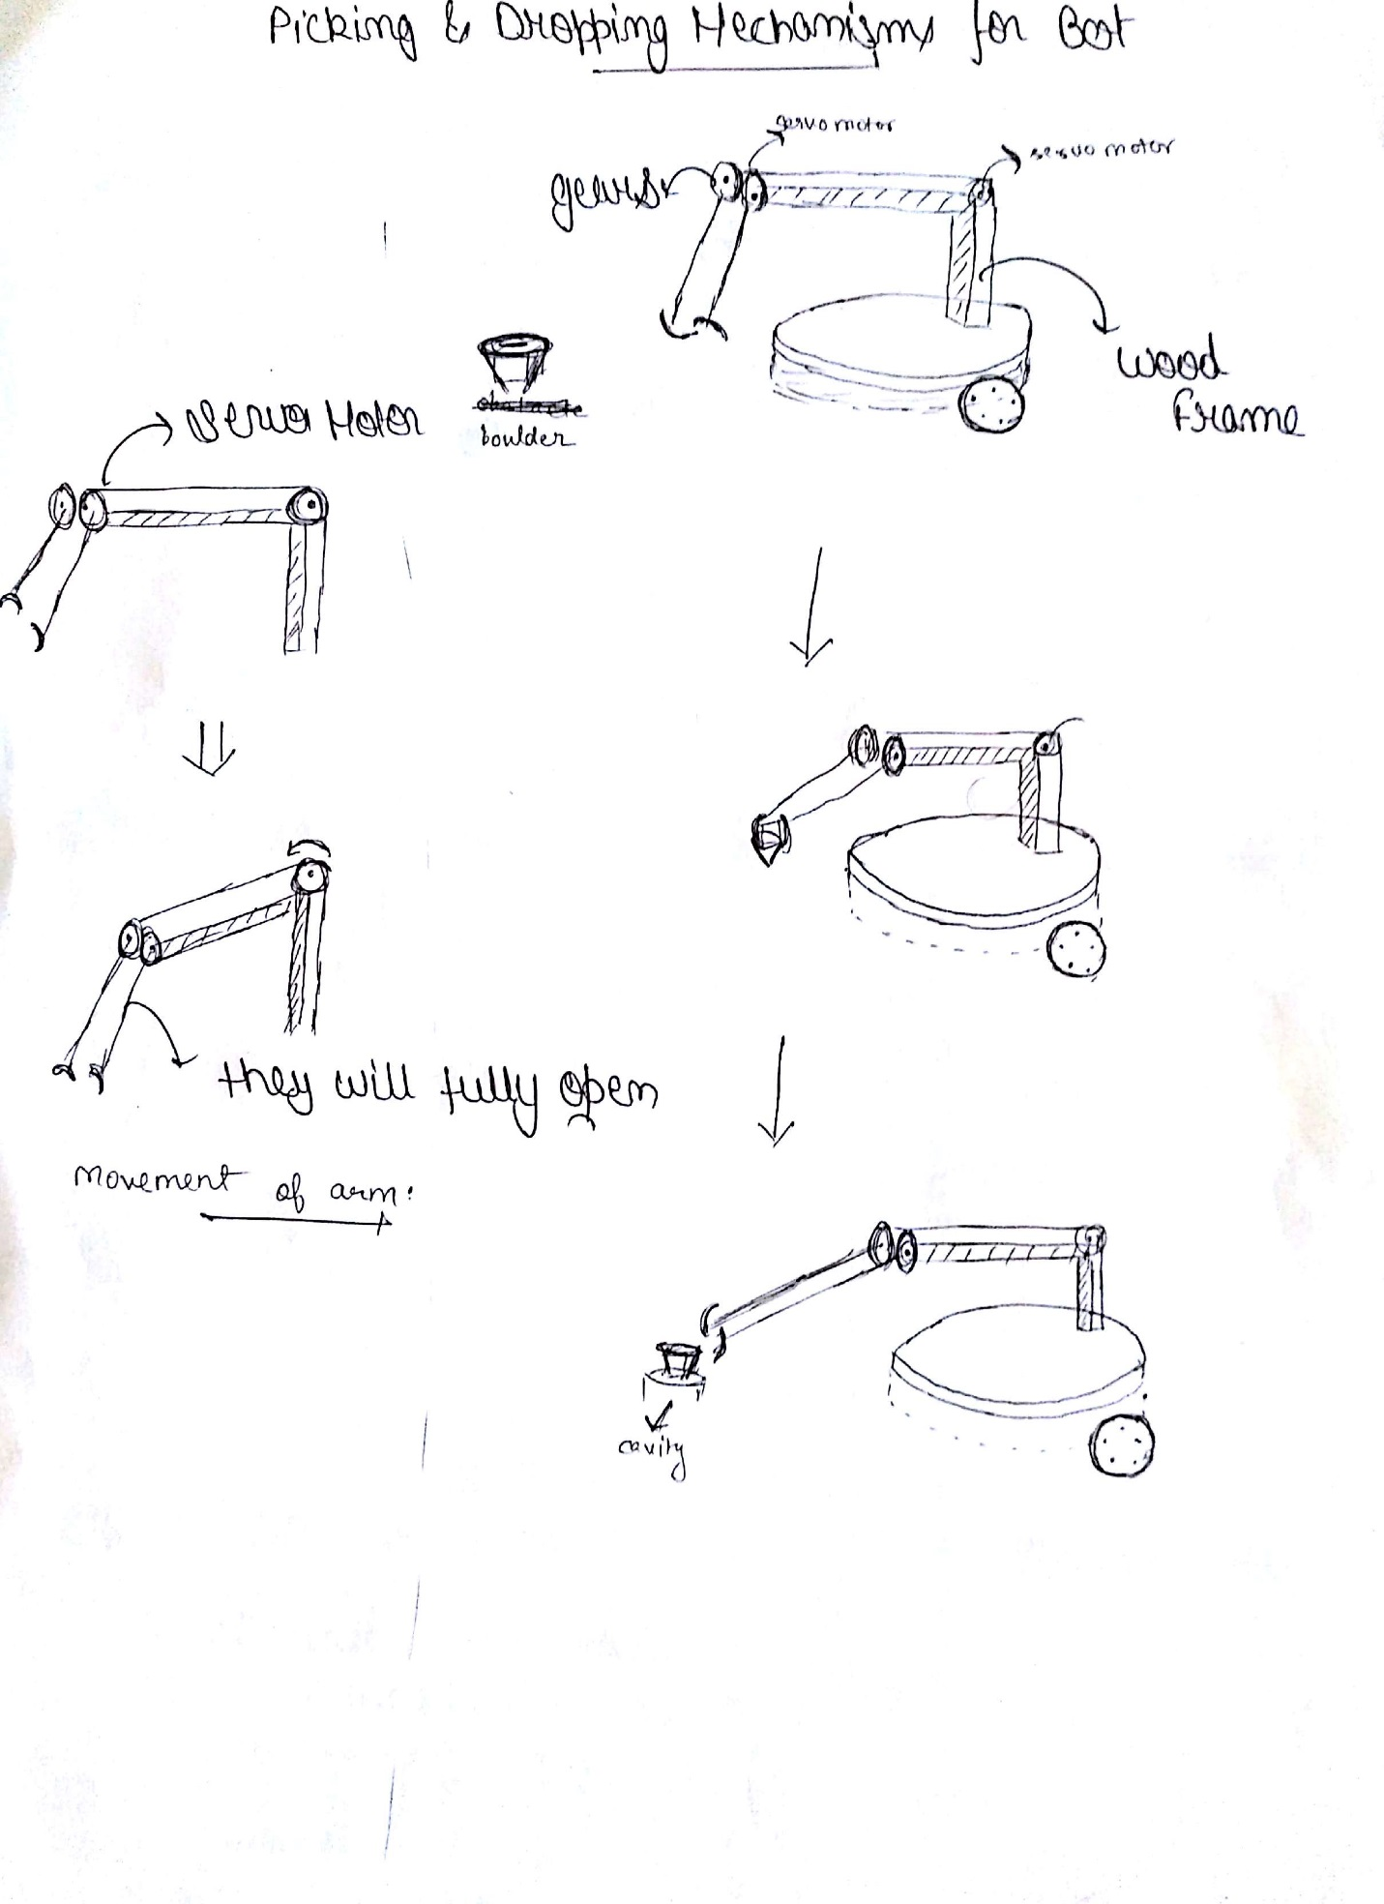

1. **To design the mechanism for picking and dropping the Boulders, what challenge/s do you expect to face and how you will overcome them? (2)**

**ANS:**

* **Challenge 1:** The basic challenge that we will face that if we try to pick up a boulder with a grip and if it fall down then we have to pick it again.

**Solution:**

For tackling this problem we will use Template matching, we will initially put template into the laptop and if that template mismatch then we will again try to pick up the boulder.

* **Challenge 2:** Another major challenge is that if, while picking the boulder if the boulder fell down.

**Solution:**

We will detect it by image processing, and then we will apply pressure on it so that it can again stand in right position and we can pick it again

**Q6. Choose the actuator/s you will use to design the mechanism. (2)**

1. **DC-Motor 2. Servo Motor 3. Stepper Motor 4. Others**

**Answer: Servo Motor**

* **ADVANTAGE OF CHOOSING SERVO MOTOR OVER OTHERs:**

1. Our choice for choosing servo motor over others is based on the tradeoff between power consumption, weight and precise control ability of the motor.
2. **DC Motor** can be used in the task but the power consumption is too high, and the motor is too heavy as we are having power constraints so therefore we cannot use DC MOTOR.
3. **Stepper Motor** give very precise control in the movement of the mechanism but it is also too heavy and too costly and power consuming so therefore cannot be used in the mechanism.

* Therefore **Servo Motor** is the best option in term of price, power consumption, control ability and weight so we are going to use servo motor in designing the mechanism, and it is very easy to code the movement of servo motor also.

**Environment Sensing**

**Q7. Explain how you will use the USB camera to decide the course of action. (5)**

**ANS:**

* First of all the overhead camera is mounted over the frame, approximately 8ft above the ground in order to get a clear image of the arena.
* The camera give the live feed of the arena and this live feed is used and various image processing algorithms are applied to it.
* Through the live feed we will get the exact position of boulders, obstacles and cavities and thus our code will dynamically update according to the data.
* Now according to the sum given to us by our mentors, the image processing will work on and the code will choose the best bridge to move on.
* When filling in the cavities the camera plays a major role as to where the dropping mechanism should place the boulder so that it goes in the right cavity.
* And by analysing the image we will get to know that everything is right in place.
* We will be using tree pruning algorithm to estimate the path based on the sum and the boulder number.
* Number on the boulder are detected using template matching using the image processing of the image captured by the camera.
* And Cavities and obstacles are coloured blue and green so that camera captures them from above and the necessary image processing is done using their color.

**Q8. Name the sensors (if any) on Firebird V used to complete the task. If used, describe the placement of these sensors on the robot and briefly explain the reason for their placement. If not, justify not using these sensors. (2)**

**ANS:**

* We are using **SHARP IR SENSOR** on Firebird V to complete the task.
* The placement of the sensor is based on the working of the sensor as the Sharp infrared ranger is able to continuously measure the distance of an object. The usable range is 10 cm to 80 cm. The device generates an analog voltage that is a function of range, and the output voltage can be measured by an analog-to-digital (ADC) input line on Firebird V.
* We are placing the sensor in front of the robot as it is used to measure the distance of the robot and the boulder so the robot does not hit the boulder and make it fall apart, the reading from sharp sensor give the robot the command to stop and execute the picking mechanism of the boulder.
* Similarly we are using **Proximity sensor,** to avoid collision with the obstacle on the bridge 1 if chosen.

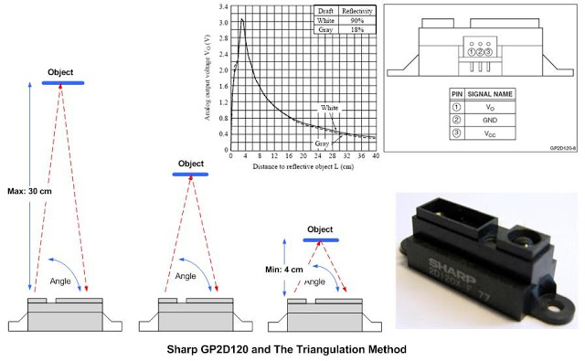

**Communication**

**Q9. Describe the method of communication between the computer and the Firebird V robot. Please draw a block diagram illustrating the same. (3)**

**ANS:**

* The method of communication between computer and Firebird V robot is using XBEE S2C module.
* 1st XBEE is connected to laptop using XBEE USB adapter and the 2nd XBEE is mounted in the Firebird V robot itself.
* Laptop is processing the image from overhead camera and communicating the necessary instructions to the Firebird V bot.
* Firebird V is processing the necessary instructions the laptop via XBEE module and doing the necessary jobs as instructed in the code.

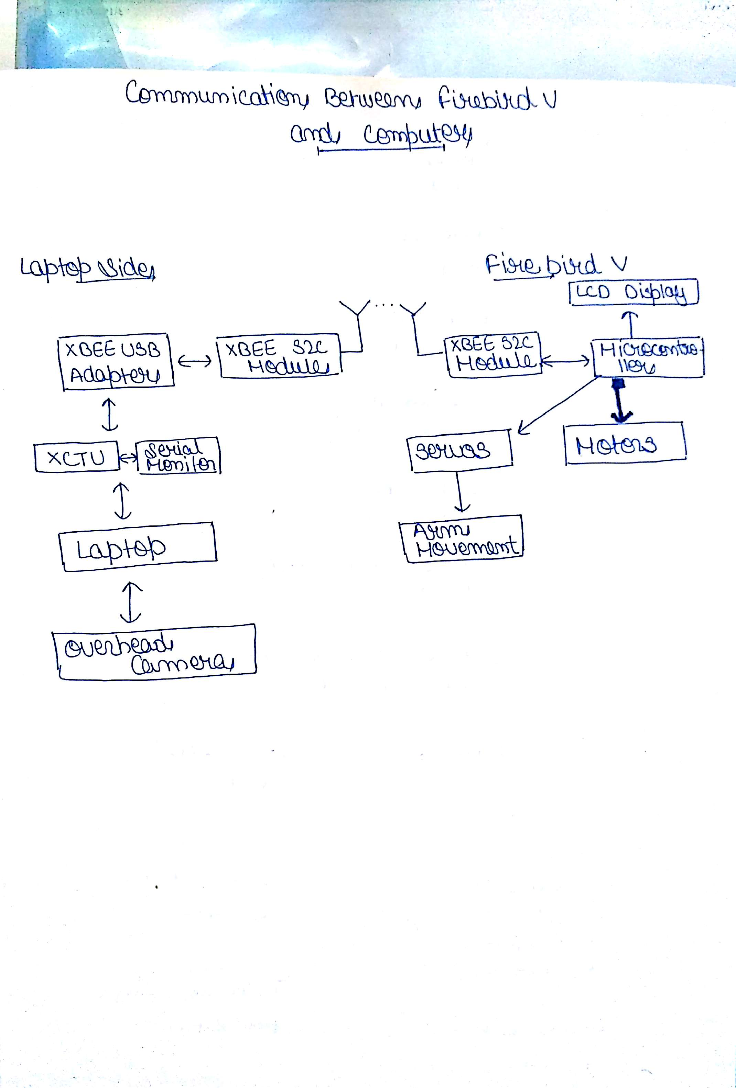

**Testing your knowledge (theme analysis and rulebook-related)**

**Q10. How will you analyse the Sum given during execution of the code? (4)**

**ANS:**

* We will analyse the sum given to us with the help of image processing by:
  1. Firstly, we will analyse all the numbers on the boulder with the help of template matching, a technique in image processing and store all the numbers on the boulders in an array.
  2. Secondly, we will calculate the sum of all the boulders numbers stored in the array and then compare the sum of all the number with the sum given to us.
  3. Thirdly, we will compare that the sum of all number is higher or equal to the sum given to us then will we follows up step 4.
  4. Now we will try to generate the sum given to us with the combinations of two numbers in the array if this is possible then we will definitely choose BRIDGE 1 and it is the most scoring one, if we fail in this step then we will follow step 5.
  5. Now we will try to generate the sum given to us with the combination of three numbers in the array and choose BRIDGE 2 because we don’t have other choice.
  6. Now when all these things are done we will traverse the chosen BRIDGE and execute our pick and drop mechanism of boulders.

**Q11. Illustrate the risks and the rewards associated with each bridge. If a Sum satisfies both bridges, how your code will decide which bridge to use? Explain the factors influencing the bridge choosing decision in this scenario. (4)**

**ANS:**

* Formula for calculating the score = Total Score = (600 – T) + (BP*100) + (BD*100) + BC1 + BC2+ (CBD*100) – (AP*60) - (P*60) + OB
* Risk with bridge 1: Major risks associated with bridge 1 are the obstacles and presence of lesser no. of cavities on it.
* Rewards: But this bridge is scoring one as we have greater chances of scoring.
* Risk with bridge 2: Risk with bridge 2 is that it has less scoring chances and also it has more cavities so that robot can move to and fro.
* Rewards: It is easy to complete as it has no obstacles.
* We will choose path dependent on the sum. If sum satisfies both the bridges, then I will choose bridge 1 as it has more chances.

**Q12. How will you detect the Cavities and Obstacles on the arena? (10)**

**ANS:**

Algorithm to detect the Cavities and Obstacles on the arena are as follows:

**STEP-1:** We will use our overhead Camera (Satellite) to take up a live feed of the arena.

**STEP-2:** We will take up the feed from camera and then take the image of the arena.

**STEP-3:** Now using this image we will first find the number on the boulder by template matching and contour detection technique to correctly match the template.

**STEP-4:** Now we have designed our cavities to be blue, here we will apply concept of thresholding and colour detection, technique in image processing to set the region with high blue colour pixel to 1 and others region to 0, to segregate other region and store that thresholded image as image1.

**STEP-5:** Now we have designed our obstacles to be green, here we will apply concept of thresholding and colour detection, technique in image processing to set the region with high green colour pixel to 1 and others region to 0, to segregate other region and store that thresholded image as image2.

**STEP-6:** Combine image1 with image2 to get the position of cavities and obstacle so that bot doesn’t fall into cavities or hit the obstacle.

**Q13. Explain in brief the navigation algorithm you will use for various regions of the arena. (10)**

**ANS:** The navigation algorithm used for the motion of the bot in various region of the arena is as follows:

1. The Bot is powered on and the white line sensor get activated and read the sensor values and then the overhead camera processes the arena and read the numbers on the boulder.
2. Now we have done all the processing of the arena and we know the exact position of the boulders, cavities and obstacle and we also know which bridge to choose.
3. Now according to the image processing the boulder is picked up, now for picking that boulder the robot first move a few step until all the sensor are on black line.
4. Now according to the image of the arena our bot dynamically update and traverse in the direction in which boulder which is to be picked up is located.
5. Then our bot make 180 degrees turn in the appropriate direction as specified by the image of the arena and then traverse to the chosen bridge during that time the bot has picked the boulder and it traverse in the direction of chosen bridge making left or right turn according to the code.
6. Now according to the bridge chosen the bot moves straight and dump the boulder and then again move backward to pick another boulder and then traverse the same bridge, avoiding obstacle and cavities in the way.
7. At last robot while crossing the bridge BRIDGE1 or BRIDGE2 makes appropriate turn left or right according to the bridge chosen traverse till all the white line sensor reading is same and then it stops their and beep buzzers for 5 seconds.

**Algorithm Analysis**

**Q14. Draw a flowchart illustrating the algorithm you propose to use for theme implementation. (10)**

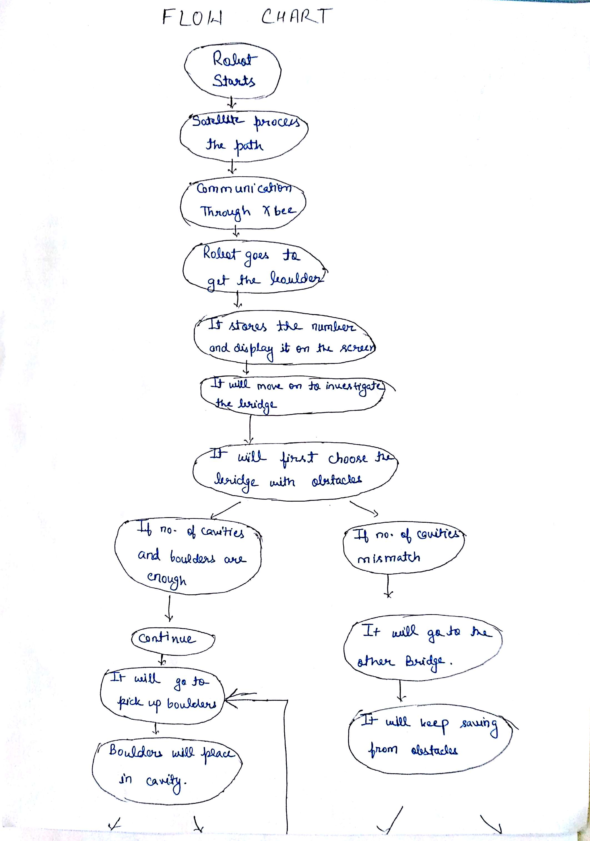

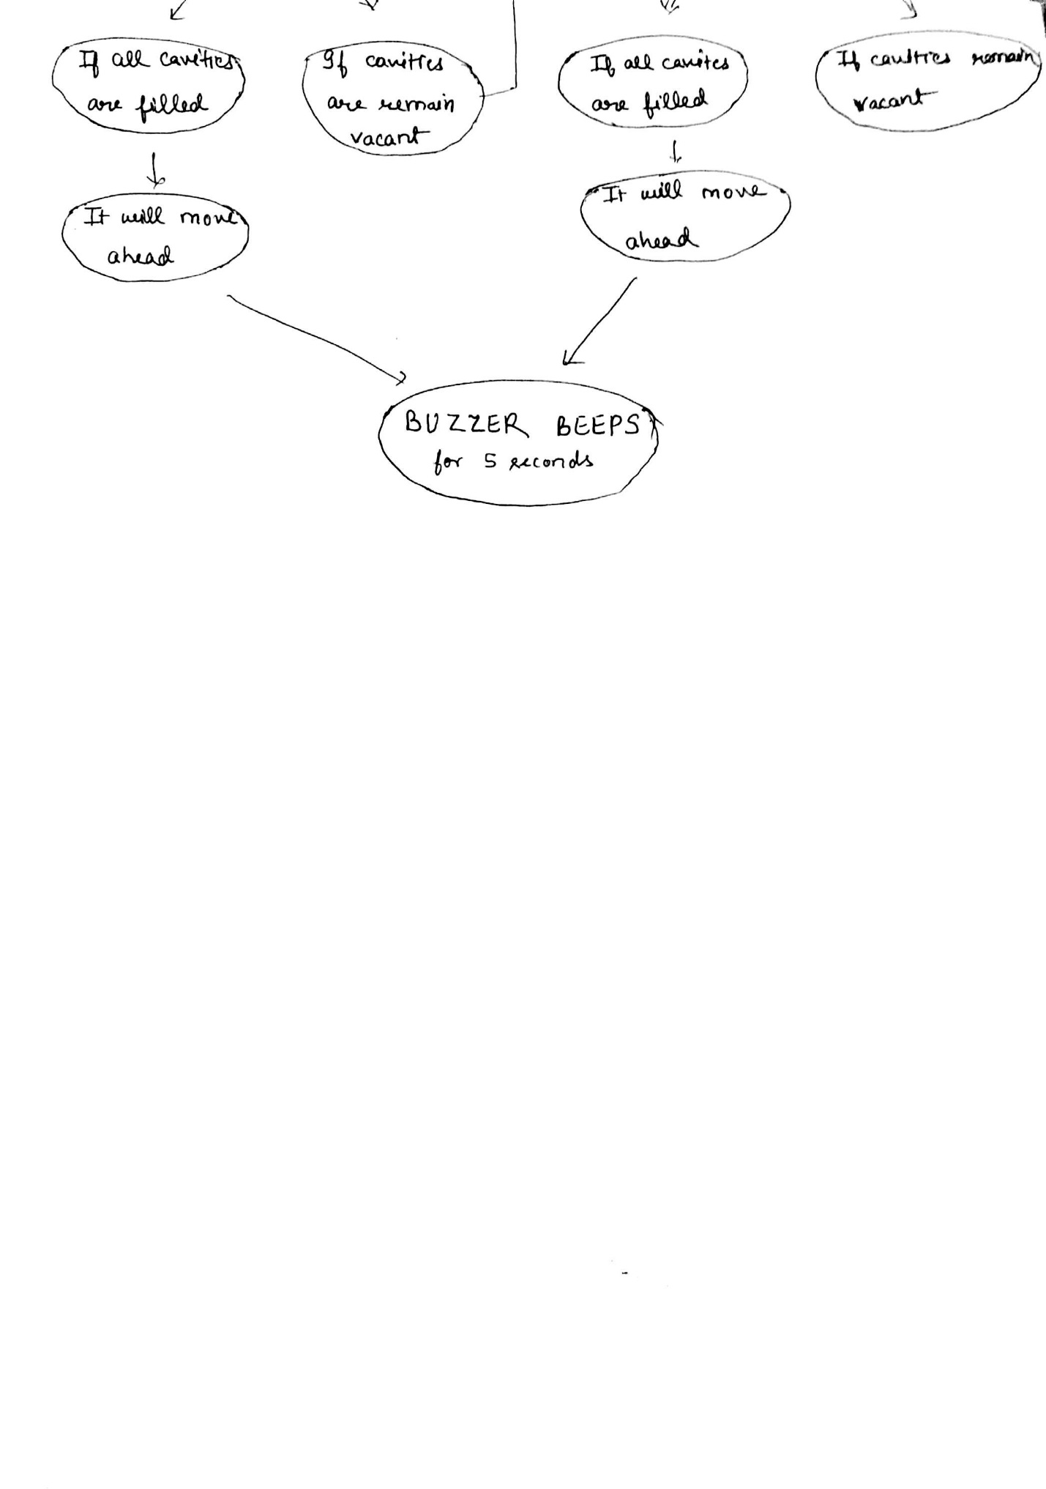

**Challenges**

**Q15. What are the major challenges that you can anticipate in addressing this theme and how do you propose to tackle them? (5)**

**ANS:**

* **Challenge 1:** The basic challenge that we will face that if we try to pick up a boulder with a grip and if it fall down then we have to pick it again. For tackling this problem we will use Template matching, we will initially put template into the laptop and if that template mismatch then we will again try to pick up the boulder.
* **Challenge 2:** Another major challenge is that if, while picking the boulder if the boulder fell down then we will detect it by image processing, and then we will apply pressure on it so that it can again stand in right position and we can pick it again.
* **Challenge 3:** Controlling the arm motion will also be the major challenge for us as there is very low possibility of error in that, because even a slight mistake can lead to a huge problem .In order to tackle that problem, we will take extra precautions in advance.