SecureGen AI Project Plan
Deep Learning and Cybersecurity Project

Members
AZIZI Yahia Nacer Brahim
GOUHMAZ Mohamed
HAMOUDI Ahmed Iyed

Problem Statement & Objectives
AI-assisted programming tools such as GitHub Copilot, CodeWhisperer, and Tabnine can improve coding speed, but they may also suggest insecure code patterns that developers accept without noticing the security risk. According to the SecurityEval benchmark used in this project, 84.6% of Copilot-generated outputs were insecure across 130 Python prompts covering 75 CWE types, and the weak cryptography category reached a 100% insecure rate. This shows that AI-generated code can create a real security problem, especially when code is reused quickly in practical development workflows.
SecureGen AI addresses the lack of immediate, context-aware vulnerability detection for AI-generated code. Instead of relying only on static analysis after development, the project aims to identify insecure code as soon as it is produced, classify the type of weakness, explain the risky tokens, and suggest a safer remediation path.
? Build a four-class project dataset view from SecurityEval using deterministic CWE mapping rules.
? Fine-tune CodeBERT for vulnerability classification with a target precision of at least 90 percent.
? Develop a FastAPI backend that returns label, confidence, and remediation guidance.
? Create a frontend dashboard for code submission, result viewing, and analysis history.
? Provide attention-based explainability so users can understand why code was flagged.

Main Features
Feature | Description | Priority
Vulnerability Detection | Detects sql_injection, hardcoded_secret, weak_crypto, and other_vuln. | P0
Attention Heatmap | Highlights influential tokens to explain model decisions. | P0
Remediation Suggestions | Maps predicted issues to secure coding fixes. | P0
REST API | Provides analysis, history, and health endpoints. | P0
Web Dashboard | Displays risk level, confidence, and prior analyses. | P1
Dataset Explorer | Supports inspection of labeled benchmark examples. | P1
Multi-Language Support | Prepares the platform for future language expansion. | P2
CI/CD Plugin Stub | Supports future integration into automated workflows. | P2

Task Breakdown (WBS)
? Data Engineering: load SecurityEval, map CWE identifiers, clean records, and engineer token and line features.
? ML Model: train baseline models, fine-tune CodeBERT, evaluate with cross-validation, and save the best model.
? Backend API: implement FastAPI endpoints, inference workflow, remediation logic, and Redis caching.
? Frontend: build the submission interface, risk display, attention view, and history panel.
? Deployment & Documentation: prepare Dockerized setup, environment configuration, and final academic deliverables.

Timeline & Roles
Week | Goal | Deliverables
Week 1 | Project definition | Project plan, architecture draft, dataset mapping rules
Week 2 | Exploratory analysis | EDA notebook, visualizations, report draft
Week 3 | Baseline benchmarking | LR, RF, SVM, and GradBoost results
Week 4 | CodeBERT training | Fine-tuned model, metrics, confusion analysis
Week 5 | Prototype development | Backend API, dashboard/demo, storage integration
Week 6 | Finalization | Documentation, final report, and project demo
Roles are distributed across ML engineering, backend development, frontend development, data analysis/quality assurance, and project coordination. This role split supports parallel progress while keeping the project manageable within the six-week timeline.

Risk Analysis
Risk | Likelihood | Impact | Mitigation Strategy
Insufficient data | High | High | Use stratified 5-fold cross-validation and regularization.
GPU constraints | Medium | High | Use small batch sizes and checkpointed training.
API latency | Medium | Medium | Add Redis caching and optimize inference steps.
High false positive rate | Medium | High | Tune thresholds and analyze baseline errors.
Annotation disagreements | Low | Medium | Use deterministic CWE-to-category mapping rules.
Scope creep | Medium | Medium | Prioritize core features and defer stretch goals.
Integration failures | Medium | High | Validate contracts early and test incrementally.

System Architecture
SecureGen AI follows a four-tier architecture separating user interaction, application logic, machine learning inference, and persistent storage. The diagram below illustrates all tiers and data flows.

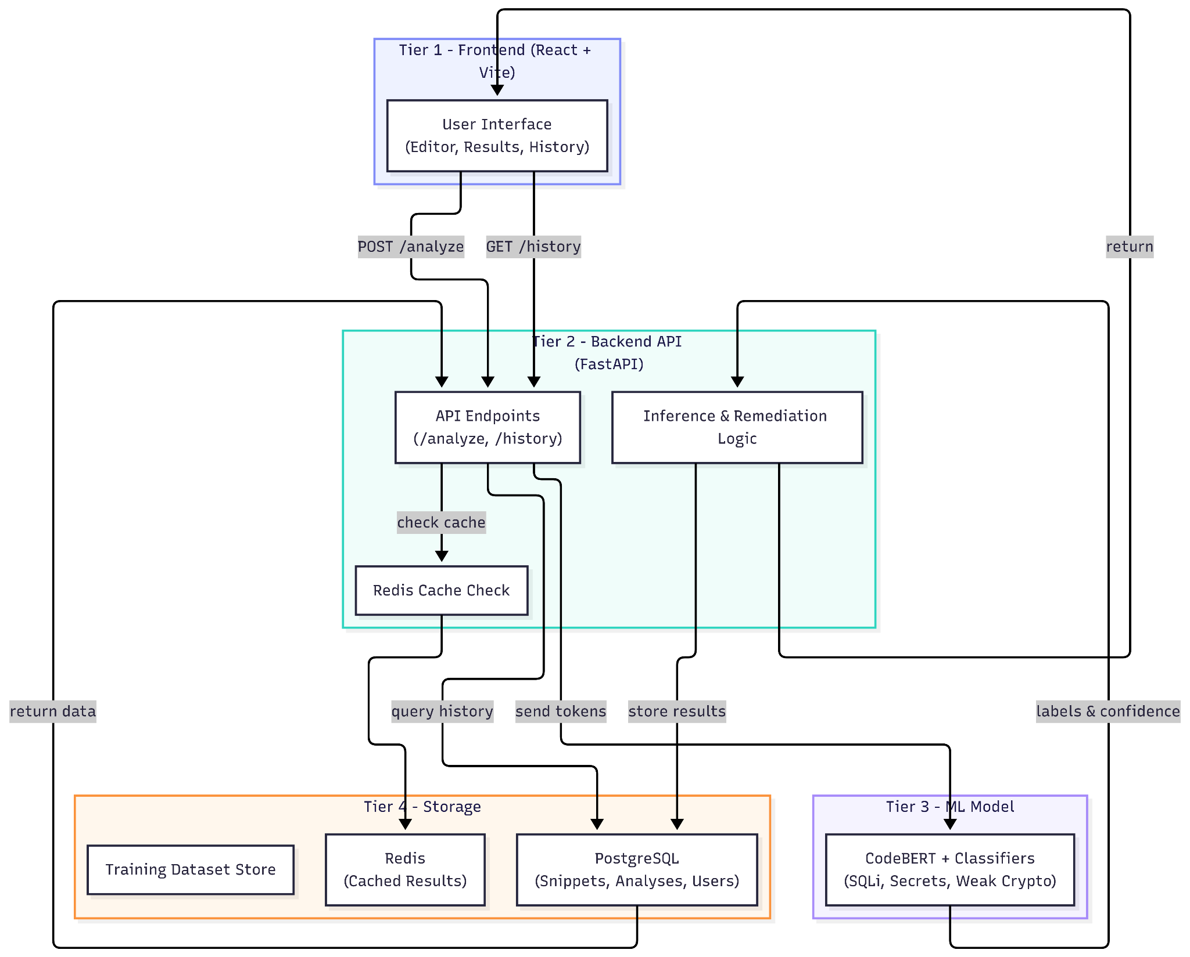
Figure 1 — SecureGen AI Product Architecture (4-Tier)

Tier Descriptions
Tier 1 — Frontend (React + Vite): The user-facing layer providing a code submission editor (CodeMirror), a risk gauge, an attention heatmap, trend charts (Recharts), and a remediation panel. User interaction is fully isolated from model logic.
Tier 2 — Backend API (FastAPI / Python): Coordinates all runtime operations. Receives code via POST /analyze, checks Redis for cached outputs, sends tokens to the model, applies CWE-to-fix remediation mappings, and returns a structured response. Also exposes GET /history and GET /health.
Tier 3 — ML Model Layer: Contains the vulnerability detection intelligence. A fine-tuned CodeBERT model classifies SQL injection, hardcoded secrets, and weak cryptography. An attention weight extractor provides token-level explainability for each prediction.
Tier 4 — Storage: PostgreSQL persists submitted snippets, analysis outcomes, and user-linked metadata. Redis acts as a fast temporary cache keyed by snippet hash with a one-hour TTL. A separate dataset store holds the annotated SecurityEval corpus for benchmarking and future retraining.

