Mini Project

Step 2

Schema:

Researcher = {researcher_id (Primary Key), first_name, last_name, email_address, organization}

GrantCompetition = {competition_id (Primary Key), title, area, description, application_deadline, status }

GrantProposal = {proposal_id (Primary Key), amount_requested, amount_awarded, status, date_awarded, other_collaborators, competition_id (Foreign Key), principal_investigator_id (Foreign Key))}

Reviewer = {reviewer_id (Primary Key), conflicts_of_interest, co_reviewers, researcher_id ( Foreign Key), proposal_id( Foreign Key)}

ReviewerAssignment = {assignment_id (Primary Key), deadline, submitted, reviewer_id( Foreign Key), competition_id (Foreign Key)}

GrantSelectionCommitteeMeeting = {meeting_id (Primary Key), meeting_date}

Relationships:

1. Researcher submits Grant Proposal: One-to-Many relationship between Researcher and GrantProposal.
2. Grant Proposal work for Grant Competition: Many-to-One relationship between GrantProposal and GrantCompetition.
3. Reviewers review the Assignment: One-to-Many relationship between reviewAssignment and Reviewer.
4. GrantProposals are discussed in SelectionMeeting: Many-to-One relationship between GrantProposal and SelectionMeeting.
5. Reviewers participate in SelectionMeeting: Many-to-One relationship between Reviewer and SelectionMeeting.
6. Researcher acts as reviewer: One-to-One relationship between Researcher and reviewer
7. reviewAssignment work for GrantCompetition: Many-to-One relationship between reviewAssignment and GrantCompetition.

Step 3

E/R Diagrams

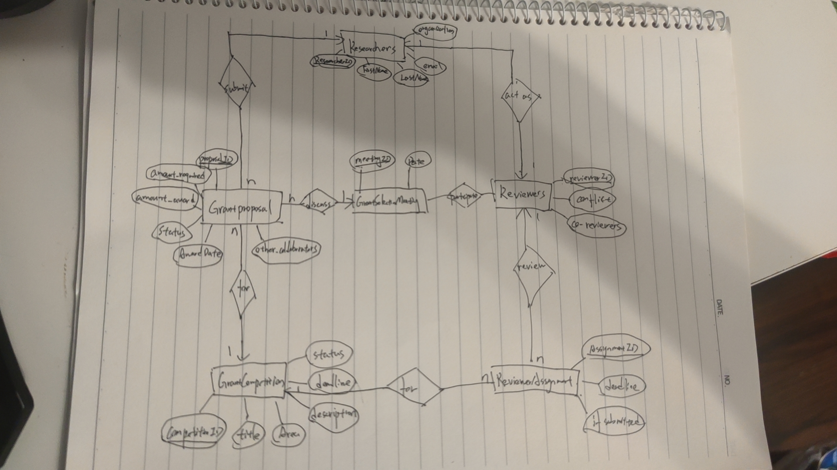

Step 4

Researcher: researcher_id -> {first_name, last_name, email_address, organization}

GrantCompetiton:competition_id -> {title, area, description, application_deadline, status}

GrantProposal:proposal_id -> {amount_requested, amount_awarded, status, date_awarded, competition_id, principal_investigator_id, other_collaborators}

Reviewer: reviewer_id -> {conflicts_of_interest, co_reviewers, researcher_id , proposal_id}

ReviewerAssignment:assignment_id -> {deadline, submitted, reviewer_id, competition_id }

SelectionMeeting: meeting_id -> meeting_date

Since there are no bad functional dependencies, the design is already in BCNF . Therefore, the design does not allow anomalies and meets the requirements without the need for re-design.