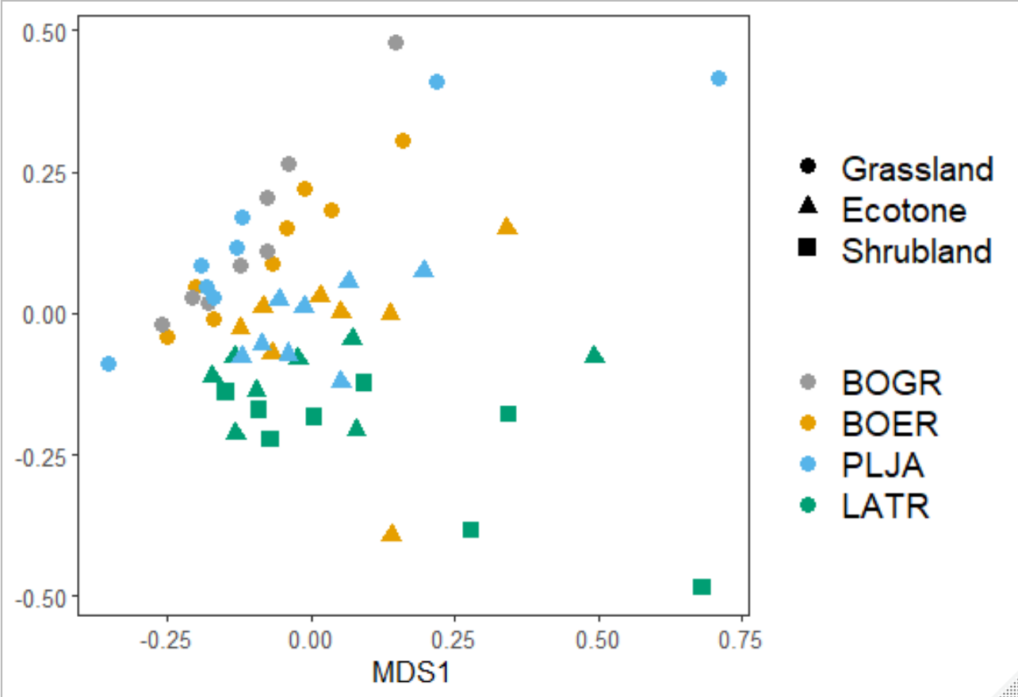

> print(test_perm)

Call:

adonis(formula = MUD.data.dist ~ MUD.data_map$Location + MUD.data_map$Spp, permutations = 10000)

Permutation: free

Number of permutations: 10000

Terms added sequentially (first to last)

Df SumsOfSqs MeanSqs F.Model R2 Pr(>F)

MUD.data_map$Location 2 1.3348 0.66742 4.2957 0.13789 9.999e-05 ***

MUD.data_map$Spp 3 0.5775 0.19250 1.2390 0.05966 0.0336 *

Residuals 50 7.7684 0.15537 0.80246

Total 55 9.6807 1.00000

---

Signif. codes: 0 ‘***’ 0.001 ‘**’ 0.01 ‘*’ 0.05 ‘.’ 0.1 ‘ ’ 1

> pairwise.perm.manova(MUD.data.dist, MUD.data_map$Location, nperm=2000)

Pairwise comparisons using permutation MANOVAs on a distance matrix

data: MUD.data.dist by MUD.data_map$Location

2000 permutations

Ecotone Grass

Grass 5e-04 -

Shrub 5e-04 5e-04

P value adjustment method: fdr

> pairwise.perm.manova(MUD.data.dist, MUD.data_map$Spp, nperm=2000)

Pairwise comparisons using permutation MANOVAs on a distance matrix

data: MUD.data.dist by MUD.data_map$Spp

2000 permutations

BOER BOGR LATR

BOGR 0.028 - -

LATR 0.001 0.001 -

PLJA 0.641 0.076 0.001

P value adjustment method: fdr

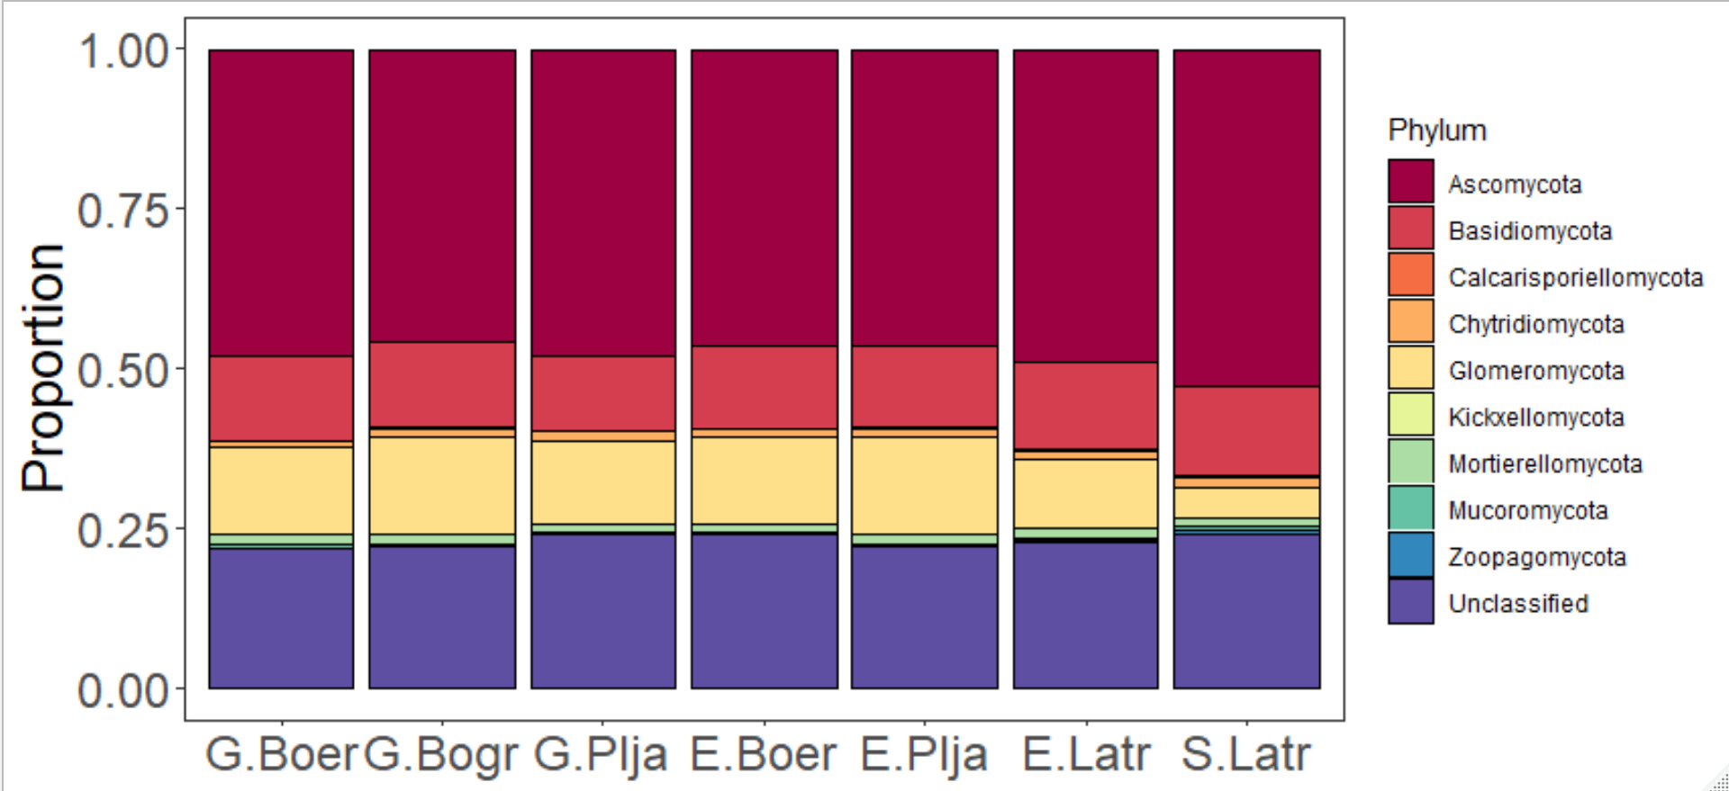

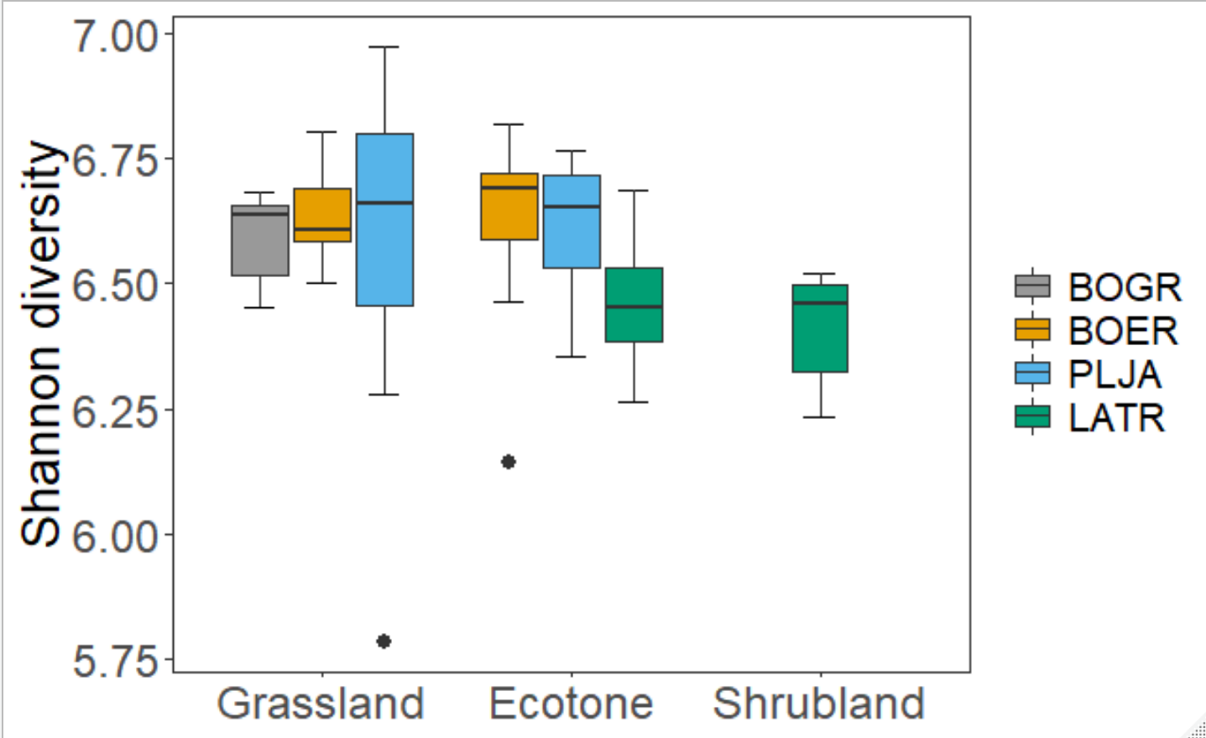

> Anova(Shannon_mod, type=3)

Anova Table (Type III tests)

Response: (Shannon)^15

Sum Sq Df F value Pr(>F)

(Intercept) 1.0452e+26 1 211.4749 <2e-16 ***

Species 2.5743e+24 3 1.7362 0.1715

Site 1.5687e+23 2 0.1587 0.8537

Residuals 2.4713e+25 50

---

Signif. codes: 0 ‘***’ 0.001 ‘**’ 0.01 ‘*’ 0.05 ‘.’ 0.1 ‘ ’ 1

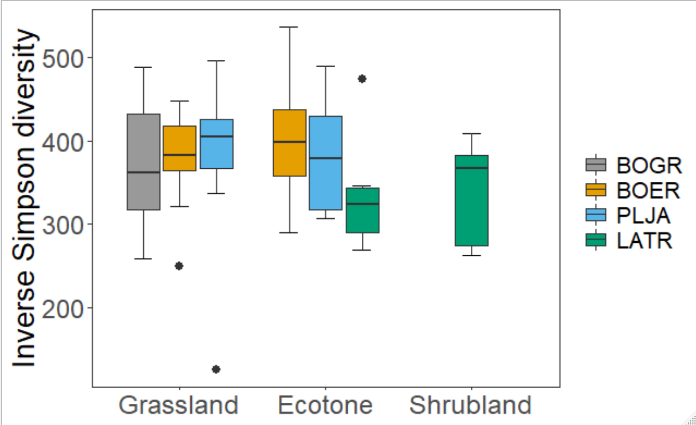

> Anova(Simpson_mod, type=3)

Anova Table (Type III tests)

Response: (InvSimpson)

Sum Sq Df F value Pr(>F)

(Intercept) 4133943 1 705.4139 <2e-16 ***

Species 20755 3 1.1805 0.3266

Site 2139 2 0.1825 0.8338

Residuals 293015 50

---

Signif. codes: 0 ‘***’ 0.001 ‘**’ 0.01 ‘*’ 0.05 ‘.’ 0.1 ‘ ’ 1

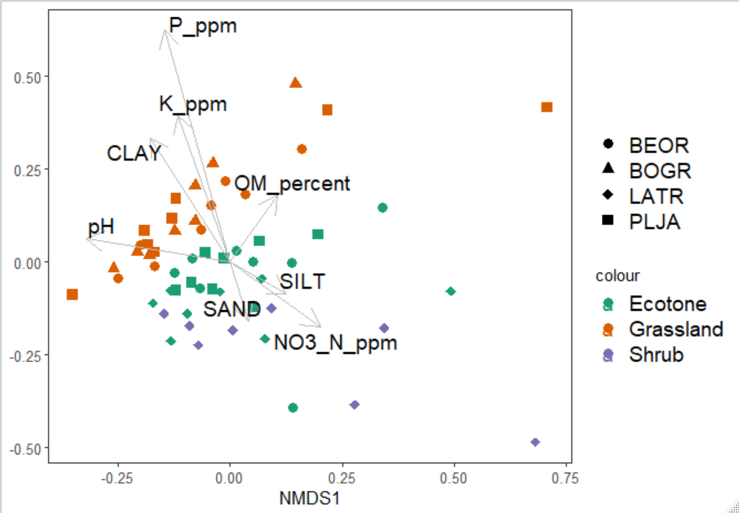

> (vec2 <-envfit(mmm1, soil, perm=9999, na.rm=TRUE)) #I think i added the environmental data

***VECTORS

NMDS1 NMDS2 r2 Pr(>r)

SAND 0.51390 0.85785 0.0253 0.5202

SILT 0.94805 -0.31814 0.0449 0.3021

CLAY -0.87547 -0.48328 0.1422 0.0203 *

pH -0.90542 0.42453 0.1257 0.0315 *

P_ppm -0.59722 -0.80208 0.4321 0.0001 ***

K_ppm -0.56847 -0.82270 0.1506 0.0132 *

OM_percent 0.12140 -0.99260 0.0600 0.1968

NO3_N_ppm 0.96653 -0.25657 0.0767 0.1184

---

Signif. codes: 0 ‘***’ 0.001 ‘**’ 0.01 ‘*’ 0.05 ‘.’ 0.1 ‘ ’ 1

Permutation: free

Number of permutations: 9999

1 observation deleted due to missingness

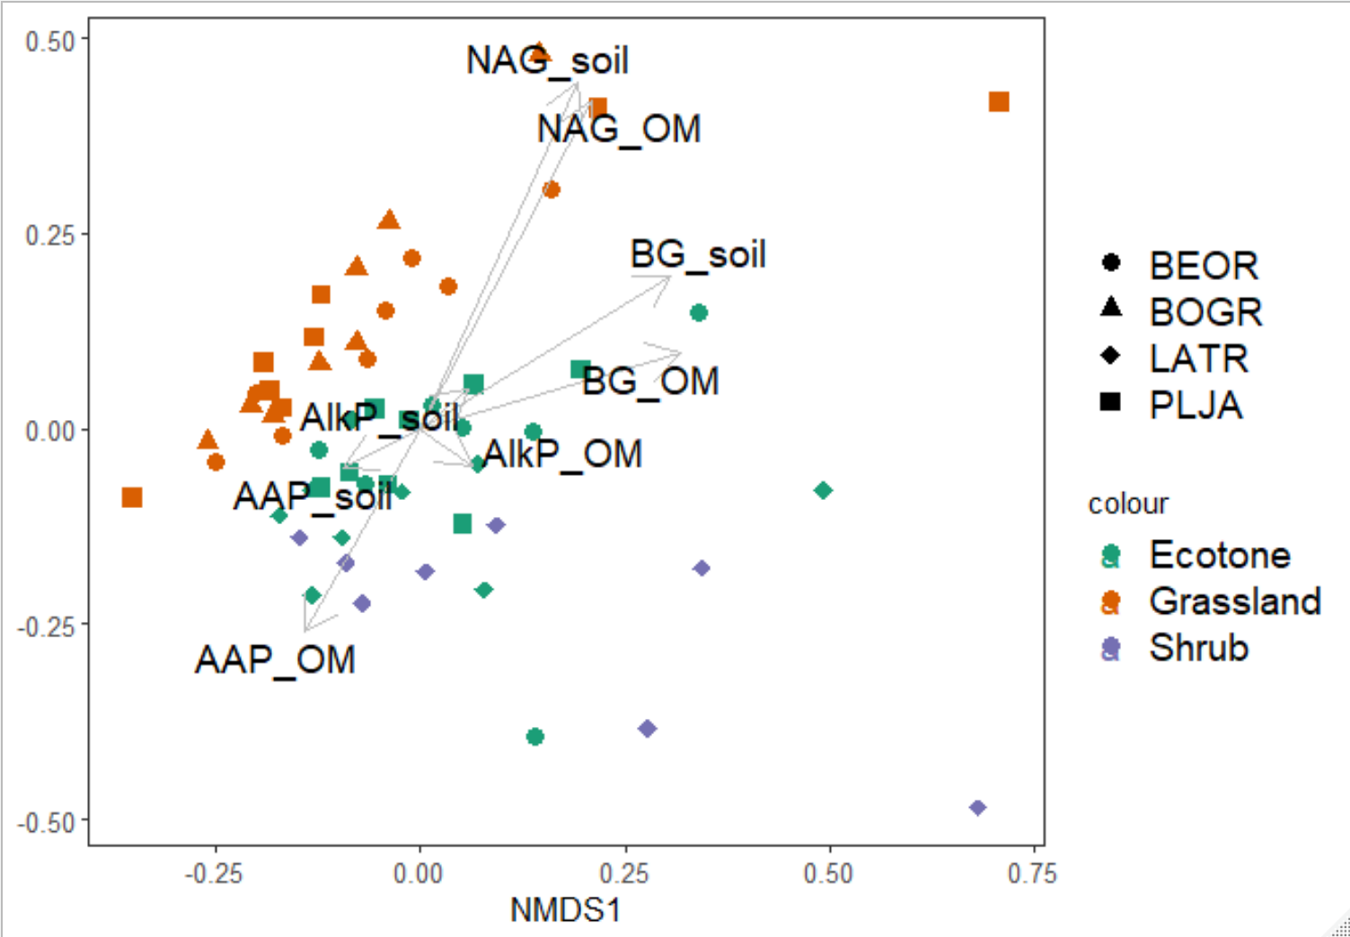

> (eea_vec <-envfit(MUD.data.ord, eea, perm=9999, na.rm=TRUE)) #I think i added the environmental data

***VECTORS

NMDS1 NMDS2 r2 Pr(>r)

NAG_soil 0.39837 0.91722 0.2333 0.0024 **

NAG_OM 0.44491 0.89558 0.2188 0.0031 **

AlkP_soil 0.74889 0.66270 0.0059 0.8639

AlkP_OM 0.79837 -0.60217 0.0062 0.8500

AAP_soil -0.88050 -0.47405 0.0114 0.7387

AAP_OM -0.47641 -0.87922 0.0873 0.0880 .

BG_soil 0.84094 0.54113 0.1320 0.0260 *

BG_OM 0.95584 0.29387 0.1102 0.0492 *

---

Signif. codes: 0 ‘***’ 0.001 ‘**’ 0.01 ‘*’ 0.05 ‘.’ 0.1 ‘ ’ 1

Permutation: free

Number of permutations: 9999

1 observation deleted due to missingness

EEA Versus Fungal community

> mantel(MUD.data.dist,eea.dist, permutations = 9999)

Mantel statistic based on Pearson's product-moment correlation

Call:

mantel(xdis = MUD.data.dist, ydis = eea.dist, permutations = 9999)

Mantel statistic r: 0.1754

Significance: 0.022

Upper quantiles of permutations (null model):

90% 95% 97.5% 99%

0.108 0.142 0.170 0.205

Permutation: free

Number of permutations: 9999

Soil characteristics versus fungal community

> mantel(MUD.data.dist,char.dist, permutations = 9999)

Mantel statistic based on Pearson's product-moment correlation

Call:

mantel(xdis = MUD.data.dist, ydis = char.dist, permutations = 9999)

Mantel statistic r: 0.4032

Significance: 1e-04

Upper quantiles of permutations (null model):

90% 95% 97.5% 99%

0.0989 0.1312 0.1613 0.1919

Permutation: free

Number of permutations: 9999

Partial mantel with Fungal versus eea given soil nutrients

> mantel.partial(MUD.data.dist,eea.dist,char.dist, permutations = 9999)

Partial Mantel statistic based on Pearson's product-moment correlation

Call:

mantel.partial(xdis = MUD.data.dist, ydis = eea.dist, zdis = char.dist, permutations = 9999)

Mantel statistic r: 0.131

Significance: 0.0634

Upper quantiles of permutations (null model):

90% 95% 97.5% 99%

0.108 0.143 0.174 0.210

Permutation: free

Number of permutations: 9999

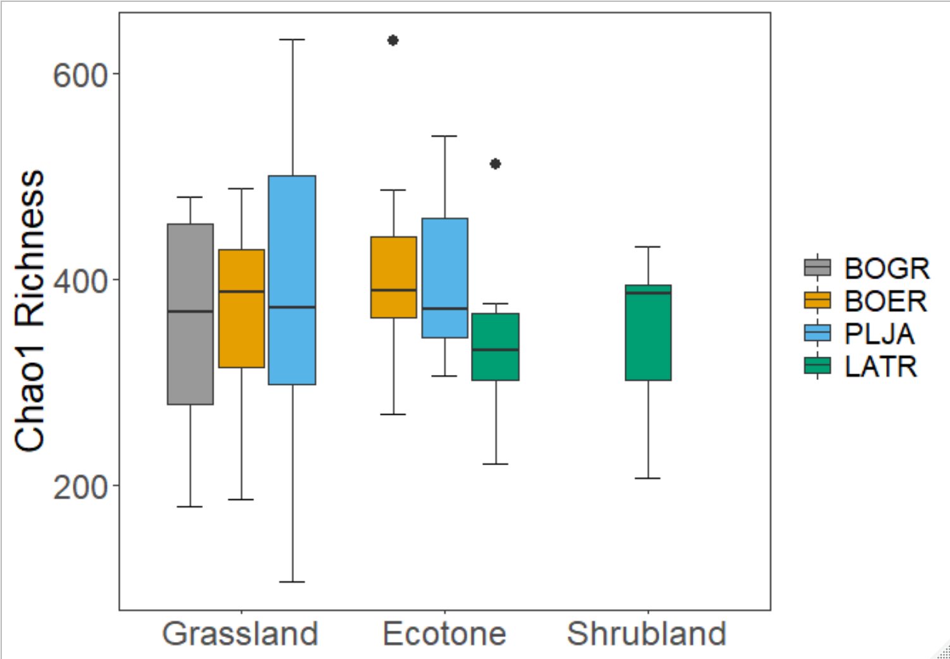

> Anova(Chao1_mod, type=3)

Anova Table (Type III tests)

Response: (Chao1)

Sum Sq Df F value Pr(>F)

(Intercept) 4198839 1 354.6235 <2e-16 ***

Species 24925 3 0.7017 0.5555

Site 6803 2 0.2873 0.7515

Residuals 592014 50

---

Signif. codes: 0 ‘***’ 0.001 ‘**’ 0.01 ‘*’ 0.05 ‘.’ 0.1 ‘ ’ 1

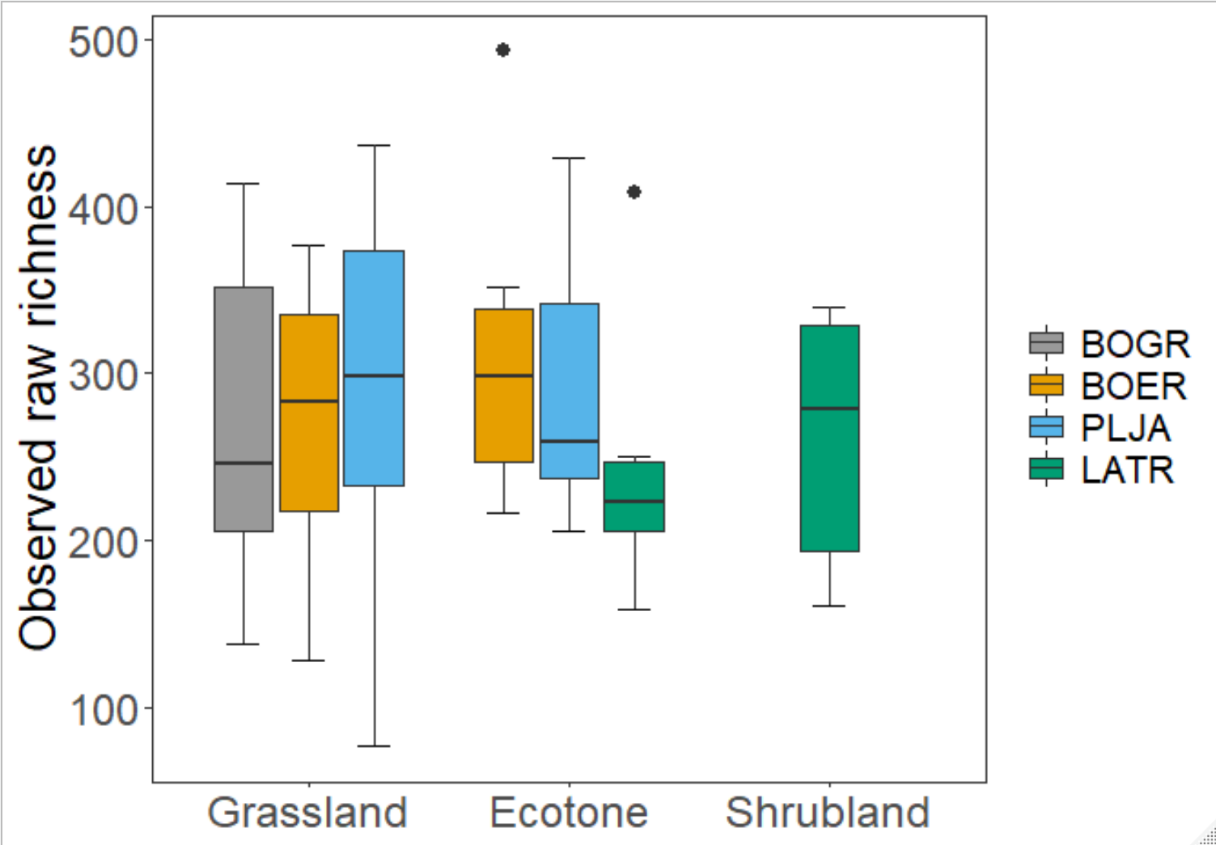

> Anova(Observed_R_mod, type=3)

Anova Table (Type III tests)

Response: (Observed)

Sum Sq Df F value Pr(>F)

(Intercept) 2377912 1 308.307 <2e-16 ***

Species 20986 3 0.907 0.4444

Site 5460 2 0.354 0.7036

Residuals 385640 50

---

Signif. codes: 0 ‘***’ 0.001 ‘**’ 0.01 ‘*’ 0.05 ‘.’ 0.1 ‘ ’ 1

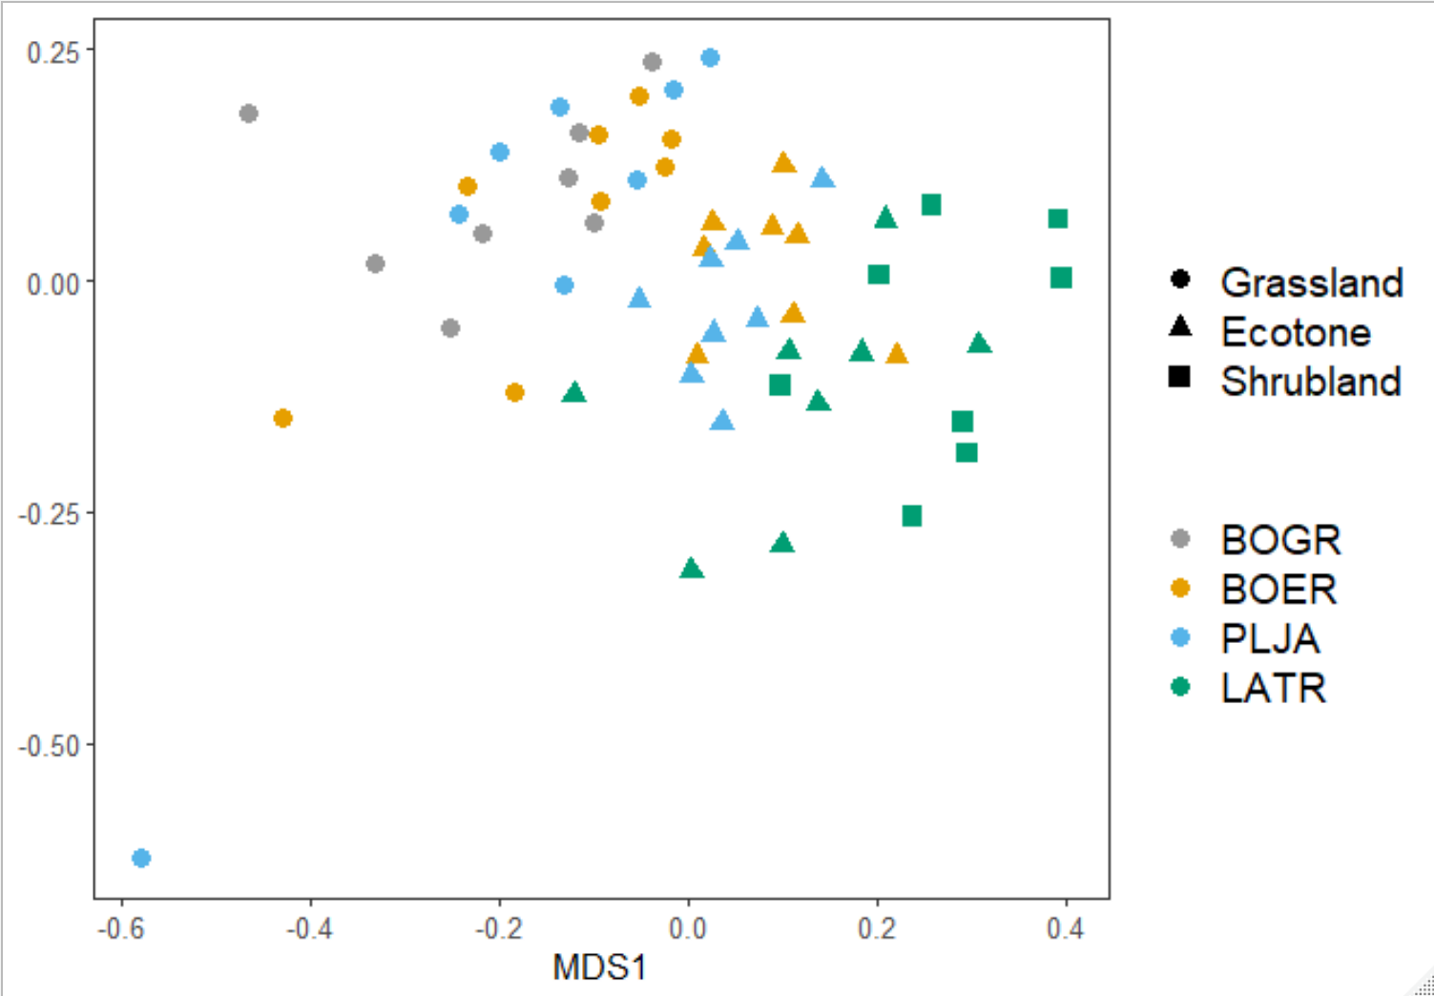

> print(test_perm.pa)

Call:

adonis(formula = MUD.data_pa.dist ~ MUD.data_pa_map$Location + MUD.data_pa_map$Spp, permutations = 10000)

Permutation: free

Number of permutations: 10000

Terms added sequentially (first to last)

Df SumsOfSqs MeanSqs F.Model R2 Pr(>F)

MUD.data_pa_map$Location 2 1.8146 0.90731 2.7186 0.09234 9.999e-05 ***

MUD.data_pa_map$Spp 3 1.1508 0.38360 1.1494 0.05856 0.0144 *

Residuals 50 16.6869 0.33374 0.84911

Total 55 19.6523 1.00000

---

Signif. codes: 0 ‘***’ 0.001 ‘**’ 0.01 ‘*’ 0.05 ‘.’ 0.1 ‘ ’ 1

> pairwise.perm.manova(MUD.data_pa.dist, MUD.data_pa_map$Location, nperm=2000)

Pairwise comparisons using permutation MANOVAs on a distance matrix

data: MUD.data_pa.dist by MUD.data_pa_map$Location

2000 permutations

Ecotone Grass

Grass 5e-04 -

Shrub 5e-04 5e-04

P value adjustment method: fdr

> pairwise.perm.manova(MUD.data_pa.dist, MUD.data_pa_map$Spp, nperm=2000)

Pairwise comparisons using permutation MANOVAs on a distance matrix

data: MUD.data_pa.dist by MUD.data_pa_map$Spp

2000 permutations

BOER BOGR LATR

BOGR 0.0082 - -

LATR 0.0010 0.0010 -

PLJA 0.7341 0.0366 0.0010

P value adjustment method: fdr