Trophic Modes

Saprotrophs

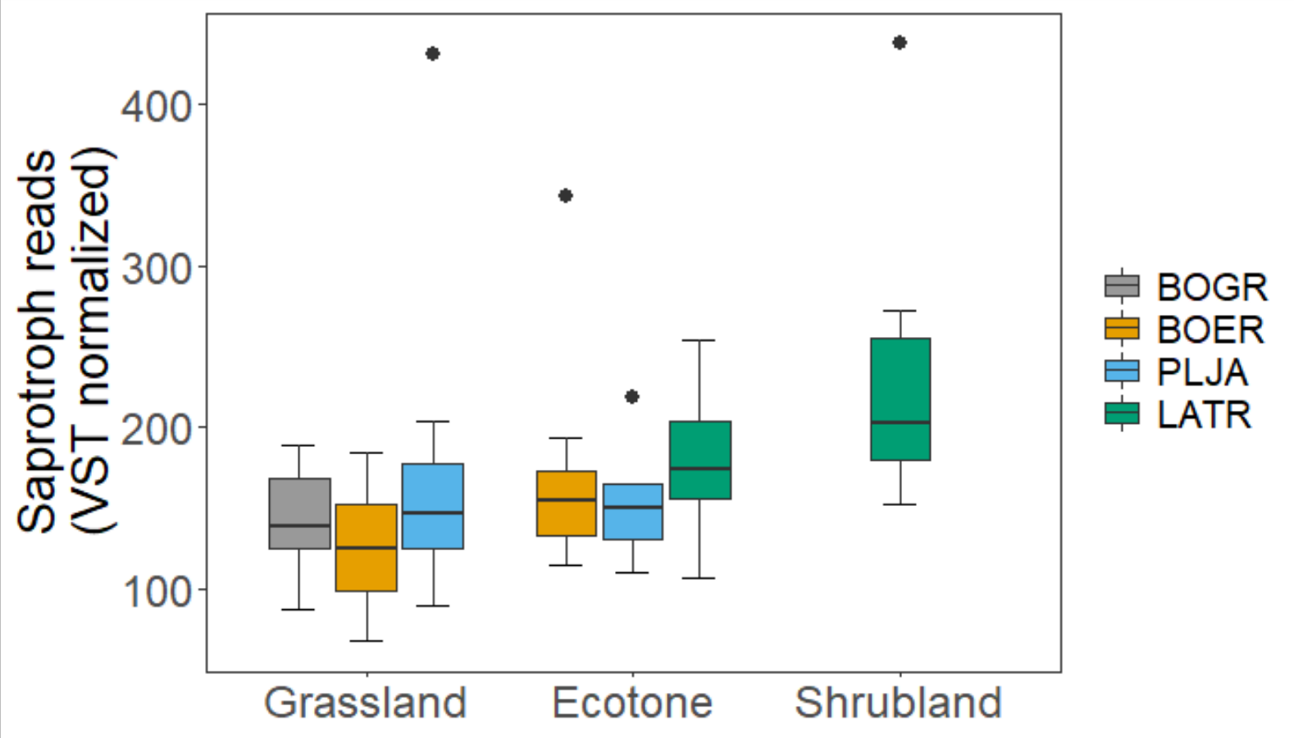

> Anova(Saprt_abun_R_mod, type=3)

Anova Table (Type III tests)

Response: log(value)

Sum Sq Df F value Pr(>F)

(Intercept) 771.41 1 6731.1194 <2e-16 ***

Species 0.16 3 0.4705 0.7042

Site 0.34 2 1.4998 0.2330

Residuals 5.73 50

---

Signif. codes: 0 ‘***’ 0.001 ‘**’ 0.01 ‘*’ 0.05 ‘.’ 0.1 ‘ ’ 1

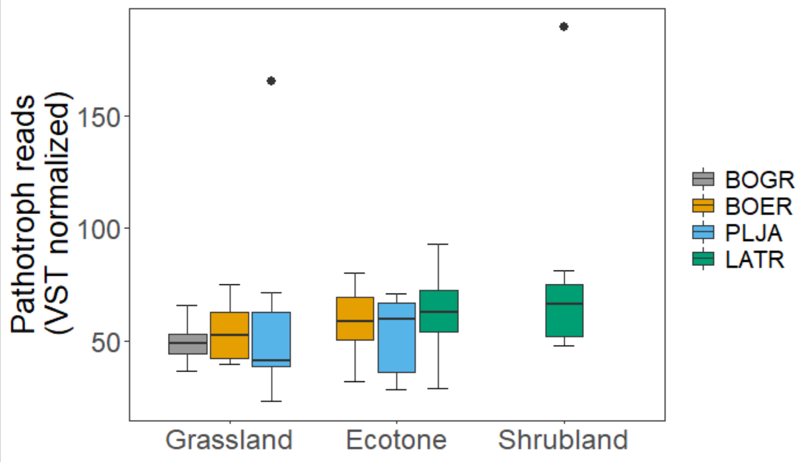

> Anova(Patho_abun_R_mod, type=3)

Anova Table (Type III tests)

Response: log(value)

Sum Sq Df F value Pr(>F)

(Intercept) 481.04 1 3405.9132 <2e-16 ***

Species 0.13 3 0.3044 0.8220

Site 0.14 2 0.4927 0.6139

Residuals 7.06 50

---

Signif. codes: 0 ‘***’ 0.001 ‘**’ 0.01 ‘*’ 0.05 ‘.’ 0.1 ‘ ’ 1

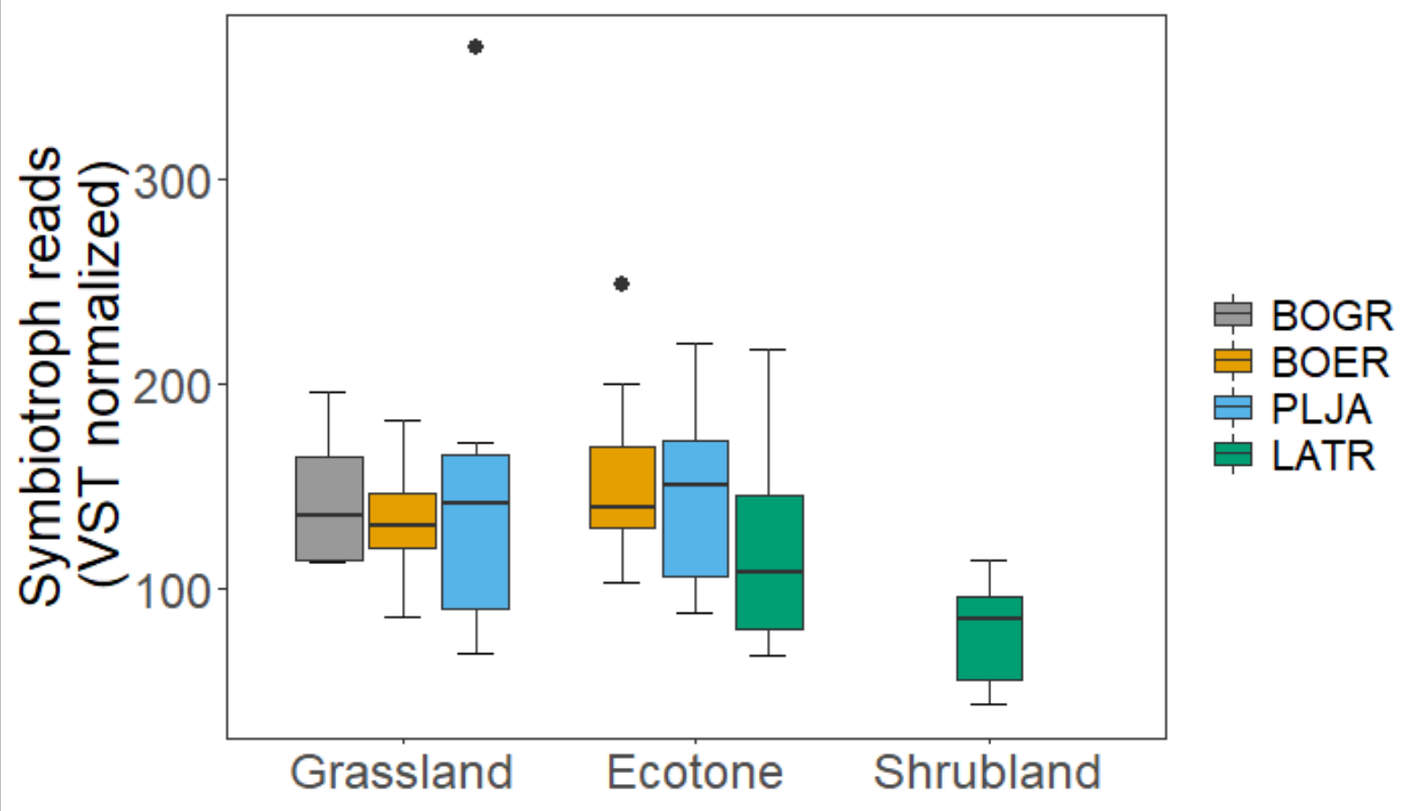

> Anova(Symbio_abun_R_mod, type=3)

Anova Table (Type III tests)

Response: log(value)

Sum Sq Df F value Pr(>F)

(Intercept) 668.63 1 5097.4038 < 2e-16 ***

Species 0.33 3 0.8462 0.47518

Site 0.77 2 2.9378 0.06219 .

Residuals 6.56 50

---

Signif. codes: 0 ‘***’ 0.001 ‘**’ 0.01 ‘*’ 0.05 ‘.’ 0.1 ‘ ’ 1

> #Site 0.77 2 2.9378 0.06219 .

> emmeans(Symbio_abun_R_mod, pairwise~Site)

$emmeans

Site emmean SE df lower.CL upper.CL

E 4.93 0.0847 50 4.76 5.10

G 4.84 0.0847 50 4.67 5.01

S 4.50 0.1782 50 4.15 4.86

Results are averaged over the levels of: Species

Results are given on the log (not the response) scale.

Confidence level used: 0.95

$contrasts

contrast estimate SE df t.ratio p.value

E - G 0.0833 0.128 50 0.650 0.7931

E - S 0.4229 0.181 50 2.335 0.0601

G - S 0.3396 0.222 50 1.531 0.2852

Results are averaged over the levels of: Species

Results are given on the log (not the response) scale.

P value adjustment: tukey method for comparing a family of 3 estimates

Guild Analyses

Arbuscular

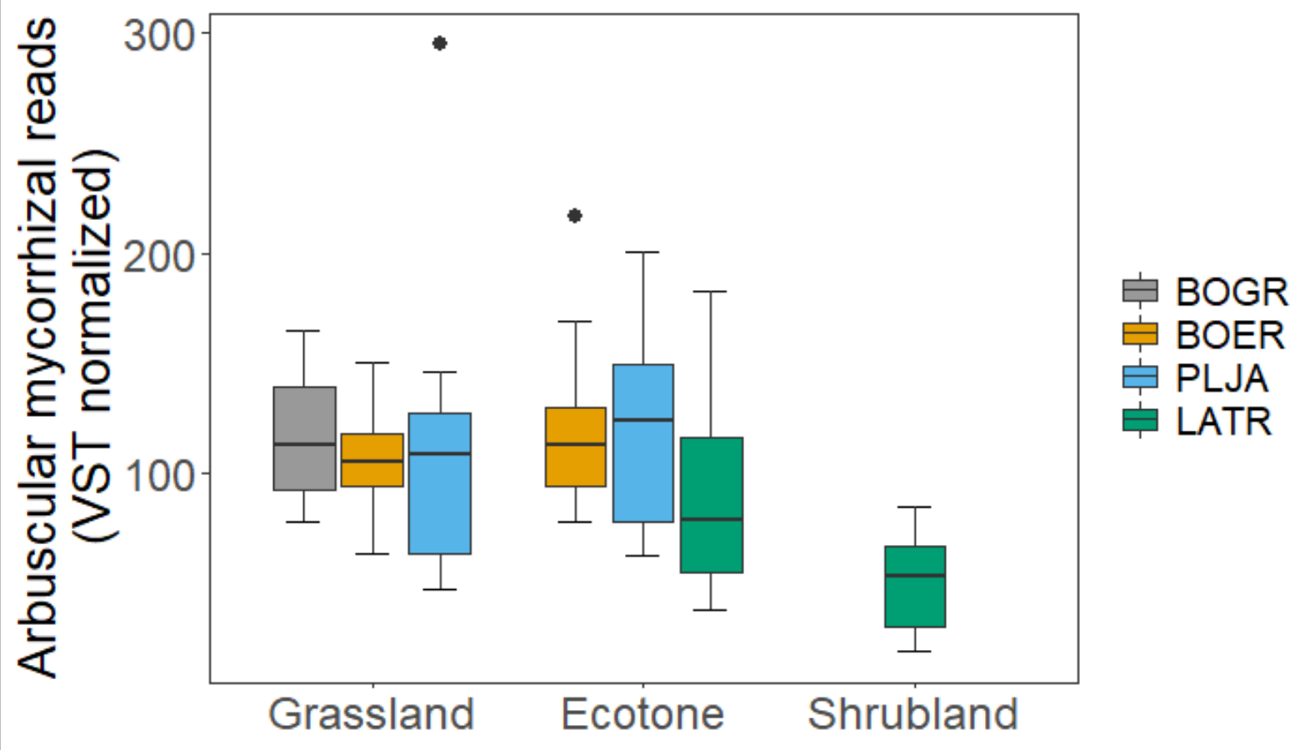

> Anova(Arbu_abun_R_mod, type=3)

Anova Table (Type III tests)

Response: log(value)

Sum Sq Df F value Pr(>F)

(Intercept) 584.05 1 2851.3159 < 2e-16 ***

Species 0.68 3 1.1124 0.35293

Site 1.57 2 3.8232 0.02851 *

Residuals 10.24 50

---

Signif. codes: 0 ‘***’ 0.001 ‘**’ 0.01 ‘*’ 0.05 ‘.’ 0.1 ‘ ’ 1

> emmeans(Arbu_abun_R_mod, pairwise~Site)

$emmeans

Site emmean SE df lower.CL upper.CL

E 4.69 0.106 50 4.47 4.90

G 4.57 0.106 50 4.36 4.79

S 4.08 0.223 50 3.63 4.53

Results are averaged over the levels of: Species

Results are given on the log (not the response) scale.

Confidence level used: 0.95

$contrasts

contrast estimate SE df t.ratio p.value

E - G 0.112 0.160 50 0.700 0.7648

E - S 0.605 0.226 50 2.675 0.0267

G - S 0.493 0.277 50 1.780 0.1866

Results are averaged over the levels of: Species

Results are given on the log (not the response) scale.

P value adjustment: tukey method for comparing a family of 3 estimates

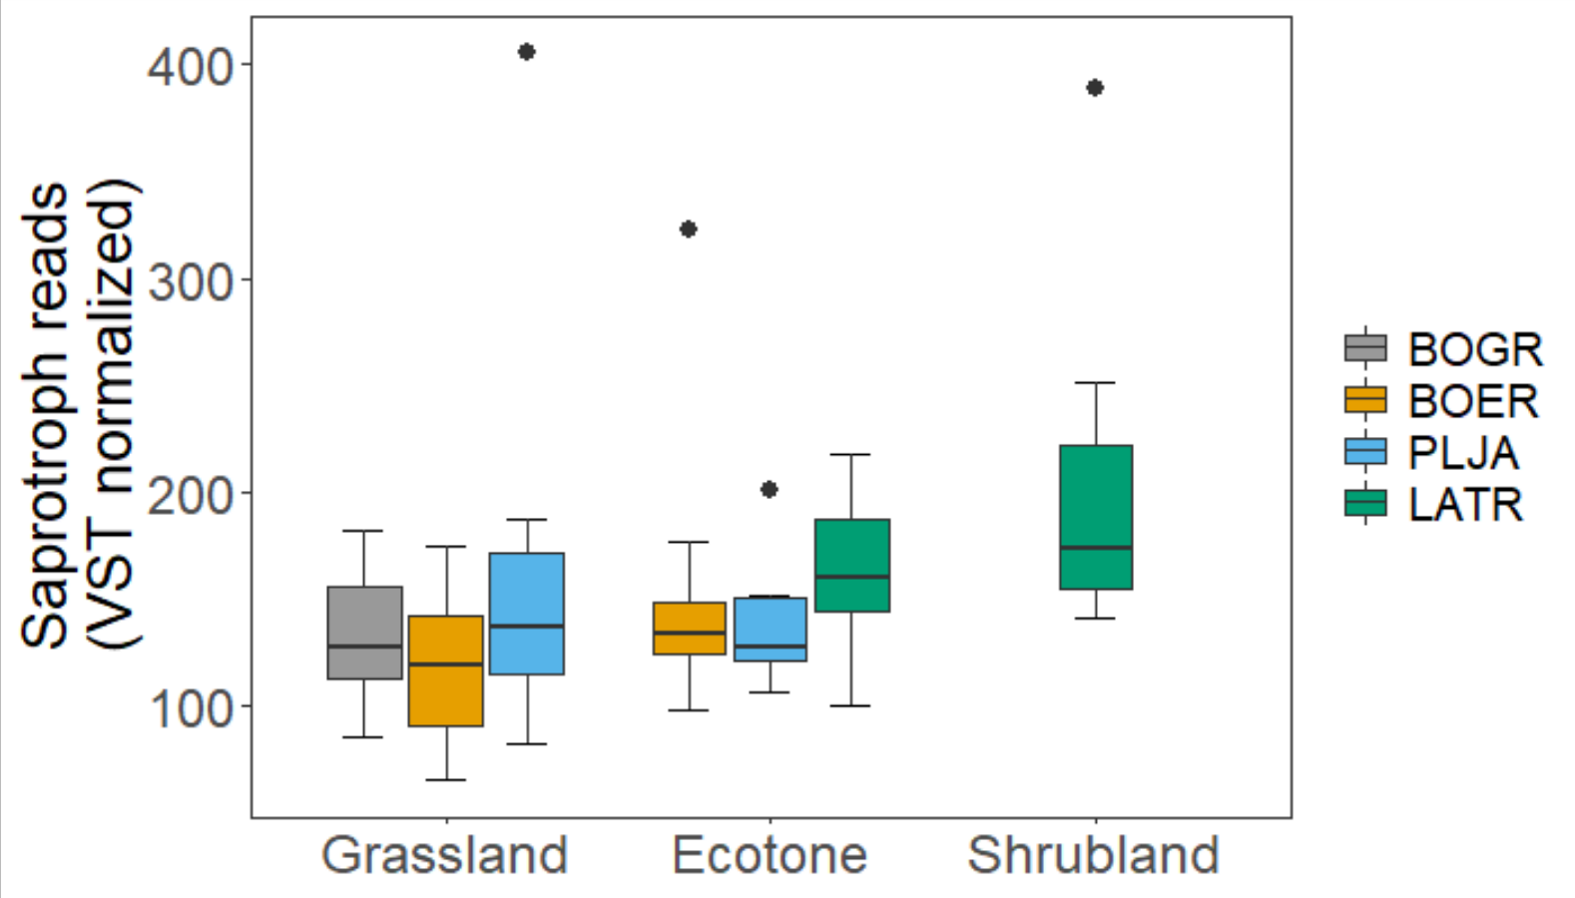

> Anova(Sapr_abun_R_mod, type=3)

Anova Table (Type III tests)

Response: log(value)

Sum Sq Df F value Pr(>F)

(Intercept) 742.58 1 6651.4750 <2e-16 ***

Species 0.18 3 0.5294 0.6641

Site 0.22 2 0.9708 0.3858

Residuals 5.58 50

---

Signif. codes: 0 ‘***’ 0.001 ‘**’ 0.01 ‘*’ 0.05 ‘.’ 0.1 ‘ ’ 1

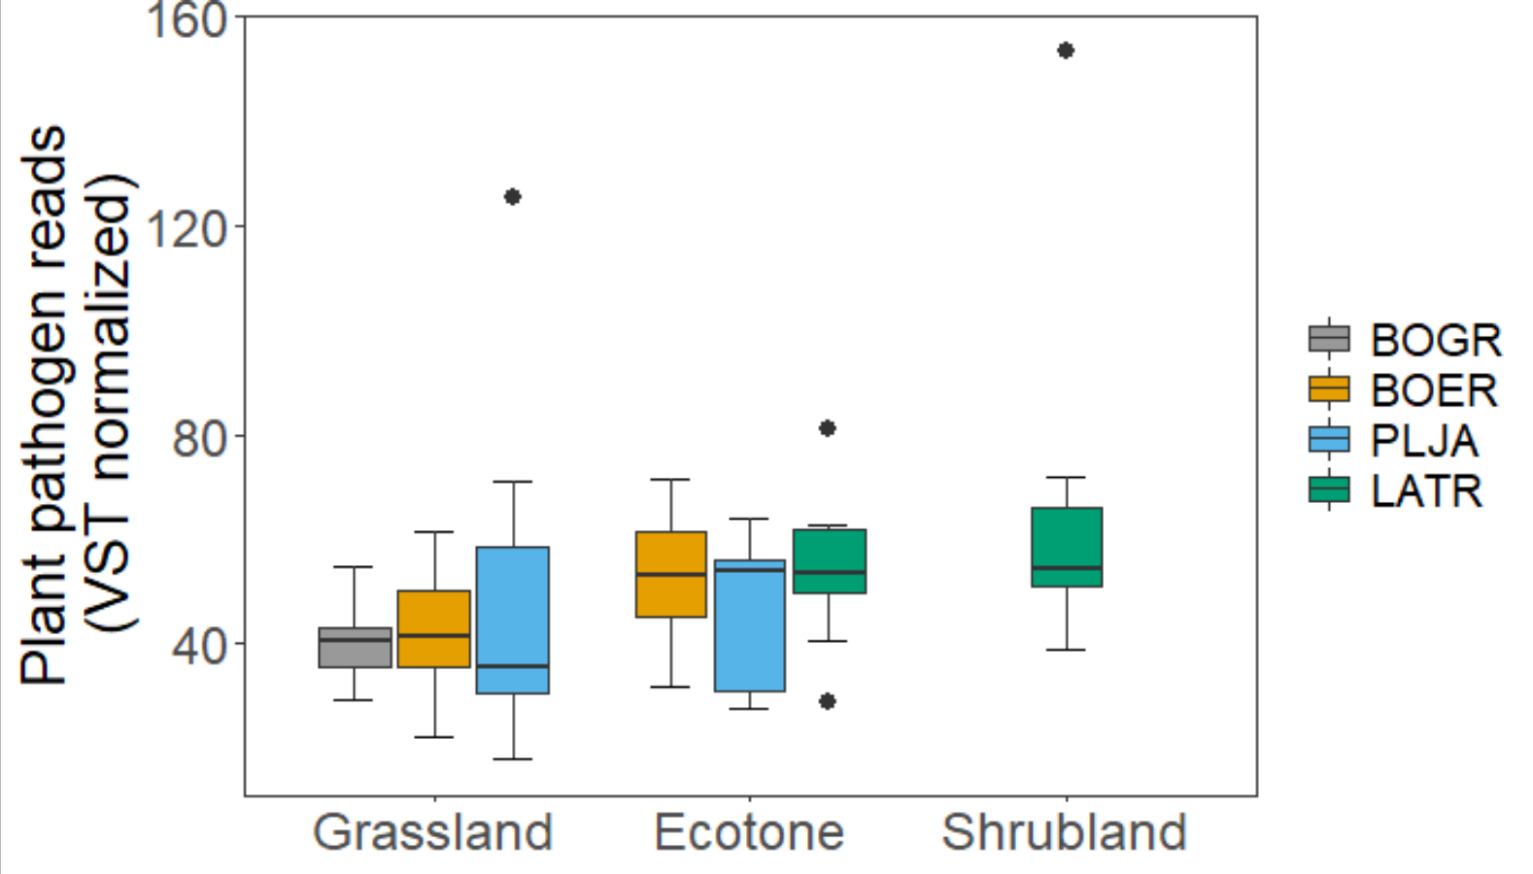

> Anova(Path_abun_R_mod, type=3)

Anova Table (Type III tests)

Response: log(value)

Sum Sq Df F value Pr(>F)

(Intercept) 444.70 1 3202.1850 <2e-16 ***

Species 0.08 3 0.2003 0.8957

Site 0.26 2 0.9431 0.3962

Residuals 6.94 50

---

Signif. codes: 0 ‘***’ 0.001 ‘**’ 0.01 ‘*’ 0.05 ‘.’ 0.1 ‘ ’ 1

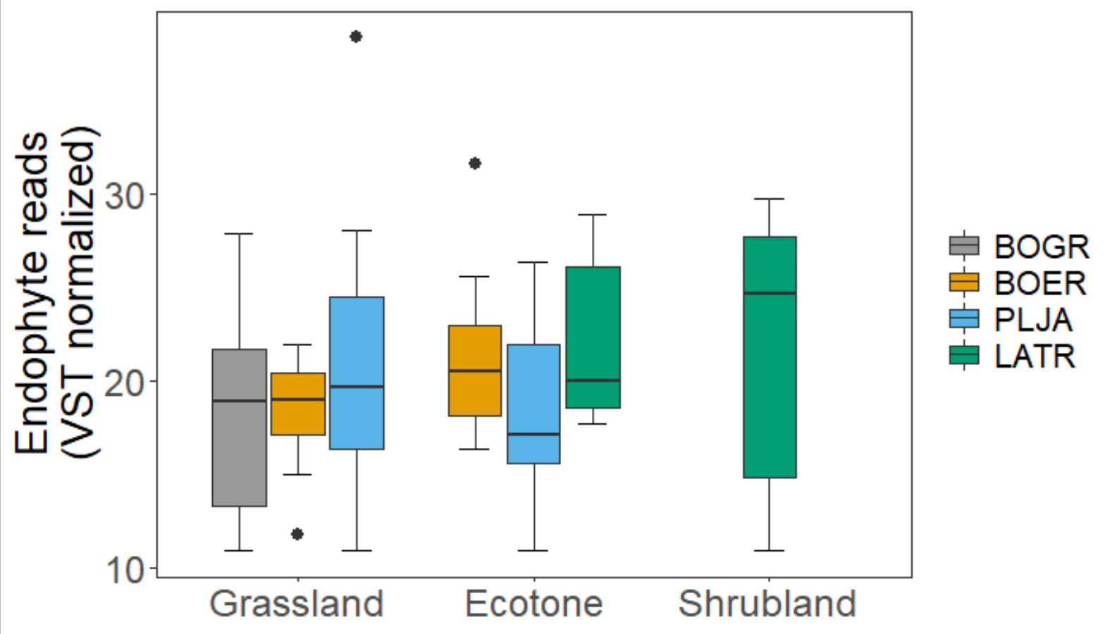

> Anova(Endo_abun_R_mod, type=3)

Anova Table (Type III tests)

Response: (value)

Sum Sq Df F value Pr(>F)

(Intercept) 11849.8 1 331.6846 <2e-16 ***

Species 35.7 3 0.3334 0.8012

Site 0.0 2 0.0006 0.9994

Residuals 1786.3 50

---

Signif. codes: 0 ‘***’ 0.001 ‘**’ 0.01 ‘*’ 0.05 ‘.’ 0.1 ‘ ’ 1