The Wedding Planner
For 2-4 Players | Ages 12+ | 60-90 Minutes

1. INTRODUCTION
Congratulations! You just got engaged. Now you have 12 months to plan the wedding of your dreams. Research venues and vendors, book them into your wedding, tackle the never-ending to-do list, and lean on friends and family when it gets overwhelming, all while building excitement for the big day.
The game plays over 12 months organized into 4 quarters. Between quarters, you'll pause for a Check-In to set goals and prepare for the next quarter.
You win by having the most gifts at the end of the game. Gifts represent the memories, experiences, and joy your wedding creates.

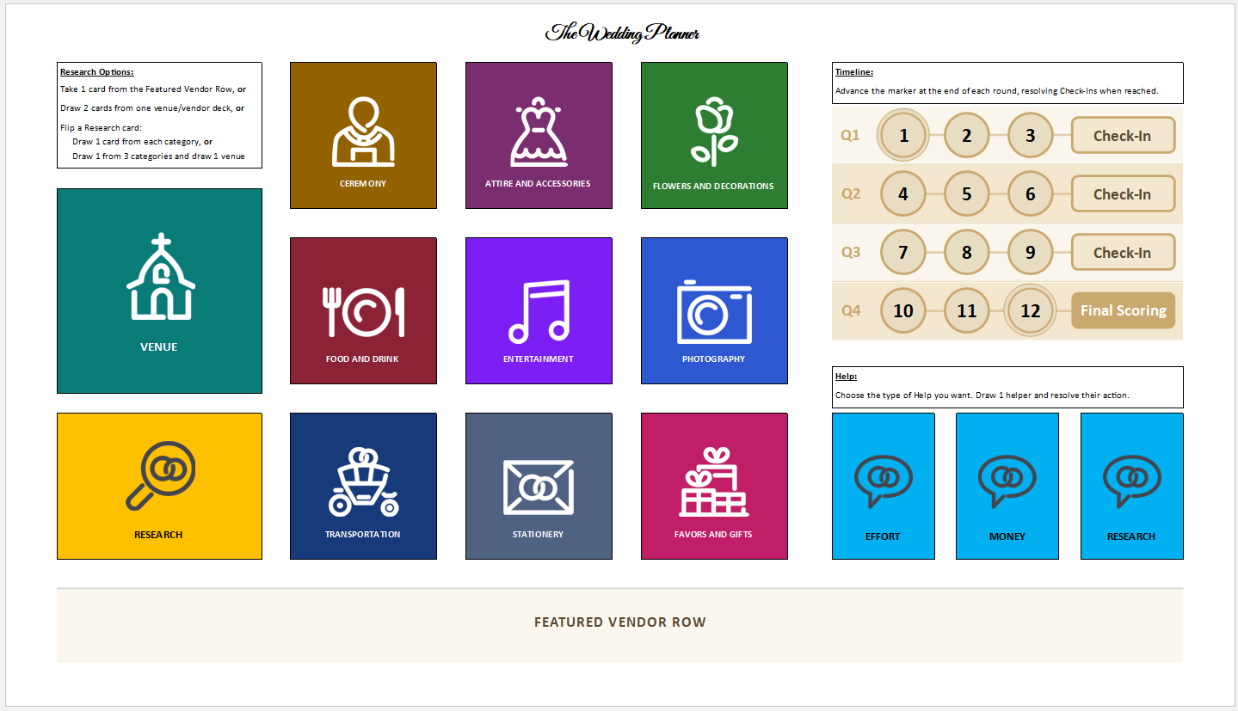
Central Board

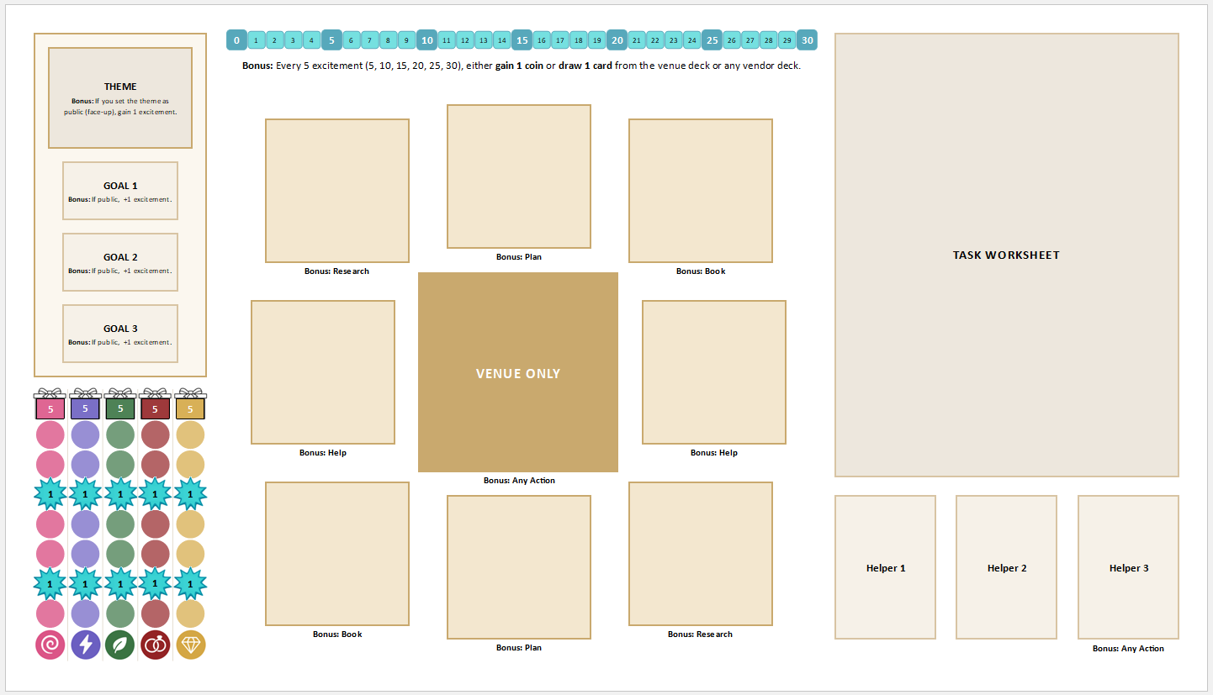
Player Board

2. COMPONENTS

Player Components (×4 sets)
- 1 Player Board
- 1 Task Worksheet (laminated for prototype)
- 1 Set of Trackers (5 theme element trackers, 1 excitement tracker)
- 1 Set of Goals (9 guest goals, 3 budget goals, 3 excitement goals, 4 theme goals, 1 theme bonus)
- 1 Meeple
- 1 Wet Erase Marker

Shared Components
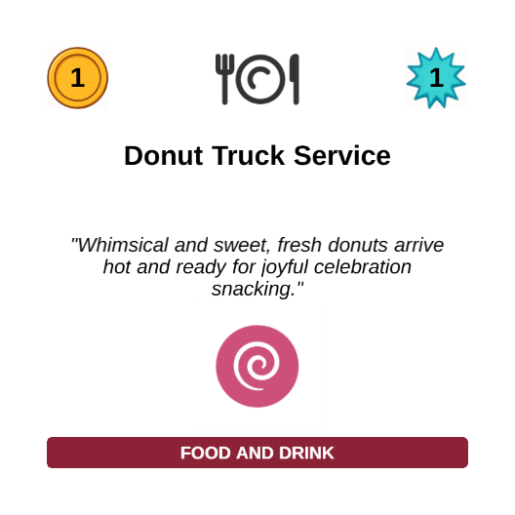
Cards:
- 108 Vendor cards (9 categories, 12 each)
- 12 Venue cards (+ 12 duplicate copies for the Stolen Venue variant)
- 8 Wedding Planner Contracts
- 1 In-House Vendor Sheet (6 vendors)
- 10 Theme cards
- 10 Personality tent cards
- 18 Help cards (6 Money, 6 Effort, 6 Research)
- 16 Moment cards
- 10 Award cards (5 Race, 5 Endgame)
- 18 Research cards


Boards & Tokens:
- 1 Central Board
- 5 Card Stands (3 for Moments, 2 for Awards)
- 1 First Player token (Engagement Ring)
- 1 Timeline token
- 100+ Gift tokens













- 60 Coin tokens
- 12 Wedding Planner effort trackers


3. SETUP

Shared Setup
1. Place Central Board
Place the central board in the center of the table, accessible to everyone.
2. Prepare Vendor Decks
Shuffle all 9 vendor category decks separately. Place them face-down on the central board in their designated category spaces.
3. Prepare Venue Deck
Shuffle all 12 venue cards and place them face-down on the central board in the Venue space.
Variant: Stolen Venue (optional) Shuffle the duplicate vendors into the venue deck (24 total). When a Venue is booked, its duplicate cannot be booked again. If it is in a player’s hand, remove it from the game.

4. Place In-House Vendor Sheet
Place the In-House Vendor Sheet near the central board. All 6 in-house vendors should be in their sleeves and available. In-house vendors are identified by an asterisk (✱) in the top right corner of the card back.
5. Prepare Research Deck
Shuffle the Research cards and place face-down on the Research space.
6. Prepare Theme Deck
Shuffle the Theme deck and place face-down near the play area.
7. Prepare Help Decks
Separate the 18 Help cards into three decks by type (Money, Effort, Research, 6 cards each). Shuffle each and place face-down on the central board.
8. Reveal Moment Cards
Shuffle all 16 Moment cards together and randomly draw 3. Place them in stands where all players can see them. You may instead choose one of the Recommended Sets below.
Recommended Sets:
- The Rehearsal (introductory): The Aisle, The Promise, The Union
- The Ceremony (intermediate): The Glance, The Spark, The Rings
- The Reception (challenging): The Giving, The Dance, Forever

9. Reveal Award Cards
Separate the Award cards into Race Awards and Endgame Awards. Randomly draw 1 from each and place both in stands where all players can see them. You may instead choose one of the Recommended Sets below.
Recommended Sets:
- The Rehearsal (introductory): Booking Momentum + Most Well-Rounded
- The Ceremony (intermediate): First Spark + Most Planned
- The Reception (challenging): Theme Breakthrough + Most Balanced Theme

10. Prepare Personality Cards
Place the Personality cards near the play area.
11. Prepare Token Supply
Place all Gift tokens, Coin tokens, and Wedding Planner effort trackers in a shared supply near the central board.

Player Setup
1. Take Player Board
Take a player board and place it in front of you.
2. Take Task Worksheet
Take a task worksheet and place it on your player board in the task area.
3. Take Goal Set
Take a complete set of goals (theme, budget, excitement, and guest goals, plus the Theme Bonus) and place them next to your player board.
4. Draw Personality Card
Each player draws 2 Personality tent cards, chooses 1, and discards the other.
5. Receive Starting Coins
Take your starting 12 coins.
6. Draw Theme Cards
Draw 2 Theme cards from the Theme deck. Keep both hidden. You'll choose 1 at the first Check-In.
7. Draw Wedding Planner Contract
Draw 1 Wedding Planner Contract randomly. Flip the exclusive venue in the sleeve to see which venue your planner has secured for you. Place the contract near your player board. You can contract with your planner later in the game if desired.
8. Set Up Trackers
- Place your Theme Element Trackers on the position 0 of each theme element track on your player board
- Place your Excitement Tracker on position 0 of the excitement track on your player board
- Place your Meeple on your Vision board area (starting position)

9. Apply Personality Setup
Follow any setup instructions on your chosen Personality tent card. These may modify your starting coins, hand, trackers, or other components established in the steps above.

Final Shared Steps
1. Determine First Player
The first player is the player whose wedding is the closest (either in the past or future). Alternatively, randomly determine the first player. Give them the First Player token.
2. Initialize Timeline
The first player takes the Timeline token and sets it to Month 1 on the timeline.
3. Seed Featured Vendor Row (FVR)
The Featured Vendor Row is a shared face-up display at the bottom of the central board. It starts empty and will fill with vendors (and later, venues) throughout the game. To seed it: the first player chooses 5 distinct vendor categories and reveals 1 card from each, placing them face-up in the FVR.

Setup Complete!
Your table should now show:
- The central board with category decks, venue deck, research deck, 5 face-up cards in the Featured Vendor Row, 3 help decks, and the Timeline token on Month 1
- 3 Moment cards and 2 Award cards in stands
- Each player with their own player board, a set of goals, meeple on Vision, trackers at 0, 2 Theme cards face-down, Personality tent card visible to others, Wedding Planner contract visible, and starting coins.

4. HOW TO PLAY
The Wedding Planner plays over 12 months in 4 quarters.

Turn Structure
On your turn:
1. Choose and move to an action
2. Resolve the action
3. Resolve any bonus actions
4. Check hand limit (end of turn)

After your turn, play passes clockwise. After all players have taken their turn, advance the timeline token. The Quarters and Check-Ins section covers what happens when the token lands on a Check-In space.

1. Choose and Move to an Action
Choose an action and move your meeple to its location:

Action | What it does | Where to move
Research | Acquire vendor or venue cards | Central board, research area
Book | Place a vendor or venue in your 3×3 grid | Player board, grid area
Plan | Apply effort to tasks on your worksheet | Player board, task area
Help | Draw from a shared Help deck | Central board, help area

Important: You must move your meeple at the beginning of every turn. Since you begin the game on your Vision board, you may choose any action during the first month.
Bonus actions do NOT move your meeple, so they don't affect what action you can perform during the next month.

2. Resolve the Action
Follow the steps for your chosen action (see Section 5: Actions in Detail).

3. Resolve Bonus Actions
Some effects grant bonus actions. Resolve them normally, but do not move your meeple.

4. Check Hand Limit
At the end of your turn, discard any excess cards face-up to the Featured Vendor Row (hand limit: 5 vendor and venue cards total). You may have at most 3 venue cards in hand at any time. Once you book a venue, immediately discard all remaining venues from your hand to the Featured Vendor Row.

Quarters and Check-Ins
After everyone completes their turn for months 3, 6, and 9, perform a Check-In (see Check-Ins section). After month 12, proceed directly to End of Game (no Check-In).

Example Turn
It's Month 5 and it's Jennifer's turn. Her meeple is currently on Plan. She has 3 vendors in hand and 8 coins.
1. Choose Action: At the start of her turn, Jennifer must move her meeple, so she cannot Plan again while it is already on Plan. She instead chooses the Book action and moves her meeple to Book on her player board.

2. Resolve Action: Jennifer books a 2-cost, 2-excitement Flowers & Decorations vendor (Nature + Tradition) from her hand, pays 2 coins, and places it in her grid.
- She advances her Nature and Tradition trackers by 1 each
- She advances her excitement tracker by 2
- She checks for completed Moments but sees no patterns completed

3. Bonus Action: The position she chose grants a Research bonus. Jennifer takes the Research action as a bonus (and does not move her meeple). She chooses to research from the Featured Vendor Row and takes 1 face-up vendor from the row that matches her theme and budget perfectly.

4. Hand Limit: Jennifer is now back to 3 vendors in hand (which is still under the 5-card limit). Her turn ends.

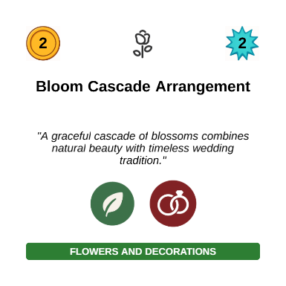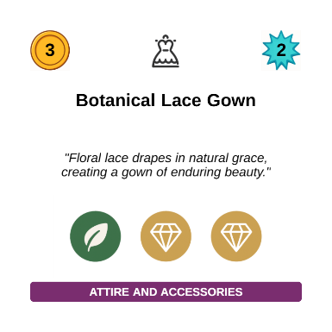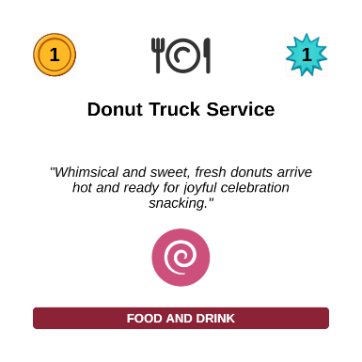
Jennifer’s Hand
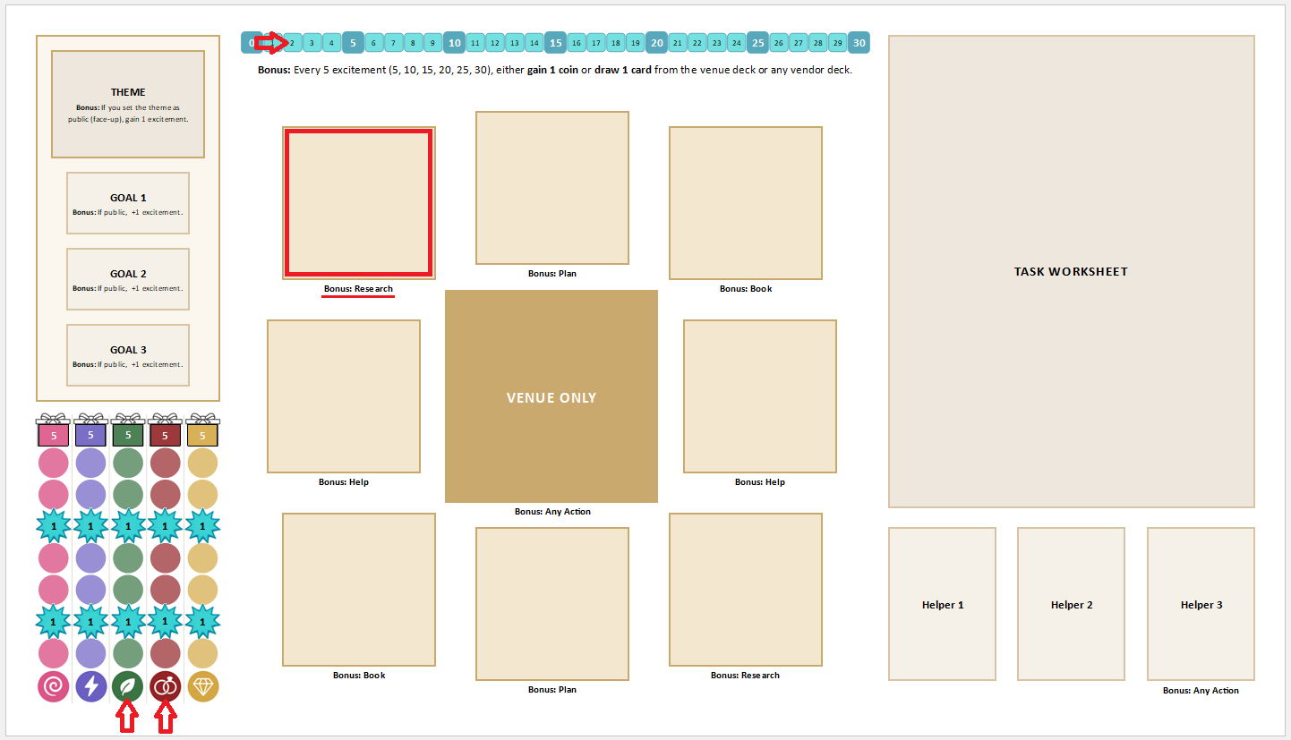
Jennifer’s Player Board

5. ACTIONS IN DETAIL

Research Action
Acquire venue or vendor cards to your hand.

Choose one option:
Option 1: Featured Vendor Row
Take 1 face-up card (vendor or venue) from the Featured Vendor Row (FVR) and add it to your hand.

Option 2: Category Search
Draw 2 venues or draw 2 vendors from a single category. Add both to your hand.

Option 3: Browse for Inspiration
Flip the top Research card. It shows 4 vendor categories. Either:
- Draw 1 vendor from each category
- Draw 1 vendor from 3 of those categories (you choose which 3) and draw 1 venue card.
Note: If any category shown is empty, discard the Research card and flip a new one. Use the new card's categories instead.

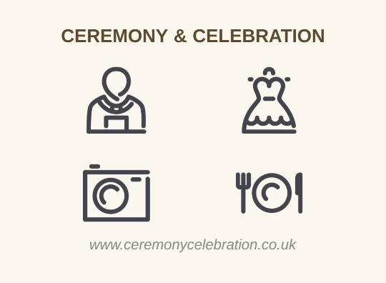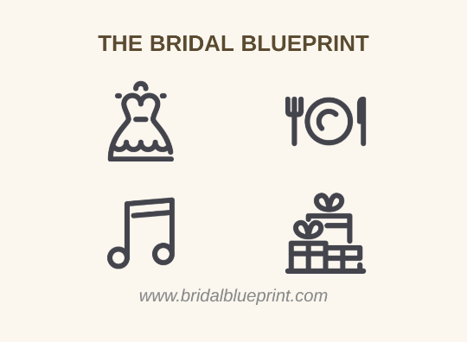
Sample Research Cards

Book Action
Place a vendor or venue from your hand into your 3×3 grid.

Steps:
1. Choose a Card
Select a vendor or venue card from your hand.
2. Pay the Cost
Pay the cost shown on the card.
3. Place in the Grid
Place the card in an empty position on your 3×3 grid. If booking a venue, it must go in the center space.
4. Gain Theme Elements
Advance each theme element tracker shown on the card by 1.
5. Gain Excitement
Advance your excitement tracker by the amount shown on the card.
6. Check Moments
Check if your grid completes any moment. If yes, score it immediately (see Moments in Section 6).
7. Resolve "When Booked" Effect
If the card has a "When Booked" effect, resolve it immediately.
8. Take Grid Bonus Action
Immediately take the bonus action shown on the grid space where you booked. Do not move your meeple.
Fallback: If you cannot take the bonus action, gain 1 excitement instead.

DIY Bookings Instead of paying a vendor's cost and booking face-up, you may book any vendor or venue face-down as DIY for free. Exclusive venues may not be DIY'd. DIY represents doing it yourself or calling on family and friends rather than hiring a professional. DIY bookings still complete moments, trigger grid bonus actions, unlock task dependencies, and contribute to guest goals. They do not trigger When Booked effects, grant theme elements, or grant excitement.

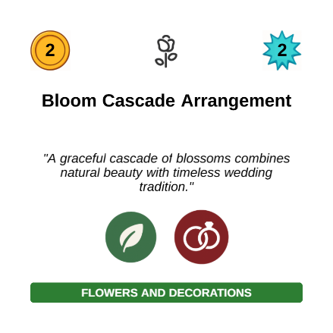
Normal Booking vs Booking as DIY

Plan Action
Apply effort toward completing tasks on your worksheet.

Steps:
1. Apply 3 Effort
Distribute 3 effort marks across any unlocked tasks on your worksheet. You may apply all 3 to a single task or split them across multiple tasks.
A task is unlocked when all of its requirements are met. Requirements are shown on the worksheet: a task may require a specific booking, a key task to be completed first, or both. Tasks with no requirements are always unlocked.

2. Resolve Symbols
As you mark effort boxes, resolve any symbols immediately:


- : Apply 1 additional effort to any unlocked task
- : Gain 1 excitement
- [ # ] : Gain that many gifts

When all effort boxes on a task are filled, it completes. Gain its gifts, resolve any remaining symbols, and mark it on your completed tasks tracker. Check the tracker for milestones:
- 4, 8, 12, 16 tasks: Gain 1 additional effort immediately
- 10 tasks: Gain 1 excitement
- 20 tasks: Gain 5 gifts

Key tasks are marked on the worksheet. Completing a key task unlocks the next group of dependent tasks. Key tasks can only be worked on by you, not by helpers or your wedding planner.
3. Wedding Planner Effort (Optional)
If contracted with your wedding planner, you have a separate pool of 3 effort trackers that can be applied to any unlocked, non-key task during any Plan action.

Help Action
Wedding planning can feel overwhelming. Sometimes you need to call in a favor. The Help action represents reaching out to friends, family, and others in your life who want to support you.

Steps:
1. Choose a Help Deck
Decide what kind of help you need and draw the top card from that deck:
- Money Help: financial support
- Effort Help: help with tasks (never key tasks)
- Research Help: vendor connections and referrals

2. Read and Resolve
Each card represents a person you've called. Read their offer and resolve it. Some cards present a choice. Decide and follow through immediately.
Note: Some cards include a commitment with a penalty at endgame if not fulfilled.

3. Place Helper
Place the card in your next available helper slot on your player board:
- Face-down if fully resolved
- Face-up if the effect is delayed or a commitment is still pending

Helper Limit: You may have at most 3 helpers total. When you fill your third slot, immediately take an Any Action bonus. Once all three slots are filled, you cannot take the Help action again.
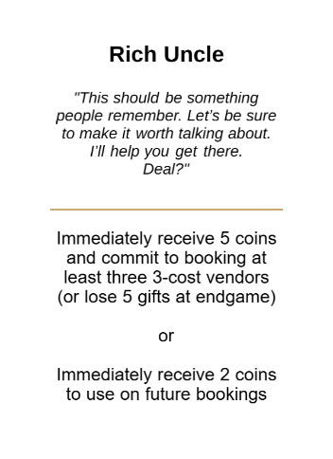
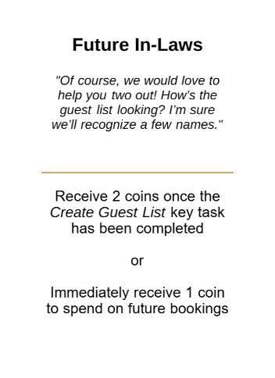
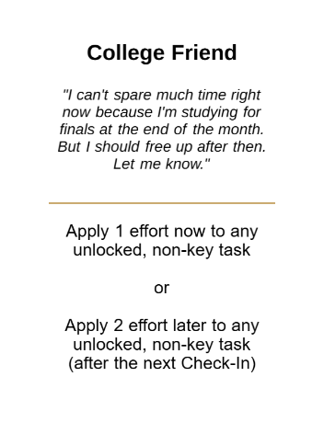

Sample Money, Effort, and Research Help Cards

6. MOMENTS
Every wedding has moments that define it. In The Wedding Planner, those moments live in the shape of your choices, specifically the vendors you book. Their placement on your grid forms patterns, patterns that tell the story of your wedding day.

Moment Scoring
Check after every booking action, including bonus bookings. If your grid exactly matches a revealed Moment, score it immediately. Filled positions must have cards booked, and empty positions must be empty.
Each Moment shows two values: First and Others. Everyone who completes a Moment in the same month receives the First value. After that month ends, all subsequent completers receive the Others value.
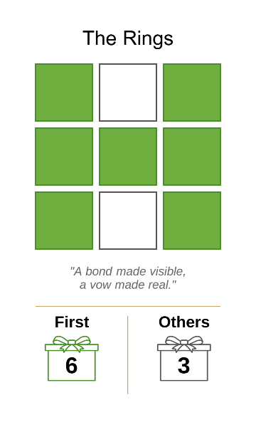
A Moment in Action: The Rings requires seven booked positions -- every position except the top and bottom center. When you place your seventh card into one of those positions, check your grid. If the two center positions are still empty and everything else is filled, you've completed The Rings and score immediately. If you’re the first player to complete The Rings, you will collect 6 gifts immediately. Everyone else who completes it in the same month will also receive 6 gifts. If a player completes it in a later month they will collect only 3 gifts.
"A bond made visible, a vow made real."

Designer Note: If you look closely you’ll see the couple facing each other exchanging rings.

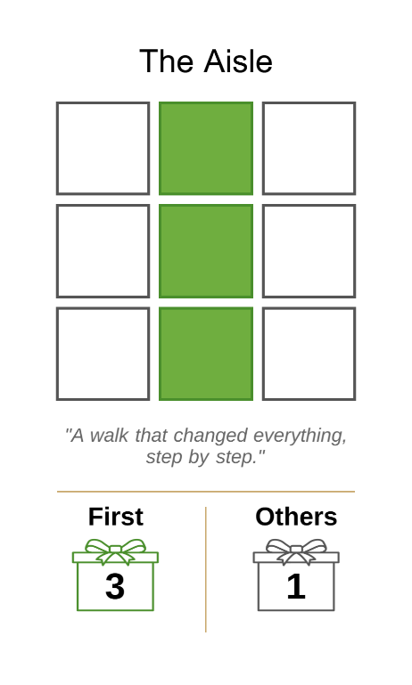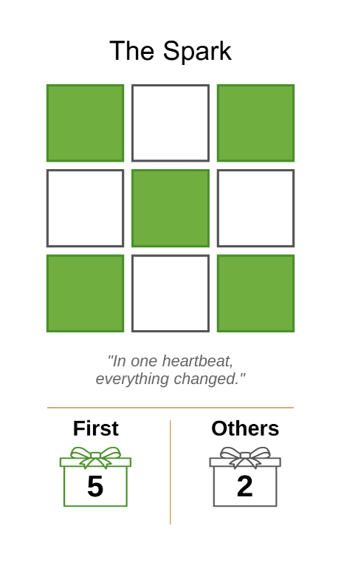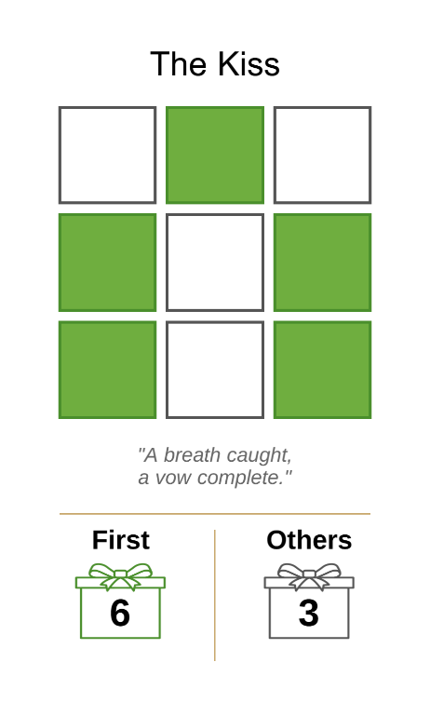

What do you see when you look at these moments?

7. THEME SYSTEM
Your wedding's theme is the aesthetic vision that ties your choices together. The theme system uses five elements that appear on vendor and venue cards.

The Five Theme Elements
1. Whimsy (pink spiral) - Playful, magical, whimsical
2. Edge (purple lightning) - Bold, modern, unconventional
3. Nature (green leaf) - Organic, natural, outdoor
4. Tradition (maroon rings) - Classic, formal, traditional
5. Elegance (gold diamond) - Luxurious, refined, sophisticated

Theme Cards
At setup, you drew 2 Theme cards from the 10 possible themes. Each Theme card combines 2 elements. At the first Check-In (after Month 3), you'll choose 1 of your 2 Theme cards and place it on your Vision board. This determines which 2 elements are your "theme elements" for Theme Goal scoring.

Theme Element Trackers
Your player board has 5 theme element trackers (Whimsy, Edge, Nature, Tradition, Elegance), each with positions 0-8+.
Gaining Theme Elements:
When you book a vendor or venue face-up, advance each theme element tracker shown on the card by 1. For each Wild icon, choose any tracker to advance by 1. Trackers stop at position 8. No further progress or bonuses beyond that. DIY bookings grant no theme elements.
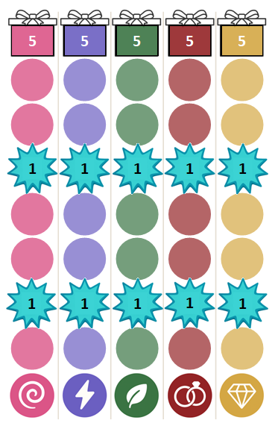
Milestones:
Gain 5 gifts when you reach this milestone
Gain 1 excitement when you reach or cross here
Gain 1 excitement when you reach or cross here
All theme element trackers start here

8. EXCITEMENT SYSTEM
Excitement represents the buzz and anticipation building for your wedding. It is gained from bookings, milestones, and other effects throughout the game. At game end, your final excitement position converts directly to gifts.
Your excitement track runs from 0-30. The tracker stops at position 30. No further progress or bonuses beyond that. At every 5 positions (5, 10, 15, 20, 25, 30), choose one:
- Gain 1 coin, OR
- Draw 1 venue or any vendor (top card of any deck)

If contracted with your wedding planner: You may draw from the Featured Vendor Row instead.
DIY bookings grant no excitement.

9. VENUES
Venues are the centerpiece of your wedding, the physical space where your ceremony and reception occur.

Venue Basics
- Venues must be booked in the center position of your 3×3 grid
- You must book exactly 1 venue per wedding
- If you reach end of game without booking a venue, there is no wedding. You cannot win.
- The center position grants the "Any Action" bonus when booked -- take any one action as a bonus without moving your meeple

When Booked Effects
All venues have powerful "When Booked" effects that trigger immediately when placed:
Effect Types:
- In-House Vendors: Add unique vendor cards to your hand (not from regular decks)
- Referrals: Draw vendors from specified categories
- Task Completion/Effort: Auto-complete or apply effort to specific tasks
- Constraints: Limit what you can book, or in what order

If a venue instructs you to take an in-house vendor, find it on the In-House Vendor Sheet and slip it out of its sleeve into your hand.
Some in-house vendors also have their own "When Booked" effects that trigger when they are booked.
A Venue in Action: When you book the Sunlit Vineyard Lawn, their Estate Wine Tasting becomes exclusively available to you, an in-house Food and Drink vendor added to your hand that no other venue can offer. They also connect you with another Food and Drink vendor from their network. This is the heart of what venues offer: introductions to vendors they already trust, and sometimes exclusives you can only get by choosing them.

Venue Hand Limit
You may have at most 3 venue cards in hand at any time. Once you book a venue, immediately discard all remaining venues from your hand to the Featured Vendor Row.
Variant: Stolen Venue (see Setup, Step 3)
Once a venue is booked, its duplicate is immediately removed from the game -- even if it's in a player's hand.

10. WEDDING PLANNERS
Wedding Planners offer professional services that ease the planning process, for a price.

Contracting
At setup, you received one of eight Wedding Planner contracts. At any point during the game, on your turn, you may pay 3 coins to contract with your planner. Take 3 effort trackers from the shared supply and place them on your contract. This does not consume your action.
Contracting is permanent. While contracted, your wedding may include at most one DIY booking in total. You may not contract if you already have two or more DIY bookings.

The Three Services
Service 1: Access
When you reach excitement milestones and choose to draw a card, you may instead take a card from the Featured Vendor Row.

Service 2: Coordination
You receive a pool of 3 effort tracked on your Wedding Planner contract. During a Plan action, you may spend one or more of this effort on any unlocked, non-key tasks in addition to your normal 3 effort. Remove a tracker each time effort is used. Once all 3 trackers are spent, this service is exhausted.

Service 3: Exclusive Access
Your exclusive venue is sleeved onto your contract and visible from the start of the game, giving you a preview before you decide to contract. It does not count toward your hand limit. When you book it, take it from the sleeve and book as normal. The exclusive venue may not be booked as DIY.

11. PERSONALITIES
Personalities add variety between plays and nudge you toward different strategies. Each one changes how you play in a unique way.
At setup, each player is dealt two Personality tent cards, chooses one, and discards the other. Your Personality is yours for the entire game and may do any combination of the following:
- Modify your starting components
- Change an existing rule for you
- Restrict certain actions
- Give you a one-time ability to use when the moment is right

The card is self-contained. Everything you need to know is printed on it.
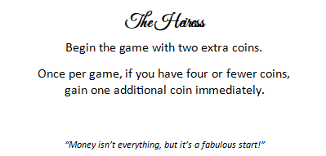


The Front and Back of The Heiress Personality tent card

12. CHECK-INS
After Months 3, 6, and 9, everyone pauses for a Check-In. This is when you set goals and prepare for the next quarter.
There is no Check-In after Month 12. The game proceeds directly to endgame scoring.

Check-In Structure
Perform these steps in order:
1. Move All Meeples to Vision Boards

2. Set Theme (First Check-In Only)
At Check-In 1 (after Month 3), you must choose 1 of your 2 Theme cards and place it on your Vision board (face-down to keep it private, or face-up to make it public and immediately gain 1 excitement). This determines your 2 theme elements for Theme Goal scoring. Discard the unchosen Theme card face-down.

3. Set a New Goal
Choose 1 goal type you haven't set yet and place it on your Vision board. You may set it face-down to keep it private, or face-up to make it public and immediately gain 1 excitement.
You may flip private goals to public later, but you do not gain excitement if you flip them after the Check-In.

4. Clear Featured Vendor Row
Discard all face-up cards from the Featured Vendor Row to the bottom of their respective decks.

5. Pass First Player Token
Give the First Player token to the next player clockwise.

6. Reveal New Featured Vendors
The new first player chooses 5 distinct vendor categories and reveals 1 card from each face-up in the Featured Vendor Row.

Check-In Complete
Advance the timeline token to the next month and begin the next quarter. The first player takes the first turn.

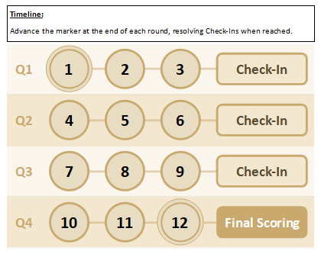

13. GOALS
Goals capture your vision for the wedding. Each goal type asks a different question about the kind of wedding you want to create and the kind of experience you want your guests to have. There are no wrong answers. Subtle is not less than Unforgettable. Refined is not less than Extravagant. The harder the vision is to achieve, the greater the reward, but the vision itself is yours alone.
Over the three Check-Ins, you will set three of the four goal types, one per Check-In.

1. Theme Goals
How do you want to describe the overall vision for your wedding?
Theme Goals evaluate how well you pursued your 2 theme elements.
If your final trackers meet or exceed your goal's condition, you score your goal's gifts. If you fall short, you score nothing.

At endgame, look at your theme element trackers and compare:
- Your 2 theme elements (shown on your chosen Theme card)
- Your 3 non-theme elements

Unforgettable - 30 gifts
Only your 2 theme elements have progress. All other 3 elements are at position 0.
Thematic - 20 gifts
Your 2 theme elements are the only top 2 elements. No ties with non-theme elements for the top 2 positions.
Coordinated - 15 gifts
Both of your theme elements are in the top 2 positions. Ties are allowed.
Subtle - 10 gifts
At least one of your theme elements is in the top 2 positions.
Bonus: Balanced
Every player has a Balanced bonus. At endgame, if your 2 theme elements are exactly equal, flip it and gain 5 additional gifts. This stacks with any theme tier above.

2. Budget Goals
How lavish do you want your wedding to feel?
Budget Goals evaluate the cost distribution of your booked cards. DIY cards do not count.
At endgame, count how many cards you booked at each cost tier (1-cost, 2-cost, 3-cost). You score your goal if your chosen tier has the most cards among all tiers. If two or more tiers are tied for the most, you score as long as yours is one of them.

Extravagant - 15 gifts
Most of your booked cards cost 3+ coins.
Refined - 10 gifts
Most of your booked cards cost 2 coins.
Modest - 5 gifts
Most of your booked cards cost 1 coin.

3. Excitement Goals
How electric do you want your wedding to feel?
Excitement Goals evaluate the excitement distribution of your booked cards. DIY cards do not count.
At endgame, count how many cards you booked at each excitement value (1-excitement, 2-excitement, 3-excitement). You score your goal if your chosen tier has the most cards among all tiers. If two or more tiers are tied for the most, you score as long as yours is one of them.

Spectacular - 15 gifts
Most of your booked cards grant 3+ excitement.
Vibrant - 10 gifts
Most of your booked cards grant 2 excitement.
Intimate - 5 gifts
Most of your booked cards grant 1 excitement.

4. Guest Goals
How do you want your guests to feel?
Guest Goals evaluate booking multiple vendors from a specific category.
At Check-In, choose one of these 9 Guest Goals:
- Admired: Photography vendors
- Amazed: Flowers & Decorations vendors
- Captivated: Entertainment vendors
- Honored: Stationery vendors
- Impressed: Attire & Accessories vendors
- Indulged: Food & Drink vendors
- Moved: Ceremony vendors
- Pampered: Favors & Gifts vendors
- Spoiled: Transportation vendors
(No Guest Goal for Venue. You must book exactly 1 venue.)

Scoring at endgame:
- 3+ vendors in chosen category: 15 gifts
- 2 vendors in chosen category: 10 gifts
- 1 vendor in chosen category: 5 gifts

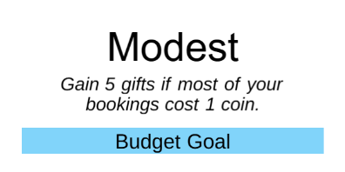
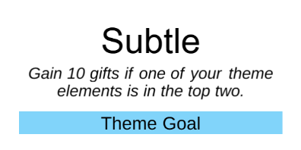
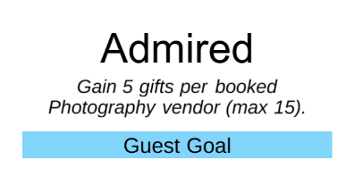
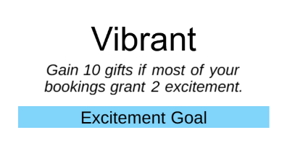

Sample Guest, Budget, Theme, and Excitement Goals

14. AWARDS
There are two types of awards: Race Awards and Endgame Awards. Race Awards go to the first player to achieve a specific milestone. Check for Race Award completion immediately after any booking, task completion, excitement gain, or other relevant effect. If multiple players reach it in the same month, all of them receive it. Endgame Awards are evaluated at the end of the game and go to whoever best meets the condition. If tied, all tied players receive it.

Race Awards (7 gifts)
- First Spark -- Be the first player to reach 12 excitement
- Ahead of Schedule -- Be the first player to complete 8 tasks
- Booking Momentum -- Be the first player to book 4 vendors face-up
- DIY Sprint -- Be the first player to DIY 3 vendors
- Theme Breakthrough -- Be the first player to reach 5 on any one theme element track

Endgame Awards (5 gifts)
- Most Well-Rounded -- Have the most different vendor categories among your vendors (including DIY)
- Most On-Theme Vendors -- Have the most vendors matching at least one of your chosen theme elements
- Most Planned -- Have the highest number of completed tasks
- Most Balanced Theme -- Your weakest theme element is stronger than every other player's weakest theme element
- Strongest Theme Element -- Your strongest theme element is stronger than every other player's strongest theme element

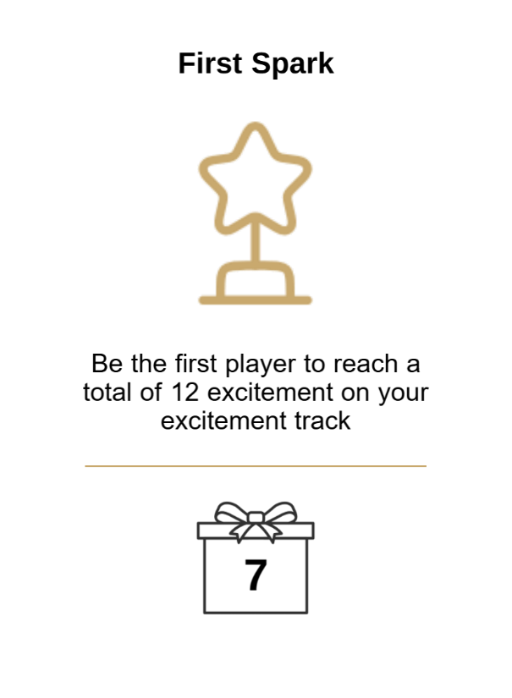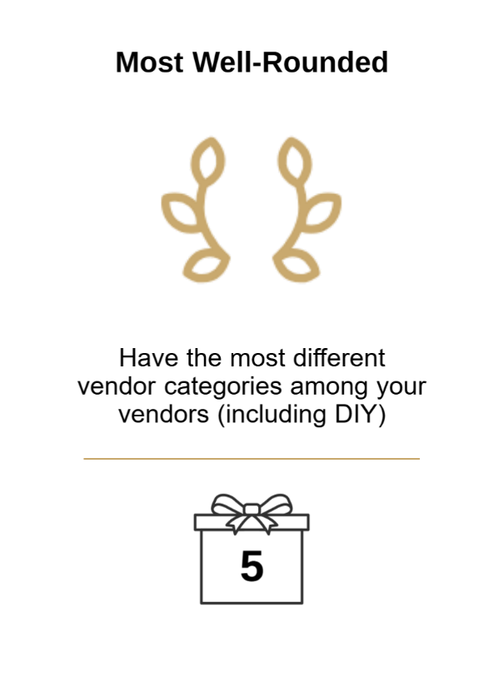

First Spark Race Award Most Well-Rounded Endgame Award

15. END OF GAME
After everyone completes Month 12, the game ends. There is no Check-In after Month 12.

Scoring
Note: If you did not book a venue, you cannot win regardless of your gift total.

Begin with the gifts already collected from moments, completed tasks, and the race award, then proceed in order:
1. Reveal Vision Board
Reveal your Theme card and all goals if still face-down.
2. Convert Excitement
Gain gifts equal to your final excitement.
3. Resolve Pending Helpers
Check any face-up helper cards. Resolve any endgame penalties for unfulfilled commitments.
4. Goals
Evaluate whether you achieved each of your 3 goals. Check for the Balanced bonus.
5. Awards
Evaluate the Endgame Award and give all award winners 5 gifts.

Total Scores
Count up your gifts and compare your totals.

Winner!
The player with the most gifts wins!

Tiebreaker
If you tie on total gifts, apply these tiebreakers in order:
1. Most vendors booked
2. If still tied: Most tasks completed
3. If still tied: Highest excitement position
4. If still tied: Shared victory


16. CLEANUP
After scoring, return the following before storing the game:
1. In-house vendors: Collect all cards with an asterisk (✱) on the card back and return them to their sleeves on the In-House Vendor Sheet.
2. Exclusive venues: Return each Wedding Planner's exclusive venue face-down to its sleeve on the respective Wedding Planner contract.

17. QUICK REFERENCE

Turn Structure
1. Choose action, move meeple
2. Resolve action
3. Resolve bonus actions (don't move meeple)
4. Check hand limit (5 cards total, at most 3 venues)

Four Actions
Book: Pay → Place → Theme/Excitement → Moment → Effect → Bonus
Plan: Apply 3 effort to unlocked tasks
Help: Draw from Money/Effort/Research deck, choose option, place in slot (max 3)
Research: FVR (take 1) / Category (draw 2) / Browse (flip Research card and draw 4 or draw 3 + 1 venue)

Check-Ins (After Months 3, 6, 9)
1. Move all meeples to Vision
2. Set Theme (Check-In 1 only)
3. Set 1 new Goal (private or public)
4. Clear FVR
5. Pass First Player token
6. Seed new FVR (5 cards)

Scoring Summary
1. Reveal Vision Board: Reveal Theme card and all goals
2. Excitement: Gain gifts equal to your final excitement
3. Helpers: Resolve any endgame penalties
4. Goals: Evaluate the 3 goals set at Check-In
5. Awards: Determine the Endgame Award recipient

Most gifts wins!

Tiebreaker: Most vendors → Most tasks → Highest excitement → Shared victory

FAQ
Q: What does "tied for the top two" mean on the Coordinated goal?
No element outside your theme can outrank both of your theme elements. Ties are fine. What fails Coordinated is a non-theme element sitting strictly above both of yours.

Q: What happens if a Help deck is empty?
Once a Help deck is empty, it remains empty for the rest of the game.

Designer Notes
The Wedding Planner began as a love letter to the wedding planning process: the overwhelming task lists, the hunt for the perfect vendors, the tension between vision and budget. After three years of brainstorming, design, development, and more than a hundred hours of playtesting, the game has evolved into a medium-weight euro that celebrates weddings in all their forms.
Special thanks to our play testers, whose feedback have shaped every system. To the couples who shared their wedding stories. To everyone who sees themselves in this game.
May your wedding, in cardboard or in life, be filled with joy, laughter, and love.

Jose Alberto Lema
© 2026 Llama Oboe Jester. All rights reserved.

