June 6, 2021
Laura Lamoureux
llamoure@syr.edu
SUID: 823691551
Portfolio milestone report
Syracuse University – Applied Data Science
Table of Contents
Introduction 1
Introduction to Data Science (IST-687) 1
Scripting for Data Analysis (IST-652) 1
Information Visualization (IST-719) 1
Introduction to Information Security (IST-623) 1
Information Policy (IST-618) 1
Learning Objectives and Conclusion 1

Introduction
The Applied Data Science Program at Syracuse is designed to provide students with the knowledge, skills, and resources to be professionals in the world of Data Science. Throughout the program instruction is focused on programing skills in SQL, Python, and R; data gathering, cleaning, and prepping; data analysis and visualization; and perhaps most important, the skills to communicate to all levels of understanding: where the data came from, how the data was shaped and molded, and what the data tells us.
While each course has its own goals and objectives for the students to accomplish, it is the Portfolio Milestone Report and Presentation that unifies the work of the individual courses. The Applied Data Science Program asks students to apply seven Learning Objectives to their work from those courses and present how their work reflects those Learning Objectives. The seven Learning Objectives are:
- Overview of the Major Practice Areas in Data Science.
- Collect and Organize Data.
- Identify Patterns in Data via Visualizations, Statistical Analysis, and Data Mining.
- Develop Alternative Strategies Based on the Data.
- Develop a Plan of Action to Implement the Business Decisions Derived from the Analysis.
- Demonstrate Communication Skills Regarding Data and its Analysis for Relevant Professionals in their Organization.
- Synthesize the Ethical Dimensions of Data Science Practice.
This report is organized by course projects and how those projects accomplished one or more of the learning objectives listed above.

Introduction to Data Science (IST-687)
This course introduces data collection, processing, transformation, management, and analysis concepts. It was also the first course to introduce working with R. There was a group project requirement for this course.

Data
Data was provided to the group from the instructor. The data consisted of 58 columns and 19,343 rows. See IST-687 in GitHub Repository: https://github.com/llamoureux/SyracusePortfolioMilestone for data, glossary and reports submitted.

Question to Answer
Primary question: Could any single variable influence the Net Promoter Score for Hyatt Hotel?

Preparation, Methodology, Observations, Results for Introduction to Data Science
The variable glossary was used to determine which variables to focus on. This led to 22 secondary questions that could help explain what affects the Net Promoter Score. While this may seem like too many questions, in the end not all questions were able to be answered due to a lack of data. This was not obvious until a deeper dive into the data occurred.
Using R, the data was prepped by converting date information to an actual date; removed irrelevant columns and rows; and replaced any “NAs” that were present.
Initial observations of the data included a look at the number of guests that were net promoters, the number of guests that were likely to recommend the hotel, and what the average length of stay was. Using R, we created the histogram and statistics below in Figure 1. The average length of stay was determined to be 2 nights.

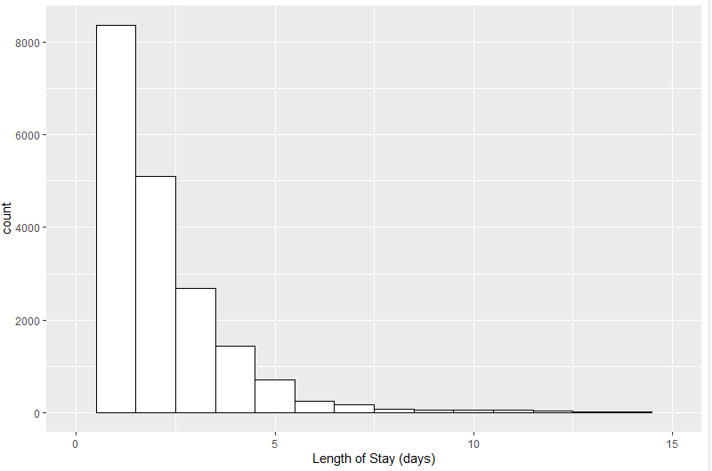 | Length of Stay  mean: 2.404808  median: 2  min: 1  max: 97  sd: 2.992155  quantile: 1 5  skewness: 9.593808
Figure 1: Histogram Depicting Length of Stay

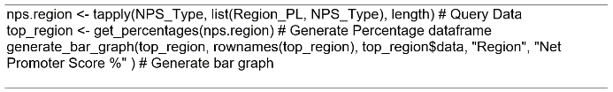
One of the other variables we looked at was which regions had the highest Net Promoter Score (NPS) and therefore does region have an impact on NPS. European hotels appeared to have some of the highest NPS Scores have while Asia Pacific hotels had some of the lowest. Figure 2 depicts the code that was used to create the histogram of NPS by Country visible in Figure 3.
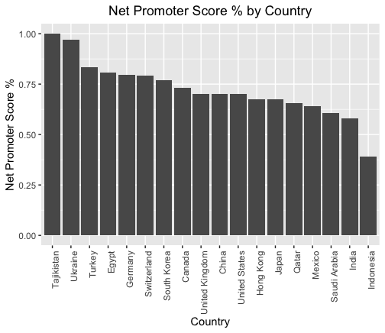
Figure 2: R Code for Creating Histogram Shown Below
Figure 3: Histogram created in R Depicting Highest NPS by Country

“Does age have an effect on Net Promoter Score?” was another question we asked. As seen Table 1 and Figure 4, people in the age group 46-55 are more likely to be promoters than another age group.

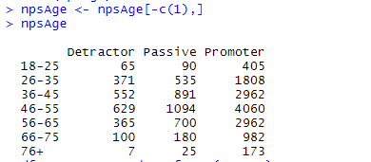
Table 1: R Code and Results Depicting Detractors, Passive, and Promoters by Age Group

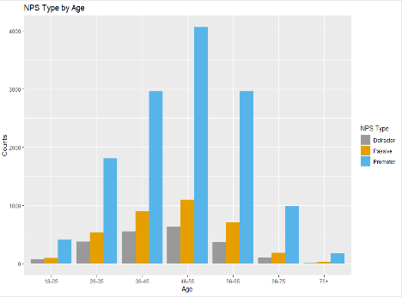
Figure 4: Histogram created in R depicting Detractor, Passive and Promoter by Age Group

We also looked at whether gender has an impact on Net Promoter Score. Using R to answer this question, we discovered that males tend to take the survey more than females; however, females were more likely to be Promoters. Tables 2 and 3 illustrates both points.
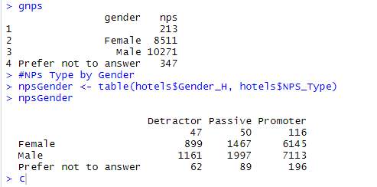
Table 2: R Code and Results Depicting Detractors, Passive, and Promoters by

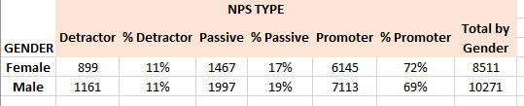
Table 3: NPS Type (Detractor, Passive, Promoter) by Gender

Final Thoughts Regarding Project
This project offered several different learning opportunities. One learning opportunity was being able to communicate with a team that had never met before. Communicating skill levels, interest in the project topic, wins and struggles are all skills that do not always come naturally to everyone. Group projects can often be viewed as more trouble than worth; however, it is important to acknowledge (after a step back) what was gained from a group project. Most importantly, for this project, was knowing it was okay to reach out with questions to someone more skilled in coding, that every voice gets to be heard, and what the project looks like in the middle is often not the final result.
Another important lesson was to start looking at data with the basics: number of columns and rows, column heading names, the structure of the data are examples. This group based the initial work on the data glossary only to find out that not all the data was available. The work continued, and questions were revised. The group choose to acknowledge what was not available in the final report. In hindsight, this was absolutely the right thing to do. As data leaders it is important to always acknowledge what is available, what is not, what can truly be accomplished, and when to ask for help. It serves no one if those things are not being discussed.

Scripting for Data Analysis (IST-652)
IST-652 learning objectives were focused on introducing Python, how to write scripts to work with structured, semi-structured and unstructured data, and prepare and transform data. There was an individual project requirement for this course.

Data
The data for the IST-652 project was found on GitHub. The JSON data file contained 18 columns with 58,292 rows. See IST-652 in GitHub Repository: https://github.com/llamoureux/SyracusePortfolio‌Milestone for data and reports submitted.

Questions to Answer for IST-652
For the IST-652 project there were 3 themed areas of questions about books: rating counts, average rating, and Twitter data. For rating counts, the questions were: what is the percentage of total ratings that each “star” makes up, what does the rating distribution look like, what are the top 20 most rated books, and does page count effect rating count. For average rating, the questions were: what the top 20 most rated authors are, does page count effect average rating, and does the number of text reviews effect the average rating. There were no specific questions for the Twitter data; just a look at what data could be gathered from Twitter using the hashtag books and what initial analysis with Python could be done.

Preparation, Methodology, Observations, Results for IST-652
Python was used to preprocess and analyze the data. Due to the large number of rows available it was determined to limit the data to books that had a language code of “eng”. The data was labeled in an unusual way. The count for ratings was listed in the format of #:###. The number before the colon is the star rating (1 to 5) and the numbers after the colon indicate how many instances that book received that star rating. For example: 1:9896 means that this book received 9896 1-star ratings. Preprocessing included splitting each one of those columns into two columns and adding them back into the data for analyzation later. It was also noted during this preprocessing phase that the “PublishMonth” column was the “Day”, and the “PublishDay” column was the “Month” data.
After the pre-processing was completed, the first question that was answered using Python was the rating distribution. While Figure 5 displays the Python code and results, it is much more telling to see the results that readers are more likely to rate books with 3 to 5 stars, represented in Figure 6.
Figure 5: Python Code and Results for Percentages of Ratings
Figure 6: Python Graph Depicting the Overwhelming Trend of 3-5 Star Ratings.

It came as no surprise that the top 20 books included many of the Harry Potter series. There were also some classic titles in that list as well. The difficulty in looking at the top 20 books is discerning all of the different ‘versions’ of book – from a cover change to a new forward if a classic book, to a different publisher. This issue can be seen here where the top book “Harry Potter and the Sorcerer’s Stone” is listed as the top most book and the third top most book; and “The Great Gatsby” is the sixth book in the list while “Fitzgerald’s The Great Gatsby” is the seventh.
Figure 7: Python Graph Showing the Number of Books with the Most Ratings
The top 20 authors data could also be considered skewed due to the different editions of their books that have been published over time.
Figure 8: Python Graph Showing the Number of Authors with the Most Ratings

Twitter data was gathered by looking at the tweets with the hashtag books (#books). Python was used to determine how many times a tweet with “#books” was retweeted less than 50 times and those retweeted more than 100 times.
Figure 9: Python Code and Results for Tweets that Have Less than 50 Retweets and Tweets that Have More Than 100 Retweets
The other interesting find from the “#books” Twitter data was that often a hashtag gets used when it does not have much to do with the tweet it is attached to. This is done because a hashtag is viewed as being popular and people want their tweets read. This can be seen in the list below as hashtags attached to the original books’ hashtag. As fun and interesting as Data Science and Python are, it is surprising how often those two tags were added to a tweet that started with “#books”.
Figure 9: Python Code and Results for the Frequency of Hashtags

Final Thoughts Regarding Project
Learning how to use Python was a particular challenge for this project as learning any new language can be. Taking an overall look at the data before diving into the work proved critical once again. Realizing that the “PublishMonth” column held “Day” data and “PublishDay” held the “Month” data early in the process saved a considerable amount of time and frustration later into the project.

Information Visualization (IST-719)
IST-719 learning objectives continued the learning of R started in IST-687, how to use Adobe Illustrator, how to find a story in the data, and how to create visualizations to tell that story. An individual project was required.

Data
The data for the IST-719 project was found on GitHub. The data file contained 14 columns with 10,981 rows. This data was originally collected from the GoodReads social media platform. See IST-652 in GitHub Repository: https://github.com/llamoureux/SyracusePortfolio‌Milestone for data and reports submitted.

Questions to Answer for Information Visualization
IST-719 used a similar book data for the IST-652 project. However, this project was focused on the visualization of book data. Visualizations were created for what languages were represented in the data, what was the average number of pages, which publisher published the most books, which authors had the most books and the most pages, and what do ratings tell us about us and the authors we love.

Preparation, Methodology, Observations, Results for Information Visualization
A different dataset from GoodReads was used with R. Prepping the data included dropping 4 rows with no data and renaming columns. Column names included BookID, Title, Authors, Average_Rating, ISBN, ISBN13, Language_Code, Num_Pages, Ratings_Count, Text_Reviews_Count, Publication_Date, Publisher.
It should be noted that the aesthetics seen in the plots below may not match the R code. As the final project was to deliver a poster of the story of the data, all the visualization work occurred at the poster level not the R coding level. However, the plots below are from the poster to show the final work related to the project.
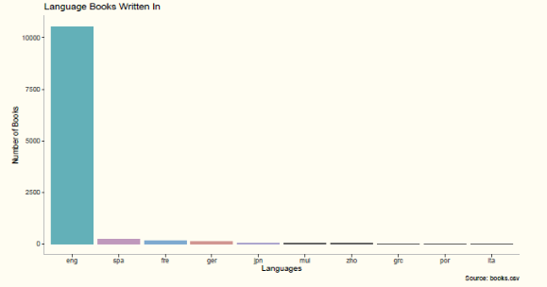
The first question was to look at what language the books were written in. On one hand it was not surprising that almost all the books listed were written in English, it was surprising how under-represented other languages were.
Figure 10: Results of R Code to Display Languages Represented in Dataset
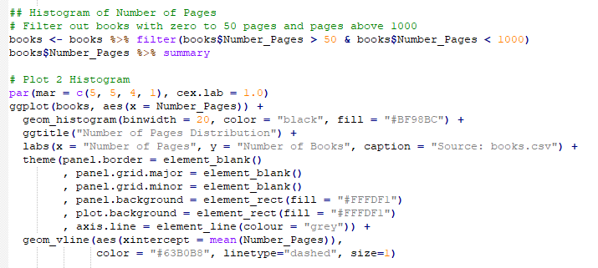
The next question was related to the average number of pages in the dataset. Again, using R a distribution plot was created. As part of the work to create this plot, books with less than 50 pages and books with more than 1,000 pages were eliminated. Reasoning was to attempt to stick with an average book that is out today. R determined that the average book is approximately 333 pages long.
Figure 11: R Code for the Histogram Below

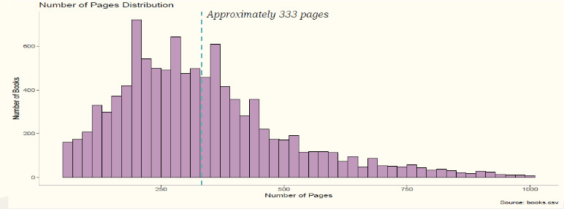
Figure 12: Histogram Representing the Average Number of Pages

Using R a histogram of the authors with the most books was created. Then it was determined what the average number of pages were for those authors. Stephen King turned out to be very prolific with 40 books and a high average number of pages. Then the average rating of the authors with the most books was looked at.
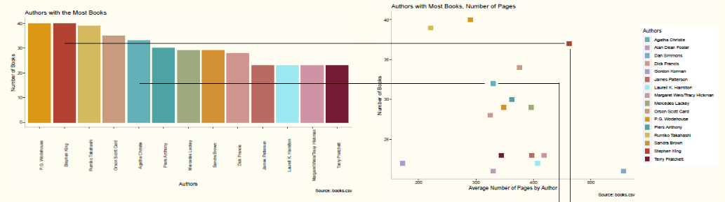
Figure 13: Authors with the Most Books, Number of Pages
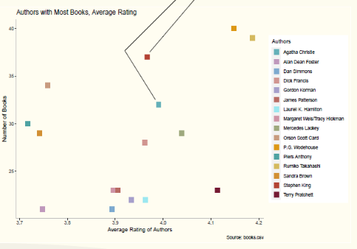
Figure 14: Authors with the Highest Average Ratings

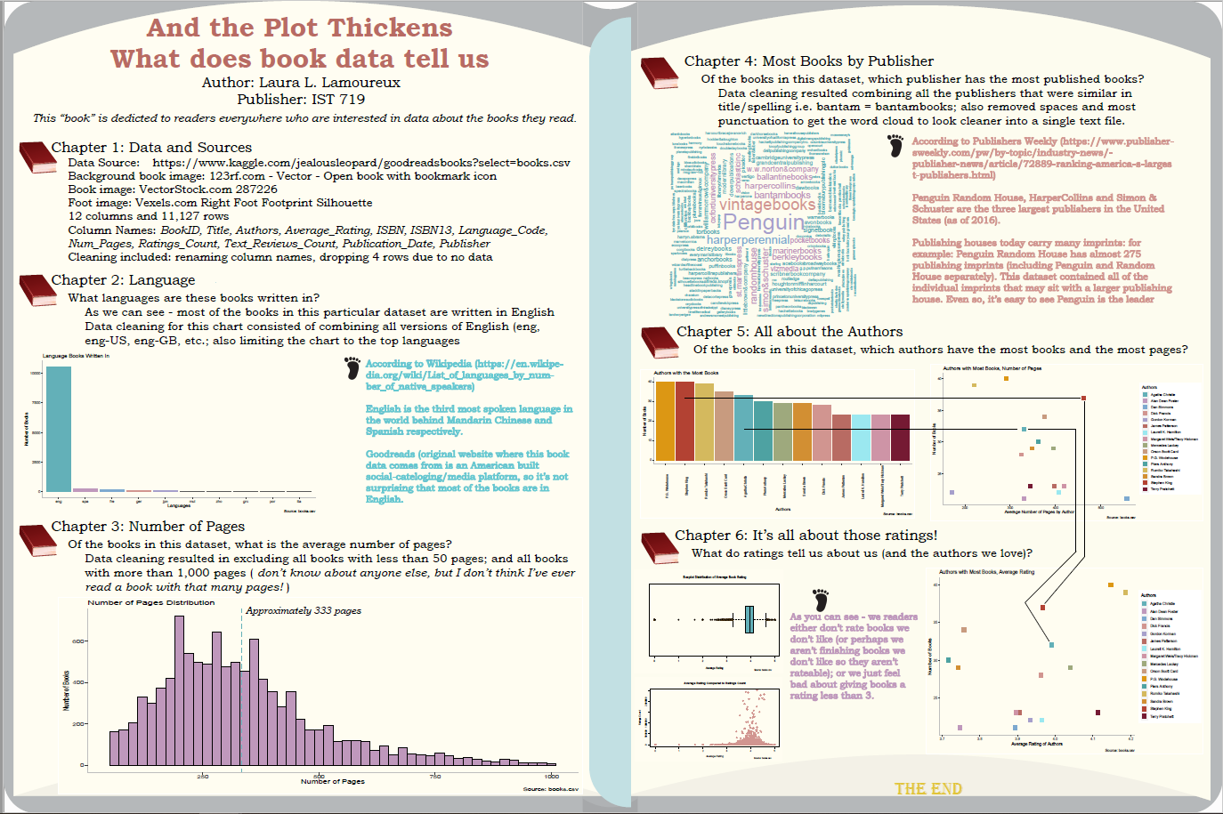
Figure 15: The Final Poster for Information Visualization

Introduction to Information Security (IST-623)
This course introduces the fundamentals of Information Security while providing hands-on ability to understand the complexities inherent within information security

Project Presentation
The goal of this project presentation was to identify a security concern as a group, conduct research and present findings. What was different about this group project was the decision (with instructor approval) to add a human element to the security concern identified. The full presentation can be found in the IST-623 folder in the GitHub Repository: https://github.com/llamoureux/SyracusePortfolio‌Milestone.
The group wanted to focus on Jamal Khashoggi and how information security (or the lack thereof) contributed to Khashoggi’s death. The NSO Group is an Israeli technology company that proclaims to be developing technology to prevent and investigate terror and crime (see https://www.nsogroup.com/‌about-us/ for more information). They are the creators of Pegasus; a software that can be installed remotely on a device without the end user being aware it is has been installed
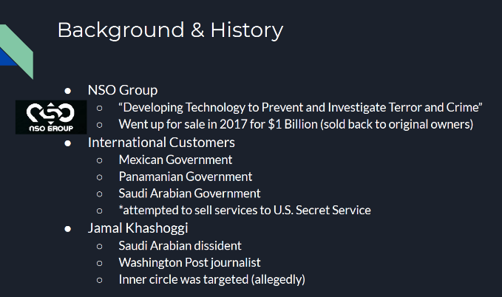
Figure 16: Slide 2 from IST-623 Project Presentation

Jamal Khashoggi was a Saudi Arabian dissident journalist living in the U.S. He went to the Saudi Arabian consulate in Istanbul to obtain documents related to his upcoming wedding. Khashoggi was never seen from again.
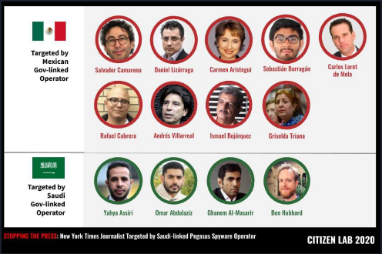
It is believed that the Saudi Arabian government was able to have Pegasus installed on the phone of a close friend of Khashoggi’s, without the friend being aware that it was installed. Pegasus was able to monitor communication between the friend and Khashoggi. The communication that was monitored led to Khashoggi being confronted and killed at the consulate. Pegasus software has been found on devices owned by other Saudi Arabian citizens critical of their government as well as Mexican and Indian citizens critical of their own governments.
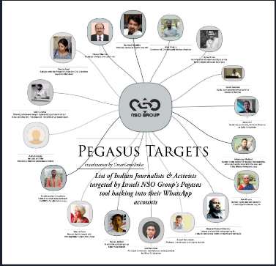
Figure 17: Slide 7 from IST-623 Project Presentation
Figure 18: Slide 7 from IST-623 Project Presentation
Once Pegasus is on a device it has access to everything from phone calls, instant messages, to file and location tracking. Pegasus does not need to rely on social engineering. It creates a missed call on your phone, and it is then installed; often the missed call is wiped from the memory of the phone after Pegasus is installed.
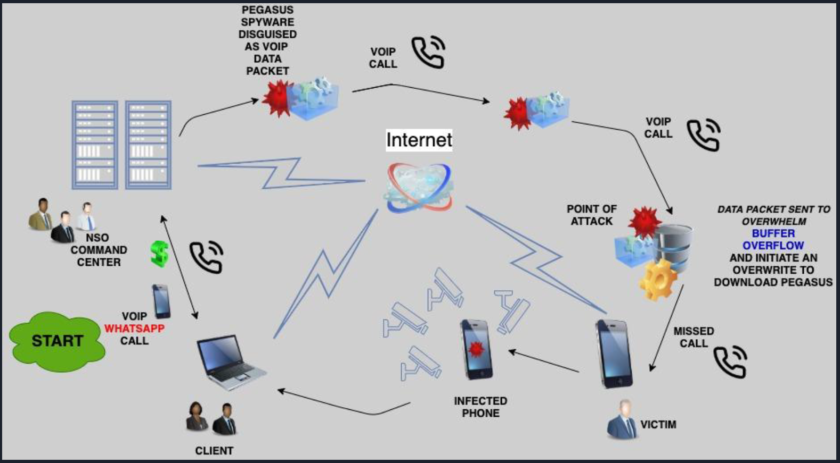
Figure 19: Slide 15 from IST-623 Project Presentation
The ability of this tool, which was developed initially to help governments combat terrorism, is now being used as a way for a government to spy on its own citizens, especially when those citizens are very vocal about their disagreement with government decisions.

Information Policy (IST-618)
This course provides an overview of public policy issues that affect information technology. It also provides on hands experience in researching policy issues and debating those issues based on the discoveries of research. The full papers mentioned here can be found in the IST-618 folder in the GitHub Repository: https://github.com/llamoureux/SyracusePortfolio‌Milestone.

Reflection Essay: Information Access and Affordability Paper: Voting is a Right
Low-income is considered 200% of the Federal poverty level. The low-income population faces barriers to education, assistance services, health, and voting. Voting is an inalienable right that the constitution grants to its citizens. Identified barriers to voting for low-income people included voter registration, transportation, and voting literacy. Digital voting could reduce these barriers if systems are in place to alleviate inaccessibility to the internet and/or devices, to ensure security of election data.
Our country should not ignore the potential impact that digital voting could have on our elections. Regardless of any affiliation, as a citizen of this country, we should want all voices to be heard. Offering options to marginalized groups such as the low-income population ensures that America remains as democratic as possible.
Digital voting is not a solution for today due to cost and inherent suspicion with the service. It may be a solution for tomorrow. However, we should start considering all the ways we can include all of the populations into the voting process now. Starting with making the information on voting including how to and where to vote, accessibility options, understanding the voting process accessible today. Municipalities need to work inside those areas where our most marginalized citizens are. Find out from them what can be done to get them to vote. Voting information should never be buried; and it should be disseminated in as many ways as possible. Once that happens, offering different ways to vote will happen naturally.

Reflection Essay: Privacy and Security: Personal Information Collection: Canada and Blackberry
Personal information collection is commonplace today. Governments like Canada and Canadian private sector companies like Blackberry Limited collect information on citizens all the time. This personal information includes name, location, race, gender, income to name just a few pieces. Canada has two privacy acts that indicate what might be collected and what is being done with that information. These two acts separate public and private sector rules in relation to personal information collected. Blackberry Limited maintains a privacy policy on their website for users to read. Ensuring accountability for collecting and using personal information is tantamount for a better digital world.
All citizens should be concerned about the information that anyone including the government is collecting on them. No one country is doing everything perfect. Canada itself recently released personal information about its citizens to a third party. These types of incidents should not be the norm (like it appears they are today). National and global private sector companies need to do their part as well. They need to be more proactive in protecting the data they collect; more transparent about what they are doing with that data. Privacy concerns are not going to abate any time soon. It is up to each of us to learn and understand how different privacy rules affect our daily lives and to encourage the companies with which we do business to be and do better.

Debate Essay: Law Enforcement Need for Backdoors into Devices and Software
*This is a debate essay: the pro side of law enforcement needing access. The con side was argued by someone else.
Security - Criminals use the advances in information technologies to perpetuate and further their criminal activity in ways that can go undetected. DHS, FBI and other law enforcement entities are facing significant challenges in combating crime in cyberspace. Whether it is domestic or foreign terrorism, disinformation campaigns, hacks, surveillance or other issues, there are unique implications on security in the digital age and governments should have as many tools in their toolkit they need. Apple and other cellular companies must create a backdoor for law enforcement to defend national security.
Law enforcement needs all possible tools in its toolbelt in order to prevent, stop and solve crimes. One missing tool in today’s world, is the ability to get into encrypted devices, i.e. a backdoor. It isn’t just about getting into a device; it’s also about getting into a device in a timely manner. If lives are at stake as they often can be in a terrorist attack; we do not need to be hampering law enforcements efforts to protect our citizens. If people are innocent, then they have nothing to fear with law enforcement having this tool available to them.
One of the main tenants of government is to protect its people. In order for the government to do that, it must have all the tools in that toolbelt. That includes the use of a backdoor. It seems odd that we’ve turned our lives over for their protection, yet we attempt to prevent them from doing so. Is it so impossible that this can’t be made possible? Let’s help Law Enforcement do what we’ve asked them to do. There is already encryption backdoors with key recovery systems in place, there is a significant lack of privacy accepted with social media practices and our national need for security is critical in the perilous times we live in. Let them in, it’s the best thing we can do for law enforcement and our safety.

Learning Objectives and Conclusion

Review of Learning Objectives
(1) Describe a broad overview of the major practice areas in data science.
It would be difficult today to find any industry that is not using data to some capacity. Whether that be sales data: items purchased and what time of day they were purchased; healthcare data: number of visits to the emergency room and why; education data: enrollment and attendance; stock market data: predicting the highs/lows of a stock; manufacturing data: how long it takes to assemble item and how many items are waiting to be shipped. The examples of how data are being used (and can be used) are endless. Data Science uses reliable, scientific means to collect, store, and analyze data and then to tell a “story” with the data. The data collected and stored are used for descriptive, predictive, and prescriptive analysis. These are the major practice areas in Data Science.
Descriptive analysis tells the story of what has happened in the past. Data are looked at using statistical models, typically over time. Historical trends are looked at to help determine why something is happening. In the education industry (pre- COVID-19), a look at attendance over past years and noticing a dip in attendance rates in December and January, could lead to a conclusion that those two months experience high absentee rates due influenza and colds. Often, data are then presented to stakeholders using visualizations: graphs, charts, or dashboards.
Predictive analysis uses historical data to forecast future outcomes. This is usually accomplished by using a machine learning model. Once the machine learning model has accurately tested the historical data it then takes on current data to help predict what will happen next.
Prescriptive analysis uses the information collected during predictive analysis to determine what to do next and what are the possible implications of each course of action. If the trend or pattern discovered during predictive analysis is a good thing – how to keep that trend going; or how best to reverse a negative trend.
Every course taken in the Applied Data Science program provided an overview of tools used, practice areas and issues faced by Data Scientists everywhere. The project for the course IST-687 allowed for a dive into the one of the major practice areas in data science: descriptive analytics. It provided an opportunity to tell a story with the data provided. The introduction of R was crucial. The use and understanding of R are critical skills in data science as it is one the most popular tools that business use today.
The exposure to Python in IST-652 provided hands-on learning of a tool that is likely to be encountered in the Data Science world. Being able to acquire, access and transform structured, semi-structured, and unstructured data within Python was invaluable. The ability to find the data, and to address errors discovered is a skill not just in Python but in all areas.
IST-719 continued the skills learned in IST-687 and provided an overview and hands-on learning of visualization tools. Hands-on learning with current tools leads to critical thinking and data storytelling.
Learning about the broad issues of Information Security in IST-623 is valuable for data scientists to know and understand how to avoid security lapses even small ones; and to keep access to data to those that need to know. The policy issues presented in IST-618, led to new avenues of critical thinking. Using that critical thinking to delve deeper in the technology-related policies can only make the work of a data scientist more valuable.
(2) Collect and Organize Data.
At the heart of Data Science is access to Data. Collecting data can be accomplished through a variety of means. Including an online survey, a filled-out form (paper or digital), or a scanner at a grocery checkout. All these methods collect data and they all store data. The data are then collated/stored for retrieval later. All the projects completed throughout the Program included some version of data collection and organization.
For the IST-687 project, the data provided was already “collected”, this project encouraged learning in reviewing data, in determining what was necessary and what was not, in leaving some room in the objectives to see where the data goes, and in organizing the data in a meaningful way.
Using Kaggle and GitHub provided some interesting challenges for the project in IST-652. Data descriptions vary and it is important to pay attention to the data. The initial data was scraped as it was not going to answer the original questions and learning how to find additional data is an important skill. Also, actively collecting data from Twitter or at the very least understanding how social media data can be collected is a vital skill in today’s job market, where social media is how business is often done.
The IST-719 data was gathered from Kaggle, where it was already organized. There was not much data preprocessing that needed to happen. Especially as this project was more about the visualizations of the data and less about the coding for the project.
In a slightly non-traditional way, both IST-623 and IST-618 provided an opportunity to research for information, to sift through what was important to the story and what was not. While it was not the same as collecting or organizing data for use in Python or R, it remains a relevant skill to use when presenting stories or information.
(3) Identify Patterns in Data via Visualizations, Statistical Analysis, and Data Mining.
Every course taken required some form of presentation, visualizations, and analysis. The IST-687 project brought forth statistical analytical skills by reviewing the results of the R code and concluding that being older, and female is more likely to generate a higher Net Promoter Score. The use of R to provide visualizations helped to see beyond the numbers especially in the question of age group.
Using Python for the IST-652 project, it was easy so just how many 3-stars to 5-stars ratings there were. It led to the conclusion that readers either do not like to rate books they do not like, or they don’t finish books that they don’t like. Perhaps giving a book a 1-star or 2-star rating does not feel okay with the reader. Using R for the poster project of IST-719, number of pages does not matter if it is a beloved author. It is interesting to note that while two different datasets and coding tools were used, the box and whisker plot for average ratings in the poster also supported the conclusion for IST-652, readers do not give many 1-stars or 2-stars ratings.
(4) Develop Alternative Strategies Based on the Data.
The data provided for the IST-687 project did not match the variable glossary that was also included. Having based on the project questions on the variable glossary, it became apparent during the deeper dive into the data that not all questions were going to be able to be answered. Because there were so many questions to answer, having to leave a few unanswered did not take away from the project. In fact, it led to the inclusion of observations and additional question not thought of originally.
As noted in the project for IST-652, started out with one set of data and had to move on to a similar set but curated from somewhere else. Also, the data that was finally used had data errors. Incorrect data for the “PublishMonth”, as there is no 16th or 31st month additional coding was required. The ability to be able to develop a strategy for correcting the data or moving on to a better data set must be part of the learning with data science. Paying attention to what the data is saying at the beginning will lessen the frustration later into a project.
(5) Develop a Plan of Action to Implement the Business Decisions Derived from the Analysis.
For IST-687, based on the conclusions, Hyatt could implement focus on female guests, and those guests that are in the age group 46-55. They could offer the Asia Pacific hotel manages an opportunity to mentor with a European hotel manager to see how they have such high Net Promoter Scores.
During the IST-623 project, it became apparent more education is needed to help people understand how vulnerable their devices are; to remain diligent in what and how they share information electronically.
(6) Demonstrate Communication Skills Regarding Data and its Analysis for Relevant Professionals in their Organization.
Every course including those represented in this document required either an individual or group presentation of the project or papers. Learning how to communicate with visualizations and within a group is skill that takes time and practice. Developing a talking plan for an individual presentation is just as important as it is for a group presentation. It is important to note that when providing a presentation of any kind, having an idea of the audience can be helpful. There may be occasions when assumptions about the audience’s exposure to the data are necessary. All assumptions should be kept to a minimum. Working within a group to facilitate how the presentation was going to start, end, and in which order everyone was going to go in demonstrates the communication skills necessary for any professional. It is also important to ensure that all of those contributing to a project get to have their voices heard.
(7) Synthesize the Ethical Dimensions of Data Science Practice.
IST-623 and IST-618 demonstrated the need for diligence in security and the role of ethics in the work that is accomplished by data scientists. Presenting visualizations in a way that is misrepresenting the data maybe easy to do; but doing so is unethical and will call into question all other data representations. Organizations need to trust that their data scientists will share the truth of the data and keep that data secure.
In conclusion, it would be wrong to assume that all the classes taken, or the projects mentioned earlier are siloed. While some may use R and some Python, the goals and the learning are the same. To attain skills to ensure that data is accurately (as possible) gathered and shared appropriately. That the data are held in a secure fashion, easily retrievable by those who need it. The lessons learned and the skills acquired throughout the course of this program have already been put into use since the first Day of classes.

