NAME  Llanda, Carl Joshua V. |  | DATE  February 04, 2017 | SCORE
SCHEDULE  Saturday 10:00-12:50 | SCORE |  | SCORE

LABORATORY EXERCISES
RECURSION

OBJECTIVES:
- Understand recursion and its parts
- Use recursion to solve programming problems

PROCEDURE:
- Encode the C++ program below.
- Save as rec1.cpp,and rec2.cpp, respectively.
- Compile and run the program by pressing Ctrl + F9.
- For each syntax or logical error encountered in the given program, do the following:
- Correct the error
- Recompile the program
- Repeat step 4 until no errors are encountered in the program.
- Illustrate the output of the modified program.

Program No. 1

#include <iostream>
Output:

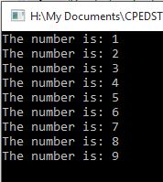
using namespace std;

void numberFunction(int i) {
cout << "The number is: " << i << endl;
i++;
if(i<10) {
numberFunction(i);
}
}

int main() {

int i = 1;
numberFunction(i);

return 0;
}

Program No. 2

#include <iostream>
using namespace std;

int factorial(int);

int main() {
int n;
cout<<"Enter a number to find factorial: ";
cin>>n;
cout<<"Factorial of "<<n<<" = "<<factorial(n);
return 0;
}
Output:

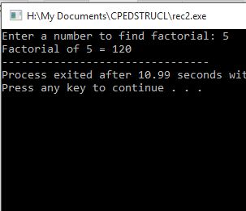
int factorial(int n) {
if (n>1) {
return n*factorial(n-1);
}
else {
return 1;
}
}

Supplementary Problem

- A recursive function that sums up the 10 integers in an array.

Program:

#include <iostream>
using namespace std;

int arr_sum(int arr[], int n ) {
if (n == 0) {
return arr[0];
}
return (arr[n] + arr_sum(arr,n-1));
}

int main()
{
int arr[] = {1,2,3,4,5,6,7,8,9,10};
int sum;

sum = arr_sum(arr,9);
cout<<"Sum is: "<<sum;

return 0;

Output:

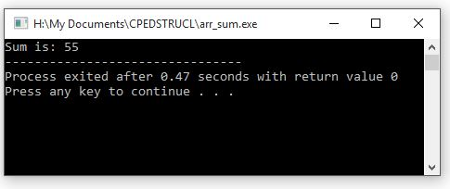

- A recursive function to produce the Fibonacci number for a given index in the series.
Use the function int fibonacci(int n)

Program:

#include <iostream>
using namespace std;

int fibonacci(int);

int main() {
int n;

cout<<"Enter integer: ";
cin>>n;

cout<<"Fibonacci: "<<fibonacci(n)<<endl;
}

int fibonacci(int n)
{
if (n<2) {
return n;
}
return (fibonacci(n-1)+fibonacci(n-2));
}

Output:

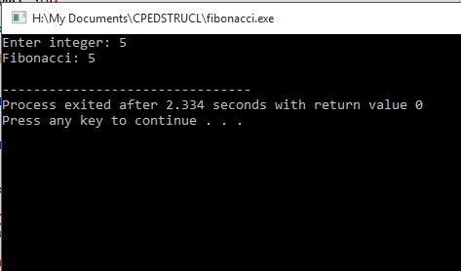

- A recursive function which raises its first parameter to the power of its second parameter.
Use the function int power(int number, int power)

Program:

#include <iostream>
using namespace std;

int exponent(int number, int power);

int main() {
int n,p;

cout<<"Enter number: ";
cin >>n;
cout<<"Raised to: ";
cin>>p;

cout<<"Answer= "<<exponent(n,p)<<endl;
}

int exponent(int number, int power) {
if (power==0) {
return 1;
}
else if(power==1) {
return number;
}
else {
return number*exponent(number,power-1);
}
}

Output:

