Engineering Notebook — Project Start

Date: Oct. 23, 2026, 8:20 PM
Phase: Pre-design
Revision: 0.1

History
In 1998, two mathematicians —Marlow Anderson and Todd Feil— discovered a method of solving Lights Out puzzles using linear algebra. Their work can be found here: (https://www.jstor.org/stable/2690705).

Main goal
My goal with this project is to turn Anderson and Feil’s mathematical algorithm into a C++ program, then design a physical machine designed to solve Lights Out puzzles using said program.

Objective
Make a “project requirements” Word document that outlines the Lights Out solver project.

Approach
Outline the project by brainstorming ideas in these categories:
- Objective
- Functional requirements
- Design constraints
- Verification criteria
- Open design decisions

Next steps
- Start working on the C++ program
- Create a function in C++ that turns the Lights Out matrix into a toggle matrix
Sign off: Oct. 23, 2026, 10:35 PM -Maiko Llanes

Engineering Notebook — Toggle Matrix
Date: Oct. 24, 2026, 5:55 PM
Phase: Pre-design
Revision: 0.2

Objective
Design a function in C++ that creates a toggle matrix using the original lights out matrix as the input.

Definition
The first step of solving a Lights Out puzzle is to find the toggle matrix. It is pertinent to first define what a toggle matrix is. Consider a 3 x 3 Lights Out puzzle; place the puzzle into a matrix, giving each tile a unique number from 1 to 9 in this configuration:
$$\left[\begin{matrix}1 & 2 & 3 \\ 4 & 5 & 6 \\ 7 & 8 & 9\end{matrix}\right]$$
To create the first row of the toggle matrix, we first check if toggling element 1 toggles element 1. Since this is true, we add an element with the value of 1 to our new matrix. Next, since toggling element 1 also toggles element 2 we add another 1 to the end of our matrix. In general, if toggling element 1 toggles element j, where j is the current element we are comparing 1 to, we add 1 to the end of our new row. If element 1 does not affect element j, we add a 0 to the end of the row instead. Following this process to the end of our original matrix will result in the row: (1 1 0 1 0 0 0 0 0). To create the following rows, we follow the same process with the next element, 2, then 3, until we use the process on element 9, resulting in the matrix:
$$\left[\begin{matrix}1 & 1 & 0 & 1 & 0 & 0 & 0 & 0 & 0 \\ 1 & 1 & 1 & 0 & 1 & 0 & 0 & 0 & 0 \\ 0 & 1 & 1 & 0 & 0 & 1 & 0 & 0 & 0 \\ 1 & 0 & 0 & 1 & 1 & 0 & 1 & 0 & 0 \\ 0 & 1 & 0 & 1 & 1 & 1 & 0 & 1 & 0 \\ 0 & 0 & 1 & 0 & 1 & 1 & 0 & 0 & 1 \\ 0 & 0 & 0 & 1 & 0 & 0 & 1 & 1 & 0 \\ 0 & 0 & 0 & 0 & 1 & 0 & 1 & 1 & 1 \\ 0 & 0 & 0 & 0 & 0 & 1 & 0 & 1 & 1\end{matrix}\right]$$
This 9 x 9 matrix is our toggle matrix for our 3 x 3 Lights Out puzzle. And in general, for any $n×n$ Lights Out puzzle, there exists a toggle matrix that is $n^{2}×n^{2}$ made up of only 0 and 1.

Approach
To determine where to place 0 and 1 in the toggle matrix, we need to find a way to identify if the position of element $i$ is the same, or adjacent to, the position of the iterating element, $j$; for simplicity, I will refer to this condition as $j$ being a neighbor of $i$. Assuming this time that the Lights Out matrix starts at position 0 instead of 1, $j$ is:
- A neighbor of $i$ if $j=i$.
- An “upstairs” neighbor of $i$ if $i-rowsize≥0 \& j=i-rowsize$.
- A “downstairs” neighbor of $i$ if $i+rowsize<matrixsize \& j=i+rowsize$.
- A “left” neighbor of $i$ if $\left(i-1\right)\text{mod}\left(rowsize\right)=i\text{mod}\left(rowsize\right)-1 \& i-1>0 \& j=i-1$.
- A “right” neighbor of $i$ if $\left(i+1\right)\text{mod}\left(rowsize\right)=i\text{mod}\left(rowsize\right)+1 \& j=i+1$.
With this knowledge it is now possible to make a function in C++ that creates a toggle matrix.

Code changes
The toggle matrix function is finished; the full code can be found on my GitHub repository.

Verification
If inputting a $3×3$ matrix results in its toggle matrix, the program is confirmed to work as intended thus far.
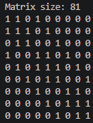
The result lines up with the toggle matrix we calculated earlier; therefore, the program is working as intended. Since my machine will have a $5×5$ grid, I also tested what a matrix of that size will look like by using this program:
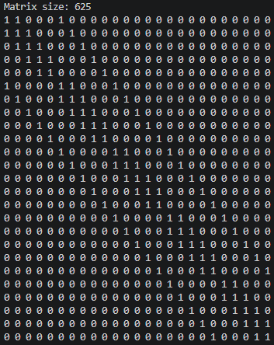

Next steps
- Create functions in the program that perform row operations on the toggle matrices using mod(2) arithmetic.

Sign off: Oct. 24, 2026, 9:16 PM Maiko Llanes

