Liam Lasurdo

To preface this, my code does not work entirely as I could not get the client and server to connect properly but I believe my logic was at least semi-correct.

I also coded the assignment entirely on remote and github as I don't have a linux machine to run c++.

My first decision was to use the command line argv to be able to use the same client code for both clients, it would just take in an arg of the input “Client X: Alice” or “Client Y: Bob”

Then the client would use this and send it as a message to the server.

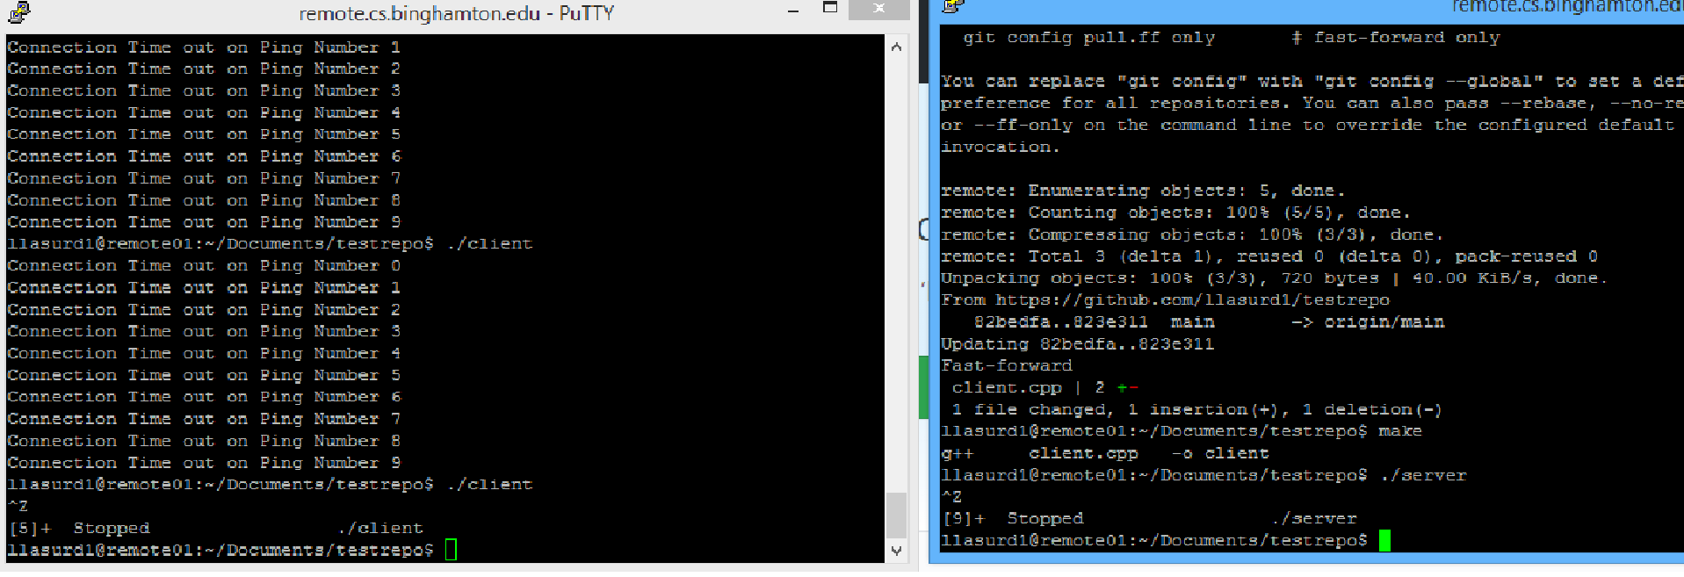The server waits to receive a message and when it does it checks to see if it is client x or y. It then checks to see if it has already received a message before this. If it hasn’t, it sends that information to both of the clients. After this loop, when 2 messages have been received, the server prints “Sent acknowledgment to both X and Y”

Back on the client side, they both wait to receive the message from the server. When they do, it and the original message they sent is printed.