⁃ Go to <https://ph.000webhost.com/>

⁃ Create a new account. You can also put your website’s name in the sign up form

⁃ Click on the build website tab then choose the Upload Own Website option (Click Upload Now)

⁃ You will be redirected to <https://files.000webhost.com/handler.php>

⁃ Go inside the public_html folder then create a new folder by clicking the new folder option in the navbar

⁃ Upload your capstone 2 folder

⁃ after uploading your capstone 2 folder, go back to the home page of 000webhost

⁃ select **“Manage Database”**

⁃ give your database a name, username and a password

⁃ 000webhost will generate something like this

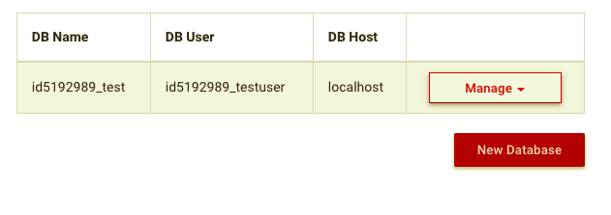

⁃ click on **“Manage”** and select PhpMyAdmin

⁃ you will be redirected to 000webhost’s phpmyadmin

⁃ look for your db name and click on it

⁃ press **“Import”** and upload your sql files into your database

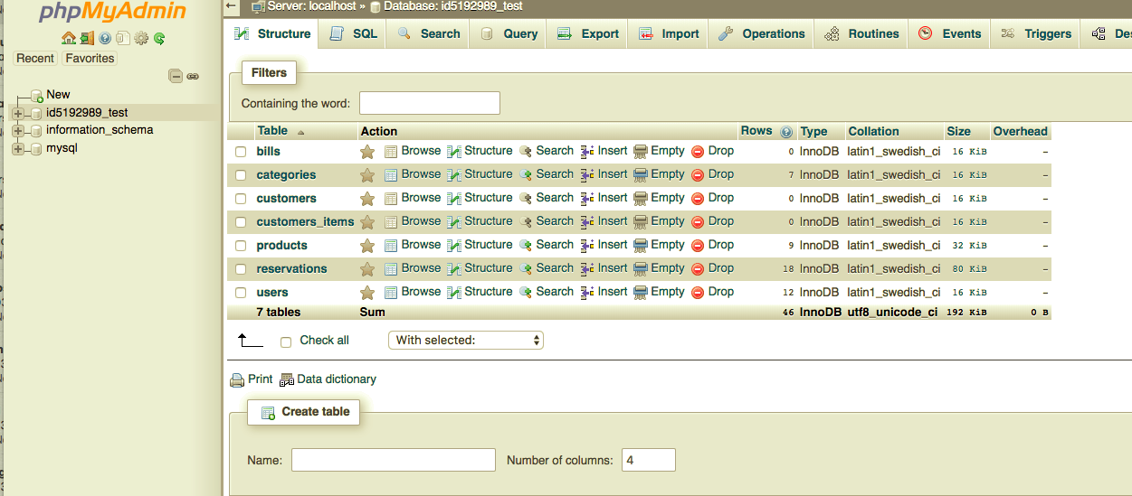

⁃ Go back to <https://files.000webhost.com/>

⁃ look for the file that you used to establish a connection with phpMyAdmin. (for example: connection.php)

⁃ open that file and replace the data with what 000webhost gave earlier

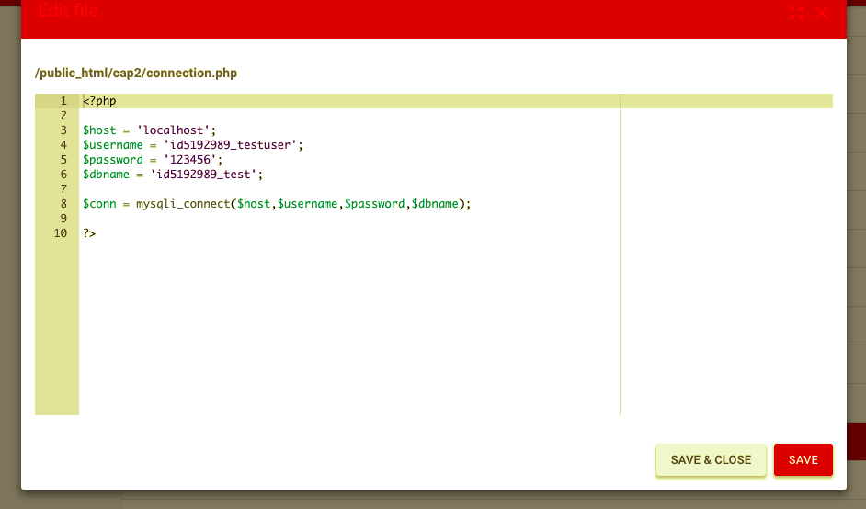

⁃ save and close

⁃ Go back to 000webhost

⁃ click on your profile and select **“My Websites”**

⁃ Select your website and enjoy!

**Note: Please use ‘index.php’ as the name of your homepage, as this is the first thing your webhost would look for.