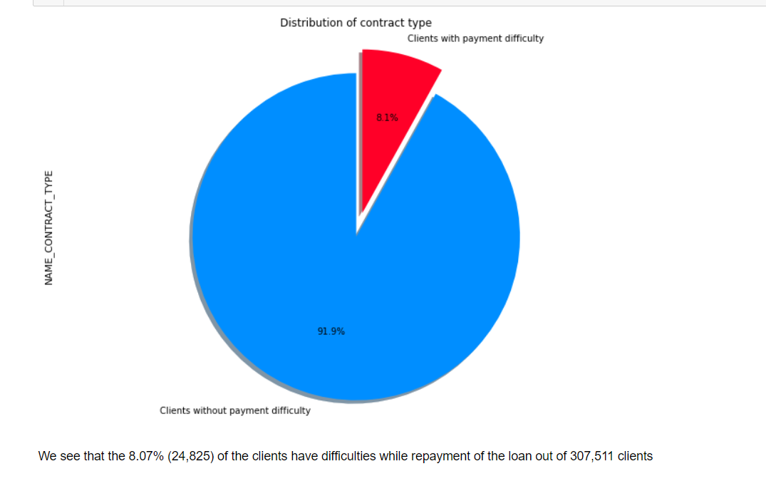

**NAME_CONTRACT_TYPE: IDENTIFICATION IF THE LOAN IS CASH OR REVOLVING**

## CODE_GENDER :- Gender of the Client

## **XNA might be people who do not want to be indentified as Female or Male** **which is understandable due to the current state of society where there are** **more than two gender** **Female number of clients is almost twice as much as Male clients at 202,448 and** **105,059 applications filled respectively** **However, a larger percentage (about 10% of the total) of men had the problems in paying the loan or making installments within time as compared to women applicants (about 7%).**

### **FLAG_OWN_CAR: Flag if the client owns a car | FLAG_OWN_REALTY: Flag if client owns a house or flat**

## *A bit over half of the applicants for loans own only 1 valuable asset(56,3%) while owning two or no valuable asset isrelatively the same at 23,5% and 20,3% respectivelyThe difference between the number of asset owned and difficulty inrepaying loans is not enormous but this feature can somewhat be useful now thatwe combine FLAG_OWN_CAR and FLAG_OWNED_REALTY together *

## AMT_INCOME_TOTAL: Income of the client

**We can tell that most people earn around 180,000 presumably US dollars** **It's easy to understand that as client's income grows, so is the probability** **that they don't have difficulty repaying loans.** **Suprisingly, people with low income at around 30,000 or less tend to repay more** **than those with the average income**

### **AMT_CREDIT: Credit amount of the loan**

**We can see from the Boxplot above that the Median Value of the Credit Amount of  
the Customers who are capable of loan repayment is slightly larger than the  
Median Value of Customers who are not capable of repayment.  
  
This basically means that the customers with higher credit amount have a  
slightly higher chances of being capable of loan repayment than customers  
with lower credit amount.  
  
Furthermore, there is a significant difference between repayable loans and  
difficulty repayable loans at the average credit amount (600,000 credit)  
where people tend to have difficulty at this amount.**

## AMT_ANNUITY: Loan annuity

**Most people pay annuity below Rs. 50K for the loans.**

## DAYS_BIRTH: Client's age

**Most number of people applying for loans are in the range of (35-40) years  
whereas this is followed by people in the range of (40-45) years whereas  
the number of applicants in people aged <25 or aged>65 is very low.  
  
Again, for the people who are deemed capable of loan repayment, people in  
the same age buckets of (35-40) years and (40-45) years are deemed to be  
most capable.  
  
People aged in the buckets (25-30) years and (30-35) years have a large chance of being deemed not capable for loan repayment.**

## NAME_TYPE_SUITE: Who was accompanying client when he was applying for the loan

**For the various types of people accompanying the client for loan, the client  
comes unaccompanied to the bank in the most number of cases, out of which  
approx. 92% of the time, the bank finds the client to be capable of loan  
repayment whereas the remaining 8% of the time, the client is not capable  
of the same.  
  
Both in capability and non capability, 'Unaccompanied' as a class is the  
majority class in this case.  
  
The curve over here falls very sharply, which means that there is a lot of variability.**

## NAME_INCOME_TYPE: Clients income type (businessman, working, maternity leave,…)

**The people who are working take the most number of loans whereas Commercial  
Associates, Pensioners and State Servants take considerably lesser number  
of loans.  
  
We have very little datapoints related to Unemployed people, Students,  
Businessmen and women on Maternity leave. Again, there's a lot of variability in this scenario.  
  
One interesting observation over here is the fact that whatever loans the  
students and businessmen have applied to, they have been deemed capable of repayment of the same**

## NAME_EDUCATION_TYPE : Level of highest education the client achieved

**Again, there's a lot of variability in this scenario among education types of  
the applicants.  
  
People with Secondary/Secondary Special as the highest level of education  
apply for most number of loans and they are also the highest defaulters.  
However, the default percentage is not very different across various education levels.**

## NAME_FAMILY_STATUS: Family status of the client

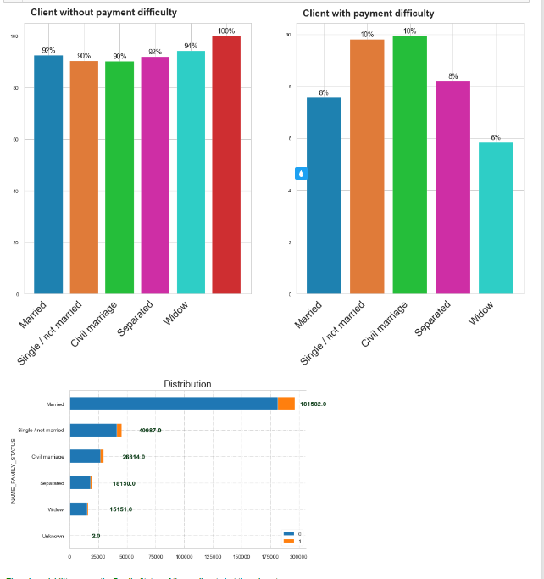

**There is variability among the Family Status of the applicants but there is not  
much variability if the majority class (Married) is ignored.  
  
Married people apply for the most number of loans and the number of people  
deemed incapable of repayment is also the highest.**

## DAYS_EMPLOYED: How many days before the application the person started current employment

Here also, we have already converted the days into years for easy analysis, and  
we can see from the histogram that most of the clients that have worked  
under 10 years(79.8%)  
Easy to understand that the longer you work the less difficult you find yourself repaying loans

## DAYS_REGISTRATION: How many days before the application did client change his registration

**Most of the clients have changed their registration less than 15000 days (41  
years) before the loan application, whereas in most cases it is less than  
5000 days (13 years).**