Weather tracking app

Marina Deletic, Brandon Clackson, hanbo Ding, Louis Choy

Team 041

MAY 5, 2016

User Guides

Version 1.0.0

**Contents**

Introduction and Purpose 2

Features 2

App Overview 3

Known Bugs or Limitation 3

# Introduction and Purpose

The weather tracking application is to enable mobile users to look up weather conditions in their current locations or check the weather in other places of interest. It will also be a location-aware app that uses an online forecasting service to present to the application user current and historic weather information for locations of interest. This document will have an overview of the features included in the application, an application overview with screenshots of various features of the application and known bugs and limitations to application

# Features

Features include:

* Locations List
  + This is the main page of the application
  + The ability to add new locations and refresh the main page are located here
* Method of adding and saving location
  + Enables the user to search and locate wanted location to be saved
  + Enable the user to provide a nickname for the saved location
* Method of viewing saved locations
  + Displays a map of the location saved
  + Shows the maximum and minimum temperatures, current humidity, wind speed and a text summary of the current weather conditions of the saved location
* Method of deleting saved locations
* Enable users to view the past 30 days on saved locations
  + A slider will display the past days weather conditions
* Allow users to view weather conditions in their current location

The application is supported on both Android and Apple phone users.

# App Overview

Launch Page (“Locations List”)

Refresh button – refreshes the page

Displays current location – when tapped, user is brought to location weather page and where the display weather forecast for current location and map of location will be displayed

Displays saved locations – also displays a weather summary and an image that corresponds to the weather summary, when tapped, user is brought to location weather page and where the weather forecast and map of location will be displayed

Add location – brings user to add location page

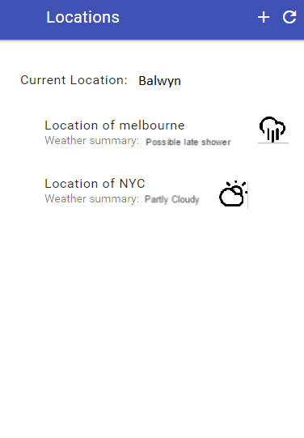

Add Location Page

Returns to launch page

Search for wanted location’s weather

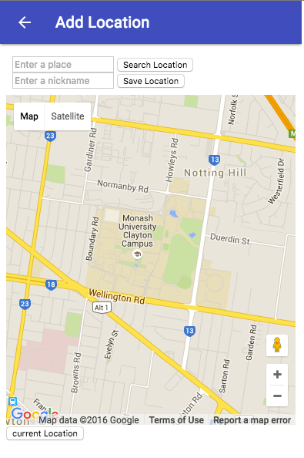

Saves location under user’s inserted nickname

Enter desired location nickname

Type in wanted location’s weather

Once tapped, map will display user’s current location

Map – displays searched location

Location Weather Page (View Location)

Location name or user’s desired location name

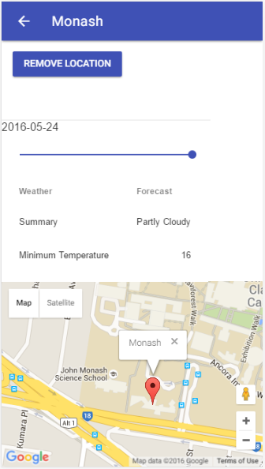

Marker – displays where on the map the location is

Returns to launch page

Remove saved location button – will remove saved data in local storage, once hit, will return to the launch page

Displays the date

Slider – to retrieve weather information from the past 30 days

Weather information – includes weather summary, minimum temperature, maximum temperature, current humidity and current wind speed

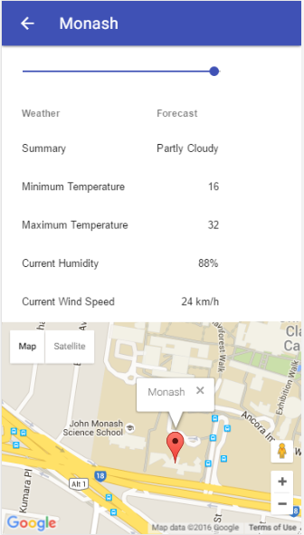

Map – Displays saved location or current location

# Known Bugs or Limitation

Limitations include:

* As Mozilla Firefox does not have a local storage, this application will not be able to be used as it is heavily based on the web browser having a local storage
* Application requires a mobile or wireless network to function as Google Maps API requires an internet connection to function
* Local storage has limited storage space, once this space is filled, the application may not be able to run

Known bugs include:

*Describe briefly any known bug or limitation with the app.*